Arts Education for Holistic Student Development: Role, Challenges, and Integration in Modern Learning Systems

Keywords—Arts education; creativity; holistic development; academic achievement; critical thinking; cultural education; STEAM integration.
I. INTRODUCTION
Education extends beyond technical knowledge and academic competencies—it plays a fundamental role in shaping creativity, emotional intelligence, and social awareness [3], [6]. Arts education, which includes visual arts, music, dance, drama, and literature, serves as a key component of holistic learning. Through artistic engagement, students develop imagination, self-expression, and reflective thinking, enabling them to approach problems from multiple perspectives [13].
In recent decades, the global education system has witnessed a strong shift toward science, technology, engineering, and mathematics (STEM) disciplines, often at the expense of creative subjects. This trend has raised concerns among educators and researchers who argue that an exclusively technical curriculum fails to produce well-rounded individuals. Arts-based learning fosters innovation and meaningful self-expression [19], qualities that are increasingly valued in today's rapidly evolving workforce.
This paper examines the role of arts education in modern learning environments, highlights its contribution to holistic and interdisciplinary development, proposes a structured Arts-Integrated Learning Model, and discusses practical challenges and future directions for the field [4], [27].
II. PROBLEM STATEMENT
The modern education system increasingly prioritizes STEM subjects, often at the expense of arts education [27]. While STEM is essential for economic and technological advancement, reduced attention to the arts creates an imbalance in student development [2]. Arts education fosters creativity, emotional intelligence, and critical thinking [5]; however, it is routinely undervalued in school curricula [29].
Several structural challenges contribute to this marginalization. Limited funding restricts the availability of arts programs and qualified instructors [36]. Standardized testing regimes further reduce time allocated to creative subjects, narrowing students' opportunities for self-expression and innovation [8], [19]. Additionally, institutional perceptions of arts as non-essential subjects hinder their integration into mainstream curricula [27]. Addressing these barriers requires policy reform, investment, and a reframing of what constitutes valuable educational experience.
III. OBJECTIVES
The study is guided by the following objectives:

A. Develop Creative Thinking
Arts education plays a key role in developing creative thinking by encouraging students to explore ideas, think independently, and solve problems in innovative ways [19], [21]. Unlike traditional methods focused on memorization, arts-based learning promotes imagination and self-expression through activities such as drawing, music, and drama [5], [7]. These activities enhance innovation, decision-making, and flexibility in thinking—skills applicable across academic and real-life situations [1], [4].
B. Enhance Cognitive Skills
Arts education improves cognitive skills such as memory, observation, and analytical thinking [5], [7]. Participation in artistic activities helps students process information, recognize patterns, and interpret meaning more effectively [23]. It also strengthens critical thinking by encouraging students to analyze and evaluate artistic work [13]. These cognitive benefits extend to subjects like mathematics, science, and language, contributing to overall academic success [2], [11].
C. Support Holistic Development
Arts education supports the holistic development of students by enhancing academic, social, and emotional growth [1], [4]. It improves engagement, creativity, and comprehension, leading to better academic performance [8], [2]. Furthermore, it cultivates communication, teamwork, confidence, and emotional intelligence through collaborative and expressive activities [15], [30], preparing students to become well-rounded individuals ready for real-life challenges [4].
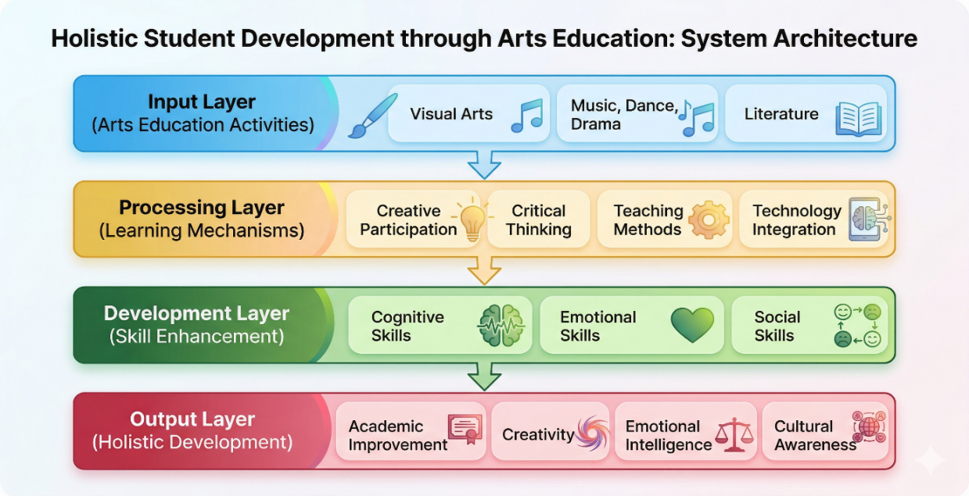
Fig. [1] Holistic System Architecture
IV. PROPOSED METHODOLOGY
This study adopts a qualitative and analytical methodology to examine the role of arts education in modern learning. It follows a descriptive and exploratory approach, focusing on students' cognitive, emotional, social, and academic development through analysis of existing literature rather than field-based research [1], [4].
Data were collected from secondary sources such as peer-reviewed journals, academic books, and reports from organizations such as UNESCO and the OECD, ensuring reliable and diverse perspectives [26], [27]. The analysis employs a thematic approach, identifying key themes—including creativity, academic achievement, emotional intelligence, and social skills—to draw meaningful conclusions [7].
The study is guided by established theoretical frameworks: Gardner's Theory of Multiple Intelligences, Dewey's Experiential Learning, and Constructivist Learning Theory [3], [6]. Digital databases including Google Scholar, ResearchGate, and JSTOR were used to gather relevant literature. This methodology is appropriate as it provides a comprehensive, reliable, and time-efficient means of analyzing trends and gaps in arts education without requiring extensive fieldwork [4].
V. ARTS-INTEGRATED LEARNING MODEL
The proposed Arts-Integrated Learning Model embeds artistic activities within regular academic subjects and consists of five interconnected components, which together provide a holistic and interactive learning experience.
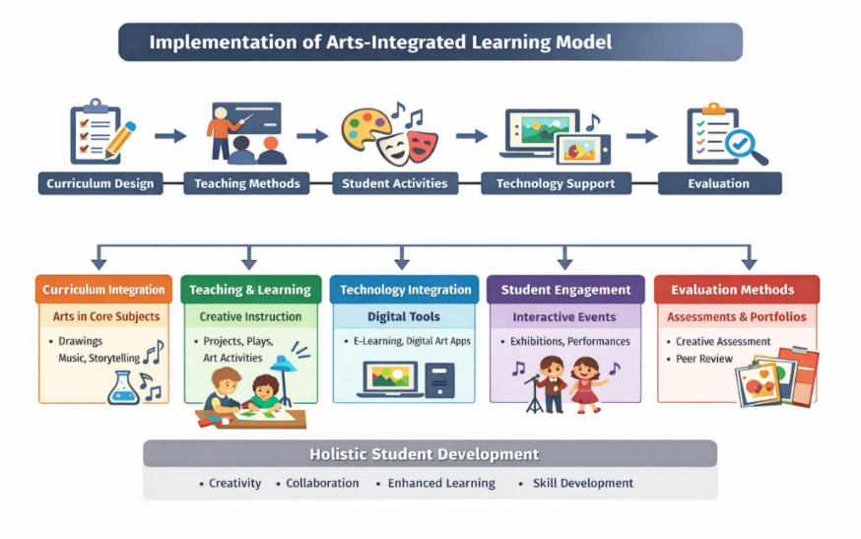
A. Curriculum Integration
Arts are integrated into core subjects such as mathematics, science, and language. For instance, drawing and diagrams are used to explain scientific concepts; musical rhythms are applied to teach mathematical patterns; and storytelling and drama are used to improve language skills. This cross-disciplinary approach reinforces subject comprehension while developing creative skills.

B. Teaching and Learning Methods
This module focuses on interactive and creative instructional techniques, including project-based learning, group activities (drama, music, and art projects), and visual and performance-based teaching. Example activities include students performing short plays to understand historical events, or creating posters to represent social issues.
C. Technology Integration
Digital tools expand creative opportunities and improve accessibility [39]. Students use digital drawing software (e.g., Canva, Adobe Photoshop), music creation applications, and online learning platforms. Virtual galleries and e-learning platforms further extend access to global artistic resources [26].
D. Student Engagement
This module ensures active student participation through art exhibitions, music and dance performances, creative competitions, and group collaboration projects. These activities build confidence, encourage teamwork, and enhance communication skills [9], [15].
E. Evaluation
Assessment is conducted using both traditional and creative methods, including performance-based assessment, portfolio submission (artwork and projects), peer and self-evaluation, and teacher observation. Students are evaluated on creativity, participation, and understanding rather than written examinations alone, providing a more accurate measure of holistic learning outcomes.
VI. IMPORTANCE OF ARTS EDUCATION
A. Cognitive Development
Arts education enhances cognitive development by improving memory, analysis, and problem-solving skills [5], [7]. Activities such as drawing and music strengthen brain function and intellectual flexibility [23]. Students involved in arts programs often perform better academically, particularly in mathematics and reading [2], [11].
B. Emotional Development
Arts provide a medium for emotional expression and personal growth [6]. Students develop confidence, empathy, and emotional intelligence through creative activities [30]. This contributes to improved mental well-being and self-awareness [21].
C. Social Skills and Collaboration
Arts education promotes teamwork, communication, and collaboration [15]. Group activities such as drama and music enhance social interaction and leadership skills [9]. Exposure to diverse artistic traditions also encourages cultural awareness and inclusivity [26].
D. Academic Achievement
Research demonstrates a strong positive relationship between arts education and academic performance [2], [18]. Arts-based teaching improves student engagement, motivation, and conceptual understanding [8]. Music education enhances memory and mathematical ability [31]; drama improves language and literacy skills [30]; and visual arts develop critical thinking and observational skills [5]. Students involved in arts programs also show higher attendance rates and lower dropout rates [34].
E. Cultural and Moral Development
Arts education preserves cultural heritage and promotes cross-cultural understanding [26]. It helps students learn about traditions, values, and societal identity [10]. Exposure to diverse artistic expressions fosters tolerance, respect, and global awareness [4], while encouraging ethical thinking about social responsibility and equality [6].
VII. CHALLENGES IN ARTS EDUCATION
Despite its well-documented benefits, arts education faces several persistent challenges. Limited funding and insufficient resources restrict program quality and reach [29]. A shortage of trained educators affects the effectiveness of instruction [36]. Standardized testing regimes reduce the time available for creative subjects, and the entrenched perception of arts as non-essential further limits their integration into curricula [8], [27].
Addressing these challenges requires coordinated policy reform, increased government and institutional investment in arts programs, enhanced teacher training, and broader public recognition of the value of arts in education [4], [36]. Collaboration with cultural organizations can provide valuable real-world learning experiences that supplement formal instruction [26].
VIII. KEY FINDINGS AND DISCUSSION
Table I summarizes the key themes and their impact on student development as identified through the literature review.
TABLE I. Key Impact Areas of Arts Education
Domain | Key Benefits | Supporting Evidence
Cognitive | Memory, analytical thinking, problem-solving | Efland [5]; Hetland et al. [7]; Arnheim [23]
Emotional | Confidence, empathy, emotional intelligence | Goldstein & Winner [30]; Csikszentmihalyi [21]
Social | Teamwork, communication, cultural awareness | Burton et al. [15]; UNESCO [26]
Academic | Higher achievement, engagement, lower dropout rates | Catterall [2]; Rabkin & Redmond [8]
Cultural/Moral | Heritage preservation, tolerance, ethical thinking | UNESCO [26]; Bamford [4]

The findings indicate a consistent pattern across the literature: engagement in arts education produces measurable benefits across cognitive, emotional, social, academic, and cultural domains. The proposed Arts-Integrated Learning Model builds on these findings by providing a structured, practical framework for embedding these benefits into everyday educational practice. Technology integration, as highlighted in this study, further extends the reach and impact of arts education by enabling digital creation and global resource access [38], [39].
IX. CONCLUSION
This paper has demonstrated that arts education is essential for holistic student development. It enhances creativity, academic performance, emotional intelligence, and cultural awareness while building social and communication skills. Despite ongoing challenges—including funding limitations, teacher shortages, and policy neglect—the evidence strongly supports greater integration of arts into mainstream education [1], [7], [29].
The proposed Arts-Integrated Learning Model offers a practical, scalable framework for schools to embed artistic activities into core curricula. As today's interconnected world demands creative, empathetic, and innovative individuals, arts education is not a supplementary option but a necessity. Policymakers, educators, and institutions must work collaboratively to ensure that arts remain a central component of well-rounded education systems [4], [19].

X. FUTURE SCOPE
Future research can explore deeper integration of emerging technologies such as Artificial Intelligence (AI), Virtual Reality (VR), and Augmented Reality (AR) to enhance arts education and increase global accessibility. Further studies can also investigate the expansion of interdisciplinary STEAM learning models that combine arts with science, technology, engineering, and mathematics to develop both creative and analytical skills simultaneously.
Policy-focused research can examine the effectiveness of government reforms in promoting arts education, particularly in developing countries, and propose scalable implementation models. Additionally, future work should explore inclusive arts education for students with disabilities and diverse learning needs, as well as the long-term impact of arts engagement on students' mental health and emotional well-being.
ACKNOWLEDGMENT
The authors would like to express their sincere gratitude to Ms. Hemangni Mehta, Assistant Professor, Department of Computer Application, PP Savani University, for her valuable guidance, continuous support, and encouragement throughout the completion of this research. We also extend our heartfelt thanks to PP Savani University for providing the necessary resources and academic environment to carry out this work effectively.
REFERENCES
[1] E. Winner, T. Goldstein, and S. Vincent-Lancrin, Art for Art's Sake? The Impact of Arts Education. Paris, France: OECD Publishing, 2013.
[2] J. S. Catterall, Doing Well and Doing Good by Doing Art. Los Angeles, CA: I-Group Books, 2009.
[3] H. Gardner, Frames of Mind: The Theory of Multiple Intelligences. New York, NY: Basic Books, 1983.
[4] S. Bamford, The Wow Factor: Global Research Compendium on the Impact of the Arts in Education. Münster, Germany: Waxmann, 2006.
[5] A. D. Efland, Art and Cognition: Integrating the Visual Arts in the Curriculum. New York, NY: Teachers College Press, 2002.
[6] J. Dewey, Art as Experience. New York, NY: Perigee Books, 1934.
[7] K. Hetland, L. Winner, S. Veenema, and K. Sheridan, Studio Thinking: The Real Benefits of Visual Arts Education. New York, NY: Teachers College Press, 2007.
[8] N. Rabkin and R. Redmond, "The arts make a difference," Educational Leadership, vol. 66, no. 5, pp. 60–64, 2009.
[9] C. S. Smithrim and R. Upitis, "Learning through the arts: Lessons of engagement," Canadian Journal of Education, vol. 28, no. 1/2, pp. 109–127, 2005.
[10] M. Greene, Releasing the Imagination. San Francisco, CA: Jossey-Bass, 1995.
[11] P. Abeles, "Music education and academic achievement," Journal of Research in Music Education, vol. 52, no. 3, pp. 196–208, 2004.
[13] E. W. Eisner, The Arts and the Creation of Mind. New Haven, CT: Yale University Press, 2002.
[15] J. M. Burton, R. Horowitz, and H. Abeles, "Learning in and through the arts," Curriculum Inquiry, vol. 33, no. 4, pp. 35–50, 1999.
[18] E. Winner and L. Hetland, "The arts and academic achievement: What the evidence shows," Journal of Aesthetic Education, vol. 34, no. 3–4, pp. 3–10, 2000.
[19] K. Robinson, Out of Our Minds: Learning to be Creative. Oxford, UK: Capstone, 2011.
[21] M. Csikszentmihalyi, Creativity: Flow and the Psychology of Discovery and Invention. New York, NY: HarperCollins, 1996.
[23] R. Arnheim, Visual Thinking. Berkeley, CA: University of California Press, 1969.
[26] UNESCO, Road Map for Arts Education. Paris, France: UNESCO, 2006.
[27] OECD, Art for Art's Sake? Overview. Paris, France: OECD Publishing, 2013.
[29] N. Rabkin and E. C. Hedberg, Arts Education in America: What the Declines Mean for Arts Participation. Washington, DC: National Endowment for the Arts, 2011.
[30] T. R. Goldstein and E. Winner, "Enhancing empathy through drama," Empirical Studies of the Arts, vol. 13, no. 1, pp. 19–37, 2012.
[31] S. Hallam, "The power of music: Its impact on intellectual, social and personal development," International Journal of Music Education, vol. 28, no. 3, pp. 269–289, 2010.
[34] L. Bresler, Knowing Bodies, Moving Minds. Dordrecht: Kluwer, 2004.
[36] F. R. Sabol, "Seismic shifts in the arts: The impact of policy," Arts Education Policy Review, vol. 114, no. 1, pp. 33–45, 2013.
[38] P. Mishra and D. Henriksen, "Creativity, technology, and education," TechTrends, vol. 62, no. 1, pp. 22–29, 2018.
[39] L. M. Stevenson and R. J. Deasy, Third Space: When Learning Matters. Washington, DC: Arts Education Partnership, 2005.

