A Practical ICT-Based Automated Framework for Sustainable Agricultural Finance and Financial Inclusion in Nigeria
Abstract
Agricultural financing institutions in Nigeria are still structurally fragmented despite growing efforts to promote digital inclusion initiatives. Majority of the existing Agri-Fintech interventions concentrate on digital payments, mobile access, or isolated credit analytics; however, they rarely offer an integrated architecture that connects data capture, decision-making automation, secure execution, and continuous monitoring. In order to addresses that gap, this study developed a Design Science-grounded ICT-based automation framework that restructures agricultural financial service delivery as an end-to-end system. Drawing on recent literature, the framework translates documented problem clusters into a five-layer architecture that includes stakeholder data formalization, interoperable ICT integration, embedded decision intelligence, secure transaction execution, and adaptive feedback mechanisms. Each layer directly addresses a literature-identified systemic weakness, with explicit traceability between theoretical gaps and architectural components. The model proposes an advancement of digital agricultural finance from modular service interventions toward an integrated automation-centric design logic. The framework offers a context-aware blueprint suitable for low-connectivity and high-risk agricultural environments, emphasizing execution integrity, transparency, and institutional accountability. Despite being conceptual, the model establishes a systematic framework for prototyping, empirical validation, and extendable policy implementation in developing countries.
Keywords: agricultural finance, financial inclusion, ICT in agriculture, digital finance, sustainable finance, rural finance, Nigeria
Introduction
In Nigeria, agriculture employs a substantial proportion of the workforce and significantly contributes to rural livelihoods and food security. Thereby positioning itself as a central pillar of Nigeria’s economy. However, the agricultural landscape is dominated by smallholder farmers, whose productivity, investment and resilience are still limited by persistent financial constraints (Balana & Oyeyemi, 2022). Traditional agricultural finance mechanisms in Nigeria are characterized by high transaction costs, information asymmetry, weak collateral structures and limited outreach to rural and informal actors, resulting in chronic financial exclusion (Adegbite, 2021; Adesugba & Mavrotas, 2020).
In recent years, the rapid expansion of Information and Communication Technologies (ICT) and digital financial services has generated renewed optimism regarding the transformation of agricultural finance systems in developing economies. According to empirical studies from Nigeria and other Sub-Saharan African nations, the adoption of digital finance is positively correlated with smallholder productivity (Adesiyan, 2025), income development, and value chain participation. In agricultural financing, it is observed that digital platforms, mobile money services, and fintech-enabled microcredit schemes can reduce transaction frictions and partially bridge institutional gaps (Ezeomah, 2021). Recent research has examined both the determinants of digital financial service adoption among smallholder farmers and the use of automation in financial decision making. These studies identified financial literacy (Kolawole et al., 2025), trust, infrastructure availability and socio demographic characteristics as major drivers of digital finance usage (Ogunfolaju et al., 2025) and inclusion outcomes. Other financial technology research emphasized that the potential of automation (Ajuwon et al., 2024), Artificial Intelligence (AI), and data-driven credit scoring (Kowsar, 2022) can help to increase lending efficiency and lessen information asymmetry. Consequently, despite the proliferation of digital finance initiatives, agricultural finance solutions in Nigeria remain technically fragmented at the system level. Existing studies and platforms tend to address isolated functions such as mobile payments, microcredit access, or digital adoption drivers without articulating how these elements can be integrated into a unified, end-to-end automated architecture that supports the full agricultural finance lifecycle (Benni, 2024). Adoption studies are largely descriptive and focus on usage patterns and impact metrics, whereas automation models are typically developed for conventional banking or SME environments. As a result, limited attention is given to how automated credit intelligence, digital access channels and agricultural risk data can be structurally integrated into a scalable system that accounts for climatic volatility, informal production structures and infrastructural constraints in smallholder agriculture in Nigeria.
The absence of a context-aware, ICT-based automated framework that methodically links farmer onboarding, ICT access, intelligent credit assessment, secure transaction execution and continuous monitoring within a single operational system which is designed for low-infrastructure environments is a critical automation-integration gap in the literature. While last-mile connectivity challenges (Umar et al., 2021) and institutional limitations are acknowledged in financial inclusion studies (Croxson et al., 2023), there is limited guidance on how modular technological architectures like multi-channel access interfaces, automated analytics, and traceable transaction mechanisms can be coordinated to provide sustainable agricultural finance at scale in rural Nigeria (Chaudhari et al., 2024).
In order to address this gap, this study adopts Peffers et al., (2007) Design Science Research (DSR) principles to develop a practical ICT-based automated framework conceptualized as a design tool for sustainable agricultural finance and financial inclusion in Nigeria. Instead of focusing solely on adoption outcomes, the study prioritises structural design, process integration, and automation logic, with particular attention to trust, climate sensitivity and infrastructural constraints. In addition to providing a scalable blueprint to guide future implementation, empirical evaluation, and policy-driven digital finance interventions in developing economies, this research adds a system-oriented perspective to the literature on digital agriculture and financial inclusion by proposing a unified, layered framework that connects smallholder agricultural data and formal financial systems.
Literature Review
In developing economies, particularly in Sub-Saharan Africa, sustainable agricultural finance is widely acknowledged as being crucial for alleviating poverty, promoting rural development and ensuring food security. Despite smallholder farmers being the backbone of agricultural production in Nigeria, decades of government intervention and donor-funded initiatives, access to formal financial services remains persistently low (World Bank, 2021). Research indicates that the lack of financial programs is not the cause of this gap, but the structural, informational and institutional weaknesses that limits the effectiveness and sustainability of the existing delivery systems.
The difficulty of identifying and profiling smallholder farmers within official banking systems is one persistent issue in the literature (Aker & Mbiti, 2019). Many maintain informal production and transaction records, operate outside of official registers and lack verifiable identification (IFAD, 2020). Without structured and verifiable data, financial institutions struggle to assess risk, monitor performance or establish institutional trust. This identity gap or mismatch forms a foundational limitation that affects the entire agricultural finance lifecycle. So also, access to digital infrastructure also forms another significant barrier. Although mobile adoption and digital financial services have grown significantly in Nigeria, rural farmers often deal with poor interoperability across digital platforms, inconsistent connectivity and low smartphone ownership (GSMA, 2022). Many digital finance initiatives assume smartphone usage and stable internet access. These assumptions do not reflect rural realities (Jack & Suri, 2014). As a result, ICT-driven interventions often fail in reaching populations that are financially excluded on a large scale.
These two issues are further compounded by information asymmetry in agricultural credit markets. Due of revenue instability, exposure to climate change and a lack of formal documentation, financial institutions often categorise smallholder agriculture as high risk (Carter et al., 2017). Major components of traditional credit scoring models include formal income records, established banking histories and collateral. Rarely do these criteria fit smallholder brackets. Although recent research demonstrates that alternative data such as farm size, crop cycles and transaction histories can improve risk assessment (Karlan et al., 2020). However, these data are rarely integrated into automated and scalable credit decision systems. As a result, poor financial decisions can be made. Furthermore, this has a high likelihood of cumulating to problem situations that arises after loan approval. Research shows that household pressures, delayed input supply or insufficient monitoring can sometimes cause agricultural loans to be redirected to unproductive uses (Khandker et al., 2016). Manual monitoring approaches are expensive and challenging to maintain in scattered rural populations. These restrictions increase the danger of default, undermine lender confidence and raise moral hazard concerns.
Fintech platforms, donor-funded programs and government efforts usually function independently, each with its own data systems and reporting needs (FAO, 2021). Hence, these different agricultural finance programs are fragmented. Limited interoperability restricts coordinated learning, real time performance tracking and policy adjustment. As a result, lessons learned from earlier initiatives are rarely institutionalised, which leads to recurring inefficiencies.
When all of these gaps are considered collectively, these studies point to a systemic issue rather than isolated operational problems. The recurring issues of identity gaps, infrastructure exclusion, information asymmetry, moral hazard and fragmentation suggest the need for an integrated, automated and system level approach. To ensure that the proposed framework directly responds to documented deficiencies, this study adopts a traceability driven design logic. The proposed ICT-based automated agricultural finance framework’s functional layers and technological interventions are mapped to the main issues identified in the literature as shown in Table 1.
Table 1: Literature-Framework Traceability Table
Framework Layer | Systemic Problem Identified in Literature | Literature Support | Framework Intervention
1. Stakeholder and Data Input | Institutional voids and identity gap. Smallholder farmers lack verifiable digital identities and structured records, limiting trust and formal profiling. | Aker & Mbiti (2019); IFAD (2020); Ezeomah (2021) | Integration of NIN linked digital farmer profiles combined with cooperative level validation to establish a trusted digital identity foundation.
2. ICT Access and Integration | Last mile infrastructure exclusion. Limited smartphone ownership, weak connectivity, and poor interoperability restrict rural participation in digital finance systems. | GSMA (2022); Donovan (2018); Jack & Suri (2014); Umar et al. (2021) | Deployment of USSD and SMS interfaces supported by interoperable APIs to enable low bandwidth access across financial institutions and fintech platforms.
3. Automation and Intelligence | Information asymmetry and inappropriate credit scoring models for informal agricultural contexts. | Stiglitz & Weiss (1981); Carter et al. (2017); Karlan et al. (2020); Ajuwon et al. (2024) | AI driven credit scoring that integrates alternative agricultural data such as farm size, crop cycles, satellite indicators, and transaction histories for automated risk assessment.
4. Secure Transaction and Execution | Moral hazard and loan diversion. Weak monitoring allows funds to be redirected away from productive agricultural use. | Banerjee et al. (2015); Khandker et al. (2016); Adesugba & Mavrotas (2020) | Conditional or tokenized digital disbursement mechanisms linked to verified input suppliers to ensure funds are used for approved agricultural purposes.
5. Monitoring and Feedback | Fragmentation and weak policy learning. Disconnected programmes limit real time performance tracking and sustainability assessment. | FAO (2021); Benni (2024); Elias et al. (2024) | Real time dashboards and automated feedback triggers that update risk models and generate performance insights for lenders and policymakers.
Table 1 functions as a synthesis mechanism that links theory to design. Each framework layer is grounded in documented empirical challenges and translated into a corresponding ICT enabled intervention. This structured alignment ensures that the proposed framework is not technology driven in abstraction, but problem driven and context responsive to Nigeria’s agricultural finance realities.
3. Research Design and Framework Development
This study adopts a DSR approach to develop an ICT based automated framework for agricultural finance in Nigeria. DSR is well-suited for complex socio technical challenges because it produces and evaluates purposeful results grounded in theory and practice. This study integrates research design with framework development rather than separating methodology from system architecture. This allows the proposed solution to emerge directly from systemic flaws in agricultural finance delivery that have been identified in the literature. The resulting framework, presented in Figure 1, is a unified and layered automated ecosystem that translates documented structural gaps into an operational architecture tailored to Nigeria’s low connectivity and high-risk agricultural environment.
3.1 Methodology
Following established DSR guidelines (Peffers et al., 2007), the study progresses through problem identification, requirement synthesis, mode design and analytical evaluation. A systematic review of recent literature on digital agriculture finance, financial inclusion and ICT-enabled automation serves as the foundation for the problem identification. The review consistently identifies five interrelated systemic problems: institutional voids and identity gaps; last mile ICT exclusion; information asymmetry and inappropriate credit scoring models; moral hazard and loan diversion; and fragmentation with weak policy learning.
These documented challenges are translated into explicit design requirements and organized into five corresponding framework layers: stakeholder and data input; ICT access and integration; automation and intelligence; secure transaction and execution; and monitoring and feedback. Table 1 formally documents the traceability between these functional layers and issues identified in the literature.
The proposed methodology moves from empirical data capture to automated financial execution.
Phase I: Data Normalization and Gating
The process begins with the conversion of unstructured agricultural activities into structured digital assets. The methodology employs Digital Identity Capture and Multi-Factor Authentication (MFA) tailored to the stakeholder’s hardware capability. This phase ensures the “Single Source of Truth” necessary for financial auditing.
Phase II: Hybrid Credit Modeling
Unlike traditional models relying solely on collateral, the proposed methodology utilizes a Hybrid Scoring Approach:
Score = α(R_{i}) + β(C_{g}) + ¥(P_{s})
Where R_{i} is individual repayment history, C_{g} is social collateral and P_{s} is production stability.
Weights (α, β, ¥) are dynamically adjusted based on the feedback loop from Layer 5.
Phase III: Automated Enforcement and Execution
Operational execution is governed by programmatic disbursement. The methodology enforces a “Purpose-Bound Money” approach, where capital is digitally ring-fenced for specific agricultural inputs, validated against the crop cycle identified in Phase I.
Phase IV: Closed-Loop Optimization
The final phase involves Continuous Performance Calibration. The system monitors the Portfolio at Risk (PAR) and Default Clustering. These outputs are not merely reported but are programmatically fed back into the Intelligence Layer to refine future eligibility thresholds.
The methodology ensures that every transaction reinforces the system. A farmer’s successful repayment doesn’t only just clear their debt, it automatically improves the Reliability Index of their entire process, lowering the barrier for the next applicant. These requirements are operationalised into a conceptual yet structured ICT-based automated architecture during the model design phase. To ensure adaptation across diverse institutional and technological environments, the framework emphasizes modularity, interoperability and rule-based automation.
This methodical process produced the five-layer automated framework illustrated in Figure 1 and described below.
3.2 Proposed ICT-Based Automated Framework
The proposed framework is structured as a five-layer automated modular ecosystem that directly addresses to the systemic agricultural finance constraints synthesized in Table 1. Each layer corresponds to a documented problem in the literature and operationalizes a targeted intervention, ensuring a clear traceability between identified gaps and system functionality. The layered architecture separates access mechanisms from core processing logic, thereby enhancing flexibility, interoperability and resilience in low-infrastructure environments. This layered design supports inclusivity while maintaining consistency in data processing, decision-making and execution.
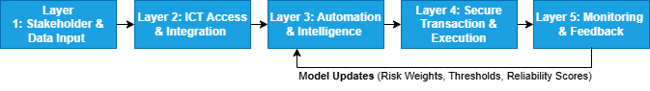
Figure 1: Simplified Flow of the Proposed Multi-Layered Architectural Framework for Automated Agri-Fintech Integration (AAFI) in Nigeria
Figure 1 illustrates a closed-loop automated decision system structured across five interdependent layers. The framework follows a sequential flow from stakeholder data capture to system-wide monitoring, with each layer performing a distinct functional role. Layer 1 structures and validates multi-source farmer and cooperative data into standardized machine-readable formats. Layer 2 enables interoperable access through multi-channel interfaces and API-driven integration with external systems. Layer 3 embeds rule-based and analytical intelligence to generate a standardized decision object through automated risk assessment and anomaly detection. Layer 4 translates these decisions into secure and conditional financial execution, incorporating validation, disbursement control and audit mechanisms. Layer 5 evaluates system performance, generates early warning signals, and updates model parameters through a continuous feedback loop that feeds back into the intelligence layer.
This closed-loop configuration ensures traceability, adaptability and scalability, particularly within low-connectivity agricultural finance environments. Figures 2 to 5 provide detailed representations of each layer and their internal functional components.
1. Stakeholder & Data Input Layer
This layer addresses institutional voids and the identity gap that limit smallholder participation in formal finance systems. Many farmers lack structured production records and verifiable digital identities, as documented in the literature, which makes trust-building and profiling difficult.
To resolve this constraint, the framework integrates structured digital farmer profiles linked to National Identification Systems (NIS) and validated through cooperative level authentication. Core data inputs include farmer identity records, cooperative membership details, farm characteristics, production histories and transaction information. This layer serves as the primary ingestion engine. It establishes a trusted and verifiable data foundation for subsequent credit assessment and monitoring procedures by standardising and digitising these inputs at the entry point through plausibility checks (FarmSize X ExpectedYield), ensuring that only verified, machine-readable profiles enter the system. This is illustrated in figure 2. Figure 2 captures the operations of both layer 1 and 2.
2. ICT Access & Integration Layer
This layer responds to the last mile infrastructure gap that excludes rural farmers due to limited smartphone ownership, weak connectivity and poor platform interoperability. Is serves as an abstraction layer that provides channel-agnosticism.
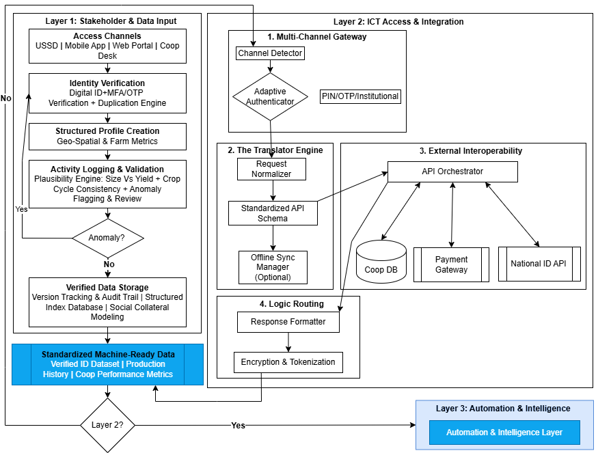
Figure 2: Stakeholder & Data Input Layer and ICT Access & Integration Layer
In addition to mobile and web platforms for users with higher capabilities, the framework allows multi-channel system participation through USSD and SMS interfaces that operate in low bandwidth environments. It translates the heterogeneous inputs (USSD, SMS, Web) into a unified internal API schema, removing device-dependency as a barrier to credit. To ensure seamless data exchange, cooperative databases, financial institutions and payment platforms are connected via interoperable application programming interfaces. By separating system participation from smartphone dependency and continuous internet access, this layer guarantee inclusive access across diverse infrastructure conditions.
3. Automation & Intelligence Layer
This is the computational core layer. Figure 3 shows how this layer targets information asymmetry and the limitations of traditional collateral-based credit scoring models that are unsuitable for informal agricultural processes.
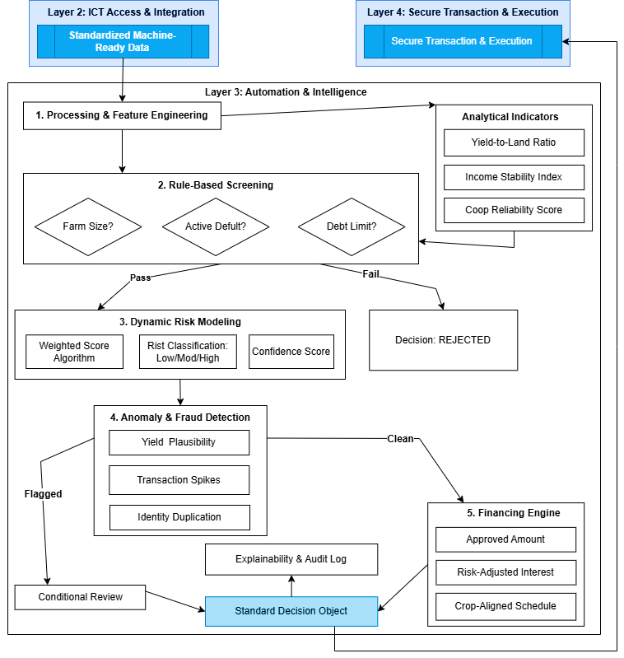
Figure 3: Automation & Intelligence Layer
It utilizes a bifurcated decision logic by first applying deterministic eligibility filters, then executing probabilistic risk-scoring algorithms to generate context-aware financing recommendations. The framework embeds AI driven and rule-based credit assessment mechanisms that integrate alternative agricultural data, including farm size, crop cycles, transaction histories, cooperative performance records and relevant environmental indicators. Automated eligibility screening and risk scoring replace discretionary and static decision processes. This layer converts agricultural data into scalable, consistent, and context-aware financial decisions by embedding intelligence within the system architecture.
4. Secure Transaction & Execution Layer
This layer plays the role of the enforcement gate. It tackles two persistent weaknesses in agricultural finance delivery systems: moral hazard and loan diversion.
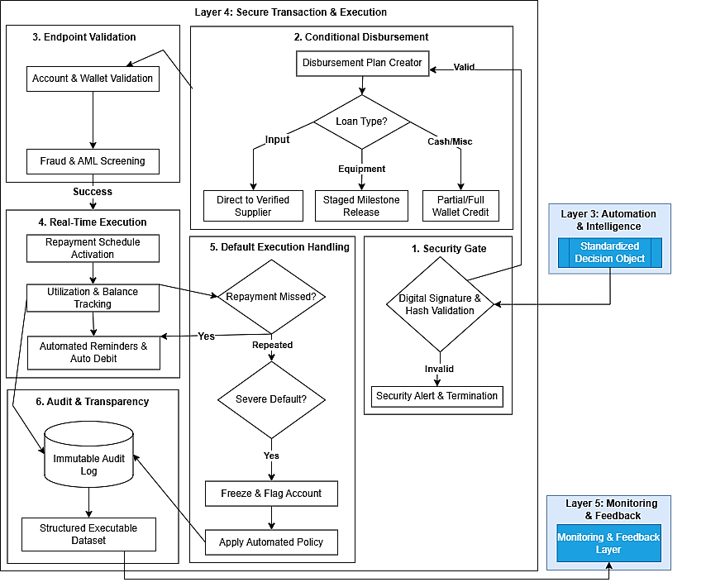
Figure 4: Secure Transaction & Execution Layer
As illustrated in figure 4, approved financing is operationalized through controlled and traceable digital disbursement mechanisms. It transitions the system from “data” to “capital” by utilizing conditional disbursement protocols (e.g., direct-to-supplier transfers), thereby eliminating loan diversion. Tokenised or conditional fund release structures guarantee that loans are allocated to verified agricultural input suppliers or predefined production purposes. Automated repayment scheduling and transaction logging enhance accountability and transparency. By embedding execution controls within the framework, this layer boosts lender confidence and reduces misuse of funds.
5. Monitoring & Feedback Layer
Figure 5 represents a detailed operation of the monitoring and feedback layer. This layer addresses policy learning gaps and fragmentation across agricultural finance programs. It serves as the self-optimizing “brain” of the system.
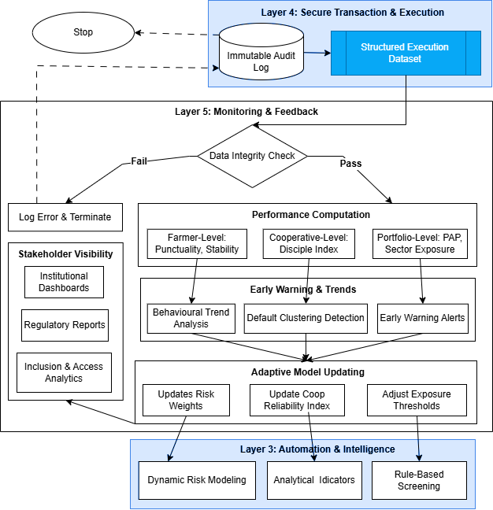
Figure 5: Monitoring & Feedback Layer
Data on loan utilisation, payback patterns and farm-level performance are compiled in real-time dashboards. It monitors real-world repayment outcomes to perform recursive parameter recalibration, updating the risk weights used by Layer 3. Automated feedback triggers update risk models and generate early warning signals based on changing agricultural and environmental conditions. Future credit decisions are improved by feeding performance results back into the automation layer. This closed loop structure transforms the framework into a continuous learning system capable of adaptive and evidence-based decision making.
4. Framework Evaluation
The framework is evaluated analytically in accordance with early-stage DSR principles. Evaluation is based on logical coherence, traceability to earlier studies, contextual feasibility and structural completeness. There was no empirical testing of the prototype. Assessment relies on structured conceptual walkthroughs and systematic mapping to the Literature-Framework Traceability Table (Table 1).
Table 1 serves as the primary validation anchor. It demonstrates how each architectural layer directly addresses specific problem clusters identified in earlier empirical and conceptual studies. The evaluation below mirrors that mapping explicitly.
Layer 1: Stakeholder and Data Input Layer
Table 1 identifies fragmented borrower profiling, incomplete agricultural datasets and weak stakeholder integration as recurring gaps. In response, this layer standardizes the collection of multi-actor data from financial institutions and farmers.
Evaluation confirms:
- Structured stakeholder registration
- Harmonized data schemas
- Reduced information asymmetry at the pre-credit stage
Conceptual walkthroughs show that complete, standardized input data improves risk visibility and reduces profiling inconsistencies.
Layer 2: ICT Access and Integration Layer
Table 1 highlights system silos, poor interoperability and limited rural connectivity as systemic constraints. Multi-channel access and modular integration mechanisms are introduced in this layer.
Evaluation confirms:
- API-enabled cross-institutional synchronization
- Reduced data duplication
- Compatibility with low-bandwidth environments
Logical assessment demonstrates improved operational continuity across heterogeneous ICT infrastructures.
Layer 3: Automation and Intelligence Layer
According to Table 1, static credit models and manual appraisal bias remain unresolved challenges. This layer integrates rule-based and knowledge-based automation to standardize eligibility checks and risk scoring.
Evaluation confirms:
- Consistent decision logic
- Reduced subjective variability
- Transparent risk classification pathways
Analytical reasoning shows that similar borrower profiles would produce consistent credit outcomes under automated rules.
Layer 4: Secure Transaction and Execution Layer
Table 1 identifies trust deficits, weak audit trails and execution opacity in digital agricultural finance systems. This layer incorporates authentication controls, role-based permissions and transaction logging.
Evaluation confirms:
- Traceable disbursement workflows
- Verifiable audit logs
- Strengthened accountability mechanisms
Conceptual analysis indicates improved institutional trust and reduced operational ambiguity.
Layer 5: Monitoring and Feedback Layer
The literature summarized in Table 1 shows weak post-disbursement monitoring and limited adaptive learning. This layer integrates repayment tracking, performance analytics and rule recalibration mechanisms.
Evaluation confirms:
- Structured monitoring cycles
- Early risk alert generation
- Feedback-driven system updates
Logical assessment indicates enhanced sustainability and long-term system intelligence.
5. Discussion and Implications
This study tackles a structural flaw in Nigeria's agricultural finance ecosystem: while digital inclusion initiatives have increased access, they have not resulted in an integrated system capable of converting data into financial processes that are automated, transparent and executable. Existing Agri-Fintech models typically concentrate on mobile payments, digital onboarding, or standalone credit scoring tools. Although these interventions increase access, they often operate as stand-alone modules. They do not structurally connect stakeholder data capture, interoperability, automated decision logic, secure execution and continuous monitoring within a unified architecture.
The proposed framework advances the discourse by repositioning digital agricultural finance as a system design problem rather than an adoption problem. It begins by formalizing multi-actor data standardization across farmers, cooperatives and financial institutions. The methodology uses structured stakeholder data as the basis for reducing information asymmetry and improving pre-credit risk visibility, rather than treating borrower profiling as a peripheral administrative activity. This directly addresses the fragmented data environments repeatedly identified in earlier studies.
Building on this foundation, the architecture incorporates interoperability and accessibility as fundamental structural principles. Many existing platforms assume reliable connectivity and centralized infrastructure. In contrast, the framework integrates modular APIs, multi-channel access pathways and low-bandwidth compatibility into its design logic. Therefore, ICT integration is treated as a functional condition for inclusive and synchronized service delivery across heterogeneous environments rather than as a technical add-on. The framework then moves to intelligent automation from digitisation. While a number of Agri-Fintech solutions digitally replicate manual appraisal processes, this model incorporates rule-based and knowledge-based decision mechanisms directly into eligibility assessment and risk classification workflows. The shift is significant. Subjective bias is reduced, decision consistency is enhanced and risk evaluation is traceable. Automation restructures the way financial judgement is carried out here and goes beyond simply accelerating processes. Security and execution integrity are positioned as structural layers rather than backend safeguards. The operational flow of fund management and credit disbursement integrated auditable transaction logs, role-based permissions and authentication controls. In doing so, the framework directly addresses documented concerns regarding trust deficits, cooperative resource misuse and limited transparency in digitally mediated agricultural finance systems. Therefore, security becomes a functional enabler of institutional legitimacy. Unlike many existing systems that terminate at disbursement, the architecture embeds structured monitoring and feedback loops. The framework is transformed into a continuous learning mechanism by providing functionalities for repayment tracking, performance analytics and adaptive rule recalibration. Financial service delivery is conceptualized as cyclical and data-responsive rather than transactional and static. This dynamic capability strengthens sustainability, especially in environments characterized by erratic climatic patterns and fluctuating market conditions.
This study advances digital agricultural finance from fragmented technological interventions toward an integrated automation architecture. Rather than proposing another access channel, mobile interface, or isolated credit scoring improvement, the framework restructures how financial processes are organized, executed and governed. It establishes a traceable linkage between stakeholder data formalization, interoperable ICT infrastructure, embedded decision intelligence, secure transactional execution and adaptive performance monitoring. This systematic configuration distinguishes the model from other Agri-Fintech approaches that are still functionally fragmented. The alignment between the literature-derived problem clusters summarized in Table 1 and the architectural configuration presented in Figure 1 strengthens the framework’s theoretical and structural grounding. Each design layer corresponds to a documented systemic vulnerability. The interdependence among the layers ensures that improvements in access, automation, security, or monitoring do not occur in isolation. Hence, the framework contributes a cohesive socio-technical design logic that connects inclusion, execution integrity and institutional accountability within a single operational continuum.
More importantly, it establishes a structured foundation upon which empirical prototyping, field validation and policy experimentation can be systematically built. This study advances both theory and practice by repositioning agricultural digital finance as an executable system architecture problem instead of a platform deployment. It offers a replicable design blueprint suitable for phased institutional implementation while preserving conceptual coherence.
Conclusion
This study addressed the structural fragmentation of agricultural finance in Nigeria by developing a Design Science-grounded ICT-based automation architecture that integrates stakeholder data formalization, interoperable access, intelligent decision logic, secure execution and adaptive monitoring within a single coherent system. The study reframed agricultural inclusion as an executable system design issue rather than examining digital finance adoption in isolation.
The contribution of this study is threefold. First, it advances scholarship in digital agricultural finance by moving away from modular service interventions and toward an integrated automation-centric architecture. Secondly, it demonstrates how interoperability, embedded intelligence and execution transparency may be structurally aligned with a context-aware blueprint designed for high-risk and low-connectivity environments. Third, by explicitly tracing gaps found in the literature to architectural components, the study strengthens design rigor and provides a replicable model for artefact-based research with respect to developing-countries.
In practical terms, the framework provides policymakers and financial institutions with a modular yet unified reference for structuring scalable digital agricultural finance systems. It prioritises systemic integration over standalone platform development, thereby supporting coordinated and sustainable inclusion policies. The framework remains conceptual and has not undergone empirical deployment. Future research should prioritize prototyping, pilot implementation and quantitative validation of performance, usability and institutional impact. Extensions may incorporate climate risk analytics, real-time agricultural data streams and cross-regional comparative testing to refine adaptability and scalability.
The study demonstrates that sustainable agricultural finance requires integrated automation architectures rather than incremental digitization. It establishes a structured foundation for empirical advancement and policy-oriented system development in ICT-enabled agricultural finance.
References
Adegbite, O. O. (2021). Financial inclusion of rural smallholder farmers in Nigeria: Measurement issues, impact on livelihood and implications for policy interventions (Publication No. 23846) [Doctoral dissertation, University of Pretoria]. UPSpace Institutional Repository.
Adesiyan, T. (2025). Leveraging agricultural credit and digital finance for enhancing smallholder productivity and rural economic growth. International Journal of Research Publication and Reviews, 6(8), 3090.
Adesugba, M., & Mavrotas, G. (2020). Agricultural finance constraints in the Nigerian agricultural sector. African Finance Journal, 22(2), 1–21.
Ajuwon, A., Oladuji, T. J., Akintobi, A. O., & Onifade, O. (2024). A model for financial automation in developing economies: Integrating AI with payment systems and credit scoring tools. Gyanshauryam International Scientific Refereed Research Journal, 7(6), 161–205.
Aker, J. C., & Mbiti, I. M. (2010). Mobile phones and economic development in Africa. Journal of Economic Perspectives, 24(3), 207–232. https://doi.org/10.1257/jep.24.3.207
Balana, B. B., & Oyeyemi, M. A. (2022). Agricultural credit constraints in smallholder farming in developing countries: Evidence from Nigeria. World Development Sustainability, 1, 100012. https://doi.org/10.1016/j.wds.2022.100012
Banerjee, A., Karlan, D., & Zinman, J. (2015). Six randomized evaluations of microcredit: Introduction and further steps. American Economic Journal: Applied Economics, 7(1), 1–21. https://doi.org/10.1257/app.20140287
Benni, N. (2024). The design and implementation of Technical Assistance Facilities to unlock agribusiness investment: Taking stock of recent experiences. FAO Agricultural Development Economics Technical Study No. 30. Food and Agriculture Organization of the United Nations. https://doi.org/10.4060/cc9534en.
Carter, M. R., de Janvry, A., Sadoulet, E., & Sarris, A. (2017). Index insurance for developing country agriculture: A reassessment. Annual Review of Resource Economics, 9, 421–438. https://doi.org/10.1146/annurev-resource-100516-053352
Chaudhari, B., Verma, S. C. G., & Somu, S. R. (2024). Transforming financial lending: A scalable microservices approach using AI and Spring Boot. International Journal of Science, Research and Modern Technology, 3, 72–81.
Croxson, K., Frost, J., Gambacorta, L., & Valletti, T. (2023). Platform-based business models and financial inclusion: Policy trade-offs and approaches. Journal of Competition Law & Economics, 19(1), 75–102.
Donovan, K. (2018). Mobile money, more freedom? The impact of M-PESA’s network power on development as freedom. International Journal of Communication, 12, 4702–4725.
Elias, O., Awotunde, O. J., Oladepo, O. I., Azuikpe, P. F., Samson, O. A., Oladele, O. R., & Ogunruku, O. O. (2024). The evolution of green fintech: Leveraging AI and IoT for sustainable financial services and smart contract implementation. World Journal of Advanced Research and Reviews, 23(1), 2710–2723.
Ezeomah, B. N. (2021). The role of digital platforms in bridging institutional voids in financing agriculture: A Nigerian case study (Doctoral dissertation, University of Manchester). Research Explorer: The University of Manchester.
Food and Agriculture Organization. (2021). The state of food and agriculture 2021: Making agrifood systems more resilient to shocks and stresses. FAO. https://doi.org/10.4060/cb4476en
GSMA. (2022). State of the industry report on mobile money 2022. GSMA.
International Fund for Agricultural Development. (2020). Rural development report 2019/2020: Creating opportunities for rural youth. IFAD.
Jack, W., & Suri, T. (2014). Risk sharing and transactions costs: Evidence from Kenya’s mobile money revolution. American Economic Review, 104(1), 183–223. https://doi.org/10.1257/aer.104.1.183
Karlan, D., Udry, C., & Zinman, J. (2016). Agricultural decisions after relaxing credit and risk constraints. The Quarterly Journal of Economics, 131(2), 597–652. https://doi.org/10.1093/qje/qjw002
Khandker, S. R., Koolwal, G. B., & Samad, H. A. (2016). Beyond ending poverty: The dynamics of microfinance in Bangladesh. World Bank.
Kolawole, A. E., Ogunfolaji, M., Okonta, O. W., John, O. N., Akangbe, J., & Abdulhamid, A. T. (2025). Knowledge and adoption of digital financial services among smallholder farmers in Kogi State, Nigeria. NIPES Journal of Science and Technology Research, 7(1), 1958–1964.
Kowsar, M. M. (2022). A systematic review of credit risk assessment models in emerging economies: A focus on Bangladesh's commercial banking sector. American Journal of Advanced Technology and Engineering Solutions, 2(1), 1–31.
Ogunfolaju, M. O., Abdulhamid, A. T., Kolawole, A. E., Akangbe, J., Olutegbe, N., & Okonta, O. W. (2025). Principal component analysis of constraints to digital financial services usage among smallholder farmers in North Central Nigeria. NIPES Journal of Science and Technology Research, 7(1), 2253–2260.
Peffers, K., Tuunanen, T., Rothenberger, M. A., & Chatterjee, S. (2007). A design science research methodology for information systems research. Journal of Management Information Systems, 24(3), 45–77.
Stiglitz, J. E., & Weiss, A. (1981). Credit rationing in markets with imperfect information. The American Economic Review, 71(3), 393–410.
Umar, M. O., Oladimeji, O., Ajayi, J. O., Akindemowo, A. O., Eboseremen, B. O., Obuse, E., Onyekachi, C. E., & Erigha, E. D. (2021). Building technical communities in low-infrastructure environments: Strategies, challenges, and success metrics. International Journal of Multidisciplinary Futuristic Development, 2(1), 51–62.
World Bank. (2021). Enabling the business of agriculture 2021. World Bank Publications. https://doi.org/10.1596/978-1-4648-1657-0

