MANAGEMENT OF ACCIDENTAL EXTRACTION OF A MAXILLARY SECOND PREMOLAR BY IMMEDIATE REPLANTATION: A CASE REPORT
ABSTRACT
Background: Accidental extraction of a permanent tooth is a rare but distressing iatrogenic complication in dental practice, particularly in the presence of retained deciduous teeth and closely approximated permanent successors.
Aim: To report the clinical management and short-term outcome of an accidentally extracted permanent maxillary second premolar managed by immediate replantation.
Case Description: A 25-year-old female patient underwent extraction of a retained deciduous molar in the maxillary first quadrant, during which the permanent maxillary second premolar was inadvertently extracted. The tooth was immediately replanted within five minutes and stabilized using sutures. Post-operative care was provided according to standard guidelines.
Results: Clinical and radiographic follow-up at three months demonstrated satisfactory periodontal healing, functional stability, and absence of pathological root resorption or ankylosis.
Conclusion: Immediate replantation of an accidentally extracted permanent premolar can result in favorable outcomes when periodontal ligament vitality is preserved and appropriate stabilization and follow-up are ensured.
Key words: Accidental extraction, Immediate replantation, Premolar, Periodontal ligament, Case report

INTRODUCTION
Accidental extraction of permanent teeth is an uncommon iatrogenic complication that may occur during routine dental procedures, particularly in cases involving retained deciduous teeth, severe root overlap, ankylosis, or inadequate pre-operative radiographic assessment [1]. Such incidents are stressful for both clinician and patient and may result in permanent tooth loss if not managed promptly and appropriately.
Immediate replantation of an accidentally extracted tooth is considered a biologically conservative and favorable treatment option when the tooth is intact and extra-oral dry time is minimal [2]. Preservation of periodontal ligament (PDL) cell viability is the most critical determinant of prognosis, as prolonged desiccation leads to irreversible damage and increases the risk of ankylosis and inflammatory root resorption [3].
The International Association of Dental Traumatology (IADT) recommends immediate replantation as the treatment of choice for avulsed permanent teeth whenever feasible, emphasizing atraumatic handling, rapid reinsertion, appropriate stabilization, and careful follow-up [4].
Despite established guidelines, literature on accidental extraction and its immediate management remains limited, particularly from developing clinical settings. This case report aims to contribute to existing evidence by describing the successful management of an accidentally extracted maxillary second premolar through immediate replantation and short-term follow-up.

METHODOLOGY
Study Design This study was designed as a descriptive single-case clinical report.
Study Area The case was managed at the Department of Oral and Maxillofacial Surgery, Dr. Rajesh R. Kambe Dental College and Hospital, Akola, Maharashtra, India.
Method of Data Collection Data were collected through detailed clinical examination, radiographic assessment, intra-operative observation, and structured follow-up visits.
Data Collection Procedure Patient demographic data, medical history, clinical findings, and radiographic features were recorded pre-operatively. Intra-operative events were documented immediately following the accidental extraction. Post-operative clinical and radiographic evaluations were conducted at one week, one month, and three months.
Study Instrument A structured clinical case documentation proforma was used to record demographic details, operative findings, treatment steps, and follow-up outcomes. Radiographic tools included intraoral periapical radiographs and orthopantomogram.
Sampling Technique Purposive sampling was employed, as the report describes a single eligible clinical case.
Data Analysis Data were analyzed descriptively based on clinical and radiographic outcomes.

CASE REPORT
A 25-year-old female patient reported with a complaint of food lodgment and discomfort in the upper right posterior region. The patient was systemically healthy and had no relevant medical history.
Clinical examination revealed a retained deciduous maxillary second molar in the first quadrant, which was grossly carious and indicated for extraction. The permanent successor was clinically absent. Pre-operative intraoral periapical radiography demonstrated close proximity and overlapping of the roots of the retained deciduous tooth with the permanent maxillary second premolar.
During extraction of the retained deciduous molar, inadvertent force transmission due to close anatomical proximity resulted in accidental extraction of the permanent maxillary second premolar. The complication was immediately recognized.
The extracted permanent premolar exhibited an intact crown and root surface with no evidence of fracture. The periodontal ligament appeared moist, and there was no visible contamination. The total extra-oral time was less than five minutes.
The tooth was gently rinsed with sterile normal saline without scraping the root surface. The socket was irrigated, and the tooth was immediately replanted into its original socket with gentle digital pressure, ensuring correct orientation and complete seating. Stabilization was achieved using 3-0 silk sutures placed around the cervical region. Occlusal contacts were adjusted to eliminate traumatic forces.
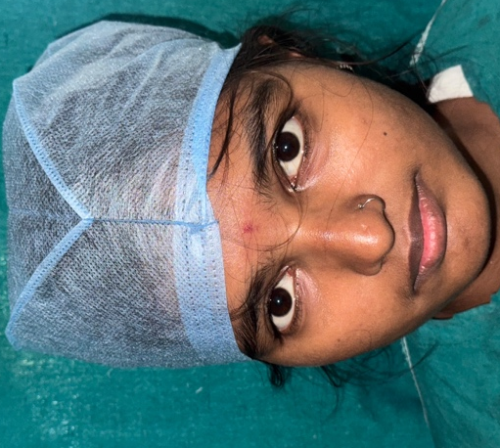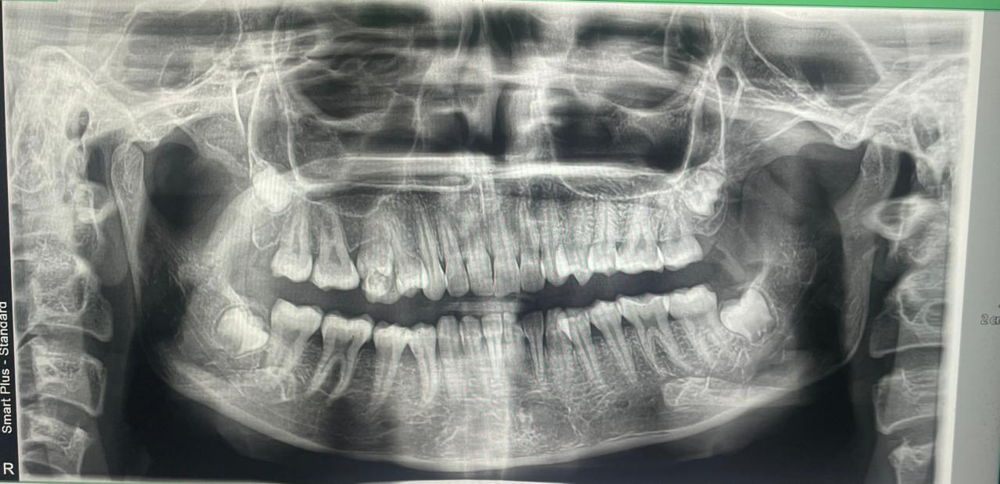
Fig no 1- Extraoral photo Fig no 2- Preoperative OPG
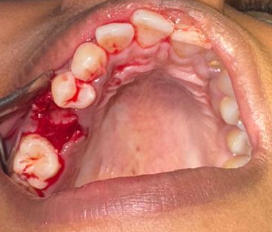 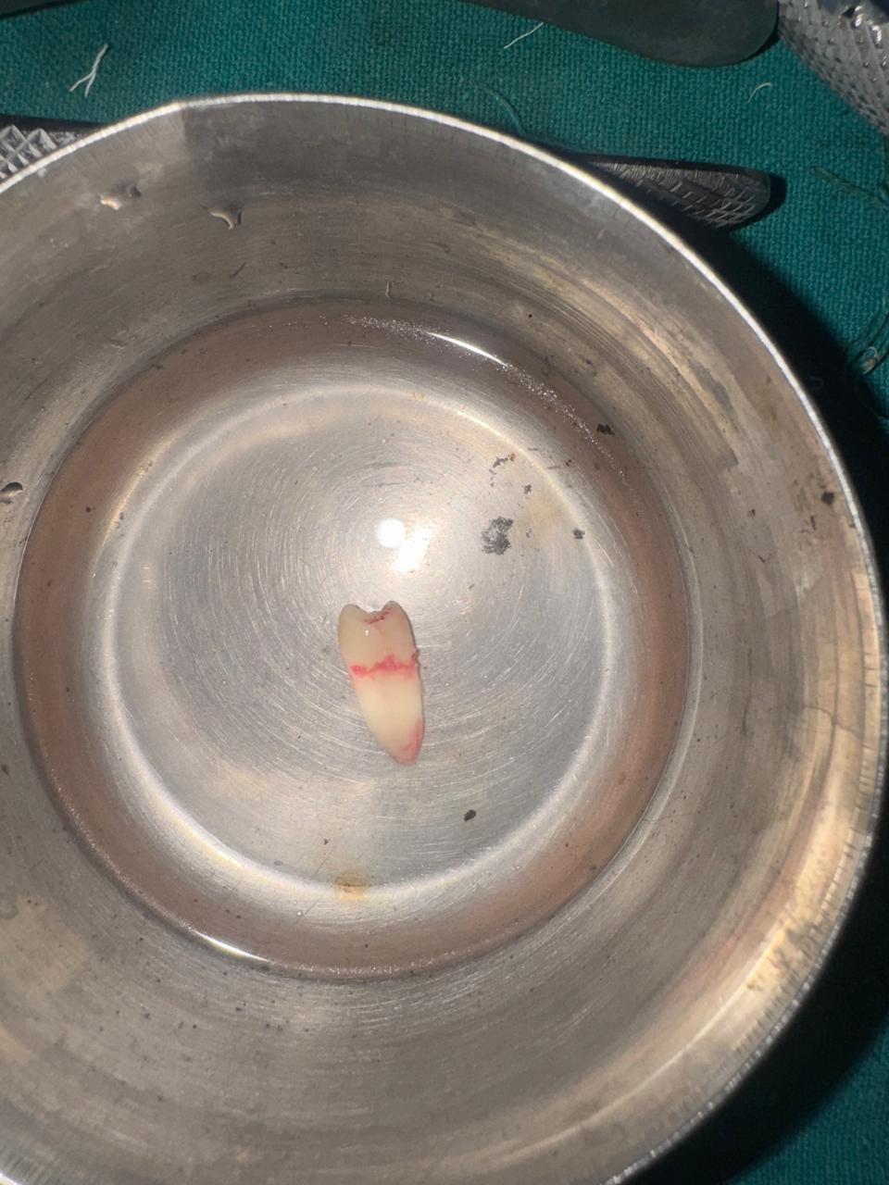 Fig no 2- Accidentally Extracted tooth of 15 Fig no 3- Extracted tooth rinsed with saline
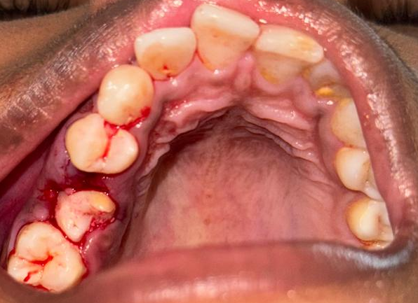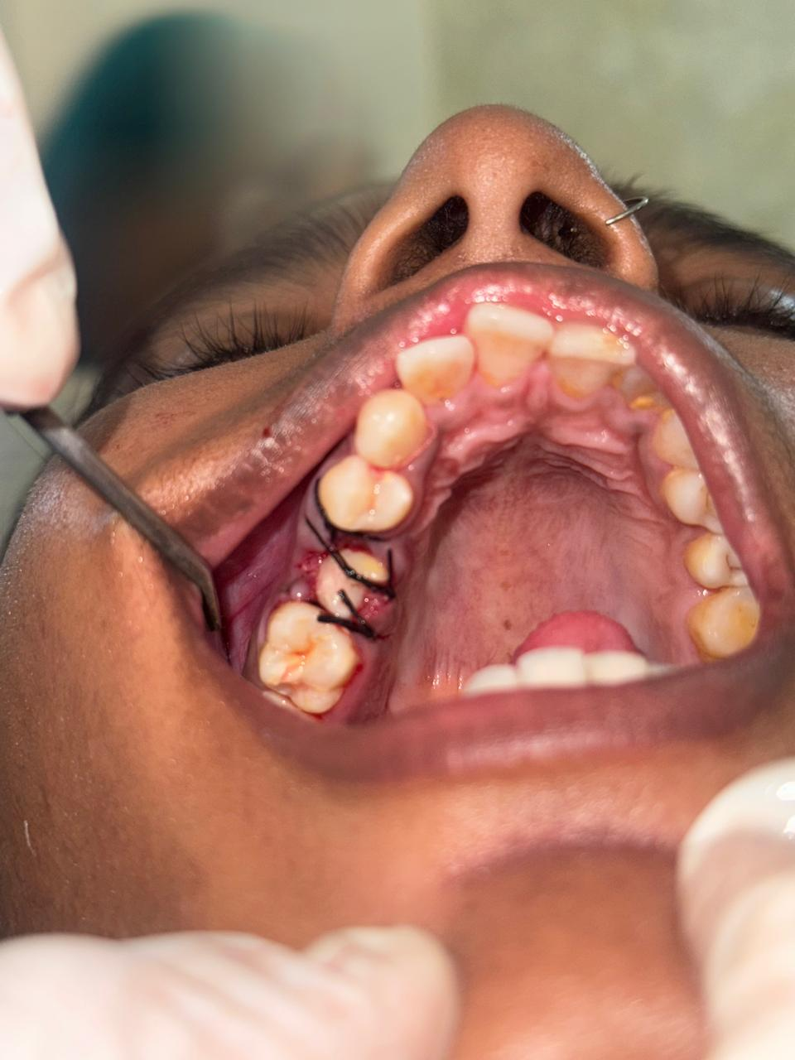
Fig no 4 - The tooth was then immediately Fig no 5 - Using 3-0 silk sutures which
replanted into its original socket provide adequate support

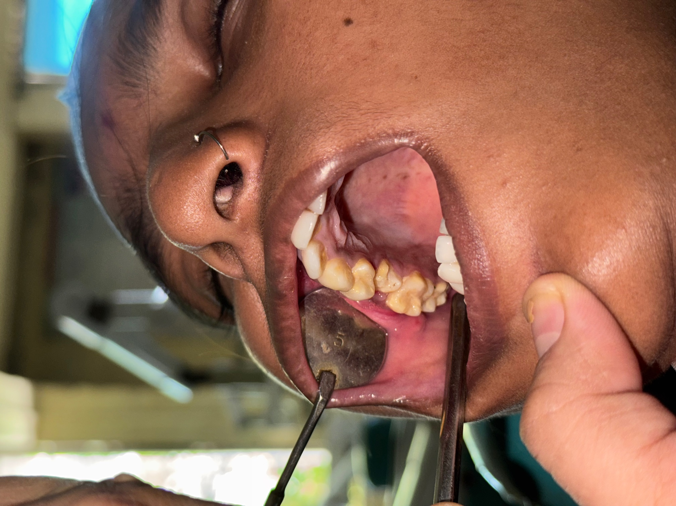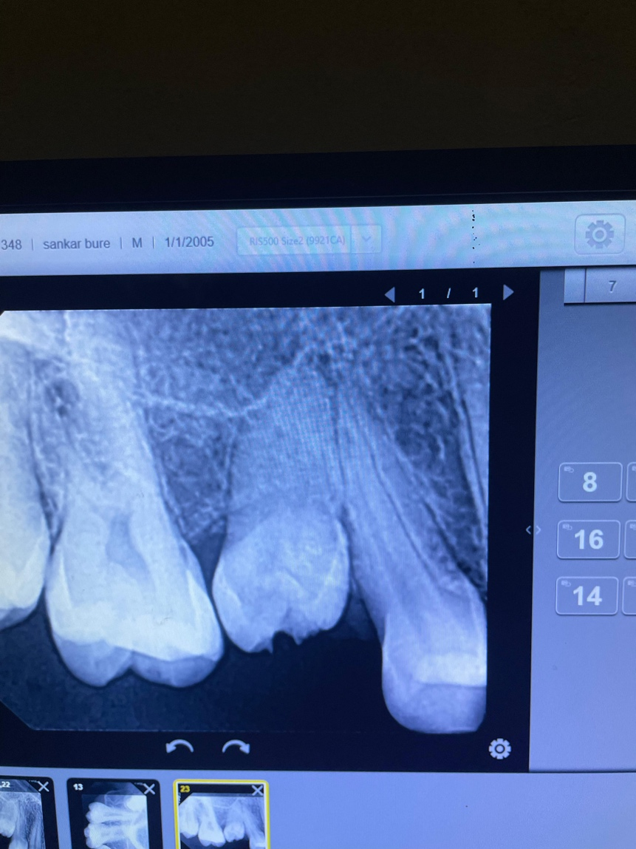
Fig no 6 - Complete seating within the Fig 7- 3-month follow-up IOPA
Alveolus after 1 months

POST-OPERATIVE MANAGEMENT
The patient was prescribed systemic antibiotics for five days, analgesics as required, and 0.12% chlorhexidine mouth rinse twice daily. Instructions included maintenance of a soft diet, avoidance of biting on the replanted tooth, meticulous oral hygiene, and immediate reporting of any symptoms such as pain, swelling, or mobility.

FOLLOW-UP AND OUTCOME
At one-week follow-up, the patient was asymptomatic with satisfactory tooth stability and healthy gingival tissues. Sutures were removed.
At one-month follow-up, the tooth demonstrated normal physiological mobility and functional stability. Radiographic examination showed satisfactory periodontal healing.
At three-month follow-up, the tooth remained asymptomatic and functional. Radiographs revealed no evidence of inflammatory root resorption, ankylosis, or periapical pathology.

DISCUSSION
Accidental extraction of permanent teeth is an uncommon iatrogenic complication but requires immediate and appropriate intervention. Literature consistently emphasizes that minimal extra-oral dry time and preservation of periodontal ligament cell viability are critical determinants of successful replantation.
In the present case, prompt recognition, atraumatic handling, immediate replantation, and appropriate stabilization contributed to a favorable outcome. Suturing provided adequate stabilization while allowing physiological mobility. Occlusal adjustment and post-operative antimicrobial measures further supported periodontal healing.
From a human medical ecology perspective, multiple factors influence such complications, including patient-level determinants such as oral hygiene practices and access to care, clinical environment factors such as operator experience and equipment quality, and systemic influences including training disparities and healthcare infrastructure. Addressing these determinants through preventive strategies and standardized protocols is essential.
Limitations of this report include limited generalizability due to its single-case design, absence of epidemiological data, and relatively short follow-up period. Long-term surveillance is necessary to detect late complications such as ankylosis or replacement resorption.

RECOMMENDATIONS
Establishment of institutional reporting systems for dental procedural complications is recommended. Mandatory pre-operative radiographic assessment should be emphasized in cases involving retained deciduous teeth. Future studies should include multi-case series or institutional audits to strengthen evidence. Integration of holistic oral healthcare, including patient education, follow-up support, and community-level oral health promotion, is encouraged.

CONCLUSION
Accidental extraction of a permanent tooth can be successfully managed through immediate replantation when extra-oral time is minimal and periodontal ligament vitality is preserved. Careful handling, appropriate stabilization, occlusal adjustment, and diligent post-operative care are essential for favorable outcomes. This case underscores the importance of preventive assessment, prompt decision-making, and conservative management in preserving natural dentition.

REFERENCES
- Andreasen JO, Andreasen FM, Andersson L. Textbook and Color Atlas of Traumatic Injuries to the Teeth. 5th ed. Oxford: Wiley-Blackwell; 2019.
- Trope M. Clinical management of the avulsed tooth. Dent Traumatol 2002;18:1-11.
- Pohl Y, Filippi A, Kirschner H. Results after replantation of avulsed permanent teeth. Dent Traumatol 2005;21:80-92.
- Andersson L, Andreasen JO, Day P, et al. International Association of Dental Traumatology guidelines for the management of traumatic dental injuries: Avulsion of permanent teeth. Dent Traumatol 2012;28:88-96.
- Flores MT, Andersson L, Andreasen JO, et al. Guidelines for the management of traumatic dental injuries. I. Fractures and luxations of permanent teeth. Dent Traumatol 2007;23:130-136.
- Kahler B, Hu JY, Marriot-Smith CS, Heithersay GS. Splinting of teeth following trauma: A review and a new splinting recommendation. Aust Dent J 2016;61(Suppl 1):59-73.
- McIntyre JD, Lee JY, Trope M, Vann WF Jr. Management of avulsed permanent incisors: A comprehensive update. Pediatr Dent 2007;29:56-63.
- Kinirons MJ, Gregg TA, Welbury RR, Cole BO. Reimplanted permanent incisors: A study of factors influencing outcome. Br Dent J 2000;189:263-266.

