Revolutionizing Green Chemistry through Artificial Intelligence and its Applications
Abstract
The integration of Artificial Intelligence (AI) into green chemistry has emerged as a transformative approach for developing sustainable and environmentally benign chemical processes. AI techniques such as machine learning, data analytics, and predictive modeling enable researchers to design eco-friendly synthesis pathways, optimize reaction conditions, reduce waste generation, and minimize energy consumption. By analyzing large chemical datasets, AI can identify greener solvents, catalysts, and reaction mechanisms that enhance efficiency while lowering environmental impact. Furthermore, AI-driven tools accelerate the discovery of sustainable materials and improve lifecycle assessment, supporting the principles of green chemistry. The application of AI also facilitates real-time monitoring and intelligent process control in industrial chemistry, leading to safer and more resource-efficient production systems. Despite challenges such as data availability, model transparency, and computational limitations, the synergy between AI and green chemistry holds significant potential for advancing sustainable innovation. Therefore, AI is expected to play a crucial role in promoting environmentally responsible chemical research and industrial practices, contributing to global sustainability goals.
Keywords: Artificial Intelligence, Green Chemistry, Sustainable Chemistry, Machine Learning, Eco-friendly Synthesis, Waste Reduction, Chemical Process Optimization.
Introduction: Role of Artificial Intelligence in Green Chemistry
Green chemistry has emerged as a fundamental approach to designing chemical products and processes that minimize environmental impact and promote sustainability. The concept focuses on reducing the use of hazardous substances, preventing waste generation, improving energy efficiency, and promoting the use of renewable resources. With the growing global concern regarding climate change, environmental pollution, and depletion of natural resources, the need for sustainable chemical practices has become more important than ever. In this context, green chemistry provides a scientific framework that encourages safer and more environmentally friendly chemical innovations.

In recent years, Artificial Intelligence (AI) has become a powerful technological tool that is transforming various scientific disciplines, including chemistry. AI refers to computational systems capable of performing tasks that typically require human intelligence, such as pattern recognition, prediction, and decision-making. Techniques such as machine learning, deep learning, and data-driven modeling enable scientists to analyze large and complex chemical datasets efficiently. These capabilities make AI particularly valuable for accelerating research and improving efficiency in chemical sciences.
The integration of AI with green chemistry has opened new possibilities for designing sustainable chemical processes. AI can predict optimal reaction pathways, identify environmentally benign solvents and catalysts, and optimize reaction conditions to reduce waste and energy consumption. By analyzing large experimental and computational datasets, AI models can assist chemists in selecting greener alternatives that follow the principles of green chemistry. Additionally, AI-driven simulations can reduce the need for extensive laboratory experimentation, thereby saving resources, time, and materials.
Furthermore, AI technologies are increasingly being applied in the development of sustainable materials, environmental monitoring, and industrial process optimization. In pharmaceutical, materials, and chemical industries, AI helps in designing eco-friendly synthesis routes and improving process efficiency while maintaining safety and productivity. The use of AI also supports lifecycle analysis and environmental impact assessment, which are essential components of sustainable chemical development.
Despite its significant potential, the application of AI in green chemistry also faces certain challenges, including limited availability of high-quality datasets, model interpretability issues, and computational resource requirements. However, continuous advancements in computational power, data science, and collaborative research are helping to overcome these limitations.
Therefore, the integration of AI with green chemistry represents a promising pathway toward achieving sustainable chemical innovation. By combining advanced computational techniques with the principles of environmentally responsible chemistry, AI has the potential to significantly enhance the development of greener chemical processes and contribute to global sustainability goals.
Role of Artificial Intelligence in Green Chemistry
The principles of green chemistry provide guidelines for developing safer and more sustainable chemical processes. AI contributes to many of these principles by assisting scientists in making informed decisions during chemical design, synthesis, and industrial production.

1.Waste Prevention
AI helps researchers design reaction pathways that generate fewer by-products. By predicting reaction outcomes and optimizing conditions before performing experiments, AI reduces unnecessary trials and chemical waste.
2.Atom Economy
Machine learning models analyze reaction mechanisms and recommend pathways in which most of the atoms from the starting materials are incorporated into the final product. This improves the efficiency of chemical synthesis and minimizes material loss.
3.Less Hazardous Chemical Synthesis
AI systems can evaluate the toxicity and reactivity of chemicals using existing databases. This allows scientists to select safer reagents and reaction conditions that reduce risks to human health and the environment.
4.Designing Safer Chemicals
Predictive AI tools can estimate the toxicity, biodegradability, and environmental persistence of newly designed molecules. This helps chemists create chemical products that perform their intended function while causing minimal ecological harm.
5.Safer Solvents and Auxiliaries
Solvents are widely used in chemical processes but many are hazardous. AI can screen large solvent databases and recommend greener alternatives that maintain reaction efficiency while reducing environmental impact.
6.Energy Efficiency
AI-driven optimization techniques help determine reaction conditions that require lower temperatures and pressures. This reduces energy consumption in chemical processes and contributes to sustainable industrial practices.
7.Use of Renewable Feedstocks
AI assists in identifying renewable and bio-based raw materials as alternatives to fossil-based Feedstocks. It can analyze the feasibility of these materials for various chemical reactions and industrial applications.
8.Catalysis
Catalysts play a crucial role in improving reaction efficiency. AI accelerates the discovery of new catalysts by predicting their activity, selectivity, and stability, which helps reduce energy use and unwanted by-products.
9.Real-Time Analysis for Pollution Prevention
AI can be integrated with monitoring systems and sensors to analyze chemical processes in real time. This allows early detection of harmful emissions and helps prevent environmental contamination.
10.Inherently Safer Chemistry for Accident Prevention
AI-based simulations can predict potential hazards in chemical reactions or industrial processes before they occur. This improves safety by allowing researchers to design safer chemical systems and avoid dangerous conditions.
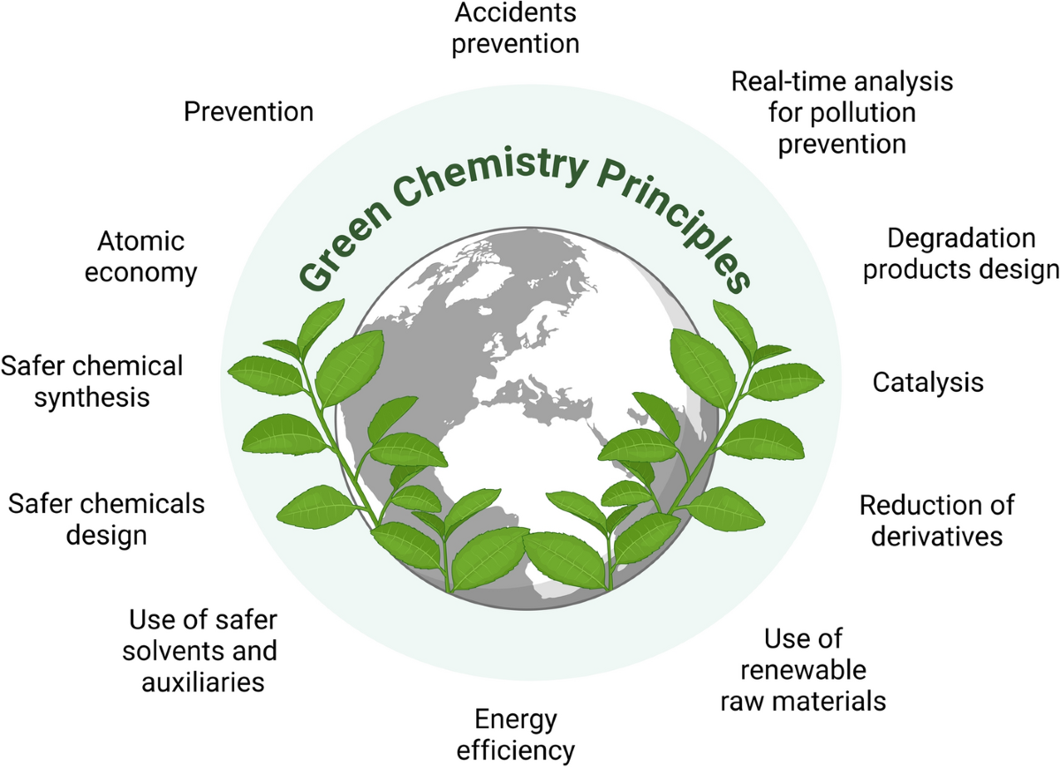
Fig 1. The Role of AI in Green Chemistry with their Principles
Recent Trends in AI Applications in Green Chemistry
1.Machine Learning for Sustainable Chemical Design
Machine learning algorithms are widely used to analyze chemical structures and reaction datasets. These models can predict the behavior, reactivity, and toxicity of chemical compounds before they are synthesized in laboratories. This approach reduces unnecessary experimentation, saves resources, and supports the development of environmentally friendly chemicals.
2.AI-Assisted Reaction Optimization
AI-based systems are now being used to optimize chemical reactions by determining the best reaction conditions such as temperature, pressure, catalysts, and solvents. Through predictive modeling and automated experimentation, AI can quickly identify conditions that maximize product yield while minimizing waste and energy consumption.
3.Discovery of Green Catalysts
Catalysts play an important role in improving reaction efficiency and reducing harmful by-products. AI technologies help scientists discover and design new catalysts by predicting their performance and stability. This accelerates catalyst development and contributes to cleaner and more efficient chemical processes.
4.Green Solvent Selection
Solvents are widely used in chemical synthesis but many traditional solvents are toxic and harmful to the environment. AI tools can analyze chemical databases to identify safer and environmentally friendly solvent alternatives. These recommendations help industries adopt greener solvent systems in chemical manufacturing.
5.AI in Sustainable Materials Development
Recent research shows that AI is being applied to develop sustainable materials such as biodegradable polymers, eco-friendly coatings, and renewable energy materials. By analyzing molecular properties and material performance, AI can accelerate the discovery of materials that are both efficient and environmentally safe.
6.Real-Time Monitoring and Smart Manufacturing
I-driven sensors and automated monitoring systems are being integrated into chemical industries to track reaction progress and environmental emissions in real time. These intelligent systems help detect potential hazards, control pollution, and improve the safety of industrial processes.
Research Methodology
The present study adopts a qualitative and analytical research approach to explore how Artificial Intelligence (AI) is revolutionizing the field of green chemistry. The methodology is designed to examine the integration of AI technologies in sustainable chemical practices and to evaluate their potential in improving environmentally friendly chemical processes. Since the topic combines technological innovation with chemical sustainability, a multidisciplinary research framework has been applied to obtain a comprehensive understanding of the subject.
This research is primarily based on secondary data collected from reliable academic and scientific sources. Various peer-reviewed research articles, scientific journals, books, conference papers, and reports related to artificial intelligence, sustainable chemistry, and green process development were carefully reviewed. Online academic databases such as research repositories, digital libraries, and scholarly publications were used to gather relevant information on the recent developments and applications of AI in green chemistry. The collected literature was selected based on its relevance, credibility, and contribution to understanding the interaction between AI technologies and sustainable chemical innovation.
A systematic literature review method was employed to identify key themes and emerging trends in the use of AI for green chemistry applications. The selected studies were analyzed to understand how artificial intelligence techniques, including machine learning, predictive modeling, and data-driven optimization, contribute to environmentally responsible chemical processes. Special attention was given to research demonstrating the use of AI in areas such as reaction optimization, prediction of greener solvents, energy-efficient synthesis routes, and reduction of hazardous waste. This approach allowed the study to identify significant technological advancements that support the principles of green chemistry.
In addition to the literature review, a comparative analytical approach was used to evaluate the differences between traditional chemical process development and AI-assisted green process design. Traditional methods often require extensive experimentation, time, and resource consumption, whereas AI-based systems can analyze large datasets and predict optimal reaction conditions more efficiently. By comparing these approaches, the study highlights how AI technologies can accelerate research, minimize experimental waste, and improve sustainability in chemical industries.
The research methodology also includes the examination of selected case studies where AI tools have been applied to improve chemical sustainability. These case studies help demonstrate practical examples of how computational intelligence can assist chemists in designing safer chemicals, optimizing reaction pathways, and improving process efficiency. The analysis of these real-world applications provides insights into the practical impact of AI in achieving environmentally responsible chemical production.
Furthermore, the methodology focuses on identifying the challenges and limitations associated with the adoption of AI in green chemistry. Factors such as data availability, algorithm reliability, technological accessibility, and interdisciplinary collaboration were considered while analyzing the collected literature. Understanding these challenges helps in providing a balanced perspective on the opportunities and barriers in implementing AI-driven solutions for sustainable chemical development.
Overall, the research methodology aims to provide a structured and comprehensive analysis of how artificial intelligence is transforming green chemistry practices. By synthesizing information from diverse academic sources and evaluating technological developments, this study highlights the growing importance of AI as a powerful tool for promoting sustainable innovation in chemistry. The methodology supports the objective of the research by systematically examining the ways in which AI can contribute to safer, cleaner, and more efficient chemical processes in the future.

Future Pathways for Research
1.Development of Comprehensive Chemical Databases
Future research should focus on creating large and standardized chemical databases that contain experimental results, toxicity data, and environmental impact information. High-quality datasets will improve the accuracy of AI models and support more reliable predictions in green chemistry.
2. Integration of AI with Automated Laboratories
The development of automated laboratories combined with AI algorithms will enable faster and more efficient experimentation. AI-guided robotic systems can perform multiple experiments simultaneously and quickly identify sustainable chemical processes.
3.Advanced Predictive Models for Environmental Impact
Future AI research can focus on predicting the environmental impact of chemicals throughout their entire life cycle. Such predictive tools can help chemists design chemicals that are biodegradable, less toxic, and environmentally sustainable.
4. Interdisciplinary Collaboration
Successful integration of AI in green chemistry requires collaboration between chemists, data scientists, environmental scientists, and engineers. Interdisciplinary research will help develop more accurate computational models and innovative sustainable technologies.
5. AI for Circular Chemical Economy
Future research may also focus on using AI to support the circular economy in chemistry. AI can help design chemical processes that promote recycling, reuse of materials, and efficient resource management, thereby reducing environmental pollution and industrial waste.
Impact of Artificial Intelligence on Green Chemistry Development
1.Improving Efficiency in Chemical Research
One of the major advantages of AI is its ability to analyze large volumes of chemical data quickly and accurately. Traditional chemical research often involves numerous experimental trials, which require significant time, materials, and energy. AI algorithms can predict reaction outcomes, molecular properties, and optimal reaction conditions before laboratory experimentation. This reduces the need for repeated experiments and improves the efficiency of chemical research.
2.Reduction of Chemical Waste
Waste generation is a major issue in chemical industries. AI plays an important role in reducing chemical waste by predicting reaction pathways that produce fewer unwanted by-products. Machine learning models can suggest efficient synthesis routes that follow the principle of waste prevention in green chemistry. By optimizing reactions and minimizing material loss, AI contributes to cleaner and more sustainable chemical production.
3.Development of Safer Chemicals
Another important contribution of AI in green chemistry is the development of safer and less toxic chemical substances. AI systems can analyze chemical structures and predict toxicity, biodegradability, and environmental persistence of compounds. These predictions help scientists design chemicals that perform their intended function while causing minimal harm to the environment and human health.
4.Energy Conservation and Process Optimization
Chemical manufacturing often requires high energy input due to extreme temperatures and pressures. AI-based optimization tools can analyze process data and determine conditions that require less energy while maintaining high product yield. By improving energy efficiency, AI helps reduce greenhouse gas emissions and promotes environmentally sustainable industrial practices.
5.Discovery of Sustainable Catalysts and Materials
Catalysts are essential for improving reaction efficiency and reducing waste formation. AI accelerates the discovery of new catalysts by predicting their activity, selectivity, and stability. Similarly, AI helps researchers design sustainable materials such as biodegradable polymers and environmentally friendly coatings. These innovations support the development of greener chemical technologies.
6.Real-Time Monitoring and Pollution Prevention
AI technologies can be integrated with sensors and monitoring systems to track chemical reactions and industrial emissions in real time. These systems can detect harmful pollutants and process irregularities at early stages. Early detection allows industries to control emissions and prevent environmental contamination, which aligns with the pollution prevention principle of green chemistry.
7.Supporting Sustainable Industrial Development
AI-driven technologies enable industries to adopt sustainable manufacturing practices by improving resource management and reducing environmental impact. Through predictive modeling and data-driven decision-making, industries can develop processes that use fewer raw materials, generate less waste, and consume less energy. This contributes to sustainable economic development and environmental protection.

8.Encouraging Innovation and Future Research
The integration of AI with green chemistry encourages interdisciplinary research involving chemists, data scientists, and environmental scientists. AI-driven tools open new opportunities for discovering innovative chemical processes and materials that were previously difficult to design using conventional methods. As computational technologies continue to advance, the role of AI in green chemistry is expected to expand further.
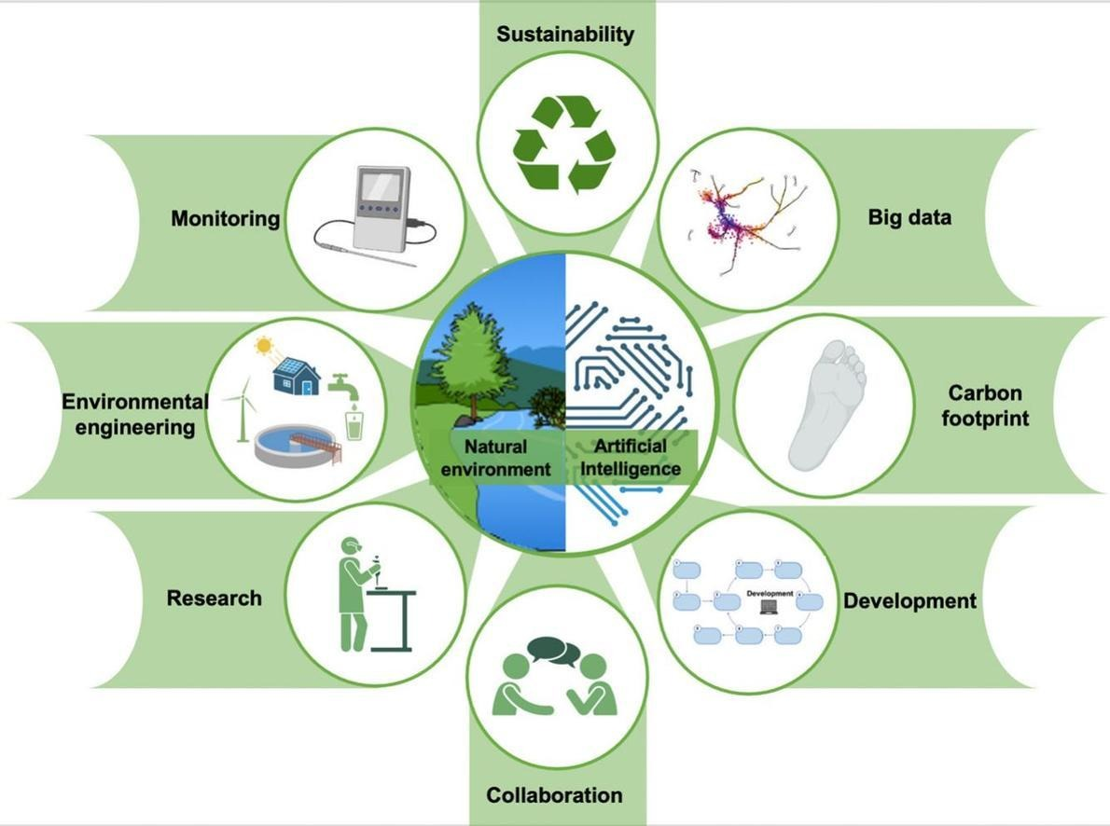
Fig 2. Enhancing Green Chemistry through Artificial Intelligence

Future Directions and Opportunities of Artificial Intelligence in Green Chemistry
The combination of Artificial Intelligence (AI) and green chemistry is creating new opportunities for developing sustainable chemical technologies. As environmental challenges such as pollution, climate change, and resource depletion increase, the need for cleaner and more efficient chemical processes has become essential. AI provides powerful computational tools that can analyze complex chemical systems, predict outcomes, and optimize processes. Future developments in AI are expected to further strengthen the application of green chemistry principles in research and industrial practices.
1.Development of Advanced Predictive Models
One important future direction of AI in green chemistry is the development of more accurate predictive models. These models can analyze molecular structures and reaction mechanisms to predict properties such as toxicity, stability, and environmental impact. Improved predictive capabilities will help chemists design safer chemicals and sustainable processes before performing laboratory experiments, reducing time, cost, and environmental risks.

2.Integration with Automated and Robotic Laboratories
The integration of AI with automated laboratory systems represents a promising opportunity for green chemistry research. AI-controlled robotic systems can perform multiple experiments simultaneously and analyze results in real time. This automated approach can rapidly identify optimal reaction conditions, reducing the consumption of chemicals, energy, and laboratory resources.
3.Expansion of Sustainable Chemical Databases
High-quality data is essential for training AI models. Future research will focus on creating large, well-organized databases containing information on chemical reactions, environmental toxicity, biodegradability, and energy efficiency. These databases will improve the accuracy of AI predictions and support the discovery of environmentally friendly chemical processes.
4.AI in Renewable Resource Utilization
Another promising direction is the use of AI to identify and develop renewable feedstocks for chemical synthesis. AI tools can analyze biological and agricultural resources to determine their potential as sustainable alternatives to fossil-based raw materials. This approach supports the development of bio-based chemicals and sustainable industrial practices.
5.Design of Eco-Friendly Materials
AI has the potential to accelerate the discovery of environmentally friendly materials such as biodegradable polymers, green solvents, and sustainable catalysts. By analyzing molecular structures and material properties, AI can suggest new compounds that meet both performance and environmental safety requirements. This will help reduce the environmental impact of industrial materials and chemical products.
6.Real-Time Environmental Monitoring
Future AI systems may be integrated with environmental sensors and monitoring technologies to track pollutants and emissions in real time. These intelligent monitoring systems can detect harmful substances and suggest corrective actions immediately. This approach will improve pollution control and support safer chemical manufacturing processes.
7.Promotion of Circular Chemical Economy
AI can support the development of a circular chemical economy, where resources are reused and recycled instead of being discarded as waste. AI-driven models can identify efficient recycling methods, optimize material recovery processes, and suggest sustainable alternatives for waste management. This will help reduce environmental pollution and improve resource efficiency.

8.Strengthening Interdisciplinary Collaboration
Future progress in AI-driven green chemistry will depend on collaboration between chemists, computer scientists, environmental experts, and engineers. Interdisciplinary research will help develop more reliable AI tools and innovative solutions for sustainable chemical production.
9.Addressing Ethical and Technological Challenges
As AI becomes more widely used in chemical research, it will be important to address challenges related to data quality, transparency of AI models, and responsible use of technology. Future research should focus on developing interpretable AI systems and ensuring that AI technologies are applied ethically and responsibly in environmental and chemical research.
Future Perspective of the Role of AI in Green Chemistry
The future of Artificial Intelligence (AI) in green chemistry is highly promising, as it is expected to significantly transform the way sustainable chemical processes and materials are developed. With continuous advancements in machine learning, data science, and computational modeling, AI will enable scientists to design environmentally friendly chemicals and efficient reaction pathways with greater accuracy and speed. In the coming years, AI is likely to be integrated with automated laboratories, advanced sensors, and large chemical databases to accelerate the discovery of green catalysts, biodegradable materials, and safer chemical products. AI-driven predictive models will also help evaluate the environmental impact and toxicity of chemicals before large-scale production, reducing potential ecological risks. Furthermore, the use of AI in optimizing industrial processes will lead to lower energy consumption, reduced waste generation, and improved resource efficiency. As interdisciplinary collaboration between chemists, data scientists, and environmental researchers increases, AI will play a crucial role in advancing sustainable innovation and supporting the global transition toward greener and more responsible chemical practices.
AI in Green Process Development
Artificial Intelligence (AI) has become an influential tool in the development of environmentally sustainable chemical processes, often referred to as green process development. In traditional chemical manufacturing, designing efficient processes requires extensive experimentation, high energy input, and large quantities of raw materials, which can lead to significant waste generation and environmental pollution. AI helps overcome these challenges by using advanced computational techniques such as machine learning, predictive modeling, and data analytics to design and optimize chemical processes more efficiently. By analyzing vast chemical datasets, AI can identify optimal reaction pathways, select safer reagents and solvents, and determine reaction conditions that minimize energy consumption and waste formation.
In green process development, AI-driven models can predict reaction yields, catalyst performance, and process efficiency before laboratory-scale experiments are conducted. This predictive capability reduces the need for repeated trial-and-error experimentation, saving both time and resources. AI can also assist in discovering greener catalysts and environmentally friendly solvents that enhance reaction selectivity while reducing the production of harmful by-products. Furthermore, AI technologies integrated with real-time monitoring systems enable continuous control of chemical processes, ensuring that reactions operate under optimal and safe conditions.
Another important contribution of AI is its ability to support process intensification and resource optimization in industrial manufacturing. AI algorithms can analyze operational data from chemical plants to identify inefficiencies and recommend improvements that reduce energy consumption and emissions. This approach not only improves the sustainability of chemical production but also enhances economic efficiency. As research in computational chemistry and data science continues to advance, AI is expected to play an even more significant role in green process development, helping scientists and industries design cleaner, safer, and more sustainable chemical manufacturing systems that align with the principles of green chemistry.
Challenges in the Role of Artificial Intelligence in Green Chemistry in Current Chemical Industries
The integration of Artificial Intelligence (AI) into green chemistry has created significant opportunities for developing sustainable and environmentally friendly chemical processes. However, despite its potential benefits, several challenges limit the widespread adoption of AI in current chemical industries. These challenges arise from technical limitations, data-related issues, economic factors, and the complexity of chemical systems.
1.Limited Availability of High-Quality Data
AI systems rely heavily on large and reliable datasets to make accurate predictions. In many chemical industries, experimental data are incomplete, inconsistent, or not standardized. Many chemical reactions and industrial processes have limited publicly available data, which makes it difficult to train effective AI models. Without sufficient high-quality data, AI predictions may become unreliable.
2.Complexity of Chemical Processes
Chemical reactions and industrial processes are often highly complex and involve multiple variables such as temperature, pressure, catalysts, and reaction mechanisms. These complex interactions are difficult for AI models to fully capture and predict accurately. As a result, developing reliable AI systems for industrial-scale chemical processes remains challenging.
3.Integration with Existing Industrial Systems
Many chemical industries operate using traditional manufacturing technologies that were developed long before AI applications became common. Integrating AI-based tools with these existing systems requires significant modification of infrastructure, which can be technically difficult and time-consuming.
4.High Implementation Cost
The adoption of AI technologies often requires advanced computational infrastructure, specialized software, and skilled professionals such as data scientists and computational chemists. These requirements can lead to high implementation costs, making it difficult for small or medium-sized chemical industries to adopt AI-based solutions.
5.Lack of Interdisciplinary Expertise
The successful application of AI in green chemistry requires collaboration between chemists, computer scientists, engineers, and environmental experts. However, many industries lack professionals who possess expertise in both chemistry and artificial intelligence. This knowledge gap slows the development and implementation of AI-driven sustainable technologies.
6.Difficulty in Interpreting AI Models
Many AI systems, especially deep learning models, function as “black boxes,” meaning their decision-making process is not always easy to interpret. For chemical researchers and engineers, understanding how AI arrives at its predictions is important for verifying the reliability and safety of chemical processes.
7.Data Privacy and Industrial Confidentiality
Chemical industries often treat experimental data and production methods as confidential information. Sharing such data for AI training can raise concerns related to intellectual property and industrial security. This limitation restricts the availability of large datasets needed for developing effective AI models.
8.Environmental and Ethical Considerations
Although AI supports sustainable chemical practices, the development and use of AI technologies themselves require computational resources and energy. High computational demands may lead to increased energy consumption, which could indirectly impact environmental sustainability if not managed properly.
9.Regulatory and Standardization Issues
The use of AI in chemical industries is still evolving, and regulatory frameworks for AI-driven chemical processes are not fully established in many regions. Lack of clear guidelines and standardization can slow down industrial adoption of AI technologies.

Conclusion
In conclusion, Artificial Intelligence (AI) has emerged as a powerful and transformative tool in advancing the goals of green chemistry. By integrating data-driven technologies such as machine learning, predictive modeling, and computational analysis, AI enables researchers to design safer chemicals, optimize reaction conditions, and develop more sustainable industrial processes. It helps reduce chemical waste, minimize energy consumption, and improve resource efficiency while supporting the discovery of environmentally friendly materials and catalysts. In addition, AI-driven monitoring and automation systems contribute to pollution prevention and safer chemical manufacturing. Although challenges such as limited datasets, computational complexity, and the need for interdisciplinary expertise still exist, ongoing technological advancements are gradually overcoming these limitations. Overall, the combination of AI and green chemistry offers significant potential for promoting sustainable scientific innovation and environmental protection. As research in this field continues to grow, AI is expected to play a crucial role in shaping the future of environmentally responsible chemical processes and contributing to global sustainability goals.
References
- Venkatesan K, Sundarababu J, Anandan SS. The recent developments of green and sustainable chemistry in multidimen-Sional way: current trends and challenges. Green Chem Lett Rev. 2024;17:231–48.
- De Marco BA, Rechelo BS, Tótoli EG, Kogawa AC, Salgado HRN. Evolution of green chemistry and its multidimensional Impacts: a review. Saudi Pharm J. 2019;27:1–8.
- Ahmad T, Zhang D, Huang C, Zhang H, Dai N, Song Y, et al. Artificial intelligence in sustainable energy industry: status quo, Challenges and opportunities. J Clean Prod. 2021;289:125834.
- Jiang X, Luo S, Liao K, Jiang S, Ma J, Jiang J, et al. Artificial intelligence and automation to power the future of chemistry. Cell Rep Phys Sci. 2024;5:102049.
- Onifade M, Zvarivadza T, Adebisi JA, Said KO, Dayo-Olupona O, Lawal AI, et al. Advancing towards sustainability: the emergence of green mining technologies and practices. Green Smart Min Eng. 2024;1:157–74.
- Kumar A, Thakur AK, Gaurav GK, Klemeš JJ, Sandhwar VK, Pant KK, Kumar R. A critical review on sustainable hazardous-Waste management strategies: a step towards a circular economy. Environ Sci Pollut Res Int. 2023;30:105030–55.
- Locatelli M, Kabir A, Perrucci M, Ulusoy S, Ulusoy HI. Ali I. Green profile tools: current status and future perspectives. Adv Sample Prep. 2023;6:100068.
- Jurisch M, Gomes JCL, Parreiras BM, Pimenta JVC, Sepulveda TM, de Macedo AN, et al. Greenness metrics for analytical Methodologies linked to mass spectrometry. Green Anal Chem. 2024;10:100140.
- Schwaller P, Gaudin T, Lanyi D, Bekas C, Laino T. Found in translation: predicting outcomes of complex organic chemistry Reactions using neural sequence-to-sequence models. Chem Sci. 2018;9:6091–8. https://doi.org/10.1039/C8SC02339E.
- Butler KT, Davies DW, Cartwright H, Isayev O, Walsh A. Machine learning for molecular and materials science. Nature. 2018;559:547–55. https://doi.org/10.1038/s41586-018-0337-2.
- Moosavi SM, Jablonka KM, Smit B. The role of machine learning in the Understanding and design of materials. J Am Chem Soc. 2020;142:20273–87. https://doi.org/10.1021/jacs.0c09105.
- Farhadi B, You J, Zheng D, Liu L, Wu S, Li J, et al. Machine learning for fast development of advanced energy materials. Next Yadav et al. Discover Chemical Engineering (2026) 6:1 Page 16 of 19
- Bornscheuer UT, Huisman GW, Kazlauskas RJ, Lutz S, Moore JC, Robins K. Engineering the third wave of biocatalysis. Nature. 2012;485:185–94. https://doi.org/10.1038/nature11117.
- Wu S, Snajdrova R, Moore JC, Baldenius K, Bornscheuer UT. Biocatalysis: enzymatic synthesis for industrial applications. Angew Chem Int Ed. 2021;60:88–119. https://doi.org/10.1002/anie.202006648.
- Elton DC, Boukouvalas Z, Fuge MD, Chung PW. Deep learning for molecular design — a review of the state of the Art. Mol Syst Des Eng. 2019;4:828–49. https://doi.org/10.1039/C9ME00039A.
- Sanchez-Lengeling B, Aspuru-Guzik A. Inverse molecular design using machine learning: generative models for matter Engineering. Science. 2018;361:360–5. https://doi.org/10.1126/science.aat2663.
- Han R, Yoon H, Kim G, Lee H, Lee Y. Revolutionizing medicinal chemistry: the application of artificial intelligence (AI) in Early drug discovery. Pharmaceuticals (Basel). 2023;16:1259.
- Hassija V, Chamola V, Mahapatra A, Singal A, Goel D, Huang K, et al. Interpreting black-box models: a review on explainable Artificial intelligence. Cognit Comput. 2024;16:45–74.
- Kapustina O, Burmakina P, Gubina N, Serov N, Vinogradov V. User-friendly and industry-integrated AI for medicinal chemists and pharmaceuticals. Artif Intell Chem. 2024;2:100072.
- Feng F, Li J, Zhang F, Sun J. The impact of artificial intelligence on green innovation efficiency: moderating role of dynamic Capability. Int Rev Econ Financ. 2024;96:103649.
- Olawade DB, Ige AO, Olaremu AG, Ijiwade JO, Adeola AO. The synergy of artificial intelligence and nanotechnology Towards advancing innovation and sustainability — a mini-review. Nano Trends. 2024;8:100052.
- Ncube A, Mtetwa S, Bukhari M, Fiorentino G, Passaro R. Circular economy and green chemistry: the need for radical innovative approaches in the design for new products. Energies. 2023;16:1752. https://doi.org/10.3390/en16041752.
- Aly AA, Górecki T. Green approaches to sample Preparation based on extraction techniques. Molecules. 2020;25:1719. https://doi.org/10.3390/molecules25071719.
- Oliveira JRP, Tusset AM, Andrade DI, Balthazar JM, Pagani RN, Lenzi GG. Action plans study: principles of green chemistry, Sustainable development, and smart cities. Sustainability. 2024;16:8041. https://doi.org/10.3390/su16188041.
- Hermann E, Hermann G, Tremblay JC. Ethical artificial intelligence in chemical research and development: a dual advantage for sustainability. Sci Eng Ethics. 2021;27:45. https://doi.org/10.1007/s11948-021-00325-6.
- Kumar R, Verma A, Shome A, Sinha R, Sinha S, Jha PK, et al. Impacts of plastic pollution on ecosystem services, sustainable Development Goals, and need to focus on circular economy and policy interventions. Sustainability. 2021;13:9963. https://Doi.org/10.3390/su13179963.
- Ray PC, Yu H, Fu PP. Toxicity and environmental risks of nanomaterials: challenges and future needs. J Environ Sci Health C Environ Carcinogen Ecotoxicology Rev. 2009;27:1–35. https://doi.org/10.1080/10590500802708267.
- Billiard KM, Dershem AR, Gionfriddo E. Implementing green analytical methodologies using solid-phase microextraction: a Review. Molecules. 2020;25:5297. https://doi.org/10.3390/molecules25225297.
- El Deeb S, Abdelsamad K, Parr MK. Greener and whiter analytical chemistry using cyrene as a more sustainable and eco-Friendlier mobile phase constituent in chromatography. Pharmaceuticals. 2023;16:1488. https://doi.org/10.3390/ph161014
- Martínez J, Cortés JF, Miranda R. Green chemistry metrics — a review. Processes. 2022;10:1274. https://doi.org/10.3390/pr10071274.
- Malik S, Muhammad K, Waheed Y. Nanotechnology: a revolution in modern industry. Molecules. 2023;28:661. https://doi.oRg/10.3390/molecules28020661.
- Yigitcanlar T, Mehmood R, Corchado JM. Green artificial intelligence: towards an efficient, sustainable and equitable Technology for smart cities and futures. Sustainability. 2021;13:8952. https://doi.org/10.3390/su13168952.

