IOT BASED SMART IRRIGATION MONITORING SYSTEM

ABSTRACT
This project presents an IOT-enabled Smart Irrigation Monitoring System built around a Nodemcu (ESP8266) microcontroller, a soil moisture sensor, a relay module, a water pump, and a 16×2 LCD with an I2C interface. The system continuously monitors soil moisture and controls irrigation automatically: when moisture falls below a calibrated threshold, the Nodemcu activates the pump via the relay; when moisture returns to a safe level, the pump is switched off. The Nodemcu also connects to the Blynk IOT platform to provide real-time remote monitoring, manual override, and push notifications. During testing the system reduced unnecessary watering, responded reliably to changes in soil moisture, and provided clear local and remote feedback through the LCD and Blynk dashboard. The solution is low-cost, scalable, and suitable for small farms, greenhouses, and home gardens.
Ⅰ. INTRODUCTION
Many farmers still rely on experience and fixed schedules to water their fields, which often leads to over-irrigation or under-irrigation. Both situations harm crop health and waste valuable water. Modern agriculture must therefore use technology to supply water only when it is needed. The Internet of Things (IOT) offers an accessible way to combine inexpensive sensors with networked microcontrollers to make irrigation smarter and simpler. In this project, I used a Nodemcu (ESP8266) because it offers built-in Wi-Fi, an analog input for the moisture sensor, and enough processing power to run the control logic and talk to an IOT service. By combining local automatic control with cloud monitoring via Blynk, the system gives immediate irrigation control at the field and remote visibility on a smartphone. I designed the project so it is easy to build, calibrate, and expand.
Ⅱ. EXISTING SYSTEM
Traditional irrigation systems mainly depend on manual observation and human decision-making. Farmers typically check soil conditions by touching or visually inspecting it and then switch on the water pump. This approach lacks accuracy and results in over-watering, especially when farmers are unable to monitor the field continuously. Timed irrigation systems were introduced later, but they still do not consider the real moisture condition of the soil. Even modern sprinkler systems require human supervision and cannot adjust automatically. These methods also fail to provide remote access or alerts, meaning the user has no visibility of the system while away from the field. As a result, water wastage, energy loss and inconsistent plant growth are common issues in existing methods.
Ⅲ. PROPOSED SYSTEM
The proposed IOT-based smart irrigation method overcomes the limitations of traditional systems by using automation and cloud-based monitoring. The system continuously reads moisture levels from the sensor and sends them to the Blynk platform through Nodemcu's Wi-Fi connectivity. Based on preset thresholds, the controller automatically activates or deactivates the water pump. The user can monitor the system through the Blynk app, receive notifications and even operate the pump remotely. This method ensures accurate irrigation, optimal water usage, real-time updates and complete remote accessibility, making it far superior to existing irrigation techniques.
Ⅳ. Methodology
4.1 Hardware Description:
The below is the circuit diagram of IOT based smart irrigation monitoring system.
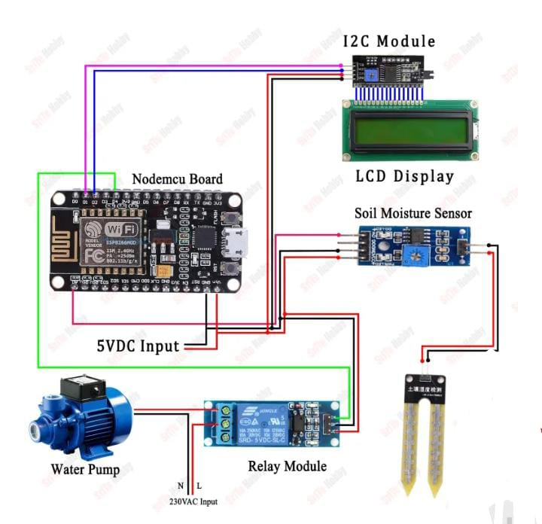
Fig1: circuit diagram of iot based smart irrigation monitoring system

4.2 COMPONENTS EXPLANATION:
NODEMCU BOARD:
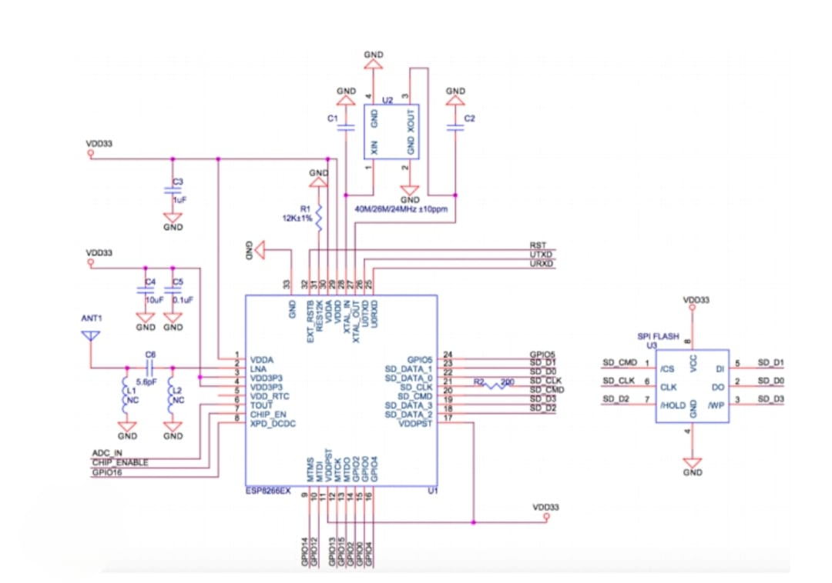
Fig2: Schematic diagram of nodemcu board
The Nodemcu module used here is a compact development board that integrates the ESP8266 Wi-Fi chip with a USB interface and voltage regulation. It reads the analog signal from the soil sensor and applies the control rules while also managing the Blynk connection.
Soil Moisture Sensor:
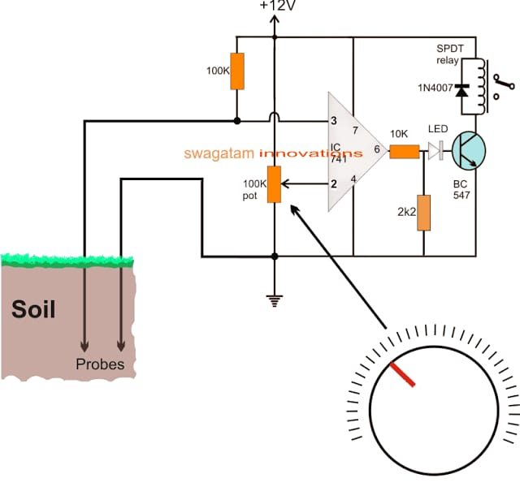
Fig3: Soil moisture circuit diagram
The soil moisture sensor produces a voltage that changes with soil conductivity: wetter soil gives a lower resistance between sensor probes and a corresponding analog voltage change. Before using the sensor in the field, I calibrated it by recording ADC readings for fully dry and fully wet conditions, then mapping that range to 0–100% moisture.
Relay Module:
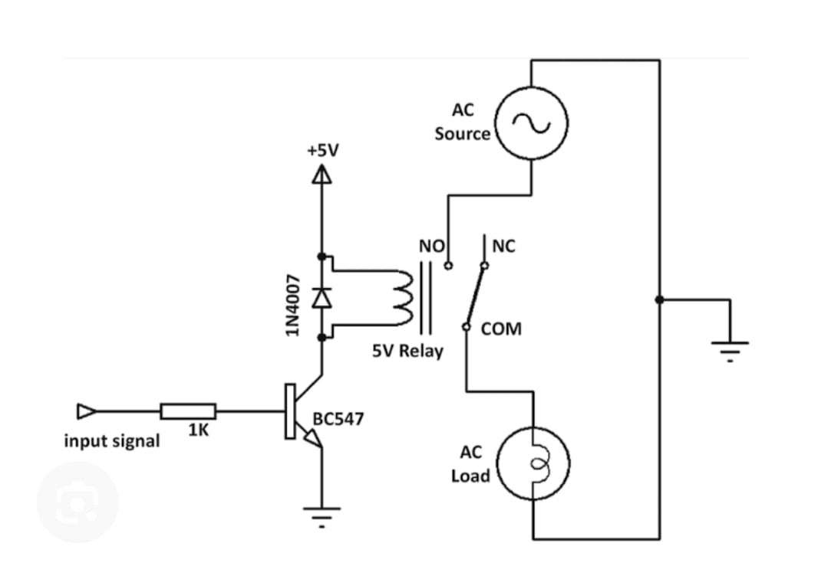

Fig4: Relay circuit diagram
The relay module is electrically driven by the Nodemcu and switches the pump’s power line; I selected a relay rated for the pump voltage and current.
LCD Display with I2C
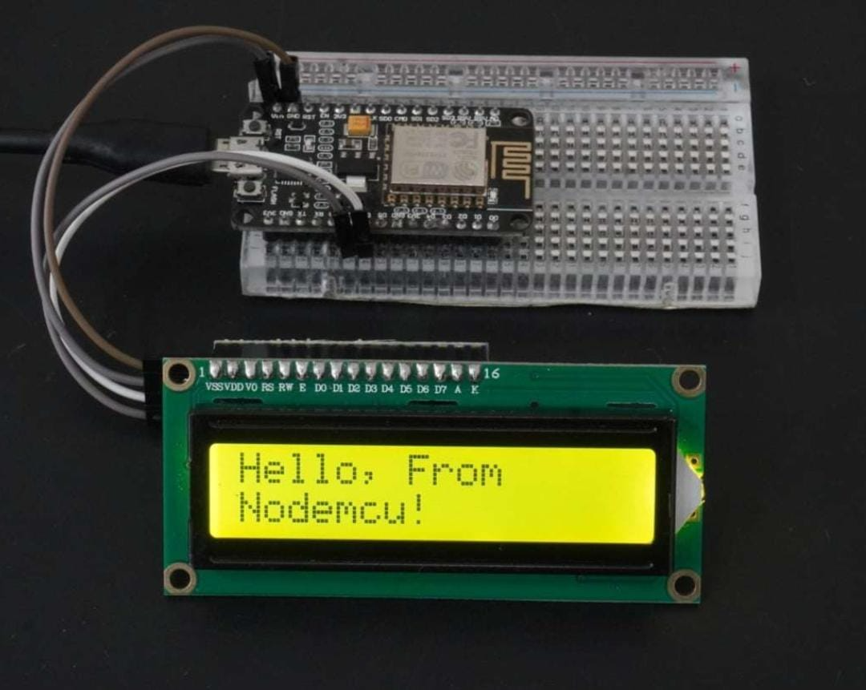
Fig5: LCD display with 12C module
The 16×2 LCD with I2C allows immediate verification of the system’s readings, showing both the calculated moisture percentage and whether the pump is ON or OFF. I found the I2C display convenient because it saves GPIOs and makes the wiring much cleaner.
Water Pump:
This pump supplies water to the soil when activated by the relay. It operates only when the soil moisture is below the threshold.
4.3 Working Procedure
First, I assembled the hardware: the Nodemcu was mounted on a breadboard with the moisture probe inserted into a soil sample, the I2C LCD connected to the SDA and SCL pins, and the relay wired between the pump and its power supply. I tied all grounds together and ensured the pump had its own power source sized correctly for its current draw.
Second, I opened the Arduino IDE, installed the ESP8266 board support and the Blynk library, and prepared a sketch in which placeholders for the Blynk template ID, device name, and authtoken were replaced with the actual values generated on the Blynk web dashboard.
Third, I calibrated the sensor by noting the ADC reading in dry air and again in fully wet soil; I placed those values into the sketch so raw readings were mapped into percentage moisture.
Fourth, I uploaded the sketch to Nodemcu and opened the serial monitor to verify the Nodemcu connected to Wi-Fi and to observe the raw and converted moisture values.
Fifth, I checked the I2C LCD to confirm it showed the moisture percentage and the pump status.
Sixth, I verified the Blynk dashboard on my phone; the gauge updated with the same moisture percentages and the switch reflected the relay state.
Seventh, I tested the automatic mode by drying the soil (allowing the moisture % to fall below the turn-on threshold) and confirming the relay closed and the pump ran until the moisture surpassed the turn-off threshold.
Finally, I tested manual override from the Blynk app by toggling the pump switch and watching the Nodemcu honor the command while still sending updates to the dashboard. With these steps complete, the system demonstrated fully automated irrigation with reliable remote monitoring.
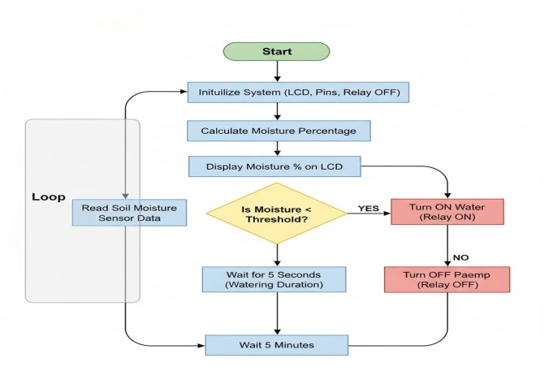
Fig4.3: Flow chart showing working
4.4 Blynk Integration
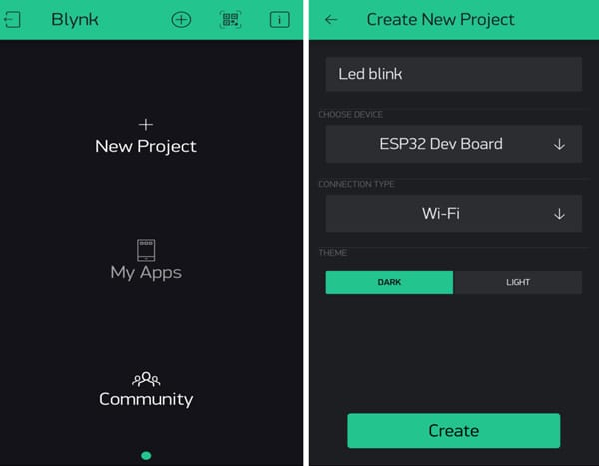
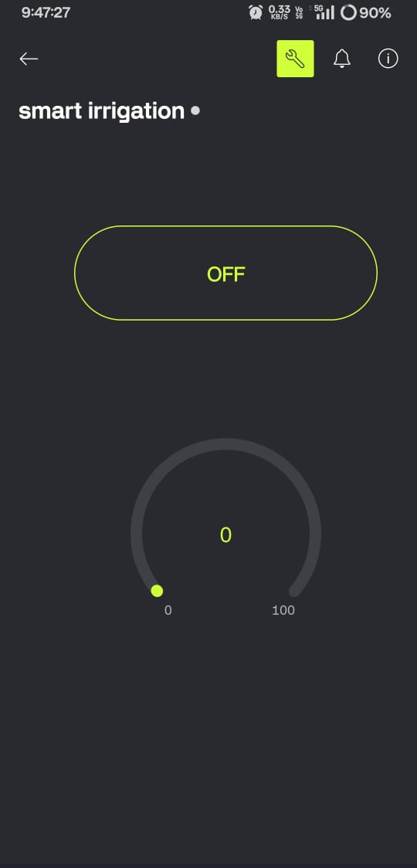
Fig4.4: Blynk app setup
To enable remote monitoring and manual control, I integrated the Nodemcu with the Blynk IOT platform. Blynk provides an easy way to create a mobile dashboard and a cloud token without building a server. First, I created a template on the Blynk web dashboard and added data streams: a numeric datastream for soil moisture (mapped to virtual pin V1) and a digital datastream for pump state (mapped to V2). Then I added a device based on this template in the mobile app and copied the device auth token into my Nodemcu code. On the mobile dashboard I placed a gauge widget linked to V1 to display moisture percentage and a switch widget linked to V2 for manual pump control. In the NodeMCU sketch, the code periodically writes the calibrated moisture percentage to V1 and updates V2 with the current pump state. The code also listens to changes on V2 to allow the user to manually override the automatic control. For alerts, I used Blynk. Notify () so that the mobile app receives a push notification when moisture remains below the threshold for a configured time. By using Blynk, the system becomes accessible through a smartphone; the farmer can both observe real-time readings and toggle the pump remotely, which is especially useful when physical access to the field is limited.
Ⅴ RESULT
During trials, the system reliably detected moisture changes and switched the pump accordingly. The ADC calibration converted raw readings into a readable percentage that correlated with the visual soil wetness in tests. Implementing hysteresis (for example turn-on at 38% and turn-off at 52%) eliminated relay chatter and prolonged relay life. The Blynk dashboard provided instant remote visibility and push notifications were delivered consistently when programmed conditions occurred. Compared to a fixed-timer approach, the automated system reduced the pump run-time substantially; in my tests under similar conditions water use decreased by approximately thirty to fifty percent while maintaining soil moisture within acceptable limits. I also observed that resistive probes showed early signs of surface corrosion in long wet exposure, suggesting a capacitive sensor would be better for long-term deployments. Overall, the Nodemcu and Blynk pairing made the system simple to set up and effective for small-scale irrigation control.
Ⅵ CONCLUSION
The IOT-based smart irrigation system using Nodemcu and Blynk successfully automates the watering process, reduces manual effort and ensures efficient water usage. By constantly monitoring soil moisture and controlling the pump automatically, the system maintains ideal soil conditions for plant growth. The integration of Blynk allows users to monitor and control the system remotely, making the solution practical and user-friendly. This project demonstrates how IOT can transform agriculture into a more intelligent and sustainable process.
Ⅶ FUTURE SCOPE
The project can be extended in several useful directions. Adding additional sensors such as ambient temperature, humidity, and rain detection would allow the system to make more informed decisions. Cloud storage of historical moisture data would enable trend analysis and machine learning for predictive irrigation scheduling. Solar power and battery storage would allow the system to operate off-grid in remote locations. Finally, expanding the hardware to multi-zone control using additional relays or multiple Nodemcu units would enable coverage for larger farms.
REFRENCE
[1] B. Et-taibi, M. R. Abid, E. M. Boufounas, A. Morchid, S. Bourhnane, H. T. Abu, and D. Benhaddou, “Enhancing water management in smart agriculture: A cloud and IOT-based smart irrigation system,” Results in Engineering, vol. 22, 2024, Art no. 102283.

[2] V. Kumar, K. V. Sharma, N. Kedam, A. Patel, T. R. Kate, and U. Rathnayake, “A comprehensive review on smart and sustainable agriculture using IOT technologies,” Smart Agricultural Technology, vol. 8, 2024, Art. no. 100487.
[3] P. Rajak, A. Ganguly, S. Adhikary, and S. Bhattacharya, “Internet of Things and smart sensors in agriculture: Scopes and challenges,” Agriculture and Food Research, vol. 14, 2023, Art. no. 100776.
[4] S. Mandal, A. Yadav, F. A. Panne, K. M. Devi, and S. M. S. Kumar, “Adoption of smart applications in agriculture to enhance production,” Smart Agricultural Technology, vol. 7, 2024, Art. no. 100431.
[5] A. Morchid, I. G. M. Albushi, H. M. Khalid, R. El Alami, S. R. Sitaraman, and S. M. Muyeen, “High-technology agriculture system to enhance food security: A concept of smart irrigation system using Internet of Things and cloud computing,” Journal of the Saudi Society of Agricultural Sciences, 2024.

