A Review of the Bioactive Compounds and Therapeutic Potential of Couroupita guanensis Aubl.
ABSTRACT
The species Couroupita guianensis Aubl is identified. It is not extensively utilized within Ayurvedic and traditional healing practices yet possesses numerous applications. Reap health advantages alongside enjoying an abundance of beneficial compounds found in plants. The objective of this critique is to gather information on various topics. Currently known for their medicinal uses and active chemical components. The profoundly healing effect of therapy is immense. Benefits of the cannonball tree include its medicinal properties such as antibacterial, antimicrobial, and analgesic effects. antimicrobial, antimycobacterial, analgesic, anti-arthritic, anti-biofilm, antidiarrheal, antifertility, antipyretic, reducing stress, combating tumors, soothing ulcers, treating fungal infections, promoting tissue repair, and enhancing immune function. The plant species C. guianensis contains significant amounts of substances such as isatin, quercetin, tryptanthrin, and indirubin. Under illumination. Amongst those discussed earlier in the text, this document focuses on current research concerning the therapeutic benefits of substances. And compounds within Couroupita guianensis, such as various active components, possess numerous applications.
Keywords:
Couroupita guianensis Aubl., Bioactive compounds, Anticancer activity, Quercitin, Nerol.
INTRODUCTION
To fulfill their fundamental needs such as attire, sustenance, habitation, and healthcare, human beings require these essentials. Had maintained an enduring connection with flora throughout the duration of terrestrial existence. People attached great significance to plants for medicinal purposes and frequently incorporated them into their regular routines. Through countless generations, scholars have diligently investigated and experimented on herbal remedies for millennia. A plethora of evidence regarding its beneficial effects. Other traditional healing systems include Ayurveda, Unani, Siddha, as well as various indigenous practices. Medical frameworks have evolved due to references ^{[1,2]}. The species Couroupita guianensis Aubl is known for its unique characteristics. It is an enormous tree standing at twenty meters in height, belonging to the category of deciduous trees. Gnarled evergreens stand tall in winter's embrace. Leaves exhibiting an alternate arrangement, being either elongated elliptical in shape without lobes or featuring slight teeth along their edges, measure between 18 and 30 centimeters in total width; they may be complete but occasionally exhibit minute notches as well. Veins adorned with fur-like texture can be seen beneath skin surface. A raceme blooms on the main stem and larger limbs of the tree. The blooms flourish. Scented, bright red in color with touches of orange at its edges, these flowers possess pollen bearing anthers attached to their pedicels. Significant Globose in color ranging from red-brown, these fruits possess a woody outer shell containing approximately two hundred to three hundred seeds per fruit, which typically measures between fifteen and twenty-four centimeters in diameter. In all ages past, dried plant powders were employed for treating ailments ranging in severity. Other plant-based items may serve in culinary preparations too. At present time, Ayurvedic practices incorporate approximately eight thousand diverse techniques. A variety of medication types along with approximately 1, 000 individual drugs proven effective exist as potential treatments. A crucial medicinal plant belonging to the Lecythidaceae family is Couroupita guianensis. Native to both Malaysia and southern India, it bears the Tamil designation of Nagalingapushpa. Glycolic acids, high-potency anabolic supplements. Several substances including glycosides, couropitinene, indican, isoquinoline alkaloids, and polyphenols were discovered across different plant tissues^{[3]}.

Plant Profile
Figure 1: Couroupita guanensis Aubl
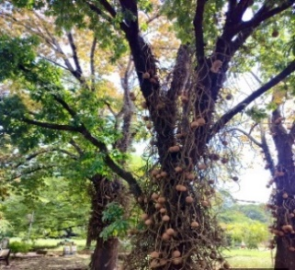
Synonyms of Cannon ball tree
- Couroupita pedicellaris Rizzini.
- Couroupita acreensis R. Knuth.
- Couroupita antillana Miers.
- Couroupita froesii R. Knuth.
- Couroupita guianensis var. surinamensis Eyma.
- Couroupita idolica Dwyer.
- Couroupita membranacea Miers.
- Couroupita peruviana O. Berg.
- Couroupita saintcroixiana R.Knuth.
- Couroupita surinamensis Mart. ex Berg.
- Courupita venezuelensis R. Knuth.
- Lecythis bracteata Willd.
- Pekea couroupita Juss. ex DC., nom. Inval.^{[4]}
Vernacular names^{[5]}
Table: 1
Languages | States | Name
Common name | - | Cannon ball tree, Snake flower
Hindi | - | Tope Gola, Naglinga, Ayahuma
Gujrati | Gujrat | Kailasapati, Shivalingi
Kannada | Karnataka | Tope Gola, Naglinga, Ayahuma
Malayalam | Kerala | Kailasapati, Shivalingi
Marathi | Maharashtra | Kailasapati, shivalingam
Odia | Orissa | Nagakesara, Nageshwara
Sanskrit | - | Not mentioned
Tamil | Tamil Nadu | Naglingam
Bengali | Bengal | Kaman Gola
Assameses | Assam | Naglingam, Nag-Champa
Telugu | Andra Pradesh | Mallikarjuna, Nagamalli
Telangana | Telengana | Nagalingam

Table: 2
Kingdom | Plantae
Sub Kingdom | Tracheobionta
Division | Magnoliophyta
Class | Magnoliopsida
Order | Lecythidales
Family | Lecythidaceae
Genus | Couroupita
Species | Couroupita guanensis Aubl.

BIOACTIVE CONSTITUENTS^{[24]}
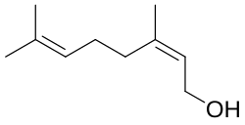
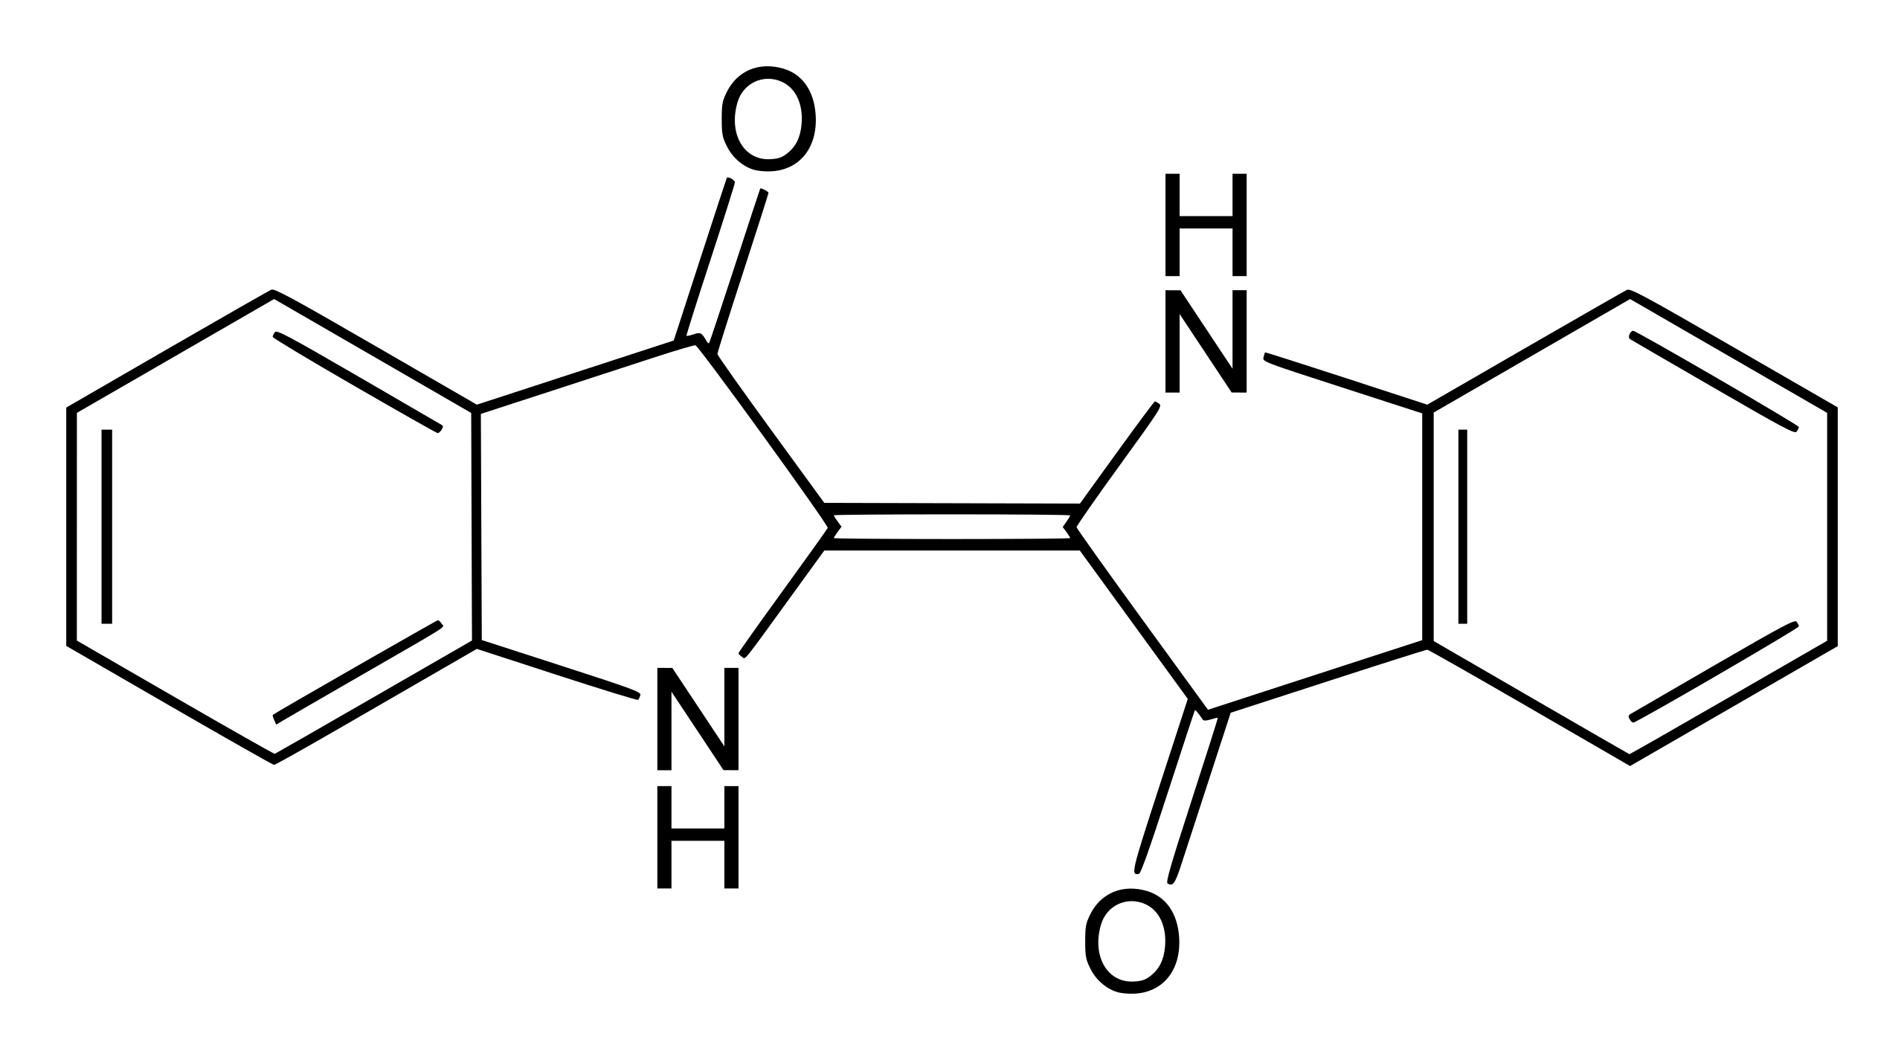
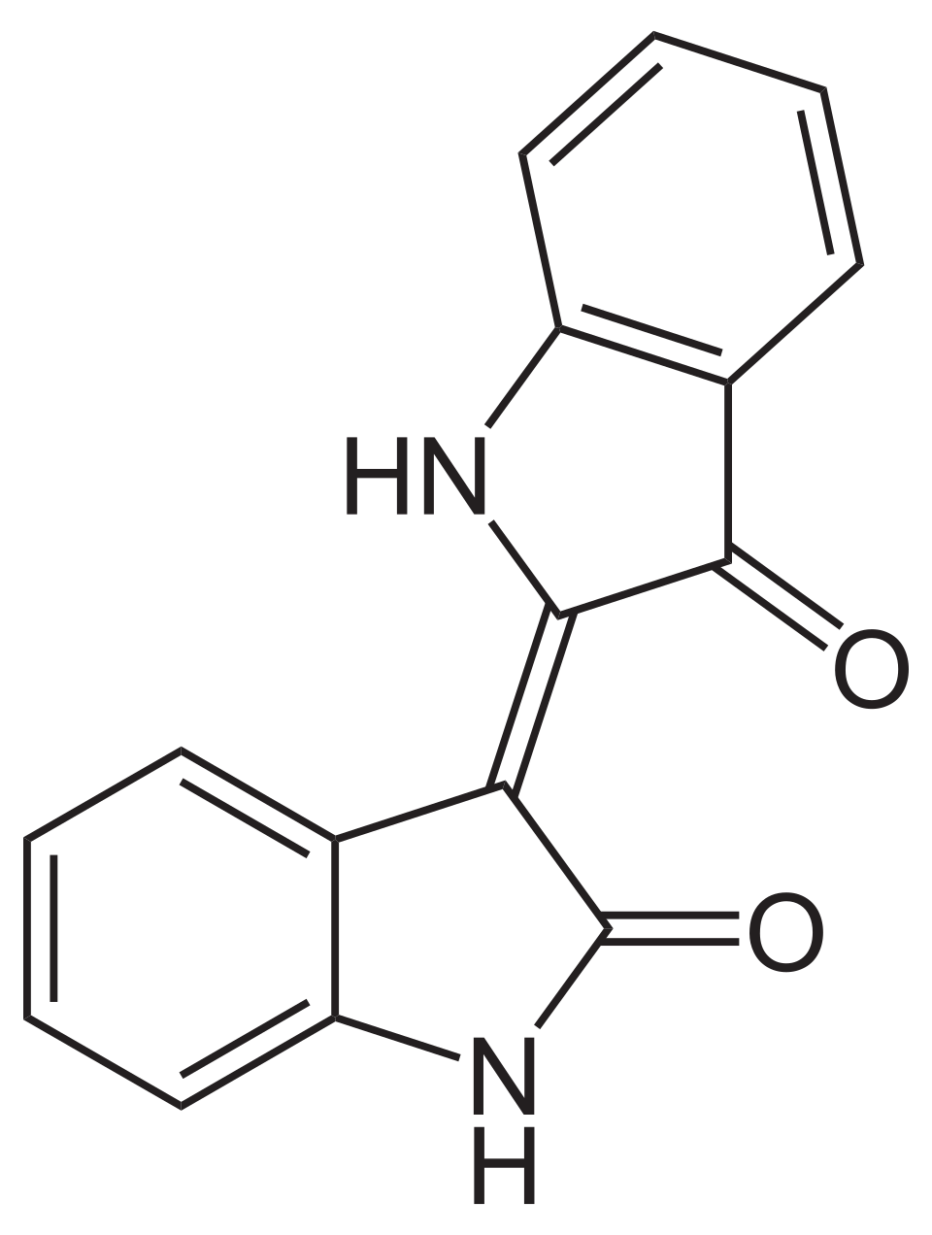
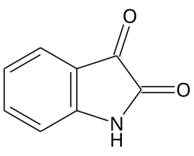
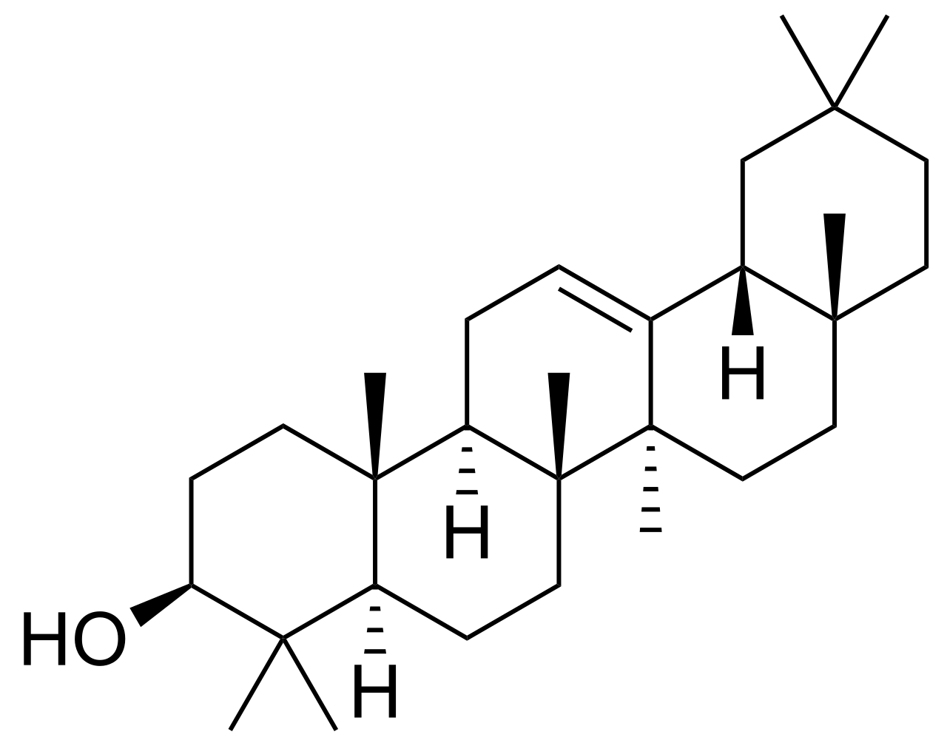
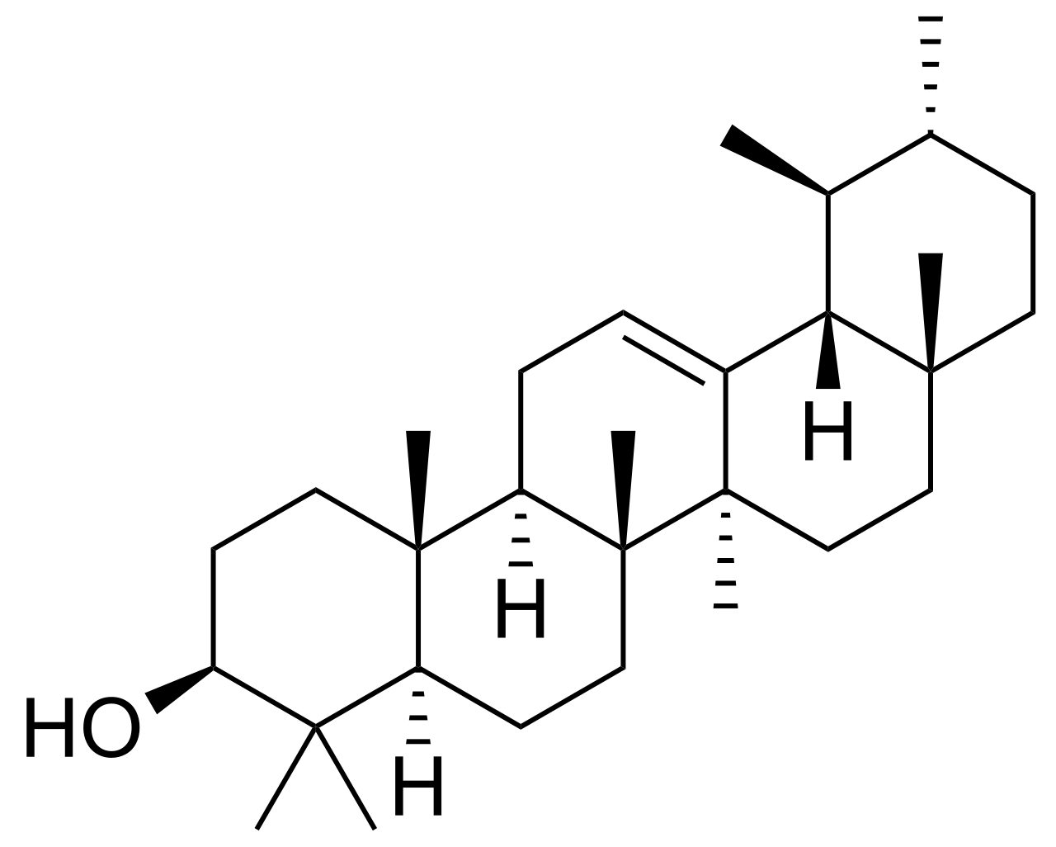
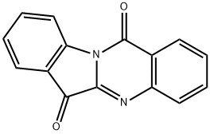
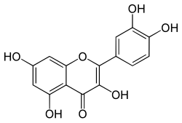
Indigo
Indigo
Indigo

Tryptanthrine
Quercitin
Indirubin
Isatin
Nerol
Indigo
Indigo

β-Amyrin
Indigo

α-Amyrin
Indigo
Indigo

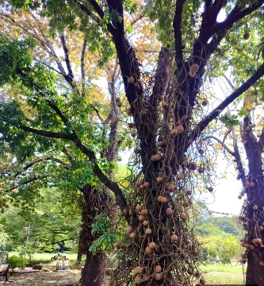

PHARMACOLOGICAL POTENTIAL

Sr.No | Name of the activity | Description
1 | Brain activity | Those investigations analyzed how an alcohol-based compound impacted outcomes in experiments. Couroupita guianensis (own family: Lecythidaceae) on motor interest, phenobarbital drowsing length, and spontaneous rota-rod performance in mice. According to the preliminary phytochemical studies, the extract contains tannins, flavonoids, alkaloids, and Starches. The dosage of 100 mg/kg, 250 mg/kg, and 500 mg/kg exhibited notable effects. A decrease in voluntary movement activities occurs gradually as dosage increases. Its impact was negligible in terms of improving motor skills measured through the rod test performance. Additionally, those extracts have reduced the duration. The introduction of hypnotic effects resulting from pentobarbital administration began. This outcome suggests. The substance in question had an influence on both the cerebral and peripheral systems. The peripheral nervous system requires additional investigation in future studies. The neuropharmacological properties of the plant.^{[6]}
2 | Anticancer activity | Employing the MTT test method, researchers analyzed the aqueous alcoholic solution derived from Couroupita guianensis leaves (HAECGL) was tested for cytotoxicity against Human colon adenocarcinoma cells derived from the HCT-116 line. In terms of cells. Viability, proliferation, and cytotoxicity, this colorimetric assay looks At cellular respiration processes. Following a twenty four hour course of therapy, The extract underwent testing across concentrations spanning from 1 to 1000 micrograms per milliliter. percentage of viable cells was calculated.^{[7]}
3 | Wounds healing activity | Cells known as connective tissue fibroblasts constitute some of the most abundant varieties found in biological systems. Organisms. In these tissues, which maintain cellular balance under typical conditions, reside specific cell types physiological conditions. Because they provide traction and Mechanical stresses promoting closure of wounds involve contractility driven by cells such as fibroblasts. Myofibroblasts play a crucial role in tissue repair after injury. In cases where cells form aggregates, damaged, fibroblasts become activated and differentiate into myofibroblasts, which produce massive contractions and actively Synthesize ECM components for promoting tissue healing at the injury site. Herein lies the situation. Introduce force technologies into both fibroblasts and myofibroblasts simultaneously. Methods employed in quantifying these molecular interactions. Two outcomes emerged simultaneously. Fibroblastuncation of repair myofibroblast wound healing processes They were selected specifically due to their positive impact on tissue healing processes. Appropriate pressure technology and matrix deposition; however, excessive pressure and matrix manufacturing causes tissue scarring And despite repairs on damaged organs. An ethanol extract of plant leaves. extract containing flavonoids such as 2′,4′-dihydroxy6′-methoxy 3′,5′ dimethylchalcone and 7-hydroxy-5-methoxy-6,8-dimethyl Flavonoids such as flavanones were also present alongside hydroxycinnamic acids like caffeic acid in this compound. Was found capable of stimulating growth in human skin cells called fibroblasts UV absorption.^{[8]} Therefore, understanding how those cells generate Entities capable of implementing suitable approaches will assist in introducing these measures. Effective treatments for wounds within medical facilities. Cells responsible for producing connective tissue fibers proliferate in response to stimuli. essential for wound healing because they promote wound contraction.^{[9]}
4 | Anti-stress activity | Investigated the stress-reducing properties of Couroupita guianensis on individuals. A methanol-based extract applied at low temperatures mitigates stress responses. Lipid class: glyceride, cholesterol. And cortisol concentrations are assessed to evaluate efficacy. A methanol-based compound alleviates anxiety symptoms. Unlike stress control measures,. Mice receive oral doses of Couropita guianensis extract in ethanol solution. A dosage regimen consisting of 100 mg/kg, 250 mg/kg, and 500 mg/kg shows notable effects. Gradually reducing each of the dosage levels systematically. The load. The levels of adrenals increased in response to administering cold restraint stress. in large doses.^{[10]}
5 | Antidiabetic and antihyperglycemic activity | A number of Couroupita guianensis components' anti-diabetic properties were examined. Mice given alloxan were administered Floral compounds dissolved in both aqueous and ethanol forms administered at a dosage equivalent to 100 milligrams per kilogram of body weight. weight. Alpha-amylase and beta-glucosidase are two gastrointestinal Enzymes responsible for breaking down carbohydrates which can be inhibited to control metabolism. postprandial hyperglycemia.^{[11,12]} Type 2 diabetes, insulin resistance, cellular dysfunction, and decreased glucose tolerance are It is widely thought to result from free radicals. Precious metal known for its value and rarity. Nanoparticles made from the leaves of Couroupita guianensis increased lipid peroxidation and antioxidant enzyme activity, including catalase, glutathione reductase, and superoxide dismutase, in diabetic rats, reducing hyperglycemia. The study assessed an individual's ability to avoid becoming obese, revealing a positive result. Discovered. A 100-gram per kilogram of body mass concentration of the plant's methanol solution is being referred to here reduced triglycerides, very-low-density lipoproteins, and general blood cholesterol while increasing excessive density lipoproteins and The levels of low-density lipoprotein cholesterol increase significantly among obese rodents as opposed to lean counterparts. Standard atorvastatin. Additionally, the extract has been demonstrated to decrease the production of atherosclerotic plaques.^{[13]}
6 | Anti-ulcer activity | Various treatments for ulcers. Impact observed within an ethanol based solution at concentrations of 150 milligrams per liter. A dosage equivalent to 300 milligrams per kilogram demonstrated notable therapeutic efficacy in Couroupita guianensis. The presence of alcohol-related gastritis leads to these lesions in the digestive tract. Pyloric ligature-produced sores. An interruption of gastric blood supply could occur. The genesis of an ethanol-related gastritis condition may lead to complications. bleeding and narcotic components of tissue destruction.^{[14]}
7 | Anthelmintic activity | Experiments in test tubes evaluated the antiparasitic efficacy. Among ethanol, acetonitrile, and dichloromethane extractives derived from Couroupita guianensis against the adult earthworm Pheritima posthuma (Indian Variation). An investigation into an organism's movement speed was conducted by measuring its locomotion duration. The worms' inability to move indicated their state of being inactive. An alcoholic extract demonstrated superior efficacy compared to chloroform. And acetone's extraction method is effective as well; it exhibits similar efficacy compared to other substances'. common drug piperazine citrate.^{[15]}
8 | Immunomodulatory activity | Numerous investigations both within cell culture environments and living organisms indicate that compound CG exerts an influence. (suppresses or activates) immune system components. In both Research revealed that an antibody reacted specifically with sheep red blood cells in conjunction with methanol as a reagent. A sample containing Chinese gallnut leaves underwent testing for allergic responses. Has been found to enhance phagocytosis. Both cell mediated and humoral-mediated immune responses are triggered, and neutrophil phagocytic activity is enhanced.^{[16]}
9 | Anti-inflammatory activity | Couroupita guianensis ethanol extract was observed to significantly Cut down on the duration devoted to grooming the paws treated in formalin. Throughout both phases of the process. The optimal approach is prevent leukocyte migration into the peritoneal hollow space Following the administration of carrageenan injections involved increasing the dosage levels to 30 mg per dose. And an intake of 100 milligrams per kilogram. At the same time, an intake of 100 milligrams per kilogram was administered. Unquestionably completely prevented mobile migration. The results Prove that the Couroupita guianensis fraction possesses anti-inflammatory properties. The effect, attributed to decreased cell movement, can be understood through two mechanisms: reduced cellular migration. And reduction in cytokine production and inflammatory mediator suppression.^{[17,18]}
10 | Antioxident | Employing the H2O2-scavenging technique alongside vitamin C. Compared to conventional benchmarks, this substance exhibits superior antioxidant activity. hydroalcoholic extract of Couroupita guianensis leaves (HAECGL) Was evaluated. The test has been proven effective in determining this information. To what extent do biologically active compounds inhibit hydrogen peroxide? Species capable of inducing oxidative stress and cell injury. Certainly! Here's an appropriately version of your input: The extraction demonstrated an increase in its capacity based on concentration levels. scavenge hydrogen peroxide.^{[19]}
11 | Antibacterial and Antifungal activity | The effectiveness of antibacterial and antifungal properties was confirmed for every member of the C. guianensis preparations. Using the disc diffusion method, C. guianensis leaf extract had encouraging effectiveness against bacteria And mold. Each component demonstrates its efficacy in combating bacteria and fungi. The letter S is known for its sharp pointy appearance. Aureus exhibited the greatest inhibition when exposed to the chloroform extract derived from leaves among all tested substances. Sections. In comparison to gram-negative bacteria, C. guianensis leaves exhibit distinct characteristics. The extraction method proved superior in its efficacy against gram-positive pathogens. A great many. Studies reveal that gram-positive microorganisms predominate in certain environments. More susceptible to medicinal plants compared to Gram-negative microorganisms. The numbers twenty-one through twenty-two inclusive have been mentioned previously. The chloroform extract exhibited enhanced antimicrobial properties; thus, this might be true. Constituted by the characteristics of the extracting agent. Effectiveness against microorganisms in leaves. Observations of additional activities were noted as well in this report various microorganisms. The antibacterial properties found in an ethanolic extract derived from C. guianensis fruits was also reported.^{[22,23]}

CONCLUSION
The species Couroupita guianensis Aubl Is identified by this botanical name. It is an herb of medicinal significance containing numerous active chemical components like. Flavonoids, alkaloids, polyphenols, and terpenes contribute significantly to their diverse array of medicinal properties. Previous research indicates these properties: antioxidative, anti-inflammatory, antibacterial, and antitumoral effects. Verifying its historical therapeutic application. Moreover, additional research will concentrate on establishing standards and assessing safety measures. Clinical verification is necessary. In summary, Couroupita guianensis Aubl Shows great potential as an inherent characteristic. The study offers potential new treatments by combining traditional plant based medicine approaches with modern scientific methods. Pharmaceutical strategy reveals novel understandings regarding active biological properties and microscopic analysis techniques. C. guianensis species of Aubletia. Consequently establishing an initial basis for its widespread application within traditional herbal remedies.
REFERENCES
1. Jamshidi-Kia F, Lorigooini Z, Amini-Khoei H. (2018) Medicinal plants: past history and future perspective. J Herbmed Pharmacol. 7(1):1-7. doi: 10.15171/jhp.2018.01.
2. Akerele O. (1993) Summary of WHO guidelines for the assessment of herbal medicines. Herbal Gram. ;28(13):13-9.
3. Kavitha R, Kamalakannan P, Deepa T, Elamathi R, Sridhar S. Suresh Kumar J. (2011) In vitro Antimicrobial Activity and Phytochemical Analysis of Indian Medicinal Plant Couroupita guianensis Aubl. 3(6):115-121.page no: 115 & 116
4. https://indiabiodiversity.org 04/02/20210.
5. MD Dravyagun. (2023) "Couroupita guianensis Aubl. (Lecythidaceae): A Medicinal Plant: Ayurvedic and Modern View", Volume 5, Issue 3, E-ISSN: 2582-2160
6. Manimegalai S, Sridharan Tb, Rameshpathy M, Devi Rajeswari V. Antioxidant, (2014). Phytochemical Screening And Antimicrobial Activity Of Couroupita Guianensis Flower Extract. Pharm Lett;6(6):251 6
7. Ajith Kumar et al. (2025) "Comprehensive Investigation Of Couroupita Guianensis Leaves Pharmacognostical, Phytochemical And Pharmacological Approaches For Colorectal Cancer", IJCRT | Volume 13, Issue 6 June 2025 | ISSN: 2320-2882.
8. Uppala Pk, Murali Krishna B, Atchuta Kumar K, Vinay Ramji Dj. (2016) Evaluation Of Anti-Coagulant Activity Of The Chloroform And Aqueous Extracts Of The Leaves Of Couroupita guianensis. Int J Pharm Pharm Res;6(4):189-99.
9. Elumalai A, Eswaraiah Mc, Didala A. (2012)Investigations On Anti-Oxidant, Anti-Arthritic And Antiplatelet Studies In Couroupita guianensis Aubl Leave By In Vitro Methods. Pharma Sci Monit;3(3):2262-9.
10. Geetha M, Shankar Mb, Mehta Rs, Saluja Ak.(2005) Antifertility Activity Of Artabotrys Odoratissimus Roxb. And Couroupita Guianensis Aubl. Journal Of Natural Remedies;5(2):121-5.
11. Ramyasai M, Babu Sm, Vadivel K. (2013) Anti-Obesity And Atherosclerotic Activity Of Methanolic Extract Of Couroupita guianensis Aubl. Flowers In Rats Fed With High-Fat Diets. Int J Univ Pharm Bio Sci;2(6):288 300.
12. Li B, Wang JH.(2011) Fibroblasts And Myofibroblasts In Wound Healing: Force Generation And Measurement. J Tissue Viability;20(4):108-20.
13. Desai Sd, Panchal Hn, Soni Mk, Mishra P, Meshram Db.(2018) In-Vitro Antiurolithiatic And Antioxidant Activity Of Couroupita guianensis Aubl Leaves. Der Pharmacia Sinica;9(1):1-6.
14. M. R. Khan M. Kihara A. D. Omoloso(2003)Antibiotic Activity of Couroupita guianensis, Journal of Herbs, Spices & Medicinal Plants, Vol. 10(3).
15. Kim Ym, Jeong Yk, Wang Mh, Lee Wy, Rhee Hi,(2005) Inhibitory Effect Of Pine Extract On Alpha Glucosidase Activity And Postprandial Hyperglycemia. Nutrition;21(6):756-61. Doi: 10.1016/J.Nut.2004.10.014.
16. Morankar Pg, Dhake As, Kumbhare Mr, Ushir Yv, Surana Ar, Patil Sd. (2013)An Evaluation Of The Antidiabetic Effects Of Couroupita guianensis Aubl. Flowers In Experimental Animals. Indo Am J Pharm Res;3(4):3114-22.
17. Mariana M.G. Pinheiro, Sidnei B.O. Fernandes, Catarina E. Fingolo , Fábio Boylan, Patrícia D. (2013) Fernandes” Anti-Inflammatory Activity Of Ethanol Extract And Fractions From Couroupita Guianensis Aublet Leaves.”Journal Of Ethnopharmacology. Vol. 146:Issue 1.
18. Pradhan D, Panda Pk, Tripathy G (2009). Evaluation Of The Immunomodulatory Activity Of The Methanolic Extract Of Couroupita guianensis Aubl. Flowers In Rats. Nat Prod Radiance;8(1):37-42.
19. Ajith Kumar et al. (2025) "Comprehensive Investigation Of Couroupita Guianensis Leaves Pharmacognostical, Phytochemical And Pharmacological Approaches For Colorectal Cancer", 2025 IJCRT | Volume 13, Issue 6 | ISSN: 2320-2882.
20. Lin J, Opoku AR, Geheeb-Keller M, Hutchings AD, Terblanche SE, Jager AK, et al. (1999) Preliminary screening of some traditional Zulu medicinal plants for anti-inflammatory and anti-microbial activities. J Ethnopharmacol 68:267-74.
21. Parekh J, Chanda S. (2006) In-vitro antimicrobial activities of extracts of Launaea procumbens Roxb. (Labiateae), Vitis vinifera L. (Vitaceae) and Cyperus rotundus L. (Cyperaceae). Afr J Biomed Res ;9:89-93.
22. Khan MR, Kihara M, Omoloso AD. (2003) Antimicrobial activity of Couroupita guianensis. J Herbs Spices Med Plants ;10:95 108.
23. Al-Dhabi NA, Balachandran C, Raj MK, Duraipandiyan V, Muthukumar C, Ignacimuthu S, et al. (2012) Antimicrobial, antimycobacterial and antibiofilm properties of Couroupita guianensis Aubl fruit extract. BMC Complementary Altern Med ;12:242.
24. Priyanka J., Vipul P., Sachinkumar P. 2022 " Medicinal properties, pharmacology, and phytochemistry of Couroupita guianensis Aubl.", IJCRT, Volume 10, Issue 10 October 2022, ISSN: 2320-2882.

