RELATIONSHIP BETWEEN POPULATION CONCENTRATION AND MIXED LAND USES IN CALABAR METROPOLIS, NIGERIA
ABSTRACT
This study examined the relationship between population concentration and mixed land uses in Calabar Metropolis, Nigeria. The study aimed at establishing a linkage between the two variables, whether population concentration is a causal factor contributing to the development of mixed land uses in Calabar Metropolis. Map analysis with the instrumentality of the linear planimeter was used to gather quantitative data matched with census data. Both qualitative and quantitative approaches were combined in the analysis. Qualitative analysis was carried out for description while quantitative analysis was used in testing the formulated null hypothesis that; there is no significant relationship between population concentration and the areal extent (m²) of mixed land uses within the neighbourhood zones of Calabar Metropolis. This was tested with the linear regression analysis and the result showed a no statistically significant relationship with the overall model fit of R² = 0.126 which was very low. This proved that development of mixed land uses is not caused by population concentration and therefore, suggests a further re-examination of the variables.
KEY WORDS: Areal extent, Likert scale, Linear regression, Map analysis, Neigbourhood zones, Population concentration.
I. INTRODUCTION
According to the US Census Bureau (2020), the impact of global population on urban land use is enormous. For example, the world population is currently estimated at 7.5 billion, and it is anticipated to reach 9.0 billion in 2050 (Yaro, Shabu, Obongha, Okon, & Tagba, 2025; US Census Bureau, 2020). The inevitable consequence of rapidly increasing world population is a growing demand for housing, food and transportation. At the same time, waste generation would increase. Therefore, satisfying human needs would mean increase in land use non-conformity. Jaeger (2013) studied population as determinant of non-conforming land uses in California. The study revealed that urban population is usually distributed by land use regulations. These regulations also have the capacity to sway the density of developed lands and the general land area of the city. Jaeger, noted that the implication of population increase is pressure on activities that takes place on land influenced by creation of incongruous land uses. For example, in Calabar South, Nigeria a grinding mill could be developed in a residential family compound by a member of the family who wished to embark on such a business and it is permitted by other members of the family. This development is capable of ruining the neighbourhood quality by generating excessive noise level. Population concentration has also led to conversion from one land use to another as well as non-harmonized mixed-use developments.
In a study in the United States, for example, Fan, Qiu & Wang (2009) found that the impact of population concentration on the future demand for land is potentially huge. It was also revealed that fast growth of population led to poor economic performance. In a similar development, Aruand (2010) found that thirty per cent of US population lives in urban centres in coastal environments, creating incompatible land uses viz; residential and agricultural within those areas. According to their studies, from a long-term perspective, rise in sea level from climate change would be expected to have a disproportionate displacement impact on non-conforming settlements in coastal areas (Barbier, Georgion, Enchelmeyer, & Reed, 2013; Siadat, Mousari, Jose, Stone, & Lee, 2009). It has been globally recognized that, persistent increase in population tends to be the most significant explanatory factor, among others, resulting in high urban concentration of people in search of greener pastures. This assertion is supported by USGS fact sheet 188-99 in 1999 which identified that, approximately fifteen per cent of the world populations were living in urban areas about 100 years ago. However, today, the percentage of the world population living in the urban centres is now approximately seventy per cent (Population World Master, 2020). In Nigeria, for example, the current population stands at 206.1 million while 51.16 per cent of this population lives in urban centres. Out of this number, 15.0 per cent is found in shanty and squatter settlements of incompatible land uses (Population World Master, 2020). Population concentration leads to urbanization that brings about visible agents of anthropogenic global forces (Pickett, Cadenasso, Grove, Boone, Grofman, & Irwin, 2011).
In Calabar, for example, the impact of urbanization has led to alteration and alternation of several land uses. Oka (2009) found that land use alteration and alternation caused by population concentration in Calabar has impacted negatively on the spatio-temporal land cover features. Alteration and alternation of the urban green areas, wetlands, riparian, mangrove forest and other green land ecosystems, are currently giving way for the construction of roads, new residential and industrial layouts in Calabar Metropolis. These processes created some non-conformity in the land use patterns of Calabar Metropolis and have seriously affected zoning regulation. The master plan in which most of the areas were zoned for industrial use has been encroached upon by residential uses as a consequence of population growth. However, this study certainly throws some light on population concentration and mixed land uses.
Mixed land uses have been reviewed by Aruand (2010) as a mixture of residential, commercial and industrial uses within a given area. Mixed land use could be a residential area but intermixed with pockets of commercial and industrial uses for the purpose of rendering some services to the residents. A study in Shagamu, Ogun State, Nigeria by Odunola & Odunjo (2015) found that mixed use of buildings brought about traffic congestion, accidents, and increase in travel time and fares. They noted that mixed land uses also caused pollution related problems such as noise, gaseous discharge, land and water pollution, and indiscriminate solid waste disposal. Traffic problems and pollution were measured as perceived by the residents of the study area.
The results of their study showed a significant relationship between pollution related variables and proximity to residential neighbourhoods. The implication is that the pollution related variables impacted negatively on the residents by making their living condition un-conducive. However, socio-economic characteristics of the residents in residential mixed land use areas were measured. The variables measured were insecurity (burglary, robbery, looting, kidnapping) and anti-social behaviuor (ASB) (fighting, disorderliness, incivilities and heavy drinking) (Obongha, 2019).
Obongha, Agbor, & Upuji, (2022) observed that there is a great mixture of businesses in the residential land use area, mainly because such businesses provide a variety of essential services to the residents, for example, shops/malls, some fabrications, and even gasoline stations. Shops and malls provide retail services to the residents and fabrication services are carried out for maintenance of residences, while gasoline stations provide fuel services for easy movement of the residents. These are positive effects of mixed land uses.
Furthermore, mixed land uses could also provide some positive impacts on a city. For example, in recent researches, emphasis has been placed on encouraging mixed uses as a means of boosting socio-cultural diversity within neighbourhoods. A study conducted by the European Commission (2021) in Germany through survey method recommended mixed use development as a means to protect organized urban open spaces, reduce energy consumption, improve access to services and facilities, utilize infrastructure more efficiently and generate agglomeration economies (Working Group on Sustainable Land Use, 2001; Burton, 2000).
Mixed land use also refers to development for a variety of uses. Some importance is attached to mixed use development as it is constantly associated with decrease in driving as measured by vehicle miles travelled (VMT) and fuel burned (Frank, Greenworld, Winkleman, Chapman, & Karage, 2010). An increase in transit-use is promoted by transit-oriented development (TOD) which advocate for mixed use and ready access (within a quarter mile) to one or more transit hubs (Munford, Contant, Weissman, Wolf, & Glanz (2011).
Frank, Greenwald, Winkleman, Chapman and Karage, (2010) carried out a study of mixed land uses in Atlanta, Georgia. They observed that the demand for mixed use/compact development is unmet. Their conclusion showed that in Atlanta, seventy per cent of the surveyed group expressed preferences for transit and pedestrian friendly environments. This group was much more likely to prefer a change from their current neighbourhoods to others who might prefer auto – oriented neighbourhoods. There are several preferences and interests as regards to mixed land uses between walkable and car dependent neighbourhoods. It can be difficult to isolate the effects of mixed uses alone, since many studies compare neighbourhoods with a bundle of traits such as; mixed use, walkable, transit-oriented, and compact to dispersed, car dependent, and single use (Carnoske, Hoerhner, Ruthmann, Frank, Hardy & Hill, 2010).
More benefits are associated with subset of mixed-use development termed transit-oriented development (TOD). Residents who live in TOD locations near to light, rail shops were found to have lower land use complexities (Brown et al., 2009). In recent times, land use professionals and some non-profit making organizations are keying-in to promoting mixed uses in support of lively, safe, and walkable cities. Examples of such are the smart growth network and the congress for new urbanism (Carnoske Hoerhner, Ruthman, Frank, Hardy & Hill, 2010).
The United Nations General Assembly organized separate studies by Calthorpe & Fulton (2001); Duany, Plater-Zyberk, & Speck (2000) on mixed land uses in selected cities. They found in-fill development as a positive impact of mixed land use. Infill development is a movement to curb sprawl and encourage city expansion, particularly in large cities. Infill development represents establishing a new land use in a previously developed district. It may involve increasing the intensity of use of a parcel of land, developing the unused land that is surrounded by development or repurposing previous development to a new use. The Charter for New Urbanism is a brain-child of the United Nations General Assembly which came up as an idea to mitigate sprawl, encourage sustainable growth, and facilitate in-fill development. The concept of new urbanism has been explained as thus:

The concept of New Urbanism was conceived as a response to contemporary problems of urban development characterized by antagonistic land uses, deteriorating environmental quality, declining public realm, and the rise of no-place-edge-city phenomena collectively seen as sprawl (Calthorpe and Fulton 2001; Duany, Plater-Zyberk, and Speck 2000).

Arguing against current pattern of development that inevitably produces sprawl, advocates of New Urbanism have offered general physical design concepts to facilitate environmentally responsible developments (Kunstler 2006; Duany & Talen 2002; Kelbaugh 2002). The presumed benefits of the New Urbanism include efficient use of land as well as preservation of environmental and ecological quality of neighbourhoods, districts, and zones.
The New Urbanism concept is expected to improve social life and enhance a sense of community wellbeing. While these claims of the advocates of New Urbanism are being contested, Ellis (2002), Till (2001), Gordon & Richardson (2000) stressed that such schemes are supported by various forms of institutional endorsements and regulatory reforms and are proliferating in the United States. Many cities and counties in the United States are already facilitating New Urbanism design schemes in new suburban developments, urban in-fill projects, and urban transit-oriented developments.

Obviously, many cities in Nigeria existed before the art of town planning and it has become rather difficult to infuse modern town planning ideas into land uses in the existing traditional cities. In a bid to carry out development and expansion of Nigerian cities, urban sprawl and peripheral development becomes uncontrollable. However, the introduction of the concept of New Urbanism as a process of reintegrating the component of modern life (housing, workplace, shopping, and recreation into compact, pedestrian-friendly, mixed-use neighbourhoods linked by transit and set in a larger regional open space framework) would help to seal-off unnecessary vacant spaces (Ayuba & Rikko, 2019). The concept of New Urbanism is applied to in-fill and development of sites within existing urbanized areas in Nigeria such as in Lagos, Port Harcourt and some areas in Calabar.

From this review, it has been found that mixed land uses possess both negative and positive impacts. While the negative impacts repel the functional theoretical principles of urban land uses, the positive impacts encourage its association in a sustainable manner. In this study it has, therefore, been established that there is need to further provide more evidence on the relationship between population concentration and mixed land uses in Calabar Metropolis. The study is therefore, aimed at finding the mid-point between concentration of people on land and development of mixed land uses. This aim was achieved by testing a null hypothesis that there is no significant relationship between population concentration and the areal extent (m²) of mixed land uses within the neighbourhood zones of Calabar Metropolis.

II. METHODOLOGY
Four methods were employed for data collection, namely: (i) Map analysis of the spatial area of land uses (m²) occupied by mixed land uses in the eighteen neighbourhood zones of Calabar Metropolis. (ii) Professional interviews with Staff of Town Planning Department, Calabar, (iii) Administration of a structured questionnaire and (iv) Projected Population Census figure.
Map analysis: an existing land use map of Calabar Metropolis was obtained from the Cross River State Geographic Information Agency. From the map, eighteen residential neighbourhoods were identified and complimented with empirical verification of features on the landscape using Google Earth Imagery and reconnaissance survey. Map analysis was carried out using the linear planimeter (Roser, Leiborici, and Jackson, 2011).
The identified mixed land uses and the areal extent of each neighbourhood was measured and summed up to give a measure of mixed land uses in that particular neigbourhood zone. These measurements were thus, taken for all the eighteen neighbourhood zones of Calabar Metropolis. The areal measure of mixed land uses was then used as index representing the Y variable. The X variable represents population concentration index obtained from the National Population Commission (NPC, 2006) gazette and projected to 2024 (Ojikpong, Ekeng, Obongha and Emri, 2016).

The linear planimeter is a standard measuring tool/instrument in the field of Urban Planning, Cartography, Geography, Land Surveying, Architecture, and Engineering which is used in determining euclidean distances/spatial area, demarcating boundaries and parcels of land on a map (Roser, et al., 2011). The usefulness of the linear planimeter to this study cannot be overemphasized. Its measurements were taken, using the map scale and represented in metres.
Interviews were conducted with six (6) members of staff of Town Planning Department, Calabar comprising one Director, two Assistant Directors and three Zonal Town Planners.
The questionnaire was also used in this study. The questionnaire was designed using responses on a Likert scale to measure the relationship between mixed land uses and population concentration in Calabar Metropolis. It contains questions with options such as Strongly Agreed (5 points), Agreed (4 points), Strongly Disagreed (1 point), Disagreed (2 points) and Undecided (3 points). For example, population density, growth and distribution are the major causes of mixed land uses. The questionnaire was used to collect qualitative data which complimented data from measurements carried out using the linear planimeter and population data as projected. Data obtained from the administration of the questionnaire were not used in testing the hypotheses, rather were used for description of evidence-based information on the subject.
The respondents were heads of household. The respondents were sampled from the total households of Calabar Metropolis with a sample size of 494 household heads. However, 494 copies of the questionnaire were distributed by the field assistants
This study is concerned with mixed land uses and population which involved activities performed by people. The complications in land use are contributed by the people. However, some of the activities performed by the people constitute land use antagonism. Hence, the inclusion of population concentration in the study becomes necessary. Therefore, a sample size of the population needed to be drawn from the existing population in order to ascertain its influence on mixed land use activities in Calabar Metropolis.

The total population of Calabar Metropolis according to the 2006 population census was 316,270 people (NPC, 2006). The population was projected to 2024 using a growth rate of 3.0 thus, bringing the projected population to 630,628 people in 2024. In this study, households were used as the sample frame. An average of six (6.0) people is officially accepted as household size in Nigeria (National Bureau of Statistics, 2021). Therefore, an average household size of six people from the total population of 630,628 people, so a total number of 105,105 households was used for the study. In all, the total sample for all the neighbourhoods is 8.1 per cent of the 105,105 households.

The sample size, therefore, amounted to 494 households for the entire study. The justification for using 8.1 per cent of the household was based on the size of population of study (105,105 households) which was a determining factor for selecting from 0.1 per cent to 10.0 per cent from the total population. However, the sample frame of each neighbourhood household as determined by the total population amounted to 8.1 per cent. Again, each neighbourhood zone also has a population represented by a sample size which was summed up to 494 households as the sample size for the entire study (Obongha, et al., 2024).

Table 1.0: Total population, households and sample size of neighbourhood zones

S/No | Neighbourhood Name | Total Population | Estimated no. of Households | % of Sample Frame | Sample Size
1. | Akim Qua Town | 42,125 | 7,020.83 | 0.6 | 42.1
2. | Big Qua Town | 40,645 | 6,774.17 | 0.5 | 33.9
3. | Duke/Cobhom Town | 42,540 | 7,090 | 0.6 | 42.5
4. | Ediba Qua Town | 36,965 | 6,160.83 | 0.5 | 30.8
5. | Efut Abua | 27,785 | 4,630.83 | 0.3 | 13.9
6. | Efut Anantigha | 27,594 | 4,599 | 0.3 | 13.8
7. | Efut Ekondo | 42,768 | 7,128 | 0.6 | 42.8
8. | Efut Uwanse | 29,187 | 4,864 | 0.4 | 19.5
9. | Ekorinim 1 and 2 | 28,995 | 4,832.50 | 0.4 | 19.4
10 | Esin Ufot | 38,863 | 6,477.17 | 0.5 | 32.4
11 | Essien Town | 27,673 | 4,612.17 | 0.3 | 13.8
12 | Henshaw Town | 41,051 | 6,841.83 | 0.5 | 34.5
13 | Ikot Ansa | 39,088 | 6,514.67 | 0.5 | 32.6
14 | Ikot Effanga Mkpa | 29,999 | 4,999.83 | 0.4 | 20.0
15 | Ikot Ishie | 38,785 | 6,464.17 | 0.5 | 32.4
16 | Ikot Omin | 27,781 | 4,630.17 | 0.3 | 13.9
17 | Mbukpa | 42,541 | 70,90.17 | 0.6 | 42.5
18 | Nyahasang | 26,243 | 4,373.83 | 0.3 | 13.2
 | Total | 630,628 | 105,105 | 8.1 | 494

Source: Compiled by the Researcher from year 2006 census data and projected to year 2024.

III. ANALYSIS

Table 2.0 showed responses on the Likert scale for mixed land uses and population concentration in Calabar Metropolis. Interviews were conducted to ascertain the relationship between population concentration and mixed land use development. Respondents chose from options on the likert scale, such as; strongly agreed (5 points), agreed (4 points), strongly disagreed (1 point), disagreed (2 points) and undecided (3 points). Each of the options showed responses from respondents according to their degree of acceptability as shown in Table 2.0. For example, population density as a major cause of mixed land use development has 196 responses who strongly agreed, 103 responses who agreed, 95 responses who strongly disagreed, 93 responses who disagreed and 9 responses that were undecided making a total of 494 responses. However, 1,232 (27.71 per cent) who strongly agreed with all the questions on the Likert scale were the largest. While 766 (17.23 per cent) undecided responses were the least on the Likert scale. However, the average percentage mean response on the Likert scale was 27.16 per cent.
R₁₁ = ⅀W∕AN (0≤ R₁₁≥1) …………………………..………………………… eqn. 1.
Where: R₁₁ = Relative importance index
⅀ = summation
W = weight given to each factor by the respondents (1-5)
A = highest weight (in this study 5)
N = sample size (in this study 494)
However, R₁₁ falls within the range of zero to one (0-1) making it possible to compare opinions. Therefore, the benchmark for deciding the significant score is 0.05 as such values ≥ 0.05 are considered not significant while values ≤ 0.05 are significant. Responses on the Likert scale are considered as qualitative in this study and were not tested further.

Table 2.0: Responses on the Likert scale to the causes of mixed land uses
Responses | Scoring Method  (5) (4) (1) (2) (3)
Responses | Strongly Agree | Agree | Strongly Disagree | Disagree | Undecided | Total | Mean
Population density as major cause of mixed land uses | 196  (980) | 103  (412) | 95 (95) | 93 (186) | 7 (21) | 494 (1694) | 338.8
Requirement for granting mixed land use approval are not often followed | 138 (690) | 94 (376) | 137 (137) | 92 (184) | 33 (99) | 494 (1110) | 222
Reasons for residential development in industrial areas is population growth and high demand for land | 123 (615) | 89 (356) | 76 (76) | 85 (170) | 121 (363) | 494  (140) | 282
Development of industrial uses in residential areas is due to unemployment | 129 (645) | 105  (420) | 64 (64) | 51  (102) | 145  (435) | 494  (1666) | 333.2
Recreational land use is often intermixed with residential and educational land uses | 101 (505) | 91 (364) | 113 (113) | 98 (196) | 91 (273) | 494 (1451) | 290.2
Mixed use areas are associated with some environmental hazards, such as fire disaster, degradation | 129 (645) | 103 (412) | 82 (82) | 93 (186) | 87 (261) | 494 (1586) | 317.2
Mixed use areas are prone to poor environmental sanitation | 115 (575) | 106 (242) | 94 (94) | 83  (166) | 96 (288) | 494  (1365) | 273
Mixed use results in some new redevelopments without approval | 119 (595) | 117 (468) | 84 (84) | 77 (154) | 97 (291) | 494  (1583) | 316.6
several use alternations for example, residential to Church are done intentional without approval | 182 (910) | 79 (316) | 63 (63) | 81 (162) | 89 (267) | 494  (1718) | 343.6
Total | 1,232 | 887 | 808 | 753 | 766 | 4,446 | 2716.1
Percentage | 27.71 | 19.95 | 18.17 | 16.94 | 17.23 | 100 | 27.16
Source: Researcher’s compilation from field survey, 2025.

Figure 1.0: Bar graph derived from Table 2.0 showing attributes of mixed land uses
Source: Researcher’s compilation, 2025.

The bar graph (Figure 1.0) is used as explanation of Table 2.0 where attributes of mixed land uses are represented according to the level of responses on the Likert scale. For example, 129 responses who strongly agreed showed that unemployment was responsible for mixed land use development. Each of the responses on the Likert scale is represented in a bar as shown in (Figure 1.0).
Table 3.0 showed data on population concentration of the 18.0 neigbourhood zones and the areal extent (m²) of various locations of mixed land uses in all the neighbourhoods of Calabar Metropolis. The independent variable (X) represents population concentration and the depenedent variable (Y) represents the areal extent (m²) of mixed land uses in all the neigbourhood zones of Calabar Metropolis. Figure 2.0 is an explanation of the Table 2.0 in a bar graph while Figure 3.0 represents population concentration of various neighbourhoods of Calabar Metropolis in a map.

Table 3.0: Population of neighbourhood zones and the areal extent (m²) of mixed land uses
S/No | Neighbourhood zone | Population (X) | Identification of land use area | Area (m²) | Total area (m²) (Y)
1 | Akim Qua Town | 42,125 | Airport  Timber market  Cemetery  Udensco Filling sta  Shafar  Gas station  Encroachment | 3,350  123  145  25  23  22  10,563 | 15,251
2 | Big Qua Town | 40,645 | Stadium  State Library  Church  Others | 284  96  89  3,000 | 3,469
3 | Duke/Cobhom Town | 42,540 | Cathedral  Open market  Others | 102  200  2,500 | 2,802
4 | Ediba Qua Town | 36,965 | Airport  Timber market  Water board  Church  Others | 3,350  210  1,250  98  4,000 | 8,908
5 | Efut Abua | 27,785 | Jebs gasoline  Eneyo  Afokang gas  Gas station  Others | 35  38  31  29  4,320 | 4,453
6 | Efut Anantigha | 27,594 | Encroachment  Open markets  Abattoir  Others | 7,485  56  16  5,000 | 12,557
7 | Efut Ekondo | 42,768 | Apostolic  Mount zion  Church  Mechanic shop  Others | 52  67  59  67  8,000 | 8,245
8 | Efut Uwanse | 29,187 | Prosperous oil  Open markets  Christ for the world mission  Others | 33  43  36  6,000 | 6,112
9 | Ekorinim | 28,995 | Golden penny  Open market  Others | 145  23  11,200 | 11,368
10 | Esin Ufot | 38,863 | UD king  UD King  Carpentry  Church at Atu  Others | 36  51  23  21  6,000 | 6,131
11 | Essien Town | 27,673 | Cemetery  Open market  Golden penny  Others | 112  33  145  4,000 | 4,290
12 | Henshaw Town | 41,051 | Cathedral  Church  Others | 115  53  5,200 | 5,368
13 | Ikot Ansa | 39,088 | St. Bernard’s  Residences/Ind  Gas station  Others | 85  7,567  50  6,000 | 13,702
14 | Ikot Effanga | 29,999 | St. Luke’s  Lutheran  Others | 27  23  10,000 | 10,050
15 | Ikot Ishie | 38,785 | Mount zion  Ikot Effah Ch  Others | 62  31  4,000 | 4,093
16 | Ikot Omin | 27,781 | Timber market  Open market  Abattoir  Others | 207  306  107  3,000 | 3,620
17 | Mbukpa | 42,541 | Oando  Mills  Apostolic faith  Others | 47  32  63  6,000 | 6,142
18 | Nyahasang | 26,243 | Airport  Poultry farms  Gasoline stations | 3,350  2.50  7,000 | 10,402.50
 | Total | 630,628 |  |  | 136,963.50

Source: Researcher’s compilation from field survey, 2025.

Figure 2.0: Bar graph derived from Table 3.0 showing population concentration and the areal extent of mixed land uses in Calabar Metropolis.

Source: Researcher’s compilation, 2023.
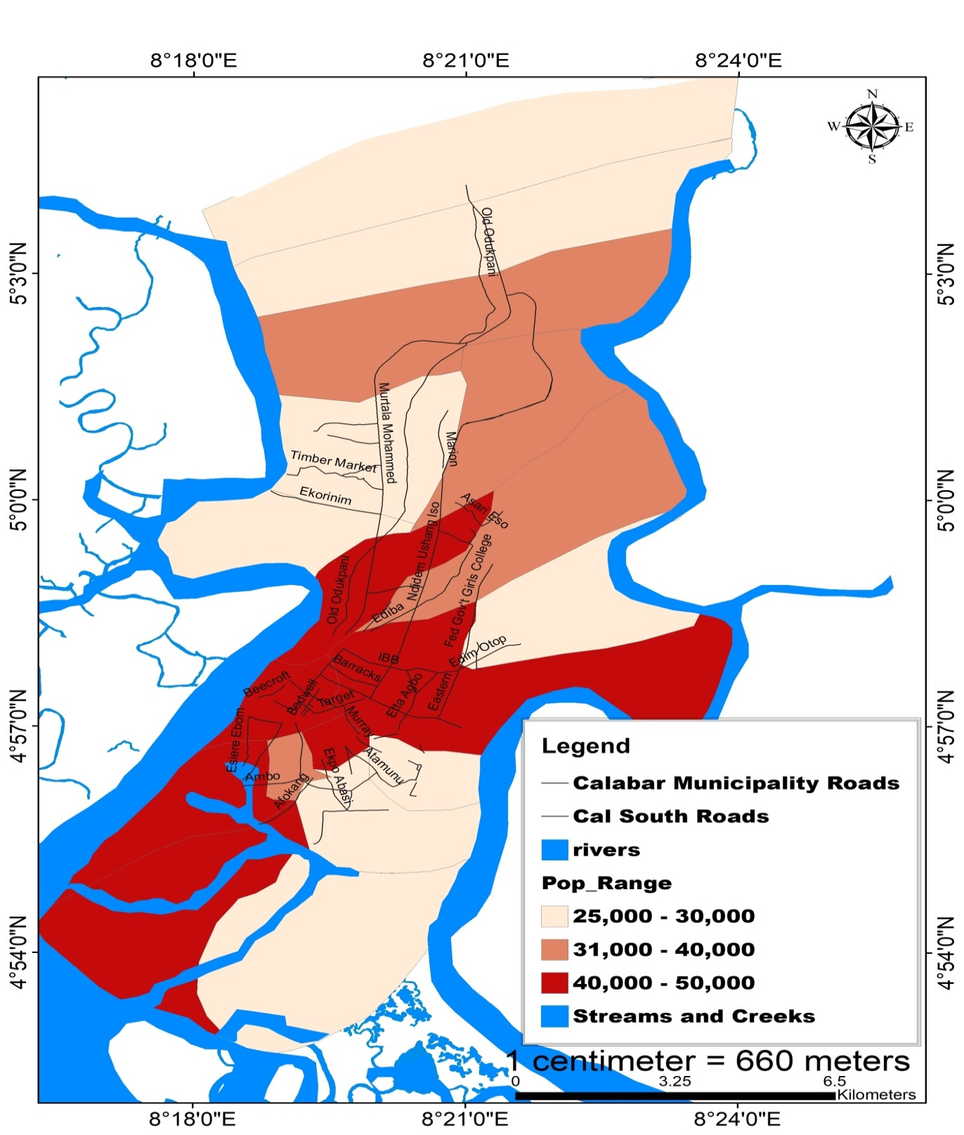
Figure 3.0: Population concentration in Calabar Metropolis from Table 3.0.
Source: Researcher’s design, 2025.

Data set in Table 3.0 was used in testing the formulated hypothesis that:
There is no significant relationship between population concentration and the areal extent (m²) of mixed land uses within the neighbourhood zones of Calabar Metropolis.
This hypothesis was tested using the Simple Linear Regression analysis with data set in Table 3.0. It is Mathematically expressed as:
Y = a+bx+e …………………………………………………………..……….……….. eqn. 2.
The assumptions/conditions of the LR showed that:
(i) The dependent variable should be measured on a continuous scale (interval or ratio scale).
(ii) There should be one independent variable, which can be either continuous or categorical.
(iii) There should be independence of observations (that is independence of residuals) which can be checked using the Durbin-Watson statistic.
(iv) There should be a linear relationship between the dependent variable and the independent variable.
(v) The data sets need to show homoscedasticity, that is, the variances along the line of best fit remain similar as movement continues along the line.
(vi) There should be no significant outliers, high leverage points or highly influential points.
(vii) The residuals (errors) should be approximately or normally

From the regression output in Table 4.0, it showed that:
- Population concentration and mixed land uses are not statistically significant.
- The overall model fit, R² = 0.126 which is very low.

- The results further showed an explanation of 7.1 per cent of variation in the areal extent of mixed land uses with linear explanatory variable of the predictor (population concentration).

- 12.6 per cent is the coefficient of determination (this means that it is the proportion of the variance in the areal extent of mixed land uses that is explained by the predictor).

- However, the Adjusted R Square penalizes the addition of extraneous predictor into the model. This explains a no relationship between population concentration and the areal extent of mixed land uses.

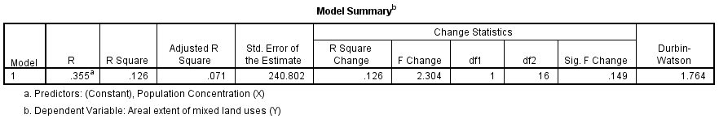
Table 4.0
Source: Researcher’s data analysis, 2025.
Table 5.0: ANOVAª

Model |  | Sum of Squares | Df | Mean Square | F | Sig.
1 | Regression | 133602.901 | 1 | 133602.901 | 2.304 | .149^{b}
1 | Residual | 927772.877 | 16 | 57985.805
1 | Total | 1061375.778 | 17
a. Dependent Variable: Areal extent of mixed land uses (Y)
b. Predictors: (Constant), Population Concentration (X)

Source: Researcher’s data analysis, 2025.
The ANOVA (Table 5.0) of the regression analysis showed a low F-value of 2.3 and a p-value of 0.149. However, considering 95.0 per cent confidence interval with 0.149 which is ≥ 0.05, therefore, the result is not statistically significant.
The Table 6.0 showed an explanation of t. value of 1.518 at confidence interval of 95.0 per cent, giving a no statistically significant relationship (p-value = 0.149) between population concentration and the areal extent of mixed land uses. The regression equation is also expressed in the Table of regression coefficients (B) as: Y=79.044+1.353x

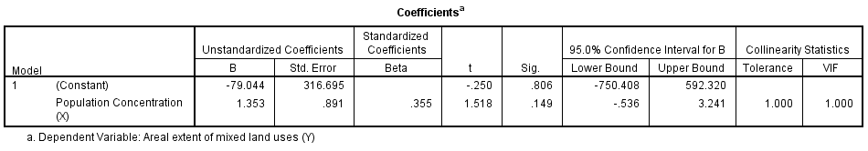
Table 6.0
Source: Researcher’s data analysis, 2025.

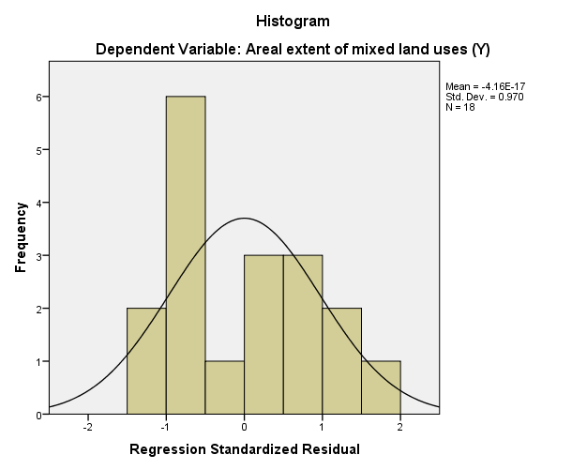

Figure 4.0: Histogram and Isoline of plots of regression analysis.

Source: Researcher’s data analysis, 2025.

The histogram of frequency of plots is s Figure 4.13 showing the distribution of regularly spaced variables. The residual plot is not normally distributed and indicates that the assumption of the residual was incorrect.
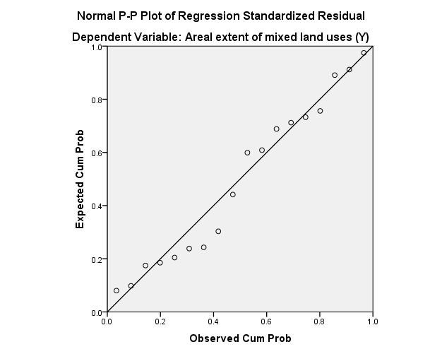
Y= -79.044+1.353X

Figure 5.0: Normal plot of regression residuals

Source: Researcher’s data analysis, 2025.

The Figure 5.0 showed the assumption that the residuals are not related to the explanatory variables and hence, the slope of the regression plot demonstrates a gradual downward movement from right to left which is normal. It also showed a straight-line relationship between the residuals and the predicted responses.

IV. DISCUSSION
The hypothesis was formulated to test whether there is a significant relationship between population concentration and the areal extent (m²) of mixed land uses. The data set in Table 3.0 was used in testing the hypothesis. The Simple Linear Regression analysis was the test statistic applied. The result was not significant and hence, accepted the null hypothesis (Ho) which states that there is no significant relationship between population concentration and the areal extent (m²) of mixed land uses within the neighbourhood zones of Calabar Metropolis. The result therefore, illustrated that the overall model fit was R² = 0.126 (Table 4.0). It implied an explanation of t.value of 1.518 and p-value of 0.149 ≥ 0.05 level of confidence at confidence interval of 95.0 per cent (Tables 5.0 and 6.0) respectively. Simply put, the result of the test showed that population concentration has not potentially predicted increase in development of mixed land uses in Calabar Metropolis. Therefore, population concentration is not a causal factor of mixed land uses. This also implied that mixed land uses are simply activity areas where people are not living. The areas of thick population comprise the settlement areas while activity areas are not living areas but areas used for businesses, offices, and other activities
This result further pointed to the fact that population concentration has not influenced the development of mixed land uses in Calabar Metropolis. However, this result showed a total deviation from the norm which should have been, where people are many, more mixed land uses would be developed in such areas, for example, Ekpo Abasi, Etta Agbor, Akim, Esin Ufot (Table 3.0 and Figure 3.0 showed these distributions). This result, therefore, calls for further investigation.
Responses on the Likert scale were also used to measure qualitatively the relationship between population concentration and mixed land uses. Table 3.0 showed the relationship between population concentration and the areal extent of mixed land uses. The analysis is represented in a bar graph (Figure 2.0).
The analyses were meant to evaluate the influence of population concentration on the areal extent of mixed land uses within the neighbourhood zones of Calabar Metropolis. This result was, however, not seen in a study by Obongha, et al., (2022) who noted that mixed land uses, such as gasoline stations, abattoir, open markets, and poultry farms in residential zones affect safety and, therefore, result to environmental degradation of the areas where they occur. The result disagreed with the views of Obongha (2019) that population concentration combined with mixed land uses within a city centre bring about insecurity (such as kidnapping, robbery, looting and burglary) and anti-social behaviour (such as fighting, heavy drinking, incivility, congestion, and disorderliness).
The findings of Odunola and Odunjo (2015) were quite different with this result since mixed land uses and population concentration are not related then, the two variables cannot bring about traffic congestion, delay fares and cause accidents. They pointed out that pollution and indiscriminate dumping of waste are causal attributes of the two variables under study. The no significant relationship between population concentration and the areal extent of mixed land uses was also not in agreement with the findings of Fan, et al., (2009) and Oka (2009). They found that the demand for land would always increase as population increases and that population concentration has resulted to land use alteration and alternation. Jointly, they cause negative impact on the spatio-temporal land cover features of Calabar Metropolis. Park’s ecological theory which explains how human population collectively adapts, invades, succeeds, and dominates the environment was also not seen in the result of this study, which calls for further investigation.

V. CONCLUSION
The introduction of positive mixed land uses that encourage compact development as a means of enhancing socio-cultural diversity is crucial. This could be done through in-fill developments as emphasized by the advocates of New Urbanism. This study strongly suggests that further studies be conducted on the relationship between population concentration and the areal extent (development) of mixed land uses. Further studies should also be carried out on appraisal of the activities of institutions responsible for land use administration.

REFERENCES
Aruand, A. (2010). Density, Housing Types and Mixed Land Use: a Smart Tool for Affordable Housing? Urban Studies, 47 (5): 1015-1036.
Ayuba, J. G., & Rikko, L. S. (2019). Dictionary of Urban and Regional Planning. Jos: Umah Publishers Nig. Ltd.
Barbier, E. B., Georgiou, I. Y., Enchelmeyer, B. & Reed, D. J. (2013). The Value of Wetlands in Protecting Southeast Louisiana from Hurricane Storm Surges. PLOS ONE, 8 (3): 1-20.
Brown, B. B., Yamada, I., Smith, K. K., Zick, C. D., Kowaleski-Jones, L., & Fan, J. X. (2009). Mixed Land Use and Walkability: Variations in Land Use Measures and Relationships with BMI Overweights and Obesity. Health and Place, 15(4): 1130-1141.
Burton, E. (2000). The Compact City: Just or Just Compact City? A Preliminary Analysis. Urban Studies, 37(11): 1969-2006.
Calthorpe, P. & Fulton, W. (2001). The Regional City. Washington DC: Island Press.
Carnoske, C., Hoehner, C., Ruthmann, N., Frank, L., Hardy, S., & Hill, J. . (2010). Developer and Realtor Perspectives on Factors that Influence Development, Scale, and Perceived Demand for Activity-Friendly Communities. Journal of Physical Activity and Health, 7(1): 20-32.
Duany, A. & Tallen, E. (2002). Transact Planning. Journal of American Planning Association, 68(3): 245-266.
Duany, A., Plater-Zyberk, E., & Speck, J. (2000). Suburban Nation: The Rise of Sprawl and Decline of the American Dream. New York: North Paint Press.
Ellis, C. (2002). The New Urbanism: Critics and Rebuttals. Journal of Urban Design, 7(3): 261-291.
Fan, F., Wang, Y., Qui, M., & Wang, Z. (2009). Evaluating the Temporal and Spatial Urban Expansion Patterns of Guangzhou from 1979-2003 by Remote Sensing and GIS Methods. International Journal of Geographical Information Systems, 23 (11): 11-36.
Frank, L. D., Greenwald, M. J., Winkleman, S., Chapman, J., & Karage, S. (2010). Carbonless Footprints: Promoting Health and Climate Stabilization through Active Transportation. Preventive Medicine, 50 (6): 18-36.
Gordon, P. & Richardson, H. W. (2000). Compactness or Sprawl: American Future vs the Present. ACSP Conferencr, (pp. 33-44). Atlanta GA.
Jaeger, W. K. (2013). Determinants of Urban Land Market Outcomes. Evidence from California Land Policy, 30 (3): 966-973.
Kelbough, D. (2002). Reparing the American Metropolis: Common Place Revisited. Seattle, USA: University of Washington Press.
Koster, H. A. and Rouwendal, J. (2012). The Impact of Mixed Land Use on Residential Property Values. Journal of Regional Science, 52 (5): 733–761.

Kunstler, J. H. (2006). The Geography of Nowhere: The Rise and Decline of American Man-made Landscape. New York: Simon and Schuster.
Mumford, K. G., Contant, C. K., Weissman, J., Wolf, J., & Glanz, K. . (2011). Physical Activity and Travel Behaviours in Residents of a Mixed Use Development. American Journal of Preventive Medicine, 41 (5): 25-40.
National Bureau of Statistics (2021). Population and households in Nigeria: The structure of Nigeria's economy. Abuja, NBS.
National Population Commission, (2007). The 2006 Census for Calabar, Cross River State. Calabar: NPC.
Obongha, U. E., Ukam, L. E. & Inah, S. A. (2024). Evaluation of residential neighbourhoods compliance with zoning of the 1973 Calabar urban master plan. Journal of the Nigerian Institute of Town Planners 30 (1): 135-146. ISSN: 0189-885
Obongha, U. E., Agbor, E. A., & Upuji, J. K. (2022). Analysis of the pattern of land use change in Calabar Municipality of Cross River State, Nigeria. International Journal of Research and Innovation in Social Sciences. 6: (1):982-988.
Obongha, U. E. (2019). The Spatial Pattern of Anti-Social Behaviour in Sheffield, UK. International Journal of Scientific and Engineering Research, 10(12): 233-251.
Odunola, O. O. & Odunjo, O. O. (2015). Effect of Mixed Land Use on Housing Live-ability in Sagamu, Ogun State, Nigeria. International Journal of Scientific and Engineering Research, 6 (2): 1454-1560.
Ojikpong, B. E., Ekeng, B. E., Obongha, U. E., and Emri, S. I. (2016). Flood risk assessment of residential neighbourhoods in Calabar Metropolis, Cross River State, Nigeria. Environment and Natural resources Research, 6(2): 115-127.
Oka, P. O. (2009). Managing the Impact of Urbanization on Biodivsersity in Emerging Urban Fringe Settlement: The Case of Satellite Town Calabar, Nigeria . Global Journal of Social Sciences, 8(1): 13-20.
Pickett, S. T. A., Cadenasso, M. L., Grove, J. M., Boone, C. G., Grofman, P. M., & Irwin, E. (2011). Urban Ecological Systems: Scientific Foundations and a Decade of Progress. Journal of Environmental Management, 92(3): 331-362.
Population World Master (2020). Retrieved from www.populationstudies.com March 3, 2020.
Roser, J. F., Leiborici, D. G., & Jackson, M. J. (2011). Rapid Flood Inundation Mapping Using Social Media, Remote Sensing and Topographic Data. International Weekly Journal of Science, 6(5): 103-120.
US Census Bureau, (2020). 2018 Census of Population and Housing, Housing Unit Counts. United States Population Summary.
Working Group on Sustainable Land Use. (2001). Twards More Sustainable Urban Land Use: Advice to European Commission for Policy and Action. Europian Commission.
Yaro, M. A., Shabu, T., Obongha, U. E., Okon, A. E. & Tagha, E. T. (2025). Impact of population growth on agricultural land use in derived savanna of Southern Nigeria. PLASU Journal of Environment Sciences. 1 (2): 40-54. https://www.pjes.ng.DOI: 10.5281/zenodo.15515873.

