MANAGING GLOBAL CARBON STOCKS: AN INTEGRATED APPROACH FOR CLIMATE MITIGATION AND SUSTAINABLE DEVELOPMENT

Abstract
In the face of escalating climate change, the management of global carbon stocks stands out as among one of the critical mitigation strategies. In this review article, we explore the concept of carbon stocks by considering three important global case studies: the Amazon Fund (Brazil) for conservation, the Himachal Pradesh Reforestation Project (India) for sequestration, and the Loess Plateau Rehabilitation (China) for landscape restoration. We analyse the implementation strategies, socio economic co-benefits, and the challenges that these projects have faced. Furthermore, we also explore how technological carbon removals play a complementary role in carbon removal. Lastly, it was concluded with an understanding that effective carbon stock projects are those that integrate climate goals while strengthening community livelihoods, robust monitoring, review and evaluation, and stable political and financial support, offering a holistic pathway toward achieving global climate targets.
Keywords: Carbon stocks management, Deforestation, Carbon climate goals, Global market volatility, Technological Carbon removal

1. Introduction: The Critical Role of the Carbon Cycle and Stocks
Carbon stocks refer to the total amount of carbon stored in various global carbon pools, including the atmosphere, oceans, fossil fuels, and terrestrial ecosystems (Giri & Pant, 2020). The balance and status of these stocks are subject to both natural and anthropogenic activities that alter the carbon cycle. The carbon cycle describes the continuous flux of carbon between the atmosphere, oceans, land, and biosphere.
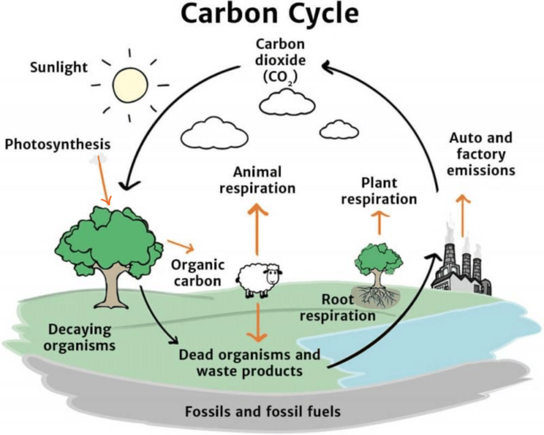
Figure 1: The Carbon Cycle
According to (Debie & Abro, 2024), they underscore its importance for regulating Earth's temperature and sustaining life. Studies have shown that land-based ecosystems alone store two to three times more carbon than the atmosphere, making them indispensable tools against climate change through carbon sequestration. Ganzemmüller et al., 2020 noted that human activities like deforestation and fossil fuel combustion are the common anthropogenic activities that alters these carbon stocks by converting them into sources of atmospheric CO₂ and contributing to the global climate change catastrophe.
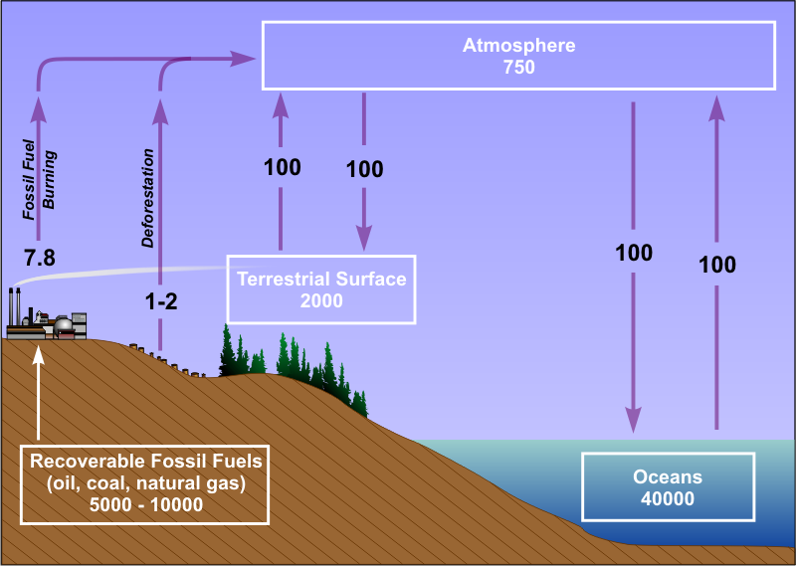
Figure 2: Comparative carbon stocks in terrestrial ecosystems and atmosphere
To strategically manage these stocks, conservation, enhancement, and restoration are among the key strategies implemented for climate mitigation. For this reason, we will explore key unique case studies that highlight each of these strategies in detail.
2. A Framework for Carbon Stock Management
Carbon stock projects generally align with three primary objectives:
Conservation: Protecting existing, high density carbon stocks from degradation or loss (e.g., preventing deforestation).
Sequestration: Actively removing carbon from the atmosphere by creating new biomass (e.g., afforestation and reforestation).
Restoration: Rehabilitating degraded ecosystems to recover their ecological functions, including their capacity to act as carbon sinks. The following case studies exemplify these approaches on a global scale.
3. Global Case Studies in Carbon Stock Management
3.1. The Amazon Fund, Brazil: A Conservation Based REDD+ Model
The Amazon rainforest, often coined the "lungs of the planet" plays a critical role in global carbon cycling and biodiversity conservation.
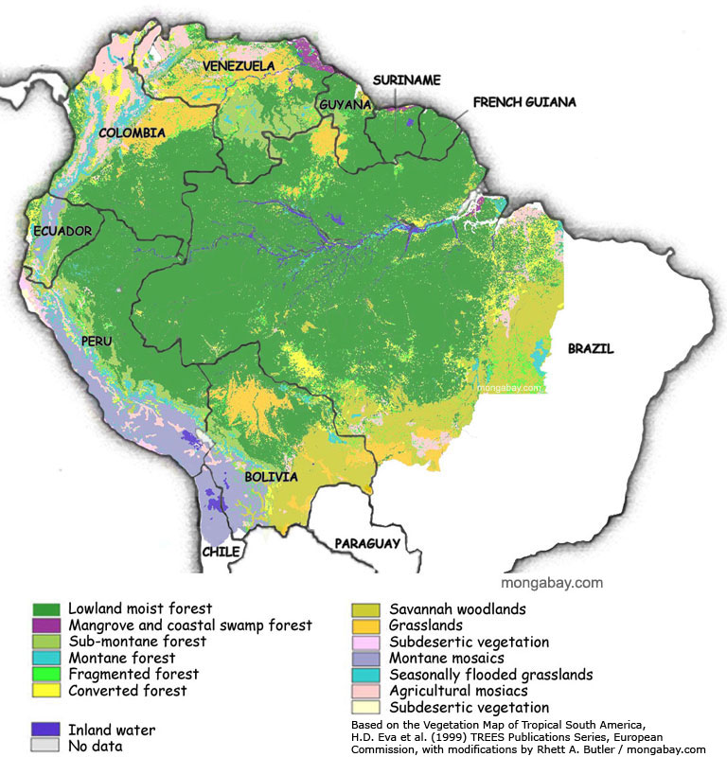
Figure 3: The Amazon basin map
Source: Eva et al. (2005)

In response to increased deforestation rates, Brazil launched the Amazon Fund (Fundo Amazônia) in 2008. It was entrusted for management by the Brazilian Development Bank (BNDES), with the fund established as a pioneer financial mechanism to mobilize resources for actions that prevent, monitor, and combat deforestation, while at the same time promoting the preservation and sustainable use of the Amazon biome. The BNDES is responsible for the fund's financial management and project portfolio. However, strategic direction is provided by a Steering Committee (COFA), which includes representatives from the federal government, state governments from the Amazon region, and Brazilian civil society organizations. This multi-stakeholder approach ensures that diverse perspectives, particularly from those most affected by deforestation and conservation policies, are integrated into decision-making (May et al., 2011). The figure below shows the trend in deforestation from 1988 to 2011.
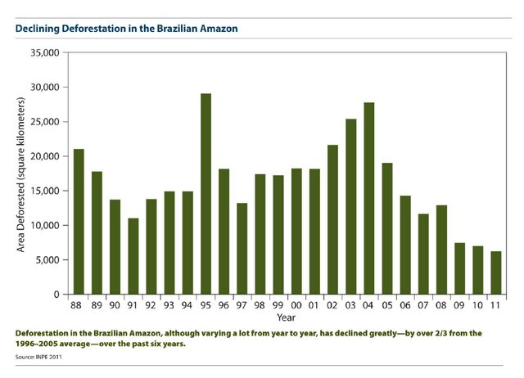Fig. 4. Declining Deforestation in the Brazilian Amazon
Source: INPE 2011

The Brazilian National Institute for Space Research (INPE), provides the official data on Amazon deforestation rates using remote sensing and satellite imagery. These transparent and scientifically sound data are used to verify emissions reductions, which in turn trigger donations to the fund. This creates a results-based framework where financial support is directly linked to proven conservation outcomes (Assunção et al., 2020).
Supported Activities and Strategic Focus
- Sustainable Forest Management and Community Forestry: Supporting practices that allow for the economic use of the forests without destroying it.
- Indigenous and Community Land Tenure: Strengthening the control and management capacities of Indigenous peoples and traditional communities, whose lands are proven to have lower deforestation rates (Nepstad et al., 2006).
- Monitoring and Enforcement: Financing advanced monitoring systems, including satellite technology and on-the-ground patrols, to combat illegal logging and land grabbing.
- Fire Prevention and Control: Funding initiatives to prevent and manage forest fires, which are a major source of carbon emissions and forest degradation.
Funding and International Partnership
Norway is the main funder, contributing about $1.2 billion between 2009 and 2021, making it one of the largest performance-based conservation agreements in history (Government of Norway, 2021). Germany, through the KfW Development Bank, was another major contributor.
Challenges: Political instability under the Bolsonaro administration led to a suspension of the Fund which saw a rebound in deforestation rates from 2019-2022. It was subsequently reactivated in 2023 when a new leadership under Lula da Silva took-over the presidency of the country, a clear indication that political will is also an important prerequisite for long term conservation. Other key take-aways include the efficacy of performance-based finance and the important role that indigenous and local communities play, acting as guardians of forest carbon.
3.2. Himachal Pradesh, India: Reforestation under the Clean Development Mechanism
In the mid-2000s, the state of Himachal Pradesh in northern India launched an afforestation and reforestation (A/R) project, establishing itself as a global exemple of carbon sequestration under the Kyoto Protocol's Clean Development Mechanism (CDM). This initiative was designed to address climate change by increasing the carbon sink capacity of the state's forest cover while at the same time tackling rural poverty and land degradation (Himachal Pradesh Forest Department HPFD, 2009). The project represented a shift from traditional forestry, aligning environmental goals with economic incentives through the sale of Certified Emission Reductions (CERs), or carbon credits.
Implementation, Governance, and Achievements
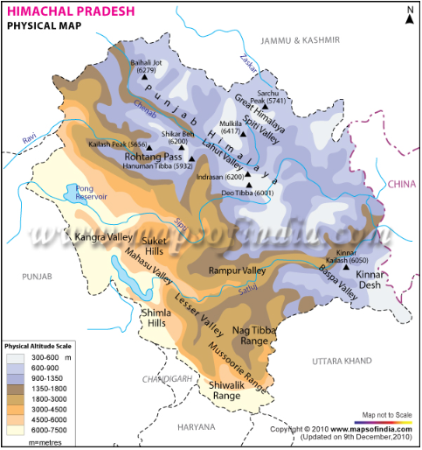
Figure 5:Himachal Pradesh region, India.
The project was implemented by the Himachal Pradesh Forest Department with financial and technical support from the World Bank's BioCarbon Fund. This partnership helped devise methodologies and procedures required for CDM validation and monitoring (World Bank, 2011).
Their strategy for implementation focused on engaging local communities to reforest degraded wastelands. The project prioritized the use of native, multipurpose tree species, such as oak, deodar, and fodder-yielding trees. From a carbon perspective, the project was designed to sequester approximately 3.5 million tons of CO₂ over a 20- to 30-year crediting period (HPFD, 2009).
However, the project's most notable achievements extended beyond carbon. By providing communities with access to fodder, fuelwood, fruit, and non-timber forest products (NTFPs), it also created livelihood benefits to local communities an approach termed "multipurpose forestry,". This way, it ensured that the local population had a direct stake in the project's success, fostering a sense of ownership and responsibility (Dogra, 2015). Furthermore, the restored forest cover contributed to ecological benefits, including enhanced control of soil erosion, improved microclimates, and increased groundwater recharge, bolstering the region's resilience to climate variability.
Challenges and Critical Lessons Learned
Despite its innovative design, the project encountered several challenges:
- Unclear Land Tenure: Unclear documentation regarding the rights and responsibilities over the degraded lands created initial barriers to community engagement and long-term project security (Gundimedia, 2013).
- High Transaction Costs: The processes for CDM certification, including baseline establishment, monitoring, and verification, incurred substantial costs, which consumed a significant portion of the carbon revenue (World Bank, 2011).
- Carbon Market Volatility: The project's financial viability was heavily exposed to the volatility of the international carbon market. Fluctuations and eventual decline in CER prices posed a major risk to its economic sustainability and replicability (Michaelowa & Hermwille, 2019).
The experience of the Himachal Pradesh project underscores that technical carbon sequestration targets are insufficient for long-term success. Community participation and tangible local benefits are not only complementary but also essential prerequisites for sustainability (Dogra, 2015). A model that integrates carbon sequestration with the immediate socio-economic needs of local communities providing fodder, fuel, and food creates a more resilient and successful project.
3.3. Loess Plateau, China: Integrated Landscape Restoration
The Loess Plateau Rehabilitation Project is another important project that focus on restoration as a carbon mitigation strategy. It was launched by China in the mid-1990s with support from the World Bank. It is as an example of large-scale, integrated landscape restoration. Confronting an area known as one of the most eroded places on Earth, the project demonstrated that even severely degraded ecosystems can be revived through a holistic approach that simultaneously addresses environmental degradation and rural poverty (World Bank, 2007).
Implementation and Achievements
The project's strategy targeted the entire watershed system rather than isolated plots. Implementation involved measures designed to restore ecological function. These included engineering interventions like terracing hillslopes to prevent soil runoff, reforestation and planting of grasses on steep slopes, and a government-enforced ban on grazing and farming on land with gradients greater than 25 degrees (Bryan et al., 2018). At the same time, farmers were encouraged and supported to adopt sustainable agricultural practices on flatter, more suitable land.
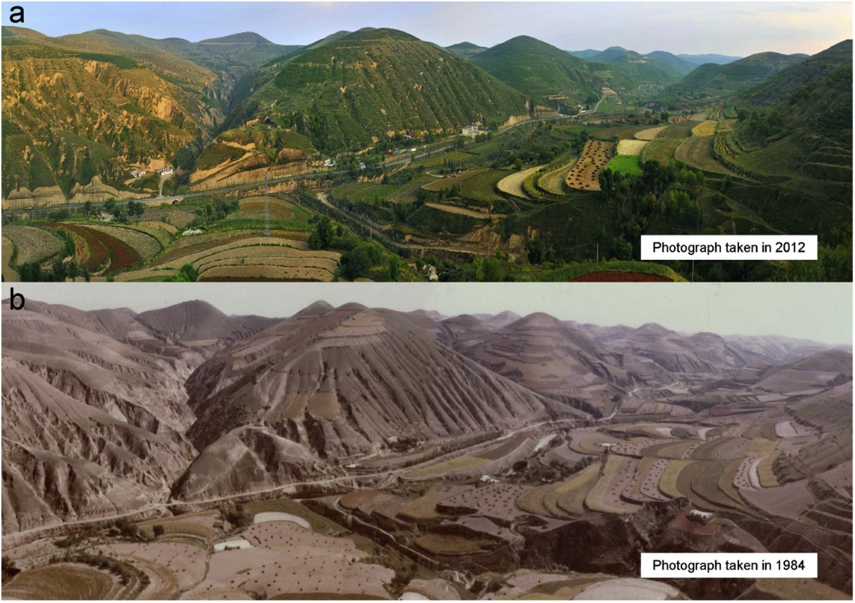
Fig.6: A view of Wuqi county in Yan’an city, Shaanxi province during summer: (a) photograph taken in 2012 and (b) photograph taken in 1984.

This project successfully restored approximately 3.6 million hectares of degraded land, and increased vegetation cover from 17% to 34% across the plateau (World Bank, 2007). This dramatic reduction in erosion led to a significant drop in the sediment load of the Yellow River, mitigating flood risks downstream. From a carbon management perspective, the restoration of forests, shrubs, and grasslands led to increased the carbon stocks, both in above-ground biomass and in the soil. It is estimated that these land-use changes sequestered between 57 and 96 million metric tons of CO₂ equivalent over two decades, highlighting the significant carbon sequestration potential of landscape restoration (Shi & Shao, 2000).

Challenges and Lessons Learned
The transformation required a fundamental shift in local livelihoods, including the displacement of traditional grazing and farming practices. This led to initial community resistance, which was addressed through education, direct payments for conversion of land, and support for alternative income sources (Bennett, 2017). Secondly, high upfront costs of engineering and implementation incurred were high. This was financed through a combination of national government investment and World Bank loans.
The primary lesson from the Loess Plateau is that large-scale ecological restoration is not only technically feasible but also socio-economically viable when environmental goals are explicitly and strategically linked with poverty reduction (World Bank, 2007). The project redesigned the agricultural system to be more productive and sustainable on less land. As a result, grain yields doubled and average household incomes tripled, as farmers benefited from more productive terraced land and diversified income streams (Bryan et al., 2018). This case powerfully demonstrates that gains in carbon stocks and ecosystem health can be achieved in tandem with dramatic improvements in food security and human well-being, creating a resilient and self-sustaining cycle of positive development.
4. The Complementary Role of Technology
While Nature-based Solutions (NbS) like forest conservation and landscape restoration are foundational to managing global carbon stocks, they face inherent limitations related for scaling up, permanence, and vulnerability to climate-driven disturbances such as wildfires and droughts. To meet the Paris Agreement, technological Carbon Capture, Utilization, and Storage (CCUS) is a critical complementary strategy, offering tools to address emissions that are otherwise unavoidable or to remove carbon dioxide from the atmosphere (IPCC, 2022).
Technological Pathways for Carbon Management
- Point-Source Capture: This involves capturing CO₂ emissions directly at the source, such as power plants and industrial facilities (e.g., cement and steel production). The captured CO₂ is then compressed and transported for utilization or permanent geological storage. This is crucial for decarbonizing hard-to-abate industrial sectors (Global CCS Institute, 2023).
- Direct Air Capture (DAC): Technologies developed by companies like Carbon Engineering in Canada and Climeworks in Switzerland sequester ambient CO₂ directly from the atmosphere. This process addresses not only current emissions but also historical CO₂, effectively reducing the atmospheric concentration (Keith et al., 2018). DAC is energy-intensive but provides a highly controllable and locatable carbon removal option.
Enhancing Permanence and Utilization
Captured carbon can be utilized (CCU) as a feedstock to produce low-carbon fuels, plastics, and building materials, creating a potential economic incentive and a circular carbon economy. However, the climate benefit of utilization depends on the longevity of the product and the lifecycle emissions of the process.
Challenges and the Path Forward
High capital and operational costs, substantial energy requirements (particularly for DAC), and the need for extensive infrastructure for CO₂ transport and storage are most prominent challenges. Widespread deployment will require strong policy support, carbon pricing mechanisms, and continued technological innovation to reduce costs (IEA, 2023).
6. Conclusion
The Amazon Fund has served as a benchmark for results-based finance in forest conservation. Its integrated approach combining rigorous, science-based monitoring with a participatory governance structure and a diverse project portfolio demonstrates a holistic pathway to reducing emissions from deforestation. While the fund faced political and operational challenges in subsequent years, its initial model highlights the importance of aligning financial mechanisms with robust monitoring, community engagement, and stable political support to effectively manage global carbon stocks.
The Himachal Pradesh Reforestation Project stands as a critical case study in linking global climate finance with local development. It demonstrated that for forest carbon projects to be truly sustainable, they must be designed as integrated "multipurpose" initiatives. The project's legacy highlights that the most effective carbon sequestration strategies are those that synergize climate goals with community livelihoods, creating a shared value proposition that can withstand market and institutional challenges.
The Loess Plateau project serves as a global model, proving that a holistic, landscape-scale approach that integrates terracing, re-vegetation, and sustainable agricultural intensification can reverse severe land degradation. Its legacy underscores that the most successful and durable carbon stock projects are those that align ecological objectives with tangible economic benefits for local communities, thereby ensuring long-term stewardship and resilience.
A pragmatic climate mitigation portfolio does not pit nature against technology. Instead, the most effective strategy is a synergistic one: aggressively deploying NbS to protect and enhance our vast natural carbon sinks while simultaneously scaling up technological CCUS to tackle industrial emissions and remove legacy carbon. These technologies, such as Carbfix in Iceland (mineralizing CO₂ into rock) and Carbon Engineering in Canada (Direct Air Capture), offer additional, durable carbon storage pathways, particularly for sectors that are difficult to decarbonize. Together, they offer a more robust and comprehensive pathway to achieving net-zero emissions and stabilizing the global climate.

References
- Giri, A., & Pant, D. (2020). Carbon management and greenhouse gas mitigation. In Encyclopedia of renewable and sustainable materials (Vol. 3, pp. 312–335). Elsevier. https://doi.org/10.1016/B978-0-12-803581-8.11567-7
- Ganzemmüller, R. (2020, August 18). Human influence reduces natural land carbon stocks by 24%, study finds. The GIST. https://phys.org/news/2020-08-human-natural-carbon-stocks.html
- Debie, E., & Abro, T. W. (2024). Carbon stock dynamics in biosphere reserves and countainous forest ecosystems. https://doi.org/10.1016/j.tfp.2024.100567
- Assunção, J., Gandour, C., & Rocha, R. (2020). The effect of rural credit on deforestation: Evidence from the Brazilian Amazon. Climate Policy Initiative. https://www.climatepolicyinitiative.org/publication/the-effect-of-rural-credit-on-deforestation-evidence-from-the-brazilian-amazon/
- Bennett, M. T. (2017). China’s Sloping Land Conversion Program: Institutional innovation or business as usual? Ecological Economics, 65(4), 699–711. https://doi.org/10.1016/j.ecolecon.2007.12.004
- Banco Nacional de Desenvolvimento Econômico e Social (BNDES). (n.d.). Amazon Fund. Retrieved [insert date of access], from https://www.fundoamazonia.gov.br/en/home/
- Bryan, B. A., Gao, L., Ye, Y., Sun, X., Connor, J. D., Crossman, N. D., … Hou, X. (2018). China’s response to a national land-system sustainability emergency. Nature, 559(7713), 193–204. https://doi.org/10.1038/s41586-018-0280-2
- Dogra, A. (2015). Community-based forest management and carbon sequestration: A case study from Himachal Pradesh, India. International Journal of Sustainable Development & World Ecology, 22(5), 409–419. https://doi.org/10.1080/13504509.2015.1063045
- Global CCS Institute. (2023). Global status of CCS 2023. https://www.globalccsinstitute.com/wp-content/uploads/2023/10/Global-Status-of-CCS-2023_Report.pdf
- Government of Norway. (2021, December 9). Norway to resume contributions to the Amazon Fund [Press release]. https://www.regjeringen.no/en/aktuelt/norway-to-resume-contributions-to-the-amazon-fund/id2888672/
- Gundimedia, H. (2013). Challenges and opportunities of the Clean Development Mechanism in India: A case of forestry sector. Journal of Environment and Development, 22(3), 321–343. https://doi.org/10.1177/1070496513492582
- Himachal Pradesh Forest Department. (2009). Himachal Pradesh Reforestation Project: Improving livelihoods and watersheds. Project design document for the Clean Development Mechanism.
- International Energy Agency. (2023). Carbon capture, utilisation and storage. IEA. https://www.iea.org/energy-system/carbon-capture-utilisation-and-storage
- Intergovernmental Panel on Climate Change. (2022). Climate change 2022: Mitigation of climate change. Contribution of Working Group III to the Sixth Assessment Report of the Intergovernmental Panel on Climate Change. Cambridge University Press. https://doi.org/10.1017/9781009157926
- Keith, D. W., Holmes, G., St. Angelo, D., & Heidel, K. (2018). A process for capturing CO2 from the atmosphere. Joule, 2(8), 1573–1594. https://doi.org/10.1016/j.joule.2018.05.006
- May, P. H., Millikan, B., & Gebara, M. F. (2011). The context of REDD+ in Brazil: Drivers, agents and institutions. CIFOR.
- Michaelowa, A., & Hermwille, L. (2019). A list of all carbon pricing models is not enough. Nature Climate Change, 9(9), 651–652. https://doi.org/10.1038/s41558-019-0563-0
- Nepstad, D., Schwartzman, S., Bamberger, B., Santilli, M., Ray, D., Schlesinger, P., … Rolla, A. (2006). Inhibition of Amazon deforestation and fire by parks and indigenous lands. Conservation Biology, 20(1), 65–73. https://doi.org/10.1111/j.1523-1739.2006.00351.x
- Shi, H., & Shao, M. (2000). Soil and water loss from the Loess Plateau in China. Journal of Arid Environments, 45(1), 9–20. https://doi.org/10.1006/jare.1999.0618
- World Bank. (2007). Restoring China’s Loess Plateau. World Bank. https://www.worldbank.org/en/results/2007/04/01/restoring-chinas-loess-plateau
- World Bank. (2011). BioCarbon Fund experience: Insights from afforestation and reforestation Clean Development Mechanism projects. World Bank Publications..
- Butler, Rhett A (2006). World Rain Forest. Retrieved 9 January 2006, from Mongabay.com / A Place Out of Time: Tropical Rainforests and the Perils They Face. Web site: https://www.mongabay.com

- Eva H, Huber O, (2005) editors. A Proposal for defining the geographical boundaries of Amazonia. EUR 21808 EN. Luxembourg (Luxembourg): Office for Official Publications of the European Communities; JRC68635. https://publications.jrc.ec.europa.eu/repository/handle/JRC68635

