ADOPTING ENERGY EFFICIENT BUILDINGS IN ACHIEVING SUSTAINABLE ENVIRONMENTS: CASES WITHIN FEDERAL UNIVERSITY OF TECHNOLOGY AKURE
Abstract
This study covers the use of renewable energy technologies in study buildings, practices of energy efficiency, building materials that promote environmental sustainability, as well as the application of energy conservation methods in construction and operation of buildings. It is aimed at ascertaining and adopting energy efficient buildings to have better efficient and sustainable buildings in Nigeria. A qualitative analysis approach was employed by the researchers, while data was obtained through keen observations and case study analysis on three sustainable buildings within the FUTA campus. The three case study buildings are the A.T.E.D building, the C.R.E.T building, and the block of shops building for S.E.E.T School, all within the FUTA campus, and these buildings were selected because of the sustainable design strategies that were adopted and implemented in the construction. Findings show that there are existing and functional buildings with energy efficient features in FUTA, and these features can be replicated in future designs and constructions in the country, if the challenges in this area can be taken care of. The study recommends that government should provide more energy efficient building codes to support environmental sustainability. Also, the environmental professionals should see sustaining the environment as a priority and hence push for practices that will ensure a safer and more sustainable environment.

Keywords: Architecture, Energy efficiency, Environment, Net-Zero buildings, Sustainability

- Introduction
In recent times, the world has seen increased concerns towards protecting, sustaining and enhancing the environment. The environment has been going through a series of changes that needs to be checkmated in other to give future generations a suitable place for living. Increasing population, increase in urbanization including rural-urban migration are some of the challenges the present-day society is facing in the area of population growth. With this increase in population comes the need to provide more of the basic needs of man – food, shelter, and clothing – making use of the earth’s resources. In providing these needs, through the use of resources, man has as a result affected the environment negatively, especially in the provision of energy for daily use. The large-scale extraction of non-renewable resources (crude oil, coal, minerals) or damage done to the natural environment can create threats of serious decline in quality, destruction or extinction (Sutton, 2014)
The rate of energy consumption in the area of housing and building use in general has seen a general increase all over the world. This can be attributed to; the introduction of new methods of construction over time in the industry, new materials for construction, new and contemporary building designs, and new technologies available for users of the buildings. Resources such as land, capital and labor, should be managed together with energy as an important production factor (Oyedepo, 2012). Currently, most buildings in Nigeria lay more importance on aesthetics, with little or no consideration for energy efficiency (Nwofe, 2014).

Recently the concept of sustainability as a major concern has gained enormous awareness globally. It is a broad and complex subject which has grown to be one of the major issues in the building industry. The idea of sustainability involves enhancing the quality of life, thus allowing people to live in a healthy environment, with improved social, economic and environmental conditions (Peter, Ezekiel & Paul, 2012). In designing a sustainable project, the building, operation and reuse, should be done in an ecological and resource efficient manner. Sustainability achieves the balance between economic development, social development, and environmental protection. Sustainability in the construction sector refers to all practices that should be adopted in order to ensure that a building is environmentally friendly, economically feasible as well as healthy and comfortable to its users. Energy efficiency in buildings is one of the fundamental steps towards reducing the agents/factors that could lead to global warming and climate change (Nwofe, 2014). The use of energy efficient measures and renewable low-carbon energy sources such as wind energy, solar energy, geothermal energy, ocean energy, bio-energy and hydropower are preferred because of their roles in reducing both the operational energy intensity and carbon footprint. (Ezema, Olotuah & Fagbenle, 2016). In the application of sustainability in the built environment, there is encouragement towards the integration of proven renewable technologies with the building for various applications such as water heating, ventilation and thermal comfort, and electricity production. The operational energy use in building is of growing importance all over the world (Chel & Kaushik, 2017).
In Nigeria, there is a great potential for energy conservation in buildings. Energy efficiency can be achieved mostly in newly constructed buildings and buildings that are to be renovated. For energy efficiency to be achieved in a building there should be the harnessing of solar energy and integration of rainwater harvesting, the usage of low energy materials in building construction, conservation of the building’s operational energy using energy efficient equipment, and lastly, integration of renewable systems with the building. Building energy efficient environments is both a responsibility and an opportunity. Homes and offices play a key role in the climate change debate. The use of energy inefficient methods and high energy consuming technologies daily by people in the built environment has also led to the depletion of environmental resources, environmental pollution, and resource wastage and misuse.

One major challenge to achieving a sustainable environment is the lack of information about the topic to people. People are less aware about issues such as, net zero energy buildings, green buildings, energy efficient building materials and construction methods, and appropriate technologies for a sustainable environment. Even though by implementing all the above listed issues, the environment becomes sustainable and available for future generations, to achieve energy efficiency is still quite difficult due to some barriers to put into practice in energy efficiency (Akadiri, Chinyio, & Olomolaiye, 2012).

- Literature Review

2.1 Sustainable Buildings
We could interchangeably use the terms “green” and “sustainable” design, though there could be subtle shades of meanings implied by each. An energy efficient building which could also be called a green building is one whose construction and lifetime of operation assure the healthiest possible environment while representing the most efficient and least disruptive use of land, water, energy and resources (Patel, 2015). Sustainable building (Green building) refers to both the structure and its processes that are environmentally responsible and resource-efficient throughout a building's life-cycle (El-Betar, 2017). Tong (2017) defines Green Buildings as the green concept of environmental protection applied to the design, construction and use of the building, through the combination with the actual situation in the construction of reasonable use of green technologies and equipment to achieve green building energy conservation, and ultimately to achieve people and Natural coordination and sustainable development. The basic objective of sustainable (also known as green buildings) green buildings is to reduce the overall impact of the building sector on the environment, indoor climate and human health (Michal, 2014). The optimum design solution is one that effectively emulates all of the natural systems and conditions of the pre-developed site – after development is complete. The intent of green design is to develop more environmentally friendly products and processes.
Green building from the design, construction, use, and maintenance has a variety of energy saving and environmental requirements. In the design of an energy efficient building it is necessary to focus on the use of environmental factors, but also emphasis should be laid o minimizing the adverse effects of the construction process on the environment, and to ensure that the building in the operational phase would provide people with low energy consumption, comfort, health and space (Tong, 2017).
In making a building achieve the status of energy efficiency, some underlying principles have to be followed. These principles involve the following elements;
- Sustainable site selection
Ii. Energy efficiency
Iii. Water efficiency
Iv. Materials efficiency
V. Design efficiency
Vi. Occupants health and safety

The sustainable buildings use energy from renewable sources, such as sunlight (solar collectors, photovoltaic equipment) or rain water. The facade of the house can become an energy contribution for the building, for example solar wall. When the building energy is completely met by renewable energy system then it is known as a highly energy efficient or zero emission green building. Green buildings often include measures to reduce energy consumption – both the embodied energy required to extract, process, transport, and install building materials and the operational energy, i.e., the energy consumed during the in-use phase of a building’s life to provide necessary services, such as heating cooling, and providing power for equipment (Shoubi et al, 2014).

The adoption of passive design as an approach to building design makes low energy architectural practices possible. Passive design is an approach to building design that utilizes architectural design to minimize energy consumption and to improve thermal comfort. In other words, passive architectural design is to consider all the surrounding environment of the building in the architectural design process, which results that the building responds to all the needs and potentials of its local climate and can dramatically reduce primary energy consumption (Atwa, 2016). The optimum target of passive architectural design is to eliminate requirements for active mechanical systems and to sustain thermal comfort for occupants. The phases of the design of sustainable buildings are: site management and design efficiencies in structural system, energy efficiency, water efficiency, materials efficiency, indoor environmental quality enhancement, operations and maintenance optimization and waste and toxics reduction (El-Betar, 2017).

2.2 Energy Efficiency in Buildings
Energy efficient buildings can be classified into four categories: low energy, passive energy, zero and plus energy buildings. A low energy building consumes only half of the energy needed by improved insulation, passive energy building consumes less than a quarter of the energy used by a standard building, zero energy building is with zero net energy consumption and zero carbon emissions annually (energy efficiency, 2018). The four main aspects in a building include first and foremost the nearly zero energy passive design before actual construction, secondly the usage of low energy building materials during its construction, thirdly use of energy efficient equipment for low operational energy requirement and lastly integration of renewable energy technologies for various applications (Arvind & Geetanjali, 2017).

In achieving energy efficiency in building we can consider the four aspects listed above. The first aspects are related to the utility of solar daylight through the use of photovoltaic or monolithic solar panels that can be installed on roofs of buildings or integrated with the building façade / envelope. Similarly, the use of proper design of daylighting can lead to tremendous reduction in use of artificial lights during daytime and thereby reduces the energy consumption by building for lighting. Hence, integration of solar passive features into the building leads to reduction in energy consumption of building which ultimately reduces the carbon emissions and helps in sustainable development (Chel & Kaushik, 2017). This also covers passive heating or cooling (in the case of hot humid and dry climates like that of West Africa). Passive cooling could be achieved through wall ceiling and floor insulation and also through provision of adequate channels for natural ventilation and building shading. Expanded polystyrene is the most widely used thermal insulation in energy buildings (57.34%) (Michal, 2015). In the hot and dry climatic zones, passive cooling designs include the heavy design of wall and roof cooling using water evaporation, roof texture designs and materials, and earth-water heat exchangers, passive downdraft space cooling, solar refrigeration, etc. (Arvind & Geetanjali, 2017). This aspect also covers the provision for rainwater harvesting to be integrated with passive building based on the prevailing climatic conditions of the site in the world. Taking southwest Nigeria for example, there can be high levels of prevailing rainfall which needs to be harnessed and used for functions such as washing, watering plants and even cooking after passing through some level of purification.

There is also the second aspect regarding the usage of low energy building materials. According to the research project Heartland Green Sheets, the recommended criteria for evaluation of sustainable buildings materials are low embodied energy, recyclability, use of renewable resources, local or regional production, energy efficiency, low environmental impact, durability, minimized waste, positive social impact and affordability (Michal, 2014). These materials usually have low carbon footprints and low emissions during use. Such building materials could include; fiber reinforced bricks, wood and stabilized adobe blocks also known as stabilized laterite blocks, bamboo, fly ash bricks, polystyrene, vacuum insulated glass, straw bale, etc. According to the sustainable development, appropriate building materials are lumber from forest, plant materials (straw or bamboo), recycled stone, recycled metal and next nontoxic, reusable, renewable materials (e.g. clay, cork, wood fiber, calcium sand stone, fiber glass, sheep wool). Such products promote resources conservation and efficiency. Building materials should be obtained and manufactured within the proximity of the construction (Michal, 2014). The reason is the reduction of energy for transportation. Using recycled materials also helps in solid waste management system. The sustainable building material minimizes the degradation of environment. Benefits derived from using green building materials could include; energy conservation, lower costs, greater design flexibility, reduced maintenance, improved occupant health and productivity (Patel, 2015). It is desirable that the energy-efficient architecture incorporated recycled and reused building materials and materials from renewable sources. The priorities for selecting building materials are:
- Using the minimal amount of materials.
- Using materials with lower embodied energy.
- Using materials created from renewable resources and locally produced materials.
- Using recycled materials.
- Reuse of building components from deconstructed buildings.
- Use of materials with high durability, high energy efficiency, high speed construction and required simple skills to manufacture.

The third aspect deals with the operational energy conservation using energy efficient equipment such as LED lighting, five star rated fans, refrigeration and air-conditioning equipment. This third aspect is to reduce energy consumption of building for operation a using energy derived from fossil fuel which in turn reduces greenhouse gas emissions (Arvind & Geetanjali, 2017). Lastly, the aspect of using integrated renewable systems such as solar water heater for the hot water utility, small wind turbine or solar photovoltaic electricity generation at the roof top of building. So as a feasible alternative the focus is on the promotion of renewable energy technology in meeting building energy requirements. We can call a building a green building or highly energy efficient building when the building energy is completely met by renewable energy systems.

2.3 Evaluating Sustainability in Buildings
There are global methods of evaluating the overall sustainability of buildings, which includes the evaluation of building materials (e.g. Leadership in Energy and Environmental Design (LEED) or Building Research Establishment Environmental Assessment Method (BREEAM)). Although new technologies such as Building Research Establishment Environmental Assessment Method (BREEAM), Building for Environmental and Economic Sustainability (BEES), Leadership in Energy and Environmental Design (LEED) etc.have evolved and are constantly being developed and updated to assess and complement current practices in creating sustainable structures, the common objective is that buildings are designed to reduce the overall impact of the built environment on human health and the natural environment.

2.4 Challenges facing the Development of Energy Efficient Buildings
One reason that energy efficient buildings are not implemented in Nigeria is the lack of mandatory regulations. There are no codes and regulations to groom energy efficiency programs. An example is given in the European Union automobile emission regulation where countries under the EU were forced to implement the regulation which came in four stages (Zhenhong, 2007). The automobile producers would not have consciously reduced their emissions level without the agenda put in place by the EU.
However, the situation of construction is not exactly like automobiles. Building industry is not monopolized by a few manufacturers. Usually construction companies are relatively small-scale, and even individual family or one person may build houses. Therefore, many stakeholders consider constructions as their private issues and they have the freedom to decide the buildings’ level. The Government (Federal. State and Local) are yet to come up with strong policy that will ensure that buildings are regulated to ensure that energy efficiency is achieved. Nwofe (2012), explained that the Nigerian government has set a target to increase electricity generation by 40,000MW of power by the year 2020 and subsequently, many gas-powered stations have been commissioned to increase generation and many more are expected to be commissioned to meet up with energy demand. These are non-renewable energy source and will result in the emission of GHGs, leading to global warming to consequently increase climate change.

The lack of agencies acting as institutional frameworks for formulating, coordinating, implementing, and monitoring energy conservation policies and programs poses a big challenge to the implementation of guidelines that could be put in place. The absence of these sort of organizations set up by the government inevitably means the absence of regulations guiding the construction industry pertaining sustainability.
In this part of the world, lack of information on the part of the public acts as huge barrier to the implementation of energy efficient housing and hinders progress in achieving a sustainable environment. Most Nigerians are not aware that buildings can influence our environment and climate (Nwofe,2012). They ignore the negative effects of buildings and tend to focus on the building aesthetics and usage of modern technology gadgets. Generally, the public is not aware of the need for energy efficiency neither do they understand the concept and its processes. The general public is not aware of the benefits of energy efficiency and have not been educated properly on preserving the environment for the use of future generations. Thus, the need for awareness on the influence of energy efficient buildings on the environment to be created in the minds of the citizenry cannot be over-stressed.

Another major important issue is unavailability of funds to finance energy efficient projects. In developing countries such as Nigeria, there are financial barriers that inhibit the ready construction of buildings using energy efficient building materials, construction methods and having energy efficient operation processes to run the building. In Nigeria, an estimated 54 per cent of the population lives below the poverty line (43 per cent urban, 64 per cent rural), and 90 per cent of the poorest people live in the north (Nigeria Country Programme document, 2014-2017, Unicef). Poverty is a strong limiting factor to energy efficient buildings as money is needed to procure the materials and human resource needed to execute such buildings (Nwoye, 2012).
Inefficient energy pricing policies also contribute to the slow progress of implementing sustainable processes in the country. The presence of subsidies on prices for petroleum products and electricity tariffs from non-renewable sources tend to not encourage people to adapt to using renewable energy sources. Current Subsidies discourages energy efficiency practice.

2.5 Achieving Environmental Sustainability through Energy Efficient Buildings
Sustainability assessment of buildings is becoming necessary for sustainable development especially in the building sector all over the world. Sustainability is a goal that allows for the continuing improvement of standard of living without reversible damage to resources we need to survive as species (Lehrer 2001). The main goals of sustainable design were to reduce deletion of critical resources such as energy, water, and raw materials; prevent environmental degradation caused by facilities and infrastructure throughout their life cycle and create built environments that are safe, productive and effective utility of the water and solar energy (Arvind & Geetanjali, 2017).
There is no doubt that sustainable development concepts, applied to the design, construction and operation of buildings can enhance both the economic welfare and environmental health of communities in Nigeria and other third world countries (Otegbulu, 2011).

- Research Methodology
An empirical method which relies on keen observation of the case buildings was adopted, as well as a case study approach on existing buildings were used as the research methodology of the study. The case studies are limited to the following case buildings; the Appropriate technology enabled development centre (A.T.E.D), the Centre for Renewable Energy Technology, (C.R.E.T) and the Block of shops for the School of Engineering and Engineering Technology building. All the three buildings are existing and are located within the FUTA Obanla main campus. The study also focused on how the different buildings have achieved sustainability through the type of building construction materials and the passive building design incorporated taking into consideration where active design is being used. Check-list serves as a visual lens to focus the study on set objectives. Energy efficient architectural features check-list was applied to purposively selected cases and this was obtained from in-depth study of literature that was developed based on the objectives of the study.
The variables apply to energy efficient designs as they relate to the Nigerian tropical climate, and how they enhance energy efficiency in buildings are analyzed. The following are the variables for the study: Building envelope, landscape design, building form, natural ventilation, day-Lighting, renewable energy source, and waste management principles.

- Results and Discussion
This section presents the results of the variables that were analyzed within the case studies on the FUTA main campus. The variables mentioned on the methodology are assessed and analyzed for the three buildings. The following energy efficient architectural features check-list are used in the assessment of the three buildings that were used as case studies in this research and the assessment are shown in Tables 1, 2 and 3. Below are the variables of study:

- Building envelope
- Natural lighting
- Natural ventilation
- Building form
- Building orientation
- Landscape design
- Renewable energy source
- Waste management

Architectural Features Checklist for the ATED center
Table 1: Assessment of the Application of Energy Efficient Architectural Features (ATED Center)
S/N | VARIABLES | CHECKLIST | LEVEL OF APPLICATION
S/N | VARIABLES | CHECKLIST | ABSENT | LOW | AVERAGE |  | HIGH
1. | Building Envelope | Suitability of the materials to the climate
1. | Building Envelope | Use of external insulation
1. | Building Envelope | Use of light colours
2. | Natural Lighting | Wall to window ration (>40%)
2. | Natural Lighting | Use of special transparent glass
3. | Natural Ventilation | Use of operable windows
4 | Building form | Large building surface area |  | 
5 | Building orientation | Sun Orientation (East -West)
5 | Building orientation | Wind Orientation  (South-West –  North-East
6 | Landscape design | Use of soft landscape
6 | Landscape design | Use of hard landscape.
7 | energy source | Solar energy
7 | energy source | Wind energy
7 | energy source | Hydro-power
7 | energy source | Diesel
8 | Waste management | Waste reduction
8 | Waste management | Waste recycling
8 | Waste management | Waste reuse
(Source: Researcher’s Field Survey, (2023).

ATED Building Assessment
- Functions of spaces: The spaces created within the building have been discovered to be efficient and serve its purpose of creation.
- Comfort: This tends to answer the question of how comfortable a user is within the different spaces in the building. This can be examined in three different ways, i.e. comfort can be measured in three different ways which are:
- Thermal comfort
- Visual Comfort
- Aural Comfort

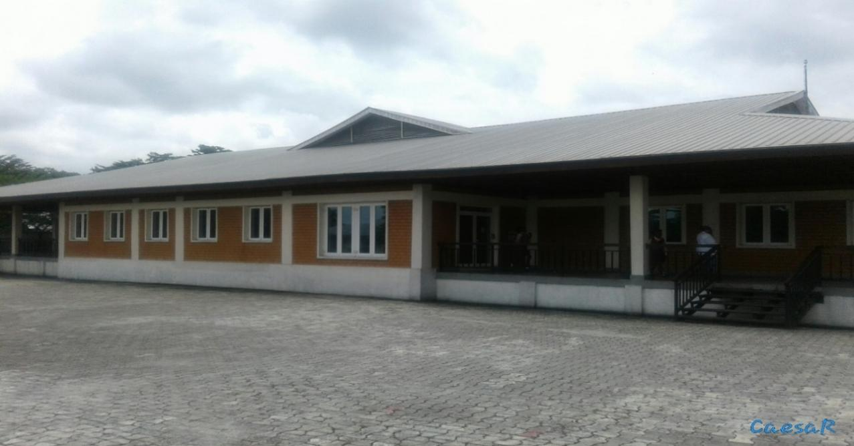
Plate 1: Approach view of the Appropriate Technology Enabled Development(A.T.E.D) Demonstration Centre Building (source; Researcher’s field study (2023).

Thermal Comfort:
this is relating to the ability of the materials and techniques used in achieving the design to balance and control the environmental weather within the building. In this case stabilized laterite bricks were used for the walls of the building and a central cooling system was used for the building. Also, the roof had provisions made to accommodate the Stark effect in buildings. It was discovered that laterite as sustainable building material is very active as building material in such a way that it will absorb heat during the day and releases it into the interior spaces at night when the weather condition of the interior is becoming too cold for the occupant. Likewise, at night the laterite walls absorb cool air and releases it into the building interior space during the harsh hot weather. It was gathered from the field of study that thermal comfort within the building is very good and almost perfect It was commented on by some of the users of the building that the building with laterite brick walls is more comfortable than those with sandcrete block walls.

Aural Comfort:
This type of comfort is relating to the acoustic of the space, i.e. the ability of the space to withstand and control the sound within and around the building. Laterite as sustainable building material is very good in resisting sound. The cement ceiling boards that were used in the interior spaces were also good absorbers of sound which prevented interference of sound from one space in the building to the other. The vitrified floor tiles used were also very good at absorbing sounds created by footsteps of people inside the building. In the ability of the building to keep out exterior sounds, the fenestrations (doors and windows) were airtight when closed which prevented exterior sound sources from filtering into the building. The building was given preference acoustically when compared to other buildings the occupants have been to.

Visual Comfort:
This is concerned with the beauty, artistic impact or appearance of the building and how pleasing it is to users in general. Large fenestration openings with large glass panes added visual value to the building.

4.2 Architectural Features Checklist of the C.R.E.T Building
C.R.E.T is an acronym for Center for Renewable Energy Technology. The purpose of the building is to create solutions towards the usage of sustainable energy within FUTA campus. The analyses of the CRET building are analyzed in Table 2, which shows all the variables on the checklist and the appropriate assessments through keen observation.

Table 2: Assessment of the Application of Energy Efficient Architectural Features (C.R.E.T BUILDING)
S/N | VARIABLES | CHECKLIST | LEVEL OF APPLICATION
S/N | VARIABLES | CHECKLIST | ABSENT | LOW | AVERAGE |  | HIGH
1. | Building Envelope | Suitability of the materials to the climate
1. | Building Envelope | Use of external insulation
1. | Building Envelope | Use of internal insulation
1. | Building Envelope | Use of light colours
2. | Natural Lighting | Wall to window ration (>40%)
2. | Natural Lighting | Use of special transparent glass
3. | Natural Ventilation | Use of operable windows
4 | Building form | Large building surface area
5 | Building orientation | Sun Orientation (East -West)
5 | Building orientation | Wind Orientation  (South-West –  North-East
6 | Landscape design | Use of soft landscape
6 | Landscape design | Use of hard landscape.
7 | energy source | Solar energy
7 | energy source | Wind energy
7 | energy source | Diesel
8 | Waste management | Waste reduction
8 | Waste management | Waste recycling
8 | Waste management | Waste reuse
Source: Researcher’s Field survey, (2023).
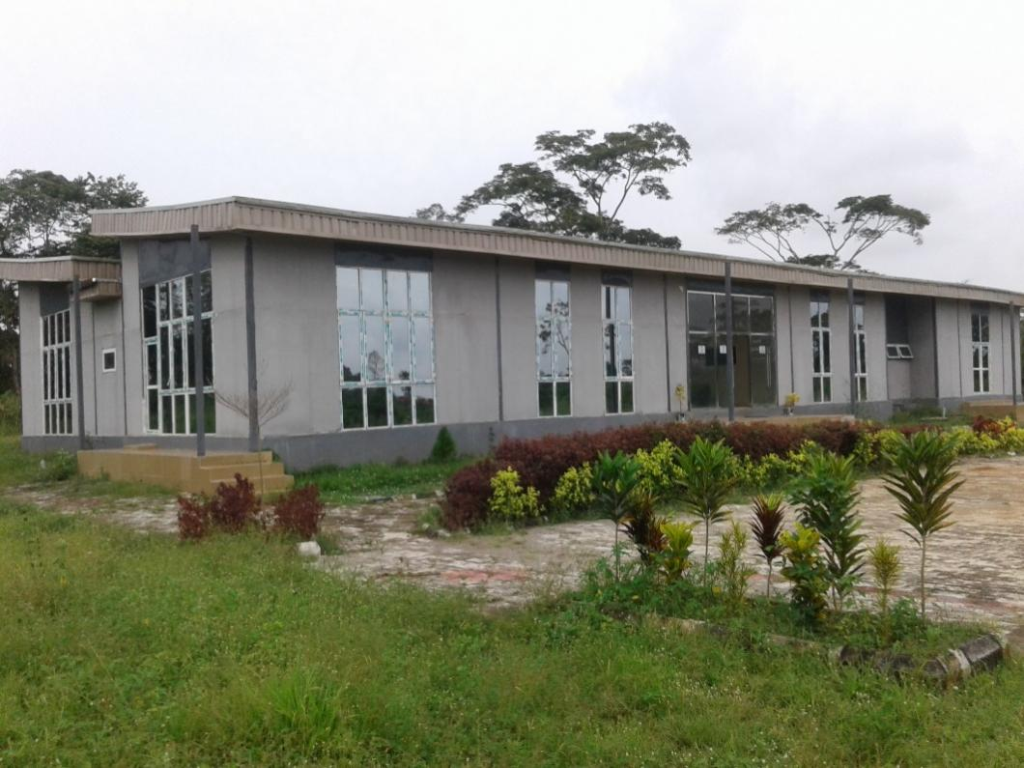
Plate 2: The front and left side views of the Center for Renewable Energy Technology,(C.R.E.T) F.U.T.A building. (Source: Researcher’s field study (2023)

C.R.E.T Building Assessment
i. Energy conservation: The building boosts of being able to conserve energy due to the active day-lighting design that was incorporated in it.
Ii. Thermal comfort: The walls of the building are insulated with polystyrene and adequately cladded giving it a cool interior aided with the use of split unit air-conditioners. The interior spaces are shaded from sun glare through the use of window blinds.
Iii. Functionality: The building design is quite functional given the purpose for which it was built. There is ease of accessibility and flow within spaces.

4.3 Architectural Features Checklist of the Block of Shops building at S.E.E.T
S.E.E.T is an acronym for School of Engineering and Engineering Technology in FUTA, Akure. The faculty building has a block of shops that was recently built using energy efficient materials such as EPL, as well as very good use of renewable resources such as the solar panels for access to unhindered electricity.
The architectural features checklist as developed by the researcher is used in making analysis of the building as seen in table 3 below:

Table 3: Assessment of the Application of Energy Efficient Architectural Features (Block of Shops, S.E.E.T, F.U.T.A).
S/N | VARIABLES | CHECKLIST | LEVEL OF APPLICATION
S/N | VARIABLES | CHECKLIST | ABSENT | LOW | AVERAGE |  | HIGH
1. | Building Envelope | Suitability of the materials to the climate
1. | Building Envelope | Use of external insulation
1. | Building Envelope | Use of internal insulation
1. | Building Envelope | Use of light colors
2. | Natural Lighting | Wall to window ration (>40%)
2. | Natural Lighting | Use of special transparent glass
3. | Natural Ventilation | Use of operable windows
4 | Building form | Large building surface area
5 | Building orientation | Sun Orientation (East -West)
5 | Building orientation | Wind Orientation  (South-West –  North-East
6 | Landscape design | Use of soft landscape
6 | Landscape design | Use of hard landscape.
7 | energy source | Solar energy
8 | Waste management | Waste reduction
8 | Waste management | Waste recycling
8 | Waste management | Waste reuse

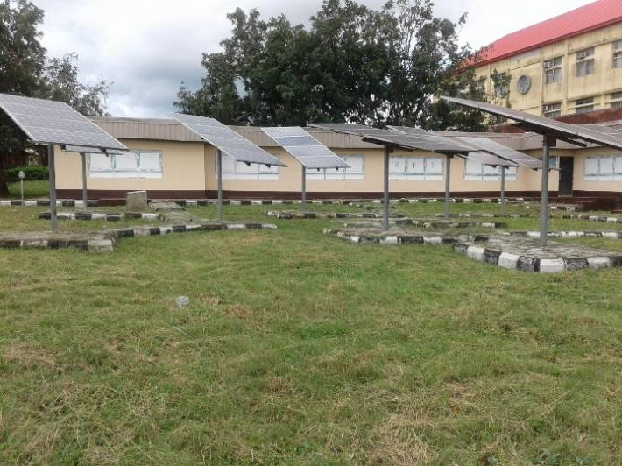
Plate 3: Showing the approach view of the shops. Source at S.E.E.T building Researcher’s field study (2023)

Architectural Advantage
The block of shops was specifically designed to augment the commercial facilities already existing in the center of the campus. There are ten stalls in it, each fitted with a large sunshade double glazed window to aid ventilation and lighting of the spaces.
The shops have their electricity supply coming from the solar panels installed in the front as shown in plate 3. The interior spaces are relatively thermally cool and comfortable.

In summary, it can be concluded that all the three buildings that were used as cases studies for this research were all appropriately captured as energy efficient buildings due to the materials that were used for their walls, landscaping elements, good use of natural ventilation, the adoption of solar installations to power the buildings among others.

5.0 Conclusion and Recommendations
In these modern times, buildings have been seen to be highly energy intensive with significance consumption of energy right from the construction stage to the operation and maintenance stage (Chel & Kaushik, 2017). At the long run, the global climate has been seriously affected as physical developments occur all over the world. Energy is essential to the survival of mankind, therefore sourcing for it and its consumption cannot be stopped so as to stop the climate change been caused by processes involved. Over the years millennium development goals (MDG’s) and sustainable development goals (SDG’s) have been put in place by the United Nations for countries of the world to follow in other to have a more sustainable environment for future generations.
This study has considered the feasibility of attaining a sustainable environment through building design in a developing country such as Nigeria. The study has shown that many factors mitigate the application of the concept of sustainability in building designs in third world countries. Some of such factors include, lack of regulations in the area of energy efficiency of buildings and sustainability, lack of agencies to enforce such regulations, lack of information, lack of adequate funding to carry out such projects, etc.
After this study was successfully carried out, various methods were found to have been applied in existing energy efficient buildings and which could be integrated into the normal building design and construction. One of such methods include the integration of solar passive design in building design. The use of stabilized laterite bricks for wall construction have been proven to provide cooler interiors in buildings situated in regions such as West Africa. Similarly, the use of proper design of day-lighting can lead to tremendous reduction in the use of artificial lights during daytime and thereby reduces the energy consumption of the building for lighting. From the above, it can be deduced that the integration of solar passive features into the building leads to reduction in energy consumption of buildings which in turn helps in providing a sustainable environment.
In future researches, other methods such as considering building orientation in designing, considering amount and sizes of fenestrations should also be applied when designing. The energy source of the building is also a very critical part of the building to consider. Energy sources that are renewable such as solar, wind and water are also seen as aiding in providing a sustainable environment.

5.3 Recommendations
Nigeria still has a long way to go in the area of building energy efficiency and environmental sustainability. The move for such and the awareness can only start with the environmental professionals. It is recommended that various professional bodies such as the Nigerian Institute of Architects, The Nigerian Institute of Town Planners, etc., should organize symposiums constantly and often where issues on energy efficiency and environmental sustainability will be critically addressed and discussed extensively. If this is done, the practicing architects will be encouraged to apply the methods and techniques that promote sustainability. The general public should be educated on these issues too. The Nigerian government has a huge role to play in all these too, through enacting laws and building regulations that enforce building practices that will be safe for the environment and sustainable for future generations.

References

Arvind, C., Geetanjali, K. (2017). Renewable Energy Technologies for Sustainable Development of Energy Efficient Buildings. Alexandra Engineering Journal, 57, 655-669.
Ezema I. C., Olotuah A. O., & Fagbenle O. I. (2016). Evaluation of Energy Use in Public Housing in Lagos, Nigeria: Prospects for Renewable Energy Sources. International Journal of Renewable Energy Development (IJRED), 5, 15-24. https://www.researchgate.net/publication/293478794.
Isidore, C. E., Olotuah, A. O., Fagbenle, O. L. (2016). Evaluation of energy use in public housing in Lagos, Nigeria: prospects for renewable energy sources. International Journal of Renewable Energy Development.
Khan K. A., & Zian S. M. (2019). The Situation of Renewable Energy Policy and Planning in Developing Countries. IJARIIE, 5(4), 557-564. http://www.ijariie.com.
Milica D. R., Dejan M. P. (2013). Improving Building Energy Efficiency Using Artificial Intelligence. Safety Engineering, pp 27-32.
Nwofe P. A. (2014). Need for Energy Efficient Buildings in Nigeria. International Journal of Energy and Environmental Research, 2 (3), 1-9. http://www.ea-journals.org.
Olotuah A. A., Olotuah A. M., Olotuah A. O. (2018). Use of Innovative Low Carbon Materials for Sustainable Energy-efficient Housing in Nigeria. WEENTECH Proceedings in Energy, Vol 4, pp.11-15. https://www.researchgate.net/publication/328492042.
Otegbulu A. C. (2011). Economics of Green Design and Environmental Sustainability. Journal of Sustainable Development, 4(2) 240-248.
Oyedepo, S. O. (2012). Energy Efficiency and Conservation Measures Tools for Sustainable Energy Development in Nigeria. International Journal of Energy Engineering(IJEE), l2 (3), 86-98.
Peter, O. A., Ezekiel, A. C., Olomolaiye, P. O. (2012). Design of a Sustainable Building: a Conceptual Framework for Implementing Sustainability in the Building Sector. Buildings, 2, 126-152.
Soheil G. (2015). Passive Solar Energy Efficiency in Older Commercial Building, famagusta. Department of Architecture, Eastern Mediterranean University, Famagusta, Turkish Republic of North Cyprus.
Sutton, P. (2014). A perspective on environmental sustainability? Victorian Commissioner for Environmental Sustainability. http://www.green-innovations. Asn.au/, PP. 1-26.
Tarun N., Lokeshwaran N. (2017). A Case Study on Assessing Energy Efficiency of Existing Residential Building and recommendations ensuring Green Efficiency in Building Construction Projects. International Journal of Civil Engineering and Technology (IJCIET).
Tong. Z. (2017). Review of the Application of Green Building and Energy Saving Technology. Ist International Global Conference on Renewable Energy and Development(IGRED), IOP Conf. Series: Earth and Environmental Science, 100, pp. 1-4.

