RESEARCH ARTICLE

STABILITY INDICATING RP-HPLC METHOD DEVELOPMENT AND VALIDATION FOR SIMULTANEOUS ESTIMATION OF DAPAGLIFLOZIN PROPANEDIOL MONOHYDRATE AND EPLERENONE IN ITS SYNTHETIC MIXTURE

ABSTRACT

The growing need for effective analytical techniques for combination drug therapy has led to the development of reliable and stability-indicating methods for quantitative estimation. The present work was aimed at developing and validating a reverse phase high performance liquid chromatographic (RP-HPLC) method for the simultaneous estimation of dapagliflozin propanediol monohydrate and eplerenone in a synthetic mixture. The chromatographic separation was achieved using a Cosmosil C18 column (250 mm × 4.6 mm, 5 µm) with a mobile phase consisting of phosphate buffer and methanol in the ratio of 30:70 % v/v. The detection was carried out at 228 nm. The retention times of dapagliflozin propanediol monohydrate and eplerenone were found to be 6.2 min and 2.6 min, respectively, indicating satisfactory separation of both analytes. The developed method was validated as per ICH guidelines for various parameters such as linearity, accuracy, precision, specificity, robustness, and system suitability. The method showed good linearity with correlation coefficients close to unity for both drugs. The accuracy of the method was confirmed by recovery studies, and precision studies showed %RSD values within acceptable limit indicating reproducibility. The specificity of the method was established by the absence of interference from excipients and degradation products. Forced degradation studies were performed under acidic, alkaline, oxidative, thermal, and photolytic conditions,and the results confirmed that the method is capable of effectively separating degradation products from the analytes, thereby demonstrating its stability-indicating nature. The developed RP-HPLC method was found to be simple, precise, accurate,and robust, making it suitable for routine quality control analysis and stability studies of dapagliflozin propanediol monohydrate and eplerenone in synthetic mixtures.

KEYWORDS
Dapagliflozin Propanediol Monohydrate, Eplerenone, Forced degradation studies, RP-HPLC, Stability-indicating method

INTRODUCTION

Introduction to disease and drug combination ^{[1-3]}

Chronic cardiovascular and renal disease
Chronic cardiovascular and renal diseases often coexist with metabolic disorders such as type 2 diabetes mellitus (T2DM). In patients with T2DM, the risks of heart failure, chronic kidney disease (CKD), and hypertension are elevated. Over the past decade, therapeutic strategies have increasingly sought not only to control glycemia or blood pressure, but to provide cardio-renal protection beyond glucose lowering. In this regard, combination therapies that address multiple pathophysiologic axes hold promise.
Eplerenone is a selective mineralocorticoid (aldosterone) receptor antagonist, primarily used in cardiovascular settings to mitigate the harmful effects of aldosterone excess (e.g. in heart failure or post-myocardial infarction). Dapagliflozin is an inhibitor of sodium–glucose cotransporter 2 (SGLT2), a newer class of medicines originally developed to enhance urinary glucose excretion and thus improve glycemic control in T2DM, but which has also shown substantial benefits on heart failure and renal outcomes. The hypothesis of combining eplerenone with dapagliflozin is to target complementary mechanisms of disease (aldosterone-mediated remodeling, fluid retention, renal stress, metabolic stress) and thereby achieve additive or even synergistic benefits, while balancing safety considerations (e.g. electrolyte disturbances, volume effects).
Below is the outline of the pharmacologic profiles of each drug, their therapeutic roles, and the mechanistic and clinical rationale for their combination.
Pharmacology of Eplerenone
Chemical and Pharmacodynamic Properties
Eplerenone is a steroidal compound that acts as a selective antagonist of the mineralocorticoid receptor (MR). It competes with aldosterone for binding to the receptor in target tissues (kidneys, heart, vasculature). Compared to older agents like spironolactone, eplerenone has a lower affinity for androgen or progesterone receptors and thus fewer endocrine side effects (e.g. gynecomastia).
By blocking aldosterone action, eplerenone reduces sodium reabsorption and water retention, attenuates potassium excretion, and diminishes maladaptive remodeling, inflammation, and fibrosis in cardiovascular and renal tissues.
Indications and Clinical Benefits
Eplerenone is indicated primarily in:
- Patients with heart failure with reduced ejection fraction (HFrEF) to reduce morbidity and mortality.
- Post‐myocardial infarction (with left ventricular dysfunction) to reduce risk of death and hospitalization from heart failure.
- Off‐label in resistant hypertension settings, particularly when aldosterone excess is implicated.
In heart failure, eplerenone helps suppress the harmful effects of elevated aldosterone signaling (ventricular remodeling, fibrosis, sodium retention) and contributes to improved outcomes when used as part of guideline-directed medical therapy.
Pharmacokinetics and Safety
Eplerenone is orally bioavailable, has moderate half-life, and is metabolized by hepatic cytochrome P450 enzymes. Because of its potassium-sparing action, hyperkalemia is a key safety concern, especially when used with other agents that increase potassium (e.g. ACE inhibitors, ARBs). Renal function must be monitored, and dose adjustment or discontinuation may be needed in renal insufficiency.
Pharmacology of Dapagliflozin
Mechanism of Action

Dapagliflozin belongs to the class of SGLT2 inhibitors. In the renal proximal tubule, SGLT2 is responsible for reabsorbing about 90 % of filtered glucose. By inhibiting SGLT2, dapagliflozin reduces reabsorption of glucose (and associated sodium) and increases urinary glucose excretion (glucosuria) — thereby lowering plasma glucose levels. Because sodium reabsorption is coupled, it also increases natriuresis moderately, reducing intravascular volume and lowering blood pressure.
Therapeutic Uses and Benefits Beyond Glycemic Control
Originally approved for improving glycemic control in T2DM as adjuncts to diet and exercise, dapagliflozin’s scope has expanded due to its favorable effects on cardiovascular and renal endpoints.
Key benefits include:
- Heart failure benefits: In patients with and without diabetes, dapagliflozin reduces risk of hospitalization for heart failure and cardiovascular death, particularly in patients with reduced ejection fraction.
- Renal protection: Slowed decline in estimated glomerular filtration rate (eGFR), reduced risk of end-stage kidney disease, and diminished progression of CKD in at-risk populations.
- Blood pressure and weight effects: Modest reductions in blood pressure (through natriuresis) and modest weight loss (due to caloric loss via glucosuria).
Pharmacokinetics and Safety Considerations
After oral administration, dapagliflozin is absorbed and becomes systemically available; it is eliminated largely via metabolism (UGT enzymes). Because its action depends on renal filtration and function, the efficacy is attenuated in patients with reduced eGFR; below certain cutoffs (often eGFR <45 mL/min/1.73 m²) its use may be contraindicated or limited.
Major safety issues include:
- Genital mycotic infections and urinary tract infections (due to glucosuria)
- Volume depletion, hypotension (especially in those taking diuretics or with low baseline volume)
- Rarely, euglycemic diabetic ketoacidosis (in susceptible individuals)
Rationale and Potential Advantages of Combination Therapy
Given the distinct but partially overlapping mechanisms of eplerenone and dapagliflozin, combining them offers several theoretical and practical advantages. Below is an outline of the rationale:
- Complementary Mechanisms
  - Eplerenone acts primarily by blocking aldosterone-mediated effects — sodium retention, potassium excretion, fibrosis, and remodeling.
  - Dapagliflozin acts via inhibition of glucose and sodium reabsorption, inducing natriuresis, osmotic diuresis, and metabolic effects.
Because the two act at different points in renal and cardiovascular homeostasis, their effects may complement rather than duplicate.
- Enhanced Natriuretic/Diuretic Effect
  - Dapagliflozin produces mild natriuresis; adding eplerenone may enhance sodium excretion further by antagonizing distal sodium retention pathways mediated by aldosterone.
  - In conditions of fluid retention (e.g. heart failure), this complementary diuretic effect may improve decongestion while potentially allowing lower doses of loop diuretics.
- Attenuation of Adverse Remodeling and Fibrosis
  - Aldosterone promotes myocardial and vascular fibrosis; eplerenone mitigates this.

  - Dapagliflozin, via hemodynamic and metabolic effects, may also lessen stress on cardiac tissue and kidneys, thereby reducing maladaptive remodeling. Some preclinical and clinical data suggest that SGLT2 inhibitors have anti-inflammatory or anti-fibrotic effects beyond hemodynamics.
- Improved Cardiovascular and Renal Outcomes
  - Both drugs individually have demonstrated cardiovascular and renal benefits in randomized trials (e.g. SGLT2 inhibitors in heart failure, MRAs in post-MI or HFrEF). Using them together may yield additive protection.
  - In patients with T2DM and heart failure, combining glycemic control (via dapagliflozin) with neurohormonal blockade (via eplerenone) might more comprehensively address disease progression.
- Mitigating Side-Effects via Dose Optimization
  - A combination approach may allow use of lower doses of each with retained benefit, potentially reducing side effects (e.g. hyperkalemia risk from MR antagonists, volume depletion from SGLT2 inhibitors).
  - Careful monitoring of electrolytes (especially potassium), renal function, and volume status would be necessary.
- Synergistic Renal Protection
  - Dapagliflozin reduces intraglomerular pressure and attenuates hyperfiltration; eplerenone may reduce aldosterone-mediated glomerular injury and interstitial fibrosis. Together, they may slow CKD progression more effectively.
However, this combination also raises potential challenges—most notably, the risk of hyperkalemia, volume depletion, and acute declines in renal function. In patients receiving ACE inhibitors, ARBs, or other potassium-sparing medications, the combination must be used with caution, with frequent monitoring.
Table 1- Summary of Eplerenone and Dapagliflozin
Feature | Eplerenone | Dapagliflozin | Combination Benefit
Drug Type | Aldosterone (mineralocorticoid) receptor blocker | SGLT2 (sodium–glucose cotransporter 2) inhibitor | Two different actions that work well together
Main Use | Heart failure, high blood pressure | Diabetes, heart failure, kidney disease | Useful for patients with both heart and kidney problems
How It Works | Stops aldosterone → less sodium and water retention | Blocks glucose and sodium reabsorption in kidneys → more sugar and salt in urine | Helps reduce blood pressure, swelling, and heart strain
Heart Benefits | Reduces heart strain and scarring | Lowers risk of heart failure and death | May give stronger heart protection
Kidney Benefits | Protects kidneys from aldosterone damage | Slows kidney damage and protein loss | Combined kidney protection
Main Side Effects | High potassium, low blood pressure | Dehydration, low BP, genital infections | Must monitor kidney function, potassium, and hydration
Form | Oral tablet | Oral tablet | Easy to take together
Monitoring Needed | Check potassium, kidney function | Check kidney function, hydration | Regular labs and BP checks

Based on these findings, CDSCO has given approval for the FDC of Dapagliflozin and Eplerenone tablets with a dose of 10mg + 25 mg to M/s. Exemed Pharmaceuticals on 07/01/2025.

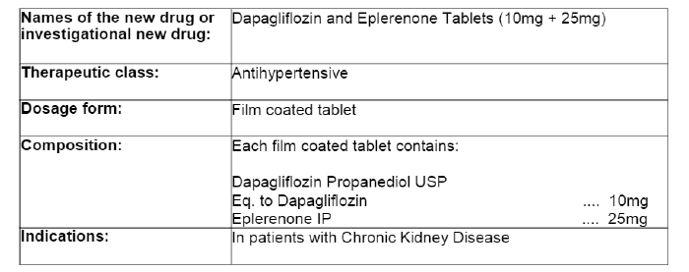
Figure 1: CDSCO approval letter

Introduction to Analytical Method Development ^{[4-10]}
Analytical methods are fundamental to modern science, quietly driving progress across many fields. In the pharmaceutical industry, however, their role becomes even more critical, as they form the backbone of ensuring that medicines are safe, effective, and consistent. Developing analytical methods is therefore not just a technical exercise but a vital process that safeguards patient health and supports innovation. This section highlights why analytical method development is essential, how the process unfolds, and the long-term benefits it brings.
The Need for Developing Analytical Methods
Drug discovery and development are fast-paced, with new compounds constantly being designed and tested. Standard analytical techniques are not always adequate for these novel drugs, each of which may have unique chemical and physical characteristics. Analytical method development fills this gap by designing approaches tailored to each molecule, covering multiple key areas:
- Characterization: Analytical techniques help in identifying a drug’s basic properties such as solubility, stability, and purity. These insights are crucial in determining whether the drug can be developed safely and effectively.
- Quantification: Precise measurement of active pharmaceutical ingredients in raw materials, intermediates, and finished products ensures consistent strength and performance across all manufactured batches.
- Quality Assurance: Every stage of drug production must meet strict quality benchmarks. Analytical methods act as quality checkpoints, detecting deviations early and ensuring regulatory compliance.
- Impurity Profiling: Impurities introduced during synthesis or storage may compromise safety. Specialized methods allow for their detection, quantification, and control, ensuring patient safety.
- Dissolution Testing: By assessing how well a drug dissolves in physiological conditions, analytical methods predict absorption and bioavailability, which are directly linked to therapeutic effectiveness.
- Stability Studies: Drugs face environmental challenges such as heat, humidity, and light. Stability testing determines how a compound holds up under these conditions, guiding shelf life and storage requirements.
The Method Development Process
Creating a robust analytical method is a systematic journey involving several stages:
- Technique Selection: Choosing the most appropriate analytical tool is the starting point. High-performance liquid chromatography (HPLC), gas chromatography (GC), spectroscopy, and mass spectrometry are among the most widely used, each selected based on the drug’s properties and the type of data required.
- Optimization: Once a technique is chosen, conditions are fine-tuned. In HPLC, for example, factors like mobile phase composition, column type, and detector wavelength are adjusted to achieve accurate separation and measurement.
- Validation: Before implementation, the method must demonstrate reliability. Validation involves testing for parameters such as accuracy, precision, specificity, linearity, robustness, and reproducibility, ensuring the method is fit for its intended purpose.

- Documentation: Every detail of the method—from equipment settings to acceptance criteria—is documented. This ensures consistency, reproducibility, and alignment with regulatory requirements.
Benefits of Effective Method Development
Well-designed analytical methods benefit both research and manufacturing:
- Improved Drug Quality: They ensure that medicines consistently meet required standards of potency, purity, and safety.
- Efficient Manufacturing: Real-time analysis during production helps quickly detect and correct problems, reducing delays and costs.
- Regulatory Readiness: Comprehensive analytical data supports submissions to regulatory agencies, streamlining the approval process.
- Accelerated R&D: Reliable methods enable researchers to better evaluate new drug candidates and move them through development pipelines faster.
Conclusion
Analytical method development is not optional but essential in pharmaceutical research and production. By enabling precise characterization, accurate measurement, and rigorous quality control, these methods protect patient safety and enhance drug reliability. As new therapies emerge and technologies evolve, advancing analytical approaches will remain a cornerstone of successful drug development.
Table 2- Key elements of analytical method development
Stage/Aspect | Purpose | Examples/Details
Characterization | To understand basic physicochemical properties of the drug. | Solubility, stability, purity, molecular structure.
Quantification | To measure the exact amount of drug substance or product. | Active pharmaceutical ingredient (API) levels in raw materials, tablets, or capsules.
Quality Control | To ensure consistent product quality during manufacturing. | Batch testing, in-process controls, detection of deviations.
Impurity Profiling | To detect, identify, and quantify impurities or degradation products. | By-products, contaminants, degradation markers.
Dissolution Testing | To evaluate how quickly and completely a drug dissolves in a medium. | Predicts absorption, bioavailability, and therapeutic effectiveness.
Stability Testing | To determine how the drug performs under environmental stress. | Effect of temperature, light, humidity on shelf life and degradation.
Method Selection | To choose the most suitable analytical technique. | HPLC, GC, UV/IR spectroscopy, Mass Spectrometry.
Optimization | To refine the chosen method for accuracy and reliability. | Adjusting mobile phase, detector settings, or instrument parameters.
Validation | To confirm the method is reliable, reproducible, and regulatory-compliant. | Accuracy, precision, specificity, linearity, robustness.
Documentation | To ensure reproducibility and regulatory approval. | Standard operating procedures, acceptance criteria, method reports.

Introduction to High Performance Liquid Chromatography ^{[4-10]}
High-performance liquid chromatography (HPLC) is one of the most widely used analytical tools in modern science. It allows researchers to separate, identify, and measure components within a liquid mixture with great precision. The technique relies on differences in how molecules interact with two phases: a stationary phase (the column packing material) and a mobile phase (a liquid solvent that flows through the column). Molecules that bond more strongly with the stationary phase move slowly, while those that interact more with the mobile phase pass quickly, resulting in effective separation. By monitoring the time taken for each compound to exit the column—known as retention time—

and using suitable detectors, scientists obtain detailed insight into the composition of complex samples.

High Performance Liquid Chromatography
Working Principle
HPLC builds upon the fundamental concept of chromatography, which involves separating substances based on differential affinities. The stationary phase provides a solid framework inside the column that interacts with analytes, while the mobile phase acts as a carrier solvent that drives the sample forward. As the sample travels through the system, different compounds migrate at different speeds depending on their interactions with the stationary and mobile phases. Careful selection of both phases, as well as optimization of experimental conditions, allows highly efficient resolution even for compounds with very similar properties.
Detection Strategies
Once separated, analytes are detected at the column outlet by specialized instruments. Common detectors include UV–Visible detectors, which measure absorbance of light at specific wavelengths, and mass spectrometers, which provide structural information about the molecules. The detector output generates a chromatogram, with each peak representing a compound in the sample. Analysis of peak shape, height, and retention time makes it possible to both identify and quantify the analytes present.
Applications of HPLC

The versatility of HPLC makes it a central technique across many scientific disciplines:

Pharmaceutical Sciences: Used extensively in drug development, HPLC helps determine drug purity, quantify active ingredients, and monitor impurities or degradation products to ensure safety and efficacy.

Environmental Testing: HPLC is employed to detect pesticides, herbicides, and industrial pollutants in water, soil, and air samples, contributing to environmental monitoring and protection.

Food and Beverage Industry: It supports quality control by identifying additives, preservatives, and contaminants, as well as quantifying nutrients such as vitamins and antioxidants.

Forensic Analysis: HPLC assists in toxicology studies by detecting drugs, toxins, and other compounds in biological specimens, as well as in the examination of trace evidence like fibers, inks, and paints.

Biochemical Research: The technique is crucial for studying biomolecules including proteins, peptides, and nucleic acids, supporting research into disease mechanisms and therapeutic targets.

Advantages of HPLC

HPLC offers a wide range of benefits that explain its dominant role in analytical laboratories:

Excellent Resolution: Capable of separating complex mixtures containing structurally similar compounds.

Versatility: Applicable to a wide range of analytes due to different stationary and mobile phase options.

High Sensitivity: Modern detectors enable detection of trace-level compounds, critical in drug metabolism and pollutant analysis.

Automation: Automated injection, solvent control, and data collection enhance accuracy and reduce operator error.

Speed and Efficiency: Faster than conventional chromatography, enabling high-throughput analysis.

Quantitative Accuracy: Provides reliable quantitative data, essential in pharmaceutical quality control.

Flexible Detection: Compatible with multiple detector types, allowing both routine and advanced analyses.

Minimal Sample Preparation: Often requires only simple pretreatment, making it time- and resource-efficient.

Destructive/Non-Destructive Use: Depending on the method, samples can either be collected post-analysis or destroyed during detection.

Wide Solvent Compatibility: Can handle a broad range of solvents, increasing applicability across diverse sample types.

Conclusion

High-performance liquid chromatography has established itself as a cornerstone of analytical science. Its ability to separate, identify, and quantify compounds with speed and accuracy has made it indispensable in pharmaceuticals, environmental monitoring, food analysis, forensic science, and biochemistry. With ongoing technological advancements, HPLC will continue to expand its scope, offering even greater precision and sensitivity in tackling the analytical challenges of the future.

Classification of HPLC
High-performance liquid chromatography (HPLC) can be grouped into different categories depending on how the separation is achieved, the type of column used, or the mobile phase strategy applied. Below is a detailed outline of the main classifications:
Based on Separation Principle
- Normal-Phase HPLC (NP-HPLC): Uses a polar stationary phase and a non-polar mobile phase. Best suited for the analysis of less polar or moderately polar compounds.
- Reversed-Phase HPLC (RP-HPLC): The most commonly applied form of HPLC. Here, the stationary phase is non-polar (such as C18), while the mobile phase is a water-organic solvent mixture. It is highly effective for separating polar and semi-polar analytes, making it essential in pharmaceutical and biological testing.
- Ion-Exchange Chromatography (IEC): Employs a charged stationary phase to separate ionic compounds. It is particularly effective for proteins, amino acids, and peptides.
- Size-Exclusion Chromatography (SEC) / Gel Permeation Chromatography (GPC): Relies on molecular size for separation. Larger molecules pass through the column more quickly, while smaller molecules are retained longer. Often used for polymers and biomacromolecules.

- Affinity Chromatography: Highly selective separation method that utilizes a stationary phase bonded with ligands to capture specific analytes. Widely used for purifying enzymes, antibodies, and other biomolecules.
Based on Column Configuration
- Analytical HPLC: The standard choice for routine qualitative and quantitative analysis. These columns are typically narrow (around 4.6 mm internal diameter) and require only small sample volumes.
- Preparative HPLC: Designed for isolating larger amounts of compounds. Columns are wider (10 mm or more), allowing higher sample loading and collection of purified fractions.
- Micro-HPLC: Utilizes columns with diameters below 2 mm. Benefits include reduced solvent use, higher resolution, and efficiency, though specialized instruments are required.
Based on Mobile Phase Program
- Isocratic Elution: Maintains a constant solvent composition throughout the run. Ideal for simple mixtures where analytes differ significantly in polarity.
- Gradient Elution: Gradually alters the mobile phase composition during analysis (e.g., increasing organic solvent content). This approach is especially useful for complex samples with a wide polarity range.
The choice of classification depends largely on the chemical nature of the analytes and the analytical goal, ensuring the right method is used for accurate and efficient separation.
Instrumentation of HPLC
An HPLC system is composed of several interconnected components, each with a critical role in ensuring reliable separation and analysis of analytes.
Main Components
- Solvent Reservoirs: Containers that hold mobile phase solvents, typically water mixed with organic modifiers. Systems often include multiple reservoirs to accommodate gradient elution.
- Degassing Unit: Removes dissolved gases from the mobile phase to prevent bubble formation, which could interfere with detector performance.
- Pump: Provides a consistent and precisely controlled flow of mobile phase through the column. Flow stability is crucial for reproducibility and resolution.
- Injector: Introduces a defined volume of sample into the system. This can be done manually with syringes or automatically with autosamplers.

- Column: The heart of the system where actual separation occurs. Packed with stationary phase material, the column’s chemistry and dimensions dictate separation efficiency.
- Detector: Monitors analytes as they elute from the column and converts their signal into measurable data. Common options include UV detectors for absorbance measurement and mass spectrometers for structural identification.
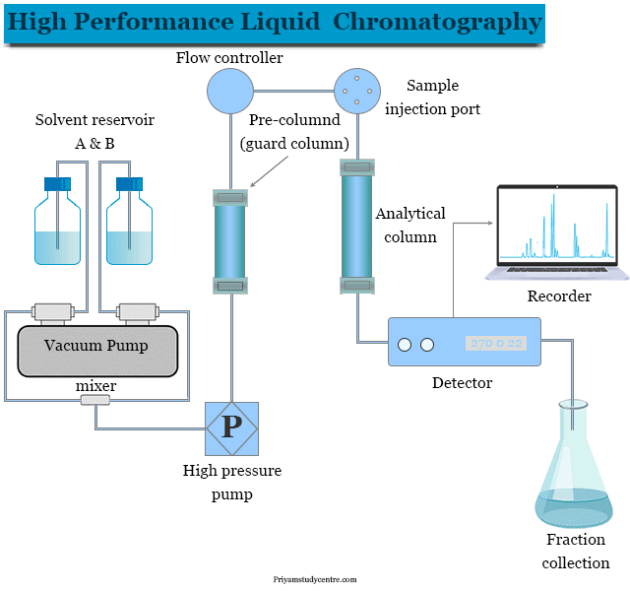

Figure 2- HPLC equipment
- Data Acquisition System (DAS): A computer-based system that manages instrument operation, records signals, and generates chromatograms. It also supports further data processing, analysis, and reporting.
Analytical Workflow
- Preparation of Mobile Phase: Appropriate solvents are prepared and degassed to remove air bubbles.
- Sample Processing: Samples are dissolved in a compatible solvent and filtered to eliminate particulates.
- Injection: The prepared sample is introduced into the column using the injector.
- Separation: The pump drives the mobile phase and sample through the column, where compounds separate according to their interactions with the stationary phase.
- Detection: Eluted compounds are identified by the detector, which generates a measurable signal.
- Data Recording and Analysis: The DAS produces a chromatogram showing peaks corresponding to analytes, enabling both qualitative and quantitative interpretation.
Additional Features
- Column Oven: Temperature control is often applied to improve reproducibility and stabilize retention times.
- Automation Options: Modern HPLC systems incorporate auto-samplers for high-throughput operation and fraction collectors for isolating separated compounds.
Introduction to Analytical Method Validation ^{[4-10]}
Analytical method validation is a critical process that assesses the performance characteristics of an analytical method to ensure it consistently delivers reliable and accurate results. It establishes the method's suitability for its intended purpose, which is to generate data that meets predetermined specifications. This process plays a vital role in various pharmacopoeias, including the United States Pharmacopeia (USP), the British Pharmacopoeia (BP), and guidelines established by the International Conference on Harmonization (ICH).
The World Health Organization (WHO) published a foundational document titled "Validation of analytical procedures used in the examination of pharmaceutical materials" in 1992. This guideline highlighted the importance of method validation as a cornerstone for proper method development and ultimately guaranteeing the quality of pharmaceutical products.
The ICH, an organization that brings together regulatory authorities from Europe, the United States, and Japan, has

issued two key guidelines on analytical method validation:

- Q2A: Text on Validation of Analytical Procedures: This guideline outlines the theoretical aspects and principles of analytical method validation.
- Q2B: Validation of Analytical Procedures Methodology: This guideline provides practical details and recommendations for conducting method validation studies.
While the USP (2004) has a dedicated section outlining analytical method validation requirements, this specific guideline is not yet incorporated into the Indian Pharmacopoeia.
Range and Linearity
One of the key parameters evaluated during method validation is range and linearity. This parameter establishes the concentration interval within which the analytical method can produce results that are directly proportional to the concentration of the analyte in the sample. Linearity can be demonstrated through various mathematical transformations:
- Calibration Curve: This approach involves analyzing a series of standards with known concentrations, typically at least five, spanning a range of 80-120% of the expected sample concentration. The analytical response (e.g., peak area) is plotted against the corresponding standard concentration. A linear regression analysis is performed on this data set. The method is considered linear if a statistically significant correlation coefficient (R-squared) is obtained and there is a minimal zero intercept. A non-significant zero intercept indicates that the response is directly proportional to the concentration within the investigated range.
- Response Factor Approach: This method utilizes a response factor, calculated by dividing the analytical response by the corresponding standard concentration. A graph of relative response (response factor) versus concentration is plotted on a logarithmic scale. Linearity is established if a horizontal line can be drawn across the entire concentration range encompassing at least 95% of the plotted data points. Deviations from linearity often occur at higher concentrations, and the upper limit of linearity is defined as the concentration where the response deviates significantly from the horizontal line.
The range of the analytical method is the concentration interval between the lower limit of quantification (LLOQ) and the upper limit of linearity (ULOQ). Within this range, the method can produce accurate and precise quantitative results. The range is typically expressed in the same units as the concentration (e.g., ppm or %).

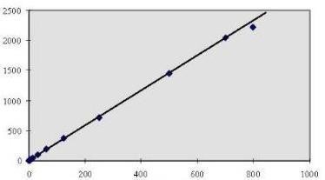
Figure: 3 Diagrammatical Representative of Linearity
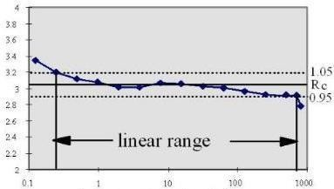

Figure 4 -Diagrammatical Representation of Range
Reproducibility and Precision
Reproducibility and precision are critical parameters evaluated during analytical method validation. They assess the method's ability to generate consistent and reliable test results.
- Reproducibility: This term refers to the method's ability to produce similar results when the analysis is performed under varying conditions. These variations could include different laboratories, analysts, instruments, or even days. A method exhibiting good reproducibility is suitable for implementation across different analytical settings.
- Repeatability: This concept focuses on the method's consistency when the analysis is conducted under identical conditions. Ideally, the same analyst uses the same instrument and reagents within a short time frame to analyze replicate samples. High repeatability indicates that the method produces consistent results within a single laboratory.
Expressing Reproducibility and Precision: Relative Validation Procedures for Reproducibility and Repeatability:
- Repeatability: At least three concentration levels within the analytical range are chosen. For each level, a minimum of six replicate analyses are performed. The RSD is calculated for each concentration level to assess repeatability.
- Reproducibility: This evaluation may involve inter-laboratory studies where the same sample is analyzed by different laboratories. Alternatively, studies can be designed within a single laboratory using different analysts, instruments, or days. The RSD is calculated to evaluate the method's reproducibility across varying conditions.
Accuracy and Recovery
Accuracy refers to the closeness of the analytical results to the true value of the analyte in the sample. Ideally, the method should produce results that are statistically indistinguishable from the actual concentration present.
Recovery Studies: Recovery studies are performed to assess the accuracy of the analytical method. This typically involves spiking a known amount of the analyte (standard) into a sample matrix (e.g., placebo or blank sample). The spiked sample is then analyzed using the validated method. The percent recovery is calculated by comparing the measured concentration of the analyte in the spiked sample to the amount of standard added.
Recovery studies are often performed at different concentration levels within the analytical range to ensure consistent accuracy across the entire working range of the method. Spiking can be done in two ways:
- Spiking the Sample with Standard: This approach is used when a placebo matrix is not readily available.
- Spiking the Placebo with Standard: This is the preferred method as it better reflects the performance of the

analytical procedure in the actual sample matrix.
Common spiking levels used in recovery studies include 50%, 100%, and 150% of the target concentration or 80%, 100%, and 120% of the target concentration.
Limit of Detection (LOD) and Limit of Quantification (LOQ)
LOD and LOQ are crucial parameters that define the analytical method's sensitivity. They establish the lowest concentration levels at which the analyte can be reliably detected and quantified, respectively.
- Limit of Detection (LOD): This is the lowest concentration of the analyte that can be identified with a certain degree of confidence in the presence of background noise. While the analyte may be detected at the LOD, quantification might not be reliable due to low signal-to-noise ratio.
- Limit of Quantification (LOQ): This is the lowest concentration of the analyte that can be quantified with acceptable accuracy and precision. At the LOQ, the signal-to-noise ratio is sufficient to ensure reliable quantification of the analyte.
Sensitivity Distinction: It's important to differentiate between LOD and sensitivity. Sensitivity refers to the method's ability to distinguish between small differences in concentration. A steeper slope of the calibration curve generally indicates higher sensitivity. However, a highly sensitive method may not necessarily have a low LOD or LOQ.

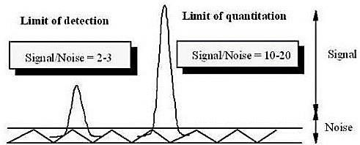
Figure 5-General representation of LOD and LOQ
Alternative Methods for Determining Limit of Detection (LOD) Besides Signal-to-Noise Ratio
While signal-to-noise ratio (S/N) is a common method for estimating LOD, other approaches can be valuable in specific scenarios. Here's a breakdown of some alternative methods:
1. Visual Determination:
This method involves manually injecting progressively lower concentrations of the analyte until a peak can just be distinguished from the background noise. The lowest concentration visually detectable, but not quantifiable, is considered the LOD. While subjective and potentially less precise than other methods, visual determination can be a useful starting point for LOD estimation.
2. Standard Deviation of the Blank (Sdb):
This approach statistically defines the LOD. A series of blank samples (samples with no analyte) are analysed, and the standard deviation (Sdb) of the blank response is calculated. The LOD is then determined by multiplying a factor (typically 3 or 3.3) by Sdb. This factor accounts for the inherent variability in the blank response. This method provides an objective measure of LOD based on the method's inherent noise level.
3. Calibration Curve-Based Methods:
Mathematical equations can be employed to estimate LOD using data from the calibration curve. These equations often rely on the standard deviation of the response (Sy) and the slope (S) of the calibration curve. The specific formula used may vary depending on the chosen approach. This method offers a more statistically robust estimation of LOD compared to visual determination.
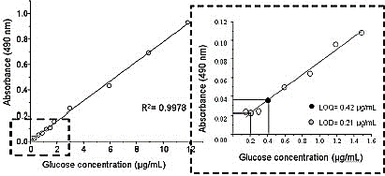
Figure 6-Regression line method for determination of LOD and LOQ
Ruggedness
Ruggedness, although not explicitly defined in regulatory guidelines, is conceptually similar to reproducibility. It refers to the method's ability to produce consistent and reliable results under normal variations in operating conditions. These variations might encompass different analysts, laboratories, instruments, or even environmental conditions. A rugged method demonstrates consistent performance within the expected range of operational variability encountered in routine analysis.
Evaluation of Ruggedness:
Ruggedness studies assess the method's reproducibility when used by different analysts within a single laboratory or across different laboratories. Homogeneous sample aliquots are analyzed under varying conditions, and the degree of response variation is statistically evaluated using tests like t-tests.
Robustness
Robustness reflects the method's ability to withstand minor, deliberate changes in the analytical procedure without significantly affecting the results. These changes should remain within a defined and realistic range encountered during routine analysis. The impact of these variations on the analytical response is measured to assess robustness.
Performing Robustness Studies:
Robustness studies are conducted to determine if minor changes in operational parameters necessitate method revalidation. Examples of parameters that can be investigated include:
- Flow rate of the mobile phase
- Mobile phase composition
- pH of the mobile phase
- Detection wavelength
The magnitude of these changes should be within a defined range, such as 2-5% of the original value.
Through robustness studies, critical method parameters that significantly influence the analytical response can be identified. These critical parameters should be documented and controlled to ensure consistent performance. It's important to note that robustness studies are not mandatory for regulatory submissions, but they provide valuable information for optimizing and maintaining method performance.
Solvent Stability
Solvent stability is crucial for ensuring the integrity of analytes during sample preparation, storage, and analysis. Certain molecules are susceptible to degradation in solution, leading to inaccurate analytical results. It's essential to evaluate the stability of both the analyte standard and the sample matrix under various conditions, such as:
- Sample preparation procedures
- Solvent extraction methods

- Sample storage conditions (e.g., automatic samplers, refrigerators)

Evaluating Solvent Stability:
Stability studies involve analyzing replicate aliquots of the standard and sample at defined time intervals, typically over 48 hours. The relative standard deviation (RSD) of the analytical response obtained at different time points is calculated. The RSD should not exceed a predefined threshold (e.g., 20%), indicating acceptable stability within the specified timeframe.
Data Elements for Analytical Method Validation
The selection of validation parameters for an analytical method used in pharmaceutical analysis depends on the intended purpose of the method. The following classification system can guide the selection of appropriate validation parameters:
Category 1:
- Compendial Methods: These methods are typically included in official pharmacopoeias and are used for the quantitative determination of the active pharmaceutical ingredient (API) in a finished dosage form, along with major excipients or preservatives.
Category 2:
- Impurity Profiling and Degradation Products: Methods in this category quantify impurities present in the API or finished product matrix, or they assess the formation of degradation products over time.
Category 3:
- Performance Testing Methods: These methods evaluate the performance of drug delivery systems, such as dissolution testing to assess drug release from a dosage form.
Category 4:
- Identification Tests: These qualitative methods confirm the presence of the API and distinguish it from potential impurities or excipients.
The selection of validation parameters for a specific method should be based on this classification system, ensuring a targeted and efficient validaton process.

INTRODUCTION TO DRUG PROFILE
Drug Profile for Dapagliflozin Propanediol Monohydrate ^{[11]}
Table 3- Drug Profile of Dapagliflozin Propanediol Monohydrate
Drug Information
Therapeutic category |  | Antidiabetic (SGLT-2 inhibitors)
Therapeutic  Indication |  | It helps to improve blood sugar (glucose) control in adults with type 2 diabetes, often used alongside diet and exercise. By working as a sodium-glucose cotransporter 2 (SGLT2) inhibitor, it increases the amount of glucose removed from the body when you urinate. This helps to lower blood sugar levels.
Mechanism of action |  | Dapagliflozin is a sodium-glucose cotransporter 2 inhibitor used to treat type 2 diabetes mellitus. Dapagliflozin, when used alongside diet and exercise in adults, enhances glycemic management by blocking glucose reabsorption in the proximal tubule of the nephron and inducing glycosuria.
Chemical Structure |  | 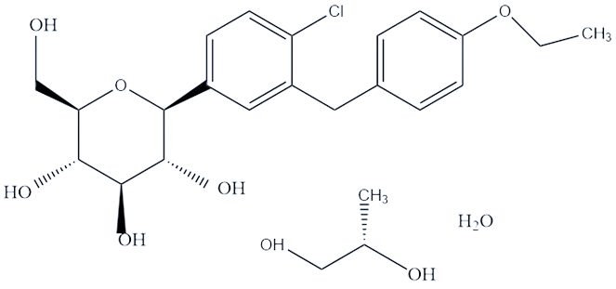
Nomenclature
International Union of Pure and AppliedChemistry (IUPAC) Name |  | (2S)-propane-1,2 diol (2S, 3R, 4R, 5S, 6R)-2-{4-chloro-3-[(4-ethoxyphenyl) methyl] phenyl}-6-(hydroxymethyl) oxane-3,4,5- triol hydrate
Empirical formula |  | C₂₄H₃₅ClO₉
Molecular weight |  | 502.99 g/mol
Chemical Abstracts Service (CAS) Number |  | 960404-48-2
Approval Status |  | Approved by FDA, CDSCO and European union.
Physicochemical Properties
Appearance | White powder
Solubility | Soluble in ethanol, DMSO, and dimethyl formamide. Sparingly soluble in aqueous buffers and water.
Melting point | 65 °C
Log p | 2.7
pKa value | 12.57

Drug Profile of Eplerenone ^{[12-13]}
Table 4- Drug Profile of Eplerenone

Drug Information
Therapeutic category |  | Anti-hypertensive Agent
Therapeutic  Indication |  | Used to treat high blood pressure and to improve survival in patients with heart failure
Mechanism of action |  | Eplerenone is a mineralocorticoid receptor antagonist. It binds to the receptor and locks the binding of aldosterone, a component of the renin-angiotensin-aldosterone-system (RAAS). Aldosterone binds to mineralocorticoid receptors in tissues, and increases blood pressure through induction of sodium reabsorption and possibly other mechanisms. Eplerenone works by blocking the actions of aldosterone, and resulting in decreasing blood pressure.
Chemical Structure |  | 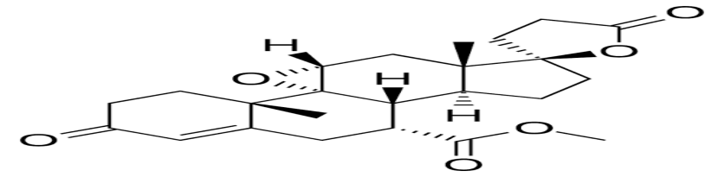
Nomenclature
International Union of Pure and Applied Chemistry (IUPAC) Name |  | methyl (1R,2S,9R,10R,11S,14R,15S,17R)-2,15-dimethyl-5,5'-dioxospiro[18-oxapentacyclo[8.8.0.01,17.02,7.011,15]octadec-6-ene-14,2'-oxolane]-9-carboxylate
Empirical formula |  | C₂₄H₃₀O₆
Molecular weight |  | 1275.7g/mol
Chemical Abstracts Service (CAS) Number |  | 107724-20-9
Approval Status |  | Official in IP, BP
Physicochemical Properties
Appearance | White colored powder
Solubility | Soluble in organic solvent (Ethanol, Chloroform)
Melting point | 242 ºC
Log p | 1.34
pKa value | Strongest Acidic- 16.44  Strongest Basic- -4.2

REVIEW OF LITERATURE
Review of Literature for Dapagliflozin Propanediol Monohydrate and Eplerenone ^{[14-40]}
Table 5- Review of official and reported methods for Dapagliflozin Propanediol Monohydrate and Eplerenone (DAPA and EPLE)
Official methods for Dapagliflozin
Sr. no. | Drugs | Matrix | Method | Brief Introduction | Reference
1. | Dapagliflozin | Bulk drug | RP-HPLC | Column:C18 (150mm×4.6mm,3.5µm)  Mobile Phase: Trifluoroacetic acid: ACN (85:15 v/v) Flow rate: 1 ml/min λmax: 220 nm | 14
Reported methods for Dapagliflozin
1. | Dapagliflozin | Tablet | UV | Solvent: Methanol, λmax: 224 nm-UV | 15
2. | Dapagliflozin | Bulk and tablet | UV | Solvent: Methanol: water (15:85 v/v), λmax: 220 nm | 16
3. | Dapagliflozin | Bulk and tablet | RP-HPLC | Column: Waters C18 (250mm×4.6mm, 5µm)  Mobile Phase: Phosphate buffer : ACN (60:40 v/v) Flow rate: 1 ml/min λmax: 237 nm | 17
4. | Dapagliflozin | Bulk drug and Tablet | RP-HPLC | Column: C18 (250mm × 4.6mm,10µm), Mobile Phase: 0.1% Triethylamine (pH-5.0): ACN (50:50 v/v), Flow rate: 1 ml/min λmax: 224 nm | 18
5. | Dapagliflozin | Bulk and Tablet | Stability indicating RP-HPLC | Column: C18 (250mm × 4.6mm, 5µm), Mobile Phase: Methanol: Water (75:25 v/v), Flow rate: 1 ml/min λmax: 230 nm | 19
6. | Dapagliflozin | Bulk and Tablet | Stability indicating RP-HPLC | Column: Agilent C18 (250mm × 4.6mm, 10µm), Mobile Phase: ACN: di-potassium  hydrogen phosphate with pH-6.5 adjusted with OPA (40:60 v/v) Flow rate: 1 ml/min λmax: 222 nm | 20
7. | Dapagliflozin and Saxagliptin | Bulk drug | RP-HPLC | Column: Phenomenex Luna C18 (250mm × 4.6mm,10µm), Mobile Phase: 10mM phosphate buffer (pH 6.8): ACN (40:60 v/v), Flow rate: 1 ml/min λmax: 260 nm | 21
8. | Dapagliflozin and Saxagliptin | Bulk and Tablet | Stability indicating RP-HPLC | Column: Xterra RP18 (150mm × 4.6mm, 5µm), Mobile Phase: ACN: Water (60:40 v/v), Flow rate: 1 ml/min λmax: 248 nm | 22
9. | Dapagliflozin, Empagliflozin and Canagliflozin | Bulk and Tablet | Stability indicating RP-HPLC | Column: Hypercil C18 (250mm × 4.6mm, 10µm), Mobile Phase: acetonitrile and 0.1% formic acid buffer, pH 3.7 (60:40 v/v) Flow rate: 1 ml/min λmax: 230, 290 nm | 23
10. | Dapagliflozin and Linagliptin | Bulk drug and tablets | Stability indicating RP-HPLC | Column: Eclipse Plus C18 (150mm × 4.6mm, 5µm), Mobile Phase: 0.1 % v/v Formic acid and ACN (40:60 v/v), Flow rate: 0.7 ml/min λmax: 260 nm | 24
11. | Dapagliflozin and Saxagliptin | Bulk drug and tablets | RP-HPLC | Column: C18 (250mm × 4.6mm, 5µm), Mobile Phase: ACN: Water (30:70 v/v), Flow rate: 1.2 ml/min λmax: 230, 250 nm | 25
12. | Metformin and Dapagliflozin | Bulk drug and tablets | QbD based RP-HPLC | Column: Hypercil C18 (250mm × 4.6mm, 10µm), Mobile Phase: Ethanol: Water (70:30 v/v) Flow rate: 1 ml/min λmax: 250 nm | 26
Official methods for Eplerenone
Sr. no. | Drugs | Matrix | Method | Brief Introduction | Reference
1. | Eplerenone | Bulk drug | HPLC | Column: Inertsil Ph-3 (250mm×4.6mm,10µm)  Mobile Phase: Phosphate buffer pH 3 with OPA : ACN (60:40 v/v)  Flow rate: 1.5 ml/min λmax: 215 nm | 27
2. | Eplerenone | Bulk drug | HPLC | Column: ODS (150mm × 4.6mm, 5 µm), Mobile Phase: 0.1 % Phosphoric acid-A and Phosphoric acid : ACN : Methanol-B (0.1: 40:60 v/v) (A:B 54 : 46 % v/v) Flow rate: 1 ml/min λmax: 240 nm | 28
Reported methods for Eplerenone
Sr. no. | Drugs | Matrix | Method | Brief Introduction | Reference
1. | Eplerenone | Tablet | UV | Solvent: 0.05 N HCl, λmax: 245 nm | 29
2. | Eplerenone | Tablet | UV | Solvent: Potassium dihydrogen orthophosphate, pH 2.0, λmax: 245 nm | 30
3. | Eplerenone | Bulk drug and Tablet | Stability indicating RP-HPLC | Column: C₁₈ (250mm × 4.6mm, 5 µm), Mobile Phase: 50 mM ammonium acetate buffer (pH 7) and ACN (55:45 v/v), Flow rate: 1 ml/min λmax: 240 nm | 31
4. | Eplerenone | Spiked human plasma | RP-HPLC | Column: HiQSil C-18HS (250mm × 4.6mm, 5 µm), Mobile Phase: ACN and Water (50:50 v/v), Flow rate: 1 ml/min λmax: 241 nm | 32
5. | Eplerenone | Human Plasma | LC-MS | Column: Zorbax XDB-C8 (250mm × 4.6mm,10µm), Mobile Phase: ACN: Water 10 mM ammonium acetate (pH 7.4) (40:60 v/v), Flow rate: 1 ml/min λmax: 246 nm | 33
6. | Eplerenone | Bulk drug | Stability indicating UPLC | Column: Waters UPLC BEH C18 (50mm ×2.1 mm, 1.7 µm), Mobile Phase: 10 mmol/L ammonium acetate adjusted to pH 4.5: methanol: ACN , Flow rate: 0.3 ml/min λmax: 245 nm | 34
7. | Eplerenone | Human Urine | LC-MS/MS | Column: Zorbax XDB-C8 (50mm × 2.1mm, 5µm), Mobile Phase: ACN: Water (40:60, v/v) containing 10 mM ammonium acetate (pH 7.4).Flow rate: 1 ml/min λmax: 245 nm | 35
8. | Eplerenone | Tablet | RP-HPLC | Column: Waters Symmetry C18 (250mm × 4.6mm,5µm), Mobile Phase: Triethyl ammonium phosphate buffer (pH 2.3) : ACN (40:60 v/v), Flow rate: 1 ml/min λmax: 240 nm | 36
9. | Eplerenone | Tablet | Stability indicating RP-HPLC | Column: C18 (250mm × 4.6mm, 5µm), Mobile Phase: 50 mM ammonium acetate buffer (pH 7): ACN (55:45 v/v), Flow rate: 1 ml/min λmax: 240 nm | 37
10. | Eplerenone | Tablet | Stability indicating RP-HPLC | Column: HiQ sil C-18HS (250mm × 4.6mm, 5 µm), Mobile Phase: Methanol and water (70:30 v/v), Flow rate: 1 ml/min λmax: 241 nm | 38
11. | Eplerenone and Torsemide | Tablets | RP-HPLC | Column: Sheisedo C18 (250mm × 4.6mm, 5µm), Mobile Phase: ACN: Methanol: water (30:50:20 v/v), Flow rate: 1 ml/min λmax: 268 nm | 39
12. | Eplerenone and Torsemide | Tablets | QbD based RP-HPLC | Column: C18 (250mm × 4.6mm, 5µm), Mobile Phase: ACN : water: methanol (50:30:20 v/v), Flow rate: 1 ml/min | 40

Summary of PSAR ^{[41-45]}
Table 6-Summary of PSAR
Sr. No. | Patent Application Number | Publish Date | Title of patent | Reference No.
1 | US6558707B1 | 2003-05-06 | Immediate release eplerenone compositions | 41
2 | CN101152187A | 2008-04-02 | Eplerenone pharmaceutical composition | 42
3 | US11660308B2 | 2023-05-30 | Pharmaceutical composition comprising dapagliflozin | 43
4 | US20190175543A1 | 2019-06-13 | Formulations Containing Amorphous Dapagliflozin | 44
5 | US10738038B2 | 2020-08-11 | Co-crystals of SGLT2 inhibitors, process for their preparation and pharmaceutical compositions thereof | 45

Novelty grade to your selected Dissertation project
>90%

- US11660308B2 - The present invention relates to solid oral pharmaceutical compositions comprising amorphous dapagliflozin. The invention further relates to a process for the preparation of the said pharmaceutical compositions. The said compositions are administered orally for the treatment of diabetes mellitus. The said compositions provide the desired immediate release of dapagliflozin and were found to be stable under accelerated conditions.
4. US20190175543A1- The present invention belongs to the field of pharmaceutical industry and relates to an amorphous solid dispersion comprising at least one polymer and dapagliflozin, to a pharmaceutical composition comprising said solid dispersion, to a process for the preparation thereof, and to the solid dispersion and pharmaceutical composition respectively obtainable by said process.

5. US10738038B2- The present invention provides solid forms of SGLT2 inhibitors, to processes for their preparation and their use in the purification of SGLT2 inhibitors and also provided pharmaceutical compositions comprising them and their use in therapy.
- Novelty grade to your selected Dissertation project- >90%
From all the patents, not a single patent described the analytical method to determine Eplerenone and Dapagliflozin in the synthetic mixture or tablet dosage form.
RATIONALE
Pharmacological Rationale
The combination of Eplerenone and Dapagliflozin Propanediol Monohydrate is pharmacologically justified for managing heart failure with reduced ejection fraction (HFrEF) or chronic kidney disease (CKD), with or without type 2 diabetes mellitus.
Eplerenone, a selective mineralocorticoid receptor antagonist, blocks the effects of aldosterone, reducing sodium and water retention, myocardial fibrosis, and adverse cardiac remodelling.
Dapagliflozin, a sodium-glucose co-transporter 2 (SGLT2) inhibitor, induces glucosuria and natriuresis, leading to osmotic diuresis, reduced plasma volume, and improved cardiac preload and afterload. It also provides cardio renal protection by lowering intraglomerular pressure and oxidative stress.
Together, these agents act through complementary mechanisms to reduce fluid overload, enhance cardiac and renal function, and improve clinical outcomes in patients with heart failure or CKD.
Analytical Rationale
A review of the available literature indicates that a few analytical methods have been reported for the estimation of Eplerenone and Dapagliflozin Propanediol Monohydrate individually; however, no work has been carried out for their simultaneous estimation in synthetic mixture as the combination is still in Phase-III clinical trial. Moreover, no specific RP-HPLC method has been reported for their concurrent quantification in a single formulation.
Considering the increasing therapeutic use of this combination in the management of cardiovascular and renal disorders, the development of a suitable analytical method is warranted. Hence, it is necessary to develop and validate a simple, rapid, precise, accurate, and reproducible RP-HPLC method for the simultaneous estimation of Eplerenone and Dapagliflozin in its synthetic mixture. Such a method will facilitate reliable quantification during formulation development and routine quality control analysis.
AIM and OBJECTIVES
AIM
- From the detailed review of literature and patent, it’s been found that no RP-HPLC method is available for this combination, Therefore, it is worthwhile to develop and validate an RP-HPLC method for determination of Eplerenone and Dapagliflozin Propanediol Monohydrate in synthetic mixture. The aim of the present work is to develop and validate a RP-HPLC method for estimation of Eplerenone and Dapagliflozin Propanediol Monohydrate in its synthetic mixture.
OBJECTIVES
- To optimize separation conditions for Eplerenone and Dapagliflozin Propanediol Monohydrate.
- To validate the developed and optimized RP-HPLC method according to ICH Q2 R2 guidelines.
- To apply the validated method for estimation of Eplerenone and Dapagliflozin Propanediol Monohydrate from its synthetic mixture.

CHEMICALS AND INSTRUMENTAL SPECIFICATIONS
Chemicals and Reagents
Drugs used in Research Work
Table 7-Drug used in Research Work
Drug | Company
Dapagliflozin Propanediol Monohydrate | Sunij Pharma Pvt. Ltd.
Eplerenone | Gratis sample from MSN laboratories

Chemicals used in Research work
Table 8- Chemicals used in Research work
Reagent | Supplier
Methyl Alcohol (AR Grade) | Anachem
Acetonitrile (HPLC Grade) | Astron Chemicals
Water (HPLC Grade) | Astron Chemicals
Ortho Phosphoric Acid | Anachem
Hydrogen Peroxide (AR Grade) | Anachem
Hydrochloric Acid (AR Grade) | Anachem
Sodium Hydroxide (AR Grade) | Anachem

Instrumental Specification
Table 9- Instrument Specification for HPLC
Make | Shimadzu
Model | LC 2010 CHT
Type | Binary Gradient
Detector | UV Detector
Software | LC Solution
Column | Cosmosil C18 (250 mm x 4.6 mm x 5 µ)
Pump | High Pressure Gradient (Reciprocating pump)

Table 10- Instrument Specification for UV Spectroscopy
Make | Shimadzu
Model | UV1800
Type | Double beam spectrophotometer
Detector | Photodiode
Scanning Range | 190-1100
Output | %T & Absorbance
Software | U.V Probe 2.42

Table 11- Instrument Specification for Weighing Balance
Make | Mettler Toledo
Minimum Weighing Capacity | 0.1 mg
Sensitivity | 1 mg

Table 12-Instrument specification for Melting Point Apparatus
Make | Sunbim
Design no. | 889339

Table 13-Instrument specification for FT-IR
Make | IR Spirit Shimadzu IR Instrument
Software | LabSolutions IR

PRELIMINARY STUDIES OF DAPAGLIFLOZIN PROPANEDIOL MONOHYDRATE AND EPLERENONE
Melting Point Study
- The melting point of Dapagliflozin and Eplerenone was determined using a digital melting point apparatus.
- To perform this measurement, two one-sided closed capillary was filled with DAPA and EPLE.
- The capillary was then placed into the melting point apparatus, and the melting point of DAPA and EPLE was observed.
- The measurement was taken from the start of melting until complete melting occurred.
- Finally, the observed melting points was compared against the reported standard melting points.
Table 14- Melting points of DAPA and EPLE
Sr No. | Drug | Reported Melting point | Observed Melting Point
1. | Dapagliflozin^{[11]} | 65-70 °C | 68-70 °C
2. | Eplerenone ^{[47]} | 242 °C | 241-244 °C

Solubility Studies
The solubility of the sample was determined following the guidelines outlined in the Indian Pharmacopoeia (IP).
Table 15- Standard values for Solubility study
Descriptive term | Parts of solvents required for part of solute
Very soluble | Less than 1
Freely soluble | From1 to10
Soluble | From 10 to 30
Sparingly soluble | From30 to100
Slightly soluble | From100 to1000
Very slightly soluble | From1000 to10000
Partially insoluble or insoluble | 10000 or more

Table 16- Solubility studies for Dapagliflozin and Eplerenone
DAPAGLIFLOZIN | EPLERENONE
Soluble: Ethanol, Methanol and Acetonitrile | Soluble in: Chloroform, Dichloromethane, Acetonitrile, Methanol
Slightly Soluble: Water | Slightly Soluble: Water

Identification of Dapagliflozin and Eplerenone by UV-Spectroscopy
1. Creating a Concentrated DAPA and EPLE Solution (100 µg/mL):

- Begin by carefully weighing out about 10 mg of DAPA and EPLE using a precise balance.
Place the measured DAPA and EPLE into a 100 mL volumetric flask.
- Add 50 mL of methanol to the flask containing the DAPA and EPLE.
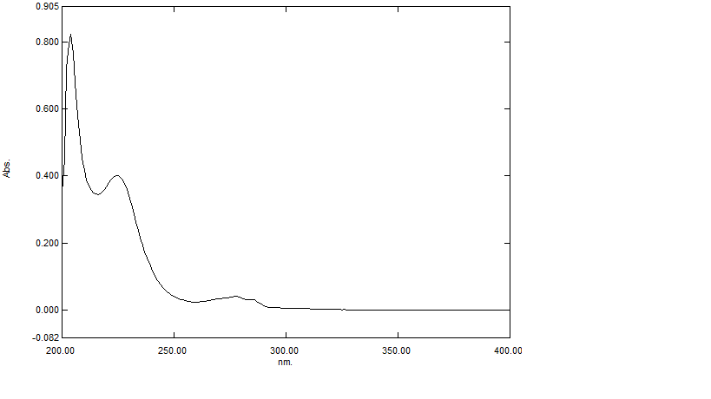
- To ensure the DAPA and EPLE fully dissolves, use a sonicator for 10 minutes.Fill the flask with methanol up to the 100 mL mark to achieve the desired concentration. This creates a concentrated solution with a target concentration of 100 µg/mL.

Briefly sonicate the final solution to guarantee uniformity.
Figure 7- Recorded UV Spectra of Dapagliflozin Propanediol Monohydrate using Methanol

2. Preparing a Diluted Working Solution (10 µg/mL):
- Take 1 mL of the concentrated DAPA and EPLE solution (100 µg/mL) and transfer it into a 10 mL volumetric flask.
- Similar to before, fill the flask to the 10 mL mark with methanol. This will result in a working solution with a target concentration of 10 µg/mL.
3. Examining the Light Absorption Properties:
- A UV spectrophotometer was used to analyze the prepared working solution (10 µg/mL) across the UV light spectrum ranging from 200 nm to 400 nm.
- The resulting spectrum was documented for further study and interpretation.
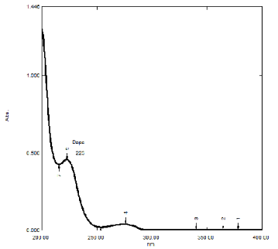

Figure 8- Reference UV Spectra of Dapagliflozin Propanediol Monohydrate using Methanol ^{[25]}
Dapagliflozin Propanediol Monohydrate | Methanol | Recorded λmax | 223 nm
Dapagliflozin Propanediol Monohydrate | Methanol | Reference λmax | 224 nm

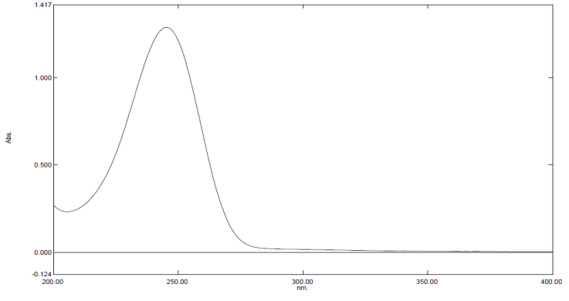
Figure 9- Recorded UV Spectra of Eplerenone using Methanol

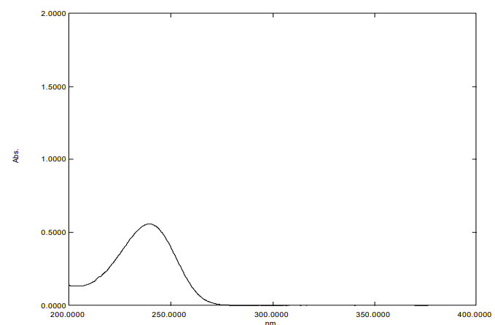
Figure 10- Reference UV Spectra of Eplerenone using Methanol ^{[48]}
Eplerenone | Methanol | Recorded λmax | 245 nm
Eplerenone | Methanol | Reference λmax | 245 nm

Identification by IR Spectra

For Dapagliflozin Propanediol Monohydrate
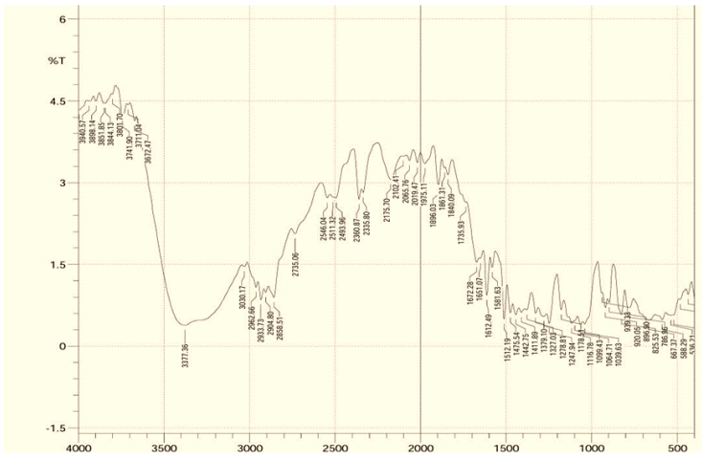
Figure-11- Reference IR of Dapagliflozin Propanediol Monohydrate ^{[46]}

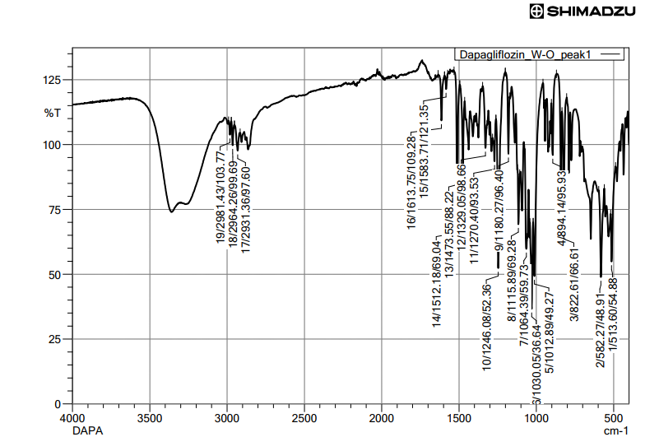
Figure 12- Recorded IR of Dapagliflozin Propanediol Monohydrate
Table 17- Interpretation of Dapagliflozin Propanediol Monohydrate IR
Sr. No. | Types of Vibration | Standard Frequency (cm⁻¹) | Observed Frequency (cm⁻¹)
1 | C=C | 1630-1585 | 1581.71-1585.71
2 | C-Cl | 800-600 | 580.27-584.27
3 | O-H | 3500-3200 | 3280.00-3284.00
4 | Ar-C-O | 1120 – 1070 | 1178.27-1182.27
5 | C-O | 1320-1210 | 1268.40-1272.40
6 | C=O | 1745-1635 | 1611.75-1615.75

For Eplerenone

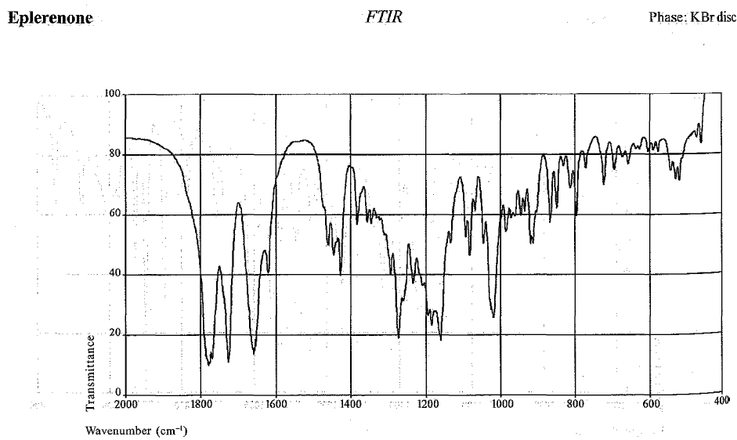
Figure-13- Reference IR of Eplerenone ^{[49]}

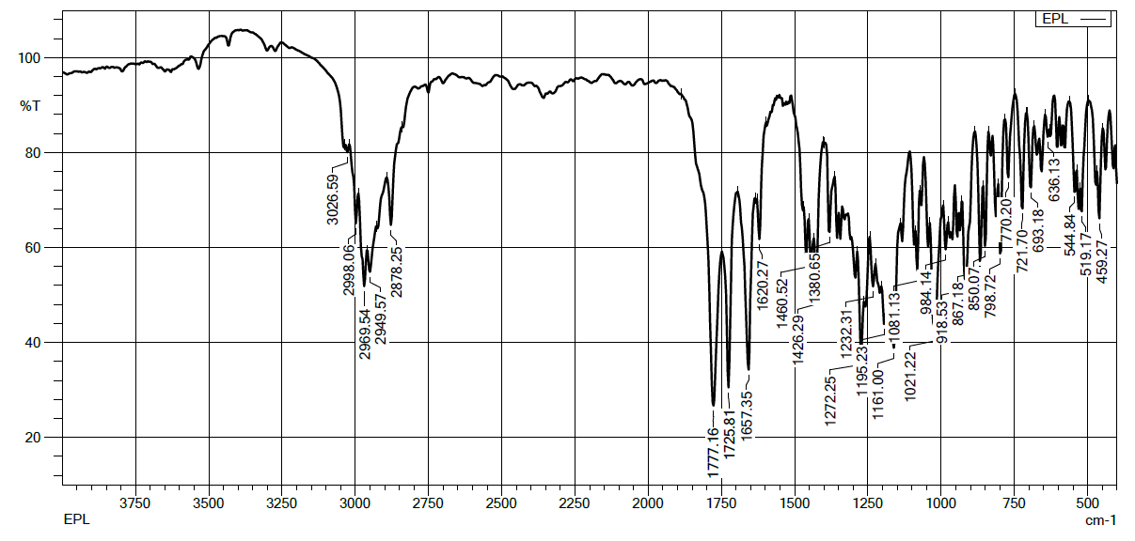
Figure 14- Recorded IR of Eplerenone
Table 18- Interpretation of Eplerenone IR
Sr. No. | Types of Vibration | Standard Frequency (cm⁻¹) | Observed Frequency (cm⁻¹)
1 | C=C | 1630-1585 | 1618.27-1622.27
2 | C-H | 2850-2960 | 2876.25-2880.25
5 | C-O | 1300-1050 | 1230.31-1234.31
6 | C=O | 1745-1635 | 1723.81-1727.81

MATERIALS AND METHODS
Method development and validation by High Performance Liquid chromatography
Ratio of drug concentration in synthetic mixture ^{[41,50]}
Dapagliflozin- 10 mg
Eplerenone- 25 mg
Microcrystalline Cellulose- 50 mg
Mannitol- 30 mg
HPMC- 3 mg
Magnesium stearate- 3 mg
Total- 121 mg
Stock: Synthetic mixture powder eq. to one tablet (Dapagliflozin 10 mg, Eplerenone 25 mg) was taken into 50 mL volumetric flask. 30 mL methanol was added. Kept in sonicator for 20 minutes. Then volume was made up with methanol. Solution was filtered through Whatman 0.45 PVDF syringe filter.
Sample solution: Further 1 mL of clear filtrate was diluted to 10 mL with methanol.
Preparation of stock and working solution
Preparation of Dapagliflozin Stock Solution (200 µg/mL)
An accurately weighed quantity of 20 mg of dapagliflozin propanediol monohydrate was transferred into a 100 mL volumetric flask. Approximately 70 mL of methanol was added to the flask, and the contents were sonicated for sufficient time to ensure complete dissolution of the drug substance. After achieving complete solubilization, the solution was allowed to attain room temperature and the volume was made up to the mark with methanol. The resulting solution had a final concentration of 200 µg/mL and was used as the primary stock solution for further dilutions.
Preparation of Eplerenone Stock Solution (500 µg/mL)
Accurately weighed 50 mg of eplerenone was transferred into a 100 mL volumetric flask. About 70 mL of methanol was added, and the mixture was sonicated to facilitate complete dissolution of the drug. After confirming that the drug was completely dissolved, the solution was diluted up to the mark with methanol and mixed thoroughly to obtain a homogeneous solution. The
final concentration of this stock solution was 500 µg/mL.
Preparation of Mixed Standard Solution (20 µg/mL Dapagliflozin and 50 µg/mL Eplerenone)
To prepare the working mixed standard solution, 1 mL of dapagliflozin stock solution (200 µg/mL) and 1 mL of eplerenone stock solution (500 µg/mL) were accurately pipetted into a 10 mL volumetric flask. The volume was then adjusted to the mark with the selected diluent and mixed well to obtain a final concentration of 20 µg/mL of dapagliflozin and 50 µg/mL of eplerenone. This mixed standard solution was used for method development and validation studies.
Selection of Detection Wavelength
Preparation of Standard Solutions for UV Analysis
Standard solutions of dapagliflozin and eplerenone were prepared separately in methanol for wavelength selection studies. A solution containing 10 ppm of dapagliflozin and another containing 25 ppm of eplerenone were accurately prepared by appropriate dilution of their respective stock solutions with methanol. The prepared solutions were mixed thoroughly to ensure uniform concentration.
UV Spectral Analysis
The individual standard solutions were scanned using a UV–Visible spectrophotometer over the wavelength range of 200–400 nm against methanol as a blank. The absorption spectra of both drugs were recorded to identify their respective maximum absorbance (λmax) and to determine a suitable wavelength for simultaneous analysis. Upon overlaying the spectra of dapagliflozin and eplerenone, a common intersection point was observed at 228 nm, indicating an isosbestic point. At this wavelength, both drugs exhibited equal absorptivity, making it suitable for simultaneous estimation without interference from each other. Therefore, 228 nm was selected as the analytical detection wavelength for further chromatographic analysis.
Selection of Diluent Medium
The selection of an appropriate diluent was based on the solubility properties of both DAPA and EPLE. To identify a suitable solvent system, accurately weighed standard quantities of DAPA and EPLE were separately transferred into individual volumetric flasks. Each drug was dissolved in different solvents to evaluate their solubility behaviour and compatibility. The solutions were prepared by adding the selected solvent and mixing thoroughly to ensure complete dissolution. The clarity of the solutions, absence of precipitation, and overall stability were carefully observed to determine the most appropriate diluent for further analytical studies.
Mobile phase selection
After various trials, Phosphate Buffer: Methanol (30:70%v/v) was selected as optimized mobile phase because it gave complete separation of drugs.
Trials for RP-HPLC method development
- Initial Trial:
A mixture of 20 µg/ml dapagliflozin + 50 µg/ml eplerenone was analysed.
Column: Cosmosil C18 (250 cm×4.6 mm, 5µm)
Mobile phase: Water: Methanol (50:50 %v/v)
Flow rate: 1 mL/min
Detection wavelength: 228 nm
Result: Both compounds eluted but peak shape is irregular.
- Second Trial:
Column: Cosmosil C18 (250 cm×4.6 mm, 5µm)
Mobile phase: Water: Methanol (40:60 %v/v)
Flow rate: 1 mL/min
Detection wavelength: 228 nm
Result: Ratio modified. Retention times of both compounds decreased but peak shape of last compound did not improve.
- Third Trial:
Column: Cosmosil C18 (250 cm×4.6 mm, 5µm)
Mobile phase: Acetonitrile: Water (50:50 v/v)

Flow rate: 1 mL/min
Detection wavelength: 228 nm
Result: ACN used instead of methanol. Merged peaks seen.
- Fourth Trial:
Column: Cosmosil C18 (250 cm×4.6 mm, 5µm)
Mobile phase: Acetonitrile: Water (40:60 v/v)
Flow rate: 1 mL/min
Detection wavelength: 228 nm
Result: Ratio modified. Both analytes separated but Last peak broad.
- Fifth Trial:
Column: Cosmosil C18 (250 cm×4.6 mm, 5µm)
Mobile phase: Phosphate buffer: Methanol (50:50 v/v)
Flow rate: 1 mL/min
Detection wavelength: 228 nm
Result: Phosphate buffer used. pH kept at 3.5. Only one analyte eluted.
- Final Trial (Optimized):
Column: Cosmosil C18 (250 cm×4.6 mm, 5µm)
Mobile phase: Phosphate buffer: Methanol (30:70 v/v)
Flow rate: 1 mL/min
Detection wavelength: 228 nm
Result: Organic modifier volume adjusted. Two sharp peaks seen. Theoretical plates more than 2000, tailing factor less than 2, resolution more than 2. Retention time were found to be 2.6 and 6.2 for Eplerenone and dapagliflozin respectively.
SST parameters
A combined solution of DAPA and EPLE at concentrations of 20 and 50 µg/mL was injected five times to evaluate system suitability test (SST) parameters, including retention time (Rt), asymmetry factor, resolution (Rs), theoretical plate count, and relative standard deviation (RSD).

Forced Degradation
Acid Degradation
Blank sample
- 1 ml methanol + 1 mL 0.1 N HCL was added in 10 ml volumetric flask.
- The flask was kept for 1 hour at room temperature.
- The solution was further neutralized with 1 mL 0.1 N NaOH, volume was made with methanol and injected into HPLC.
Treated Sample

- Sample stock solution 1 ml + 1 mL 0.1 N HCL was added in 10 ml volumetric flask.
- The flask was kept for 1 hour at room temperature.
- The solution was further neutralized with 1 mL 0.1 N NaOH, volume was made with methanol and injected into HPLC.
Base degradation
Blank sample
- 1 ml methanol + 1 mL 1 N NaOH was added in 10 ml volumetric flask.
- The flask was kept for 1 hour at room temperature.
- The solution was further neutralized with 1 mL 1 N HCl, volume was made with methanol and injected into HPLC.
Treated Sample
- Sample stock solution 1 ml + 1 mL 1 N NaOH was added in 10 ml volumetric flask.
- The flask was kept for 1 hour at room temperature.
- The solution was further neutralized with 1 mL 1 N HCl, volume was made with methanol and injected into HPLC.
Peroxide degradation
Blank sample
- 1 ml methanol + 1 mL 3% H₂O₂ was added in 10 ml volumetric flask.
- The flask was kept for 3 hours at room temperature.
- Volume was made with methanol and injected into HPLC.
Treated Sample
- Sample stock solution 1 ml + 1 mL 3% H₂O₂ was added in 10 ml volumetric flask.
- The flask was kept for 3 hours at room temperature.
- Volume was made with methanol and injected into HPLC
Thermal degradation
- The sample was transferred to a conical flask and was kept in preheated oven at 60 °C for 3 hours.
- The dried residue was dissolved in Methanol and then transferred to a 10 mL volumetric flask and the volume was made up with Methanol and was injected into HPLC.

Validation of RP-HPLC method
Specificity
The specificity of the developed HPLC method was assessed to ensure the reliable identification of Dapagliflozin and Eplerenone in the presence of other components.
Individual standard solutions of Dapagliflozin and Eplerenone were prepared separately and injected into the chromatographic system under optimized conditions to establish their respective retention times. A mixed standard solution containing both analytes was then analyzed to confirm proper separation and peak resolution.

Subsequently, the sample solution was injected, and the resulting chromatogram was examined. The peaks
corresponding to Dapagliflozin and Eplerenone were identified by matching their retention times with those obtained from the standard solutions.
The absence of overlapping peaks and the consistency in retention behavior were used as criteria to confirm the specificity of the method for accurate peak identification.
Range and Linearity
The linearity of the proposed HPLC method was established by analyzing a series of standard solutions of Dapagliflozin and Eplerenone at different concentration levels.
Standard stock solutions of both analytes were appropriately diluted to obtain five concentration levels, namely 10+25 µg/mL, 15+37.5 µg/mL, 20+50 µg/mL, 25+62.5 µg/mL, and 30+75 µg/mL for Dapagliflozin and Eplerenone, respectively.
Each prepared solution was injected into the chromatographic system in triplicate under optimized conditions, and the corresponding peak areas were recorded. Calibration plots were generated by plotting peak area against concentration for both analytes.
The linear relationship between concentration and detector response was evaluated across the selected range, which was chosen to encompass the expected working concentrations for routine analysis.
Dapagliflozin Stock Solution (200 µg/mL)
Accurately weigh 20 mg of dapagliflozin propanediol monohydrate and transfer it into a 100 mL volumetric flask. Add approximately 70 mL of methanol and sonicate the solution to ensure complete dissolution of the drug. After complete dissolution, allow the solution to cool if necessary and make up the volume to the mark with methanol. Mix well to obtain a stock solution containing 200 µg/mL of Dapagliflozin.
Eplerenone Stock Solution (500 µg/mL)
Accurately weigh 50 mg of eplerenone and transfer it into a 100 mL volumetric flask. Add about 70 mL of methanol and sonicate until the drug is completely dissolved. The solution is then diluted to volume with methanol and mixed thoroughly to obtain a stock solution containing 500 µg/mL of Eplerenone.
Table 19 Preparation of solution for linearity
Concentration of stock solution (μg/mL) | Volume of stock solution (mL) | Final dilution | Concentration of mixtures for linearity (μg/mL) (DAPA+EPLE)
DAPA+ EPLE 200+ 500 μg/mL) | 0.5 | Dilution in 10 mL volumetric flask with the diluent. | 10+25
DAPA+ EPLE 200+ 500 μg/mL) | 0.75 | Dilution in 10 mL volumetric flask with the diluent. | 15+37.5
DAPA+ EPLE 200+ 500 μg/mL) | 1 | Dilution in 10 mL volumetric flask with the diluent. | 20+50
DAPA+ EPLE 200+ 500 μg/mL) | 1.25 | Dilution in 10 mL volumetric flask with the diluent. | 25+62.5
DAPA+ EPLE 200+ 500 μg/mL) | 1.5 | Dilution in 10 mL volumetric flask with the diluent. | 30+75

Repeatability
The repeatability of the developed HPLC method was assessed to evaluate the consistency of the system under

identical operating conditions over a short time interval.
A standard mixture solution containing Dapagliflozin and Eplerenone at a concentration of 20 µg/mL and 50 µg/mL, respectively, was prepared as per the developed method. This solution was injected into the HPLC system six consecutive times.
The chromatographic responses for each injection were recorded in terms of peak areas for both analytes. The repeatability of the method was determined by calculating the mean, standard deviation (SD), and percentage relative standard deviation (%RSD) of the obtained responses.
The uniformity of the peak areas across replicate injections reflects the precision of the method under the same analytical conditions
Intraday Precision
The intra-day precision of the developed HPLC method was evaluated to determine the consistency of the analytical results within a single day.
Standard mixture solutions of Dapagliflozin and Eplerenone were prepared at three different concentration levels, namely 10 µg/mL and 25 µg/mL, 20 µg/mL and 50 µg/mL, and 30 µg/mL and 75 µg/mL, respectively. Each concentration level was analyzed in triplicate (n = 3) at different time intervals on the same day under identical chromatographic conditions.
The peak areas obtained for each injection were recorded, and the precision was assessed by calculating the mean, standard deviation (SD), and percentage relative standard deviation (%RSD) for both analytes.
The variation in responses at different time intervals was used to evaluate the intra-day precision of the method.
Inter-day precision
The inter-day precision of the developed HPLC method was carried out to assess the reproducibility of the analytical results over multiple days.
Standard mixture solutions of Dapagliflozin and Eplerenone were prepared at three concentration levels, namely 10 µg/mL and 25 µg/mL, 20 µg/mL and 50 µg/mL, and 30 µg/mL and 75 µg/mL, respectively. Each concentration level was analyzed in triplicate (n = 3) on different days under the same chromatographic conditions.
The peak areas obtained for each run were recorded, and the results were statistically evaluated by calculating the mean, standard deviation (SD), and percentage relative standard deviation (%RSD) for both analytes.
The consistency of the analytical responses across different days was used to establish the inter-day precision of the method.
Accuracy
The accuracy of the developed analytical method was assessed using the standard addition approach. This technique involves the addition of known quantities of the analytes to a placebo matrix to evaluate the method’s ability to recover the true amount of drug in the presence of formulation excipients.
Target Concentration:
The target concentration for the spiked samples was fixed at Dapagliflozin + Eplerenone = 20 + 50 µg/mL. This concentration lies within the established working range of the method and serves as a suitable midpoint for accuracy evaluation.

Accuracy Levels:
Accuracy was evaluated at three levels, corresponding to 50%, 100%, and 150% of the target concentration.

Appropriate quantities of standard solutions were added to the placebo matrix to achieve these levels.
Placebo Composition:
The placebo used for the study consisted of commonly employed excipients in tablet formulations, including:
Microcrystalline cellulose- 50 mg
Magnesium stearate- 3 mg
Mannitol- 30 mg
HPMC- 3 mg
Procedure:
The placebo mixture was spiked with a known amount of standard solution containing Dapagliflozin and Eplerenone. The resulting solutions were prepared according to the method and analyzed under optimized chromatographic conditions.
By evaluating the recovery of the added analytes from the placebo matrix, the influence of excipients on the analytical performance was determined. This approach provides a reliable measure of the method’s accuracy and its suitability for quantitative analysis in pharmaceutical formulations. The accuracy of the method was determined by calculating the percentage recovery of the added standard for both analytes. The extent of recovery at each level was used as an indicator of the method’s accuracy and its ability to measure the analytes in the presence of other formulation components.
Table 20 Preparation of sample solution for accuracy studies
Level of Spiking | Quantity of Placebo (mg) | Volume of stock solution added (mL) | Final dilution in 10 mL volumetric flask | Final Concentration (µg/mL)  DAPA EPLE
Un-spiked | 86 | 0 | Volume was made up with the diluent (methanol) | - | -
50% | 86 | 0.5 | Volume was made up with the diluent (methanol) | 10 | 25
100% | 86 | 1 | Volume was made up with the diluent (methanol) | 20 | 50
150% | 86 | 1.5 | Volume was made up with the diluent (methanol) | 30 | 75
P reparation of Standard Solution
Step 1: Preparation of Stock Solution
Accurately weigh 20 mg of Dapagliflozin and 50 mg of Eplerenone and transfer both into a 100 mL volumetric flask. Add approximately 70 mL of methanol and sonicate the solution until complete dissolution of both analytes is achieved. After ensuring complete dissolution, make up the volume to the mark with methanol to obtain a combined stock solution having a concentration of 200 µg/mL of Dapagliflozin and 500 µg/mL of Eplerenone.

LOD and LOQ
The sensitivity of the developed HPLC method was evaluated by determining the Limit of Detection (LOD) and Limit of Quantification (LOQ) for Dapagliflozin and Eplerenone.
- Principle:
The LOD and LOQ were calculated based on the standard deviation of the response (σ) and the slope (S) of the calibration curve obtained from linearity studies.
- Calculation:
The following equations were used for estimation:

$$\text{LOD}\text{=3.3×}\frac{\text{σ}}{\text{S}} \\ \text{LOQ}\text{=10×}\frac{\text{σ}}{\text{S}}$$
- Procedure:
The calibration curve was constructed using multiple concentration levels of Dapagliflozin and Eplerenone. The slope (S) of the calibration curve was determined, and the standard deviation of the response (σ) was calculated from the y-intercepts of the regression lines.
The calculated LOD represents the lowest concentration of the analyte that can be reliably detected, whereas the LOQ indicates the lowest concentration that can be quantified with acceptable precision and accuracy.
Robustness
To verify the reliability of the analytical procedure under practical conditions, the robustness of the method was investigated by deliberately altering selected operational parameters. The objective was to determine whether such minor adjustments would influence the performance of the method.
Variations were introduced in key chromatographic conditions, specifically the mobile phase flow rate and composition. Each parameter was modified independently while maintaining all other conditions constant, ensuring that the effect of each change could be evaluated in isolation.
Under each altered condition, the standard mixture of Dapagliflozin and Eplerenone was analyzed, and the resulting chromatograms were carefully examined. Particular attention was given to any observable changes in peak profile, retention characteristics, and detector response.
The method was considered robust as these controlled variations did not produce any significant deviation in the analytical outcome. This demonstrates that the method possesses sufficient tolerance to minor changes and can be reliably applied in routine laboratory analysis.
Assay of synthetic mixture
Preparation of Solutions for Assay
The synthetic mixture was prepared in a fixed ratio of Dapagliflozin to Eplerenone of 2:5. Accordingly, the mixture contained 20 mg of Dapagliflozin and 50 mg of Eplerenone along with common pharmaceutical excipients.
Preparation of Concentrated Stock Solution:
- Weighing and Mixing:
Accurately weigh 20 mg of Dapagliflozin and 50 mg of Eplerenone along with excipients such as Microcrystalline cellulose, Magnesium stearate, and Talc in appropriate proportions.
- Dissolution of Components:
Transfer the weighed mixture into a 100 mL volumetric flask and add about 70 mL of methanol. Sonicate the solution to ensure complete dissolution of the active pharmaceutical ingredients.
- Volume Adjustment:
After complete dissolution, make up the volume to 100 mL with methanol to obtain a concentrated stock solution containing 200 µg/mL of Dapagliflozin and 500 µg/mL of Eplerenone.
- Dilution to Intermediate Solution:
Transfer 10 mL of the above stock solution into a 100 mL volumetric flask and dilute to volume with methanol. This results in an intermediate solution having concentrations of 20 µg/mL of Dapagliflozin and 50 µg/mL of Eplerenone.
Test Solution Preparation:

- A suitable aliquot of the intermediate solution was filtered through a 0.45 µm membrane filter.
- The filtered solution was directly used as the working test solution for analysis.
Following optimization of chromatographic conditions, triplicate injections (n = 3) of the prepared solution (injection volume: 20 µL) were carried out, and the chromatograms were recorded for quantitative evaluation.

RESULTS AND DISCUSSION
Analytical wavelength detection
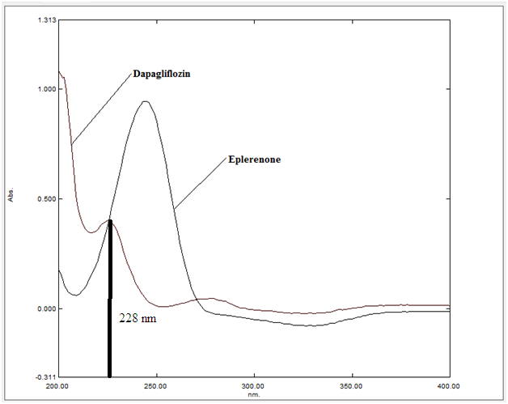
Figure 15 Overlay spectra of Dapagliflozin and Eplerenone
UV preparation: 10 ppm of dapagliflozin and 25 ppm of eplerenone solutions were prepared in methanol and scanned in the range of 200 to 400 nm.
Results: Isosbestic point 228 nm.
Chromatographic condition optimization
Following a series of experiments to optimize chromatographic parameters for DAPA and EPLE analysis, a robust RP-HPLC method was established. This method will be further validated to ensure its accuracy, precision, and other performance characteristics.
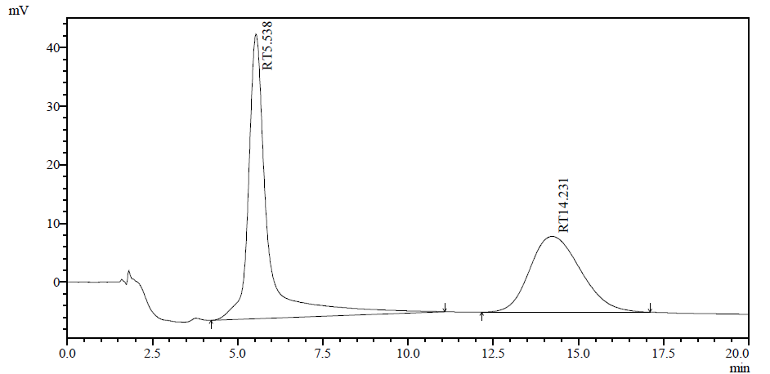
Figure 16 Trial 1- 20 µg/ml dapagliflozin + 50 µg/ml eplerenone, M.P- Water : Methanol (50:50 %v/v)

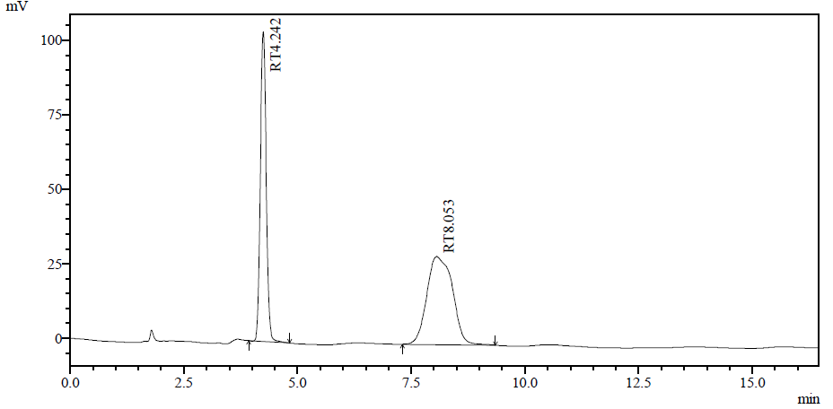
Figure 17 Trial 2- 20 µg/ml dapagliflozin + 50 µg/ml eplerenone, M.P- Water : Methanol (40:60 %v/v)
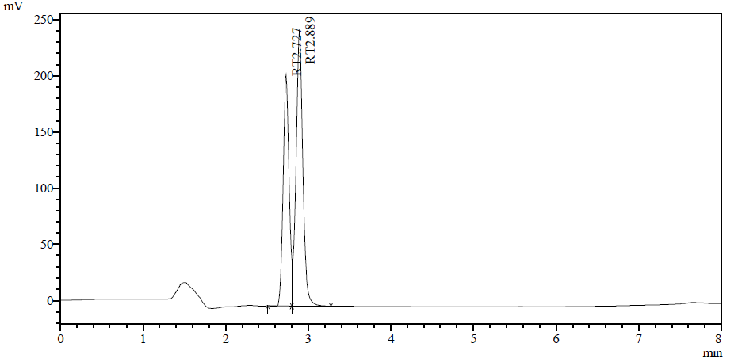
Figure 18 Trial 3- 20 µg/ml dapagliflozin + 50 µg/ml eplerenone, M.P- Water : Acetonitrile (50:50 %v/v)
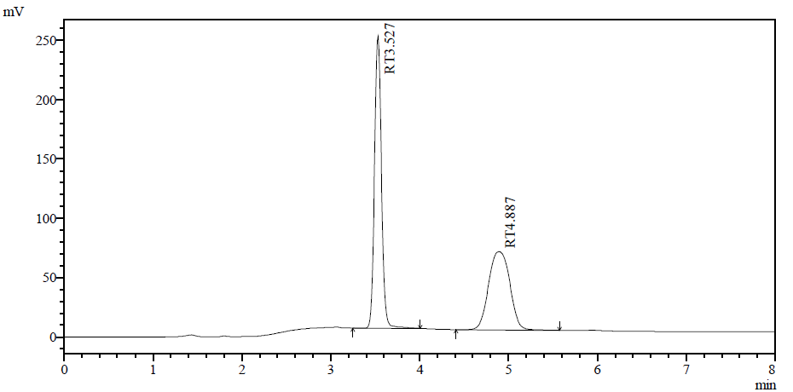
Figure 19 Trial 4- 20 µg/ml dapagliflozin + 50 µg/ml eplerenone, M.P- Water : Acetonitrile (60:40 %v/v)
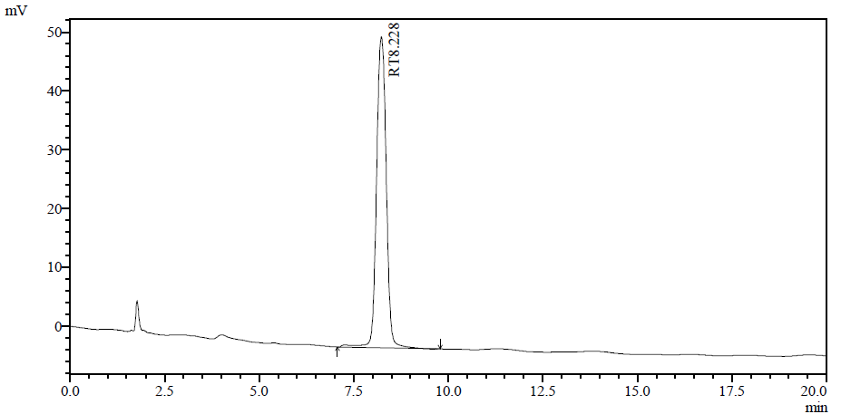
Figure 20 Trial 5- 20 µg/ml dapagliflozin + 50 µg/ml eplerenone, M.P- Phosphate buffer : Methanol (50:50 %v/v)
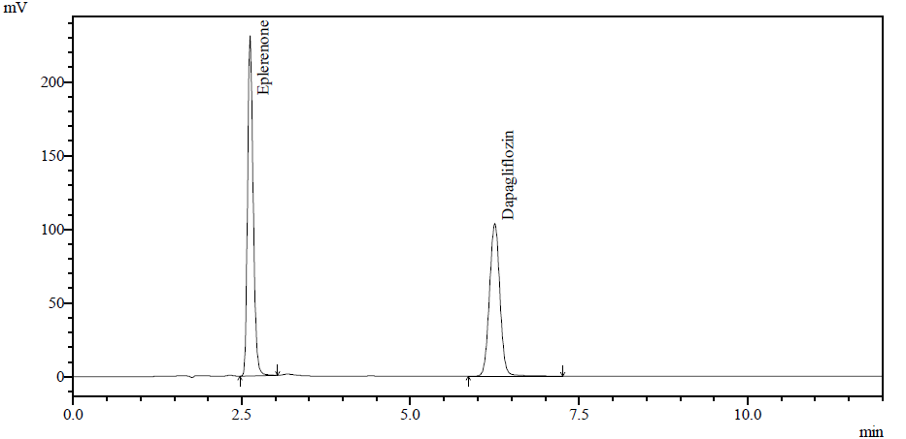
Figure 21 Trial 6- 20 µg/ml dapagliflozin + 50 µg/ml eplerenone, M.P- Phosphate buffer : Methanol (30:70 %v/v)
Table 21 Optimized chromatographic conditions
Stationary Phase | Cosmosil C18 (250 cm×4.6 mm, 5µm)
Mobile Phase (v/v) | Phosphate Buffer: Methanol (30:70%v/v)
Diluent | Methanol
Mode of elution | Isocratic
Flow Rate (mL/min) | 1.0 ml/min
Detection Wavelength (nm) | 228 nm
Column Temperature | 25 °C
Injection Volume (µL) | 20 µL
Run Time (minutes) | 12 min
Retention time (minutes) | DAPA- 6.2 min, EPLE- 2.6 min

System suitability parameters
The DAPA + EPLE solution at concentrations of 20 and 50 µg/mL was injected five times to evaluate system suitability test (SST) parameters, including retention time (Rt), number of theoretical plates, peak area, resolution and tailing factor (n = 5).
Table 22 System suitability parameters for DAPA (n = 5)
Parameters | Mean ± SD | % RSD
Retention time | 6.19 ± 0.04 | 0.72
Tailing factor | 1.03 ± 0.02 | 1.47
Theoretical plates | 7502.60 ±16.62 | 0.22
Area | 111676.80 ± 15.07 | 0.01
Resolution | 16.30 ± 0.24 | 1.46

Table 23 System suitability parameters for EPLE (n = 5)
Parameters | Mean ± SD | % RSD
Retention time | 2.66 ± 0.03 | 0.97
Tailing factor | 1.28 ± 0.01 | 0.78
Theoretical plates | 4045.80 ± 9.15 | 0.23
Area | 134361.80 ± 19.24 | 0.01
Resolution | - | -

Forced Degradation studies
Acid hydrolysis
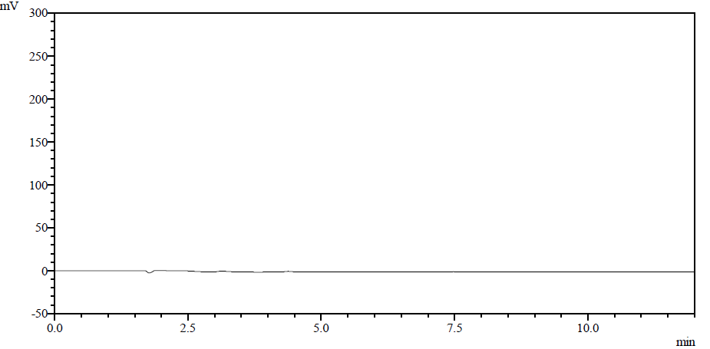
Figure 22 Acid blank
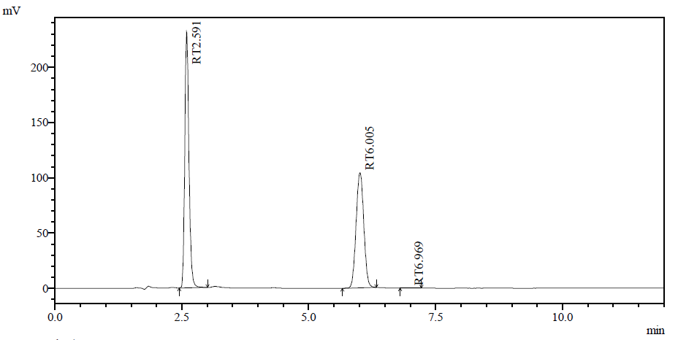
Figure 23 Standard API
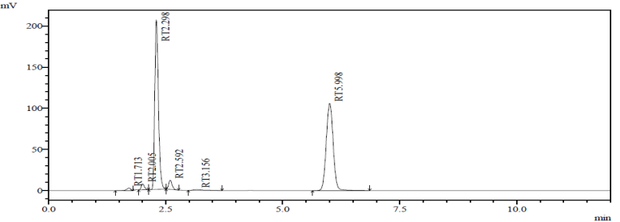
Figure 24 Sample of DAPA and EPLE for Acid degradation
The acid degradation study was performed by exposing the sample solution to acidic conditions to evaluate its stability behaviour. The chromatogram obtained after acid treatment showed noticeable degradation of the drug substance. A significant decrease in the peak area of the active pharmaceutical ingredient was observed compared to the untreated sample, indicating susceptibility to acid hydrolysis.
Base hydrolysis
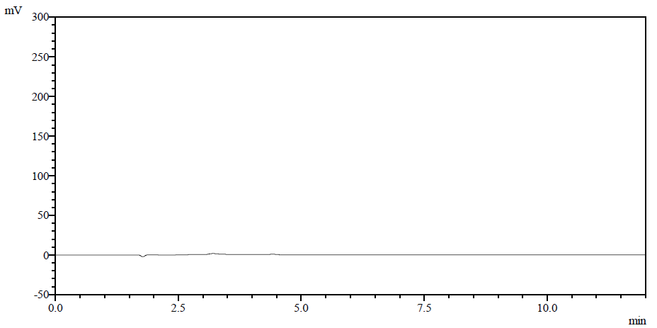

Figure 25 Base blank
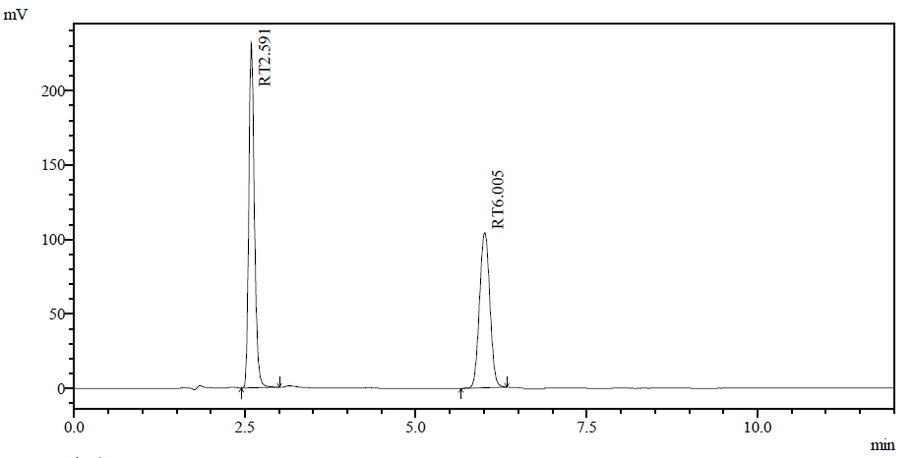
Figure 26 Standard API
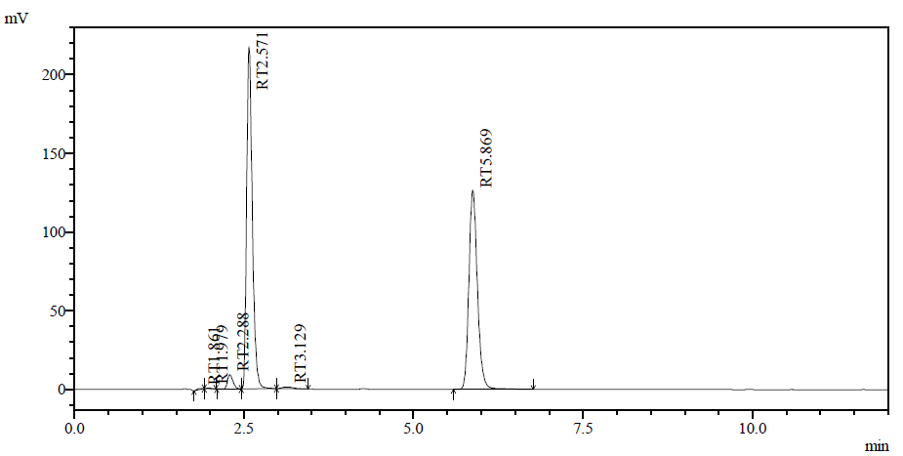
Figure 27 Sample of DAPA and EPLE for Base degradation
The base hydrolysis study was conducted by exposing the drug solution to alkaline conditions to evaluate its stability under basic stress. After treatment, the chromatogram showed a noticeable reduction in the peak area of the active pharmaceutical ingredient when compared to the untreated standard solution, indicating degradation under alkaline conditions. Additional peaks corresponding to degradation products were observed at different retention times. These degradant peaks were well separated from the principal drug peak, confirming the specificity and stability-indicating nature of the developed analytical method.
Peroxide hydrolysis
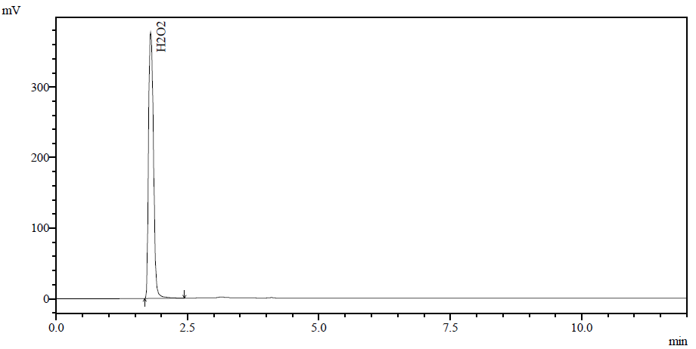
Figure 28 Peroxide blank

Figure 29 Standard API

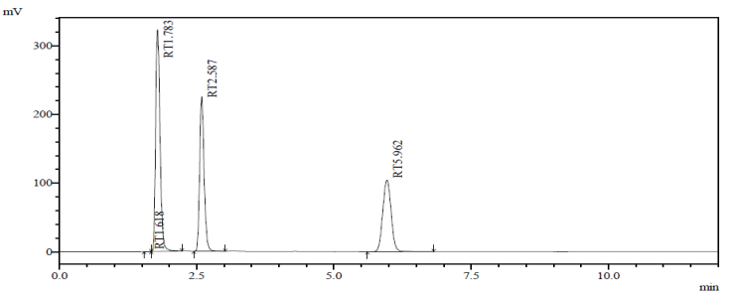
Figure 30 Sample of DAPA and EPLE for Peroxide degradation
The oxidative degradation study was carried out by treating the drug solution with hydrogen peroxide to evaluate its stability under oxidative stress conditions. After the specified exposure period, the chromatogram exhibited a reduction in the peak area of the active pharmaceutical ingredient compared to the untreated sample, indicating susceptibility to oxidative degradation. One or more additional peaks corresponding to oxidative degradation products were observed at distinct retention times. These degradant peaks were well resolved from the principal drug peak, confirming the selectivity and stability-indicating capability of the developed analytical method.
Thermal Degradation
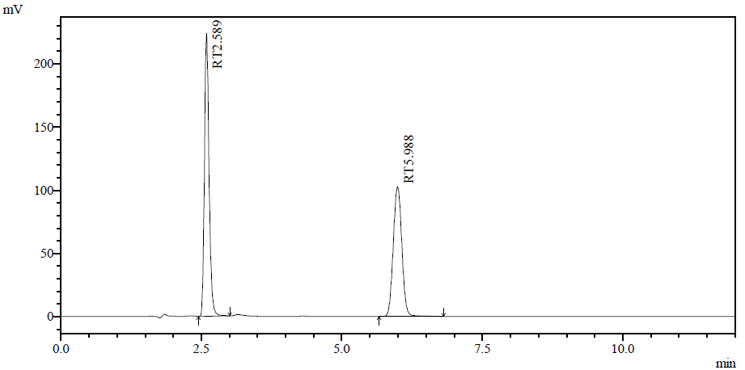
Figure 31 Standard API
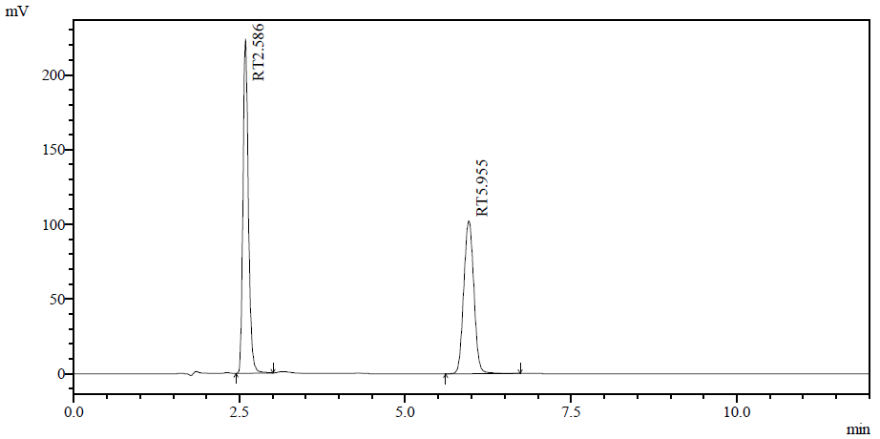
Figure 32 Sample of DAPA and EPLE for Thermal degradation
The thermal degradation study was performed by exposing the drug substance to elevated temperature conditions for a specified period to assess its stability under heat stress. After thermal treatment, the chromatogram showed a slight reduction in the peak area of the active pharmaceutical ingredient compared to the untreated sample, indicating partial degradation due to heat exposure.
Table 24 Summary of forced degradation studies
Stress Condition | Compound | Std. Area | Obs. Area | % Degradation
Acid | DAPA | 111682 | 105151 | 5.848
 | EPLE | 134350 | 111923 | 16.693
Base | DAPA | 111478 | 100512 | 9.837
 | EPLE | 134478 | 126429 | 5.985
Oxidative | DAPA | 111528 | 101051 | 9.394
 | EPLE | 134587 | 127655 | 5.151
Thermal | DAPA | 111748 | 108828 | 2.613
 | EPLE | 134357 | 128053 | 4.692

Conclusion of Forced Degradation Studies
Forced degradation studies of Dapagliflozin (DAPA) and Eplerenone (EPLE) under various stress conditions, including acidic, basic, oxidative, and thermal environments, revealed that both analytes undergo degradation to varying extents.
Dapagliflozin showed maximum degradation under basic and oxidative conditions, followed by acidic stress, while it remained relatively stable under thermal conditions. On the other hand, Eplerenone exhibited significant degradation under acidic conditions, whereas comparatively lower degradation was observed under basic, oxidative, and thermal stress.
The results indicate that both drugs are susceptible to degradation under stress conditions, with distinct degradation behavior for each analyte. However, the degradation products did not interfere with the main peaks, demonstrating that the developed HPLC method is stability-indicating in nature.
Validation of the developed RP-HPLC method
Specificity results
The specificity of the developed HPLC method was critically evaluated through the analysis of individual standard solutions and their combined mixture for Dapagliflozin and Eplerenone. The chromatographic profiles demonstrated that both analytes produced sharp, symmetrical, and well-resolved peaks at distinct retention times. The retention behavior of each compound in the combined mixture was found to be consistent with that observed in the individual standard injections, thereby confirming the identity of the respective peaks. Furthermore, no extraneous or co-eluting peaks were detected at or near the retention times of the analytes, indicating the absence of interference from formulation excipients or other potential impurities. The baseline around the peaks remained stable, and adequate resolution between the two analytes was achieved. These findings substantiate that the developed method possesses a high degree of specificity and is capable of unequivocally identifying Dapagliflozin and Eplerenone in the presence of other components, making it suitable for routine analytical applications.
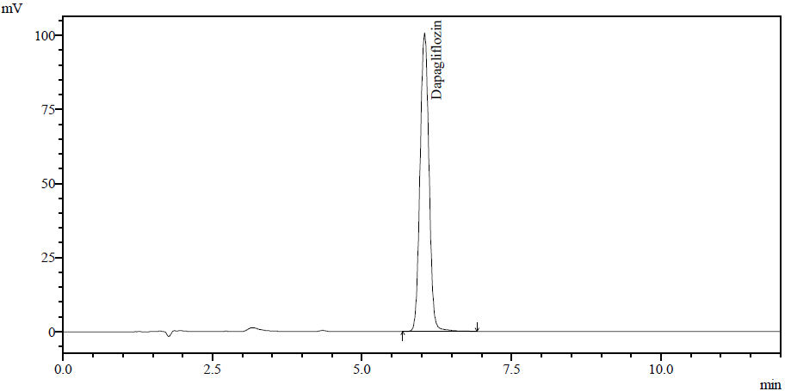

Figure 33 Peak identification for Dapagliflozin

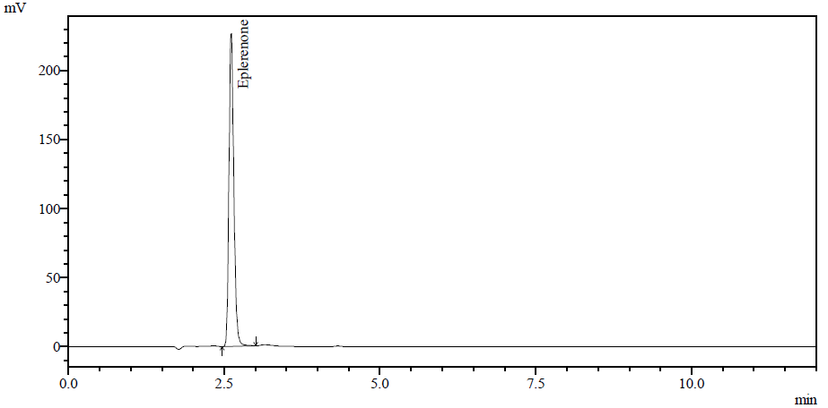
Figure 34 Peak identification for Eplerenone
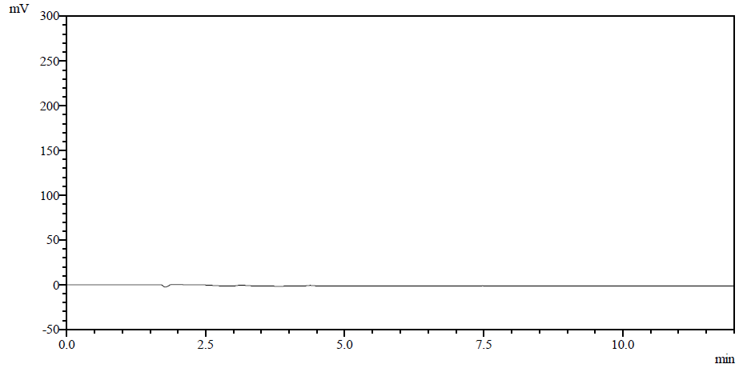
Figure 35 Chromatogram of mobile phase
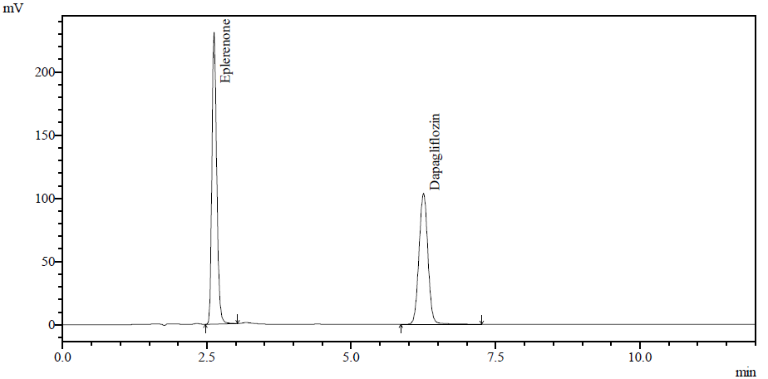
Figure 36 Chromatogram of standard solution
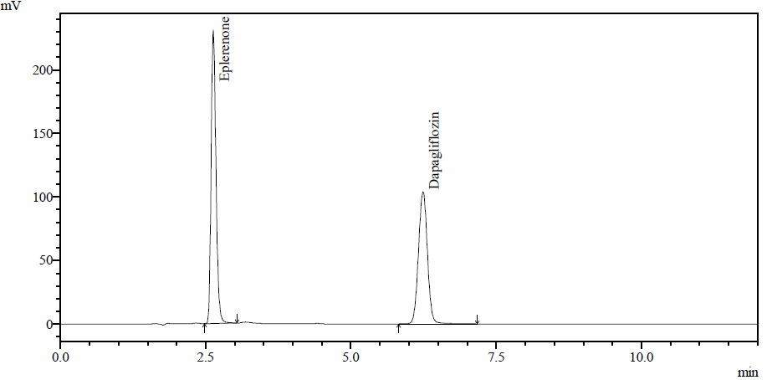
Figure 37 Chromatogram of synthetic mixture
Result- No extraneous or co-eluting peaks were detected at or near the retention times of the analytes, indicating the absence of interference from formulation excipients or other potential impurities. The baseline around the peaks

remained stable, and adequate resolution between the two analytes was achieved.
Range and Linearity
The linearity of the developed HPLC method was established by analyzing standard solutions of Dapagliflozin and Eplerenone at five concentration levels over the selected working range. Calibration curves were constructed by plotting peak area against concentration for both analytes. Dapagliflozin exhibited linearity in the concentration range of 10–30 µg/mL, while Eplerenone showed linearity in the range of 25–75 µg/mL. The obtained calibration plots demonstrated a direct and proportional relationship between concentration and detector response across the studied range. The regression analysis indicated a high degree of linearity, as evidenced by correlation coefficient (R²) values close to unity for both analytes. Additionally, the chromatographic responses at each concentration level were consistent, indicating the reliability of the method within the selected range. The established linearity range adequately covers the working concentrations used for routine analysis.
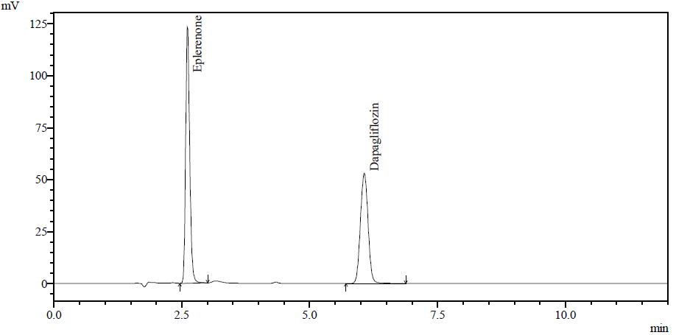
Figure 38 Chromatogram of Linearity 50%
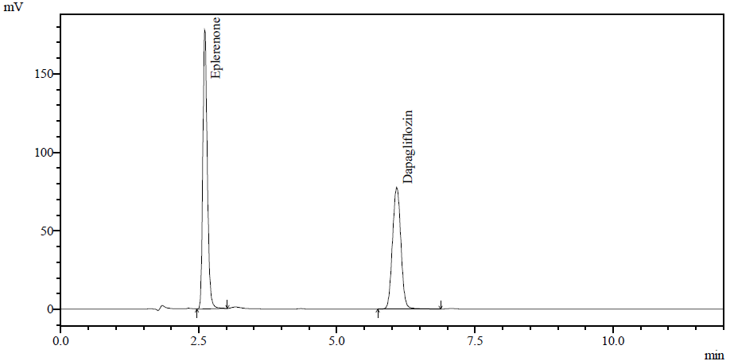
Figure 39 Chromatogram of Linearity 75%
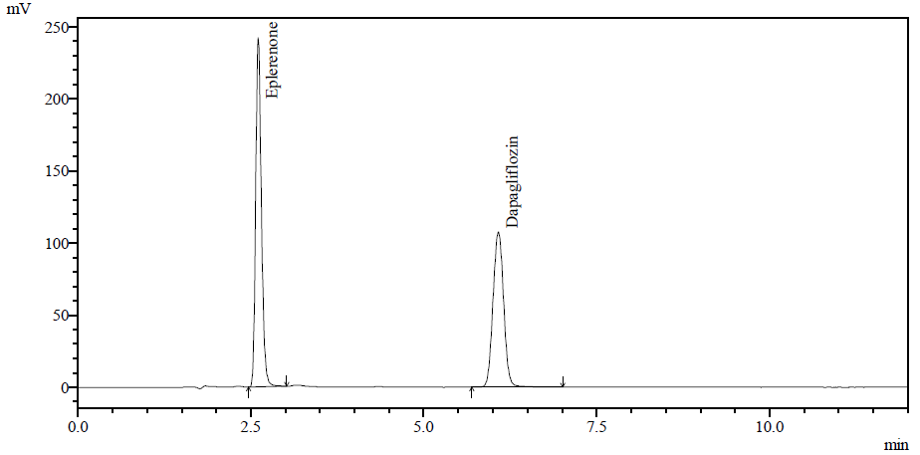
Figure 40 Chromatogram of Linearity 100%

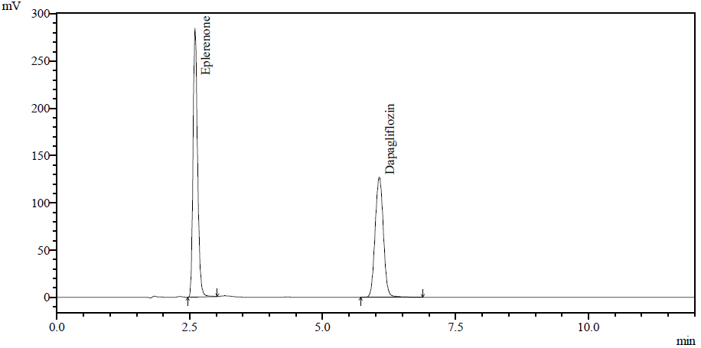
Figure 41 Chromatogram of Linearity 125%

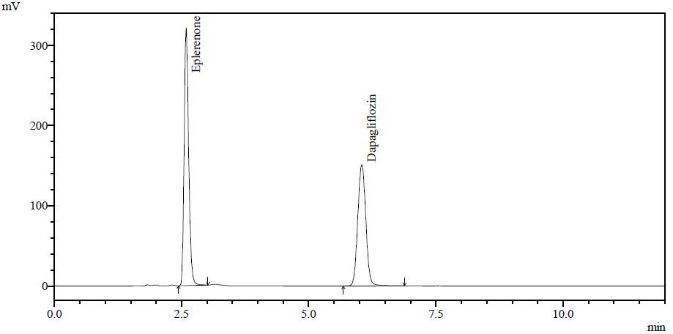
Figure 42 Chromatogram of Linearity 150%
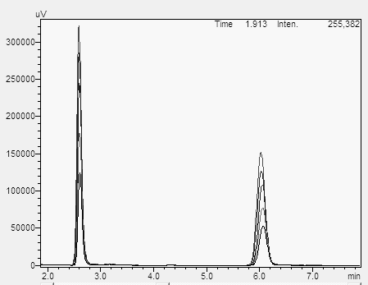
Figure 43 Overlay Chromatogram of Linearity
Table 25 Linearity data for DAPA
Sr. No. | Concentration (μg/mL) | Peak Area (Mean ± S. D. ) | % RSD
1. | 10 | 55587.00 ± 53.11 | 0.10
2. | 15 | 82281.33 ± 63.57 | 0.08
3. | 20 | 111883.33 ± 113.78 | 0.10
4. | 25 | 137372.67 ± 56.08 | 0.04
5. | 30 | 166461.67 ± 134.40 | 0.08
Linear Regression equation |  |  | y=5535.5x – 5.7333
Linear Regression Coefficient |  |  | R² =0.9996

Figure 44 Calibration curve for DAPA
Table 26 Linearity data for EPLE
Sr. No. | Concentration (μg/mL) | Peak Area (Mean ± S. D. ) | % RSD
1. | 25 | 68450.33 ± 96 | 0.14
2. | 37.5 | 100577.00 ± 87.43 | 0.09
3. | 50 | 137406.33 ± 278.99 | 0.20
4. | 62.5 | 169586.00 ± 314.50 | 0.19
5. | 75 | 199353.67 ± 223.51 | 0.11
Linear Regression equation |  |  | y=2646.5x +2748.4
Linear Regression Coefficient |  |  | R² =0.9988

Figure 45 Calibration curve for EPLE

This study was conducted to evaluate the linearity of the proposed RP-HPLC method for the simultaneous estimation
of Dapagliflozin and Eplerenone over a defined concentration range. A minimum acceptance criterion of correlation coefficient (r²) greater than 0.995 was considered to confirm adequate linearity of the method.
Results:
The calibration data produced correlation coefficient (r²) values of 0.9996 for Dapagliflozin and 0.9988 for Eplerenone. These values are well within the acceptable limits, demonstrating a strong and direct relationship between concentration and chromatographic response for both analytes.
Conclusion:
Based on compliance with the established linearity criteria, the developed RP-HPLC method is considered reliable for quantitative analysis of Dapagliflozin within the concentration range of 10–30 µg/mL and Eplerenone within 25–75 µg/mL. The validated linear range confirms the suitability of the method for accurate estimation of both drugs in routine analysis.
Repeatability
Table 27 Repeatability Data for DAPA
Area | Concentration of DAPA ( 20 µg/mL)
1. | 115928
2. | 115268
3. | 115654
4. | 115123
5. | 115789
6. | 115874
Mean | 115606.00
SD | 334.32
% RSD | 0.29

Table 28 Repeatability Data for EPLE
Area | Concentration of EPLE (50 µg/mL)
1. | 140467
2. | 139650
3. | 140102
4. | 140987
5. | 139784
6. | 140620
Mean | 140268.33
SD | 514.63
% RSD | 0.37

Repeatability evaluates the ability of the analytical method to produce consistent results when multiple measurements are carried out under the same experimental conditions. As per ICH guidelines, the method is considered precise if the percentage Relative Standard Deviation (%RSD) does not exceed 2%.
Results:
The % RSD values obtained for Dapagliflozin and Eplerenone at the selected concentration level (20 µg/mL and 50 µg/mL, respectively) were found to be less than 2%. This indicates minimal variation among replicate injections and demonstrates good system consistency.
Conclusion:
Since the % RSD values for both analytes were within the acceptable limit, the developed RP-HPLC method can be considered repeatable. The results confirm that the method provides reliable and consistent responses for the quantitative determination of Dapagliflozin and Eplerenone.
Intraday Precision
Table 29 Data of Intraday precision of DAPA and EPLE
Conc. DAPA (µg. mL⁻¹) | Intraday (Mean Area ± SD) | % RSD | Conc. EPLE (µg. mL⁻¹) | Intraday (Mean Area ± SD) | % RSD
10 | 55471.67 ± 86.41 | 0.16 | 25 | 68451.33 ± 94.50 | 0.14
20 | 115485.33 ± 546.87 | 0.47 | 50 | 140245.67 ± 521.50 | 0.37
30 | 166048.33 ± 819.48 | 0.49 | 75 | 199645.67 ± 300.91 | 0.15

Intra-day precision assesses the consistency of the analytical method when measurements are performed multiple times within the same day at different time intervals. According to ICH guidelines, the method is considered precise if the percentage Relative Standard Deviation (%RSD) is less than 2%.
Results:
The intra-day precision was evaluated at three concentration levels, corresponding to 50%, 100%, and 150%, i.e., 10 µg/mL and 25 µg/mL, 20 µg/mL and 50 µg/mL, and 30 µg/mL and 75 µg/mL for Dapagliflozin and Eplerenone, respectively. The %RSD values obtained for both analytes at all concentration levels were found to be less than 2%, indicating good repeatability of results within the same day.
Conclusion:
A s the %RSD values were within the acceptable limit for all concentration levels, the developed RP-HPLC method demonstrates good intra-day precision. This confirms that the method is capable of providing consistent and reliable results during routine analysis performed within a single day.
Inter-day precision
Table 30 Data of Inter-day precision of DAPA and EPLE
Conc. DAPA (µg. mL⁻¹) | Inter-day (Mean Area ± SD) | % RSD | Conc. EPLE (µg. mL⁻¹) | Inter-day (Mean Area ± SD) | % RSD
10 | 55531.67 ± 370.24 | 0.67 | 25 | 68489.00 ± 414.34 | 0.60
20 | 115855.33 ± 851.05 | 0.73 | 50 | 140291.00 ± 623.37 | 0.44
30 | 166649.00 ± 697.36 | 0.42 | 75 | 199073.33 ± 767.51 | 0.39

Inter-day precision evaluates the reproducibility of the analytical method when measurements are carried out on

different days under similar experimental conditions. As per ICH guidelines, a %RSD value not exceeding 2% is considered acceptable for demonstrating adequate precision.
Results:
The inter-day precision was assessed at three concentration levels, corresponding to 50%, 100%, and 150%, i.e., 10 µg/mL and 25 µg/mL, 20 µg/mL and 50 µg/mL, and 30 µg/mL and 75 µg/mL for Dapagliflozin and Eplerenone, respectively. The %RSD values obtained for both analytes at all concentration levels across different days were found to be less than 2%, indicating minimal variability in the results.
Conclusion:
The observed %RSD values within acceptable limits confirm that the developed RP-HPLC method possesses good inter-day precision. The method is therefore reliable and reproducible for the quantitative estimation of Dapagliflozin and Eplerenone over multiple days.
Accuracy
Table 31 Accuracy data for DAPA and EPLE
Accuracy Data for DAPA
Level of  Spiking | Quantity of  placebo(mg) | Amount of drug  Added (µg/mL) | Amount of drug  Recovered (µg/mL) | Std area | Test area (Mean) | % Mean recovery ± SD
Un-spiked | 86 | - | - | - | - | -
50% | 86 | 10 | 9.999 | 55568 | 55565.00 | 99.995 ± 0.009
100% | 86 | 20 | 19.999 | 111928 | 111924.67 | 99.997 ± 0.004
150% | 86 | 30 | 30.000 | 166610 | 166609.33 | 100.000 ± 0.002
Accuracy data for EPLE
Un-spiked | 86 | - | - | - | - | -
50% | 86 | 25 | 24.999 | 68546 | 68489.00 | 99.996 ± 0.007
100% | 86 | 50 | 49.995 | 137467 | 140291.00 | 99.990 ± 0.008
150% | 86 | 75 | 74.998 | 199545 | 199073.33 | 99.997 ± 0.008

Accuracy represents the closeness of agreement between the experimentally obtained values and the true value of the analytes. As per ICH guidelines, the method is considered accurate if the percentage recovery lies within the acceptable range of 98% to 102%.
Results:
The accuracy of the method was evaluated at three concentration levels corresponding to 50%, 100%, and 150%, i.e., 10 µg/mL and 25 µg/mL, 20 µg/mL and 50 µg/mL, and 30 µg/mL and 75 µg/mL for Dapagliflozin and Eplerenone, respectively. The percentage recovery values obtained for both analytes at all levels were found to be within the range of 98% to 102%.
Conclusion:
The recovery results within the acceptable limits confirm that the developed RP-HPLC method is accurate. The method is therefore suitable for the reliable quantification of Dapagliflozin and Eplerenone in pharmaceutical formulations.
LOD and LOQ
The LOD & LOQ were calculated on basis of formula
LOD = 3.3 × σ / S
LOQ = 10 × σ / S
LOD for Dapagliflozin was found to be- 0.034
LOQ for Dapagliflozin was found to be- 0.104
LOD for Eplerenone was found to be- 0.080
LOQ for Eplerenone was found to be- 0.243
Criteria:
Although ICH guidelines do not make it mandatory to determine LOD and LOQ for assay methods, these parameters are useful for understanding the sensitivity of the developed analytical method. Hence, LOD and LOQ were evaluated for Dapagliflozin and Eplerenone.
Results:
The LOD values obtained for Dapagliflozin and Eplerenone indicate the minimum concentration at which the analytes can be detected reliably. Similarly, the LOQ values represent the lowest concentration at which the analytes can be quantified with acceptable precision and accuracy. The calculated values demonstrate that the method is sufficiently sensitive for the detection and quantification of both analytes at low concentration levels.
Conclusion:
The determined LOD and LOQ values confirm that the developed RP-HPLC method possesses adequate sensitivity for the estimation of Dapagliflozin and Eplerenone. The method is therefore suitable for routine analysis, even at low concentration levels.
Robustness
Table 32 Robustness data for DAPA and EPLE
DAPA
PARAMETER | LEVEL | AREA | MEAN | %RSD
Mobile phase composition | 28:72 | 116021 | 116437.67 | 0.35
Mobile phase composition | 28:72 | 116841 | 116437.67 | 0.35
Mobile phase composition | 28:72 | 116451 | 116437.67 | 0.35
Mobile phase composition | 32:68 | 114512 | 114453.33 | 0.32
Mobile phase composition | 32:68 | 114789 | 114453.33 | 0.32
Mobile phase composition | 32:68 | 114059 | 114453.33 | 0.32
Flow Rate  (ml/min) | 0.8 | 115928 | 115418.67 | 0.39
Flow Rate  (ml/min) | 0.8 | 115241 | 115418.67 | 0.39
Flow Rate  (ml/min) | 0.8 | 115087 | 115418.67 | 0.39
Flow Rate  (ml/min) | 1.2 | 117841 | 117325.33 | 0.39
Flow Rate  (ml/min) | 1.2 | 116981 | 117325.33 | 0.39
Flow Rate  (ml/min) | 1.2 | 117154 | 117325.33 | 0.39
EPLE
Mobile phase composition | 28:72 | 158963 | 158553.00 | 0.26
Mobile phase composition | 28:72 | 158149 | 158553.00 | 0.26
Mobile phase composition | 28:72 | 158547 | 158553.00 | 0.26
Mobile phase composition | 32:68 | 130214 | 130523.67 | 0.22
Mobile phase composition | 32:68 | 130789 | 130523.67 | 0.22
Mobile phase composition | 32:68 | 130568 | 130523.67 | 0.22
Flow Rate  (ml/min) | 0.8 | 140467 | 140393.00 | 0.17
Flow Rate  (ml/min) | 0.8 | 140587 | 140393.00 | 0.17
Flow Rate  (ml/min) | 0.8 | 140125 | 140393.00 | 0.17
Flow Rate  (ml/min) | 1.2 | 125412 | 125617.00 | 0.15
Flow Rate  (ml/min) | 1.2 | 125789 | 125617.00 | 0.15
Flow Rate  (ml/min) | 1.2 | 125650 | 125617.00 | 0.15

Criteria:
Robustness evaluates the reliability of an analytical method under small and deliberate variations in method parameters. As per general acceptance criteria, the method is considered robust if the percentage relative standard deviation (%RSD) remains below 2% under varied conditions.
Results:
The robustness of the developed RP-HPLC method was assessed by introducing slight variations in mobile phase composition and flow rate. For Dapagliflozin, the %RSD values were found to be in the range of 0.32–0.39% for changes in mobile phase composition and flow rate. Similarly, for Eplerenone, the %RSD values ranged from 0.15–0.26% under the same varied conditions.
These low %RSD values indicate that the chromatographic responses remained consistent despite minor changes in

analytical parameters.
Conclusion:
Since the %RSD values for both Dapagliflozin and Eplerenone were well within the acceptable limit, the developed method can be considered robust. The method demonstrates reliability and stability under small variations, confirming its suitability for routine analytical applications.
Assay of synthetic mixture
Table 33 Determination of DAPA and EPLE from synthetic mixture
Drug | Amount taken  (µg/mL) | Amount found  (µg/mL) (Mean ± SD) | % Assay (Mean ± SD)
DAPA | 20 | 20.07 ± 0.04 | 100.33 ± 0.03
EPLE | 50 | 49.82 ± 0.54 | 99.65 ± 0.81

Criteria:
The assay of pharmaceutical formulations is performed to determine the amount of active drug present in the sample. As per general acceptance criteria, the percentage assay value should lie within the range of 98% to 102% of the labelled claim.
Results:
The assay of the synthetic mixture was carried out using the developed RP-HPLC method. The amount of Dapagliflozin and Eplerenone found was 20.07 ± 0.04 µg/mL and 49.82 ± 0.54 µg/mL, respectively. The corresponding percentage assay values were 100.33 ± 0.03% for Dapagliflozin and 99.65 ± 0.81% for Eplerenone.

Conclusion:
The obtained assay values for both analytes were within the acceptable limits, indicating that the method is accurate and suitable for quantitative estimation. The low standard deviation values further confirm the consistency and reliability of the method for routine analysis of Dapagliflozin and Eplerenone.
CONCLUSION
Summary of HPLC method development and validation
Table 34 Summary of HPLC method
Stationary Phase | Cosmosil C18 (250 cm×4.6 mm, 5µm)
Mobile Phase (v/v) | Phosphate Buffer: Methanol (30:70%v/v)
Diluent | Methanol
Mode of elution | Isocratic
Flow Rate (mL/min) | 1.0 ml/min
Detection Wavelength (nm) | 228 nm
Column Temperature | 25 °C
Injection Volume (µL) | 20 µL
Run Time (minutes) | 12 min
Retention time (minutes) | DAPA- 6.2 min, EPLE- 2.6 min

Table 35 Summary of Validation parameters
Parameter | Dapagliflozin | Eplerenone
System suitability (Mean± % RSD) | 111676.80 ± 15.07 | 134361.80 ± 19.24
Linearity & Range (n=3) | 10-30 ppm | 25-75 ppm
Correlation coefficient (R²) | 0.9996 | 0.9988
Intra-day precision (% RSD) | 0.16-0.49 | 0.14-0.37
Inter-day Precision (% RSD) | 0.42-0.73 | 0.39-0.60
Repeatability (% RSD) | 0.29 | 0.37
Accuracy (% Mean recovery ± SD) | 99.995 ± 0.009  99.997 ± 0.004  100.00 ± 0.002 | 99.996 ± 0.007  99.990 ± 0.008  99.997 ± 0.008
Robustness | % RSD < 2 for all parameters | % RSD < 2 for all parameters
LOD | 0.034 | 0.080
LOQ | 0.104 | 0.243
Assay | 100.33 ± 0.03 | 99.65 ± 0.81

Table 36 Summary of Forced Degradation Studies
Stress Condition | Compound | Std. Area | Obs. Area | % Degradation | Remarks
Acid | DAPA | 111682 | 105151 | 5.848 | No interference
 | EPLE | 134350 | 111923 | 16.693 | Significant degradation
Base | DAPA | 111478 | 100512 | 9.837 | Moderate degradation
 | EPLE | 134478 | 126429 | 5.985 | Stable
Oxidative | DAPA | 111528 | 101051 | 9.394 | Moderate degradation
 | EPLE | 134587 | 127655 | 5.151 | Stable
Thermal | DAPA | 111748 | 108828 | 2.613 | Stable
 | EPLE | 134357 | 128053 | 4.692 | Stable

Conclusion of the method
In the present investigation, a reliable and efficient RP-HPLC method was successfully developed for the simultaneous estimation of Dapagliflozin and Eplerenone in synthetic mixture. The method was systematically optimized to achieve satisfactory chromatographic separation with well-defined and resolved peaks for both analytes.
The validation studies confirmed that the method complies with ICH guidelines. The linearity results demonstrated a strong correlation between concentration and response over the selected range, indicating the suitability of the method for quantitative analysis. Precision studies, including repeatability as well as intra-day and inter-day precision, revealed low variability (%RSD < 2%), confirming the consistency and reproducibility of the method.
Accuracy was established through recovery studies, with results falling within the acceptable limits, indicating that the method is free from interference by excipients. The robustness evaluation further demonstrated that small, deliberate variations in chromatographic conditions did not significantly affect the analytical performance, confirming the method’s reliability.
The assay results showed that the content of both Dapagliflozin and Eplerenone in the synthetic mixture was within acceptable limits, supporting the applicability of the method for routine quantitative estimation. Additionally, forced degradation studies revealed that both analytes undergo degradation under various stress conditions, with distinct degradation behavior. However, the method was capable of effectively separating the degradation products from the main peaks, indicating its stability-indicating nature.
In conclusion, the developed RP-HPLC method is simple, precise, accurate, robust, and stability-indicating. It can be confidently applied for routine quality control and stability studies of Dapagliflozin and Eplerenone in pharmaceutical formulations.

APPENDIX-I LIST OF ABBREVIATIONS

Abbreviations | Expanded Forms
T2DM | Type 2 Diabetes Mellitus
CKD | Chronic Kidney Disease
SGLT2 | Sodium–Glucose Cotransporter 2
MR | Mineralocorticoid Receptor
HFrEF | Heart Failure with Reduced E jection Fraction
ACE | Angiotensin-Converting Enzyme inhibitors
ARBs | Angiotensin II Receptor Blockers
eGFR | Glomerular Filtration Rate
UGT | Uridine Diphosphate-  Glucuronosyltransferase
MRAs | Mineralocorticoid Receptor Antagonists
BP | Blood Pressure
CDSCO | Central Drugs Standard Control Organization
HPLC | High-Performance Liquid Chromatography
GC | Gas Chromatography
R&D | Research and Development
API | Active Pharmaceutical Ingredient
UV | Ultraviolet Spectroscopy
IR | Infrared Spectroscopy
NP-HPLC | Normal Phase High Performance Liquid Chromatography
RP-HPLC | Reverse Phase High Performance Liquid Chromatography
IEC | Ion-Exchange Chromatography
SEC | Size-Exclusion Chromatography
GPC | Gel Permeation Chromatography
DAS | Data Acquisition System
USP | United States Pharmacopeia
IP | Indian Pharmacopeia
BP | British Pharmacopoeia
ICH | International Conference for Harmonization
WHO | World Health Organization
LLOQ | Lower Llimit of Quantification
ULOQ | Upper Limit of Quantification
RSD | Relative Standard Deviation
CV | Coefficient of Variation
LOD | Limit of Detection
LOQ | Limit of Quantification
IUPAC  CAS | International Union of Pure and Applied Chemistry  Chemical Abstracts Service
FDA | Food and Drug Administration
BCS | Biopharmaceutics Classification System
DMSO | Dimethyl sulfoxide
RAAS | Renin-Angiotensin- Aldosterone-System
DAPA | Dapagliflozin Propanediol Monohydrate
EPLE | Eplerenone
ACN | Acetonitrile
QbD | Quality by Design
MET | Metformin
BDS | Base Deactivated Silica
OPA | Ortho Phosphoric Acid
LC-MS | Liquid Chromatography-Mass Spectrometry
UPLC | Ultra Performance Liquid  Chromatography
AR Grade | Analytical Reagent Grade
PVDF | Polyvinylidene Fluoride Filter
SST | System Suitability Test
RT | Retention Time
Rs | Resolution
% | Percentage
°C | Degree Celsius
µg/mL. | Microgram Per Millilitre
µg | Microlitre
Pka | Dissociation Constant
Log P | Partition Co-efficient
Tf | Tailing Factor

REFERENCES
1.Olokoba, A. B., Obateru, O. A., & Olokoba, L. B. (2012). Type 2 diabetes mellitus: A review of current trends. Oman Medical Journal, 27(4), 269–273.
2.Provenzano, M., Puchades, M. J., Garofalo, C., Jongs, N., D’Marco, L., Andreucci, M., De Nicola, L., & Gorriz, J. L. (2022). Albuminuria-lowering effect of dapagliflozin, eplerenone, and their combination in patients with chronic kidney disease: A randomized crossover clinical trial. Journal of the American Society of Nephrology, 33(8), 1569–1580.
3.Soulié, M., Stephan, Y., Durand, M., Lima-Posada, I., Palacios-Ramírez, R., Nicol, L., Lopez-Andres, N., Mulder, P., & Jaisser, F. (2024). Benefit of combination therapy with dapagliflozin and eplerenone on cardiac function and fibrosis in rats with non-diabetic chronic kidney disease. Scientific Reports, 14(1), 23955.
4.CDSCO. (2024). FDC of dapagliflozin and eplerenone. Retrieved August 28, 2025, from https://www.cdsco.gov.in/opencms/resources/UploadCDSCOWeb/2018/UploadCTApprovals/FDC_MA_24_000133_Exemed.pdf
5.Rajamahanti, S. G. (2017). Analytical method development and validation of a few drugs by RP-HPLC in pharmaceutical dosage forms (PhD thesis). Andhra University.
6.Braun, R. D. (2012). Introduction to instrumental analysis (2nd ed.). PharmaMed Press/BSP Books.
7.Bose, A. (2014). HPLC calibration process parameters in terms of system suitability test. Austin Chromatography, 1(2), 1–4.
8.Patil, P. S., & Kavita, D. (2022). High-performance liquid chromatography (HPLC) method development and validation. International Journal of Pharmaceutical Sciences Review and Research, 74(2), 23–29.
9.International Council for Harmonisation (ICH). (2022). Validation of analytical procedures: Text and methodology Q2(R2).Retrieved from https://database.ich.org/sites/default/files/ICH_Q2-R2_Document_Step2_Guideline_2022_0324.pdf
10.Vidushi, Y., Meenakshi, B., & Bharkatiya, M. (2017). A review on HPLC method development and validation. Research Journal of Life Sciences, Bioinformatics, Pharmaceutical and Chemical Sciences, 2(6), 166–178.
11.DrugBank. (2025). Dapagliflozin propanediol monohydrate. Retrieved September 2, 2025, from https://go.drugbank.com/drugs/DB06292
12.DrugBank. (2025). Eplerenone. Retrieved September 3, 2025, from https://go.drugbank.com/drugs/DB00700
13.PubChem. (2025). Eplerenone. Retrieved September 3, 2025, from https://pubchem.ncbi.nlm.nih.gov/compound/Eplerenone
14.United States Pharmacopeia. (2024). United States pharmacopeia and national formulary (pp. 1364–1365).
15. Mante, G. V., Gupta, K. R., & Hemke, A. T. (2017). Estimation of dapagliflozin from its tablet formulation by UV-spectrophotometry. Pharmaceutical Methods, 8(2), 102–107.
16.Vadla, S., Putta, V., Nadipudi, S., Bilakanti, S., & Kudumula, N. (2023). Estimation method for dapagliflozin in bulk and marketed dosage form. International Journal of Pharmaceutical and Phytopharmacological Research, 13(4), 1–6.
17.Debata, J., Kumar, S., Jha, S. K., & Khan, A. (2017). A new RP-HPLC method development and validation of dapagliflozin. International Journal of Drug Development and Research, 9(2), 48–51.
18.Mante, G. V., Hemke, A. T., & Umekar, M. J. (2018). RP-HPLC method for estimation of dapagliflozin. International Journal of ChemTech Research, 11(1), 242–248.
19.Manoharan, G., Ismaiel, A. M., & Ahmed, Z. M. (2018). Stability-indicating RP-HPLC method development. Chemical Research Journal, 3(2), 159–164.
20.Verma, M. V., Patel, C. J., & Patel, M. M. (2017). Development and stability indicating HPLC method.

International Journal of Applied Pharmaceutics, 9(5), 33–41.
21.Rao, B. R., Rao, V. V., & Venkateswarlu, B. S. (2019). RP-HPLC method for simultaneous estimation of dapagliflozin and saxagliptin in bulk samples. Journal of Pharmaceutical Sciences and Research, 11(1), 254–257.
22.Deepan, T., & Dhanaraju, M. D. (2018). Stability indicating HPLC method for the simultaneous determination of dapagliflozin and saxagliptin. Current Issues in Pharmacy and Medical Sciences, 31(1), 39–43.
23.Sharif, S., Bashir, R., Adnan, A., Mansoor, S., Ahmad, I., Ch, A. R., & Tahir, M. S. (2020). Stability indicating, pH and pKa dependent HPLC–DAD method for simultaneous determination of SGLT2 inhibitors. Chromatographia, 83(12), 1453–1465.
24.Siddique, W., Zulcaif, Umar, H., Usmani, S. J., Waqas, M., Gul, M., & Gul, M. (2025). Method development and validation of metformin HCl and dapagliflozin by RP-HPLC. Acta Chromatographica, 37(2), 176–182.
25.Kladi, E., Zerva, M., & Dotsikas, Y. (2024). A novel HPLC method for the simultaneous determination of empagliflozin and dapagliflozin. Archives of Pharmacy, 74(2), 267–280.
26.Prajapati, P., Rana, B., Pulusu, V. S., & Shah, S. (2024). Simultaneous chromatographic estimation of vildagliptin and dapagliflozin. Journal of AOAC International, 107(1), 212–222.
27.Indian Pharmacopoeia Commission. (2022). Indian pharmacopoeia (Vol. 2, pp. 2250–2251). Ghaziabad, India.
28.British Pharmacopoeia Commission. (2024). British pharmacopoeia.
29.Shailaja, B., Swarna, K., Afreen, M., & Kumar, A. (2015). A rapid assay method development and validation for
estimation of eplerenone. International Journal of Pharmacy and Pharmaceutical Sciences, 7(9), 327–330.
30.Manasa, P., Jaffer, S. K., Ashwini, M., & Kumar, A. A. (2015). A simple UV assay method development for estimation of eplerenone. International Journal of Pharmacy and Pharmaceutical Sciences, 7(10), 348–351.
31.Rane, V. P., Patil, K. R., Sangshetti, J. N., Yeole, R. D., & Shinde, D. B. (2009). Stability-indicating RP-HPLC method for analysis of eplerenone. Acta Chromatographica, 21(4), 619–629.
32.Gide, P., Sonawane, S., & Chitnis, A. (2012). Development and validation of RP-HPLC method for estimation of eplerenone in spiked human plasma. Journal of Pharmaceutical Analysis, 2(5), 390–393.
33.Zhang, J. Y., Fast, D. M., & Breau, A. P. (2003). Development and validation of LC–MS/MS assay for eplerenone in plasma. Journal of Chromatography B, 787(2), 333–344.
34.Du, M., Pan, C., Chen, J., Song, M., Zhu, T., & Hang, T. (2016). Stability-indicating UPLC method for impurities in eplerenone. Journal of Separation Science, 39(15), 2907–2918.
35.Zhang, J. Y., Fast, D. M., & Breau, A. P. (2003). SPE–LC-MS/MS assay for eplerenone in human urine. Journal of Pharmaceutical and Biomedical Analysis, 31(1), 103–115.
36.Kumar, D. V., Srinivas, S., & Kumar, A. A. (2015). RP-HPLC method development and validation for estimation of eplerenone in tablets. International Journal of Pharmacy and Pharmaceutical Sciences, 360–364.
37.Sangshetti, J. N., Shinde, D., & Ma, B. A. (2009). Stability-indicating RP-HPLC method for eplerenone. Acta Chromatographica, 21(4), 619–629.
38.Sonawane, S., & Gide, P. (2011). Experimental design approach for forced degradation studies of eplerenone. Journal of Liquid Chromatography & Related Technologies, 34(17), 2020–2031.
39.Patel, K. S., Bendale, A., Luhar, S. V., & Narkhede, S. B. (2016). RP-HPLC method for simultaneous estimation of eplerenone and torsemide. Journal of Pharmaceutical Science and Bio-Scientific Research, 6(3), 283–290.
40.Hinge, M. A., & Patel, D. (2022). Optimization of HPLC method using central composite design. Brazilian Journal of Pharmaceutical Sciences, 58, e20219.
41.Thosar, S., Gokhale, R., & Tolbert, D. (2003). Immediate release eplerenone compositions (U.S. Patent No. 6,558,707).

42.Bian, Z. (2008). Eplerenone pharmaceutical composition (China Patent No. CN101152187A).
43.Shah, V., Redasani, V., & Ghongade, A. (2023). Pharmaceutical composition comprising dapagliflozin (U.S. Patent No. 11,660,308 B2).
44.Staric, R., & Berglez, S. (2019). Formulations containing amorphous dapagliflozin (U.S. Patent No.
US20190175543A1).
45.Chivukula, K. R. (2020). Co-crystals of SGLT2 inhibitors and pharmaceutical compositions (U.S. Patent No. 10,738,038 B2).
46.Joshi, I., Jawarkar, S., & Sawale, A. (2022). Formulation and evaluation of pulsatile drug release tablets. International Journal of Creative Research Thoughts, 10(5), 872–885.
47.TCI Chemicals. (2026). Eplerenone. Retrieved January 1, 2026, from https://www.tcichemicals.com/IN/en/p/E0905
48.Hinge, M., Patel, D., & Patel, A. (2019). Development and validation of UV spectrophotometric method for estimation of torsemide and eplerenone. International Journal of Pharmaceutical Sciences Review and Research, 56(2), 63–67.
49.Indian Pharmacopoeia Commission. (2022). Indian pharmacopoeia (Vol. 1, p. 618). Ghaziabad, India.
50.Kaczmarek, M., Przerada, S., Hrakovsky, J., & Dzik, J. (2022). Pharmaceutical composition comprising dapagliflozin (WO Patent No. WO2021165316A1).

