CULTURAL AUTHENTICITY AND IMPLICATIONS FOR CULTURAL TOURISM DEVELOPMENT AN ETHNOGRAPHIC INTEROGATION OF SANGO FESTIVAL IN OGBOMOSO, OYO STATE, NIGERIA
ABSTRACT
As festivals help to strengthen social ties and promote a sense of community by bringing people together to celebrate their cultural heritage, the question of Sango festival being authentic remains questionable as it forms the bases of this work. This paper deals with cultural authenticity and implications for cultural tourism development an ethnographic interrogation of Sango festival in Ogbomoso, Oyo state, Nigeria. The objectives are to examine the authenticity of Sango festival, in Ogbomoso town, to find out the level of custodian’s fervency of Sango deity and to examine the effects on tourism development in Ogbomoso. The methods used are: Participant Observation:- Immersing in the festival activities to observe rituals, performances, and interactions and Gaining firsthand experience of how cultural authenticity is maintained and In-Depth Interviews:- Conducting interviews with festival organizers, cultural custodians, participants, and local community members to understand their perspectives.. Sango festival is not celebrated as it was originally because out of the hundred respondents consulted, 83% of the respondents strongly agree that Sango festival is fading out. On the issue of the custodians, those people celebrating the Sango festival only demonstrate the magical aspect of Sango in form of play. On the custodians of Sango being adherent to Sango festival like before, 93% of the respondents strongly agree that there have not been fervency again while 2% of the respondents strongly disagreed and 2% of the respondents having not aware and 3% of the respondents having neutral option respectively. The study therefore shows that lack of authenticity and poor participation of some devotees leads to low patronage of tourists.
Keywords: Culture, Authenticity, Festival Tourism and Sango
INTRODUCTION AND LITERATURE REVIEW
Culture is the totality of learned, socially transmitted customs, knowledge, material objects and behaviour. It includes the ideas, value, customs and artifacts of a group of people. Charles Taylor defined it as "that complex whole which includes knowledge, belief, art, law, morals, custom, and any other capabilities and habits acquired by man as a member of society"(Taylor, 1991). Culture is a pattern of human activities and the symbols that give these activities significance. It is what people eat, how they dress, beliefs they hold and activities they engage in. It is the totality of the way of life evolved by a people in their attempts to meet the challenges of living in their environment, which gives order and meaning to their social, political, economic, aesthetic and religious norms and modes of organisation thus distinguishing people from their neighbors. Culture comprises material, institutional, philosophical and creative aspects.
Oxford English Dictionary (https://www.vocabulary.com) defined authenticity as being the quality of being genuine or real or “in accordance with fact, as being true in substance.” The dictionary defines authenticity again “as being what it professes in origin or authorship; as being genuine.” In this second definition we get the sense that authenticity is rooted in creativity and self - expression rather than in conformity to social forces. A third definition offered by the Oxford English Dictionary characterizes the authentic as that which is “real, actual.” Here, the authentic stands against replicas, pretense, and posing—a narrative common in popular culture. Synonymously, the word suggests the genuineness of a thing, unique quality, the validity, accuracy and faithfulness of a thing/person to itself and what it represents. What each of these definitions share in common is the reification of authenticity in everyday culture and discourse? Authenticity is to be understood as an inherent quality of some object, person or process. As a philosophical concept, it denotes the genuine, original, true state of human existence. The concept arises from the insights that human beings generally live or exist in an inauthentic way and that the genuine sense of self and its relationship with others have been lost, hence the quest for its restoration. According to Smith (2018, Tan (2018), such festivals help to reduce cultural barriers and promote social cohesion by encouraging interaction and mutual respect among participants from different backgrounds. Thomas (2019) found that the festival not only boosts the local economy but also promotes cultural exchange and understanding, helping to build a more inclusive and cohesive society. According to Moyo (2019), such festivals help to strengthen social ties and promote a sense of community by bringing people together to celebrate their cultural heritage. Oliveira (2020) found that festival also promotes cultural understanding by showcasing Brazil's rich cultural diversity, helping to bridge social divides and foster a sense of unity. These events highlight the importance of cultural festivals in fostering social harmony in diverse societies.
SANGO DEITY
Sango was one of the prominent deities that came from heaven. This Sango is different from Sango Itiolu who was the Alaafin of Oyo Ile, he was powerful and made and idol. The oracle that brought Sango was Okanran Meji, it was this oracle that brought Sango to the earth. Since that time if any herbalist is consulting an oracle and it comes out from the plate of Ifa Oracle both the herbalists and non-herbalist (Ogberi) there will have to bow down letting their fore heads to touch ground. According to history there was a time that Orunmila told Sango that he would invoke Ifa oracle for Sango that Sango should go and bring money, Sango couldn’t get money, Orunmila kept 120 cowries and forty coins to invoke ifa for Sango after that Sango promised to be invoking Ifa Oracle always asking Orunmila to give him an apprentice to be following him giving him directions and other ifa priests. Sango was given seere (device of consult) 1 bag (apo laba) ero pesepese (calmness) and kabiyesi (respect) greeting.
Since that time if Sango enters a place with lightning and thunder the people then will shout kabiyesi or tototo as a respect. Sango will then turn back clamming that the house he entered is one of the houses belonging to his father.
Another story related to Sango is that there was a time that Sango brought two goats and asked his wife to give one to his friend Osanyin (another deity) Osanyin prepared the goat and put it in a pot to go back and give her husband but should not open the pot along the road. This woman disobeyed it and open the pot and ate one piece of the meat, her mouth started smoking, she ate another one and covered it back. When she got home and was about to talk to her husband, her mouth was bringing out smoke that was the time Sango was aware that she had ate out of the meat. Sango ate the others since that time anytime they are making sacrifice those Sango priests like Mogba (head of the Sango priest) Adosu Sango (the person that forecast for Sango) and Elegun (those that use to be caught by Sango spirit used to bring out smoke and fire when talking).
However, the Sango Festival in Yoruba land, especially in Ogbomoso is a vibrant cultural event that celebrates the Yoruba deity of thunder and fire. It holds significant potential for cultural tourism development, as it showcases the rich traditions, music, dance, and rituals of the Yoruba people. The concept of cultural authenticity plays a crucial role in such festivals, as it ensures that the traditions and practices remain true to their origins, attracting tourists seeking genuine cultural experiences.
STATEMENT OF THE PROBLEM
Africans have had a terrible experience of the destruction of life and community, cultural heritage and cultural values. The peculiar institution of the slave trade was actually an unprecedented enemy of life and community in Africa. Colonialism and racism targeted life, human dignity and human rights of the Africans. Since the independence of African nations, life has continued to be destroyed, distorted and harmed in so many cruel ways by colonialists and our fellow African leaders. Hence, Africa is seen today in the world community as a continent of misery. Many statistics trumpet this reality, (Ibekwe, 2018). As observed by Ibkwe, (2018) uthenticity have become more common within social psychology and the sociology of culture only in the last fifteen years or so. But the topics of tourists’ experiences of authenticity and inauthenticity, of travel as a quest for the authentic and of the authenticity of cultural expressions, rituals, and artefacts produced for tourists have been a staple of research and debates in the interdisciplinary field of travel and tourism studies for quite a bit longer. Explorations of authenticity in this field can hardly come into their own without taking into account. This analysis emphasizes the fact that authenticity and culture are closely related. This destructive trend therefore affected many of our cultural values and norms which include Sango festival that this research focuses in Ogbomoso in Oyo state.
THEORETICAL FRAMEWORK
A theoretical framework for cultural authenticity in cultural tourism, such as Sango Festival, uses concepts like objective vs. subjective authenticity and the tourist gaze to understand how cultures are presented, perceived, and experienced. The ethnographic interrogation of the festival would involve exploring these theoretical concepts by examining the festival's cultural activities, its presentation to tourists, the community's involvement, and the resulting social and economic impacts, aiming to contribute to sustainable tourism development and cultural preservation.
SOCIAL CAPITAL THEORY,
It was originally developed by Pierre Bourdieu and later expanded by Robert Putnam, is an essential framework for understanding the role of cultural festivals in promoting social cohesion and cultural understanding. Bourdieu (1986) conceptualized social capital as the resources available to individuals and groups through their social networks, relationships, and memberships in social institutions. Putnam (2000) further developed the theory, emphasizing the importance of social networks, norms of reciprocity, and trust in fostering community engagement and cooperation. Social capital is divided into bonding, bridging, and linking social capital. Bonding social capital refers to the relationships within a homogenous group, bridging social capital to connections across diverse groups, and linking social capital to interactions with institutions. Cultural festivals create opportunities for individuals to build and strengthen these types of social capital by participating in shared cultural activities, fostering trust, and establishing new social networks. For instance, the Notting Hill Carnival in the UK serves as a prime example of how cultural festivals can enhance social capital by bringing together diverse communities and promoting intercultural dialogue (Putnam, 2000). This theory is relevant to the study because it provides a lens to analyze how cultural festivals contribute to the formation and reinforcement of social networks, which are crucial for social cohesion and cultural understanding.
THEORY OF CULTURAL IDENTITY
This was developed by Stuart Hall, is another critical framework for exploring the impact of cultural festivals on social cohesion and cultural understanding. Hall (1990) posits that cultural identity is not a fixed essence but rather a fluid and dynamic construct shaped by historical, social, and political contexts. He emphasizes the role of cultural practices and representations in the continuous construction and negotiation of identities. Cultural festivals play a significant role in this process by providing a platform for individuals and communities to express and celebrate their cultural identities. These events allow participants to engage with their cultural heritage, reaffirm their sense of belonging, and negotiate their identities in relation to others. For example, the Brazilian Carnival showcases the diverse cultural traditions of Brazil and provides an opportunity for participants to celebrate their cultural heritage while also engaging with other cultural expressions (Hall, 1990). This theory is pertinent to the study as it helps to understand how cultural festivals facilitate the articulation and reinforcement of cultural identities, which are essential for fostering mutual respect and understanding among differ communities.
RESEARCH QUESTIONS
1 Do we still have the authentic custodians of Sango deity?
2 Has Sango festival not been adulterated in Yoruba land?
3 How has this affect tourism development in Yoruba land?
OBJECTIVE OF THE STUDY
General objective
The general objective of this work is to assess the cultural authenticity of Sango festival and the implications for cultural tourism development in Ogbomoso in Oyo state, Nigeria.
SPECIFIC OBJECTIVES
1 To examine the authenticity of Sango festival custodians in Ogbomoso town
2 To find out the level of custodian’s fervency of Sango deity.
3 To examine the effects on tourism development in Yoruba
SCOPE AND LIMITATION TO THE STUDY
The scope of this research is focusing on Cultural Authenticity and Implications for Cultural Tourism Development: An Ethnographic Interrogation of the Sango Festival in Ogbomoso in Oyo state, Nigeria could encompass the following areas:
Understanding Cultural Authenticity:
Exploration of what "authenticity" means within the context of the Sango Festival.
Examination of how the traditions and rituals are preserved or adapted in contemporary settings.

Ethnographic Approach:
Use of ethnographic methods, such as participant observation, interviews, and documentation, to gather insights from stakeholders (e.g., participants,
SIGNIFICANCE OF THE STUDY
The significance of the research on Cultural Authenticity and Implications for Cultural Tourism Development: An Ethnographic Interrogation of the Sango Festival in Ogbomoso could be multifaceted:
Cultural Preservation:-The research could contribute to preserving the traditions, rituals, and practices of the Sango Festival by highlighting their importance and promoting their continued relevance.
Economic Benefits:- By exploring ways to integrate the festival into tourism development, the research could suggest strategies to boost local economies, create jobs, and enhance income for artisans, performers, and communities involved in the festival.
METHOD OF DATA COLLECTION
For research on Cultural Authenticity and Implications for Cultural Tourism Development: An Ethnographic Interrogation of the Sango Festival in Ogbomoso, the methods of data collection could include:
- Participant Observation:- Immersing in the festival activities to observe rituals, performances, and interactions and Gaining firsthand experience of how cultural authenticity is maintained.
- In-Depth Interviews:- Conducting interviews with festival organizers, cultural custodians, participants, and local community members to understand their perspectives.
STUDY POPULATION AND SAMPLE SIZE
The study population for a research on Cultural Authenticity and Implications for Cultural Tourism Development: An Ethnographic Interrogation of the Sango Festival in Ogbomoso would likely include the following groups:
- Local Community Members:- People living in the area where the Sango Festival is held, including cultural custodians, elders, and families who uphold the traditions.
- Festival Organizers and Performers:- Individuals responsible for planning, coordinating, and performing during the Sango Festival events.
- Tourists and Visitors:- Because the research is qualitative in nature aiming for rich, in-depth insights, you might prioritize a smaller sample size. For example: 15 key informants were interviewed (e.g., cultural custodians, organizers, scholars). Five each. And 5 focus groups, each with 10 participants (e.g., local community members, artisans, tourists).
The sample size will be put at hundred (100) respondents.
RESEARCH DESIGN AND SAMPLING TECHNIQUES
Purposive Sampling (Judgmental Sampling):- This technique involves selecting participants based on their relevance to the research topic. Included in this work are: the cultural custodians in which 25 questionnaire will be administered to, festival organizers 20 questionnaires, and performers who have direct knowledge of the Sango Festival and its authenticity 15 questionnaires, and tourists having 40 respondents.
Snowball Sampling:- The first hand informants referred other relevant participants for the study

DATA ANALYSIS
Thematic analysis was used in this qualitative research, the method was used to identify, analyze, and interpret patterns or themes within a dataset. It is however used to explore people's experiences, perceptions, and ideas, often from questionnaires. This will however be shown on tables and bar charts
STUDY AREA
Ogbomoso in Yoruba land is one of the cultural town of the Yorubas in Western Nigeria, Africa. It borders by, Osun, Ondo, Ekiti and Lagos. It covers a total area of 142, 114km2 (54, 871sqmi) of this land area, 106,016km2 (74.6%) lies within Nigeria, 18.9% in Benin and the remaining 6.5% is in Togo. It has a population of over 55million.
GEOGRAPHICAL LOCATION OF OGBOMOSO
Ogbomosho is a city located in Oyo state, in southern Nigeria. It lies on the plateau of Yorubaland, an area of savanna and farmland. It is located about 100km north of Ibadan and about 52 km from Ilorin 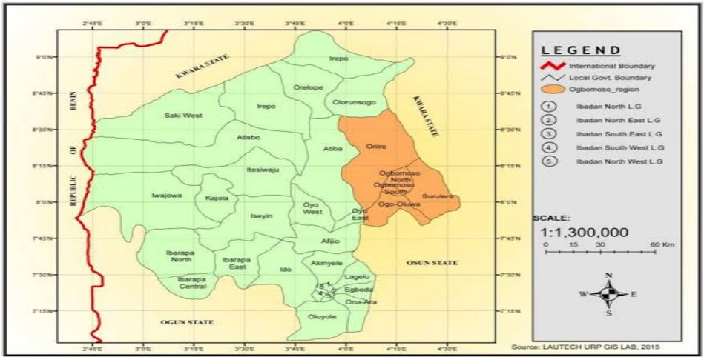
Google map,2025

RESULTS AND DISCUSSION
Demographic Characteristics of the Respondents (Table 1)
PERSONAL DATA | CATEGORIES | FREQUENCIES | PERCENTAGES (%)

SEX Male 81 81
Female 19 19
TRIBES Yoruba 90 90
Non indigene 10 10
NATIONALITY Nigerians 100 100
AGE 15-25 13 13
26-35 12 12
36-45 21 21
46-50 34 34
50 and above 20 20
OCCUPATION Civil servant 26 26
Unemployed 12 12
Self-employed 44 44
Students 18 18
Source: Field Survey, 2026

Table 2: Authenticity of Sango festival in Ogbomoso town
Variables | SA | SD | NA | N
Sango festival is not celebrated as it was originally | 83 | 13 | 2 | 2
Custodians only demonstrate the magical aspect of Sango originality | 78 | 17 | 4 | 1
Celebration of Sango festival is only done during occasions or events | 36 | 55 | 1 | 8
Most of the items of worshiping Sango are considered fetish | 87 | 7 | 4 | 2
Source: Field Survey, 2025

Chat 1: Authenticity of Sango festival in Ogbomoso town
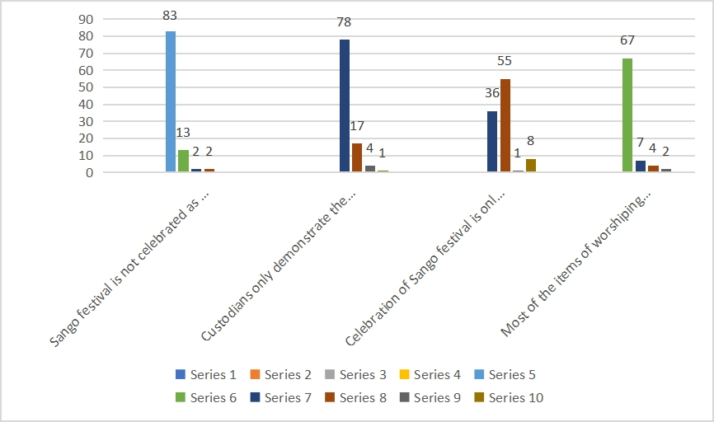
Source: Field Survey, 2026
The above chat shows the result of the authenticity of Sango festival celebration in Yoruba land. Looking from the variables, Sango festival is not celebrated as it was originally because out of the hundred respondents consulted, 83% of the respondents strongly agree that Sango festival is fading out while 13% strongly disagree and others followed respectively. On the issue of the custodians, those people celebrating the Sango festival only demonstrate the magical aspect of Sango in form of play, this is shown on the percentage of the respondents as strongly agree having 78% and 17% having strongly disagree while not aware and neutral having 4% and 1% respectively. On whether Celebration of Sango festival is only done during occasions or events, 55% of the respondents claimed that is not being displayed only during occasions but still being remembered on the appointed time of the festival while 36% of the respondents claimed that it is only being remembered during occasions or events, not aware 1% and neutral 8% respectively. However, on the issue of the items of worshiping of Sango being considered fetish 87% of the respondents strongly agreed having 87% while strongly disagree having 7% of the respondents and not aware having 4% and neutral having 2% respectively.

Table 3: The level of custodian’s fervency of Sango deity in Ogbomoso.
Variables | SA | SD | NA | N
Few traditional Sango worshipers are still fervent | 92 | 4 | 3 | 1
The custodians of Sango are not adherent to Sango festival like before | 93 | 2 | 2 | 3
Western religions have eroded the Sango belief system | 79 | 13 | 7 | 1
Most of the deities’ properties were either threw away or stolen | 67 | 23 | 3 | 7

Chat 2: The level of custodian’s fervency of Sango deity Ogbomoso.
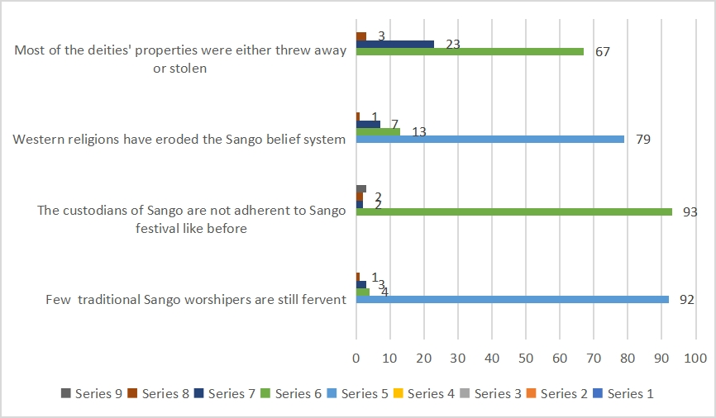
Source: Field Survey, 2026
The above chat shows the level of custodian’s fervency of Sango deity worshipers, from the respondents, few traditional Sango worshipers are still fervent having 92% and strongly disagree having 4% not aware having 3% and neutral having 1% respectively. On the custodians of Sango being adherent to Sango festival like before, 93% of the respondents strongly agree that there have not been fervency again while 2% of the respondents strongly disagreed and 2% of the respondents having not aware and 3% of the respondents having neutral option respectively.

Table 4: The effects on tourism development in Ogbomoso
Variables | SA | SD | NA | N
It has low patronage of tourists | 13 | 71 | 4 | 12
Interest on attending Sango festival is no more because it is no more authentic | 59 | 31 | 10
Most of the states do not have tourists’ measurement to determine the tourists’ patronages. | 74 | 21 | 2 | 1
If promoted it is a great potential to attract tourists | 88 | 12

Chat 3: The effects on tourism development in Ogbomoso
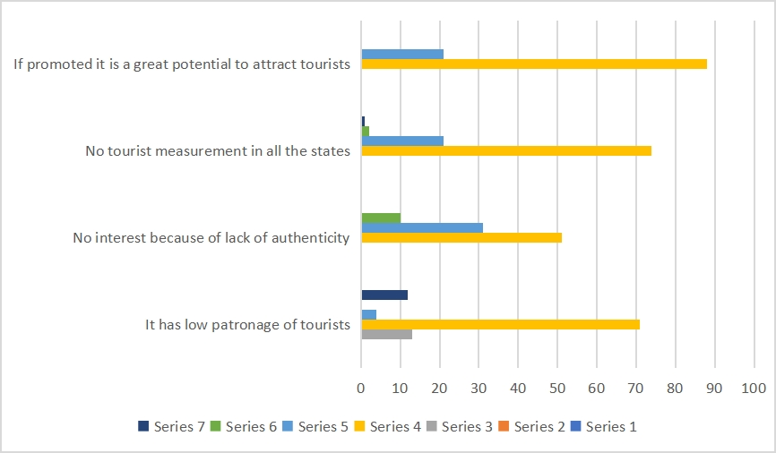
Source: Field Survey, 2026
From the above findings, It shows that lack of authenticity and poor participation of some devotees leads to low patronage of tourists having 13% of the respondents while strongly disagree having 71% of the respondents not having 4% and neutral having 12%. On having no interest because of not being authentic, the findings shows that strongly agreed having 59% and strongly disagree having 31% of the respondents while not aware having 10%. While on the issue of not having measurement to take the statistics of the tourists by the states, strongly agree having 74% of the respondents and strongly disagree having 21% of the respondents not aware having 2% and neutral having 1% respectively. And on the fact that if this festival is promoted it will attract tourists, the option strongly agree having 88% of the respondents while strongly disagree having 12% respectively.

CONCLUSION
Sango festival is generally known in Yoruba land especially the area that have the historical background tied to Sango deity and Alaafin of Oyo. However, in most of the towns consulted, Oyo has the highest devotees and has the highest tourist attendance. These towns are: Oyo town, Ibadan, Ogbomoso all in Oyo state. Ikirun and Ede in Osun state. In Ekiti, Ado and Gogo Ekiti are still having the remembrances of the deity. In Kwara too we have Odo Owa and ilofa that are still havin devotees. However with these towns, it is in Oyo, Ogbomoso and Ibadan that are still having the authentic celebration that are well known and registered as world heritage by UNESCO especially Oyo township. According to this findings therefore, the challenges of not getting the accurate number of tourists due to lack of tourism measurement or statistics constitute major problem of tourist patronages.
RECOMMENDATIONS
1 From the above findings therefore the following are recommended for the development and promotion of tourism activities in Ogbomoso town.
2 The devotees should be encouraged by giving them adequate finance.
The dates of this deity should be put into calendar for tourist awareness.
3 Government should endeavor to recognize the Isese day so that all these deities would have authentic celebrations in Yoruba land.

REFERENCES
Bourdieu, P. (1986). The forms of capital. In J. G. Richardson (Ed.), Handbook of Theory and
Research for the Sociology of Education (pp. 241-25
Hall, S. (1990). Cultural identity and diaspora. In J. Rutherford (Ed.), Identity: Community,
Culture, Difference (pp. 222-237).
https://www.vocabulary.com
https://www.researchgate.net/publication/380998788 a review of cultural festivals and cultural tourism development in rural areas of Nigeria
Ibekwe E. (2018), Africa and Cultural Authenticity, Asian Themes in Social Sciences Research ISSN: 2578-5516 Vol. 1, No. 2, pp. 50-59 2018
Moyo, P. (2019). Traditional storytelling and social cohesion in Zimbabwean communities. African Studies Review, 62(4), 689-706. https://doi.org/10.1017/asr.2019.88
Nakamura, K. (2017). The role of tea ceremonies in fostering social cohesion in Japan. Journal
of Japanese Studies, 43(1), 123-145. https://doi.org/10.1353/jjs.2017.0004
Nakamura, K. (2017). The role of tea ceremonies in fostering social cohesion in Japan. Journal
of Japanese Studies, 43(1), 123-145. https://doi.org/10.1353/jjs.2017.0004
Oliveira, R. (2016). The role of Brazil's Carnival in promoting social cohesion and cultural
understanding. Latin American Research Review, 51(1), 3-20.
https://doi.org/10.25222/larr.1040
Oliveira, R. (2020). Cultural festivals and community cohesion in rural Brazil: The case of
Festa Junina. Latin American Research Review, 56(2), 347-365.
Putnam, R. D. (2000). Bowling Alone: The Collapse and Revival of American Community.
Simon & Schuster.
Smith, J. (2018). Community-based cultural festivals in the United States: Enhancing social
cohesion and cultural understanding. Journal of Community Psychology, 46(6), 720-735.
https://doi.org/10.1
Taylor, C. (1991). The ethics of authenticity. Massachusetts: Harvard University Press.
Tan, E. (2018). Heritage festivals and social cohesion in Singapore. International
Journal of Heritage Studies, 24(4), 377-392.
https://doi.org/10.1080/13527258.2017.1378908
Thomas, P. (2019). The Edinburgh Festival Fringe and its impact on cultural
understanding and social cohesion. International Journal of Cultural Policy,
25(3), 387-400. https://doi.org/10.10

