Silent Assistance for Emergencies (SAFE):
A Mobile-Based Emergency Reporting Application
for the Deaf and Mute Community

Abstract – This paper is about the development of SAFE, which stands for Silent Assistance for Emergencies. The SAFE system is a mobile-based emergency reporting system. It is designed to help the mute community in Alaminos City. Most emergency services need people to talk to them. This makes it hard for people who are deaf and mute to get help when they need it. The city is increasingly utilizing technology for its public services. This technology can really help make things more accessible and safer for everyone, the deaf and mute community, by using SAFE, the mobile-based emergency reporting system. The development of the SAFE application provides users with one-tap emergency buttons, GPS-based location sharing, and visual alerts for silent reporting. This study employed a developmental research approach using the Rapid Application Development (RAD) model to create a working mobile application suitable for emergency reporting. The evaluation results show that the system achieved an Excellent rating in terms of functionality, usability, reliability, and performance, indicating that SAFE is an effective and accessible emergency reporting tool for the deaf and mute community.
Keywords: emergency reporting system, deaf and mute, mobile application, accessibility, Alaminos City

I. INTRODUCTION

An emergency response system provides the public with a valuable channel through which they can relay reports of crimes, medical emergencies, fires, and disasters to obtain immediate assistance. In some countries, like the Philippines and most other countries, access to emergency services can be availed mainly through voice-based hotlines like 911 and other local emergency numbers of different government agencies [1]. As helpful as these systems are for the mainstream population because there is a requirement for verbal communication in reporting the need for help; these become major limitations for the deaf or mute or both [2]. Researches show that hearing and speech-impaired individuals often experience delayed emergency responses resulting from miscommunications or sometimes not being able to communicate an emergency at all due to barriers in communication [3].
Globally, more than 430 million people have disabling hearing loss; this number will increase in tandem with global population aging as well as increased attention and enhanced diagnostic efforts [4]. Disability advocacy groups and government institutions stressed the need to have an inclusive public service that will pave the way for equal access by all persons with disabilities in the Philippines. Though there are laws on the inclusion of people with disabilities, emergency systems are less accessible to non-verbal individuals. Most of the deaf and mute population use textual means and social media, as well as family members or neighbors helping them, delays that are dangerously delaying reports to the police, and which compromise personal safety.
There is a chance to close this accessibility gap because smartphones and mobile internet are widely used. Because it allows for real-time communication, location tracking, and quicker emergency response, mobile technology has emerged as a crucial tool in the provision of public services [7]. By giving responders instant alerts and GPS location data, mobile-based emergency systems have been demonstrated to enhance situational awareness and response time [8]. However, the majority of current emergency applications still prioritize audio communication and voice calls, which makes them inappropriate for individuals with speech and hearing impairments. Mobile systems that facilitate touch-based, visual, and silent emergency reporting are therefore in high demand [9].

Agencies like the Philippine National Police, the Bureau of Fire Protection, and the City Disaster Risk Reduction and Management Office are in charge of emergency response in Alaminos City, Pangasinan. Emergency situations are typically reported over the phone, and the caller is required to give a verbal description of the situation as well as the location. This procedure is very challenging or impossible for deaf and mute people, which causes them to rely on middlemen or postpone reporting [10]. These restrictions not only put people with disabilities at greater risk, but they also make emergency responders less effective because they rely on accurate and timely information.

This study created SAFE (Silent Assistance for Emergencies), a mobile emergency reporting app made especially for the deaf and mute community, in order to address these issues. Users can use one-tap buttons to report emergencies, send their GPS location automatically, and see a visual confirmation that their alert was sent. The Persons with Disability Affairs Office (PDAO), which acts as a central authority in charge of coordination and verification with emergency agencies, receives all reports. For people with disabilities, similar mobile-based emergency systems have been demonstrated to increase accessibility and response effectiveness [11].

Mobile-based solutions are becoming crucial for enhancing public safety and service delivery in the Philippines due to the swift expansion of digital services, particularly in local government operations [12]. By eliminating communication barriers and offering a silent, user-friendly emergency reporting tool, SAFE adoption supports the transition toward digital governance and disability-inclusive systems. The creation of the SAFE mobile application is discussed in this paper as a workable and long-term way to increase Alaminos City's accessibility for emergency response.

II. METHODOLOGY
The Rapid Application Development (RAD) methodology was used in this study to create a mobile emergency reporting system that accommodates deaf and mute users. RAD is a software development methodology that prioritizes iterative improvement, rapid prototyping, and ongoing user feedback. Because the system needs regular validation from users and emergency responders to guarantee accuracy, accessibility, and dependability, this approach is appropriate for SAFE. Analysis, quick design, prototyping, testing, and implementation are the five stages of the RAD model. Figure 1 illustrates the RAD process.
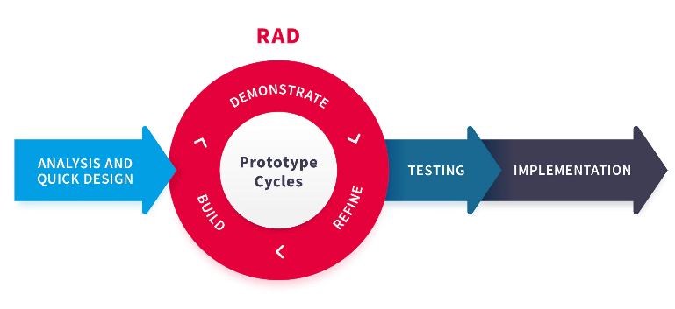

Figure 1. Rapid Application Development (RAD) Model.
Source: SlideTeam (template), RAD Model – Rapid Application Development diagram showing prototype cycles and phases [13].
Gathering system requirements and comprehending the shortcomings of current emergency reporting techniques were the main goals of the analysis phase. Personnel from the Persons with Disability Affairs Office (PDAO) and emergency responders were interviewed and observed in order to determine communication barriers, reporting protocols, and essential features like GPS tracking, pre-programmed messages, and visual confirmations.
The researchers developed the application flow, database design, and system structure during the quick design stage. To illustrate how deaf and mute users interact with the mobile app and how PDAO staff members receive alerts via the web dashboard, use case diagrams, data models, and interface layouts were created. Large buttons, icons, and little text input were used in the user interface's straightforward and approachable design.
During the prototyping stage, functional versions of the PDAO web dashboard and the SAFE mobile application were created. To make sure that reports, locations, and alerts were transmitted accurately and clearly, these prototypes were continuously tested and improved based on input from emergency personnel.
To ensure that every feature functioned as intended, the system was put through functional, interface, and performance testing during the testing phase. Simulated emergency scenarios were used to test dashboard notifications, GPS location accuracy, and emergency alert transmission.
The fully developed SAFE system was finally put into use in a controlled setting during the implementation phase. Every feature, such as pre-programmed alert messages, real-time GPS sharing, and one-tap emergency buttons, was turned on and ready for practical use.
III. RESULTS AND DISCUSSION
To find out how deaf and mute people currently report emergencies, the researchers conducted a number of observations and interviews. To ascertain current protocols, communication obstacles, and information needs, personnel from the Persons with Disability Affairs Office (PDAO) and nearby emergency responders were interviewed. Additionally, observations were made regarding the current procedures for receiving, confirming, and forwarding emergency reports. Through these exercises, the researchers were able to determine the shortcomings of voice-based emergency systems and the necessity of a mobile, silent reporting system.
The current emergency reporting procedure is depicted in Figure 2.
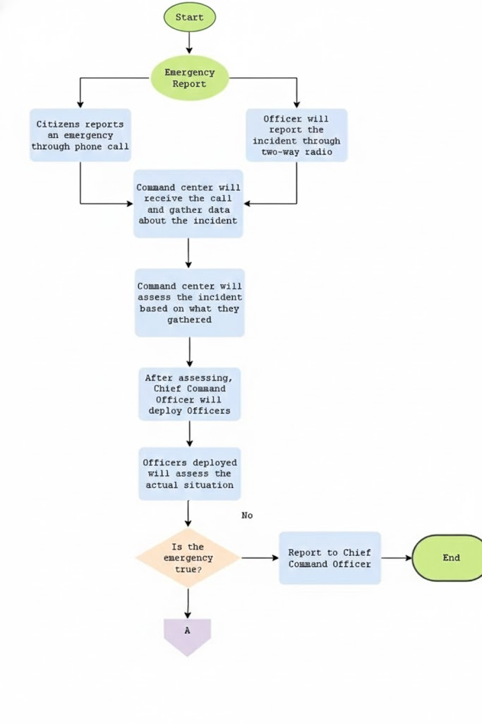

Figure 2. Existing Emergency Reporting Process
In order to contact emergency services under the current system, people who are in an emergency must either make a voice call or rely on others, like family members or neighbors. This frequently results in incomplete information, miscommunication, and delayed reporting for deaf and mute people. Users with speech or hearing impairments are often unable to verbally describe the nature of the emergency, the location, and the circumstances.
The present emergency reporting procedure is impacted by a number of significant issues that the researchers found. Communication obstacles, slow response times, inaccurate location data, reliance on middlemen, and the lack of an easily accessible reporting channel are some of these. For non-verbal users, these issues lead to an unreliable and ineffective system. A fishbone diagram showing the main issues with the current emergency reporting procedure is shown in Figure 3.
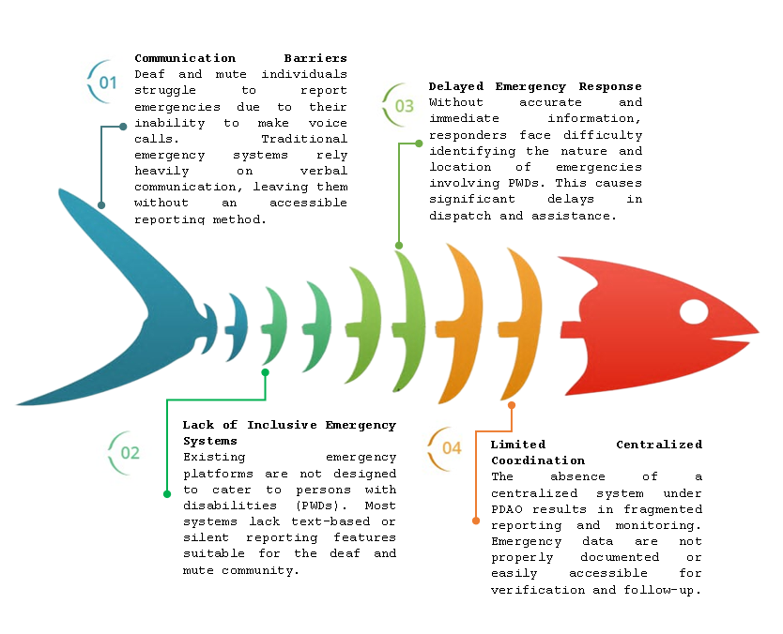

Figure 3. Fishbone Diagram of Challenges in Emergency Reporting for the Deaf and Mute Community
Users are unable to adequately explain their circumstances due to communication barriers. Responders find it challenging to find the victim in the absence of GPS-based reporting. When users have to wait for someone else to report on their behalf, delays happen. During emergencies, these problems put deaf and mute people at high risk.
Proposed SAFE System Framework
A framework in system development offers the structure and rules needed to create a dependable and useful application. Deaf/Mute Users and PDAO Personnel are the two main user roles that the SAFE system is intended to support.
Through a mobile application, deaf and mute users can report emergencies using pre-programmed messages, one-tap emergency buttons, and automatic GPS location sharing. Emergency reports can be received, monitored, verified, and forwarded to the relevant agencies by PDAO staff using a web-based dashboard.
Users can choose the incident type (fire, medical, criminal, or disaster) and send the report immediately using the emergency reporting module. The user's GPS location, time stamp, and alert type are all included in the report.
PDAO employees can view real-time alerts, verify details, and communicate with emergency responders via the monitoring module. The user receives visual confirmation from the notification module that their emergency request was successfully sent.
Proposed SAFE System Architecture
The SAFE system follows a three-tier architecture, consisting of the presentation tier, application tier, and data tier, as shown in Figure 4.
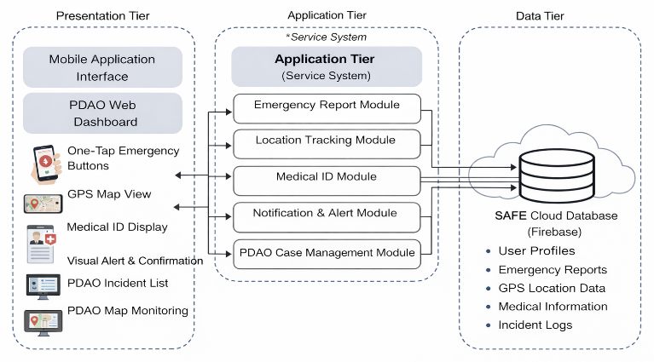

Figure 4. SAFE Three-Tier System Architecture
The web dashboard for PDAO staff and the SAFE mobile application for deaf and mute users are part of the presentation tier. While PDAO employees view reports via a browser-based interface, users engage with the system through straightforward buttons and visual alerts.
All business logic is handled by the application tier. When a user submits an emergency report, the system uses Firebase services to process the request, verify the information, and send it to the PDAO dashboard.
The Firebase Realtime Database is where the data tier keeps user profiles, incident history, GPS locations, and emergency reports. This makes it possible for the PDAO system and the mobile app to synchronize in real time.
The app transmits the location and alert to Firebase when a user hits an emergency button. The PDAO dashboard instantly displays the data, enabling employees to take action. Firebase Authentication is used to manage authentication and access control so that only employees and authorized users can access the system.
IV. CONCLUSION
By offering fresh approaches to enduring issues and enhancing current systems, innovation propels advancement. In order to help the deaf and mute community access emergency services, SAFE (Silent Assistance for Emergencies) was created. The system allows users to independently and swiftly request assistance without using voice communication by offering a mobile platform with one-tap emergency reporting, GPS-based location sharing, and visual confirmation alerts.
Emergency reports can now be more effectively verified, tracked, and sent to the relevant agencies through the centralized PDAO web dashboard. The SAFE system enhances response coordination, digitizes the conventional emergency reporting procedure, and fosters safety and inclusivity for people with communication impairments. Because of this, SAFE provides a dependable and easily accessible solution that enhances emergency response services and gives the deaf and mute community the ability to ask for help when they need it most.
V. REFERENCES
[1] Department of the Interior and Local Government (DILG), Philippine National Emergency Hotline 911, Republic of the Philippines, 2023.
[2] World Health Organization (WHO), World Report on Hearing, Geneva, Switzerland, 2021.
[3] K. Punch and R. Hyde, “Communication barriers and emergency response for deaf and hard-of-hearing individuals,” Journal of Disability Studies, vol. 18, no. 3, pp. 210–223, 2020.
[4] World Health Organization (WHO), Deafness and Hearing Loss Fact Sheet, 2022.
[5] National Council on Disability Affairs (NCDA), Philippine Magna Carta for Persons with Disability (RA 7277), Republic of the Philippines, 2019.
[6] J. Power and M. Rehling, “Emergency communication challenges among deaf and mute individuals,” International Journal of Emergency Management, vol. 14, no. 2, pp. 145–160, 2021.
[7] R. K. Park and J. Lee, “Mobile technology in public safety and emergency response,” Journal of Information Systems in Public Service, vol. 12, no. 1, pp. 55–68, 2020.
[8] S. Al-Sultan, M. Al-Dossary, and A. Rahman, “GPS-based emergency response systems using mobile applications,” International Journal of Computer Applications, vol. 176, no. 28, pp. 12–18, 2019.
[9] A. Smith and L. Jones, “Designing accessible mobile applications for people with disabilities,” Universal Access in the Information Society, vol. 19, no. 4, pp. 843–856, 2020.
[10] City Disaster Risk Reduction and Management Office – Alaminos City, Emergency Response Manual, Pangasinan, Philippines, 2022.
[11] M. Santos and L. Rivera, “Mobile emergency reporting systems for persons with disabilities,” Philippine Journal of Assistive Technology, vol. 5, no. 1, pp. 33–47, 2021.
[12] Department of Information and Communications Technology (DICT), Philippine Digital Government Roadmap, Republic of the Philippines, 2023.
[13] SlideTeam, “RAD Model – Rapid Application Development diagram showing prototype cycles and phases,” Slide template, 2023. [Online]. Available: https://www.slideteam.net

