DESIGN AND IMPLEMENTATION OF AN ADAPTIVE
ON-BOARD CHARGER FOR ELECTRIC VEHICLES
ABSTRACT
The increasing demand for efficient battery charging systems in electric vehicle (EV) and power electronic applications has led to the development of power factor correction (PFC) techniques. Conventional AC-DC converters suffer from poor power factor, high harmonic distortion, and increased input current, which reduces overall system efficiency. This paper presents the design and simulation of an Active Power Factor Correction (PFC) converter using a MOSFET-based boost topology implemented in MATLAB. The system converts a 230 V AC input into a regulated DC output suitable for charging a 60 V, 60 Ah battery. A MOSFET switch, controlled through a PWM-based feedback loop, ensures that the input current follows the input voltage waveform, thereby improving the power factor close to unity. The proposed system significantly reduces reactive power, input current distortion, and line losses. Simulation results demonstrate improved performance in terms of power factor (up to 0.95), reduced Total Harmonic Distortion (THD), and efficient energy transfer to the battery.
Keywords: Power Factor Correction, MOSFET, Boost Converter, EV Charger, THD

- INTRODUCTION
The rapid advancement of electric vehicles (EVs) and modern power electronic systems has created a strong demand for efficient, reliable, and high-performance battery charging solutions. In conventional charging systems, AC–DC converters are widely used; however, they often suffer from major drawbacks such as low power factor, high Total Harmonic Distortion, and increased power losses. These issues not only degrade system efficiency but also adversely affect power quality and increase the burden on the electrical grid.
To overcome these limitations, Power Factor Correction (PFC) techniques have become an essential part of modern power electronic converters. PFC methods are primarily used to improve the input power factor, reduce harmonic distortion, and ensure that the input current waveform closely follows the input voltage waveform. Among various PFC approaches, active PFC techniques are more effective compared to passive methods due to their superior performance, compact size, and better controllability.
In particular, MOSFET-based boost converters are widely adopted for active PFC applications because of their high switching speed, low conduction losses, and ability to provide precise control through Pulse Width Modulation (PWM) techniques. These converters operate by regulating the input current in such a way that it remains sinusoidal and in phase with the input voltage, thereby achieving near-unity power factor.
This progress focused on the design and simulation of an active PFC converter for a 60 V battery charging application powered from a 230 V AC supply. The proposed system ensures effective input current shaping using a PWM-controlled MOSFET switch, resulting in improved power factor, reduced harmonic distortion, and minimized reactive power. Furthermore, the system provides a stable and regulated DC output suitable for efficient battery charging. The overall objective is to enhance system efficiency, improve power quality, and support the growing demand for advanced EV charging technologies.

3. EXISTING METHOD
Traditional electric vehicle (EV) charging systems primarily use Constant Current–Constant Voltage (CC–CV) charging techniques, which are simple and widely adopted but lack adaptability to real-time battery conditions such as temperature, state of charge, and overall health. These systems typically rely on conventional AC–DC converters that operate with a low power factor, often less than 0.8, due to the absence of power factor correction mechanisms. As a result, they produce high harmonic distortion in the input current, leading to poor power quality and increased stress on the electrical grid. Additionally, these chargers do not incorporate communication with Battery Management Systems (BMS), limiting their ability to optimize charging performance and ensure battery safety. Consequently, the existing method suffers from reduced efficiency, higher power losses, and decreased battery lifespan, making it less suitable for modern, high-performance EV charging applications.

4. PROPOSED METHODOLOGY
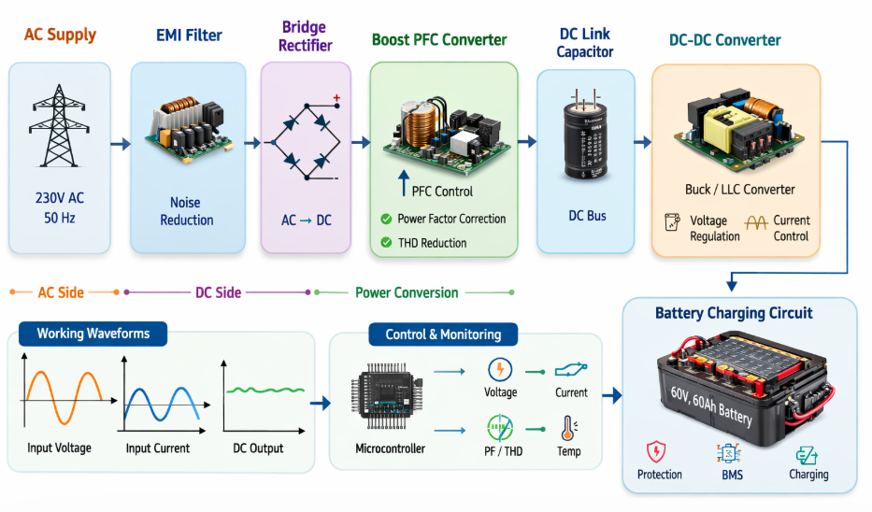
BLOCK DIAGRAM OF APFC CONVERTER

4.1 AC–DC Conversion Stage
The proposed system begins with a 230 V AC input supply, which is converted into an unregulated DC voltage using a diode bridge rectifier. This stage provides the necessary DC input for further processing. However, the rectified output contains ripples and does not ensure a high power factor, which necessitates the use of a power factor correction stage.

4.2 Boost Converter Design
A boost converter is employed after the rectification stage to step up and regulate the DC voltage. The converter consists of an inductor, diode, MOSFET switch, and output capacitor. The inductor stores energy when the MOSFET is ON and releases it when the MOSFET is OFF, thereby boosting the output voltage. The output capacitor filters the voltage to provide a smooth and stable DC output suitable for battery charging.

4.3 MOSFET Switching Control
The MOSFET acts as the primary switching device in the boost converter. It operates at high switching frequency, enabling efficient energy transfer and reduced losses. The switching action is controlled using a Pulse Width Modulation (PWM) signal, which determines the duty cycle of the MOSFET and directly influences the output voltage and current.

4.4 PWM-Based Feedback Control
A closed-loop feedback control system is implemented to maintain output voltage regulation and improve power factor. Sensors are used to measure input current and output voltage, and this information is fed back to the controller. The PWM controller adjusts the duty cycle of the MOSFET in real time to ensure that the input current waveform follows the input voltage waveform.

4.5 Power Factor Correction Technique
The main objective of the proposed system is to achieve near-unity power factor. By controlling the MOSFET switching through PWM, the input current is shaped to be sinusoidal and in phase with the input voltage. This significantly reduces Total Harmonic Distortion (THD), reactive power, and line losses, thereby improving overall system efficiency and power quality.

4.6 Output Filtering and Battery Charging
The output of the boost converter is filtered using a capacitor to eliminate voltage ripples and provide a stable DC output. This regulated DC voltage is then used to charge a 60 V, 60 Ah battery. The system ensures efficient and reliable charging while maintaining improved power quality.

5. WORKING OF APFC CONVERTER IN THIS PROJECT:
The Active Power Factor Correction (APFC) converter improves power quality by shaping the input current to follow the input voltage waveform. Initially, the AC supply is converted into DC using a bridge rectifier. The rectified output is then processed through a boost converter consisting of an inductor, MOSFET, diode, and capacitor. The MOSFET switching is controlled using a PWM signal based on a feedback control loop. This control ensures that the input current remains sinusoidal and in phase with the input voltage. As a result, the system achieves near-unity power factor, reduced harmonic distortion, and efficient battery charging

6. MATHEMATICAL ANALYSIS
Given Data
- Battery Voltage = 60 V
- Battery Capacity = 60 Ah
- AC Supply Voltage = 230 V
6.1 Battery Energy (Capacity)
The battery energy is calculated using the formula:
$$E=V×Ah \\ E=60×60=3600 Wh=3.6 kWh$$
Battery Energy = 3.6 kWh

6.2 DC Charging Current (Assumed)
Normally, the charging current is taken as 0.2C to 0.3C of battery capacity.
$$I_{charge}=0.2×60=12 A$$
Charging Current =12 A

6.3 Charging Time
Charging time is calculated using:
$$t=\frac{Ah}{I} \\ t=\frac{60}{12}=5 hours$$
Actual Charging Time = 5.5 to 6 hours

6.4 DC Output Power
$$P_{DC}=V×I \\ P_{DC}=60×12=720 W$$

6.5 AC Input Power (with efficiency)
$$P_{AC}=\frac{P_{DC}}{η} \\ P_{AC}=\frac{720}{0.9}=800 W$$

6.6 AC Input Current
$$I_{AC}=\frac{P}{V}$$
$$I=\frac{P}{V}$$
$$I_{AC}=\frac{800}{230}=3.48 A$$

6.7 Power Factor Correction Current
$$I_{AC}=\frac{P}{V×PF}$$
$$I_{AC}=\frac{800}{230×0.9}=3.86 A$$

6.8 BEFORE POWER FACTOR CORRECTION
1. Input Current
$$I_{before}=\frac{P}{V×PF}$$
$$I_{before}=\frac{800}{230×0.7}=4.97 A$$

2. Apparent Power
$$S_{before}=V×I$$
$$S_{before}=230×4.97=1143 VA$$

3. Reactive Power
$$Q_{before}=\sqrt{S^{2}-P^{2}}$$
$$Q_{before}=\sqrt{{1143}^{2}-{800}^{2}}=816 VAR$$

6.9 AFTER POWER FACTOR CORRECTION
1. AC Input Current (Unity Power Factor)
$$I_{AC}=\frac{P}{V}$$
$$I_{AC}=\frac{800}{230}=3.48 A$$

2. AC Input Current (PF = 0.9)
$$I_{AC}=\frac{P}{V×PF}$$
$$I_{AC}=\frac{800}{230×0.9}=3.86 A$$

7. SIMULINK DIAGRAM / SIMULINK WAVEFORM

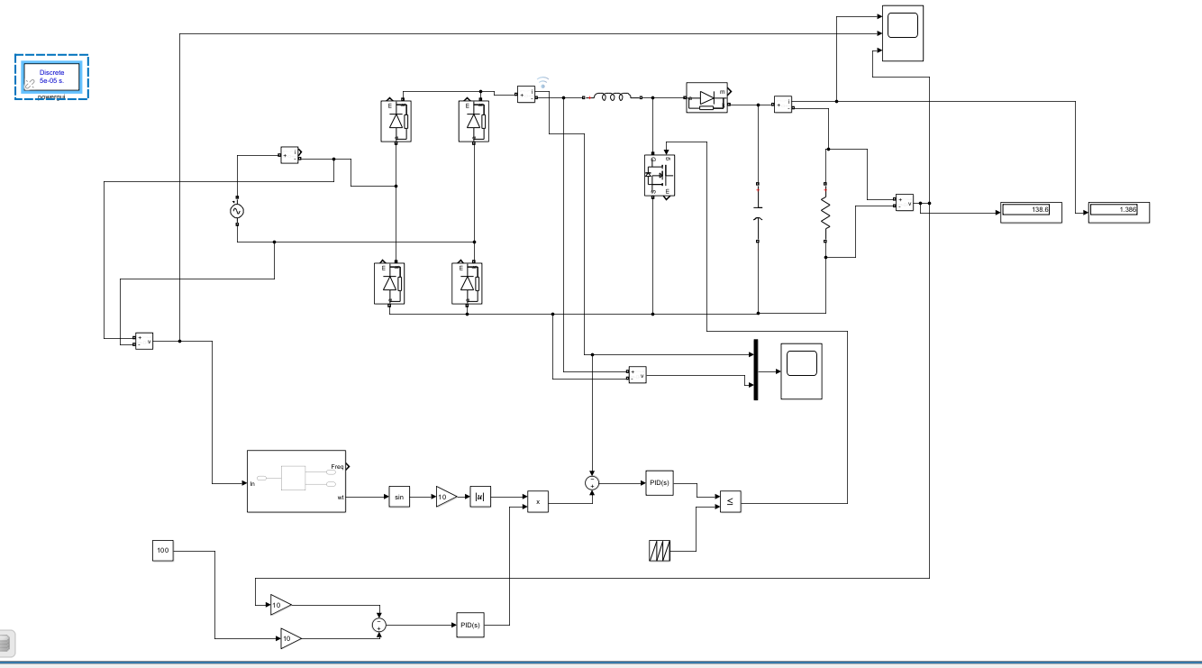
MATLAB Simulink Diagram

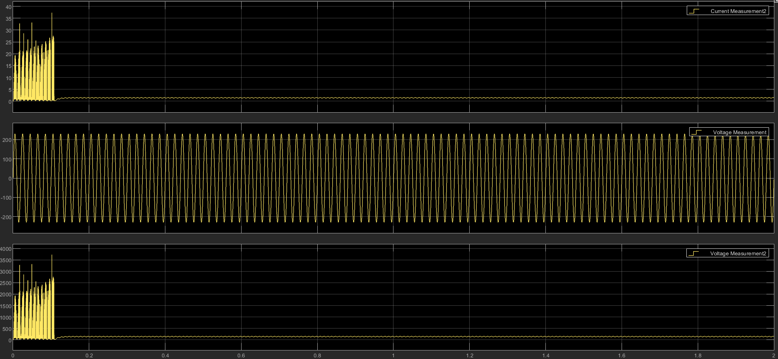
Scope 1 : 1)Input current measurement
2)Input voltage measurement
3)Output voltage measurement
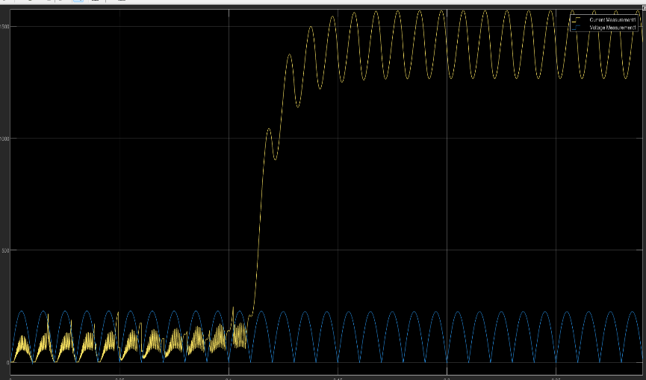
Scope 2 : 1)Output Current measurement
2)Output Voltage measurement
7. RESULTS AND DISCUSSION
The proposed APFC converter was simulated in MATLAB/Simulink to evaluate its performance. The results show that the input current waveform becomes sinusoidal and closely follows the input voltage waveform. The power factor is improved significantly from around 0.7 to 0.95, achieving near-unity operation. Total Harmonic Distortion (THD) is reduced considerably compared to the conventional system. The input current is minimized, which helps in reducing line losses and improving overall efficiency. The output voltage is stable and regulated, achieving approximately 130 V DC. The system also demonstrates good voltage regulation under varying load conditions. Reactive power is significantly reduced, improving overall power quality. Due to high-frequency switching of the MOSFET, the converter achieves faster dynamic response and improved energy transfer. This high-frequency operation enables fast charging capability by allowing efficient current control and reduced charging time. The system maintains stable performance even during rapid charging conditions. Overall, the results confirm that the proposed system provides efficient, reliable, and high-performance fast charging suitable for modern EV applications.

8. CONCLUSION
The proposed MOSFET-based Active Power Factor Correction converter significantly improves EV charging system performance. It achieves near-unity power factor, reduces THD, and enhances efficiency. The system ensures stable and efficient battery charging, making it suitable for modern EV applications.

9. REFERENCES :
[1] Y. Chen, P. Jain, and H. Jin, “High-Frequency Power Factor Correction Converter for EV Battery Charging Applications,” IEEE Transactions on Power Electronics, 2019.

[2] B. Mohan and V. Indragandhi, “Review of Power Factor Correction (PFC) AC/DC–DC Power Electronic Converters for Electric Vehicle Applications,” IOP Conference Series: Materials Science and Engineering, vol. 906, 2020.

[3] A. Kumar et al., “A Modified PFC Rectifier Based EV Charger Employing CC/CV Mode of Charging,” IFAC-PapersOnLine, vol. 53, no. 2, pp. 13551–13556, 2020.

[4] M. K. Prasanna et al., “Efficient AC–DC Power Factor Corrected Boost Converter Design for Battery Charger in Electric Vehicles,” Energy, vol. 221, 2021.

[5] A. Blinov et al., “Isolated High-Frequency Link PFC Rectifier with Reduced Energy Circulation,” IEEE Journal of Emerging and Selected Topics in Industrial Electronics, 2021.

