INCORPORATING GOTHIC ARCHITECTURE INTO MODERNIZATION ERA

ABSTRACT
Gothic Architecture, originated in 12th century Europe, is distinguished by pointed arches, ribbed vaults, flying buttresses, and stained-glass windows, embodying verticality, light, and craftsmanship. Historically associated with medieval cathedral and civic monument, Gothic design pursued both aesthetics and structural innovations. In contemporary and modern architectural practices, the principles of Gothic architecture have been reinterpreted to harmonize historical aesthetics with modern functionality, materials, and technologies. A famous example of Gothic architecture is the Notre dame cathedral in Paris. Its enormous rose windows and smaller stained features, flying buttresses that support the tall roof structure, and decorative gargoyles that peer down over visitors are a truly exemplary image of Gothic style.

KEYWORDS
Gothic architecture, Modernization era, Gothic elements, Contemporary materials, Sky lighting.

INTRODUCTION
Renowned for its pointed arches, ribbed vaults, and flying buttresses, Gothic design emphasized verticality, light, and structure ingenuity. These innovations allowed architects to construct taller, more open, and visually striking buildings, transforming the way space and light were experienced. While historically associated with cathedrals, the principle of Gothic architecture continued to resonate in contemporary design. In the modern era, characterized by rapid urbanization, technological advancements, and evolving functional needs, Gothic elements offer both aesthetic and structural opportunities.

AIM
Incorporating Gothic elements into modernization era buildings using contemporary materials.

OBJECTIVES
- Incorporating contemporary materials into modern buildings, using contemporary materials into modern buildings using pointed arches with concrete or steel, designing elaborate façade with materials like dark stones, glass, or aluminum composite panels, and large contemporary rose windows using stained glass and modern LED.
- Utilizing contemporary materials such as steel and reinforced glass to create soaring, light-filled interiors and pointed forms.
- Maximizing natural light by introducing skylights, lightwells, larger openings.

SCOPE

The scope for incorporating Gothic elements into modern buildings using contemporary materials is vast, balancing timeless drama and elegance with modern functionality. Architects and designers draw from gothic traditions to create structures that evoke a sense of history, grandeur, and artistic intricacy while meeting modern standards for comfort, sustainability and efficiency. Gothic elements like pointed windows, vaulted ceilings, and complex wooden tracery are used to bring a sense of history and elegance to modern buildings. Th large light filled spaces typical of gothic cathedrals offer lessons for sustainable design, utilizing large windows for better ventilation and natural lighting, reducing reliance on artificial energy. Composite materials and precisions engineering for intricate details once carved from stone. Concrete and aluminum to achieve strength, durability, and modern aesthetic contrast.

RESEARCH QUESTIONS

- How can key Gothic architectural elements such as pointed arches, ribbed vaults, adapted into modern architectural design without losing their historical essence?
- What are the aesthetic and symbolic impacts of integrating Gothic features into contemporary architecture?
- How can Gothic forms be reinterpreted using modern design principles such as minimalism and sustainability?

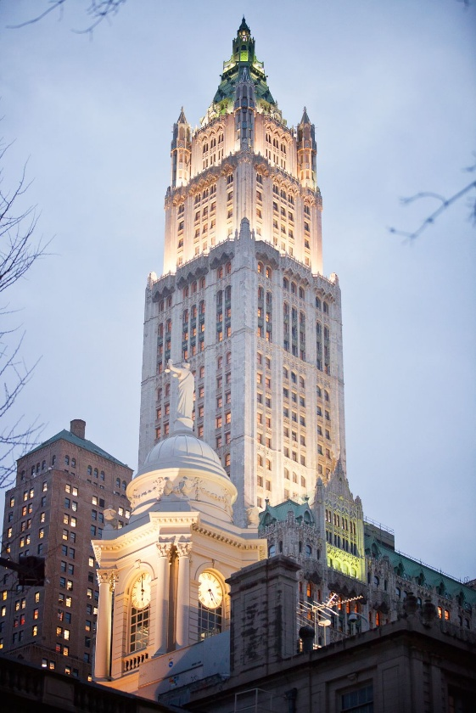
CASE-STUDY 1
THE WOOL WORTH BUILDING NEWYORK
Newyork City’s Wool Worth Building, by Cass Gilbert, was constructed in 1913 using the Chicago Frame system. At the time of its construction in 1913, it was the world’s tallest building. With the collapse of the 110 story twin towers of the World Trade Center in 2001, visible in the foreground, it resumed its place as the tallest structure in Lower Manhattan, and its 1931 successor for the title of World’s Tallest Building, the Empire State Building, also a Chicago Frame type structure, resumed its place as the tallest building in New York City. The Woolworth building is an early prominent example of a Gothic skyscraper that integrates Gothic design with modern construction techniques and materials.
Gothic elements: the building features classic gothic architectural details, including pointed arches, intricate tracery, and decorative finials, which create a sense of verticality and drama. 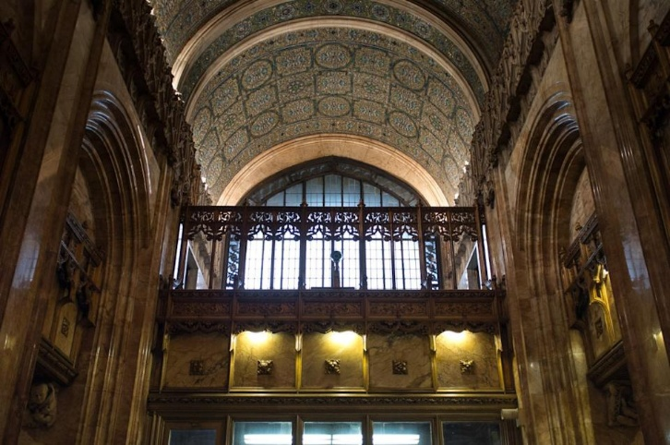
Modern materials and techniques:
The structural core is a steel frame, a technology that enabled unprecedented height and was not available during the original Gothic period.
The elaborate terra-cotta ornamentation on the exterior was an innovative, lightweight alternative to traditional stone, making the decorative elements possible at such a great height.
Large windows, a hallmark of Gothic design, are enabled by the steel frame, which carries the building's load and allows for larger openings in the curtain wall. 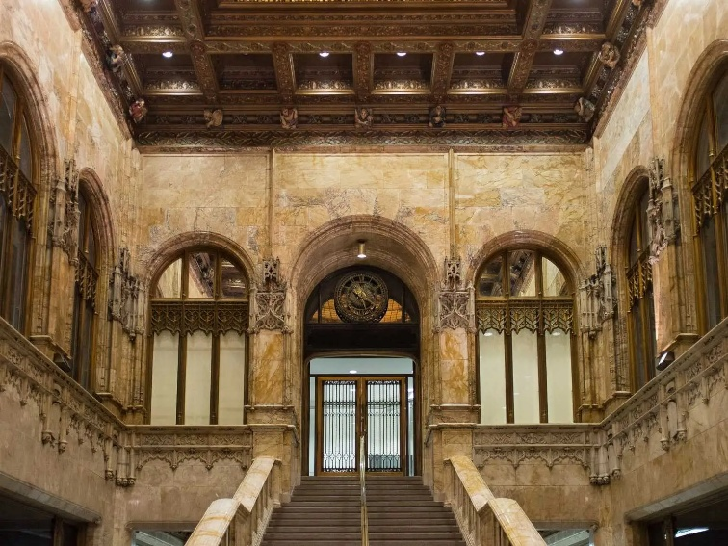
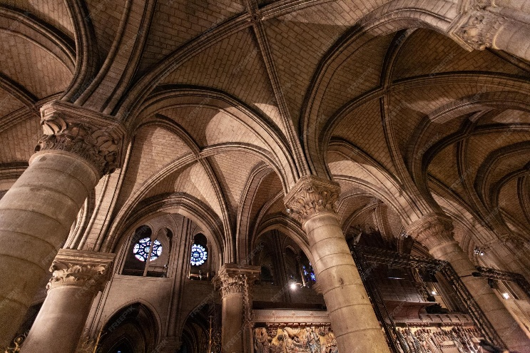
Outcome: the Woolworth building successfully uses modern materials and methods to achieve the same aesthetic goals of traditional architecture, including a soaring verticality and intricate detail, but on a Vastly different scale.

CASE-STUDY 2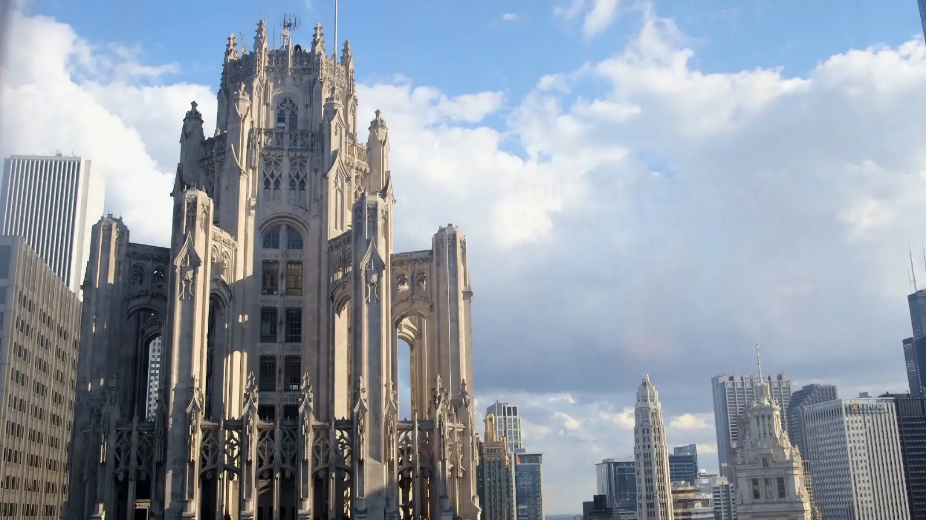
THE TRIBUNE TOWER
The tribune tower is a 463-foot-tall (141 m), 36-floor neo-gothic skyscraper located at 435 north Michigan avenue in Chicago, Illinois, united states. The early 1920s international design competition for the tower became a historic event in 20th-century architecture. Built for Chicago tribune owner Robert R. McCormick, since 2018 it has been converted into luxury residences and in 2023 won a Driehaus prize for architectural preservation and adaptive reuse from landmarks Illinois. This was a late example, perhaps the last important example, and criticized for its perceived historicism. Construction on the Tribune Tower was completed in 1925 and reached a height of 462 feet (141 m) above ground. The ornate buttresses surrounding the peak of the tower are especially visible when the tower is lit at night.

The tower features carved images of Robin Hood (Hood) and a howling dog (Howells) near the main entrance to commemorate the architects. The top of the tower is designed after the Tour de beurre (″butter tower″) of the Rouen Cathedral in France, which is characteristic of the Late-Gothic style, that is to say, without a spire but with a crown-shaped top.
Rene Paul Chambellan contributed his sculpture talents to the buildings ornamentation, gargoyles and the Aesops' Screen over the main entrance doors.
Key Architectural Features:
Design & Style: Winning design from a 1922 international competition, it combines Beaux-Arts ideals with Gothic forms (Neo-Gothic/American Perpendicular).
The Crown: The top is designed after the Tour de beurre (Butter Tower) of the Rouen Cathedral in France, featuring ornamental, non-structural flying buttresses that create a striking illuminated silhouette, according to Wikipedia and this YouTube video.
Exterior: The base incorporates stone fragments from iconic sites including the Taj Mahal, Pyramids of Giza, Berlin Wall, and the Alamo.
Ornamentation: Sculptures by Rene Paul Chambellan include gargoyles, the "Aesop's Screen" over the main door, and carved figures of a dog and a tree/hood (howling dog for Howells, Robin Hood for Hood).
Structure & Materials: Features a steel frame with white limestone cladding and limestone gargoyles.

CONCLUSION
The research into the Woolworth Building and the broader integration of Gothic principles into the modern era reveals that architectural history is not a closed book, but a living language. While the 12th-century cathedrals were defined by stone and master craftsmanship, the transition to steel frames and terra-cotta ornamentation proved that the "soul" of Gothic design—its soaring verticality and intricate play of light—is not tied to a single material.
Ultimately, this study shows that incorporating these traditional elements into modern construction is about more than just nostalgia. It is a functional harmony: using the structural strength of the modernization era to achieve the atmospheric drama of the past. By reinterpreting features like ribbed vaults and pointed arches through the lens of sustainability and contemporary materials, architects can create spaces that feel both technologically advanced and deeply human. The Woolworth Building stands as the primary evidence that when we marry historical aesthetics with modern engineering, the result is a timeless urban landmark that respects where we came from while looking firmly upward The Tribune Tower is more than just a beautiful old building. It proves that we don’t have to choose between a building that works well and a building that has a soul.
Why It Matters for Modern Architecture:
- Buildings That Last and Evolve: The way the tower shifted from a busy newspaper office to high-end luxury homes—even winning the Driehaus Prize for preservation in 2023—shows that Gothic design isn't a "dead end." It’s incredibly flexible. It proves that when we build with detail and craftsmanship, we create structures that people want to save and reuse, rather than tear down. That is the ultimate form of sustainability.
- A Sense of Place in a Glass World: In a world full of sleek but often soulless glass boxes, the Tribune Tower uses its "stone fragments" from around the globe to ground itself in history. It acts as a literal anchor, reminding us that modern architecture can still feel permanent, storytelling, and deeply connected to the rest of the world.
- The Best of Both Worlds: The tower’s real secret is its "hybrid" nature cutting-edge steel frame hidden under beautiful limestone and ornate carvings. This "American Perpendicular" style proves that we don't have to give up beauty for the sake of engineering. We can use modern tech to support the kind of human-centric, artistic details that make a city feel like home.

REFERENCES
- Research review on gothic architecture and style. (2016)
- article “design and revolution”: Morris, modernism and urban gothic. (2023)
- journal “the relationship between gothic and modern design” by dana McIntyre. (2016).
- Journal “gothic revival architecture: influence and legacy in modern times”. (2024)
- Article “experiencing the gothic style” (2019)

