Developing a Church Mobile App:
A Digital Solution For NTCC Management And Communication

ABSTRACT
Mobile technology pushes groups, including businesses and other institutions to utilize digital tools to better manage and communicate in this era of digital advancement. This research is on work on a Church Mobile Application for NTCC (New Testament Christian Church). The Church Mobile Application is intended to disseminate information, keep members engaged, and improve Church communication. The primary objective is to develop an online application. A centralized mobile platform for all church leaders and members who regularly need announcements, events, devotional content, and regular church information. Using the RAD (Rapid Application Development) methodology, which is aimed at iterative development to facilitate constant interaction with the users and rapid prototyping. The Research Study also used Survey and Questionnaire to gather data that can be used in carrying out this study. The Church Pastor, Leaders as well as other Members of New Testament Christian Church (NTCC) were given the Survey Questionnaire. According to the results of the evaluation, the NTCC Church Mobile App reached a weighted mean of 4.67. That score is Strongly Agree. The NTCC Church Mobile App demonstrates user-level acceptance and satisfaction. The findings showed that the NTCC Church Mobile App solved problems with communication and manual information management. The NTCC Church Mobile App is a solution for church management and communication. Future works need to incorporate push notifications, multimedia feature integration, and expansion to NTCC branches.
Keywords: Church Mobile Application, NTCC, Rapid Application Development, Church Management System, Digital Communication
INTRODUCTION
Since the advent of mobile technology, the process of storing information, managing records, and interacting with stakeholders has undergone radical changes. Smartphones and mobile applications used throughout society enable institutions to send timely information, increase operational effectiveness, and increase user engagement using digital environments (Laudon & Laudon, 2020). Communities in the form of churches are increasingly encouraged to engage mobile technology to promote communication, maintain appropriate records, and connect more strongly with members (Hutchings, 2017). Indeed, many local churches, including the New Testament Christian Church (NTCC), employ the traditional modes of communication and management, such as oral announcements in the form of church services, paper-based documentation, and scattered social media usage, despite these technological advantages.
Despite their efficiency and effectiveness, these methods have historically resulted in irregular information sharing, information delay, data redundancy, and poor access to church-related information for non-communicated participants who are unable to attend more regularly (Goh & Cheong, 2019). This calls attention to the requirement for a centralized and efficient digital means of delivering a modern church service. To alleviate these issues, the NTCC church mobile application was created to unify key functions in regards to church managing and communication in one platform. It also combines features like sharing daily devotion, centralized announcements, event scheduling, profiling of members, and tracking of donations.
The integration of such services into a mobile application would facilitate better organization, visibility and information-related information for all members, facilitating immediate access for participants (Pressman & Maxim, 2020). Additionally, the mobile app serves as a logical and user-friendly platform that helps churchmen and women to better manage church affairs. With role-wise access and digital records handling the system minimizes the need for manual work and minimizes data loss or false information. This research thus aims to determine if the NTCC Church Mobile App is effective, usable and acceptable in its general adoption as a digital tool to overcome the challenges pertaining to communication and management of the church.
Objectives of the Study
The general purpose of this study is to design and develop a comprehensive mobile application for NTTC Churches, serving as a digital solution for management and communication. Specifically, it aims to achieve the following:
- to identify the existing processes in NTCC's Church management and communication,
- to identify the difficulties and challenges currently faced in NTCC's Church management and communication,
- to develop features that could be integrated within the development of the System; and
- to determine the acceptability level of the developed system.
METHODOLOGY
A descriptive developmental research design guided the study, focusing on examining current NTCC church processes and developing a tailored mobile solution to address identified issues.
Applying the RAD methodology enabled efficient delivery of a functional Church Management system prototype that met identified requirements. Early and ongoing user involvement led to improved design usability and ensured alignment with user needs. The iterative construction process helped quickly identify and resolve issues, enhancing system quality and acceptance. Stakeholders reported satisfaction with the system's features and its usability, attributing this success to RAD’s collaborative and flexible development approach.
The needs planning phase is the starting point. At this stage, the stakeholders and developers get together to have open conversations about the system's objectives, the problems it should solve, and the features that are essential. To understand the true needs and experiences of the consumers, the team collects data through surveys, observations, and interviews. This step is important before any development begins since it helps everyone agree on the system's direction and aim. The User Design phase involves close collaboration between developers and users. Instead of waiting until the system is finished, developers create early concepts and rudimentary prototypes that consumers may review immediately. We encourage comments, suggestions for improvements, and the identification of any ambiguities. This active participation guarantees that the system is easy to use and that its functionality and design truly live up to user expectations. Throughout the prototyping, testing, and refinement phases, the system is constantly developed throughout several cycles. Users develop and test a working version of the system to identify flaws, usability problems, or missing features. In response to user comments, the system is updated and enhanced. This cycle is repeated until the system is reliable, stable, and user-satisfying in order to prevent major issues before final deployment. The system is completed during the construction phase. Developers focus on writing the final code, integrating all system components, and implementing the approved features. Since most design difficulties were already resolved in earlier stages, development during this phase is more organized and efficient. Ongoing testing is also carried out to ensure that each system component functions as intended. The Cutover phase marks the end of the system's actual use. This phase includes final testing, data preparation, and user training to make sure everyone is ready to utilize the system. Once these procedures are completed, the system is officially deployed and made accessible to users. The system is currently fully operational and ready to help with real tasks.
Figure 1. Rapid Application Development Model
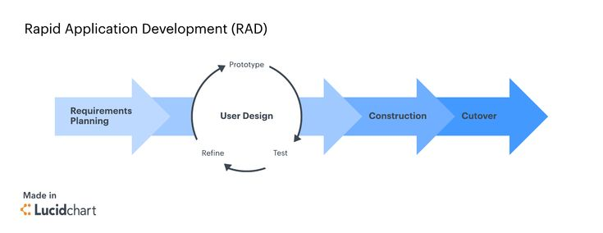
Purposive sampling selected 21 participants: the church pastor (1), church leaders (5), church members (9),and first-time attendees (6), all from NTCC Tiep Bani.
In this study, we utilized data collection from many dimensions such as interviews, questionnaire-based surveys, and internet research data. These data collected from such a range of sources offered ample opportunity to have a comprehensive account of data generation. Different analytic devices were employed to analyze and illustrate the system's design and operation. Entity relationship diagrams were created to represent associations among entities in data to assist in designing and organizing the database. The flowchart representation was helpful to describe the operations and workflows of the system, facilitated process mapping and potential improvements.
Quantitative measurement techniques were used to assess the system acceptance and usability. Average scores were calculated based on the weighted mean, which accounted for the relative importance or frequency of responses, making it possible to get a more nuanced insight into user feedback. A Likert scale was employed as a standardized method to gauge participant attitudes and perceptions towards the system – a scale from strong disagreement to strong agreement with the statements. These measurement tools jointly provided helpful insights into overall acceptance of the system, emphasizing strengths and areas ripe for improvement from the users’ perspective.
Table 1. Respondents of Study
Respondent Type | Number of Respondents
Pastor | 1
Church Leader | 5
Church Member | 9
First Timer | 6
Total | 21

A ISO/IEC 25010 Questionnaire was used to measure the system’s acceptability. The researchers evaluated the system’s performance and effectiveness using a Likert Scale, where 5 is the highest and 1 is the lowest value. The Average Weighted Mean was used to interpret the collected data. The NTCC Church Mobile App obtained a rating of 4.75 in Functionality, 4.53 in Reliability, 4.71 in Usability, 4.71 in Efficiency, 4.61 in Security, 4.70 in Maintainability, and 4.61 in Portability, with an overall Average Weighted Mean of 4.67, which is interpreted as Strongly Agree. This means that the system is highly acceptable and effective according to the respondents. The results are presented in Table 2.
Table 2. Acceptability Test
Acceptability | Weighted Mean | Description
Functional Sustainability | 4.22 | Very Good
Performance Efficiency | 4.15 | Very Good
Usability | 4.17 | Very Good
Reliability | 3.97 | Very Good
Security | 3.88 | Very Good
Maintainability | 4.01 | Very Good
Portability | 3.93 | Very Good
Average Weighted Mean | 4.05 | Very Good

The analysis of the ISO/IEC 25010 Acceptability Test responses allowed the researchers to gain meaningful insights regarding the effectiveness of the NTCC Church Mobile App. A review of existing communication platforms such as Facebook Messenger and other social media tools revealed common limitations in managing church-related information, such as scattered announcements and delayed communication. These findings guided the development of the system to better meet the needs of church leaders and members by providing a centralized and organized platform.
The development team utilized Android Studio for mobile application development and integrated Firebase services for real-time data management. The system interface was designed to be simple, clean, and user-friendly, ensuring accessibility for users with different levels of technical experience. Firebase enabled real-time updates for announcements, events, and user data, ensuring that members receive accurate and up-to-date information anytime.
A Fishbone Diagram was also used to analyze and identify the root causes of the problems in the existing church management system. The analysis revealed several issues such as unorganized member data, inconsistent communication, lack of centralized information access, and dependence on multiple platforms. These challenges resulted in delays, confusion, and reduced engagement among church members. Based on these findings, it can be concluded that the existing system is inefficient and unstructured, which justified the development of the NTCC Church Mobile App as a digital solution to improve communication, organization, and overall church management.
Figure 2. Fishbone Diagram
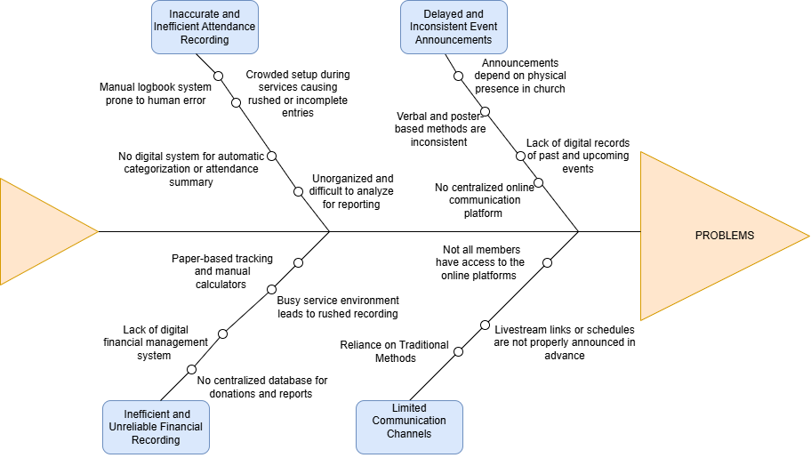
As a result of these identified factors, the development of the NTCC Church Mobile App produced a system that effectively meets the needs of both church leaders and members. By addressing the key challenges in the existing communication and management processes, the application provides a centralized platform for announcements, events, devotional content, and member information. This system enhances accessibility, improves information dissemination, and promotes better engagement among members of the New Testament Christian Church, ultimately contributing to a more organized and efficient church management experience.
RESULTS AND DISCUSSION
The Three-Tier Architecture is a well-known and effective architectural model that consists of three main layers: the presentation tier, the application tier, and the data tier. The presentation tier is responsible for the graphical user interface, the application tier handles the system’s logic and processing, and the data tier is used for storing and managing data. The NTCC Church Mobile App utilizes this three-tier architecture to ensure better scalability, organization, and maintainability of the system (Chiaramonte, 2024).
Users can access the NTCC Church Mobile App through their mobile devices, as shown in Figure 3, which represents the presentation tier. This layer allows users to interact with features such as announcements, events, daily Bible verses, and member profiles through a user-friendly interface. The application tier handles the core functionalities of the system, including user authentication, role-based access, and processing of requests using Firebase services. Meanwhile, the data tier utilizes Firebase Firestore to store and retrieve data such as user information, announcements, event details, and other system records in real time, ensuring data consistency and reliability throughout the application.
Figure 3. CampusBites Food Ordering Mobile Application Three-Tier Architecture
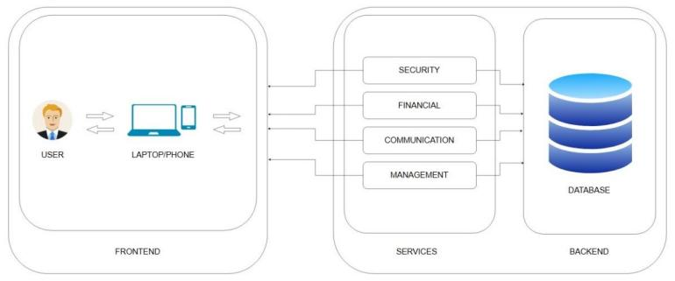
Within the Presentation Tier of the NTCC Church Mobile App, the user interface serves as the main gateway for church members, leaders, and administrators to interact with the system. Members can easily view announcements, access daily Bible verses, and stay updated on upcoming church events, while administrators can create events, manage announcements, and monitor user activity. This layer also includes essential functions such as user login, navigation, and access to different modules, making it the primary point of interaction for all users.
User actions such as viewing announcements, accessing event details, and updating user information generate requests that are processed by the Application Tier through Firebase services. This layer handles the system’s core logic, including user authentication, role-based access (admin and member), and processing of data requests. Firebase Authentication ensures that only authorized users can access specific features, maintaining system security and proper data handling.
The Data Tier serves as the storage component of the system, where all important data such as user profiles, announcements, event details, and system records are securely stored. Firebase Firestore is used to manage and retrieve this data in real time, ensuring that any updates made by the administrator—such as new announcements or events—are instantly reflected in the users’ interface. This real-time capability improves the reliability and responsiveness of the system.
By utilizing the Three-Tier Architecture, the NTCC Church Mobile App achieves a well-structured, scalable, and efficient system design. This approach allows the application to handle increasing user demands while maintaining performance and organization. For future enhancements, improvements may include refining the user interface, adding more interactive features, and continuously gathering feedback from church members to ensure that the system remains aligned with their needs and expectations.
CONCLUSION
Innovation is to improve organizational efficiency that allows for bringing in the latest solutions to existing challenges and improving our service delivery. In church management, digital innovation means that a religious institution is more or less current, organized, and responsive to the needs of its members. In order to save time, we came up with NTCC Church Mobile App as a solution for the New Testament Christian Church managing and communicating effectively which provided information where it needed to be in its different systems as they have scattered information, announcements that don't appear in a timely manner and still have been left to get by on a semi-agile and fragmented basis.
Having integrated unified mobile application, it can support a good church announcements system, event system, daily devotional updates and membership information. The system increases accessibility as it enables churchgoers, irrespective of location to receive timely information and spiritual offerings, irrespective of their presence at church. For church leaders and personnel, the application facilitates the sharing of info with minimum effort, organisation of information and enhanced decision-making since we facilitate better decision-making from structured data management. The results of evaluation revealed that the system is rated as satisfactory, regarding functionality, reliability, usability, efficiency, maintainability, portability, and reliability.
These findings demonstrate that the NTCC Church Mobile App effectively solves these challenges and provides a credible and working digital solution as an administrative and communications tool for the management and information about the NTCC Church. Taken together, the system not only enhances interaction, accountability, and efficiency within the NTCC community, but it is also promising toward adoption and ongoing adoption/upgrading to the rest of NTCC.
ACKNOWLEDGEMENT
The completion of this study would not have been possible without the invaluable support and contributions of several individuals who played significant roles throughout its development. The proponents would like to express their sincere gratitude to all those who helped bring this project to fruition.
To the proponents’ Capstone Adviser, Sir Carlo Genster P. Camposagrado, for providing clear direction, guidance, and insights that enabled the researchers to better understand and improve their work. His patience, support, and expertise greatly contributed to the successful completion of this study.
To the proponents’ adviser, Sir Christian Paul O. Cruz, for his invaluable advice, encouragement, and continuous guidance throughout every stage of the project. His dedication and willingness to assist the proponents were instrumental in refining the system and achieving the study’s objectives.
To the chairman and panelists of the project, for their constructive criticisms, recommendations, and suggestions that helped enhance and improve the quality of the system.
To their parents, for their unwavering support, encouragement, and sacrifices, which gave the proponents the strength and determination to persevere and complete this research.
Above all, to the Almighty God, for granting wisdom, strength, and guidance to overcome challenges and successfully accomplish this study.
REFERENCE
- M. Baptista and T. Oliveira, “Understanding mobile banking: The unified theory of acceptance and use of technology combined with cultural moderators,” Computers in Human Behavior, vol. 50, pp. 418–430, Sep. 2015. [Online]. Available: https://www.sciencedirect.com/science/article/pii/S0747563215002246. [Accessed: Jan. 12, 2026].
- A. Alalwan, Y. Dwivedi and N. Rana, “Factors influencing adoption of mobile banking by Jordanian bank customers,” Journal of Retailing and Consumer Services, vol. 22, pp. 100-108, Jan. 2015. [Online]. Available: https://www.sciencedirect.com/science/article/pii/S0969698914001645. [Accessed: Jan. 12, 2026].
- S. Church and A. Oakley, “Digital transformation in faith-based organizations: Opportunities and challenges,” Journal of Religious Leadership, vol. 19, no. 2, pp. 45–60, 2020.
- ISO/IEC, ISO/IEC 25010:2011 Systems and software engineering — Systems and software Quality Requirements and Evaluation (SQuaRE), International Organization for Standardization, 2011.
- P. Pressman and B. Maxim, Software Engineering: A Practitioner’s Approach, 9th ed. New York, NY, USA: McGraw-Hill Education, 2019.
- Firebase, “Cloud Firestore Documentation,” Google Developers, 2024. [Online]. Available: https://firebase.google.com/docs/firestore. [Accessed: Jan. 12, 2026].
- Amazon Web Services, “What is a Framework?,” AWS, 2024. [Online]. Available: https://aws.amazon.com/what-is/framework/. [Accessed: Jan. 12, 2026].
- J. Kylliäinen, “The Importance of Innovation – What Does it Mean for Businesses and Our Society?,” Viima, Apr. 26, 2019. [Online]. Available: https://www.viima.com/blog/importance-of-innovation. [Accessed: Jan. 12, 2026].
- Serrano, E. A., & Go, C. D. L. G. (2024). A Study of Modified Mobile Church Application for Filipino Catholics. 14th International Conference on Software Technology and Engineering. https://doi.org/10.1109/ICSTE63875.2024.00022
- Sherpa, T. N. (2022). Church Management System. SRM University Sikkim.
- Sihombing, I. N. I. (2023). Administration in Improving Church Stewardship. International Journal of Social Research, 2(7).https://doi.org/10.55324/josr.v2i7.1224
- Subsplash. (2023). The Complete Platform. Subsplash. https://www.subsplash.com/
- Turner, T. (2023). The Role of the Church in Using Technology: A Practical Guide in Mentoring Youth Programs. ResearchGate.
- Weaver, J. (2020). Technology, Management and the Evangelical Church. McFarland.
- Witzel, L. (2023). The Digital Transformation of Church Communication. https://larrywitzel.com/wp-content/uploads/2023/11/The-Digital-Transformation-of- Church-Communication.pdf
- Amankwa, E., & Awuku-Gyampoh, R. K. (2022). Building the twenty-first century Church: the role of the youth. Journal of Youth and Theology, 21(2), 148–171. https://doi.org/10.1163/24055093-bja10025
- Anthony, P. I. (2025). 15 Incredible Ways Church Leaders Can Prepare for Challenges in 2025. Prayer and Scriptures for Encouragement.

