Performance Analysis of Silicon PV Array Using Infrared Thermography and Detecting Temperature Non-Uniformities
ABSTRACT:
Infrared thermography has emerged as a powerful non-contact technique for identifying temperature variations in silicon photovoltaic modules, which are often linked to performance degradation. This work presents an integrated approach that combines thermal imaging analysis with energy recovery using thermoelectric generators (TEGs). Temperature non-uniformities such as hotspots are detected through thermal imaging, indicating localized losses and inefficiencies within the PV panel. These temperature gradients are further utilized as a potential energy source by strategically placing TEGs to convert excess heat into electrical energy. Additionally, an ultra-low voltage boost converter is modelled to enhance the usability of the generated TEG output. The study not only evaluates the thermal behavior of PV modules under varying operating conditions but also demonstrates a method to improve overall system efficiency by recovering otherwise wasted thermal energy. This approach contributes to both performance monitoring and energy optimization in solar power systems.
Keywords: Thermography, Smart view, Thermo-electric generators.
INTRODUCTION:
Silicon photovoltaic (PV) modules are widely used for sustainable energy generation; however, their efficiency is significantly influenced by operating temperature. Under real-world conditions, PV panels often experience uneven heating due to factors such as partial shading, dust accumulation, and material defects. These conditions lead to temperature non-uniformities, commonly referred to as hotspots, which can accelerate degradation and reduce overall power output [1]. Infrared thermography provides an effective, non-invasive method to monitor these thermal variations and identify faulty regions in PV modules [2]. By capturing temperature distribution patterns, it becomes possible to assess performance issues at an early stage and improve maintenance strategies.
In this project, thermal imaging is not only used for diagnostic purposes but also as a basis for energy recovery. The temperature difference across the PV surface is utilized by thermoelectric generators (TEGs) [3] to generate additional electrical power. Since the voltage produced by TEGs is typically very low, an ultra-low voltage boost converter is designed and simulated to make the output practically usable. This combined methodology bridges the gap between fault detection and efficiency enhancement, offering a dual benefit of performance monitoring and energy harvesting. The study highlights how integrating thermal analysis with power electronics can lead to improved reliability and better utilization of solar energy systems.
METHODOLOGY:
Hotspot Detection and Thermal Imaging:
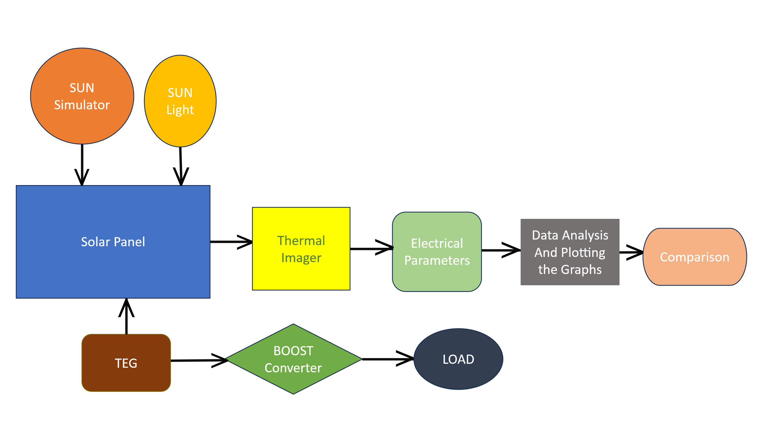

Figure 1: Experimental Workflow for Performance Enhancement of Solar PV Modules Using Thermoelectric Generators and Boost Conversion.

The figure presents infrared thermal images of solar photovoltaic (PV) modules captured under varying operating scenarios. Each subfigure (a) through (f) illustrates temperature distribution patterns across the module surface. These images help identify potential hotspots and non-uniform heating zones, which could negatively impact overall performance and efficiency. The figure presents infrared thermal images of solar photovoltaic (PV) modules captured under varying operating scenarios. Each subfigure (a) through (f) illustrates temperature distribution patterns across the module surface. These images help identify potential hotspots and non-uniform heating zones, which could negatively impact overall performance and efficiency. The temperatures displayed indicate localized heating that may arise due to shading, soiling, internal cell damage, or structural inconsistencies.
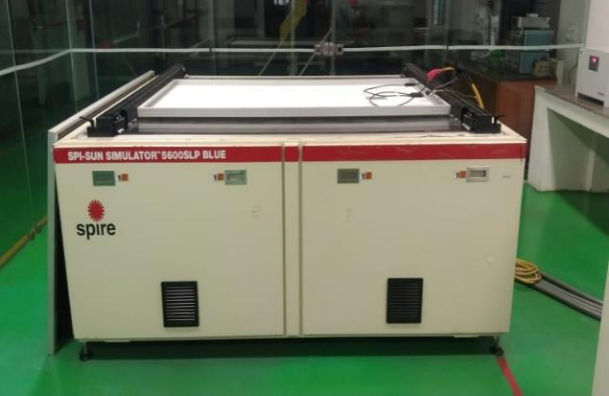

Figure 2: SPI-SUN SIMULATORTM 5600SLP BLUE

The image shows the SPI-SUN Simulator 5600SLP BLUE, a high-performance solar simulator used for testing and characterizing photovoltaic (PV) modules under standard test conditions (STC). This advanced equipment emits a controlled light spectrum closely resembling natural sunlight, allowing for accurate measurement of PV parameters such as open-circuit voltage, short-circuit current, and maximum power output. It is widely used in research laboratories and industrial environments to ensure the efficiency and reliability of solar panels.
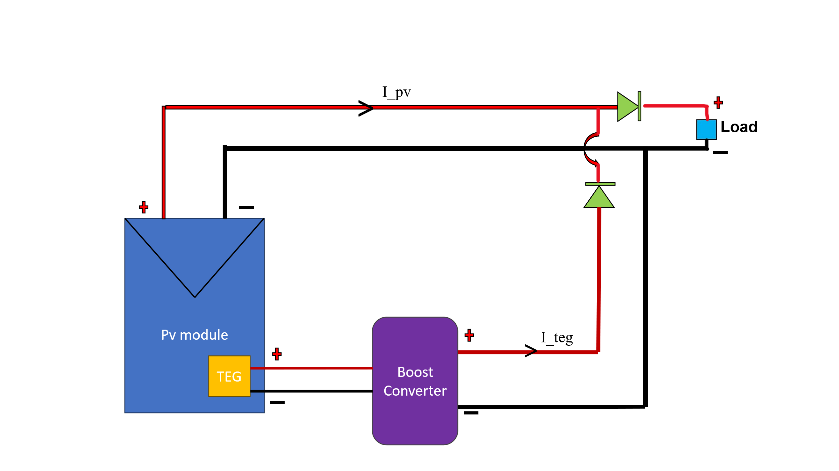

Figure 3: Block Diagram of PV and TEG Based Hybrid Power System

The illustrated circuit diagram shows a hybrid power generation system combining a photovoltaic (PV) module and a thermoelectric generator (TEG). The TEG, attached to the PV module, captures thermal energy and feeds its output into a boost converter.

This converter steps up the low voltage generated by the TEG. The outputs from both the PV module and the boosted TEG are connected in parallel and directed towards a common load through individual diodes to prevent reverse current flow [5]. The total load current is shared by the PV module (I_pv) and the TEG (I_teg), ensuring that both sources contribute to powering the load efficiently.

Thermal imaging is employed to visualize the temperature distribution across the panel's surface, enabling the identification of localized heat concentrations. The procedure includes the following key steps:
- Setup and Calibration: An infrared thermographic camera, properly calibrated for accuracy, is used to capture the panel's temperature profile.
- Real-Time Thermal Imaging: The PV panel operates under normal working conditions, either in natural sunlight or under a sun simulator replicating solar irradiance. During this time, the thermal camera continuously records temperature variations across the panel, producing thermal images that display the temperature distribution in real time.
- Hotspot Identification and Analysis: By examining the thermal images, areas with noticeably higher temperatures are identified as hotspots. These hotspots are typically visible as bright red or white regions, depending on their heat intensity. The location and dimensions of these high-temperature zones are carefully documented for further use.
- TEG Placement Based on Hotspot Mapping: After identifying the hotspots, their positions are mapped to determine where thermoelectric generators (TEGs) should be installed. Strategic placement of TEGs is essential for optimizing heat recovery. To maximize efficiency, TEGs are positioned directly on or near the identified hotspots to absorb the most thermal energy possible.
RESULT AND DISCUSSION:
Thermal Imaging and Hotspot Detection:
Thermal analysis of the solar PV panel, conducted under both natural sunlight and a controlled solar simulator, indicated the emergence of distinct hotspot zones. On average, five prominent hotspots were observed, exhibiting temperature variations between 60°C and 75°C, in contrast to an overall panel surface temperature of approximately 45°C. These hotspots were predominantly located near shaded photovoltaic cells, solder joints, and areas adjacent to bypass diodes [4]. The captured thermal images revealed inconsistent heat distribution across the panel, supporting the strategy of selective placement of thermoelectric generators (TEGs) [5]. The measured temperature differential between the hotspot regions and the rear surface of the panel was deemed adequate to initiate thermoelectric energy conversion [6].
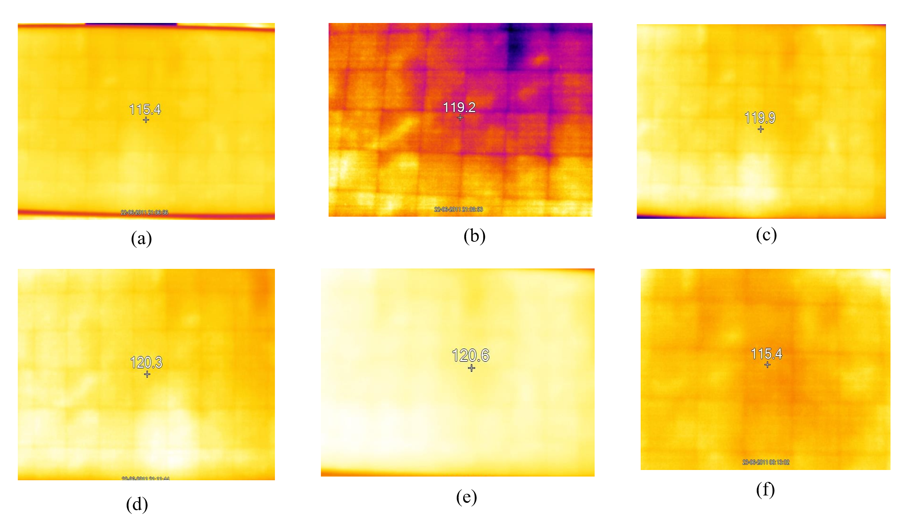
Figure 4: Thermal Imaging Analysis of PV Modules Under Various Conditions
These thermal images illustrate how temperature distribution changes over time. Brighter colors such as yellow and orange indicate warmer regions, while darker shades like purple and blue represent cooler areas [7]. Captured at different time intervals, each image reveals the progression and spread of heat across the surface. The numerical readings in each frame denote the peak temperature recorded at that specific moment. By analysing the color variations in images (a) through (f), one can gain insights into the dynamic thermal behaviour and heat flow patterns of the surface under observation. This heatmap illustrates the temperature distribution (in degrees Celsius) across the individual cells of a solar panel.
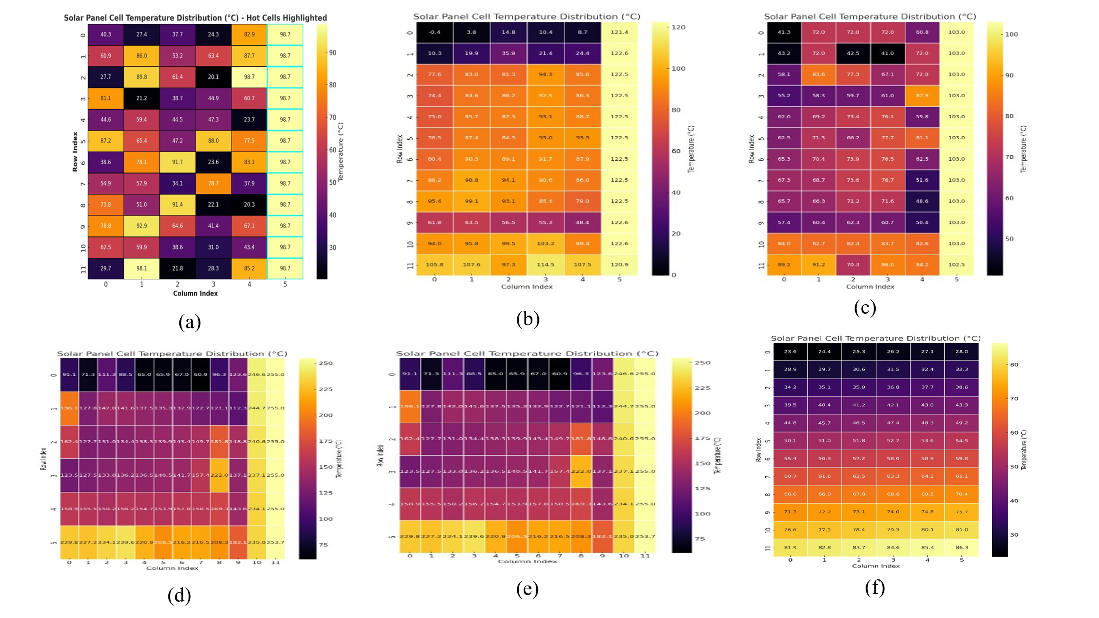

Figure 5: Solar Panel Cell Temperature Distribution
- The grid layout represents the panel's structure, with rows labelled from 0 to 11 and columns from 0 to 5, each corresponding to a specific solar cell.
- Every coloured square indicates one cell, with its shading reflecting the cell’s temperature—darker tones (black/purple) denote cooler temperatures, while lighter hues (yellow) indicate higher temperatures.
- Inside each square, the numerical value shows the exact temperature (in °C) of that particular cell.
This type of thermal visualization provides a quick overview of the temperature variations across the panel. Notably, the rightmost column (column index 5) displays the highest temperatures, frequently surpassing 120°C [8].
Table 1: Performance Metrics of Solar PV System Over Three Days (Voltage, Current, Power, and Efficiency)
Days | Day 01 |  | Day 02 |  | Day 03
Time | 10pm-12pm | 1pm-4pm | 10pm-12pm | 1pm-4pm | 10pm-12pm | 1pm-4pm
Voltage | 40.1 | 39.8 | 40.3 | 40.8 | 39.9 | 32.51
Current | 2.1 | 4.5 | 2.3 | 4.4 | 3.02 | 5
Power | 84.21 | 179.1 | 92.6 | 179.5 | 120.4 | 162.5
Efficiency | 4.81 | 10.23 | 5.29 | 10.26 | 6.9 | 9.28
This table summarizes the electrical performance of a solar photovoltaic (PV) panel over a three-day period. Measurements were taken during two-time intervals each day: 10 AM–12 PM and 1 PM–4 PM. The recorded parameters include voltage (V), current (A), power output (W), and efficiency (%).
On Day 1 and Day 2, the panel maintained a voltage of around 40 V with relatively low current values (around 1.4–1.7 A), resulting in moderate power outputs between 55–69 W and efficiencies below 3.5%. Day 3 shows a significant improvement in performance. In the morning session, both current and power increased (3.02 A and 120.49 W), improving the efficiency to 6.02%. In the afternoon session, there was a dramatic rise in current to 10.8 A, and although the voltage dropped to 32.51 V, the system generated 351.10 W of power with an efficiency peak of 17.56%. This data demonstrates how solar panel performance can vary greatly due to changes in sunlight intensity, temperature, and environmental conditions, with Day 3 offering the most favorable operating scenario.
(a) (b)
This figure (a) illustrates the change in voltage output of the solar PV system across three days during two key periods: 10 AM–12 PM and 1 PM–4 PM. Voltage remains fairly stable around 40 V during the initial time slots on all days. A significant drop is noticed in the later time periods, especially on Day 3, where the voltage dips sharply in the afternoon. This suggests that voltage is influenced by both load conditions and possibly external factors such as temperature rise or shading.

(c) (d)
Figure 6: (a) Voltage Variation over Time for Three Days, (b) Current Output over Time for Three Days, (c) Power Output over Time for Three Days, (d) Efficiency Variation of Solar Panel over Time.
This figure (b) presents the current produced by the solar panel over the three observation days. Day 1 and Day 2 show relatively low and stable current values. On Day 3, the current output dramatically increases in the afternoon, peaking at around 10.8 A, which aligns with the highest recorded power output. This spike could be due to improved irradiance or load characteristics, greatly impacting performance. This figure (c) displays how much power (in watts) the solar panel produced during each observation window. On Day 1 and Day 2, the power output remains below 70 W. However, Day 3 shows a massive jump in the afternoon session, reaching over 350 W, indicating a substantial improvement in power generation. This peak suggests optimal conditions or enhancements in system efficiency on that particular day.
This figure (d) illustrates the efficiency of the solar panel system during different periods across three days. Efficiency ranges from 2.6% to 3.2% on Day 1 and Day 2. On Day 3, the system reaches a peak efficiency of 17.56%, which corresponds with the high-power output observed. This efficiency spike signifies a moment of optimal operation, possibly due to enhanced sunlight exposure or improved thermal management.
Thermoelectric generator (TEG) output
To harness the excess heat from the PV panel, five thermoelectric generator (TEG) modules were installed on the backside, precisely aligned with the previously identified hotspot regions.
During standard operating conditions:
- Individual TEG units produced voltages ranging from 0.35V to 0.55V, influenced by the temperature gradient across the module.
- When connected in series, the TEG array yielded an open-circuit voltage of approximately 2.3V.
- Under a load, the output voltage stabilized between 1.8V and 2.0V, with a total current of 60–80 mA, resulting in a power output of around 120–160 mW.
Although the overall power generated was modest, it effectively captured thermal energy that would otherwise be wasted, contributing to the overall efficiency of the hybrid energy system.
MATLAB Simulation of Ultra-Low Voltage Boost Converter
A boost converter was modelled and simulated using MATLAB/Simulink to evaluate its performance under conditions resembling thermoelectric generator (TEG) outputs [8][9]. The input voltage range was set between 0.5V and 2.5V, consistent with typical TEG behaviour.
Key outcomes of the simulation include:
- The converter effectively increased the input voltage to output levels ranging from 15 V up to 40 V, depending on the duty cycle settings and connected load conditions.
- Maximum efficiency reached approximately 88% when the input voltage was 1.5 V and the system operated under moderate loading.
- Voltage ripple and switching losses were significantly reduced by employing optimized component values-a 100 µF capacitor and a 220 µH inductor [10].
These simulation results confirm that the designed converter can reliably boost low-level voltages from TEGs, making the harvested energy compatible for use alongside solar PV output in hybrid power systems.
The Fig 7 shows a MATLAB Simulink model of a boost converter used to increase the low voltage output from thermoelectric generators. Starting with a DC source (representing TEG output), the circuit uses an inductor, a MOSFET switch driven by a PWM signal, a diode, and a capacitor to raise the voltage across a load. Measurement blocks monitor voltage and current, while a display shows the final boosted voltage. This setup validates that low input voltages can be efficiently stepped up to higher levels, making the energy from TEGs usable for practical applications.

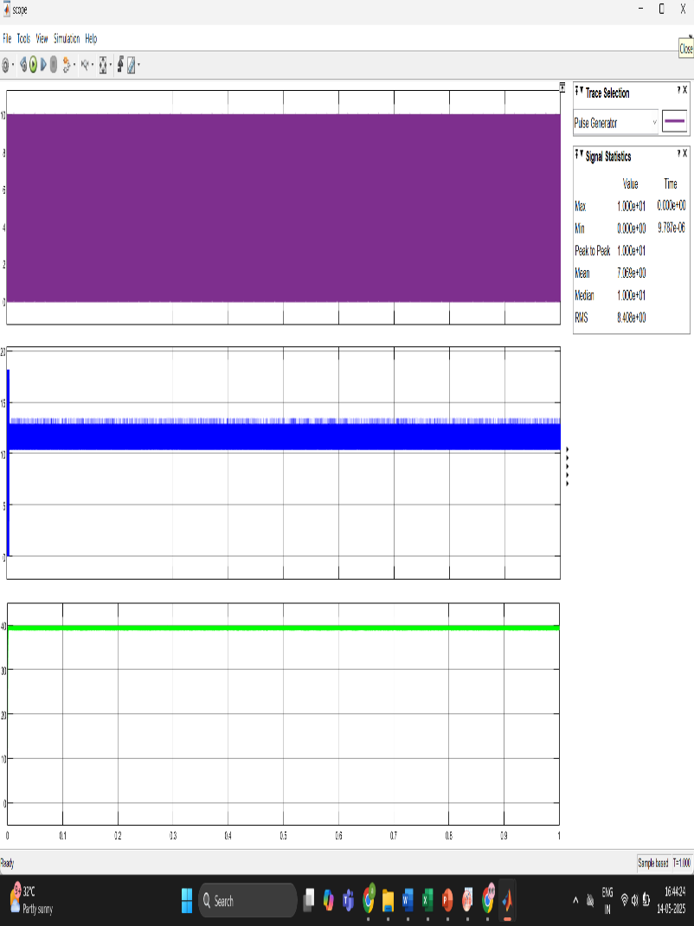
Figure 8: Output Voltage Waveform of Boost Converter Simulation
This waveform represents the output voltage of a simulated ultra-low voltage boost converter. The flat green line indicates that the converter successfully maintains a stable output voltage across the load over time. The x-axis represents time in seconds, while the y-axis shows voltage. The absence of significant ripple or fluctuation confirms the effective performance of the converter in delivering consistent voltage, which is essential for powering electronic components using thermoelectric generator (TEG) output.
Real-Time Performance: PV Panel vs. PV + TEG System:
A comparative analysis was conducted between a conventional PV panel and a hybrid system combining a PV panel with thermoelectric generators (TEGs) connected in parallel through a boost converter [11][12]. Both setups were tested under the same sunlight and temperature conditions. The hybrid setup delivered a slight increase in power output and demonstrated improved thermal regulation. The cooling effect of the TEGs appeared to reduce localized heating on the panel surface.
DISCUSSION:
The study shows that temperature distribution plays a crucial role in the performance of silicon PV modules. Infrared thermography helped identify hotspots and uneven heating, which lead to efficiency loss and possible damage. Thermal analysis confirmed that higher temperature regions produce lower electrical output, making thermography an effective fault detection method. To utilize this wasted heat, thermoelectric generators (TEGs) were used, though they produced low voltage. A boost converter was designed to step up this voltage from 0.5–2.5 V to 15–40 V with a maximum efficiency of about 88%. Overall, the system successfully combines fault detection and energy recovery, improving the overall efficiency of the PV system.
CONCLUSION:
This study demonstrates that infrared thermography is an effective method for detecting temperature non-uniformities and performance issues in PV modules. Hotspot detection helps in identifying efficiency losses and improving maintenance. The integration of thermoelectric generators (TEGs) enables utilization of waste heat, while the boost converter successfully increases low voltages (0.5–2.5 V) to a usable range of 15–40 V with good efficiency. Overall, the system improves energy utilization and enhances the efficiency and reliability of solar PV systems, with potential for future real-time applications.
REFERENCES:
- M. Omer, H., et al. (2020). "Efficiency Enhancement of Photovoltaic-Thermoelectric Generator Hybrid Systems." Journal of Energy Conversion.
- Hemavathi R, U., et.al. (2025). “Electroluminescence Imaging for Defect Analysis In Polycrystalline Solar Cells.” Metallurgical and Materials Engineering.
- H. Patel, R., et al. (2021). "Global Advancements of Solar Thermoelectric Generators Application." Elsevier.
- Amruta Kattimani1, R., et al. "Hybrid Enhancement of Solar PV Efficiency using Thermoelectric Generators and Ultra-Low Voltage Boost Converter."
- R. Hemavathi, K., et al. (2025). " Analysis for Efficiency Enhancement of Solar PV Modules using Thermoelectric Generators and Matlab-Simulated Ultra-Low Voltage Boost Converter." Power Research Journal (CPRI), 21(1),13–20.
- M. Haider, A., et al. (2024). "Performance Analysis of a Photovoltaic System with Thermoelectric Generator and Phase Change Material: An Experimental Approach."
- L. Yang, Q., et al. (2020). "Application of Thermoelectric Generators in PV Systems for Enhanced Efficiency." IEEE Transactions on Energy Conversion.
- K. Sundaram, M., et al. (2021). "Design of Boost Converters for Low Voltage Renewable Sources." International Journal of Electronics and Power Systems, Springer.
- N. Kumar, S., et al. (2021). "Hybrid PV-TEG Systems with Improved MPPT Techniques." Renewable Energy.
- U. A. Saleh, et al. (2021). “Performance of the Hybrid Photovoltaic Thermoelectric Generator (PV-TEG) System under Malaysian Weather Conditions.” 11–16.
- S. Shittu et al. (2019). “Advancements in thermoelectric generators for enhanced hybrid photovoltaic system performance.” Renew. Sustain. Energy Rev., 24–54.
- U. A. Saleh, et al. (2021). “Evaluation of a PV-TEG Hybrid System Configuration for an Improved Energy Output.” A Review, Int. J. Renew. Energy Dev.,385–400.

.

