Evaluation of Strains for their Nodulation in Improving Soil Fertility and on Yield of Soybeans at Bako and Gobu Sayo Districts, Western Oromia

ABSTRACT
Productivity is constrained by high nutrient depletion and land degradation. Unless efforts are taken in confronting the problems of nutrient depletion and land degradation, deteriorating productivity will seriously undermine the foundations of sustainable agricultural production. On-farm and on station trials were, therefore, conducted in G/Sayo and BARC on station during (2022-2023) main cropping season to evaluate the response of two soybean varieties and six strains inoculation. Those two inoculated soybean varieties (Diddessa and Jalalle) were evaluated for their response to different strains ((Bradyrhizobium, MAR-1495, MURDOCK, SB-12, SB-LF and TAL-379). Recommended phosphorus fertilizer (100 kg/ha) was applied uniformly to all observations except for the negative control. The objective is to evaluate the effect of different strains on nodulation process, yield and yield components of soybean varieties. The experiment was laid out in RCBD replicated 3 times. The combined effect of soybean verities and inoculants significantly increased nodulation, yield and yield components of the soybean variety. The analysis of variance showed that the highest grain yield (2507kg/ha) was obtained from the combination of MAR1495 Vs Diddessa Variety at G/Sayo District and the lowest yield 1324 kg/ha was recorded from the control of the same district. Besides, the highest (100.33) number of nodules and effective nodules (81.93) were also recorded from MAR-1495 strain. This result is a good indicator of fixation of atmospheric nitrogen which has great contribution in increasing soil fertility. Eventually, PED of the result will a pre-requisite activity for further scaling up of the output in the study areas.

Key words: Grain yield, Nodulation, Soybean, Strain.

1. INTRODUCTION
Soybean (Glycine max L. Merrill) is an economically important leguminous crop containing substantial amounts of all the essential amino acids, oil, minerals, and vitamins, and it is regarded as a nutrient storage (Tefera H., and A. Sudaric, 2010). It is also the most important legume worldwide, which can be used for a variety of purposes including human food, animal feed, soy milk, oil, and its role in soil amelioration (Zinaw D. et al, 2013) Soybean has an average protein content of 40% and is more protein-rich than any of the common vegetable or animal food sources ( Collombet R. N., 2013). Soybean seeds also contain about 20-22% oil on a dry matter basis, and this is 85% unsaturated and cholesterol-free (Dugje I. Y., et al. 2009). It is highly industrialized in developed countries, providing more than a quarter of the world’s food (CSA, 2017). Globally, 349.31 million metric tons of soybean was produced in 2016 with an average productivity of 3.21 t·ha⁻¹. From 349.31 million metric tons, USA accounted for 34% (the leading producer) followed by Brazil accounting for 30% and Argentina accounting for 18%. In Ethiopia, soybean contributes nearly 10 percent to the country’s total oilseed production and accounts for only 4 percent of area planted to oilseeds. Due to the increasing demand for soybean as a cash crop, the production has reached to 86,467.869 tons with an average productivity of 2.271 t·ha⁻¹. Despite the increasing demand for soybean as a cash crop in the country, the average productivity of soybean in Ethiopia is still below the world average productivity of 3.21 t·ha⁻¹and its potential productivity that could go up to 4 t·ha⁻¹, which may be related to soil constraints and management of the crop (CSA, 2018).
In addition, the total production of soybean is still below the expected level and does not meet the country’s oil demand and other soybean products. Due to this fact, still Ethiopia imported 522,000 metric tons of cooking oil, valued at nearly $530 million in the year 2017. Of this imported oil, more than 87 percent by volume was palm oil; and Ethiopia imports 15 million kilograms of soybean products and spends 11 million USD for importing various soybean products every year (CSA, 2018).Soybean production is increasing in Western Ethiopia, driven by its high value for food, oil, feed, and its ability to improve soil fertility (CSA, 2018). Despite the increasing demand for soybean in Western Ethiopia, the average productivity of soybean is less than (3 t·ha⁻¹) in Western Ethiopia particularly in Bako and Gobu Sayo districts is very low compared with the world average yield. The major factors that limit the productivity of soybean in Western Ethiopia particularly in Bako and Gobu Sayo districts are soil acidity, low soil fertility problems, unable to utilizing N-fixing Bradyrhizobium japonicum strains for seed inoculation and over all poor soil management practices.
The effectiveness of Legume-Rhizobium symbiosis depends upon the specificity of rhizobial strains and responses of host plant. Generally 100 kg/ha nitrogen can be expected through Legume-Rhizobium symbiosis if the conditions are moderately favorable (Vincent, 1974). In case of soybean- Bradyrhizobium symbiosis, it fixes the atmospheric nitrogen within the root nodules and provides it to the host that plays the crucial role in growth and development of the host plant. Hence, evaluation and updating the best effective rhizobia strain and providing recommendation for soybean is important from time to time for increasing the production and productivity of the crop for farming communities were very crucial. Therefore, the objective(s) of this trial was:
- To screen and evaluate the best biological organism in nodulation, nitrogen fixation and consequently improving soil fertility status in the study areas
- To identify and recommend proper interaction effect of biological organisms and soybean variety(s) in soil fertility improvement, boosting yield and yield components of soybeans in the study areas
2. Materials and methods
2.1. Description of the study area
The experiment was conducted in two sites at Bako Agricultural Research Center (BARC) on station and in Gobu Sayo districts for the last two consecutive years (2022-2023). Bako sub-site lies at latitude of 9⁰ 6’N and longitude of 37⁰ 9’E and altitude of 1650m above sea level. BARC is 250 km to West of Addis Ababa, The location characterized by warm humid climate with annual mean minimum and maximum air temperature of 13.5 and 29.7 ⁰c, respectively. The location receives a mean annual Rain fall of 1402.77mm with maximum prepetition recorded in the months of May to September (Ref. BARC Meteorological data).
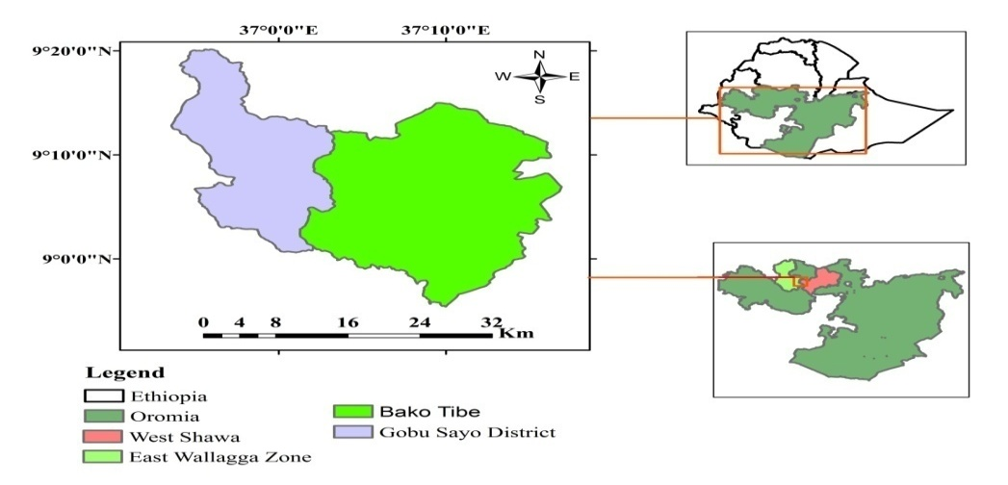
Fig.1. Location map of the study area.
2.2. Experimental Design and Procedure
Soybean varieties were used as test crop for conducting this experiment. Treatments such as two Soybean varieties (Jallalle, Diddessa) and six different strains (Bradyrhizobium, MAR-1495, MURDOCK, SB-12, SB-LF and TAL-379) were collected from HARC, Menagesha and Nekemte Soil Lab. Research Center. Those treatments were combined factorially together with two control treatments replicated three times. Over all fourteen (14) treatments were evaluated in two districts for the two continuative main cropping seasons/years/. Lime was applied to the experimental sites one month prior to sowing for buffering soil acidity and to avoid the confounding effects of other factors and to create uniform environment for the experimental factors to clearly observe their effect. Recommended quantity of chemical fertilizers 100 kg/ha NPS was applied to all plots evenly except for those negative control plots. It was designed in RCBD replicated three times having an area of 3m x 3m=9m² net plot size for each plot at both experimental sites. The plot has six total rows having two borders, one distractive row for measuring nodule number per plant, nodule fresh and dry weight, effective and none effective nodules and three harvestable rows. The seed was inoculated with those strains according to its procedure and assigned randomly to overall plots.
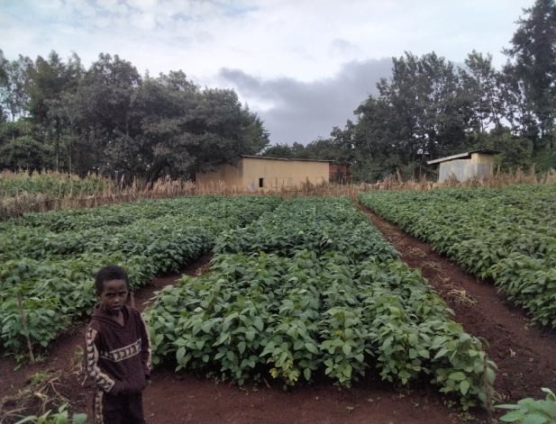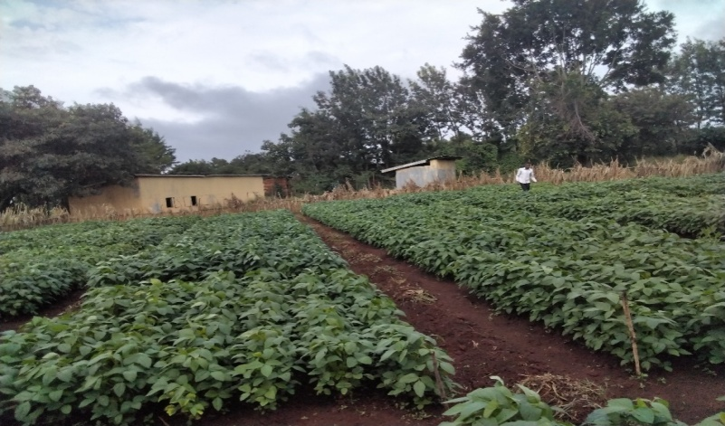

- RESULTS AND DISCUSSIONS
3.1. Pooled Mean Grain Yield per Hectare (kgha⁻¹)
The analysis of variance indicated that highly significant differences (P<0.005) were observed between treatments. The combined analysis of variance showed that mean grain yield of soybean was significantly influenced (P<0.001) by the interaction of strain and soybean variety (Table: 1). It was observed that MAR-1495 strain interaction with Diddessa variety gave the highest pooled mean grain yield (2507kgha⁻¹) at G/Sayo while the lowest yield (1324 kgha⁻¹) was obtained from the control treatment of the same district (Table 1).
Table: 1.Pooled Mean Grain Yield of Soybean as Influenced by the Interaction of Strains and Variety at Bako and G/Sayo Districts of Western Oromia.
 |  | Variety
Locations | Type of strain | DIDESSA | JALALE
Bako | Control | 1324 | 1653
 | Bradyrhizobium | 1723 | 2072
 | MAR1495 | 2458 | 1905
 | MURDOCK | 2260 | 2030
 | SB12 | 2283 | 1833
 | SBLF | 2494 | 1587
 | TAL379 | 2162 | 1564
G/Sayyo | Control | 2176 | 2132
 | Bradyrhizobium | 2222 | 2250
 | MAR1495 | 2507 | 2118
 | MURDOCK | 2333 | 2035
 | SB12 | 2396 | 2083
 | SBLF | 1896 | 2236
 | TAL379 | 2181 | 1972
LSD(<0.05) | 380.371
CV(%) | 11.2
3.2.2. Above ground dry biomass yield (kg ha-1)
The analysis of variance showed that the interaction of Bradyrhizobium strain and Diddessa variety was highly significant effect (P<0.001) for the above ground dry biomass yield at harvesting. The highest dry biomass yield (6329 kgha⁻¹) was obtained from the interaction of Bradyrhizobium strain and Diddessa variety at G/Sayo district. The lowest biomass yield (3773 kgha⁻¹) was obtained from the control treatments of Jalalle variety (Table 2).
Table: 2.Biomass Yield of Soybean as Affected by the Interaction of Strains and Variety at Bako and G/Sayo Districts Western Oromia
 | Variety
TAYPE_STRAIN | DIDESSA | JALALE
Control | 4373de | 3773^{f}
Bradyrhizobium | 6329ª | 5253^{bc}
MAR1495 | 4899^{cd} | 4864^{cd}
MURDOCK | 5673^{b} | 4848^{cd}
SB12 | 5051^{c} | 4157^{ef}
SBLF | 5775^{ab} | 3659^{f}
TAL379 | 4899^{cd} | 4404de
LSD(<0.05) | 578.217
CV(%) | 10.3
Means followed by the same letters within columns and rows for a factor is not significantly different at 5% level of significance.
    - Nodule Number Per plant and Effective Nodules
The analysis of variance showed that number of nodules per plant and effective nodules were statistically significant. The highest nodule number per plant (100.33) was recorded from the interaction of MAR-1497 strain with diddessa variety and the lowest value (17.93) was obtained from the control treatment of Jalalle variety.
Table: 3. Nodule Number and Effective Nodules of Soybean as Affected by the Interaction of Strains and Variety at Bako and G/Sayo Districts, Western Oromia
 |  | NNPP
TAYPE_STRAIN | VARIETY | DIDESSA | JALALE
Control |  | 40.93 | 17.93
Bradyrhizobium japo. |  | 66.73 | 58.83
MAR-1497 |  | 100.33 | 52.9
MURDOCK |  | 48.13 | 50.4
SB-12 |  | 97.53 | 58.33
SBLF |  | 27.1 | 68.33
TAL-379 |  | 43.47 | 107.33
LSD (5%) | 7.85
CV(%) | 11.3
 |  | ENPP
Control |  | 19.93 | 13.47
Bradyrhizobium japo. |  | 40.21 | 30.27
MAR-1497 |  | 81.93 | 32.33
MURDOCK |  | 35.1 | 33.73
SB-12 |  | 64.2 | 24.8
SBLF |  | 20.23 | 27.3
TAL-379 |  | 34.2 | 88.63
LSD (5%) | 9.79
CV (%) | 21.7

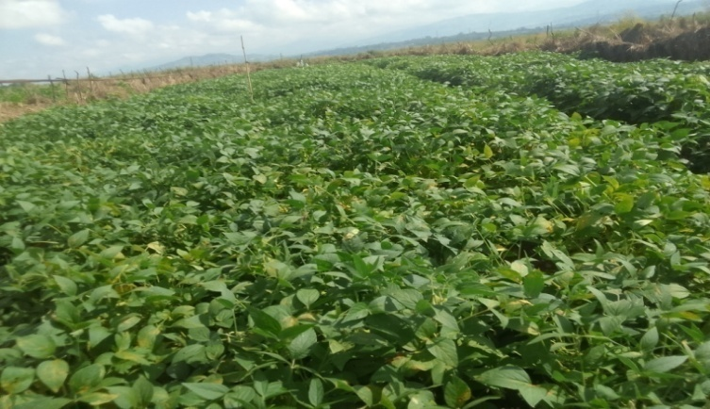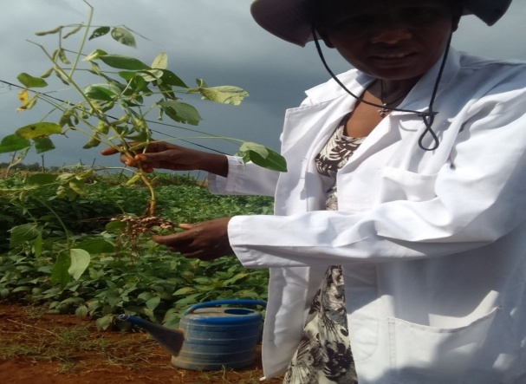
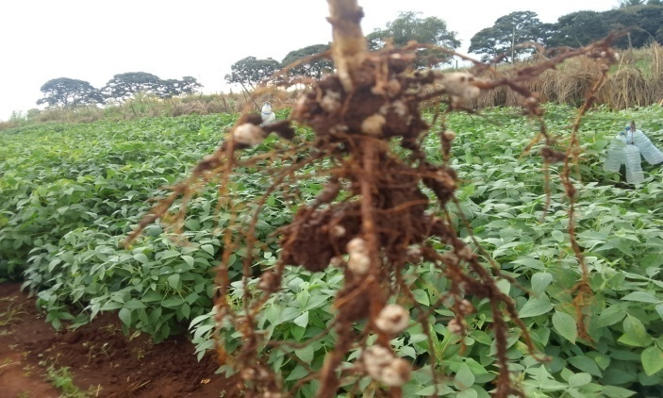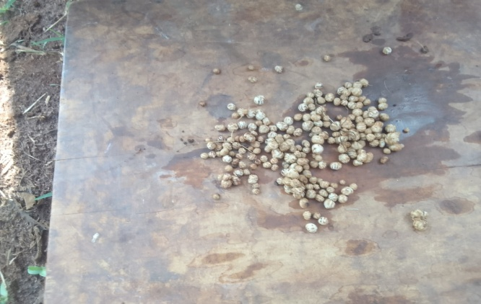

- CONCLUSION AND RECOMMENDATIONS

The decrease in biological activity in soil as a result of compaction is quite concerning. Organic matter is the most important component in the integrity of the soil structure. Therefore integration of organic and inorganic fertilizers for boosting crop production as well as keeping soil health is critical issue. The strains (MAR-1495 and TAL-379) were selected majorly for nodulation processes and to obtain reasonable yield of soybean in the study areas. In general besides boosting crop yield, biological organisms are environmental friendly and have great contribution for increasing soil fertility for sustainable crop production. By using these selected strains and soybean variety(s) further demonstration and pre-scaling up will be a pre requisite activity.
- References
Collombet R. N., Investigating Soybean Market Situation in Western Kenya: Constraints and Opportunities for Smallholder Producers, 2013, Wageningen University, Wageningen, Netherlands, 1–43.
CSA (Central Statistics Agency of Ethiopia), Report on Area and Crop Production Forecast for Major Crops, 2017, CSA, Addis Ababa, Ethiopia.
CSA (Central Statistics Agency of Ethiopia), Report on Area and Crop Production Forecast for Major Crops, 2018, CSA (Central Statistics Agency of Ethiopia), Addis Ababa, Ethiopia.
Dugje I. Y., LO O., Ekeleme F., Bandyopadhyay R., Kumar P. L., and Kamara A. Y., Farmers Guide to Soybean Production in Northern Nigeria, 2009, International Institute of Tropical Agriculture, Ibadan, Nigeria, 1–16.
Tefera H., A. Sudaric, Breeding for promiscuous soybeans at IITA, Soybean–Molecular Aspects of Breeding. (2010) InTech, Rijeka, Croatia, http://www.intechopen.com/books/soybean- molecular-aspects-of-breeding/beeding-for-promiscuous-soybeans-at-iita.
United states Department of Agriculture (USDA), Annual Report, 2017, United states Department of Agriculture (USDA), Washington, DC, USA.
Zinaw D., Seltene A., and Addisu G., Genetic variability and heritability of soybean (Glycinemax (L.) Merrill) genotypes in Pawe district, Metekel zone, Benishangul Gumuz regional state, northwestern Ethiopia, Wudpecker J. Agric. Res.,. (2013) 2, no. 9, 240– 245.

