GIS-Based Land Utilization and Suitability Analysis for Optimal Crop Selection in Ratnapura District of Sri Lanka: Case Study for Tea, Paddy and Rubber

ABSTRACT
Land suitability evaluation for agricultural crop cultivation is crucial to maximum agricultural productivity with sustainability of the environment. Land suitability evaluation for tea, paddy and rubber plantations in the Ratnapura District in Sri Lanka is conducted in this research using remote sensing and GIS technologies. Significant environmental conditions like slope, aspect, elevation, rainfall, minimum and maximum temperature, soil type and pH were analyzed and reclassified. Fuzzy membership functions and fuzzy overlay techniques were used to generate crop-specific suitability maps. Supervised classification using the Random Forest method was employed for getting the most recent land use map with 81.42% accuracy and 0.7683 Kappa coefficient, confirming good reliability of classification. Mismatch analysis revealed that 19.45% of tea, 31.98% of paddy and 29.06% of rubber plantations are performed in low or not suitable places, reflecting inefficiency in land utilization currently. To this, a crop reallocation study was conducted to identify substitute crops that are suitable for these unsuitable regions. Results showed that a significant proportion of these lands is highly convertible to other crops, for example, 46.58% of tea mismatch lands are convertible to paddy and rubber, while 46.11% of rubber mismatch lands are convertible to tea and paddy. These findings support the use of alternative or mixed cropping systems to enhance land use efficiency and sustainability. The study recommends data-driven planning, environmentally friendly methods such as terracing and best irrigation and regular GIS-based monitoring for agricultural sustainability. Overall, GIS-based land suitability analysis is an effective means of land use optimization and minimizing environmental impacts in the Ratnapura District.
Keywords: Fuzzy overlay, Land suitability analysis, Land Utilization, Mismatch analysis, Random Forest
INTRODUCTION
Land suitability analysis for agriculture aids sustainable agricultural planning. It considers the potential of land for agricultural use based on parameters such as soil-related information, surface characteristics, water availability and climate conditions (Han et al., 2021); (Khoi & Murayama, 2010). It helps determine areas that are appropriate for crop cultivation to increase productivity while preventing land degradation (Layomi Jayasinghe et al., 2019).
The Food and Agriculture Organization (FAO) contains the fundamental basis for evaluating land suitability and aligning crop types with land characteristics to maximize optimal resource utilization (Saremi et al., 2011). By proposing the optimal cultivation area, it plays an important role in future land use (Maddahi et al., 2017).
Land use refers to the productive and effective use of land for agriculture. Inefficient use leads to loss of fertility and erosion, as well as decreased yields (Khoi & Murayama, 2010). Land Misuse, regardless of suitability leads to major productivity losses and degradation (Anushiya & Illeperuma, 2017).
GIS technology supports land suitability analysis by combining georeferenced information such as elevation, soils and climate to produce suitability maps for efficient planning (Saremi et al., 2011); (Suthakar, 2018). GIS-based multi-criteria evaluation (MCE) has proven efficient in identifying areas of cultivation based on slope, elevation and soil data (Debesa et al., 2020). Fuzzy overlay maximizes accuracy by handling data uncertainty (Maddahi et al., 2017), presenting more qualitative and realistic land suitability assessments (Prakash, 2003).
Agriculture is one of Sri Lanka's major industries, making a major contribution to economic stability and rural life. Ratnapura District located in the southwest, consists of diverse agroecological conditions favourable for tea, paddy and rubber (Layomi Jayasinghe et al., 2019); (Anushiya & Illeperuma, 2017). Its varied topography presents challenges in optimizing land use. Mismatches between current use and land suitability must be eliminated to increase productivity and sustainability (Debesa et al., 2020); (Suthakar, 2018).
Land suitability is critical for sustainable agriculture, especially with increased population and climate changes (Debesa et al., 2020). Suitability analysis helps in the reallocation of less productive lands to more appropriate crops, yielding the maximum and minimum degradation (Saremi et al., 2011); (Han et al., 2021).
Tea, rubber and paddy are the major plantation crops of the area. They are specific to the climatic conditions and the nature of lands and are effective ways of achieving maximum cultivation by the evaluation of the land suitability. Tea, for example, requires well-draining upland conditions while watery lands and lowlands are the predominant areas of paddy cultivation (Layomi Jayasinghe et al., 2019). The study will be added with remote sensing, multi-criteria analysis and GIS to create feasible inputs for agricultural productivity optimization and sustainability for the Ratnapura District.
METHODOLOGY
Study Area
Ratnapura district is located in the south-western part of Sri Lanka between Northern latitudes 6º41' and 6º42' and Eastern longitudes 80º23' and 80º24' and is the capital of Sabaragamuwa Province. It covers an area of 3,275.4 square kilometers and 18 Divisional Secretariat divisions. Ratnapura is especially found in three climatic zones, wet, dry and intermediate. It experiences varied environmental conditions with annual rainfall of 3000 - 4000 mm and elevations of 259 - 3596 feet above sea level. The tropical climate (25°C - 27°C) and dominant red-yellow podzolic and reddish-brown earth soils make the district highly suitable for cultivating tea, rubber and paddy.
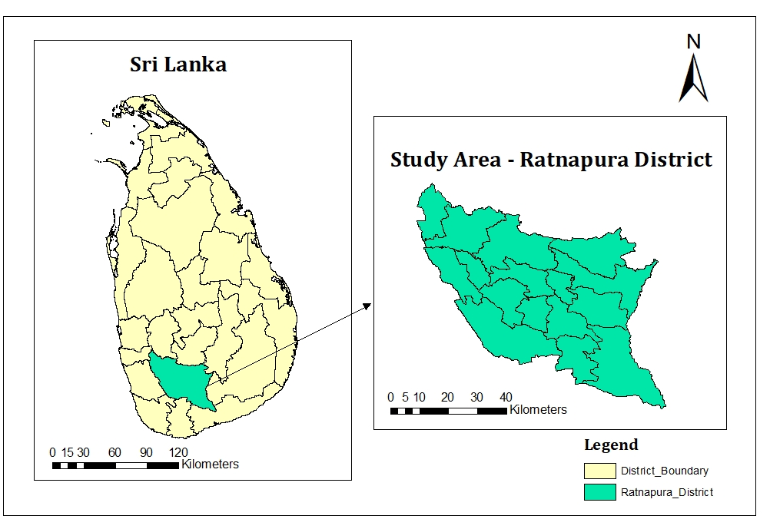
Figure 1: Study Area

Data Requirements
The study utilized spatial datasets for land suitability assessment and land use classification in Ratnapura District. Sentinel-2 imagery from Google Earth Engine (GEE) supported supervised classification. SRTM DEM from USGS provided slope, elevation and aspect data. Soil pH and soil type were sourced from ISRIC SoilGrids and NSDI respectively. Rainfall and temperature data from 2010 to 2023 were obtained from the Department of Irrigation and the Department of Meteorology. Land use training data were prepared using ESRI 10m Global landcover datasets along with manually digitized polygons from Google Earth Pro.
Method
DEM
Soil Data
Climate Data
Satellite Image
(Sentinel - 2)
Land Use Data
Slope
Aspect
Elevation
Soil pH
Soil Type
Temperature
Rainfall
Supervised Classification
Accuracy Assessment
Reclassification
Fuzzy Overlay Analysis
Suitability Maps for Tea, Paddy and Rubber
Spatial Matching
Land Use-Suitability Comparison
Current Land Use map
Fuzzy Membership Function
Identifying Suitable Crops for Mismatched Areas
Final Recommendation
Figure 2: Flow Chart for Methodology of the Research
All collected datasets were first preprocessed to ensure consistency in projection and resolution. Sentinel-2 imagery was preprocessed in Google Earth Engine (GEE) by applying cloud masking using the QA60 band. A median composite image was generated to reduce cloud contamination and clipped to study area. Using Shuttle Radar Topography Mission (SRTM), derive terrain parameters such as slope, elevation and aspect using the Spatial Analyst Toolbox in ArcGIS Pro. Soil data has been rasterized and standardized, and climatic datasets including rainfall and temperature from 2010 to 2023 were interpolated using the Inverse Distance Weighted (IDW) method to generate continuous raster surfaces for suitability analysis.
To evaluate land suitability for tea, paddy and rubber cultivation, reclassification was carried out for environmental factors such as slope, elevation, aspect, temperature, rainfall, soil pH and soil type. Based on literature-defined thresholds, each parameter was classified in five categories: Highly Suitable, Suitable, Moderately Suitable, Low Suitable and Unsuitable. Following this, fuzzy membership functions were applied in ArcGIS Pro to convert the reclassified datasets into continuous suitability values ranging from 0 (least suitable) to 1 (most suitable). The linear fuzzy membership function is expressed as:
${ µ}_{A}\left(y\right)=\left\{\begin{aligned}\frac{y-y_{1}}{y_{2}-y_{1}}, &for y_{1}<y<y_{2} \\ 0, &otherwise\end{aligned}\right.$ (1)
Where µ_{A}(y) is the fuzzy membership value, y is the input value and y₁, y₂ are the minimum and maximum membership scaling values.
All fuzzy layers were integrated using the Fuzzy Overlay tool in ArcGIS Pro with the Gamma operator set at 0.9, ensuring a balanced influence of all parameters while maintaining smooth suitability transitions. Final suitability maps were generated for tea, paddy and rubber.
Supervised classification of land use was conducted using the Random Forest algorithm in ArcGIS Pro. Training data for eight land cover classes such as Tea, Paddy, Rubber, Forest, Built-up area, Bare land, Shrubland and Water bodies were prepared by combining manually digitized polygons and the ESRI 10 m land cover dataset. A single shapefile was created with unique attribute values for each class. The classifier was trained using 200 decision trees and a maximum depth of 20 to ensure optimal performance.
After classification, an accuracy assessment was conducted using a confusion matrix. Reference points were collected using high-resolution imagery in Google Earth Pro. The following formulas were used to calculate overall accuracy and Kappa coefficient:
$Overall Accuracy= \frac{\sum{C_{ii}}}{T} X 100$ (2)
Where,
C_{ii} - Correctly classified samples (diagonal values of the confusion matrix)
T - Total number of classified samples
$Kappa Coefficient= \frac{P_{o}-P_{e}}{1-P_{e}}$ (3)
Where,
P_{o} - Overall Accuracy as a decimal
P_{e} - Probability of agreement by chance
$P_{e}=\sum{\left(\frac{\left(R_{i}×C_{i}\right)}{T^{2}}\right)}$ (4)
Where,
R_{i} - Row total for class i
C_{i} - Column total for class i
The classified land use map was overlaid with crop-specific suitability maps using the Raster Calculator in ArcGIS Pro. Areas, where current land use did not align with the corresponding suitability levels, were extracted as mismatch zones. The mismatch zones indicate lands under cultivation currently that fall in low or unsuitable classes for the crop being grown. Each of the mismatch zones was also further analyzed by overlaying it with the highly suitable zones of the remaining two crops. This enabled the identification of more environmentally suitable alternative crops for each mismatched area. Reallocation analysis provided spatial recommendations favoring more effective land use, increasing crop yield potential and promoting long-term sustainable agriculture development in the Ratnapura District.
RESULTS AND DISCUSSION
The result is the outcome of land use classification and land suitability analysis for tea, rubber and paddy cultivation in the Ratnapura District. Using fuzzy overlay analysis, supervised classification and spatial mismatch assessment, suitability maps were generated to show environmental favorability, while the land use map showed current crop distribution. A comparative analysis revealed inconsistencies between land use and crop suitability, which formed the basis for making recommendations to improve land-use efficiency and contribute to sustainable agricultural planning.
Fuzzy Overlay Analysis
The continuous suitability maps for tea, paddy and rubber cultivation based on environmental characteristics including slope, elevation, aspect, soil class, soil pH, temperature and rainfall were produced through Fuzzy Overlay Analysis. Results generated suggest suitability on a scale of 0 (least suitable) to 1 (most suitable) to show environmental favourability in the spatial variation. Figures 3, 4 and 5 show the suitability maps of each crop, which are used to compare present land use to ideal crop distribution.
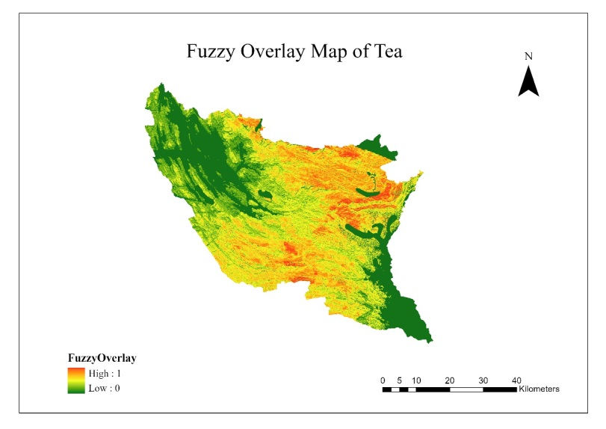
Figure 3: Fuzzy Overlay Map of Tea
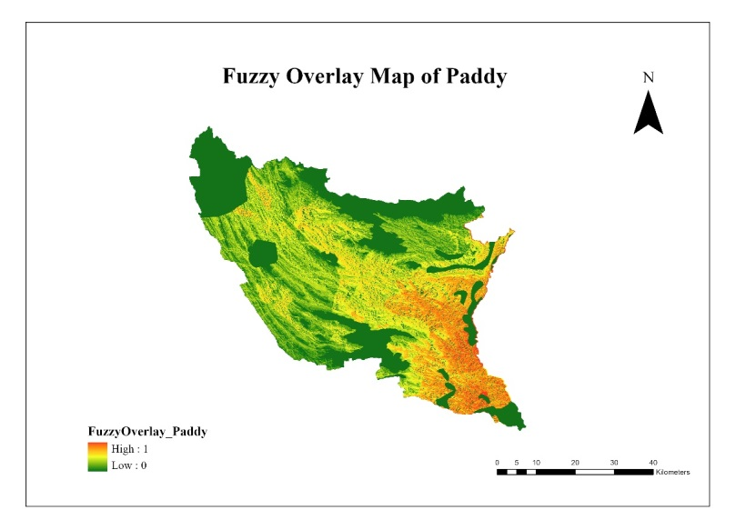
Figure 4: Fuzzy Overlay Map of Paddy

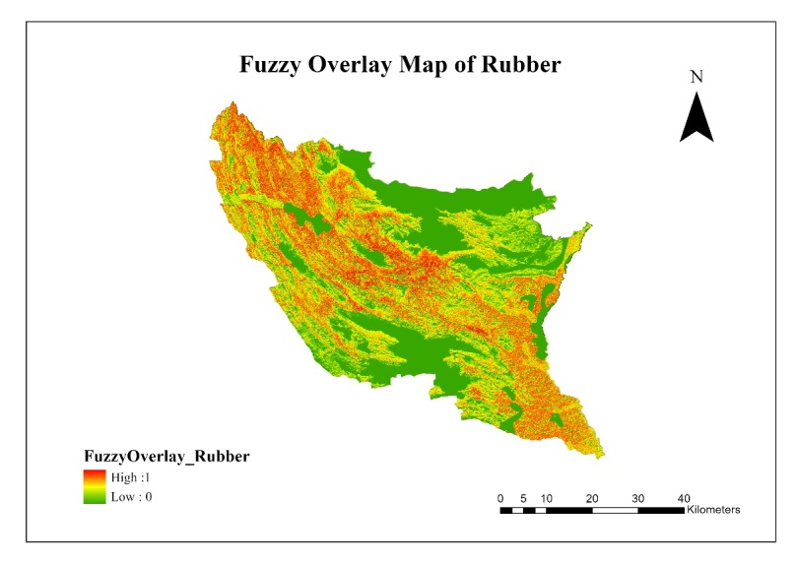
Figure 5: Fuzzy Overlay Map of Rubber
Land Suitability Analysis
The suitability maps generated using fuzzy overlay analysis illustrated distinct spatial patterns for tea, paddy and rubber cultivation in the Ratnapura District. Topographic, climatic and soil-related parameters significantly influenced suitability zones for each crop. Figures 6, 7 and 8 present the final suitability maps for tea, paddy and rubber respectively. These maps classify the landscape into five categories: Highly Suitable, Suitable, Moderately Suitable, Low Suitable and Unsuitable areas.
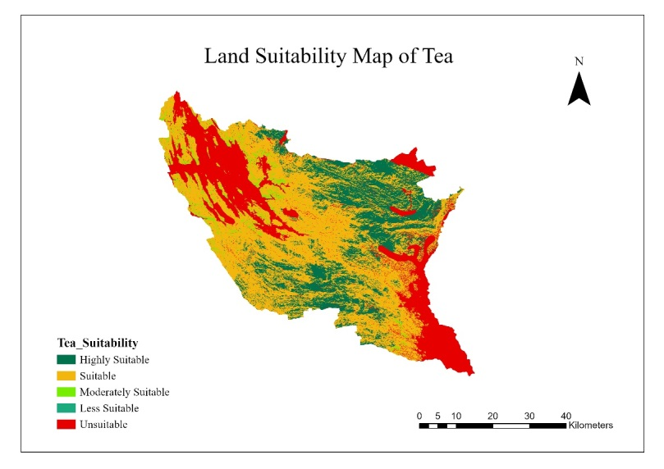
Figure 6: Land Suitability Map of Tea
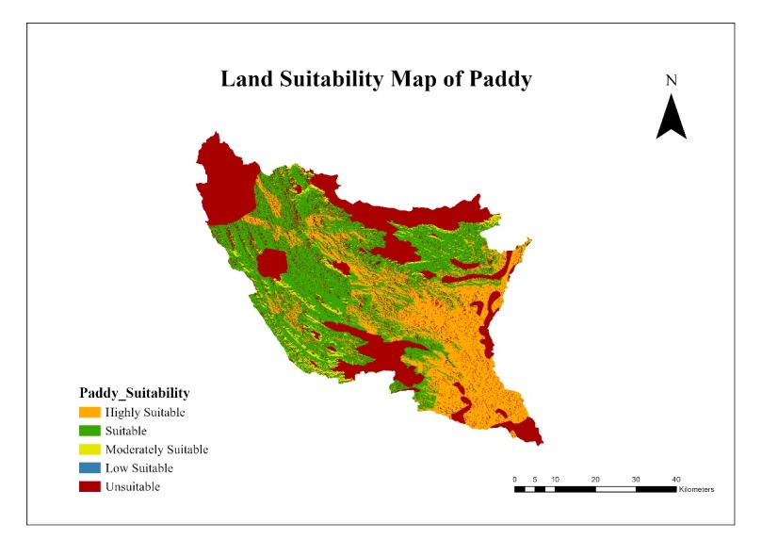

Figure 7: Land Suitability Map of Paddy
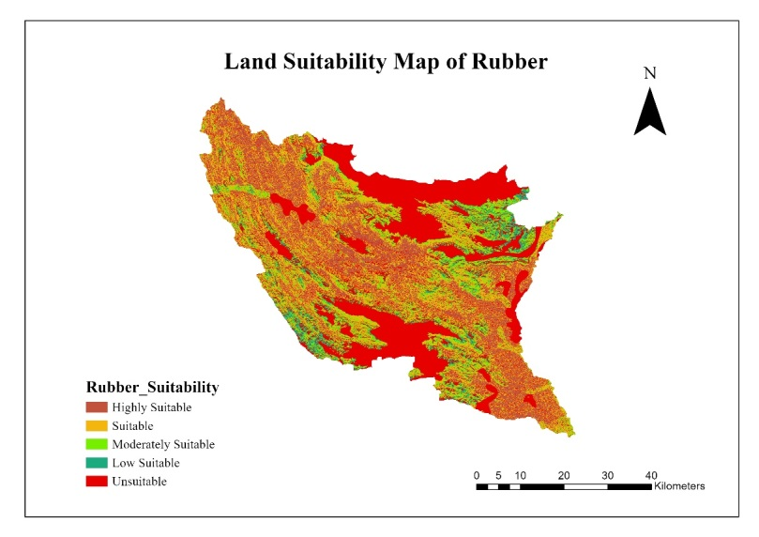
Figure 8: Land Suitability Map of Rubber
Table 1 summarizes the suitability class distribution for each crop. The highest percentage of highly suitable land was observed for tea (21.78%), followed by rubber (21.55%) and paddy (25.24%).
Table 1: Percentage of Land Area by Suitability Class for Tea, Paddy and Rubber
Suitability Class | Tea (%) | Paddy (%) | Rubber (%)
Highly Suitable | 21.78 | 25.24 | 21.55
Suitable | 50.87 | 36.88 | 25.36
Moderately Suitable | 2.62 | 3.70 | 13.68
Low Suitable | 0.009 | 0.002 | 4.53
Unsuitable | 24.72 | 34.18 | 34.89
Land Use Classification
The current land use was mapped using the supervised classification of Sentinel-2 imagery in ArcGIS Pro, applying the Random Forest algorithm. Eight land cover classes were identified: Tea, Paddy, Rubber, Forest, Built-up areas, Shrubland, Bare land and Water bodies. Training data were developed using a combination of digitized samples and global land cover data. The classified output yielded an overall accuracy of 81.42% and a Kappa coefficient of 0.7683 indicating strong model performance.
Figure 9 shows the final land use classification map for the study area.
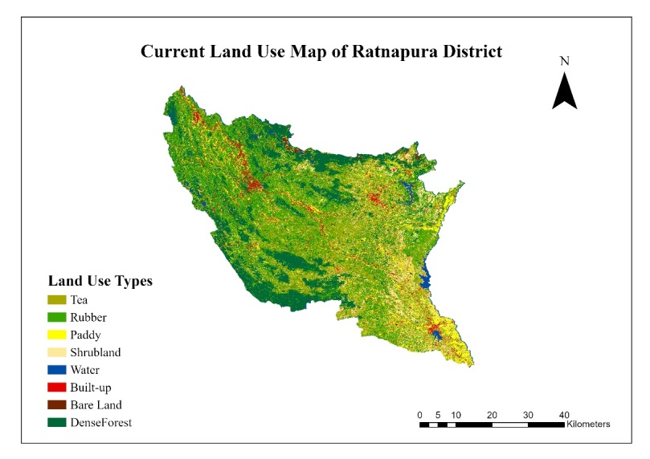
Figure 9: Current Land Use Map of Ratnapura District
Mismatch Analysis
A mismatch analysis was carried out by overlaying the current land use map with the crop-specific suitability maps using the Raster Calculator in ArcGIS Pro. This process identified areas where existing cultivation occurs on land classified as either low suitable or unsuitable. These areas represent inefficiencies in land allocation, where agricultural practices do not align with environmental conditions.
Among the three crops, paddy had the highest mismatch percentage at 31.98%, indicating a considerable portion of paddy cultivation takes place on less suitable land. Rubber showed a 29.06% mismatch, while tea exhibited the lowest at 19.45%, suggesting better alignment between current tea cultivation and land suitability.
Table 2: Mismatches Percentage
Crops | Mismatch Percentage (%)
Tea | 19.45
Paddy | 31.98
Rubber | 29.06

Figures 10, 11 and 12 illustrate the spatial mismatch zones for tea, paddy and rubber respectively,
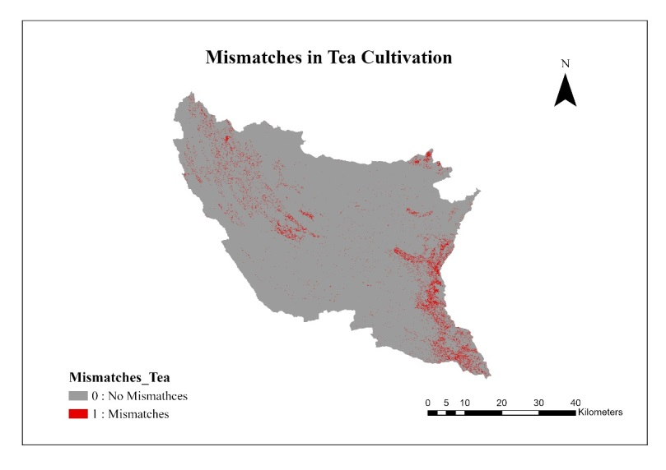
Figure 10: Mismatches Map of Tea Cultivation
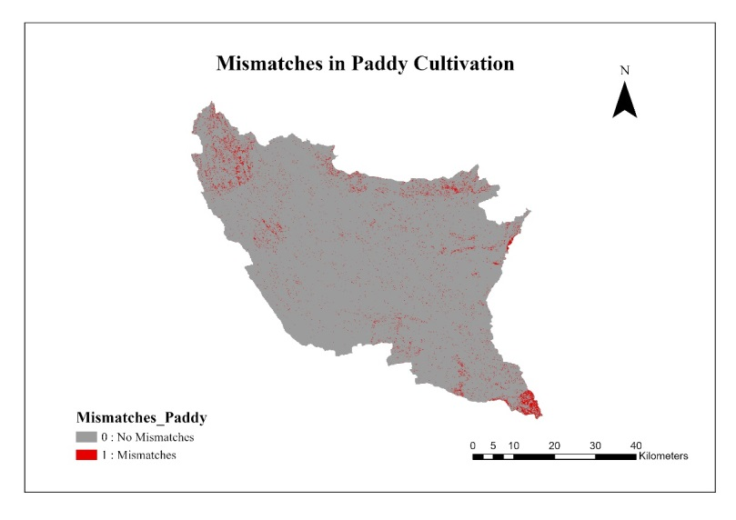
Figure 11: Mismatches Map of Paddy Cultivation
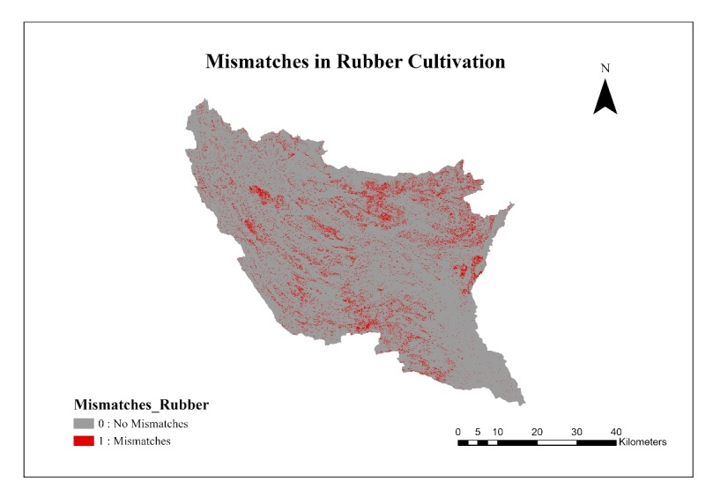
Figure 12: Mismatches Map of Rubber Cultivation
3.4 Crop Reallocation Analysis
Following the mismatch analysis, a further evaluation was conducted to identify suitable alternative crops for ineffectively used areas. By overlaying mismatch zones with fuzzy suitability maps, the study revealed strong reallocation potential. This helps assess whether tea, paddy or rubber mismatch areas can be better utilized through crop switching or mixed cropping, supporting more sustainable and efficient land use in the Ratnapura District.
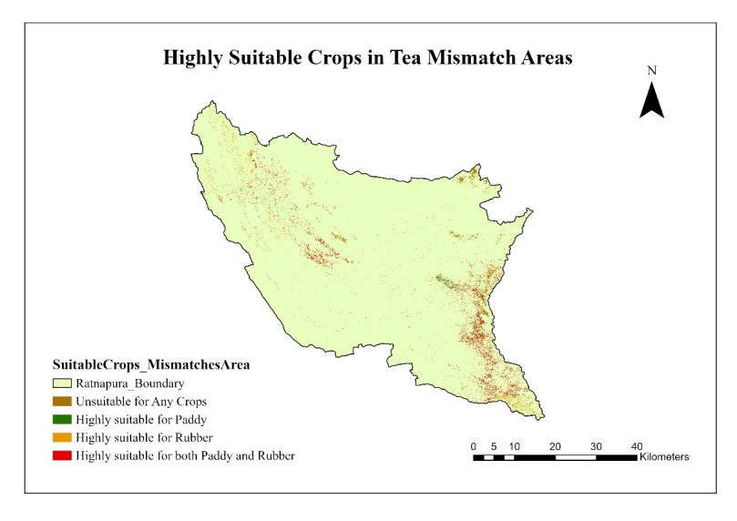
Figure 13: Highly Suitable Crops in Tea Mismatch Areas
Table 3: Tea Mismatch Area Statistics
Suitability Class | Area (Sqkm) | Percentage (%)
Unsuitable for any crop | 23.42 | 20.24
Highly suitable for Paddy | 15.83 | 13.68
Highly suitable for Rubber | 22.57 | 19.5
Highly suitable for both crops | 53.9 | 46.58

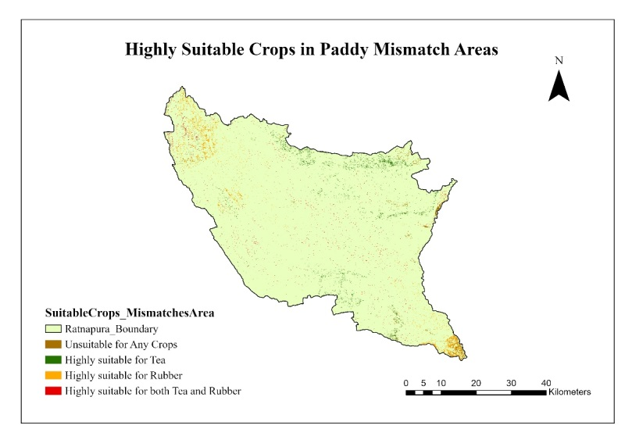
Figure 14: Highly Suitable Crops in Paddy Mismatch Areas
Table 4: Paddy Mismatch Area Statistics
Suitability Class | Area (Sqkm) | Percentage (%)
Unsuitable for any crop | 18.57 | 17.05
Highly suitable for Tea | 31.86 | 29.26
Highly suitable for Rubber | 40.91 | 37.58
Highly suitable for both crops | 17.53 | 16.1
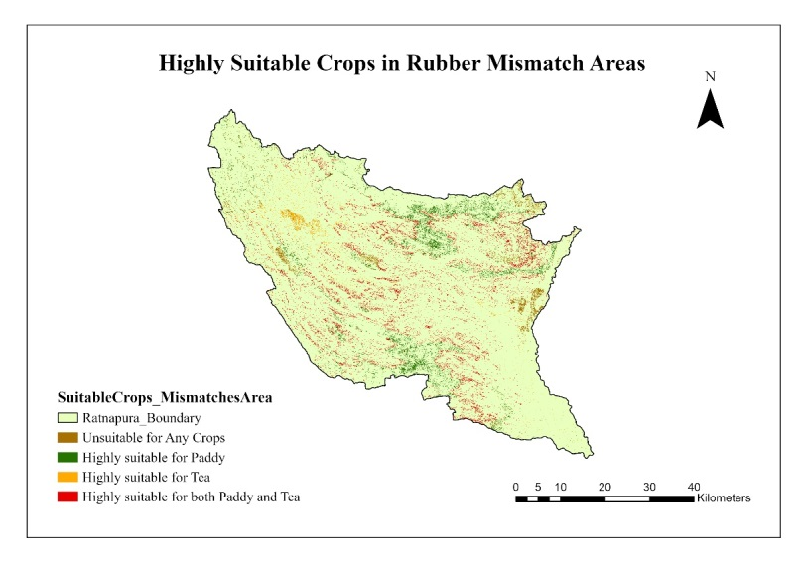
Figure 15: Highly Suitable Crops in Rubber Mismatch Areas

Table 5: Rubber Mismatch Area Statistics
Suitability Class | Area (Sqkm) | Percentage (%)
Unsuitable for any crop | 43.26 | 14.56
Highly suitable for Paddy | 89.75 | 30.21
Highly suitable for Tea | 27.06 | 9.11
Highly suitable for both crops | 136.97 | 46.11

CONCLUSION
This study assessed mismatches between current agricultural land use and environmental suitability for tea, paddy and rubber cultivation in Ratnapura District. Findings revealed that significant areas of paddy and rubber cultivation occur in environmentally unsuitable places, indicating inefficiencies and poor alignment with agro-ecological conditions. The mismatches indicate the significance of improved land-use decisions, as economic forces tend to overwhelm ecological suitability. However, many mismatched lands were highly suitable for other crops, demonstrating strong potential for crop reallocation and diversification. The study confirms the application value of geospatial techniques, GIS, remote sensing and fuzzy overlay analysis in land suitability analysis and agricultural planning. Ratnapura is given as an example of how spatial analysis combined with environmental information can contribute towards promoting sustainable agriculture and evidence-based land management for future food security and climate resilience.
REFERENCES
- Anushiya, J. and Illeperuma, I., 2017. Suitability Analysis For Paddy Cultivation Sites Using A Multi Criteria Evaluation And GIS Approach Case Study: Imbulpe DS Division In Sri Lanka. 37th Asian Conference on Remote Sensing (ACRS 2016), Colombo, Curan Associates, Inc,
- Ayehu, G. T. and Besufekad, S. A., 2015. Land suitability analysis for rice production: A GIS based multi-criteria decision approach. American Journal of Geographic Information System, 4(3), 95-104.
- Bansal, H., Sharma, P., Jabalia, N., Chaurasia, A., Rani, M. and Pathak, H. Characterization of Soil Resources Using Geographical Information System for Improved Crop Management.
- Bondre, D. A. and Mahagaonkar, S., 2019. Prediction of crop yield and fertilizer recommendation using machine learning algorithms. International Journal of Engineering Applied Sciences and Technology, 4(5), 371-376.
- Chen, C.Y. and Huang, J.-J., 2022. Deriving Fuzzy Weights from the Consistent Fuzzy Analytic Hierarchy Process. Mathematics, 10(19), 3499.
- Debesa, G., Gebre, S. L., Melese, A., Regassa, A. and Teka, S., 2020. GIS and remote sensing-based physical land suitability analysis for major cereal crops in Dabo Hana district, South-West Ethiopia. Cogent Food & Agriculture, 6(1), 1780100.
- FAO., 1976. A Framework for Land Evaluation; soils bulletin No. 32; Food and Agriculture Organization of the United Nations (FAO): Rome, Italy, 1976.
- Fernando, P., Nianthi, R. and Subasinghe, S., 2023. Evaluating Tea Land Suitability and Potential Challenges in the High Grown Region (HGR) of Sri Lanka: A Case Study of Kothmale DS Division, Sri Lanka. IOP Conference Series: Earth and Environmental Science.
- Han, C., Chen, S., Yu, Y., Xu, Z., Zhu, B., Xu, X. and Wang, Z., 2021. Evaluation of agricultural land suitability based on RS, AHP, and MEA: A case study in Jilin Province, China. Agriculture, 11(4), 370.
- Hoang, T. H. N., Nguyen, M. H. and Bui, Q. D., 2022. A combined approach for sustainable use of mountainous agricultural land: land suitability evaluation and ecological economic model. Vietnam Journal of Earth Sciences, 44(4), 451-469.
- Jiang, H. and Eastman, J. R., 2000. Application of fuzzy measures in multi-criteria evaluation in GIS. International Journal of Geographical Information Science, 14(2), 173-184.
- Khan, R. M. and Ahmed, P., 2023. Agricultural land use suitability analysis using GIS and AHP technique in Baramulla district of the Kashmir valley, India.
- Khoi, D. D. and Murayama, Y., 2010. Delineation of suitable cropland areas using a GIS based multi-criteria evaluation approach in the Tam Dao National Park Region, Vietnam. Sustainability, 2(7), 2024-2043.
- Layomi Jayasinghe, S., Kumar, L. and Sandamali, J., 2019. Assessment of potential land suitability for tea (Camellia sinensis (L.) O. Kuntze) in Sri Lanka using a GIS-based multi-criteria approach. Agriculture, 9(7), 148.
- Maddahi, Z., Jalalian, A., ZARKESH, M., KHEIRKHAH, M. and HONARJO, N., 2017. Land Suitability Analysis for Rice Cultivation Using a GIS-based Fuzzy Multi-criteria Decision Making Approach: Central Part of Amol District, Iran. Soil & Water Research, 12(1).
- Mulugeta, H., 2010. Land suitability and crop suitability analysis using remote sensing and GIS application; a case study in Legambo woreda, Ethiopia. An MSc thesis submitted to the school of graduate studies, Addis Ababa University, Ethiopia.
- Prakash, T. N., 2003. Land suitability analysis for agricultural crops: a fuzzy multicriteria decision making approach.
- Rodriguez-Galiano, V. F., Ghimire, B., Rogan, J., Chica-Olmo, M. and Rigol-Sanchez, J. P., 2012. An assessment of the effectiveness of a random forest classifier for land-cover classification. ISPRS journal of photogrammetry and remote sensing, 67, 93-104.
- Saremi, H., Kumar, L., Sarmadian, F., Heidari, A. and Shabani, F., 2011. GIS based evaluation of land suitability: A case study for major crops in Zanjan university region. Journal of Food, Agriculture & Environment, 9(1), 741-744.
- Suthakar, K., 2018. Assessment of Land Suitability Potential for Selected Field Crops Using GIS-Based Multi-Criteria Analysis (MCA): Evaluating the Case for Jaffna Peninsula, Sri Lanka. SSRN.
- Wati, S. F. A., Fitri, A. S. F., Kartika, D. S. Y., Wulansari, A. and Safitri, E. M., 2022. GIS Land Suitability to Increasing Agricultural Production for the Agriculture Supply Chain: A Systematic Literature Review. IJCONSIST JOURNALS, 3(2), 13-18.
- Wijesinghe, D. C., 2024. GIS-based AHP and MCDA Modeling for Cropland Suitability Analysis: A Bibliometric Analysis. Gazi University Journal of Science Part A: Engineering and Innovation, 11(3), 598-621.
- Yalew, S. G., Van Griensven, A., Mul, M. L., & van der Zaag, P. (2016). Land suitability analysis for agriculture in the Abbay basin using remote sensing, GIS and AHP techniques. Modeling Earth Systems and Environment, 2, 1-14.

