Importance of examination of feces in the diagnosis of Intestinal parasites - A review

Abstract
The stool exam is a crucial diagnostic tool for identifying intestinal parasites. It is a non-invasive procedure that involves analyzing a stool sample to detect the presence of parasites, their eggs, or larvae. This test is particularly important for diagnosing infections caused by organisms such as Giardia, Entamoeba histolytica, and various types of worms. Common gastrointestinal infections are reported as food poisoning or stomach infections. The stool exam is also vital for early detection, which can prevent complications like dehydration and severe nutrient deficiencies. It plays a significant role in public health, allowing healthcare provides to tract outbreaks and implement preventive measures. The test’s accuracy and reliability have been enhanced by advances in laboratory techniques, including stool microscopy and molecular testing.

Key words: Intestinal parasites, stool examination, diagnosis

Introduction
Intestinal parasites are considered health problems in many countries, especially in developing countries. One of the important indicators of health and well-being of any society is the status of people in that society with parasitic infections. Infection with these parasites is one of the problems and obstacles to economic and social development in most countries of the world and despite the continuous efforts and extensive planning, they are still one of the main health problems in developing countries. According to the World Health Organization, the rate of infection with these agents in the world is estimated to be 3.5 billion people, which leads to 4.5 million cases of clinical symptoms. Infection may be asymptomatic or can lead to disability and eventually death, depending on the nutritional status, health and socioeconomic status of patients.
Intestinal parasitic diseases are among the most important infectious diseases that are directly related to personal and public health. Because intestinal parasitic infections are usually chronic, an infected person may be asymptomatic for a long time and transmit the infection to the community. Severe gastrointestinal symptoms and disordered may also develop over time. Infection with these parasites leads to malnutrition, insufficient physical growth, anemia, and reduced learning, especially in children. Water, vegetables and food are the most important sources of these infections.
Today, due to the diversity of climate, type of work and life of people, the use of animal and human fertilizers in plant breeding, the inclusion of raw vegetables in the diet, and epidemiological, cultural and economic criteria, there are a great variety of parasites in the world.
A stool test is a test used to diagnose an infection or intestinal parasitic infection. Gastrointestinal infections occur for a variety of reasons, therefore, this test is valuable along with other complementary tests.
Entamoeba histolytica and Giardia lamblia are two of the most common pathogenic protozoa worldwide. Proper diagnosis of infection will be critical for the management of these diseases and prevention of new cases. Parasites that are detected in the feces of immunocompromised individuals such as those with AIDS include Cryptosporidium, Microsporidia, E. histolytica, G. lamblia, Isospora belli and Strongyloides stercoralis. Amoebic cysts, Giardia cysts, and worm eggs can be obtained from solid stools, while trophozoites are often found in loose or watery stool. The observation of erythrophagocytic trophozoites in bloody mucoid stools is a good evidence for invasive amoebiasis. In these cases, smear stained with trichome or iron hematoxylin confirms the presence of E. histolytica,
which is detected in only 50 % of biopsy specimens. In patients with amoebic liver abscess, the amoeba are not always present in the stool and serological tests are more reliable in these patients.

Indication for requesting a Stool test
Stool tests are recommended for patient with symptoms of a gastrointestinal infection. The symptoms include prolonged diarrhea, abdominal pain (cramps), nausea and vomiting, stools with blood and mucus.
Examination of feces is helpful in the investigation of diseases of the GI tract as follows:
Detection of parasites: Stool examination is done for detection of worms (adult worms, segment of tapeworms, larvae, ova), and protozoa (trophozoites and cysts).
Evaluation of chronic diarrhea
Evaluation of dysentery: Identification of causative organism is definitive in differentiating amoebic from bacillary dysentery.
Bacteriologic examination: Infection by bacteria such as Salmonella, Shigella, Vibrio, Yersinia or clostridium difficile can be identified by stool culture

Stool sampling
- The sample should be delivered to the laboratory within 30 minutes to one hour and examined. Direct examination of motile trophozoites can only be performed on fresh specimens.
- Watery or loose stools that cannot be delivered to the laboratory within one should be preserved.
- Because the presence of parasites in the stool is variable and may be intermittent, in cases of strong clinical suspicion, multiple samples should be taken over 7 to 10 days.
- For trichomonas vaginalis, fresh urine should be delivered to the laboratory within one hour without refrigeration.
- For Schistosoma haematobium, the urinary sediment may contain multiple eggs trapped in the mucus. The peak of egg-laying is between noon and 3 pm.
- To collect the sample, a clean dry wide mouthed plastic container for stool and a sterile plastic container for urine should be selected.
- Immediately after sampling, transfer the sample to the microbiology for analysis in less than 1 hour.
- The place, time and date of sampling should be recorded on the test sheet.
- Keep notes of the patient’s history of travel to endemic areas, clinical diagnosis or suspected parasitic infection. It is important to know the patient’s use of contaminated water or food.

Further information about stool test
Giardia lamblia and E. histolytica are two of the most common intestinal protozoan parasites worldwide. The symptoms caused by intestinal pathogenic protozoa are similar (such as diarrhea, abdominal pain and nausea) and are neither specific nor diagnostic. In addition, clinical symptoms vary depending on the type of protozoan infection and the patient’s immune status. Definitive diagnosis of intestinal protozoan infections depends on microscopic examination of fecal samples.

Best way to do a stool test
Concentration method
It increases the chances of detecting a small number of parasites by removing additional materials. This method is divided into two techniques of flotation and sedimentation.

Direct microscopic method
In this method, a certain amount of stool is mixed with a drop of serum on a clean slide. The movement of live trophozoites inside the suspension can be seen under a microscope. In this method, a certain amount of stool is mixed with a drop of Lugol’s iodine on a clean slide. Iodine solution stains the internal structures of parasites and cysts, which improves diagnostic power.the direct microscopic method is more widely used in medical laboratories due to its speed and simplicity of testing.

Description of stool test
A stool test, often called an ova and parasites test, detects intestinal parasites, their eggs(ova) or cysts by examining feces under a microscope for common culprits like Giardia or crypto sporidium, diagnosing infection causing diarrhea, gas and cramps, using method like direct smear, concentration or advanced techniques like PCR for DNA detection, all crucial for digestive health diagnosis.
In cases of suspected Enterobius vermicularis, in addition to feces, a sample taken with Scotch glue should be used. Urine samples may be needed in the middle of the day to detect certain parasites. Trichomonas vaginalis, Schistosoma hematoma, Entamoeba histolytica and Oxyuris vermicularis eggs may be seen in the urine. Geographical location and travel history will be helpful in considering potential interference.

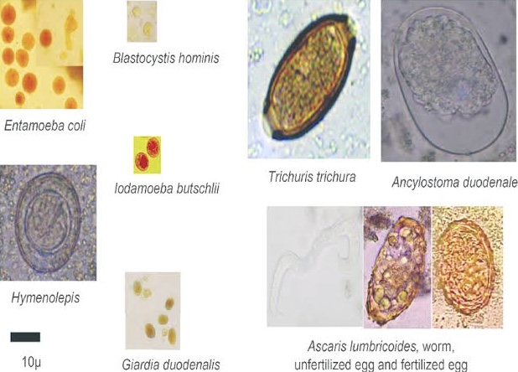

Interfering factors in fecal testing

A negative test will not rule out the possibility of parasitic infection. Entamoeba dispar and Entamoeba moskovskii are morphologically similar to E. histolytica but they are non-pathogenic and non-invasive. In Giardia infection, in the early stages of the disease, patients who periodically excrete the organism in the feces, and in chronic cases of the disease, a stool test may be negative. The sensitivity of microscopic methods for detecting Giardia is 46-95%. Artifacts should be kept in mind when examining feces.(Fig. 1)

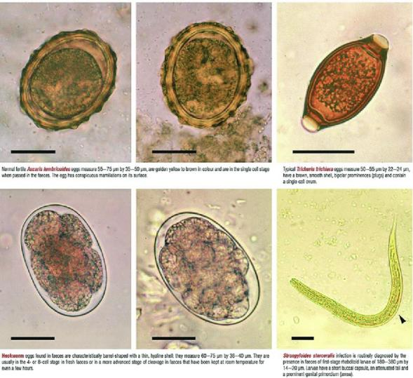

Stool culture test
A routine stool culture should be capable of detecting Salmonella, Shigella, Campylobacter, E.coli, Aeromonas and vibrio. Stool tests for harmful organisms can help doctor identify the cause of symptoms. Stool cultures can help them identify the type of harmful bacteria and treatments that may be effective. If harmful bacteria are found in the stool, the doctor may prescribe antibiotics or other medications. If no dangerous bacteria are found, the symptoms may be due to other causes. The doctor may do more follow-up tests. For example - patient may look for symptoms of irritable bowel syndrome, parasitic infection, or other problems.

Conclusion

Stool test are crucial for diagnosing intestinal parasites by directly identifying organisms, their eggs (ova) or cysts, enabling targeted treatment for issues like diarrhea, pain and malnutrition and preventing complication with advanced methods like PCR offering high sensitivity, making them essential for accurate GI health assessment and improved patient outcomes.
In conclusion, stool tests are indispensable for diagnosing intestinal parasites, offering specific identification, guiding effective therapies and ensuring better patient health by addressing the root cause of GI distress.

References

- Essential of clinical pathology by Shirish M Kawthalkar 3rd edition 2025 :127-143
- Dash N,Panigrahi D. Prevalence of intestinal parasitic infections 2010;2(1):21024
- Cartwright CP. Utility of multiple-stool-specimen ova and parasite examination in a high-prevalence setting. J Clin Microbiol. 1999;37 (8):2408-2411
- Sawitz WG, Faust EC. The probability of detecting intestinal protozoa by successive stool examination 1942;22(2):131-136
- Nazer H, Greer W, Donnelly K,et al. The need for three stool specimens in routine laboratory examinations for intestinal parasites. Br J clinical pract. 1993;47(2):76-78
- Silvesti C, Greganti, G, Arzeni D, et Intestinal parasitosis : data analysis 2006-2011 Infez med 2013;21(1):34-39
- Thomson RB Jr, Haas RA, Intestinal parasites: the necessity pf examining multiple stool specimens. Mayo Clin. Proc. 1984;59(9):641-642
- Boonjaraspinyo S, Boonmars T. A cross-sectional study on intestinal parasitic infection in rural communities, 2013;51(6):7272-734

