A Secure Messaging Framework with Integrated IDS and Quantum Cryptography
Abstract
The fast evolution of digital communication technologies has prompted greater concerns about the security of data and communication channels. Classical cryptographic algorithms, although efficient, are becoming more susceptible to the power of future computational devices, especially those based on quantum computers. This article discusses the implementation of the Quantum Secure Messaging System, which seeks to improve secure communication systems by combining state-of-the-art security algorithms with an intuitive user interface. Although the messaging system does not rely on quantum cryptographic devices, the design of the system incorporates quantum-resistant cryptography concepts by emphasizing its ability to resist future attacks. This paper shows how secure messaging systems can be developed using modern web technologies.

Keywords

Quantum Secure Messaging, BB84 Protocol, Quantum Key Distribution (QKD), Encryption, Authentication, Secure Communication, Cybersecurity, Web-Based Application, Data Privacy, Anomaly Detection

1.Introduction
In this modern era, where secure communication is highly critical because of the exchange of a vast amount of information over various network infrastructures, there are several issues faced by the existing systems. These include unauthorized access, hacking, data leakage, and message interception by cyber attackers. Moreover, current encryption mechanisms are increasingly vulnerable owing to the development of high-performance computational machines and advanced technological innovations. For instance, the growing popularity of quantum computing systems is likely to render existing classical cryptography ineffective in the future. Therefore, the need to develop highly secure systems against any cyber attack in the future arises. To mitigate these problems, this project aims at developing a quantum-based messaging system that employs authentication, encryption, and quantum-inspired mechanisms to ensure safe communication. It uses the BB84 protocol, invented by Charles H. Bennett and Gilles Brassard, to generate a shared secret key for the encryption and decryption of messages sent over the network. Post-login, users will be redirected to the dashboard containing the following features, namely Encrypt Message, Decrypt Message, Inbox, History, and Logout. Each module has unique IDs assigned to it for easy identification and utilization.
2 A STUDY ON EXISTING WORK
Most secure messaging systems that are already in place use old-fashioned encryption methods like AES and RSA to keep data safe. But as quantum computing gets better, these methods might not work as well. To fix this, quantum cryptography, especially the BB84 protocol, is used to safely send keys.
Many systems also use Intrusion Detection Systems (IDS) to find attacks like brute force. However, most existing solutions focus only on encryption or attack detection separately.This project builds on previous work by putting quantum encryption, secure messaging, intrusion detection, and real-time alerts all into one system.
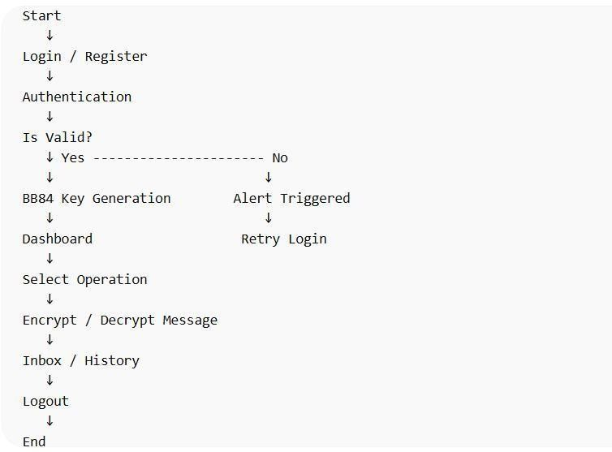
3.Algorithm Used
The system incorporates the BB84 Quantum Key Distribution algorithm, authentication, and encryption/decryption algorithms to achieve secure transmission of information.
A. BB84 Algorithm:
The BB84 algorithm is employed in the generation of a secret key by sending bits using random bases. Any discrepancies in the transmission process lead to the discard of such bits, with the resulting bits forming a secret key. Any attempt at intercepting the information being transmitted can easily be detected at this stage.
B. User Authentication:
The system authenticates the user through verification of the username/password entered against those stored in the database. Access will be given if there is a match; otherwise, it will not be given.
C. Encryption and Decryption Algorithms:
Encryption is performed by converting the message to binary form and then applying an XOR algorithm on the shared key.
- Methodology
The system they've come up with is a step-by-step way to keep communications safe using quantum cryptography and security checks. First, users sign up and get verified, which means they create an account and log in with the right credentials. This makes sure that only people who are supposed to be using the system can actually get in. By doing it this way, they're making it harder for unauthorized users to access the system, which helps keep everything secure. The whole process is designed to be secure and reliable, so users can trust that their information is protected. When you log in successfully, the system uses a special way to create a secret key that only the sender and receiver can use. This method, called BB84 Quantum Key Distribution, makes sure the key is safe by sending special kinds of information in random ways. Only the information that matches up correctly between the sender and receiver is used to create the key. This process also helps figure out if someone is trying to listen in without permission. When a key is created, the person sending the message types it out, and it gets turned into a code made of zeros and ones. This code is then locked using the key that both the sender and receiver have. The locked message is sent safely through the system to the person getting it. The person receiving the message uses the same key to unlock it and turn it back into words they can read. In parallel, the system incorporates an Intrusion Detection System (IDS) to enhance security. The IDS continuously monitors system activities such as login attempts and message access. If abnormal behavior, such as repeated failed login attempts (brute-force attack), is detected, the system triggers alerts and records the event in security logs. The system also has a dashboard that shows what's going on, like how many times data is encrypted or decrypted, and any alerts that come up. This helps users and people in charge keep an eye on how the system is doing and if it's secure, all in real time. So, to make sure messages are sent safely and efficiently, this method combines a few key things: checking who's sending the message, creating secret keys using quantum technology, sending messages securely, and detecting any attacks in real time. This way, the whole messaging system is reliable and works well.
5 Architectural Components
The proposed system consists of several key components that work together to ensure secure communication and monitoring:
a.User Interface (UI):
Provides screens for user registration, login, message sending, inbox, and dashboard. It allows users to interact easily with the system.
b.Authentication Module:
Verifies user credentials (username and password) and ensures that only authorized users can access the system.
c.BB84 Key Generation Module:
Implements the BB84 algorithm to generate a secure shared key between sender and receiver, ensuring safe key distribution.
d.Encryption & Decryption Module:
Encrypts messages using the generated key before transmission and decrypts them at the receiver side to retrieve the original message.
e.Message Transmission Module:
Handles sending and receiving of encrypted messages between users through the system.
f.Intrusion Detection System (IDS):
Monitors user activities such as login attempts and detects attacks like brute force, triggering alerts when suspicious activity is found.
g.Alert&Logging Module:
Generates alerts and maintains logs of detected attacks and system activities for analysis.
h.Dashboard & Visualization Module:
Displays graphical information such as number of encryptions, decryptions, and alerts, helping users monitor system performance.

6. Implementation

from flask import Flask, request, redirect, session
from database import Database
from encryption import Encryption
from quantum_key import QuantumKey

app = Flask(__name__)
app.secret_key = "secret"

db = Database()
failed = {}

# LOGIN + BRUTE FORCE DETECTION
@app.route('/login', methods=['POST'])
def login():
u = request.form['username']
p = request.form['password']

if db.login(u, p):
session['user'] = u
failed[u] = 0
return redirect('/dashboard')
else:
failed[u] = failed.get(u, 0) + 1
if failed[u] >= 3:
print("Brute Force Detected")
return redirect('/')

# ENCRYPT + SEND MESSAGE (BB84)
@app.route('/send', methods=['POST'])
def send():
msg = request.form['message']
r = request.form['receiver']

n = len(msg)
bits = QuantumKey.generate_bits(n)
bases = QuantumKey.generate_bases(n)

key, _ = QuantumKey.match_bits(bases, bases, bits)
if key == "": key = "1"

enc = Encryption.encrypt(msg, key)
db.save_msg(session['user'], r, enc, key)

return "Message Sent"

# DECRYPT MESSAGE
@app.route('/decrypt/<int:id>')
def decrypt(id):
msg = db.get_msgs(session['user'])[0]
return Encryption.decrypt(msg[3], msg[4])

if __name__ == "__main__":
app.run()

7.Results and Output:

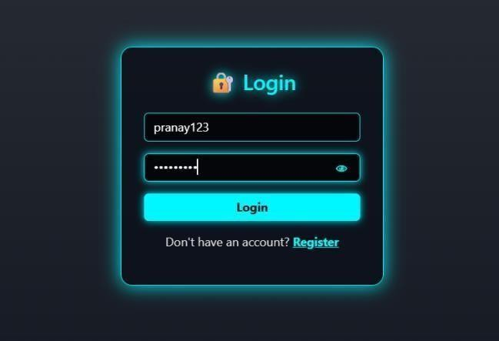
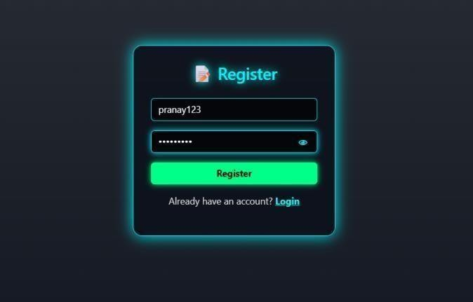
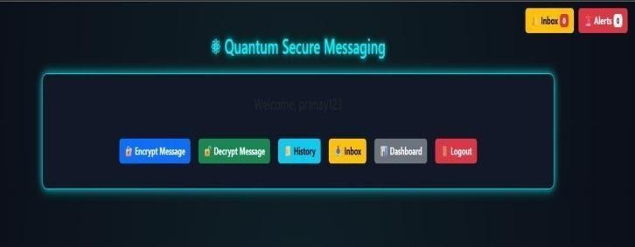
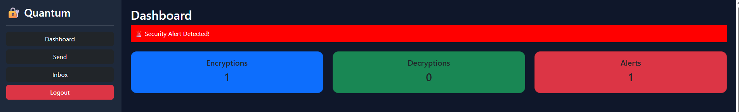

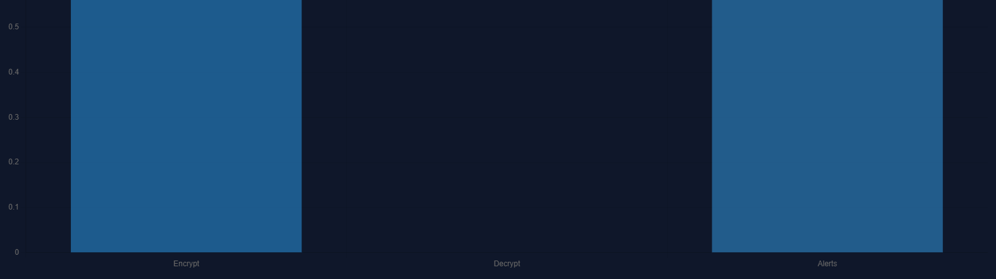
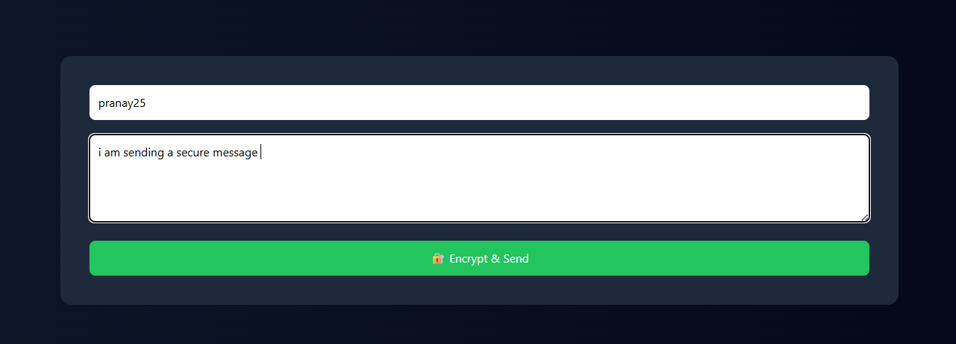

The suggested system successfully implements the BB84 quantum key distribution algorithm for secure messaging. Encryption and decryption are carried out effectively using the generated key. The system detects any brute force attacks or any suspicious activities using its IDS technique.The dashboard shows the real-time statistics of encryption, decryption, and alerts in graphical form. Alerts are generated whenever there is any unusual activity.
8 Justification
Justification of the Quantum Secure Messaging System would involve arguing that this solution addresses several security threats faced by the existing communication systems. Some of these threats include issues such as access to information, data thefts, and real-time monitoring. This system addresses these challenges owing to the use of the quantum-inspired techniques used in the generation of keys and encryption process. This is because the use of the BB84 algorithm helps in enhancing the security of the application by detecting any intrusion and maintaining the privacy of the information provided. The authorization mechanism is another factor that helps in enhancing the security since it does not allow everyone to access the application. Furthermore, the use of encryption and decryption ensures that the application maintains its integrity. Lastly, the alerting feature ensures that no suspicious activity goes unnoticed in the system

9 Conclusion
Through the Quantum Secure Messaging System, a successful demonstration of how a secure communication system could be designed by means of authentication, encryption, and key generation using the BB84 protocol has been presented. It is clear that this project can be said to be performing well according to its main objectives.
The need for security in modern communication systems is emphasized through this project as it provides solutions to challenges that may emerge as a result of potential security attacks such as access to unauthorized data. Quantum-based methods for solving security concerns in information systems have been identified as more reliable compared to traditional solutions.As far as future improvements to the system are concerned, there are various areas where improvements may be made. These include incorporation of real-time quantum cryptography and database services. Multi-factor authentication is another aspect which could be considered for development.
10 Refernces
[1]H.-K. Lo, M. Curty, and K. Tamaki, “Secure Quantum Key Distribution,” pp. 595–604, 2014 (widely cited in post- 2015 research).
[2]Valerio Scarani et al., “The Security of Practical Quantum Key Distribution,” recent studies (2015+).
[3]Mark M. Wilde, “Quantum Information Theory,” Cambridge University Press, 2017 (used extensively in modern QKD research).
[4]Sebastian L. Braunstein and Stefano Pirandola, “Quantum Teleportation and Entanglement Distribution,” Reviews of Modern Physics, vol. 87, pp. 513– 577, 2015.
[5]Stefano Pirandola et al., “Advances in Quantum Cryptography,” Advances in Optics and Photonics, vol. 12, no. 4, pp. 1012–1236, 2020.
[6]Makarov, “Quantum Cryptography: Security and Practical Challenges,” IEEE Journal of Selected Topics in Quantum Electronics, vol. 21, no. 3, pp. 1–
10, 2015.
[7]Stephanie Wehner, David Elkouss, and Ronald Hanson, “Quantum Internet: A Vision for the Road Ahead,” Science, vol. 362, 2018.
[8]National Institute of Standards andTechnology, “Status Report on the Second Round of the NIST Post-Quantum Cryptography Standardization Process,” 2019

 | Paturi Pranay, pursuing Master of Computer applications, Department of Computer Science, GSS, GITAM (Deemed to be University), Visakhapatnam. His area of interest in Cyber Security
 | Dr Vanitha Kakollu is currently working as Assistant Professor in the Department of Computer Science, GIS, GITAM (Deemed to be University). Her main areas of research include Image Processing, Data Mining and Machine Learning.

