“DESIGN AND EXPERIMENTAL ANALYSIS OF A LOW-COST MULTI-GAS AIR QUALITY MONITORING SYSTEM WITH MQ135 SENSOR USING ARDUINO”

Abstract: This project focuses on the measurement and analysis of multi-gases such as carbon dioxide (CO₂), alcohol (ethanol), benzene, and ammonia using a low-cost gas detection system based on Arduino. The main aim is to develop an affordable and easy-to-use system that can monitor harmful gases in the environment. In this system, MQ135 gas sensor is connected to an Arduino microcontroller to detect the presence and concentration of gases. The sensor sends data to the Arduino, which processes the information and displays the results. The device is tested using gases like carbon dioxide (CO₂), alcohol (ethanol), benzene, and ammonia to check its performance and accuracy. The results show that the system can successfully detect these gases and provide useful information about their levels. The proposed system is low-cost, simple to build, portable device and suitable for use in homes, industries, and laboratories. It can help improve safety by providing early warning of harmful gases. This project demonstrates an effective way to monitor air quality using basic electronics and programming.

Index Terms: MQ 135 Gas Sensors, Arduino Uno, Harmful Gases, Low Cost and Portable Device.

INTRODUCTION
Air pollution has become one of the most critical environmental challenges in the modern world due to rapid industrialization, urbanization, and increased vehicular emissions. The release of harmful gases such as carbon dioxide (CO₂), ammonia (NH₃), nitrogen oxides (NOₓ), and volatile organic compounds (VOCs) into the atmosphere has significantly affected air quality, leading to severe health and environmental consequences [1]. The deterioration of air quality has been linked to various respiratory diseases, cardiovascular disorders, and ecological imbalances. According to environmental studies, continuous exposure to polluted air can lead to long-term health risks, emphasizing the need for effective monitoring and control systems [1]. Therefore, real-time air quality monitoring has become essential for assessing pollution levels and ensuring environmental safety.

Traditional air quality monitoring systems are generally expensive, bulky, and require sophisticated instrumentation, making them unsuitable for widespread deployment. These systems often rely on advanced analytical techniques such as gas chromatography and spectrometry, which, although accurate, are not cost-effective for everyday applications [2]. Hence, there is a growing demand for low-cost, portable, and efficient monitoring solutions. In recent years, the development of embedded systems and sensor technology has enabled the design of compact and affordable air quality monitoring devices. Microcontroller-based systems, particularly those using the Arduino Uno, have gained significant popularity due to their simplicity, flexibility, and ease of programming [3]. These systems can be integrated with gas sensors to measure environmental parameters in real time.

In this project the MQ135 Gas Sensor is used for detecting air pollutants due to its sensitivity to a range of gases. It operates on the principle of semiconductor gas sensing, where the resistance of the sensing material changes in response to gas concentration [4]. This property allows the conversion of chemical information into electrical signals, which can be processed and analyzed. The working principle of semiconductor gas sensors is based on surface adsorption phenomena. Oxygen molecules adsorb onto the surface of the sensing material and capture free electrons, increasing the resistance. When reducing gases are present, they react with the adsorbed oxygen, releasing electrons back into the material and decreasing the resistance [5]. This change in resistance is directly related to the concentration of gases in the environment. The integration of the MQ135 sensor with the Arduino Uno allows the measurement of gas concentration through analog-to-digital conversion. The analog signal generated by the sensor is converted into digital form using the built-in ADC of the microcontroller. Mathematical models are then applied to determine parameters such as sensor resistance (Rs), calibration resistance (Ro), and gas concentration in parts per million (PPM) [4].

This project focuses on the design and development of a low-cost and portable air quality monitoring system that utilizes the MQ135 sensor and Arduino Uno to measure and display air quality in real time. The device is tested using gases like carbon dioxide (CO₂), alcohol (ethanol), benzene, and ammonia to check its performance and accuracy. The results show that the system can successfully detect these gases and provide useful information about their levels. The system aims to provide a simple yet effective solution for environmental monitoring, particularly in indoor and urban environments.

1. Technical Description
Our project is the gas detecting system which detects multi-gases like carbon dioxide (CO₂), ammonia (NH₃), benzene (C₆H₆), and alcohol vapors. This system composed of four principal elements shown in figure 1.

- The first component is an Arduino board, a microcontroller board based on the ATmega328 microprocessor. This part controls the other components that are going to be used.
- Next is the MQ 135 gas sensor for measuring the multi-gases concentration in air.
- LCD display module that shows the analog value from the sensor which are used to convert output voltage (V_{out}).
- The final component is the control panel, consisting of a breadboard with a power supply charging module, +9 V chargeable batteries and a switch. This component is used to provide the power to whole system will make it portable.

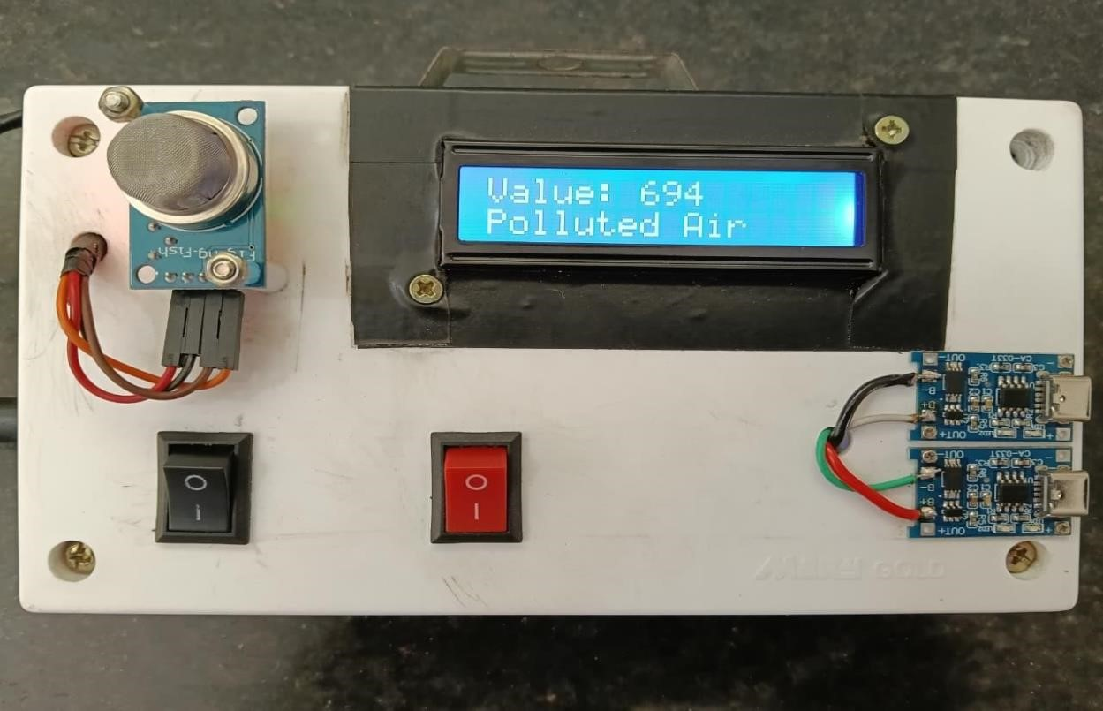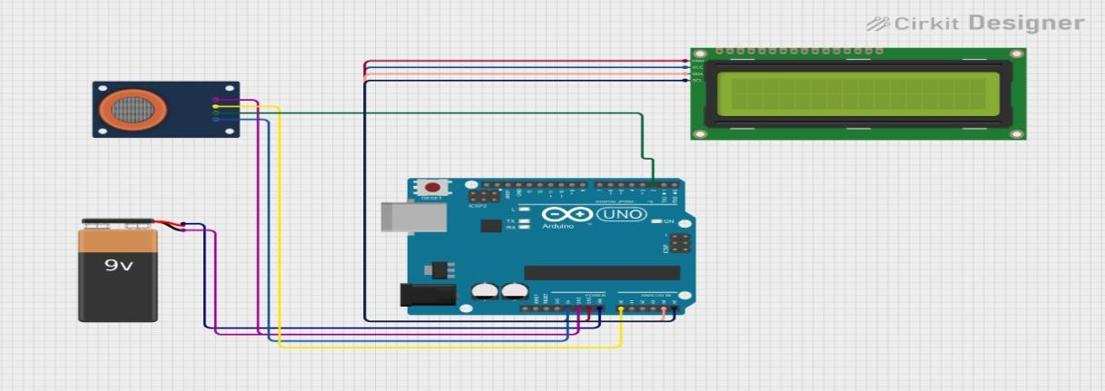
Figure 1. Photo of gas detecting system(left) and Diagram of the praposed gas detecitng system (right) consist of four principal elemnts: (A) Arduino board, (B) MQ135 sensor, (C) LCD display, and (D) Control pannel with chargeble battry system.

The connections of these four elements as shown in d figure 1. Before starting multi-gases measurements, the code must be loaded onto the Arduino board, which in turn is connected to a standard USB port on any laptop or desktop computer to supply power and enable data acquisition. Others power sources for the Arduino, such as mains or battery, are also possible. Moreover, connecting it to a battery will make it mobile.

The sensor output is processed using the Arduino platform, and analog values for different air which are shown by LCD display are recorded for analysis of concentration of multi-gases in ppm by mathematical formulas.
Followings are the steps to measure the value of gas concentration in ppm manually:

Step-1: To get (measure) the output voltage from the MQ135 Gas Sensor using an Arduino Uno, we need to placed sensor near the
gas and read the analog value from the sensor pin and convert it into output voltage (V_{out}).
Step-2: For Arduino voltage calculation: V_{out} = (Analog Value/1023) × 5. (Where, 1023 = maximum ADC value and 5 V = Arduino
reference voltage).
Step-3: Calculate Sensor Resistance R_{s}: R_{s} = (V_{c}-V_{out}/V_{out}) x R_{L}. (Where, V_{c}= Source Voltage = 5V and R_{L} = Load Resistance =
10KΩ)
Step-4: Calculate Ratio = (R_{s}/R₀), Where, R₀ = Sensor resistance in clean air (calibrated value) = 76 KΩ for MQ135 sensor.

Step-5: CO₂ Concentration Formulas:
For the MQ135 carbon dioxide curve, a commonly used approximation is: CO₂(ppm) = 116.6020682×(Ratio) ^{−2.769034857}.

Similarly, approximation consider for multi gases are given below:
Ammonia (NH₃) concentration in ppm = NH₃ (ppm) = 102.2 × (R_{s}/R₀)^{-2.473}
Benzene (C₆H₆) concentration in ppm = 24.45 × (R_{s} / R₀)^{-2.35}
Alcohol (C₂H₅OH) concentration in ppm = 77.250 × (R_{s}/R₀)^{-3.18}

In this project we developed the Arduino program logically using above mathematical operations, that shown the multi-gas concentration (in ppm) in air.
For presentation here take CO₂ gas sensing for MQ135 gas sensor. The complete Arduino program and flowchart to interface the MQ135 Gas Sensor with Arduino Uno and display CO₂ (approx.) on a 16×2 LCD shown in figure 2.

Figure 2 complete Arduino program and flowchart to interface the MQ135 Gas Sensor with Arduino Uno and display CO₂ (approx.) on a 16×2 LCD.

2. Result and Discussion:
We now present multi-gas sensing activities implemented in various purposes in order to show how suitable this measurement system is for different activities such as indoor and outdoor monitoring, driver alcohol detection system, educational use, and basic environmental analysis.

2.1 Measuring CO₂ levels in air at different places using MQ135 sensor:

Figure 3 (a), 3 (b) and 3 (c) shows the graphs of CO₂ concentration in ppm at various palace. We measure the CO₂ levels in air under indoor and outdoor activities.

We perform the experimental analysis of level of CO₂ in air at different places. Put the sensor in the particular place such as garden, near trees, open ground, crowd places, vehicle traffic places and record the reading of level of CO₂ (ppm) in air at mention places. The graphs in figure 3 (a), (b) and (c) show the variation of CO₂ level in air as per the places.

2.2 Measuring the level of ammonia (NH₃), benzene (C₆H₆), and alcohol vapors in air using MQ135 sensor:
The sensor is placed inside a closed container with ammonia (NH₃) solution in a beaker. Initially the percentage of alcohol in beaker is 25 ml; sensor shows the ppm value of concentration of ammonia vapor in air. While the percentage of alcohol is increasing (from 25 ml to 50 ml, 75 ml up to 100 ml) in beaker, sensor shows the non-liner increasing the ppm value of concentration of ammonia vapor in air as shown in fig. 4 (a). The same procedure is repeated for the benzene and alcohol solution. We also got non-liner behavior of sensor for the respective chemicals as shown in fig. 4 (a) and 4 (b). The last picture shows the experimental setup to measure the concentration of multi-gases.
Figure 4 (a), (b) and (c) shows the variation of ammonia, benzene and alcohol gas concentration in ppm with the different percentages of respective chemicals in ml. The last picture shows the experimental setup to measure the concentration of multi-gases.
3. CONCLUSION
This project successfully presents the design and implementation of a low-cost air quality monitoring system using Arduino Uno and the MQ135 gas sensor. The system detects harmful gases such as carbon dioxide (CO₂), ammonia (NH₃), benzene (C₆H₆), and alcohol vapors. The MQ135 sensor works on the principle of resistance variation with gas concentration. The Arduino Uno processes this data using its built-in ADC and displays real-time values on an LCD module. Experimental results show that the system responds effectively to changes in air quality. Although the sensor exhibits non-linear behavior, calibration and mathematical modeling allow estimation of gas concentration in PPM. Overall, the system is cost-effective, portable, and suitable for indoor and outdoor monitoring, driver alcohol detection system, educational use, and basic environmental analysis.

4. DISCUSSION OF ADVANTAGES AND LIMITATIONS OF THE DEVICE
On the basis of the experiences presented above, we can highlight some advantages and limitations of the device.
4.1 Advantages:
The entire cost of the setup is around $ 17, which is 15 times cheaper than some commercial sensors. The device can be used in multiple situations (inside a closed container, in a classroom, outdoors, etc.). The Arduino setup can be used from multiple approaches. Obviously, it enables inquiry-based instruction, in which students design their own experiments and carry out their own measurements using the device.
4.2 Limitations in Results:
The sensor MQ 135 limited for specific gases. The analog output value depends on power stability. The environmental conditions are influence the output value. The sensor drifts over time.

REFERENCES
- Winsen Electronics Technology Co., Ltd. (n.d.) Datasheet of MQ-135 gas sensor.
- Pino, H., Pastor, V., Grimalt-Álvaro, C. and López, V. (2019) ‘Measuring CO₂ with an Arduino: Creating a low-cost, pocket-sized device with flexible applications that yields benefits for students and schools’, Journal of Chemical Education, 96, pp. 377–381.
- World Health Organization (WHO) (n.d.) Air quality guidelines. Available at: https://www.who.int (Accessed: 5 April 2026).
- U.S. Environmental Protection Agency (EPA) (n.d.) Air quality index (AQI) basics. Available at: https://www.epa.gov (Accessed: 5 April 2026).
- Kumar, A. and Singh, B. (2020) ‘Air quality monitoring system using Arduino and MQ sensors’, International Journal of Engineering Research & Technology (IJERT).

