Electricity Load Forecasting and Power Optimization Using Machine Learning
Abstract
The growing complexity of modern power systems demands accurate forecasting and intelligent optimization to ensure reliable, cost-effective, and efficient electricity management. This paper proposes a framework for short-term electricity load forecasting and optimization using machine learning and mathematical programming. Historical load and weather data are preprocessed with lag features, rolling statistics, and temporal indicators to capture seasonality and demand fluctuations. The forecasting framework employs an XGBoost regressor that leverages engineered features for precise predictions, and captures weather patterns and load data. The forecasted demand is then integrated into a Pyomo-based optimization module, where a linear programming-driven economic dispatch model minimizes total generation costs while satisfying demand and capacity constraints. Results demonstrate that the proposed XGBoost forecasting combined with Pyomo optimization provides a scalable, data-driven solution for electricity demand management, offering significant benefits for utilities, industries, and smart grid applications.

Keywords - Electricity Load Forecasting, Machine Learning, XGBoost, Economic Dispatch, Pyomo, Energy Management, Smart Grid

1. Introduction
Electricity is one of the most essential resources for modern society, supporting residential, industrial, and commercial activities. As energy consumption continues to increase, efficient planning and operation of power systems become increasingly important. One of the key challenges faced by power utilities is accurately predicting electricity demand and optimizing generation resources accordingly (Wood, 2013).
Electricity load forecasting is an important component of power system management. Accurate forecasting enables utilities to schedule power generation efficiently, reduce operational costs, and ensure reliable electricity supply. Short-term load forecasting, which typically predicts electricity demand from a few hours to several days ahead, plays a crucial role in operational planning and energy market participation (Hong, 2016).
Traditional forecasting methods such as statistical regression models and time series techniques have been widely used in electricity demand prediction. However, these methods often struggle to capture complex nonlinear patterns present in modern electricity consumption data.
With advancements in artificial intelligence and machine learning, data-driven forecasting approaches have gained significant attention. Machine learning algorithms can analyze large volumes of historical data and identify hidden patterns that improve prediction accuracy.
This paper proposes a hybrid framework that combines machine learning-based load forecasting with optimization technique for efficient power management. The forecasting component utilizes the XGBoost algorithm to predict electricity demand, while the optimization employs the Pyomo framework.
The proposed approach aims to enhance forecasting accuracy and improve power system efficiency, thereby supporting smarter electricity management.
2. Literature Review
Electricity load forecasting has been widely studied using different computational techniques. Early approaches relied on statistical methods such as autoregressive models, moving average models, and regression-based techniques. Although these methods are simple and computationally efficient, they often fail to capture nonlinear relationships between electricity demand and influencing factors such as weather conditions and human activities (Taylor, 2003).
Artificial Neural Networks (ANN) have been extensively applied in load forecasting due to their ability to learn complex nonlinear patterns (Zhang, 2018). Support Vector Machines (SVM) and Random Forest models have also demonstrated promising results in electricity demand prediction (Hong, 2016) (Hippert H. S., 2001).
(Chen, 785–794) introduced the Extreme Gradient Boosting (XGBoost) algorithm, which has gained popularity for its high prediction accuracy and scalability. XGBoost is particularly effective in handling structured datasets and has been successfully applied in various forecasting problems, including energy demand prediction.
Recent research has also explored combining forecasting models with optimization frameworks to enhance power system efficiency (M. Cordeiro-Costas, 2023) (Zhang, 2018). Economic dispatch models are commonly used to determine the optimal allocation of power generation resources while minimizing operational costs (Wood, 2013).
Optimization frameworks such as Pyomo allow researchers to formulate and solve mathematical programming problems efficiently. Integrating accurate forecasting models with optimization techniques can significantly improve decision-making processes in power system operations (Hart, 2017).
However, there is still a need for integrated approaches that combine advanced machine learning models with optimization frameworks to improve electricity demand management in modern smart grids.
3. Research Methodology
The proposed system consists of three major stages: data preprocessing, electricity load forecasting, and power optimization.
3.1 Data Collection
Historical electricity load data were collected from the Electricity Demand, Solar and Wind Generation Data of India (September 2021–June 2025) available on Mendeley Data, covering the period from November 2021 to November 2023. Weather data were obtained from meteorological datasets provided by NASA. Weather parameters such as temperature, wind speed, and humidity significantly influence electricity consumption patterns and are therefore included as input features in the forecasting model.
3.2 Data Preprocessing and Feature Engineering
Data preprocessing is performed to clean and prepare the dataset for analysis. Missing values are handled, and irrelevant features are removed. Feature engineering techniques are applied to extract useful information from the dataset.
The following features are generated:
- Lag features representing previous electricity demand values
- Rolling statistics such as moving averages and standard deviation
- Temporal features including hour of the day, day of the week, and month
These features help capture seasonal trends and demand fluctuations.
3.3 Load Forecasting using XGBoost
Extreme Gradient Boosting (XGBoost) is used as the machine learning model for forecasting electricity demand. XGBoost is an ensemble learning technique based on gradient boosting decision trees.
The model is trained using historical load data and engineered features. During the training phase, the model learns patterns in electricity consumption and develops a predictive relationship between input variables and electricity demand.
After training, the model generates short-term electricity load predictions.

3.4 Power Optimization using Pyomo
The predicted electricity demand is used as input to an optimization model developed using Pyomo.
The objective function of the optimization model is to minimize total electricity generation cost:
Formula:
Cost_{(g)} = ​ $b_{g}$× $P_{g}$ + $c_{g}$
Where:
- $P_{g}$= Power generated (MW)
- $b_{g}$= Cost per MW (₹/MW)
- $c_{g}$= Fixed cost (₹)
Minimize:
Total Cost = Σ (Generation Cost × Power Generated)
Subject to the following constraints:
- Power generation must meet electricity demand
- Each generator must operate within its minimum and maximum capacity limits
- System operational constraints must be satisfied
The optimization problem is solved using a linear programming solver.
4. Results
The proposed electricity load forecasting and power optimization framework was implemented in Python using libraries such as Pandas, NumPy, Matplotlib, XGBoost, and Pyomo. Historical electricity load data collected between November 2021 and November 2022 were utilized for training and evaluating the forecasting model.
4.1 Electricity Load Analysis
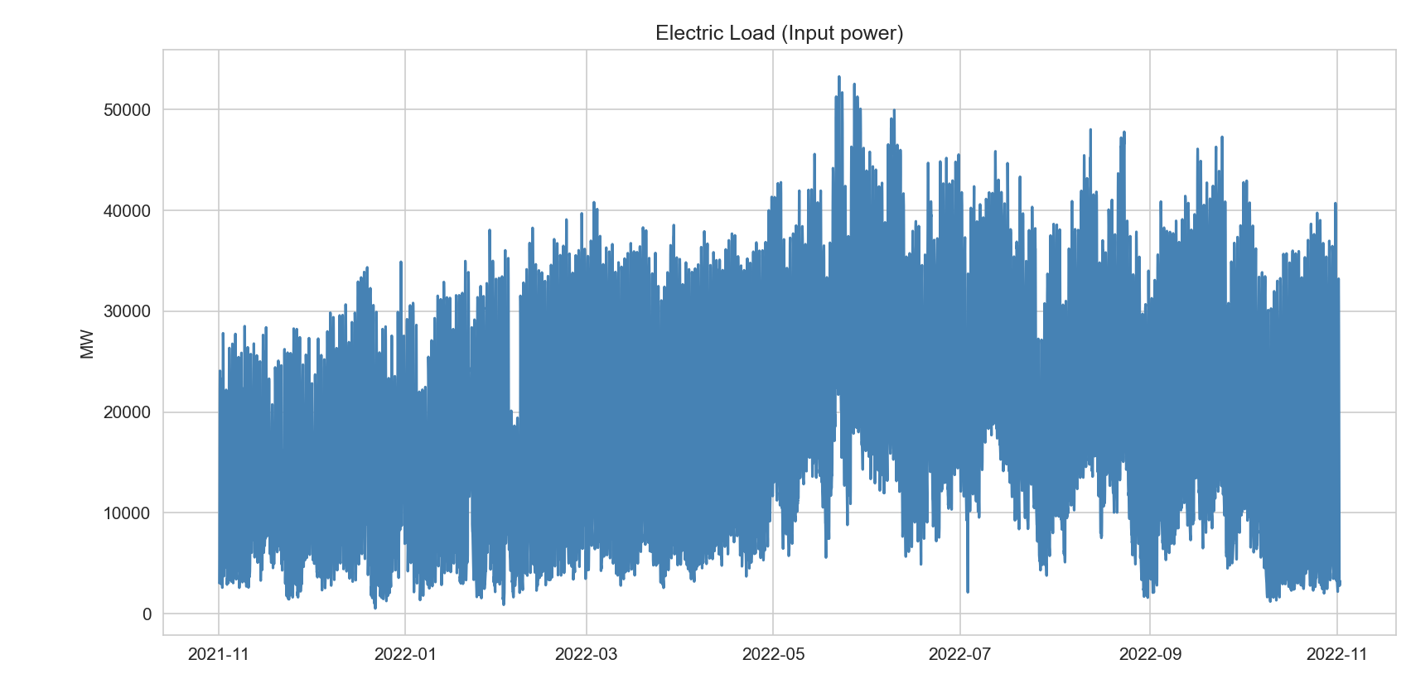
Figure 1: Historical electricity load data of year 2021
Figure 1 illustrates the hourly electricity load variations over the observed time period. The dataset exhibits significant fluctuations in electricity demand due to seasonal variations, daily consumption patterns, and external factors such as weather conditions and human activities.
The electricity demand ranges approximately between 2,000 MW and 55,000 MW, with most values concentrated between 20,000 MW and 45,000 MW. Higher electricity consumption can be observed during peak operational periods, reflecting increased industrial activity and residential energy usage.
These variations highlight the importance of accurate electricity load forecasting models to support efficient power generation planning and energy management in modern power systems.
4.2 Load Forecasting using XGBoost
The Extreme Gradient Boosting regression model XGBoost was used to forecast short-term electricity demand. The model was trained using several engineered features that help capture temporal dependencies in electricity consumption patterns. These features include lag variables, rolling mean values, and temporal indicators such as hour of the day, day of the week, and month of the year.
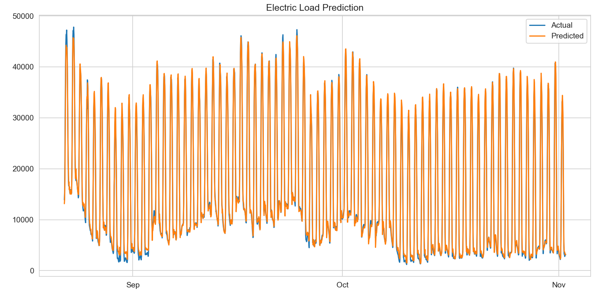
Figure 3: the actual electricity load and predicted load values generated by the XGBoost model
Figure 3 presents the comparison between the actual electricity load values and the predicted load values generated by the XGBoost model. The predicted curve closely follows the pattern of the actual electricity demand, indicating that the model effectively captures the nonlinear and seasonal characteristics present in the dataset.
The performance of the forecasting model was evaluated using Root Mean Square Error (RMSE), which is defined as:
$$RMSE=\sqrt{\frac{1}{n}\sum_{i=1}^{n}{(}y_{i}-{\hat{y}}_{i})^{2}}$$where:
- $y_{i }$- represents actual load values
- ${\hat{y}}_{i}$- represents predicted load values
- $n$- represents the number of observations
The proposed forecasting model achieved an RMSE value of approximately 1269.54, indicating a reasonably accurate prediction performance for electricity load forecasting.
The forecasting model achieved an RMSE value of 1269.55 MW. Considering that the average electricity demand in the dataset is approximately 28,000 MW, the prediction error corresponds to about 4.5% of the load, indicating good forecasting accuracy for electricity demand prediction.
4.4 Future Load Prediction
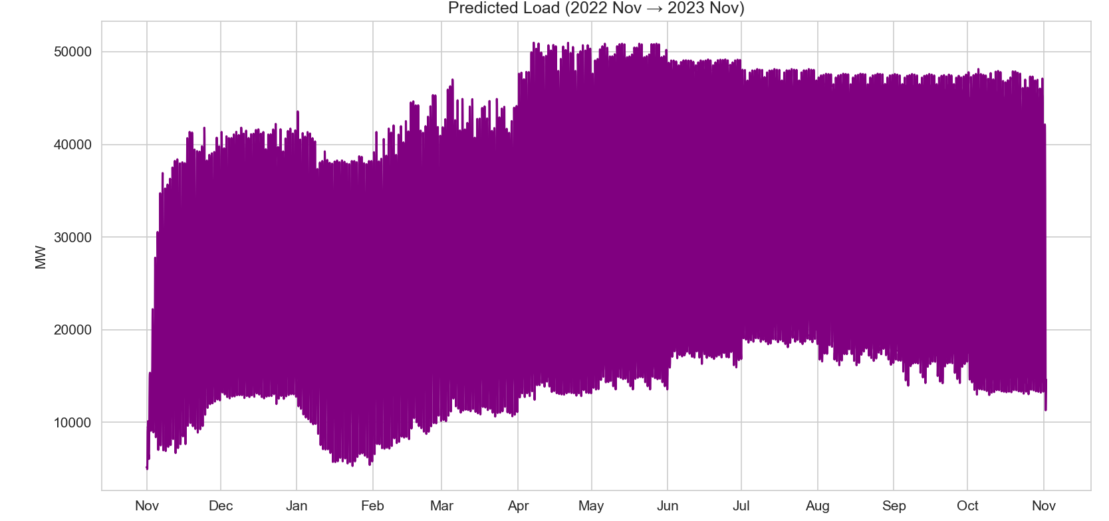
Figure 4: Predicted Electricity Load year 2022 to 2023
Using the trained XGBoost model, electricity demand was forecasted for the future time horizon from November 2022 to November 2023, as illustrated in Figure 4. The model generates predicted load values by utilizing learned temporal patterns and engineered features such as lag variables, rolling averages, and time-based indicators.
The predicted load curve demonstrates clear seasonal and periodic consumption patterns, which are consistent with historical electricity demand behavior. Higher electricity demand is observed during the mid-year months, which may correspond to increased industrial activity and seasonal weather conditions that influence energy consumption. In contrast, relatively moderate demand levels are predicted during other periods of the year.
These forecasting results provide valuable insights for power system planning and operational management. Accurate demand predictions allow power utilities to optimize generator scheduling, reduce operational costs, and ensure reliable electricity supply by maintaining a balance between generation and demand.
4.5 Power Optimization using Economic Dispatch
The predicted electricity demand was used as input to a Pyomo-based economic dispatch optimization model. The objective of the optimization model was to minimize total power generation cost while satisfying system demand and generator capacity constraints.
Generator Modeling and Capacity Constraints
To demonstrate the economic dispatch optimization framework, a three-generator system is considered. A small generator set is commonly used in academic studies and research demonstrations because it simplifies visualization of optimal dispatch while preserving the essential characteristics of power system optimization (Zimmerman, 2011.).
Each generator operates within minimum and maximum generation limits determined by rated capacity, thermal constraints, and operational safety margins. These limits are incorporated as capacity constraints in the optimization model.
The generator operating limits considered in this study are shown in below Table.
Generator Capacity Constraints:
Generator |  |  |  |  |  |  | Minimum Power (MW) |  |  |  |  |  |  | Maximum Power (MW)
Generator 1 |  |  |  |  |  |  | 1000 |  |  |  |  |  |  | 30000
Generator 2 |  |  |  |  |  |  | 800 |  |  |  |  |  |  | 25000
Generator 3 |  |  |  |  |  |  | 500 |  |  |  |  |  |  | 20000
These limits are selected based on typical generator operating ranges reported in IEEE economic dispatch benchmark systems (Alsac) (Zimmerman, 2011.).
Optimal Power Dispatch Results
Using the predicted electricity demand obtained from the machine learning model, the Pyomo optimization framework solves the economic dispatch problem to minimize total generation cost while satisfying power balance and generator constraints. The optimal power generation schedule obtained from the model is summarized in the below table.
Optimal Power Generation
Using the predicted electricity demand obtained from the forecasting model, the Pyomo optimization framework solves the economic dispatch problem to determine the optimal generator output levels.
The predicted system demand from the forecasting model is:
Predicted Demand = 28008.54 MW
The optimal generator dispatch obtained from the optimization model is shown below.
Generator |  |  |  |  | Power Output (MW)
Generator 1 |  |  |  |  | 26708.55
Generator 2 |  |  |  |  | 800.00
Generator 3 |  |  |  |  | 500.00

The resulting total generation cost is ₹15,216,020.03.
These results indicate that the optimization model effectively allocates power among available generators while minimizing operational cost and respecting generator limits.
Due to the unavailability of real generator cost data from utilities, standard cost coefficients and generator limits from IEEE benchmark economic dispatch studies are adopted to ensure realistic modeling conditions (Wood, 2013).
4.6 Discussion
The experimental results show that the proposed framework effectively combines machine learning forecasting with optimization techniques for electricity demand management. The XGBoost model provides accurate predictions with a low RMSE value, while the economic dispatch optimization ensures cost-efficient power generation.
The integration of these techniques offers a practical solution for modern smart grid systems, enabling utilities to improve operational efficiency and reduce energy costs.
5. Conclusion
This study presented an integrated framework for electricity load forecasting and power optimization using machine learning and mathematical programming techniques.
The XGBoost model demonstrated strong predictive capabilities for short-term electricity demand forecasting. The optimization model implemented using Pyomo successfully minimized generation costs while meeting electricity demand and operational constraints.
The proposed approach offers a scalable and efficient solution for modern power systems and smart grid applications. By combining machine learning forecasting with optimization techniques, utilities can improve operational efficiency and reduce energy generation costs.
Future work may focus on incorporating renewable energy sources and real-time energy market data to further enhance forecasting accuracy and optimization performance.
6. Statements and Declarations
Funding
This research received no external funding.
Conflicts of Interest
The authors declare no conflict of interest.
Acknowledgment
The authors thank the Department of Electrical and Electronics Engineering, Stanley College of Engineering and Technology for Women, Hyderabad, for supporting this research work.

7.References
- Alsac, O. &. (n.d.). Optimal load flow with steady-state security. IEEE Transactions on Power Apparatus and Systems, PAS-93(3), 745-751.
https://doi.org/10.1109/TPAS.1974.293985
- Chen, T. &. ( 785–794). XGBoost: A scalable tree boosting system. Proceedings of the ACM SIGKDD International Conference on Knowledge Discovery and Data Mining.
https://doi.org/10.1145/2939672.2939785
- Hart, W. E. (2017). Pyomo – Optimization modeling in Python (2nd ed.). Springer.
https://doi.org/10.1007/978-3-319-58821-6
- Hong, T. &. (2016). Probabilistic electric load forecasting: A tutorial review. International Journal of Forecasting, 32(3), 914–938.
https://doi.org/10.1016/j.ijforecast.2015.11.011
- Taylor, J. W. (2003). Using weather ensemble predictions in electricity demand forecasting. . International Journal of Forecasting, 19(1), 57–70.
https://doi.org/10.1016/S0169-2070(01)00158-5
- Wood, A. J. (2013). Power generation, operation, and control (3rd ed.). Wiley.
http://103.203.175.90:81/fdScript/RootOfEBooks/E%20Book%20collection%20-%202023%20-%20B/EEE/Power-Generation-Operation-Control-Allen-Wood.pdf
- Zimmerman, R. D.-S. (2011.). IEEE Transactions on Power Systems. MATPOWER: Steady-state operations, planning, and analysis tools for power systems research and education., 26(1), 12–19.
https://doi.org/10.1109/TPWRS.2010.2051168
- Hippert, H. S., Pedreira, C. E., & Souza, R. C. (2001). Neural networks for short-term load forecasting: A review and evaluation. IEEE Transactions on Power Systems, 16(1), 44–55. https://doi.org/10.1109/59.910780
- Zhang, G., Eddy Patuwo, B., & Hu, M. Y. (2018). Forecasting with artificial neural networks: The state of the art. International Journal of Forecasting, 14(1), 35–62. https://doi.org/10.1016/S0169-2070(97)00044-7
- M. Cordeiro-Costas, D. Villanueva, P. Eguía-Oller, M. Martínez-Comesaña, and S. Ramos, “Load Forecasting with Machine Learning and Deep Learning Methods,” Applied Sciences, vol. 13, no. 13, 2023. https://www.mdpi.com/2076-3417/13/13/7933

