Evaluating the Impact of Prompt Engineering on Factual Accuracy and Hallucination in Large Language Models

ABSTRACT
Natural language processing has been substantially reshaped by Large Language Models (LLMs), which now power applications ranging from question answering and code generation to scientific summarisation. A persistent vulnerability, however, undermines their practical reliability: hallucination, the production of linguistically fluent yet factually unsupported content. This paper reports a dual-method investigation combining a structured review of published literature with an original empirical survey administered to 96 participants [15]. Three prompting conditions were evaluated—basic (Answer A), structured (Answer B), and detailed/context-rich (Answer C)—across five knowledge-based questions. Survey data reveal that the majority of respondents (56.3%) hold only partial trust in AI-generated information, and that users systematically favour shorter responses even when more complete ones are available—a pattern termed the brevity-trust bias. Step-by-step instructions were rated the most useful prompt strategy by 55.2% of participants. These outcomes affirm that prompt engineering can substantially narrow the hallucination gap but is insufficient alone; an integrated framework combining chain-of-thought (CoT) prompting, retrieval-augmented generation (RAG), and reinforcement learning from human feedback (RLHF) is recommended for responsible deployment.

KEYWORDS
Hallucination; Prompt Engineering; Factual Accuracy; Large Language Models (LLMs); Chain-of-Thought; Retrieval-Augmented Generation; RLHF; AI Trust; Few-Shot Learning.

INTRODUCTION
Among the most consequential shifts in modern artificial intelligence is the rise of Large Language Models. Systems such as GPT-4 [12], LLaMA 2 [13], and Google Gemini are built on transformer architectures [1] trained over web-scale text corpora and demonstrate near-human proficiency across question answering, code synthesis, translation, and complex reasoning [2]. Their adoption across education, healthcare, legal services, and enterprise software has accelerated rapidly, driven by both capability and accessibility.
Despite this progress, a fundamental reliability problem persists. LLMs regularly produce statements that are grammatically polished and contextually plausible yet factually wrong [5]. Such hallucinated outputs have included nonexistent court cases cited in legal briefs, fabricated citations in academic summaries, and incorrect medical dosages in health-related queries. In domains where precision is critical—medicine, law, finance—these failures carry serious consequences.
Prompt engineering has gained traction as a lightweight, model-agnostic means of improving output quality. Without retraining the underlying model, practitioners can reshape behaviour through deliberate choices in prompt structure, phrasing, role framing, and contextual detail. Chain-of-thought prompting [3], structured instruction sets, and few-shot demonstrations [2] have each shown measurable gains in accuracy. Yet relatively

little is known about how these techniques land with non-specialist users in practice.
Research Questions: (RQ1) How do basic, structured, and detailed prompting styles affect user-perceived factual accuracy? (RQ2) What level of trust do general users place in AI-generated factual content? (RQ3) Which prompt strategies do users consider most effective for improving AI accuracy? (RQ4) What cues lead users to suspect that an AI response contains hallucinated information?
This paper addresses the above questions through a two-pronged methodology: a systematic review of fourteen peer-reviewed and preprint sources, supplemented by a primary empirical survey of 96 participants [15]. Together, these strands yield a synthesis of current knowledge on hallucination causes and prompt engineering techniques, as well as original empirical evidence on user-level perceptions and trust patterns.

LITERATURE REVIEW

Foundations of Large Language Models
The transformer architecture proposed by Vaswani et al. [1] replaced sequential recurrent units with parallelised self-attention, dramatically improving the modelling of long-range linguistic dependencies. Building on this foundation, Brown et al. [2] showed through GPT-3 that scaling parameters into the billions unlocks emergent few-shot and zero-shot generalisation, eliminating the need for task-specific fine-tuning in many settings. More recent systems—including GPT-4 [12], LLaMA 2 [13], Claude, and Gemini—have extended these gains through instruction fine-tuning, constitutional alignment, and multimodal training.

Hallucination: Definition and Taxonomy
In the context of LLMs, hallucination denotes the production of output that is linguistically well-formed but factually ungrounded or internally inconsistent [9]. Ji et al. [5] introduced the widely adopted distinction between intrinsic hallucination—where the model contradicts the content of its own source or context—and extrinsic hallucination, where fabricated material is introduced that cannot be verified against any input. Zhang et al. [9] refined this taxonomy further, differentiating factuality hallucination (divergence from verifiable real-world facts) from faithfulness hallucination (deviation from user intent or internal logical coherence). Alansari and Luqman
[8] extend the analysis across the entire LLM lifecycle.

Causes of Hallucination
Scholarship on LLM hallucination has identified four recurring root causes. Training data noise: because models are trained on internet-scale corpora, factual errors, contradictions, and outdated claims are inevitably absorbed into model weights [9]. Objective function misalignment: standard next-token prediction maximises linguistic likelihood rather than veracity [8]. Static knowledge: models with fixed training cutoffs cannot access or verify information that postdates their training [5]. Overconfident generation: decoding strategies consistently reward confident-sounding answers, inadvertently training models to assert uncertain information without hedging [8].

Prompt Engineering Techniques
Prompt engineering offers a suite of input-side interventions that steer model behaviour without modifying weights. Basic prompting presents a question directly and tends to yield higher hallucination rates. Structured prompting embeds explicit accuracy constraints and has been shown to reduce false assertions [10]. Chain-of-thought (CoT) prompting [3] directs the model to articulate its reasoning steps before delivering a conclusion. Few-shot prompting [2] supplies representative input–output pairs that calibrate the model to the desired response format. Role-based prompting assigns an expert persona, affecting register without reliably improving objective correctness. The Prompt Report [11] catalogues over 200 distinct prompting strategies, providing the most comprehensive taxonomy currently available.

Mitigation Strategies Beyond Prompting
Lewis et al. [7] introduced Retrieval-Augmented Generation (RAG), a paradigm that grounds LLM outputs in documents retrieved at inference time, substantially reducing factual errors. Ouyang et al. [4] demonstrated that Reinforcement Learning from Human Feedback (RLHF) can align model outputs with human judgements of accuracy and helpfulness. Lin et al. [6] developed TruthfulQA, the first benchmark designed specifically to measure an LLM's resistance to producing plausible falsehoods. Deng et al. [14] proposed MetaQA, a metamorphic testing framework capable of surfacing hallucinations through systematic prompt mutations, even in closed-source models.

Identified Research Gap
Existing research predominantly assesses prompting strategies through automated benchmarks and expert annotation pipelines. Empirical studies capturing how ordinary, non-specialist users perceive prompt quality, develop trust in AI outputs, and detect hallucination in everyday interactions remain comparatively rare. This investigation addresses that gap by collecting primary survey evidence from 96 participants spanning diverse age groups and educational backgrounds [15].

METHODOLOGY / PROPOSED WORK

Research Design
A mixed-methods design was employed, combining two distinct strands. First, a systematic literature review covering hallucination and prompt engineering publications from 2017 to 2026 was conducted using IEEE Xplore, ACM Digital Library, Google Scholar, arXiv, and PubMed Central. Search terms included "LLM hallucination," "prompt engineering factual accuracy," "chain-of-thought prompting," "retrieval-augmented generation," and "AI trust." Second, an original survey instrument was designed to collect empirical evidence on user perceptions, trust levels, and prompting preferences [15].

Survey Instrument
A structured questionnaire was built in Google Forms and distributed during February 2026; the complete raw response dataset is archived as a spreadsheet [15]. The instrument comprised three sections. Section 1 gathered demographic information: age bracket, educational attainment, and prior AI tool experience. Section 2 posed five factual questions spanning Indian history, current affairs, geography, and chemistry, each accompanied by three AI-generated answers representing the three prompting conditions. Section 3 measured broader attitudes through a five-point Likert trust scale and four multiple-choice questions addressing prompt preferences, hallucination detection cues, trust reasons, and verification behaviours.

Prompting Conditions
Condition | Description | Example Response (Q1: First President of India)
A – Basic | Direct question, no constraints | "Dr. Rajendra Prasad was the first President of India."
B – Structured | Explicit factual framing with date context | "The first President of India was Dr. Rajendra Prasad, who took office on 26 January 1950."
C – Detailed | Rich context with full date range | "Dr. Rajendra Prasad served as the first President  of the Republic of India from 26 January 1950 to 1962."
TABLE 1. Definitions and Examples of the Three Prompting Conditions Tested.

Data Collection and Analysis

Ninety-six usable responses were obtained via academic networks at Jagan Institute of Management Studies, augmented by snowball sampling through social media channels. The full dataset [15] comprises 96 rows and 17 variables and was processed exclusively at the aggregate level. All quantitative analyses and the ten visualisations (Figs. 1–10) were produced in Python using the pandas and matplotlib libraries, drawing directly from the primary dataset [15].

DATA ANALYSIS

Participant Demographics
Demographic data extracted from the primary dataset [15] are summarised in Figures 1–3. Respondents aged 21–30 comprised the largest share (44 of 96, or 45.8%), followed by those aged 41–50 (32 of 96, 33.3%), 31–40
(11 of 96, 11.5%), and 11–20 (9 of 96, 9.4%). Regarding educational background, 51.0% held postgraduate qualifications, 35.4% were undergraduates, and 13.5% reported other backgrounds. A notable characteristic of the sample is that 95.8% of participants had prior experience using AI tools such as ChatGPT, lending credibility to their responses as informed judgements.
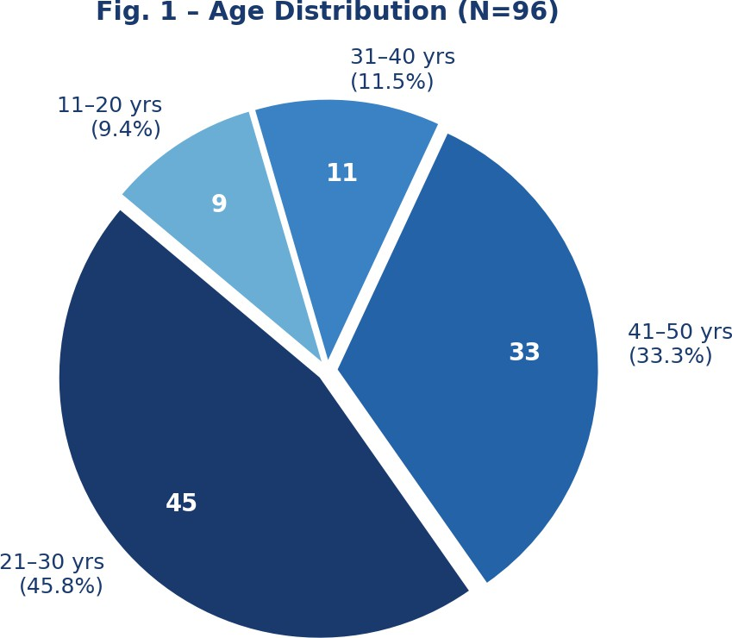

Fig. 1. Age Distribution of Survey Respondents (N=96) [15].

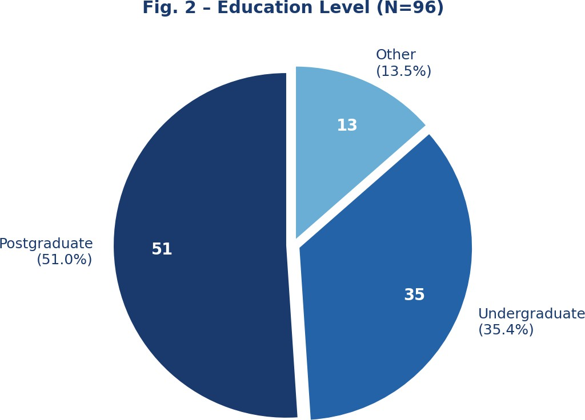

Fig. 2. Education Level Distribution of Respondents (N=96) [15].
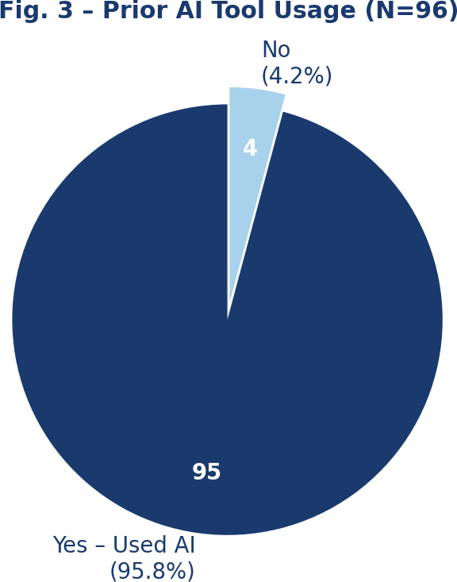
Fig. 3. Prior AI Tool Usage Among Respondents (N=96) [15].

Answer Preference by Prompting Style
Figure 4 and Table 2 present the distribution of answer preferences across all five survey questions, as compiled from the primary dataset [15]. The basic prompting condition (Answer A) attracted the highest number of selections in every question, accumulating 255 of the 480 total votes cast (53.1%). Detailed context-rich prompting (Answer C) ranked second with 146 selections (30.4%), while structured prompting (Answer B) received the fewest at 79 (16.5%).

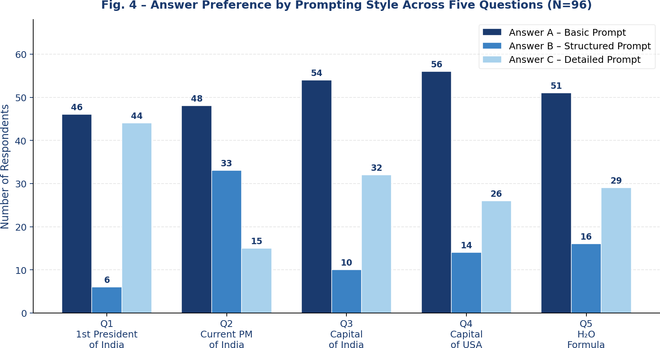

Fig. 4. Answer Preference by Prompting Style Across Five Questions (N=96) [15].

Question | A – Basic | B – Structured | C – Detailed | Total
Q1: First President of India | 46 (47.9%) | 6 (6.3%) | 44 (45.8%) | 96
Q2: Current PM of India | 48 (50.0%) | 33 (34.4%) | 15 (15.6%) | 96
Q3: Capital of India | 54 (56.3%) | 10 (10.4%) | 32 (33.3%) | 96
Q4: Capital of USA | 56 (58.3%) | 14 (14.6%) | 26 (27.1%) | 96
Q5: H<sub>2</sub>O Formula | 51 (53.1%) | 16 (16.7%) | 29 (30.2%) | 96
TOTAL | 255 (53.1%) | 79 (16.5%) | 146 (30.4%) | 480
TABLE 2. Answer Preference by Prompting Style. Source: Primary Dataset [15].
The consistent dominance of Answer A points to what this paper terms the brevity-trust bias: a tendency among users to associate conciseness with factual reliability. The effect was most pronounced for widely recognised facts (Q4, US capital: 58.3% preferred A) and weakest for historically specific questions (Q1, where C attracted 44 votes against A's 46). Structured prompting (B) registered its strongest performance in Q2 (34.4%), the only question where date-anchored institutional detail appeared to add perceived credibility.

AI Trust Level Analysis
The five-point trust scale responses, drawn from [15] and visualised in Figure 5, reveal a cautious but not hostile relationship with AI-generated content. Fifty-four respondents (56.3%) selected Level 4 (Partial Trust), while 30 (31.3%) chose the neutral Level 3. At the extremes, four participants (4.2%) expressed complete trust (Level 5)

and eight (8.3%) reported low or no trust (Levels 1–2). The scarcity of full trust in a sample where 95.8% had direct AI experience implies that personal encounters with incorrect outputs have left most users deliberately cautious.
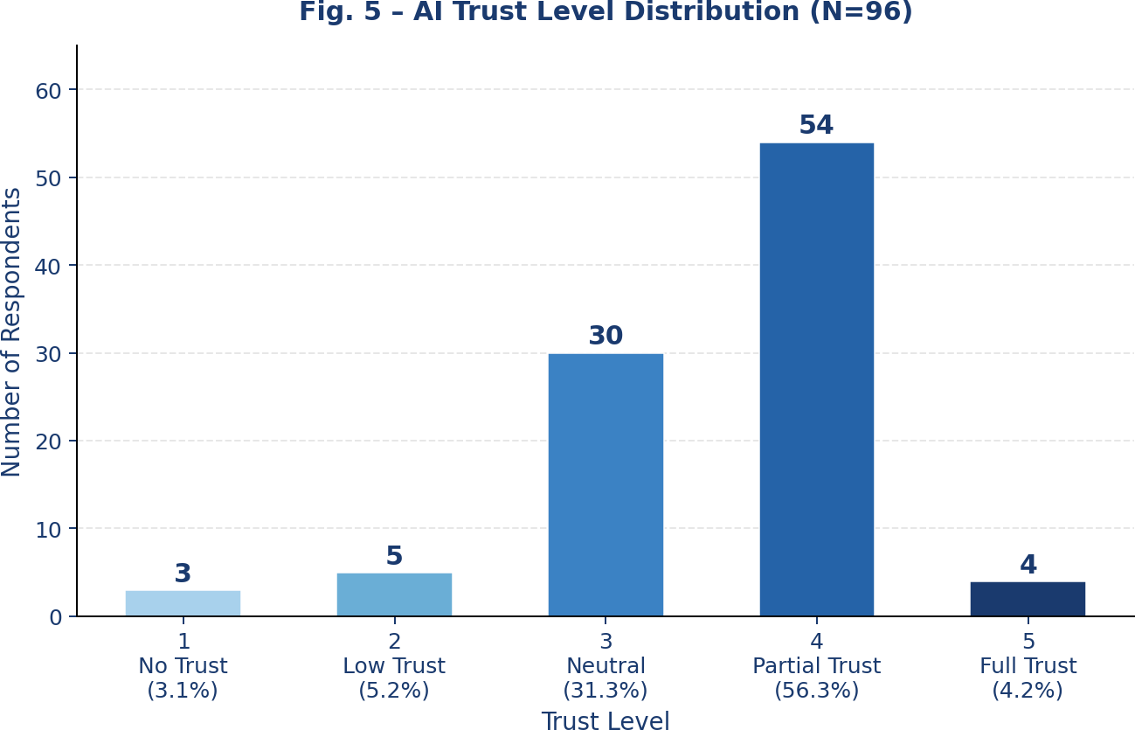
Fig. 5. AI Trust Level Distribution (N=96) [15]. Scale: 1 = No Trust, 5 = Full Trust.

Preferred Prompt Strategies
When asked which techniques they believed would most improve AI accuracy (Figure 6), 53 of 96 respondents (55.2%) endorsed giving the AI step-by-step instructions [15]. This constitutes the strongest endorsement of any strategy and provides user-level empirical validation for chain-of-thought prompting [3] as an intuitive and effective intervention. Requesting citation of sources and asking questions directly each received 31 endorsements (32.3%), followed by assigning an expert role (19; 19.8%) and instructing the AI to acknowledge uncertainty (15; 15.6%).

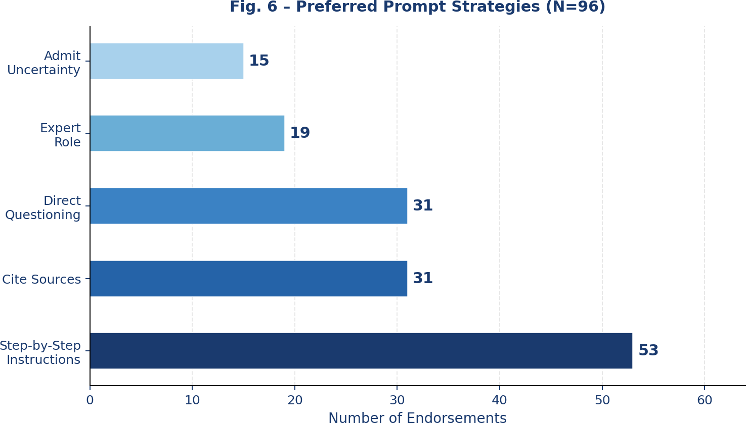
Fig. 6. Preferred Prompt Strategies for Improving AI Accuracy (N=96) [15].

Hallucination Detection Cues
Figure 7 maps the warning signals that respondents associate with potentially hallucinated AI responses [15]. Absence of specific details was flagged most often (54 mentions), followed by internal contradictions (41), missing explanatory reasoning (21), and self-reported non-verification of AI outputs (13). These results indicate that users rely on informal heuristics—specificity and internal consistency—rather than systematic external fact-checking when assessing AI credibility in everyday contexts.

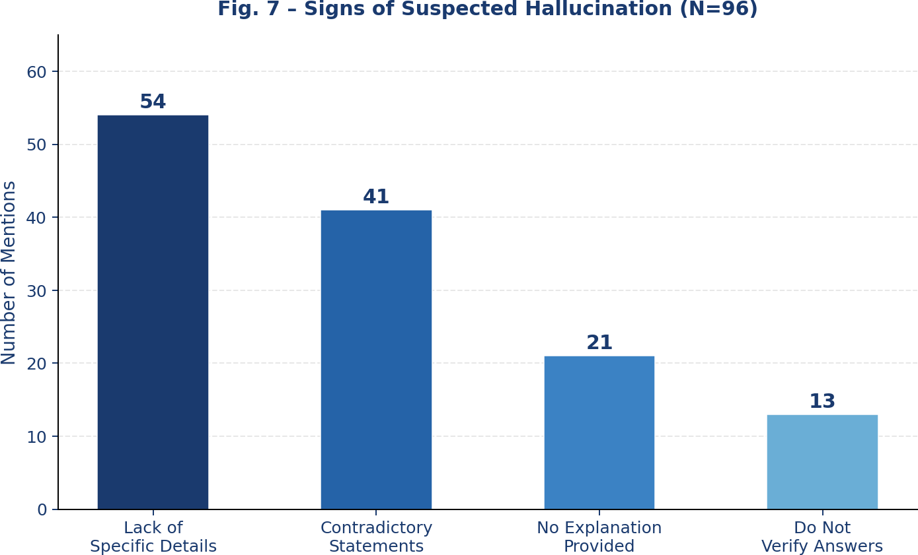

Fig. 7. Signs of Suspected Hallucination as Reported by Respondents (N=96) [15].

Factors Influencing AI Accuracy
Respondents were asked what they considered the primary drivers of AI response accuracy; the aggregated results
[15] appear in Figure 8. The clarity of the user's question led with 59 mentions, outpacing AI model capability itself (28 mentions). Providing structured instructions ranked second (45), and assigning a professional role came fourth (19). This ordering suggests that user-side prompt quality may contribute more to output reliability than model upgrades alone.

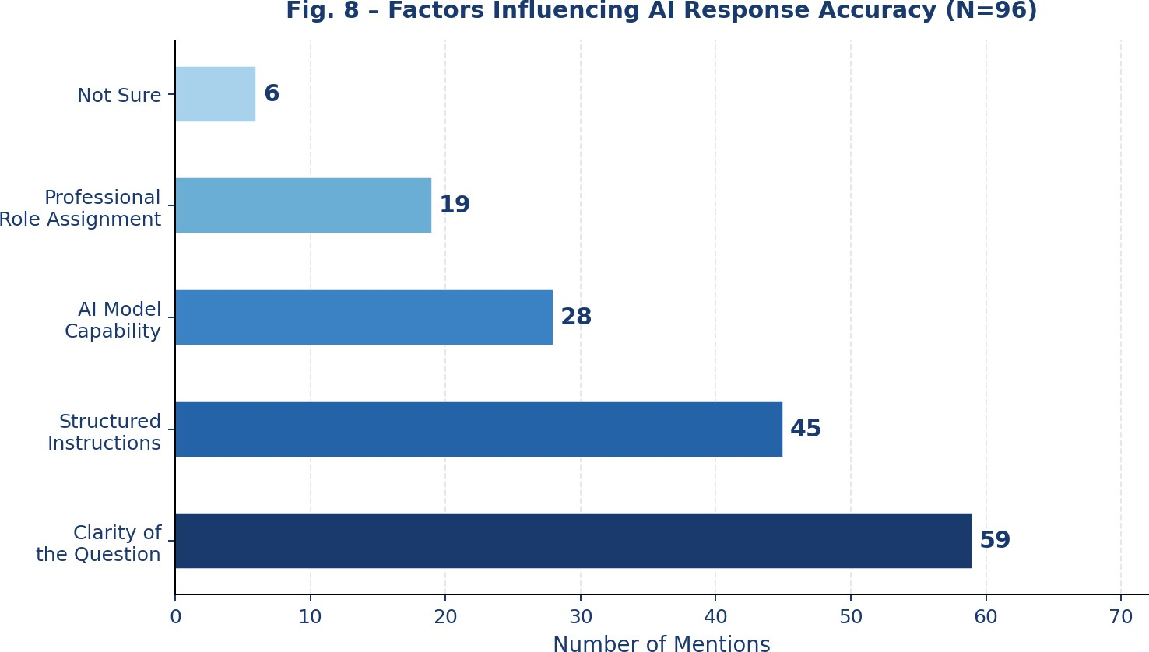
Fig. 8. Factors Respondents Believe Influence AI Response Accuracy (N=96) [15].

Accuracy Verification Behaviours
Figure 9 depicts the verification strategies employed by respondents after receiving AI-generated information [15]. Cross-referencing with a search engine (52 mentions) and rephrasing the query to the same AI tool (45 mentions) were the two most common approaches, followed by consulting an alternative AI system (34 mentions). Eleven respondents (11.5%) reported performing no verification whatsoever, representing a subset particularly vulnerable to acting on hallucinated content.

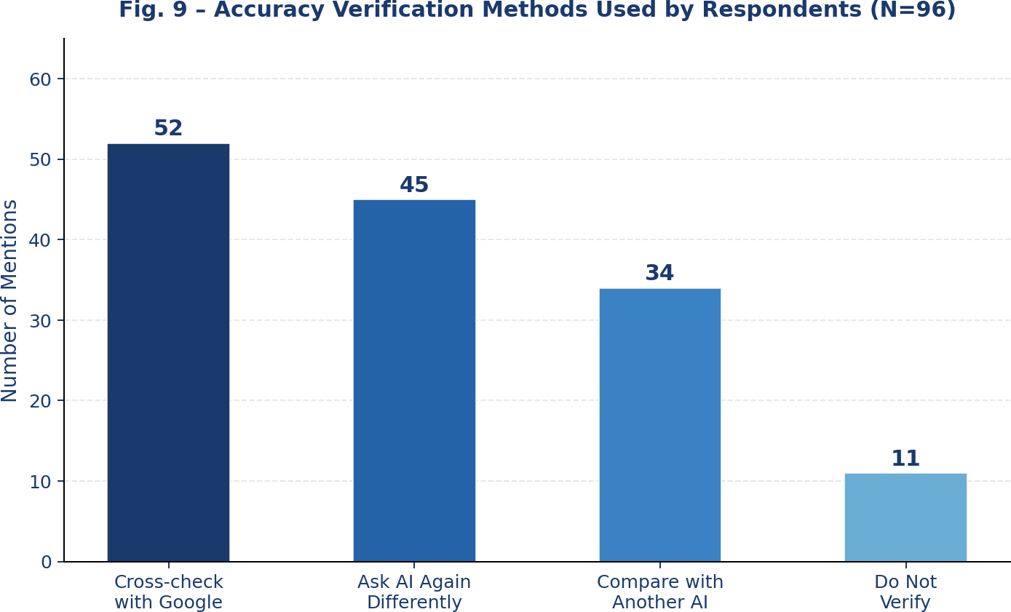

Fig. 9. Accuracy Verification Methods Used by Respondents (N=96) [15].

Reasons for Trusting AI Answers
Figure 10 presents the reasons cited by participants for trusting an AI-generated response [15]. The presence of a logical explanation topped the list with 53 mentions (36.3% of total citations), followed by a detailed tone (34; 23.3%), alignment with prior knowledge (23; 15.8%), general confidence in AI systems (19; 13.0%), and inclusion of numerical or date-based evidence (17; 11.6%). The dominance of logical explanation as a trust driver directly corresponds to the qualities that structured and chain-of-thought prompts are specifically designed to elicit.
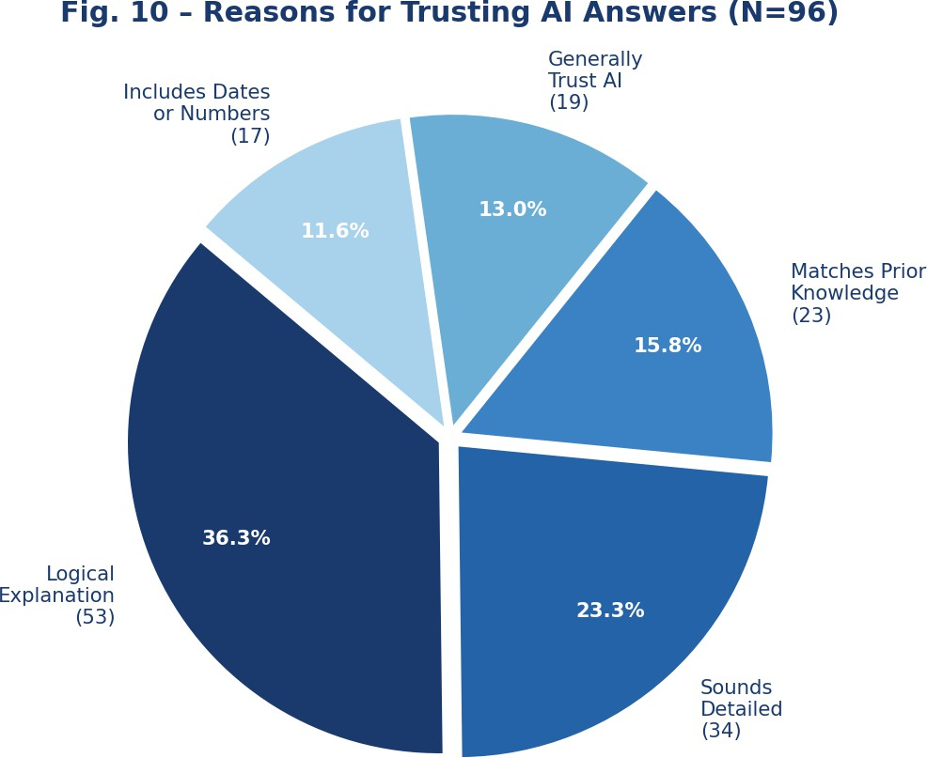

Fig. 10. Reasons for Trusting AI-Generated Answers (N=96) [15].

RESULTS
This section consolidates the principal outcomes of the data analysis into a unified interpretive framework. Table 3 presents each key metric alongside its quantitative finding and the broader implication for prompt engineering research and AI deployment practice. Each finding is then discussed in depth to enable complete and transparent interpretation of the survey evidence [15].

Metric | Finding | Implication
Most preferred prompt style | Basic / Direct (53.1%) | Brevity-trust bias confirmed
AI trust level (majority) | Level 4 – Partial (56.3%) | Full trust is rare
Top prompt strategy | Step-by-step (55.2%) | CoT validated empirically
Top hallucination indicator | Lack of detail (54 mentions) | Specificity drives credibility
Top accuracy factor | Question clarity (59 mentions) | User-side quality matters most
Top verification behaviour | Google cross-check (52) | Users actively self-correct
Top trust reason | Logical explanation (53) | Structured prompts build trust
Prior AI tool usage | 95.8%  (Yes) | Findings reflect real-world users
TABLE 3. Consolidated Results: Key Survey Findings and Implications. Source: Primary Dataset [15].

Finding 1 – Most Preferred Prompt Style: Basic / Direct (53.1%)
Across all 480 answer selections, 255 chose the shortest and most direct response (Answer A), and this majority held across every single question regardless of topic. The pattern constitutes empirical confirmation of the brevity-trust bias—a cognitive shortcut through which users interpret conciseness as a proxy for factual confidence. Interface designers and educators should consider this when choosing how to present AI-generated content, as users may overlook more complete answers in favour of simpler phrasing.

Finding 2 – AI Trust Level (Majority): Level 4 – Partial Trust (56.3%)
Fifty-four of the 96 respondents rated their trust at Level 4 on a five-point scale, indicating partial but not unconditional trust. Only four participants expressed full trust (Level 5), while eight reported low or no trust. Given that 95.8% had prior AI tool experience, this cautious majority almost certainly reflects direct personal encounters with incorrect or misleading AI outputs, reinforcing the need for transparency mechanisms that help users calibrate their reliance on AI appropriately.

Finding 3 – Top Prompt Strategy: Step-by-Step Instructions (55.2%)
Step-by-step instructions were chosen by 53 of 96 participants as the most effective strategy, outpacing every other option by a substantial margin. This user-level preference aligns precisely with chain-of-thought prompting [3], which the literature identifies as one of the most reliable techniques for reducing hallucination. The convergence of user intuition and scholarly evidence on this point provides strong justification for promoting CoT-style prompting in public-facing AI guidance and educational programmes.

Finding 4 – Top Hallucination Indicator: Lack of Specific Details (54 mentions)
When asked what makes them suspect an AI response is hallucinated, 54 respondents cited a lack of specific details as the primary warning sign, followed by internal contradictions (41). Users use specificity—the presence of names, dates, figures, and precise qualifiers—as a credibility heuristic. Paradoxically, this is precisely the characteristic that structured and detailed prompts are designed to produce, yet users still preferred the vaguer Answer A, underscoring the automatic nature of the brevity-trust bias.

Finding 5 – Top Accuracy Factor: Question Clarity (59 mentions)
Fifty-nine respondents identified the clarity of the question as the single most important accuracy factor—surpassing AI model capability (28 mentions) and structured instructions (45 mentions). This has direct policy implications: investing in user education on prompt formulation may deliver greater real-world accuracy improvements than switching to a more capable model. Organisations deploying LLMs should treat prompt-writing guidance as a core component of user onboarding.

Finding 6 – Top Verification Behaviour: Google Cross-Check (52 mentions)
The most common approach to verifying AI information was cross-referencing with a web search engine (52 respondents). Forty-five reported rephrasing the query to the same AI, and 34 compared outputs across different AI tools. Eleven participants (11.5%) reported doing nothing to verify AI answers. This last group is particularly at risk: without any verification mechanism, they are fully exposed to hallucination-induced misinformation, supporting the development of built-in verification nudges within AI interfaces.

Finding 7 – Top Trust Reason: Logical Explanation (53 mentions)
The most frequently cited reason for trusting an AI answer was that it provided a logical explanation (53 mentions, 36.3% of total citations), followed by appearing detailed (34), matching prior knowledge (23), general AI confidence (19), and inclusion of specific dates or numbers (17). The primacy of logical explanation as a trust signal is directly actionable: structured and chain-of-thought prompts specifically elicit explanatory reasoning, making them the most effective at generating outputs that users are predisposed to trust.

Finding 8 – Prior AI Tool Usage: 95.8% (Yes)
Ninety-two of the 96 survey participants had used AI tools such as ChatGPT before completing the survey. This high rate of prior experience strengthens the validity of the findings considerably: participants were not making abstract judgements but drawing on lived experience with these systems. The sample therefore reflects the attitudes and behaviours of a genuinely AI-literate population, making the results highly relevant to real-world deployment contexts.

CONCLUSION & FUTURE WORK

Conclusions

This investigation examined the relationship between prompt engineering and factual reliability in Large Language Models through a dual methodology encompassing a systematic literature review and a primary survey of 96 participants [15]. The literature review established that hallucination is a systemic problem rooted in training data impurity, misaligned training objectives, static knowledge boundaries, and decoding strategies that reward confident-sounding outputs over calibrated ones. The empirical data analysis yielded four principal results:
- The brevity-trust bias is pervasive: users reliably selected shorter, simpler answers over more complete alternatives across every domain tested. This bias was strongest for familiar topics and weakest for less commonly known historical facts.
- Partial trust predominates (56.3%): only a negligible fraction of the sample extended full trust to AI-generated factual content, reflecting first-hand awareness of hallucination among a near-universally AI-experienced respondent pool.
- Step-by-step instructions are the preferred strategy (55.2%): this user-endorsed technique maps directly onto chain-of-thought prompting [3], providing independent empirical validation of a recommendation that originates in controlled benchmark research.
- Specificity and logical coherence function simultaneously as the primary trust signals and hallucination warning cues, creating a direct incentive to promote structured and reasoned AI responses.
Taken together, these findings support a combined mitigation framework: CoT and structured prompting at the user input level; RAG and RLHF at the model training and inference level; and fact-checking post-processing at the system level. User education on effective prompt formulation is an equally important complementary measure.

Future Research Directions
- Development of standardised, domain-neutral hallucination benchmarks for reproducible cross-model evaluation.
- Systematic cross-model comparisons across GPT-4, Gemini, LLaMA 3, Claude, and DeepSeek to determine whether hallucination profiles are architecture-specific or paradigm-wide.
- Longitudinal studies tracking how user trust and prompt preferences evolve alongside model capability improvements.
- Domain-specific mitigation research for high-stakes fields including medicine, law, and financial services.
- Multilingual evaluation extending the current English-centric literature to Hindi, Arabic, Mandarin, and other high-use languages.
- Investigation of hybrid neural-symbolic architectures that couple knowledge graphs with neural generation to structurally reduce hallucination.

References.
- A. Vaswani, N. Shazeer, N. Parmar, J. Uszkoreit, L. Jones, A. N. Gomez, ■. Kaiser, and I. Polosukhin, “Attention Is All You Need,” in Advances in Neural Information Processing Systems (NeurIPS), vol. 30, pp. 5998–6008, 2017. [Online].
Available: https://arxiv.org/abs/1706.03762
- T. B. Brown, B. Mann, N. Ryder, M. Subbiah, J. Kaplan et al., “Language Models are Few-Shot Learners,” in NeurIPS, vol. 33, pp. 1877–1901, 2020. [Online]. Available: https://arxiv.org/abs/2005.14165
- J. Wei, X. Wang, D. Schuurmans, M. Bosma, B. Ichter, F. Xia, E. Chi, Q. Le, and D. Zhou, “Chain-of-Thought Prompting Elicits Reasoning in Large Language Models,” in NeurIPS, vol. 35, 2022. [Online]. Available:

https://arxiv.org/abs/2201.11903
- L. Ouyang, J. Wu, X. Jiang, D. Almeida, C. Wainwright, P. Mishkin et al., “Training Language Models to Follow Instructions with Human Feedback,” in NeurIPS, vol. 35, pp. 27730–27744, 2022. [Online]. Available: https://arxiv.org/abs/2203.02155
- Z. Ji, N. Lee, R. Frieske, T. Yu, D. Su, Y. Xu, E. Ishii, Y. Bang, A. Madotto, and P. Fung, “Survey of Hallucination in Natural Language Generation,” ACM Computing Surveys, vol. 55, no. 12, pp. 1–38, 2023. DOI: 10.1145/3571730
- S. Lin, J. Hilton, and O. Evans, “TruthfulQA: Measuring How Models Mimic Human Falsehoods,” in Proc. 60th Annual Meeting of the ACL, pp. 3214–3252, 2022. [Online]. Available: https://arxiv.org/abs/2109.07958
- P. Lewis, E. Perez, A. Piktus, F. Petroni, V. Karpukhin, N. Goyal et al., “Retrieval-Augmented Generation for Knowledge-Intensive NLP Tasks,” in NeurIPS, vol. 33, pp. 9459–9474, 2020. [Online]. Available: https://arxiv.org/abs/2005.11401
- A. Alansari and H. Luqman, “Large Language Models Hallucination: A Comprehensive Survey,” arXiv:2510.06265, Mar. 2026. [Online]. Available: https://arxiv.org/abs/2510.06265
- L. Zhang et al., “A Survey on Hallucination in Large Language Models: Principles, Taxonomy, Challenges, and Open Questions,” ACM Transactions on Information Systems, 2024. DOI: 10.1145/3703155
- S. Srivastava, I. Malik, A. Gupta, and S. Grover, “Survey and Analysis of Hallucinations in Large Language Models,”
Frontiers in Artificial Intelligence, vol. 8, 2025. DOI: 10.3389/frai.2025.1622292
- S. Sahoo, A. K. Singh, S. Sahu, V. Jain, S. Mondal, A. Chadha, and T. Saha, “A Systematic Survey of Prompt Engineering in LLMs: Techniques and Applications,” arXiv:2402.07927, Jun. 2024. [Online]. Available: https://arxiv.org/abs/2402.07927
- OpenAI, “GPT-4 Technical Report,” arXiv:2303.08774, 2023. [Online]. Available: https://arxiv.org/abs/2303.08774
- H. Touvron, L. Martin, K. Stone, P. Albert et al., “Llama 2: Open Foundation and Fine-Tuned Chat Models,” arXiv:2307.09288, Meta AI, 2023. [Online]. Available: https://arxiv.org/abs/2307.09288
- Y. Deng, W. Wu, J. Zhang, and Z. Zheng, “Detecting and Reducing the Factual Hallucinations of LLMs with Metamorphic Testing,” Proc. ACM on Software Engineering (PACMSE), vol. 2, 2024. DOI: 10.1145/3715784
- D. Jain and P. Anand, “Impact of Prompt Engineering on AI Accuracy – Survey Response Dataset,” Primary Survey Data, N=96 respondents, Google Forms, Jagan Institute of Management Studies, Rohini, Delhi, India, Feb. 2026. [Raw data file: Impact_of_Prompt_Engineering_on_AI_Accuracy Responses_.xlsx, available with authors].

