Optimization and Quality Evaluation of Red Banana–Mango Composite Fruit Leather Using Response Surface Methodology

ABSTRACT: The current study aimed to develop and evaluate a fruit leather made from red banana (Musa acuminata var. Red Dacca) and mango (Mangifera indica) as a fruit product with added value. Fruit leather is a dehydrated snack made from fruit. It offers a longer shelf life while keeping important nutrients and flavors. In this study, ripe red banana and mango pulps were mixed in various proportions with liquid glucose to improve sweetness, texture, and stability. We used Response Surface Methodology (RSM) to optimize the recipe and examine how the variables affected product quality. We analyzed the produced fruit leather for physicochemical properties such as moisture content, ash, protein, fat, carbohydrates, titratable acidity, total sugars and energy value. Texture Profile Analysis was performed to evaluate qualities like hardness, cohesiveness, springiness, gumminess, and chewiness. We also assessed functional properties, including antioxidant activity and total phenolic content. Shelf-life studies were conducted over one month under regular storage conditions. Microbial analysis included total plate count, yeast and mold count and coliform count to check product safety. The results showed that the optimized recipe had desirable physicochemical properties and acceptable texture. The microbial load stayed within safe limits during storage. The product also demonstrated good antioxidant potential. Overall, the study shows that using Musa acuminata var. Red Dacca and Mangifera indica can successfully create a nutritious fruit-based snack. This research highlights the potential of this product as a functional food with added value in the fruit processing industry.

KEYWORDS: Red banana, Mango, Fruit leather, Response Surface Methodology (RSM), Physicochemical properties, Texture Profile Analysis, Liquid glucose, Shelf-life study, Microbial analysis, Functional food product.

I.INTRODUCTION:
Banana is one of the most widely grown and eaten fruit crops globally because it produces a lot, is available year-round, and offers great nutrition. Among different types, red banana (Musa acuminata) is getting more attention for its better nutritional profile and unique taste. Red banana has a reddish-purple peel, creamy pulp and sweet flavor. It has high levels of dietary fiber, potassium, vitamin C, vitamin B6 and bioactive compounds like carotenoids and phenolic substances, which help with antioxidant activity and various health benefits (Sagar and Kumar 2018). This fruit is mainly grown in tropical areas, especially in southern India, including Tamil Nadu and Kerala, where it is important for local farming and food systems.
Mango (Mangifera indica L.), often called the “king of fruits,” is another key tropical fruit prized for its bright color, nice smell and delicious taste. Mango is rich in β-carotene, vitamin C, polyphenols and dietary fiber, which give it strong antioxidant effects and health benefits (Tharanathan et al., 2016).
Even with their nutritional and economic significance, both banana and mango spoil quickly because of their high moisture content, making them prone to rapid ripening and losses after harvest. Turning these fruits into value-added products is a smart way to extend their shelf life, cut down on waste and boost their market value. One such product is fruit leather, a dried fruit snack made by drying fruit pulp into thin, flexible sheets. Mixing red banana and mango in fruit leather can enhance nutritional quality, flavor, color and overall appeal while also offering a convenient and healthy snack option (Fellows 2017).
II.METHODOLOGY:
This section deals with formulation and optimization of leather processing by Response Surface Methodology, biochemical, sensory evaluation and shelf life of the product.
2.1. Raw materials and ingredients used in Processing of Leather
The primary ingredients used in the preparation of red banana leather are red banana pulp, mango pulp, liquid glucose and potassium metabisulphite. Each ingredient contributes to the product’s nutritional, sensory and preservation characteristics. The optimization of raw materials and ingredients are done with the help of Response Surface Methodology (RSM).
2.2 Processing of Leather
2.2.1 Response Surface Methodology
Response Surface Methodology (RSM) is a statistical and mathematical technique used for modeling, analyzing and optimizing processes where a response of interest is affected by multiple variables. It is commonly applied in food product development to improve formulation and processing parameters with fewer experimental trials, while also maximizing product quality. RSM typically includes three main steps: experimental design, development of a regression model, and optimization of responses. Common designs used are Central Composite Design (CCD), Box-Behnken Design (BBD) and Three-Level Factorial Design. These designs cut down on the number of experimental runs compared to traditional full-factorial experiment gives enough data to assess linear, quadratic and interaction effects.

Table no:2.1 RSM trials

Std | Run | Factor 1  A: Red banana% | Factor 2  B:Mango % | Factor 3  C: Liquid glucose | Response 1  Moisture content % | Response 2  pH | Response 3  Ash content g | Response 4  Overall  Acceptability
2 | 1 | 90 | 10 | 5 | 9.8 | 5 | 2.7 | 8
15 | 2 | 70 | 34.5 | 17.5 | 10.4 | 4.4 | 2.3 | 8.8
9 | 3 | 50 | 34.5 | 17.5 | 9.9 | 4.3 | 2.1 | 8.2
11 | 4 | 70 | 10 | 17.5 | 9.6 | 4.8 | 2.2 | 7.8
3 | 5 | 50 | 59 | 5 | 10.8 | 3.8 | 2.3 | 7.5
6 | 6 | 90 | 10 | 30 | 8.8 | 4.9 | 2.3 | 7.6
8 | 7 | 90 | 59 | 30 | 11.3 | 4 | 2.6 | 7.2
7 | 8 | 50 | 59 | 30 | 10.4 | 3.9 | 2.1 | 7
12 | 9 | 70 | 59 | 17.5 | 11.4 | 4.1 | 2.5 | 7.9
5 | 10 | 50 | 10 | 30 | 8.9 | 4.7 | 1.8 | 7.3
18 | 11 | 70 | 34.5 | 17.5 | 10.6 | 4.5 | 2.4 | 8.7
19 | 12 | 70 | 34.5 | 17.5 | 10.5 | 4.4 | 2.3 | 8.8
14 | 13 | 70 | 34.5 | 30 | 9.4 | 4.3 | 2.1 | 7.9
20 | 14 | 70 | 34.5 | 17.5 | 10.4 | 4.4 | 2.3 | 8.6
16 | 15 | 70 | 34.5 | 17.5 | 10.7 | 4.5 | 2.4 | 8.9
1 | 16 | 50 | 10 | 5 | 8.3 | 4.8 | 2.2 | 7.7
10 | 17 | 90 | 34.5 | 17.5 | 10.8 | 4.5 | 2.6 | 8.4
13 | 18 | 70 | 34.5 | 5 | 10.5 | 4.4 | 2.3 | 8.7
4 | 19 | 90 | 59 | 5 | 11.2 | 4.6 | 2.8 | 8.3
17 | 20 | 70 | 34.5 | 17.5 | 10.4 | 4.4 | 2.4 | 8.8

2.3 Processing flowchart

Fig No 2. 1 Flow Chart of Preparation of Red Banana Mango Leather

2.4 Preparation of Red Banana Mango Leather
The preparation of red banana leather involves a series of processing steps to ensure hygiene, consistency, safety and effective dehydration. The following methodology outlines a practical approach for producing high-quality fruit leather using solar drying technology (Figure:2.1).
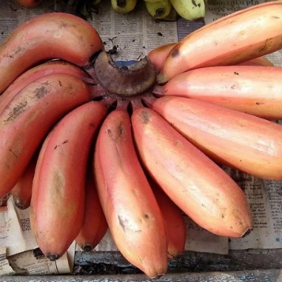
Figure :2.1 Red Banana
2.4.1 Washing
Freshly harvested, ripe red bananas are selected for their uniform ripeness, firmness and lack of defects. The fruits are thoroughly washed under clean running water to remove dust, soil, latex and other impurities. This washing process ensures hygienic handling without using chlorine or chemical sanitizers, helping to preserve the fruit's natural characteristics (Arah I.K. et al., 2016).
2.4.2 Peeling
The washed bananas are manually peeled (Figure: 2.2) using clean stainless-steel knives. Care is taken to avoid damaging the soft pulp during this step. As red bananas have a delicate texture, handling them properly during peeling helps maintain pulp quality and prevents browning. The peeled bananas are collected in clean food-grade containers for immediate pulping.
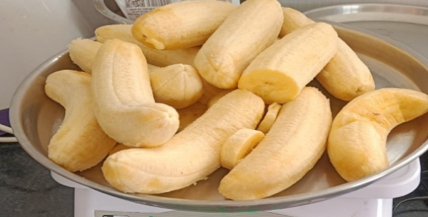
Plate no:2.3 Peeled Banana
2.4.3 Pulping
The peeled bananas are blended using a mixer, grinder or mechanical pulper to create a smooth and uniform puree. Pulping releases natural sugars and pectin, which provide a good base for leather formation (Sagar V.R. et al., 2018). A well-blended pulp ensures even spreading and drying.
2.4.4 Filtering
The fresh pulp is strained through a fine sieve or muslin cloth to remove coarse fibers, unblended pieces, and lumps. Filtering improves the smoothness of the pulp, enhances its spreading qualities and ensures a consistent texture in the final product. Removing unwanted fibers also helps with uniform drying and prevents grainy surfaces.
2.4.5 Pretreatment
Pretreatment was done to improve safety, inactivate enzymes, and increase pulp viscosity. The filtered banana pulp was heated to 80 °C for 20 minutes while being stirred continuously in a stainless-steel vessel. It was then cooled to about 40 to 50 °C. Potassium metabisulphite (100 ppm) was added to stop enzymatic browning and maintain color (Sagar et al., 2018; Siddiq et al., 2017).

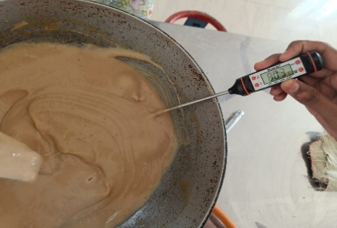
Figure:2.3 Pretreatment
2.4.6 Cooking
Next, the pre-treated pulp was cooked at 70 to 75 °C with continuous stirring, and liquid glucose was added at this stage. Cooking helped reduce moisture, inactivate enzymes and improve flavor and aroma (Sagaret al., 2018) (Figure: 2.4).
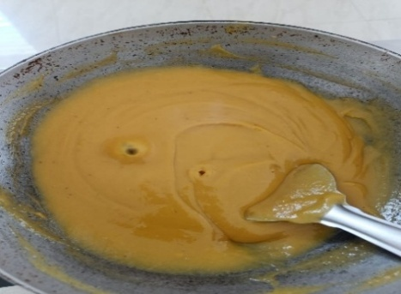
Figure:2.4 Cooking
2.4.7 Spreading
The pretreated and preservative-added pulp is evenly spread onto trays lined with butter paper or food-grade silicone sheets. The pulp is spread using a sterilized spatula to achieve a uniform thickness of 3–5 mm (Sagar V.R. et al.,2018). Uniform spreading directly influences the final appearance, quality and drying rate (Figure:2.5).
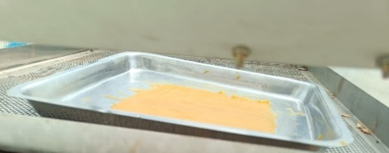
Figure:2.5 Spreading
2.4.8 Drying
Drying takes place in an indirect solar dryer, which provides controlled airflow and protects against dust and contamination. The drying temperature inside the solar dryer usually ranges from 55–65 °C (Sagar V.R. et al., 2018), depending on sunlight intensity and design. The sheets are monitored periodically to prevent over drying or uneven drying (Figure: 2.6)
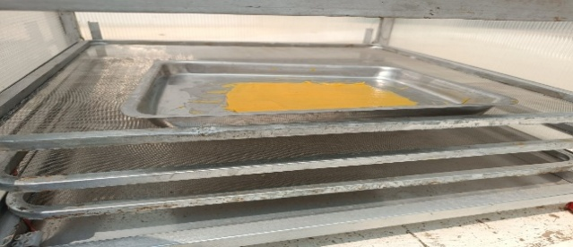
Figure:2.6 Solar Drying
2.4.9 Packaging
Once the leather reaches the desired pliable texture, it is gently peeled off the tray liner and cut into uniform rectangular pieces. The pieces are separately packed in the polyethylene polymer package to prevent the leather from various external conditions. (Figure: 2.7). Proper packaging ensures extended shelf stability, protection from environmental humidity and ease of handling during storage and transportation.
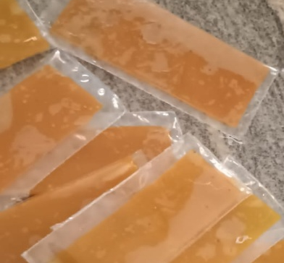
Figure: 2.7 Packaged leather

2.5 Determination of Physicochemical Properties
The physicochemical properties of the developed red banana and mango leather were evaluated to assess its composition, structural stability, and storage potential. These properties provide valuable information about moisture content, nutrient composition, acidity, sugar concentration, mineral content and the functional features of the final product. Standard analytical methods were used to determine each parameter accurately.
2.5.1 Determination of Moisture Content
The moisture content was assessed to evaluate the water in the fruit leather, as it affects texture, microbial stability, and shelf life. The test followed the method from the FSSAI manual for Fruits and Vegetables. The analysis relied on weight loss during drying. A known sample weight was dried in a hot air oven at 105°C until it reached a constant weight. The weight reduction corresponds to the moisture removed from the sample. Moisture content was calculated using the formula in equation 2.1:
$Moisture content\%=\frac{Initial weight-Final weight}{Initial weight}X100$----(eq 2.1)
Keeping moisture between 12% and 15% is crucial for flexibility and to prevent microbial spoilage.
2.5.2 Determination of Water Activity (aw)
The water activity indicates the amount of free water available for microbial growth and chemical reactions. It was measured using a water activity meter that determines the equilibrium relative humidity of the sample. Water activity is expressed in equation 2.2:
$aw=\frac{Vapour pressure of sample}{Vapour pressure of pure water}$ --- (eq 2.2)
Lower aw values, generally below 0.6, indicate better shelf stability and a lower risk of microbial growth.
2.5.3 Determination of Ash Content
The ash content represents the total mineral matter in the fruit leather. This determination is based on completely incinerating organic matter in a muffle furnace at around 550°C until a white or light gray residue is left. The inorganic residue after combustion is measured as ash. The testing method followed IS 7219. Ash percentage was calculated using equation 2.3:
$Ash\%=\frac{Weight of ash}{Weight of sample}X100$---(eq 2.3)
This value reflects the overall mineral content of the product.
2.5.4 Determination of Protein Content
The protein content was estimated using the Kjeldahl method, which measures total nitrogen in the sample. The test followed the method from the FSSAI manual for Fruits and Vegetables. During digestion, nitrogen in proteins converts to ammonium sulfate and is then quantified. The nitrogen amount is multiplied by a conversion factor, usually 6.25, to estimate protein content using equation 2.4: ‘
Protein (%) = Nitrogen (%) x 6.25--- (eqn 2.4)
This parameter contributes to the nutritional evaluation of the product.
2.5.5 Determination of Fat Content
The fat content was determined using solvent extraction (Soxhlet method) to extract fat from the sample with a non-polar solvent like petroleum ether. After extraction, the solvent is evaporated, and the residue is weighed and calculated through equation 2.5. This procedure follows the FSSAI manual for Fruits and Vegetables.
$Fat\%=\frac{Weight of extracted fat}{Weight of sample}X100$--- (eq 2.5)
While fruit leather generally has low fat, this value plays a role in complete proximate analysis.
2.5.6 Determination of Carbohydrate Content
The total carbohydrate content was calculated by the difference method, subtracting moisture, protein, fat and ash from 100, and calculated using equation 2.6. This test followed the method IS 1656.
Carbohydrate (%) =
100 - (Moisture + Protein + Fat + Ash) ---(eq 2.6)
Carbohydrates are the main component of fruit leather and add sweetness, structure and energy value.
2.5.7 Determination of Energy Value
The Energy value was calculated using the Atwater factors, which assign caloric values to macronutrients, and it is calculated using equation 2.7:
Energy (kcal/100 g) = (Protein x 4) + (Carbohydrate x 4) + (Fat x 9) ---(eq 3.7)
This indicates the caloric contribution of the developed product. The method followed ALT/SOP/03/01:2016.
2.5.8 Determination of Titrable Acidity
The titrable acidity measures the total organic acids present, which influence flavor and preservation. The sample extract was titrated with standard sodium hydroxide and used phenolphthalein as an indicator. Acidity was expressed as a percentage of the predominant acid (e.g., citric acid) and calculated with equation 2.8:
$Titrable Acidity \% =\frac{Volume of NaOH × Normality × Equivalent weight of acid× 100 }{Weight of sample × 1000}$--- (eq 2.8)

This parameter affects taste balance and microbial stability. The method followed the FSSAI manual for Fruits and Vegetables.
2.5.9 Determination of Total Sugars
The total sugars were measured using standard colorimetric methods, such as the phenol-sulfuric acid method, where sugars react to create a colored complex measured spectrophotometrically. Sugar concentration was calculated using a standard calibration curve and expressed as a percentage of the sample. Sugars contribute to sweetness, browning reactions and texture. The test followed the FSSAI manual for Fruits and Vegetables.
2.5.10 Determination of Potassium, Iron and Calcium
The mineral content (potassium, iron, and calcium) was determined using atomic absorption spectroscopy (AAS) after acid digestion of the sample. The concentration of each mineral was calculated from standard calibration curves and expressed as mg per 100 g of sample. These minerals are important for electrolyte balance, hemoglobin formation, and bone health. The method followed ALT-CH-SOP-006.
2.5.11 Determination of Total Phenolic Content
The Total phenolic content was measured using the Folin–Ciocalteu reagent method, where phenolic compounds react to create a blue-colored complex measurable at 765 nm. Results were expressed as mg gallic acid equivalents (GAE) per 100 g of sample. Phenolics contribute to antioxidant activity and functional properties.
2.5.12 Determination of Antioxidant Activity
Antioxidant activity was evaluated using methods like the DPPH radical scavenging assay (Blois, M.S., 1958). A decrease in absorbance indicates the scavenging ability of the sample's antioxidants, and higher values represent stronger antioxidant potential.
2.5.13 Determination of Beta-Carotene
Beta-carotene content was measured through solvent extraction and then spectrophotometric measurement at the appropriate wavelength (around 450 nm) (A. O. A. C. 2005). The concentration was calculated from absorbance values and expressed as mg per 100 g. Beta-carotene contributes to color and provitamin A activity.
2.6 Texture Profile Analysis
The Texture Profile Analysis (TPA) of the developed red banana and mango fruit leather was conducted with a texture analyzer. This analyzed the mechanical properties that affect consumer acceptability. The analysis included a double compression test to simulate chewing action. Textural parameters like hardness, cohesiveness, springiness, gumminess, chewiness and adhesiveness were obtained from the force and time curve. Uniformly cut samples ensured consistency during testing. The analysis provided quantitative data on the structural integrity and textural quality of the fruit leather.
3.7 Shelf Life and Microbial Analysis
The shelf life of the developed fruit leather was assessed over one month under normal storage conditions. The samples were packed in airtight LDPE pouches and analyzed at 0, 15, and 30 days to monitor microbial growth and spoilage. Total Plate Count (TPC) was measured using Plate Count Agar, while yeast and mold counts were evaluated with Potato Dextrose Agar. Coliform count was measured using Violet Red Bile Agar to check hygienic quality. The microbial results were compared with acceptable limits and the product remained microbiologically safe for one month when stored properly (Fellows 2017).
2.8 SENSORY EVALUATION
A sensory evaluation of the red banana and mango fruit leather was done to check its acceptability based on taste and other sensory attributes. Semi-trained panelists evaluated the samples for color, flavor, taste, texture and overall acceptability. A 5-point hedonic scale was used, with 5 meaning like very much and 1 meaning dislike very much. The samples were coded and presented in clean conditions to avoid bias.

III. RESULT AND DISSCUSSION
3.1RSM Trial Optimization
The following set of graphs has been created using Response Surface Methodology (RSM) software. They provide insights into how different formulation parameters interact and affect the developed leather.
3.1.1 Moisture Content
Figure 3.1 displays the normal plot of residuals for moisture content. Most data points are close to the straight line, which shows that the experimental data aligns with normal distribution. This means the RSM model is suitable for analysis. Figure 3.2 shows the predicted versus actual plot for moisture content. Here, the points are close to the diagonal line, demonstrating a good match between the experimental and predicted values. The contour plot in Figure 3.3 illustrates the interaction effect of red banana pulp and mango pulp on moisture content. Lastly, the 3D response surface plot in Figure 3.4 demonstrates how changing the proportions of ingredients affects moisture levels in the fruit leather.
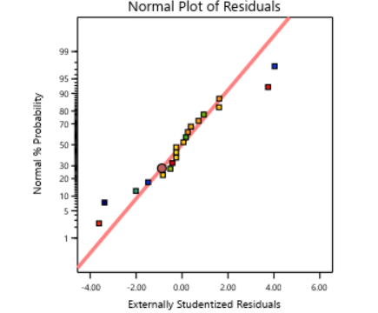
Figure:3.1 Normal plots towards Moisture content
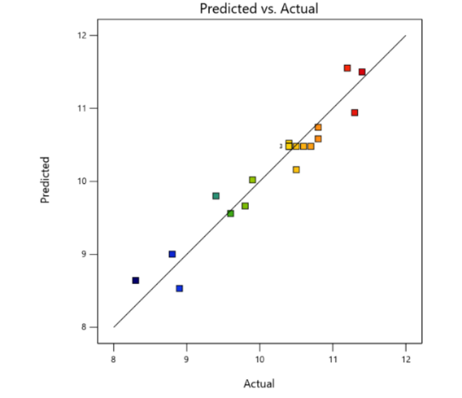
Figure:3.2 Plot for Predicted Vs Actual values
towards the response moisture content
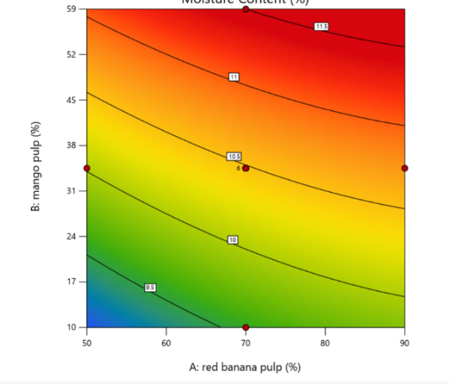
Figure :3.3 Contour plot towards the moisture
content
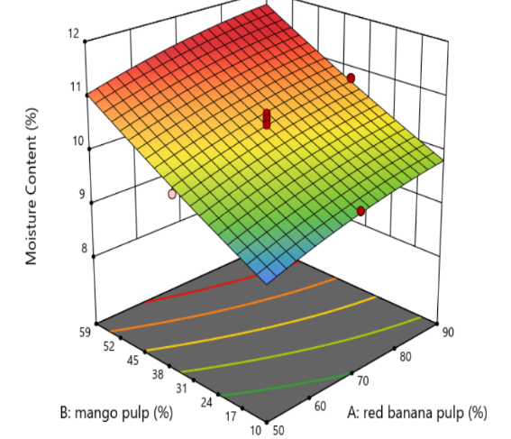
Figure:3.4 The 3D plot towards the response
moisture content
3.1.2 pH
Figure 3.5 shows the contour plot representing the interaction between red banana pulp and mango pulp on the moisture content of fruit leather. Figure 3.6 reveals that the color gradient shifts from blue/green to yellow/red. This indicates an increase in moisture levels with changes in ingredient proportions. Figure 3.7 shows the curved contour lines, showing that both variables significantly influence the response. Figure 3.8 presents the 3D response surface plot, which visually explains how moisture content changes with variations in red banana and mango pulp levels. The peak and slope of the surface indicate the optimum region where desirable moisture content for fruit leather can be achieved.
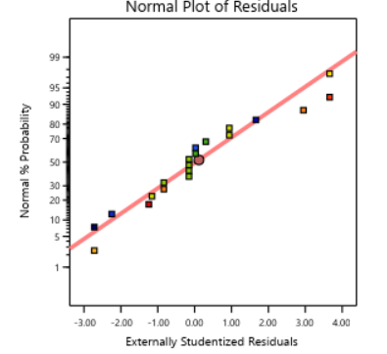
Figure:3.5 Normal plots towards pH 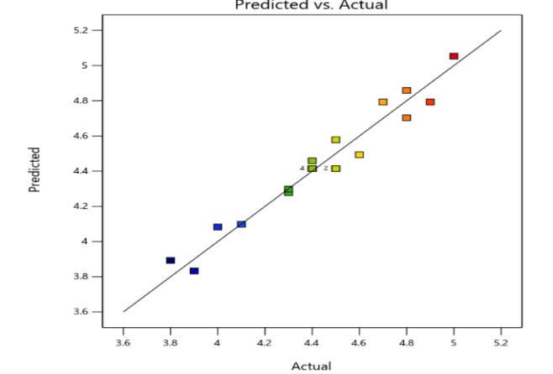
Figure:3.6 Plot for Predicted Vs Actual values
towards the response pH

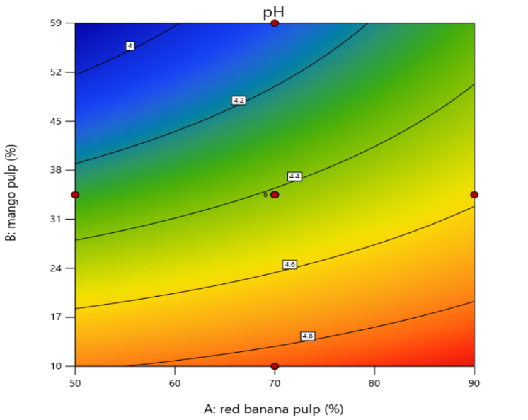
Figure:3.7 Contour plot towards the response pH
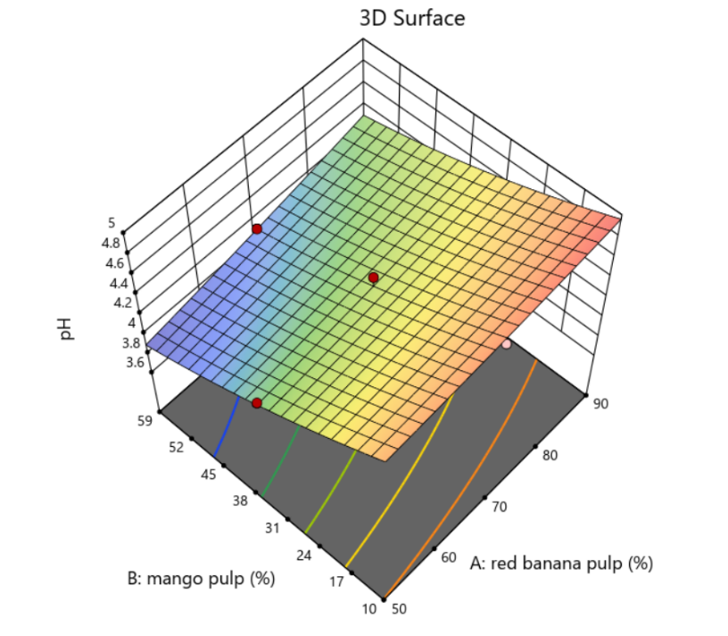
Figure:3.8 The 3D plot towards the response pH

3.1.3 Ash Content
Figure 3.9 depicts the normal probability plot for ash content. The points are close to the straight line, indicating that the residuals follow a normal distribution and that the model is statistically valid. Figure 3.10 illustrates the predicted versus actual plot for ash content. The points are near the diagonal line, showing good agreement between experimental and predicted values. Figure 3.11 presents the contour plot demonstrating the interaction effect of red banana pulp and mango pulp on ash content. The color variation indicates changes in mineral content with different ingredient levels. Figure 3.12 displays the 3D response surface plot, which explains how ash content varies with different proportions of red banana and mango pulp, helping to identify the best formulation region.

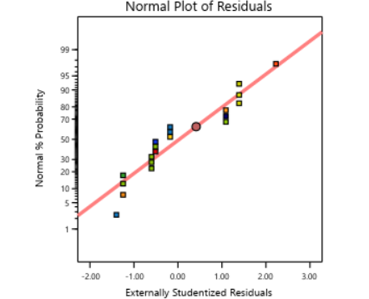
Figure:3.9 Normal plots towards ash content
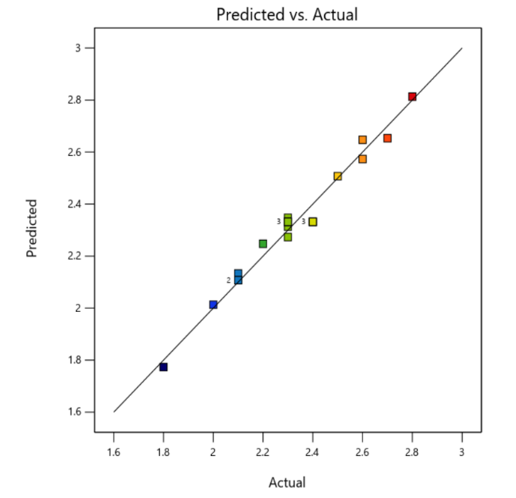
Figure:3.10 Plot for Predicted Vs Actual values towards the response ash content
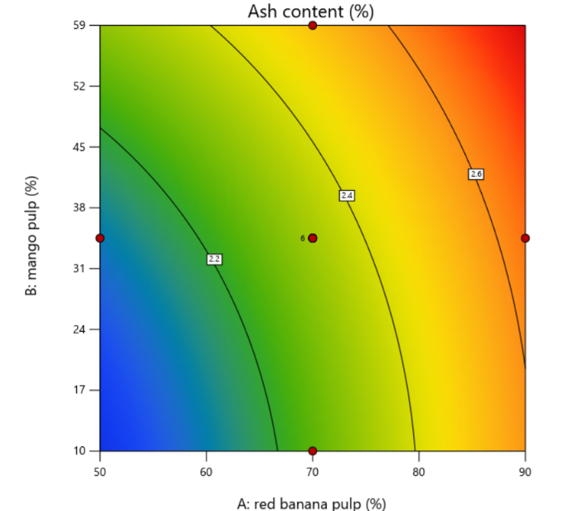
Figure 3.11: Contour plot towards the response
ash content
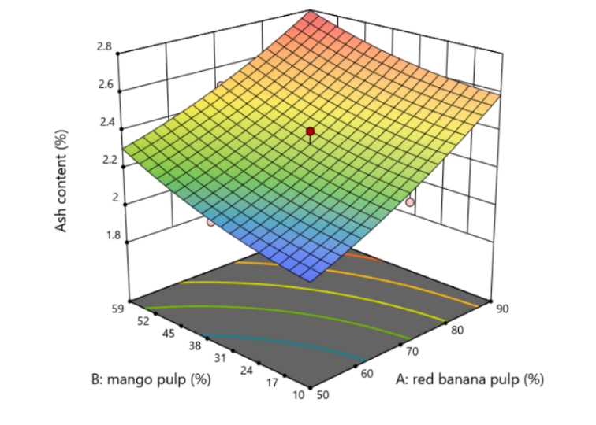
Figure:3.12 The 3D plot towards the response
ash content
3.1.4 Overall Acceptability
Figure 3.13 presents the normal probability plot for overall acceptability. The data points are close to the straight line, which shows that the residuals follow a normal distribution and that the model is appropriate. Figure 3.14 displays the predicted versus actual plot, where the points are near the diagonal line. This demonstrates good agreement between predicted and experimental sensory scores. Figure 3.15 shows the contour plot illustrating the interaction effect of red banana pulp and mango pulp on overall acceptability. The color gradient indicates changes in sensory scores with different ingredient levels. Figure 3.16 features the 3D response surface plot. This visually represents the region where maximum overall acceptability is achieved, helping to identify the best formulation.
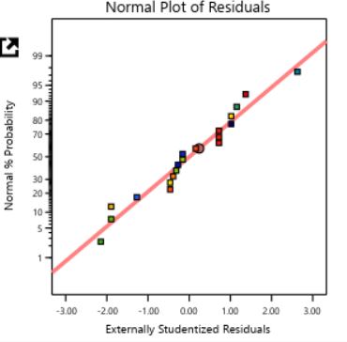
Figure:3.13 Normal plots towards overall acceptability
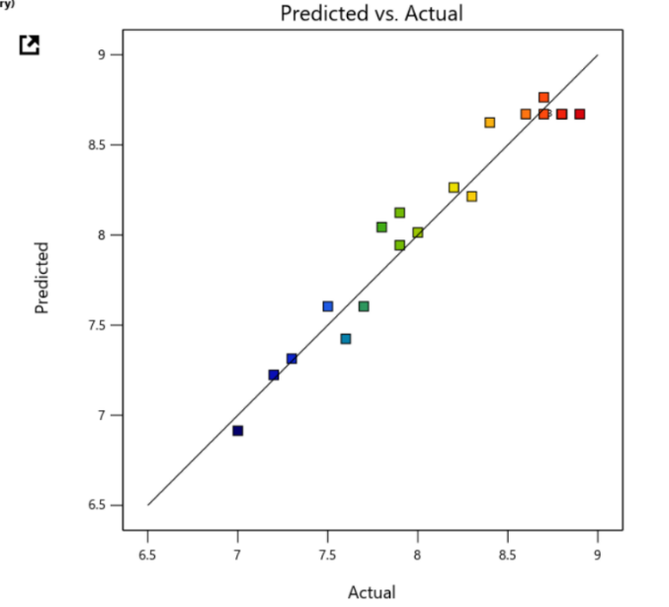
Figure:3.14 Plot for Predicted Vs Actual values
towards the response overall acceptability
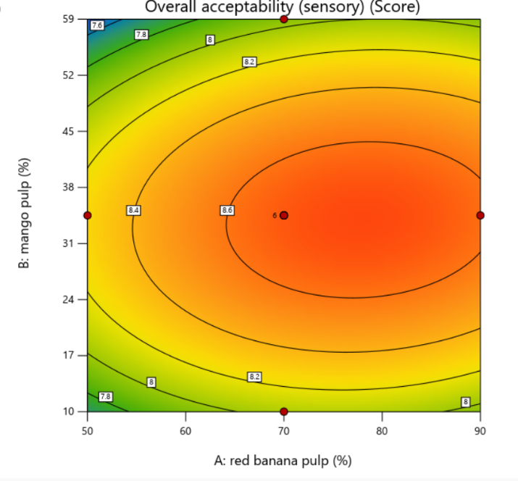
Figure 3.15: Contour plot towards the response
response overall acceptability
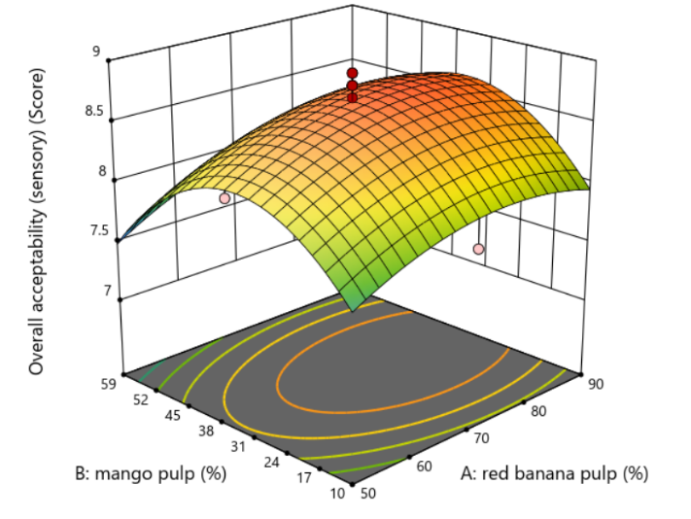
Figure:3.16 The 3D plot towards the
overall acceptability

3.1.5 Raw materials proportion
The raw material optimization is done by software Response Surface Methodology and proportion of the raw materials are given in table 3.1
Table: 3.1 Raw materials proportion
Raw materials | Proportion (%)
Red Banana | 60.05
Mango | 30.5
Liquid Glucose | 14.7
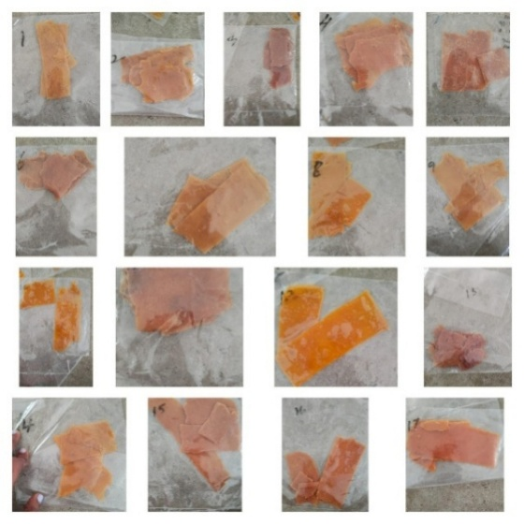
Figure :3.17 RSM Trials
From the Figure 3.17, we did twenty trials to optimize the final ratio proportion for our final product.

3.2 Nutritional Analysis
The analysis of the nutritional composition was carried out on the final product to assess its key nutrient content. The evaluation focused on important factors such as carbohydrates, protein, total sugars, fat and energy value. These components are crucial in determining the product's nutritional value and health benefits. The nutrient compounds do not have specific values from FSSAI. A part of the sample was used for the analysis, and the results are summarized in the table below. This provides an overview of its nutritional profile. The values can be found below table 4.4.

Table :4.10 Nutrional Analysis values
S.No | Parameter | Values
1. | Carbohydrate(g/100g) | 85.24
2. | Protein(g/100g) | 1.38
3. | Fat(g/100g) | 0.08
4. | Total Sugar(g/100g) | 9.02
5. | Energy Value(Kcal/100g) | 357.18

Nutritonal Value = Moisture Content + Protein + Fat + Ash Content + Carbohydrate
=10.89 + 1.38 + 0.08 + 2.41 + 85.24 = 99.99g
3.3 Moisture Content
The moisture content of the fruit leather was measured at 10.89%. This level is low, which is important for improving shelf stability and preventing microbial growth. The moisture content was calculated using equation 3.1. According to FSSAI standards, the moisture content of fruit leather should be 12-15%. Our lower measurement came from extended drying time during processing.
3.4 Ash Content
The ash content shows the total minerals present in the product. The ash value for this product is 2.41g, indicating essential minerals from both red banana and mango. Ash content was calculated using equation 3.3. FSSAI's range for ash content is 2-3%, and our result falls within this range.
3.5 Water Activity
Water activity (aw) is an important factor that affects the availability of free water in food products. It also influences microbial growth and shelf stability. The water activity of the developed fruit leather was found to be 0.6850, which is suitable for dried products. It was calculated using equation 3.2 and meets FSSAI standards. Lower water activity decreases the likelihood of microbial growth and spoilage during storage.
3.6 Titrable Acidity
Titrable acidity is crucial for defining the flavor, taste, and microbial stability of fruit products. The titratable acidity in the fruit leather mainly comes from the natural organic acids found in mango and red banana pulp. The measured acidity is 1.40%, which enhances the flavor and helps inhibit spoilage microorganisms' growth.
3.7 Minerals
The mineral analysis showed that the developed fruit leather contains essential minerals like potassium, calcium and iron. Potassium is the most abundant mineral, with a value of 64.5mg/kg, primarily from red banana, which is rich in potassium. This mineral is vital for maintaining electrolyte balance and the proper function of muscles and nerves. The calcium content, which supports bone health and structural functions in the body, is 14.6mg/kg. Iron, which is important for hemoglobin formation and preventing anemia, is present at 2.4mg/kg in the final product. The presence of these minerals shows that the fruit leather retains important micronutrients even after processing.
3.8 Total Phenolic Compounds
The total phenolic content of the fruit leather is 44.78 mg GAE/100g extract, indicating the presence of bioactive compounds that contribute to the product's functional properties. Phenolic compounds are known for their antioxidant abilities and their role in reducing oxidative stress in the body. Both red banana and mango are natural sources of these compounds and combining them in the fruit leather improves the overall phenolic content.
3.9 Antioxidant
The antioxidant activity of the developed fruit leather was evaluated to determine how well it neutralizes free radicals. The results showed significant antioxidant activity, attributed to phenolic compounds, vitamins and other phytochemicals in the fruits. The antioxidant value is 45.15 μg/3mL (Prior et al., 2005).

3.10 Beta-Carotene
Beta-Carotene The beta-carotene content was also measured, as it is an important precursor of vitamin A. Mango is particularly rich in beta-carotene, which gives the fruit leather its yellow-orange color. The presence of beta-carotene boosts the product's nutritional value and supports key functions such as vision, immune response and skin health. The total beta-carotene in the final product is 136.70 ± 0.86 mg.
3.11 Texture Profile Analysis
The Texture Profile Analysis of the red banana and mango fruit leather showed measurable values for hardness and adhesiveness. The hardness value was 528.829 N, representing the force needed to compress the sample and indicating the firmness of the product. This suggests that the fruit leather has a firm yet flexible texture suitable for eating. The adhesiveness value was 0.01057 N, reflecting the product's stickiness due to natural sugars and liquid glucose.
3.12 Shelf life
The shelf life of the leather is under the ambient temperature of storage. The parameters such as Total plate count, Total coliform and Yeast & Mould are less than 10 at zeroth day and same for the 30th day. So the results are came under the limits.
3.13 Sensory Evaluation
The sensory evaluation of the red banana and mango fruit leather involved five panelists using a 5-point hedonic scale to assess color, flavor, taste, texture and overall smell. The panelists rated the samples based on their preferences, with 5 indicating "like very much" and 1 indicating "dislike very much." The mean sensory scores showed good acceptance of the product, indicating that the fruit leather had appealing sensory characteristics and was well received by the panelists. The radar chart below illustrates the hedonic scale ratings.

IV.CONCLUSION:
The current study showed how to make red banana-mango fruit leather, adding value to fruit products. Combining red banana and mango pulp produced a nutritious and tasty item with good sensory and physicochemical traits. We used Response Surface Methodology to improve the recipe and assess how different factors affect product quality. The physicochemical analysis found that the fruit leather had suitable moisture content, water activity and titratable acidity. These factors are key for keeping the product stable and extending its shelf life. The nutritional analysis showed it contains important minerals like potassium, calcium, and iron, which boost its nutritional value. The fruit leather also had high levels of phenolic compounds, antioxidant activity and beta-carotene, highlighting its potential as a functional food that promotes health. Texture Profile Analysis indicated acceptable hardness and stickiness, confirming the product's pleasant texture. Sensory evaluation with a five-point hedonic scale showed that panelists liked the color, flavor, taste and overall acceptability. Shelf-life studies over one month revealed that the microbial load stayed within safe limits, proving good storage stability. These results suggest that this fruit leather can be a convenient and nutritious snack. The study also points out the potential to add value to red bananas and mangoes through processing. This product may help decrease post-harvest fruit losses. Overall, this research supports developing healthy and functional fruit products for the food processing industry.
REFERENCES:
1. Arah I. K., Ahorbo G. K., Anku E. K., Kumah E. K., & Amaglo H. (2016). Postharvest handling practices and treatment methods for tomato handlers in developing countries: A review. Advances in Agriculture, 2016, 1–8.
2. AOAC. (2005). Official methods of analysis of AOAC International (18th ed.). Association of Official Analytical Chemists.
3. Blois M. S. (1958). Antioxidant determinations by the use of a stable free radical. Nature, 181, 1199–1200.
4. Fellows P. J. (2017). Food processing technology: Principles and practice (4th ed.). Woodhead Publishing.
5. Kader A. A. (2013). Postharvest technology of horticultural crops (3rd ed.). University of California Agriculture and Natural Resources.
6. Ranganna S. (2010). Handbook of analysis and quality control for fruit and vegetable products (2nd ed.). Tata McGraw Hill.
7. Sagar V. R., & Kumar P. S. (2018). Recent advances in drying and dehydration of fruits and vegetables: A review. Journal of Food Science and Technology, 55(10), 3871–3883.
8. Siddiq M., Ahmed J., Lobo M. G., & Ozadali F. (2017). Tropical and subtropical fruits: Postharvest physiology, processing and packaging. Wiley-Blackwell.
9. Tharanathan R. N., Yashoda H. M., & Prabha T. N. (2016). Mango (Mangifera indica L.), the king of fruits—An overview. Food Reviews International, 22(2), 95–123.
10. Jay J. M., Loessner M. J., & Golden D. A. (2005). Modern food microbiology (7th ed.). Springer.
12. Potter N. N., & Hotchkiss J. H. (2012). Food science (5th ed.). Springer.
13. Robertson G. L. (2016). Food packaging: Principles and practice (3rd ed.). CRC Press.
13. Sharma S. K., Mulvaney S. J., & Rizvi S. S. H. (2015). Food process engineering: Theory and laboratory experiments. Wiley.
14. Montgomery D. C. (2017). Design and analysis of experiments (9th ed.). Wiley.
15. Myers R. H., Montgomery D. C., & Anderson-Cook C. M. (2016). Response surface methodology: Process and product optimization using designed experiments (4th ed.). Wiley.
16. Prior R. L., Wu X., & Schaich K. (2005). Standardized methods for the determination of antioxidant capacity and phenolics in foods and dietary supplements. Journal of Agricultural and Food Chemistry, 53(10), 4290–4302.
17. Damodaran S., Parkin K. L., & Fennema O. R. (2017). Fennema’s food chemistry (5th ed.). CRC Press.
18. Belitz H. D., Grosch W., & Schieberle P. (2009). Food chemistry (4th ed.). Springer.
19. Barbosa-Cánovas G. V., Vega-Mercado H. (2014). Dehydration of foods. Springer.
20. Rahman M. S. (2007). Handbook of food preservation (2nd ed.). CRC Press.
21. Lawless H. T., & Heymann H. (2010). Sensory evaluation of food: Principles and practices (2nd ed.). Springer.
22. Wrolstad R. E. (2012). Food analysis (4th ed.). Springer.
23. Mujumdar A. S. (2015). Handbook of industrial drying (4th ed.). CRC Press.
24. Vega-Gálvez A., Miranda M., Ah-Hen K., et al. (2012). Effect of air-drying temperature on physicochemical properties of apple slices. Food Chemistry, 132, 51–59.
25. Ahmed J., Ramaswamy H. S., & Hiremath N. (2005). The effect of high pressure treatment on rheological characteristics and color of mango pulp. International Journal of Food Science & Technology, 40(8), 885–895.
26. Singh B., Panesar P. S., & Nanda V. (2006). Utilization of carrot pomace for preparation of a value-added product. World Journal of Dairy & Food Sciences, 1(1), 22–27.
27. FAO. (2019). Fruit and vegetable processing and preservation. Food and Agriculture Organization.
28. FSSAI. (2016). Manual of methods of analysis of foods: Fruits and vegetables products. Food Safety and Standards Authority of India.
29. Desrosier N. W., & Desrosier J. N. (2012). The technology of food preservation. AVI Publishing.
30. Bhandari B., Bansal N., Zhang M., & Schuck P. (2013). Handbook of food powders: Processes and properties. Woodhead Publishing.

