Molecular Epidemiology and Virulence Profiling of Escherichia coli from Cattle Carcasses and Slaughterhouse Environments in Abuja, Nigeria

ABSTRACT
This study investigated the molecular characteristics, virulence gene profiles, phylogroup distribution, and genetic relatedness of Escherichia coli isolated from cattle carcasses and slaughterhouse environments in Abuja, Nigeria. A total of 540 swab samples were collected from processed carcasses and meat-contact surfaces, including butchers’ hands, knives, wheelbarrows, kill floors, washing water, and effluent, at a government-owned Gwagwalada slaughterhouse (n = 340) and a privately owned Dei-Dei slaughterhouse (n = 200). Standard microbiological methods were used for isolation and identification. Overall, 105 confirmed E. coli isolates were recovered, yielding a prevalence of 19.4% (18.5% in Gwagwalada and 21.0% in Dei-Dei). All isolates were screened by polymerase chain reaction (PCR) for eight virulence-associated genes (eaeA, EAST, traT, hly, omp, bfp, stx, and cnf) and classified into phylogroups using the Clermont quadruplex PCR method. The most prevalent virulence genes were omp (96.4%), cnf (74.5%), and stx (72.7%). Phylogroup analysis revealed predominance of B1 (38.1%) and A (28.6%), while virulence-associated phylogroups B2 and D accounted for 21.9% of isolates. No statistically significant association was observed between virulence gene carriage and sample source (p > 0.05). Genetic relatedness assessed using the unweighted pair group method with arithmetic mean (UPGMA) clustering demonstrated five major clusters and one singleton at an 80% similarity threshold. Clusters comprised isolation from carcasses, knives, effluent, and washing water, indicating potential intra-facility cross-contamination and shared contamination routes. The coexistence of diverse phylogroups and high prevalence of Shiga toxin and necro toxigenic determinants underscores significant food safety and occupational health risks. These findings highlight slaughterhouses as critical convergence points for pathogen amplification within animal–human–environment interfaces. Strengthening hygiene enforcement, wastewater treatment, and routine molecular surveillance under a One Health framework is essential to mitigate zoonotic and foodborne transmission in Nigeria and similar settings.
Keywords: Escherichia coli; virulent genes; phylogroups; molecular epidemiology; food safety.
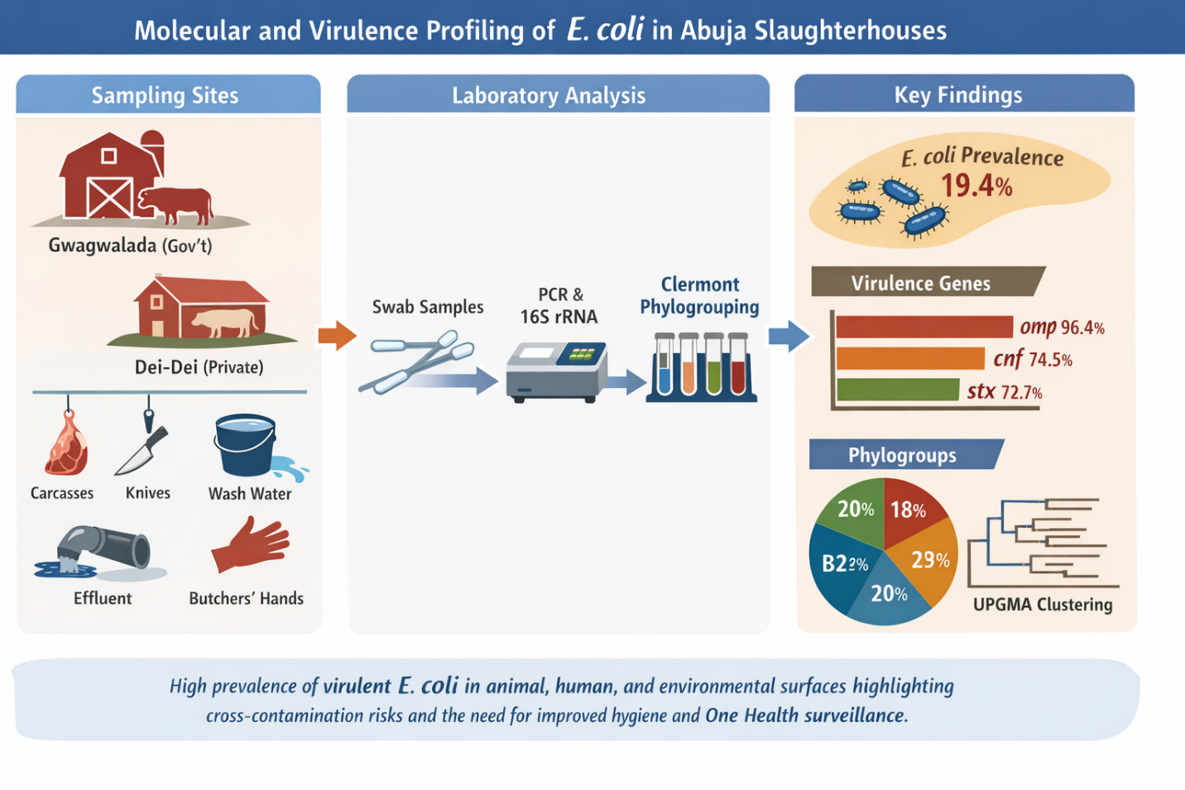Fig 1: GRAPHICAL ABSTRACT
INTRODUCTION
Escherichia coli (E. coli) is the most prevalent and clinically significant species within the genus Escherichia. This Gram-negative, rod-shaped, facultatively anaerobic bacterium commonly inhabits the lower gastrointestinal tract of humans and other warm-blooded animals as part of the normal intestinal microbiota. While most strains are harmless commensals that contribute to intestinal homeostasis, certain strains possess specific virulent determinants that enable them to cause a wide spectrum of intestinal and extraintestinal diseases (1).
Based on clinical manifestations and molecular characteristics, human E. coli strains are broadly categorized into three groups: commensal strains, intestinal pathogenic E. coli (IPEC), and extraintestinal pathogenic E. coli (ExPEC). Although most strains residing in the colon are non-pathogenic, pathogenic variants harbor virulence-associated genes that facilitate colonization, immune evasion, toxin production, and tissue invasion. Most extraintestinal infections, except gastroenteritis and neonatal meningitis, are endogenous in origin. These infections occur when E. coli from the host’s normal microbiota gains access to normally sterile body sites, particularly when host defenses are compromised due to trauma, immune suppression, or underlying disease (1). Clinically, E. coli is implicated in gastroenteritis, urinary tract infections (UTIs), septicemia, bacteremia, neonatal meningitis, cholecystitis, and cholangitis, making it one of the most versatile bacterial pathogens in both community and hospital settings.
Intestinal pathogenic E. coli (IPEC) strains are subdivided into several pathotypes according to their virulence factors, pathogenic mechanisms, and disease presentations. Enterotoxigenic E. coli (ETEC) is a major cause of watery diarrhea characterized by dehydration, nausea, vomiting, fever, and abdominal discomfort. It predominantly affects children under five years of age in developing countries and adults traveling to endemic regions. The pathogenicity of ETEC is mediated by the production of heat-stable (ST) and heat-labile (LT) enterotoxins, along with colonization factors that promote adherence to the small intestinal epithelium (2). Enteropathogenic E. coli (EPEC) is primarily associated with secretory and persistent diarrhea in infants and young children, occasionally affecting adults. EPEC pathogenesis involves the locus of enterocyte effacement (LEE), plasmid-encoded adherence factor (pEAF), bundle-forming pili (BFP), and non-LEE encoded effectors, which together facilitate attaching-and-effacing lesions on intestinal epithelial cells (3).
Enteroaggregative E. coli (EAEC) causes persistent and acute diarrhea across all age groups, including immunocompromised individuals such as those infected with HIV. EAEC exhibits a characteristic aggregative “stacked-brick” adherence pattern mediated by aggregative adherence fimbriae (AAF) and produces toxins such as enteroaggregative heat-stable toxin (EAST-1), plasmid-encoded toxin (Pet), protein involved in colonization (Pic), and Shigella enterotoxin-1 (ShET-1) (4). Shiga toxin-producing E. coli (STEC), also referred to as verotoxin-producing E. coli (VTEC) or enterohemorrhagic E. coli (EHEC), can cause disease ranging from mild diarrhea to severe hemorrhagic colitis with bloody diarrhea and abdominal pain. These strains produce Shiga toxins (Stx1 and Stx2), which are central to their virulence and may lead to hemolytic uremic syndrome (HUS), particularly in young children (5). Enteroinvasive E. coli (EIEC) invades and destroys colonic epithelial cells, initially producing watery diarrhea that may progress to dysentery characterized by fever, abdominal cramps, and blood and leukocytes in stool. Diffusely adherent E. coli (DAEC) has been implicated in watery diarrhea in children and is characterized by the expression of Afa/Dr adhesins. Adherent-invasive E. coli (AIEC), although not typically associated with acute gastroenteritis, has been linked to chronic intestinal inflammation and Crohn’s disease due to its ability to adhere to epithelial cells, invade tissues, and persist within macrophages (6).
Beyond human infections, pathogenic E. coli strains are important causes of disease in animals. In cattle, ETEC is a principal agent of neonatal diarrhea affecting the small intestine, while EPEC and STEC are associated with hemorrhagic dysentery in young calves, and certain strains contribute to bovine mastitis in adult cows. In pigs, ETEC is responsible for neonatal, post-weaning, and young pig diarrhea, whereas STEC strains are implicated in edema disease. Poultry may experience embryonic mortality, dermatitis, cellulitis, and intestinal infections associated with E. coli. Similarly, dogs, cats, and rabbits may develop diarrheal illnesses linked to ETEC or EPEC infections. These animal infections are of both economic and public health importance, particularly because of food-producing animals, especially cattle—serve as reservoirs for zoonotic STEC strains (7).
The pathogenicity of both intestinal and extraintestinal E. coli strains is mediated by a wide range of virulence factors, including fimbrial and afimbrial adhesins, capsules, hemolysins, exotoxins, enterotoxins, invasins, and iron acquisition systems. In ExPEC strains, virulence-associated genes encode proteins that enhance colonization of extraintestinal sites, promote serum resistance, facilitate iron uptake, and enable systemic dissemination. The diversity and distribution of these virulence genes determine the pathogenic potential of specific isolates (8). In developing countries, slaughterhouses frequently operate under suboptimal sanitary conditions, thereby facilitating the transmission of pathogenic E. coli from animal carcasses to workers, equipment, and the surrounding environment (9). Inadequate carcass handling, contaminated water used for washing, poor effluent management, and improper sanitation of meat-contact surfaces contribute to cross-contamination within abattoir systems. Such contamination poses significant risks to food safety and public health, particularly when meat products enter the consumer market without adequate processing or cooking.
Molecular detection of virulence-associated genes and analysis of phylogenetic relatedness among E. coli isolates provide critical insights into contamination sources, transmission pathways, and zoonotic risk. Although several studies have reported the presence of E. coli in Nigerian abattoirs (10, 11), limited research has simultaneously examined both virulence gene profiles and genetic relatedness of isolates recovered from multiple slaughterhouse niches, particularly within Abuja. Therefore, this study aimed to (i) analyze E. coli isolates from cattle carcasses and meat-contact surfaces for virulence-encoding genes and (ii) determine their phylogenetic relatedness. The findings will enhance understanding of the public health implications of pathogenic E. coli in abattoir environments and support the development of evidence-based strategies to improve slaughterhouse hygiene and food safety in Nigeria
2. MATERIALS AND METHODS
2.1 Study Area and Study Design
This cross-sectional study was conducted in two major slaughterhouses located in Abuja, Federal Capital Territory (FCT), Nigeria: the government-owned Gwagwalada slaughterhouse and the privately owned Dei-Dei slaughterhouse. The Gwagwalada slaughterhouse is situated in New Kutunku Ward, a densely populated residential area adjacent to a tributary of the River Usuma. The facility comprises three operational sections: slaughtering, processing, and waste disposal. Geographically, it lies between latitudes 08°55′N and 09°00′N, and longitudes 07°00′E and 07°05′E (12). The Dei-Dei slaughterhouse is located within the Abuja International Livestock Market (latitude 9.0993°N, longitude 7.2789°E). It is operated under the supervision of the Federal Capital Territory Administration (FCTA) and represents one of the largest privately managed slaughter facilities in the region, processing both indigenous and exotic livestock breeds (13, 14). The study targeted cattle carcasses, meat-contact surfaces (MCS), and environmental samples within both facilities (Fig 2).
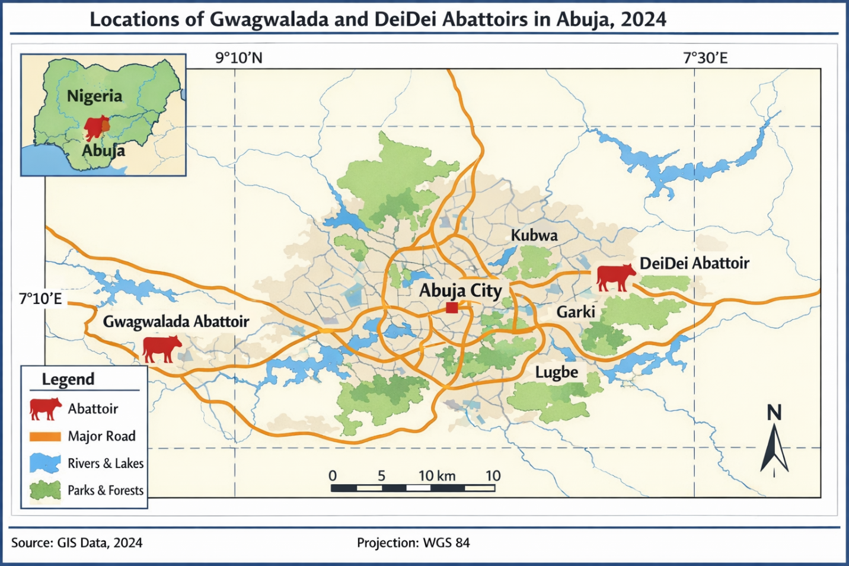
Fig 2: Map of Abuja indicating the Study Area
2.2 Sample Size Determination and Sample Collection
The sample size was determined using the Raosoft® Sample Size Calculator (https://www.raosoft.com/samplesize.html). For cattle carcasses, a 95% confidence level, 5% margin of error, and an assumed prevalence of 50% yielded a minimum sample size of 277. This was increased to 300 to enhance statistical robustness (15). For meat-contact surfaces, a previously reported prevalence of 36% yielded a minimum sample size of 240 (16). Sampling was conducted biweekly over a four-month period, comprising 20 visits to the Gwagwalada slaughterhouse and 15 visits to the Dei-Dei slaughterhouse.
Carcass Sampling
Sterile swab samples were collected aseptically from three anatomical sites: the flank, loin, and neck of cattle carcasses.
Meat-Contact Surface Sampling
A total of 240 swab samples were collected from butchers’ hands, knives, wheelbarrows, slaughter floors, effluent channels, and washing water. Swabs were moistened with sterile normal saline and applied to predetermined surface areas using parallel and rotational strokes to maximize bacterial recovery. All samples were transported in ice-packed containers under aseptic conditions to the Public Health Laboratory, University of Abuja, and were processed on the same day.
2.3 Isolation and Phenotypic Identification of Escherichia coli
Isolation and identification were performed using standard bacteriological procedures (17). Swab samples were streaked onto MacConkey agar and incubated at 37°C for 18–24 hours. Lactose-fermenting (pink) colonies were subsequently subcultured onto Eosin Methylene Blue (EMB) agar and incubated under similar conditions. Colonies exhibiting a characteristic green metallic sheen on EMB agar were considered presumptive Escherichia coli. These isolates were further characterized using Gram staining and standard biochemical tests.
2.4 Molecular Confirmation of Escherichia coli
Genomic DNA was extracted from presumptive isolates using the phenol-chloroform extraction method. Fifteen isolates were randomly selected for molecular confirmation through amplification of the 16S rRNA gene using universal primers:
- 27F: 5’-AGAGTTTGATCCTGGCTCAG-3’
- 1492R: 5’-GGTTACCTTGTTACGACTT-3’ (18)
Polymerase Chain Reaction (PCR) was performed using a GeneAmp 9700 Thermal Cycler (Applied Biosystems, USA). Amplicons were resolved on a 1.5% agarose gel, purified, and sequenced using an Applied Biosystems 3130xl Genetic Analyzer. Sequence alignment was performed using ClustalW, and sequence similarity was assessed using the NCBI GenBank database via BLAST. Phylogenetic analysis was conducted using MEGA version 7. The obtained sequences were deposited in GenBank under accession numbers OP930819–OP930833.
2.5 Detection of Virulence Genes by PCR
A total of 55 confirmed Escherichia coli isolates were screened for eight virulent genes (eaeA, EAST, traT, hly, omp, bfp, stx, and cnf). Detection was performed using one multiplex PCR assay (targeting eaeA and EAST) and six singleplex PCR assays (19, 20, 21, 22, 23). PCR amplification was carried out using a GeneAmp 9700 Thermal Cycler. Amplicons were resolved on 1.5% agarose gel at 120 V for 45 minutes and visualized under ultraviolet illumination. Band sizes were estimated using a 100-bp DNA ladder, and appropriate positive controls were included in each run.
Table 3: Primers Used for PCR Detection of Virulence Genes in E. coli Isolates
PCR Type | Gene | Primer | Sequence (5' → 3') | Expected Amplicon Size (bp) | PCR Conditions | Reference
Multiplex | EAST | EAST-F | CACAGTATATCCGAAGGC | 97 | Initial denaturation 94°C 5 min; 35 cycles of 94°C 30 s, 60°C 30 s, 72°C 60 s; final extension 72°C 10 min | 19
Multiplex | EAST | EAST-R | CGAGTGACGGCTTTGTAG | 97 | Same as above | 19
Multiplex | eaeA | eaeA-F | GACCCGGCACAAGCATAAGC | 248 | Initial denaturation 94°C 5 min; 35 cycles of 94°C 30 s, 55°C 30 s, 72°C 60 s; final extension 72°C 10 min | 19
Multiplex | eaeA | eaeA-R | CCACCTGCAGCAACAAGAGG | 248 | Same as above | 19
Singleplex | traT | traT-F | GGTGTGGTGCGATGAGCACAG | 290 | Initial denaturation 94°C 5 min; 35 cycles of 94°C 30 s, 53°C 30 s, 72°C 20 s; final extension 72°C 10 min | 20
Singleplex | traT | traT-R | CACGGTTCAGCCATCCCTGAG | 290 | Same as above | 20
Singleplex | hly | hly-F | AACAAGGATAAGCACTGTTCTGGCT | 1,177 | Initial denaturation 94°C 5 min; 35 cycles of 94°C 30 s, 53°C 30 s, 72°C 60 s; final extension 72°C 10 min | 20
Singleplex | hly | hly-R | ACCATATAAGCGGTCATTCCCGTCA | 1,177 | Same as above | 20
Singleplex | omp | omp-F | AGCTATCGCGATTGCAGTG | 919 | Initial denaturation 94°C 5 min; 35 cycles of 94°C 30 s, 48°C 30 s, 72°C 50 s; final extension 72°C 10 min | 21
Singleplex | omp | omp-R | GGTGTTGCCAGTAACCGG | 919 | Same as above | 21
Singleplex | bfp | bfp-F | AATGGTGCTTGCGCTTGCTGC | 324 | Initial denaturation 94°C 5 min; 35 cycles of 94°C 30 s, 52°C 30 s, 72°C 30 s; final extension 72°C 10 min | 22
Singleplex | bfp | bfp-R | GCCGCTTTATCCAACCTGGTA | 324 | Same as above | 22
Singleplex | stx | stx-F | TCTCAGTGGGCGTTCTTATG | 388 | Initial denaturation 94°C 5 min; 35 cycles of 94°C 30 s, 47°C 30 s, 72°C 30 s; final extension 72°C 10 min | 19
Singleplex | stx | stx-R | TACCCCCTCAACTGCTAATA | 388 | Same as above | 19
Singleplex | cnf | cnf-F | TCGTTATAAAATCAAACAGTG | 446 | Initial denaturation 94°C 5 min; 35 cycles of 94°C 30 s, 43°C 30 s, 72°C 30 s; final extension 72°C 10 min | 19
Singleplex | cnf | cnf-R | CTTTACAATATTGACATGCTG | 446 | Same as above | 19

2.6 Clermont Phylogrouping of Escherichia coli
Phylogenetic grouping of Escherichia coli isolates was performed using the updated Clermont quadruplex PCR method (24), which classifies isolates into phylogroups A, B1, B2, C, D, E, and F. Genomic DNA extracted from confirmed isolates served as the template. Each 25 µL PCR reaction mixture contained 12.5 µL of 2× PCR Master Mix (Thermo Fisher Scientific, USA), 0.5 µM of each primer, 50 ng of DNA, and nuclease-free water.
PCR cycling conditions were as follows:
- Initial denaturation at 94°C for 5 minutes
- 30 cycles of:
  - Denaturation at 94°C for 30 seconds
  - Annealing at 57°C for 30 seconds
  - Extension at 72°C for 30 seconds
- Final extension at 72°C for 5 minutes
Amplicons were separated on 2% agarose gel, stained with ethidium bromide, and visualized under ultraviolet light. Phylogroup assignment was determined based on the presence or absence of target genes according to the Clermont algorithm. Representative isolates from each phylogroup served as internal controls.
2.7 Genetic Relatedness and Phylogenetic Analysis
Fifteen Escherichia coli isolates were analyzed to determine nucleotide sequence variation within the 16S rRNA gene. Genetic distances were estimated using the Kimura two-parameter model. Phylogenetic trees were constructed using the Neighbor-Joining method with 1,000 bootstrap replicates in MEGA version 7. Additionally, Unweighted Pair Group Method with Arithmetic Mean (UPGMA) clustering based on banding patterns was used to assess genetic similarity among isolates. Clusters exhibiting ≥80% similarity were considered genetically related (25, 26).
2.8 Statistical Analysis
Data were analyzed using GraphPad Prism version 8.0.4 (GraphPad Software, USA). Associations between virulence gene distribution, phylogroups, and sample sources were evaluated using Fisher’s exact test. A p-value of less than 0.05 was considered statistically significant.
3. RESULTS
3.1 Isolation Rate of Escherichia coli from Meat and Contact Surfaces
A total of 540 samples comprising cattle carcasses and associated contact surfaces were collected from two slaughterhouses: the government-owned Gwagwalada (GGs; n = 340) and the privately owned Dei-Dei (PDs; n = 200). At Gwagwalada, samples included processed carcasses (n = 180), effluent (n = 45), slaughterhouse workers’ (SHWs) hands (n = 25), wheelbarrows (n = 20), knives (n = 35), kill floor (n = 20), and washing water (n = 15). Similarly, samples from Dei-Dei comprised processed carcasses (n = 90), effluent (n = 35), SHWs’ hands (n = 10), wheelbarrows (n = 15), knives (n = 20), kill floor (n = 15), and washing water (n = 15) (Table 4).
Table 4: Distribution of E. coli isolation rates in government-owned Gwagwalada (n = 63) and privately owned Dei-dei (n = 42) slaughterhouses in Abuja
Sample Type | Gwagwalada (n = 340) |  | Dei-Dei (n = 200) |  | OR | 95% CI | p-value
 | No. Examined | No. Positive (%) | No. Examined | No. Positive (%)
SHWs’ hands | 25 | 9 (36.0) | 10 | 4 (40.0) | 1.2 | 0.31–5.10 | 0.998
Processed carcasses | 180 | 12 (6.7) | 90 | 9 (10.0) | 1.6 | 0.65–3.60 | 0.343
Wheelbarrow swabs | 20 | 7 (35.0) | 15 | 3 (20.0) | 2.2 | 0.51–8.90 | 0.458
Butchers’ knives | 35 | 11 (31.4) | 20 | 7 (35.0) | 1.2 | 0.34–4.10 | 0.989
Meat washing water | 15 | 3 (20.0) | 15 | 4 (26.7) | 1.5 | 0.32–6.70 | 0.998
Effluent | 45 | 12 (26.7) | 35 | 8 (22.9) | 1.2 | 0.42–3.60 | 0.797
Kill floor | 20 | 9 (45.0) | 15 | 7 (46.7) | 1.1 | 0.29–4.40 | 0.988
Total | 340 | 63 (18.5) | 200 | 42 (21.0) | 1.2 | 0.75–1.80 | 0.501
OR = Odds ratio; CI = Confidence Interval; Fisher's exact test (GraphPad Prism®, version 8.0.4, CA, USA)

Overall, Escherichia coli was isolated from 105 (19.4%) of all samples. The isolation rate was slightly higher in Dei-Dei (21.0%) compared to Gwagwalada (18.5%), although this difference was not statistically significant (OR = 1.2; 95% CI: 0.75–1.80; p = 0.501). Across individual sample types, higher isolation rates were observed on contact surfaces than on carcasses. At Gwagwalada, the highest prevalence was recorded on the kill floor (45.0%), followed by SHWs’ hands (36.0%), wheelbarrows (35.0%), and knives (31.4%), while processed carcasses had a lower prevalence (6.7%). A similar pattern was observed at Dei-Dei, where the kill floor (46.7%) and SHWs’ hands (40.0%) showed the highest contamination levels, whereas processed carcasses recorded a comparatively lower prevalence (10.0%). When grouped into broader categories (Table 5), human-related contact surfaces exhibited the highest contamination rates in both slaughterhouses (36.0% in GGs and 40.0% in PDs), followed by environmental sources, while animal sources (carcasses) showed the lowest prevalence. However, no statistically significant association was observed between isolation rates and slaughterhouse location or sample source (p > 0.05). This clearly shows contamination is surface-driven rather than carcass-origin, even though statistical significance was not achieved.
Table 5: Distribution of phenotypically identified E. coli isolates (N = 105) from Gwagwalada (n = 63) and Dei-dei (n = 42) slaughterhouses based on broad sample sources
Sample Source Category | Gwagwalada (n = 340) |  | Dei-Dei (n = 200) |  | OR | 95% CI | p-value
 | No. Examined | No. Positive (%) | No. Examined | No. Positive (%)
Human (SHWs’ hands) | 25 | 9 (36.0) | 10 | 4 (40.0) | 1.2 | 0.31–5.10 | 0.999
Animal (Processed carcasses) | 180 | 12 (6.7) | 90 | 9 (10.0) | 1.6 | 0.65–3.50 | 0.343
Environmental* | 135 | 42 (31.1) | 100 | 29 (29.0) | 1.1 | 0.62–1.90 | 0.775
OR = Odds ratio; CI = Confidence Interval; Fisher's exact test (GraphPad Prism®, version 8.0.4, CA, USA)
Human: SHW’s hands
Animal: processed carcasses
Environmental sources: wheelbarrow, butchers’ knife, meat washing water, Effluent, kill floor

3.2 Molecular Confirmation of Escherichia coli
Amplification of the 16S rRNA gene was successful in all 55 selected isolates, producing amplicons of approximately 1,500 bp (Fig 3). Sequence analysis and BLAST comparison revealed that 51 isolates (92.7%) were confirmed as Escherichia coli, while one isolate (1.8%) was identified as Shigella flexneri, and three isolates (5.5%) as Escherichia fergusonii. The Shigella flexneri isolate originated from butchers’ knives, whereas Escherichia fergusonii isolates were recovered from the kill floor, effluent, and washing water.
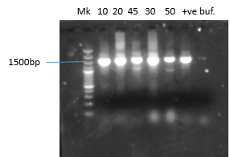
Fig 3: Gel pictures show positive amplification of 16S rRNA genes of the isolates.
Note bands at 1500bp,
MK molecular weight marker (100bp ladder)
tve: control,
buf= buffer (-ve)

3.3 Distribution of Virulence-Associated Genes
A total of 55 confirmed Escherichia coli isolates were screened for eight virulence-associated genes (eaeA, EAST, traT, hly, omp, bfp, stx, and cnf) in Fig. 4(A-G), Overall, the most frequently detected genes were omp (96.4%), cnf (74.5%), and stx (72.7%), indicating a high prevalence of potentially pathogenic strains within the slaughterhouse environment (Fig 5, Table 6).
Table 6: Virulence-associated genes in E. coli isolated from the Gwagwalada (n = 36) and Dei-dei (n = 19) slaughterhouses in Abuja, according to sample types
Sample Type | No. of Isolates | eaeA (%) | EAST (%) | TraT (%) | hly (%) | omp (%) | bfp (%) | stx (%) | cnf (%)
Gwagwalada Slaughterhouse (n = 36)
Processed carcass | 6 | 1 (16.7) | 4 (66.7) | 3 (50) | 1 (16.7) | 6 (100) | 5 (83.3) | 4 (66.7) | 5 (83.3)
Wheelbarrow | 5 | 0 (0) | 3 (60) | 2 (40) | 0 (0) | 4 (80) | 4 (80) | 4 (80) | 4 (80)
SHWs’ hands | 3 | 0 (0) | 0 (0) | 2 (66.7) | 0 (0) | 3 (100) | 1 (33.3) | 2 (66.7) | 2 (66.7)
Butchers’ knives | 6 | 0 (0) | 2 (33.3) | 3 (50) | 1 (16.7) | 5 (83.3) | 4 (66.7) | 4 (66.7) | 4 (66.7)
Effluent | 7 | 0 (0) | 5 (71.4) | 5 (71.4) | 0 (0) | 7 (100) | 5 (71.4) | 3 (42.9) | 6 (85.7)
Kill floor | 6 | 2 (33.3) | 1 (16.7) | 3 (50) | 1 (16.7) | 6 (100) | 5 (83.3) | 6 (100) | 5 (83.3)
Meat washing water | 3 | 0 (0) | 1 (33.3) | 1 (33.3) | 0 (0) | 3 (100) | 2 (66.7) | 3 (100) | 0 (0)
GGs Total | 36 | 3 (8.3) | 16 (44.4) | 19 (52.8) | 3 (8.3) | 34 (94.4) | 26 (72.2) | 26 (72.2) | 26 (72.2)
Dei-Dei Slaughterhouse (n = 19)
Processed carcass | 3 | 0 (0) | 1 (33.3) | 2 (66.7) | 0 (0) | 3 (100) | 1 (33.3) | 2 (66.7) | 3 (100)
Wheelbarrow | 2 | 1 (50) | 0 (0) | 1 (50) | 0 (0) | 2 (100) | 0 (0) | 0 (0) | 0 (0)
SHWs’ hands | 2 | 0 (0) | 2 (100) | 0 (0) | 0 (0) | 2 (100) | 2 (100) | 2 (100) | 2 (100)
Butchers’ knives | 4 | 0 (0) | 0 (0) | 3 (75) | 0 (0) | 4 (100) | 2 (50) | 2 (50) | 3 (75)
Effluent | 4 | 0 (0) | 1 (25) | 0 (0) | 0 (0) | 4 (100) | 2 (50) | 4 (100) | 3 (75)
Kill floor | 3 | 0 (0) | 0 (0) | 2 (66.7) | 0 (0) | 3 (100) | 1 (33.3) | 3 (100) | 3 (100)
Meat washing water | 1 | 0 (0) | 1 (100) | 0 (0) | 0 (0) | 1 (100) | 1 (100) | 1 (100) | 1 (100)
PDs Total | 19 | 1 (5.3) | 5 (26.3) | 8 (42.1) | 0 (0) | 19 (100) | 9 (47.4) | 14 (73.7) | 15 (78.9)
Overall Total (n = 55) | 55 | 4 (7.3) | 21 (38.2) | 27 (49.1) | 3 (5.5) | 53 (96.4) | 35 (63.6) | 40 (72.7) | 41 (74.5)

At Gwagwalada, the predominant genes were omp (94.4%), bfp (72.2%), cnf (72.2%), and stx (72.2%), whereas at Dei-Dei, omp was detected in all isolates (100%), followed by cnf (78.9%) and stx (73.7%). Despite variations in prevalence across sample types and locations, no statistically significant association was observed between virulence gene distribution and sample sources (human, animal, or environmental) (p > 0.05) (Table 7). Although statistical significance was not observed, virulence genes—particularly stx (72.7%)—were widely distributed across all sample types, including carcasses, hands, and environmental surfaces, suggesting multiple contamination routes within the slaughterhouse environment (Fig 6).
Table 7: Distribution of Virulence Genes by Broad Sample Sources in E. coli Isolates
Virulence Gene | Human (n = 5) | Animal (n = 9) | Environment (n = 41) | p-value
eaeA | 0 (0) | 1 (11.1) | 3 (7.3) | 0.745
EAST | 2 (40) | 5 (55.6) | 14 (34.1) | 0.487
TraT | 2 (40) | 5 (55.6) | 20 (48.8) | 0.853
Hly | 0 (0) | 1 (11.1) | 2 (4.9) | 0.646
Omp | 5 (100) | 9 (100) | 35 (85.4) | 0.317
Bfp | 3 (60) | 6 (66.7) | 26 (63.4) | 0.969
Stx | 4 (80) | 6 (66.7) | 30 (73.2) | 0.859
Cnf | 4 (80) | 8 (88.9) | 29 (70.7) | 0.505
Fisher's exact test (GraphPad Prism®, version 8.0.4, CA, USA)
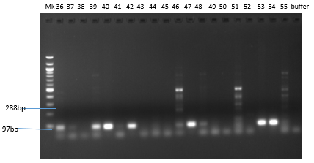

Fig 4(A)
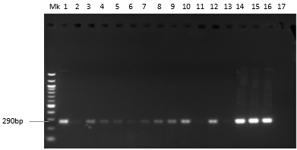

Fig 4(B)
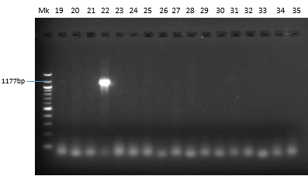
Fig 4 (C)
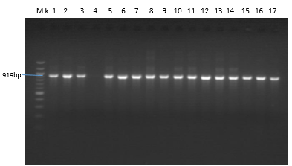

Fig 4(D)

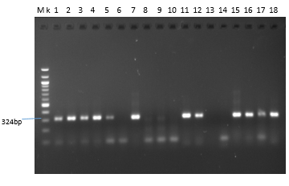
Fig 4(E)
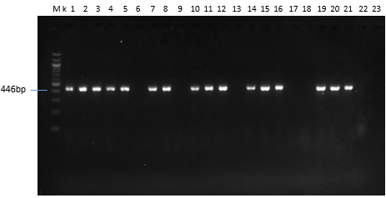 Fig 4(F) 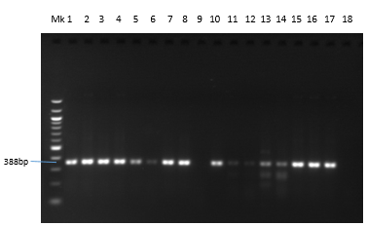Fig 4(G)
Figure 4 A-G. Gel pictures for PCR products of virulence-associated genes detected in E. coli isolates from Gwagwalada and Dei-dei slaughterhouse in Abuja. (A) eaeA and EAST (288bp and 97bp) (B) TraT (290bp) (C) hly (1177bp) (D) OMP (919bp (E) bfp (324bp) (F) stx (388bp) (G) cnf (446 bp). MK 100bp molecular size marker
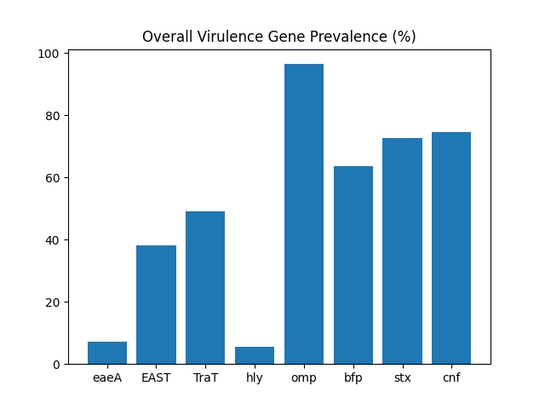
Fig 5: Bar chart illustrates overall prevalence of virulence-associated genes among Escherichia coli isolates.
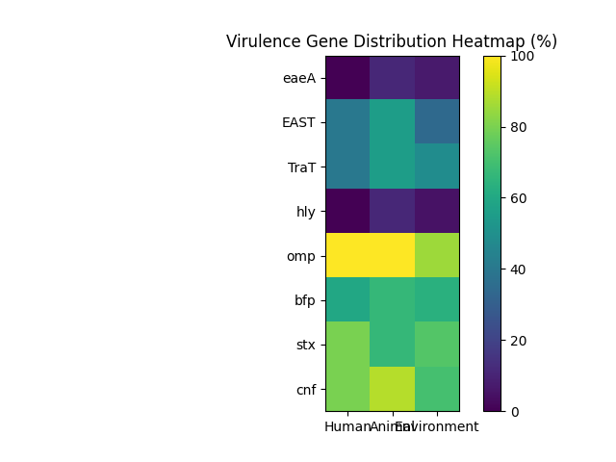
Fig 6: Heatmap showing distribution of virulence-associated genes across different sample sources. X-axis: Sample types (hands, knives, carcass, water, etc.), Y-axis: Virulence genes (stx, cnf, omp, etc.), Color: prevalence %.
3.4 Phylogenetic Distribution of Escherichia coli Isolates
All 105 confirmed Escherichia coli isolates were successfully assigned to phylogenetic groups using the Clermont quadruplex PCR method. Phylogroup B1 was the most predominant (38.1%), followed by phylogroup A (28.6%). Phylogroups associated with increased virulence—B2 (7.6%) and D (14.3%)—collectively accounted for 21.9% of isolates. Minor phylogroups (C, E, and F) constituted the remaining proportion (Table 8). When grouped functionally, commensal/environment-associated phylogroups (A and B1) accounted for 66.7% of isolates, whereas virulence-associated phylogroups (B2 and D) represented 21.9%.
Table 8. Distribution of E. coli Phylogroups among 105 Isolates

Phylogroup | Number (n) | Percentage (%)
A | 30 | 28.6
B1 | 40 | 38.1
B2 | 8 | 7.6
C | 5 | 4.8
D | 15 | 14.3
E | 4 | 3.8
F | 3 | 2.9
Total | 105 | 100

3.5 Distribution of Virulence Genes Across Phylogenetic Groups
Virulence genes were widely distributed across all phylogenetic groups (Table 9). No statistically significant association (p > 0.05) was observed between phylogroup classification and the presence of most virulent genes. However, a higher frequency of the cnf gene was observed among isolates belonging to pathogenic phylogroups (B2 and D), although this trend did not reach statistical significance. These findings indicate that both commensal and pathogenic phylogroups contribute to the dissemination of virulent determinants within the slaughterhouse environment.

Table 9: Distribution of virulent genes among phylogenetic groups of E. coli isolates (n = 55)
Phylogroup Category | No. of isolates | eaeA n (%) | TraT n (%) | omp n (%) | bfp n (%) | stx n (%) | EAST n (%) | cnf n (%) | hly n (%)
Commensal (A + B1) | 22 | 2 (9.1) | 15 (68.2) | 20 (90.9) | 11 (50.0) | 14 (63.6) | 10 (45.5) | 11 (50.0) | 3 (13.6)
Pathogenic (B2 + D) | 12 | 0 (0.0) | 7 (58.3) | 10 (83.3) | 5 (41.7) | 9 (75.0) | 5 (41.7) | 8 (66.7) | 2 (16.7)
Minor (C + E + F) | 21 | 4 (19.0) | 10 (47.6) | 18 (85.7) | 9 (42.9) | 13 (61.9) | 8 (38.1) | 11 (52.4) | 3 (14.3)
Total | 55 | 6 (10.9) | 32 (58.2) | 48 (87.3) | 25 (45.5) | 36 (65.5) | 23 (41.8) | 30 (54.5) | 8 (14.5)
Statistical test: Fisher’s Exact Test (Freeman–Halton extension), Significance level: p < 0.05
3.6 Genetic Relatedness of Escherichia coli Isolates
UPGMA cluster analysis of 15 selected isolates revealed five clusters and one singleton at a similarity threshold of 80% (Figure 7).
Clusters comprised isolates originating from multiple sources, including carcasses, effluent, washing water, and contact surfaces. For example:
- Cluster 2 included isolates from both effluent and carcasses
- Cluster 5 contained isolates from carcasses, knives, and effluent
This clustering pattern suggests genetic relatedness across different sample types, supporting the occurrence of cross-contamination within the slaughterhouse environment.
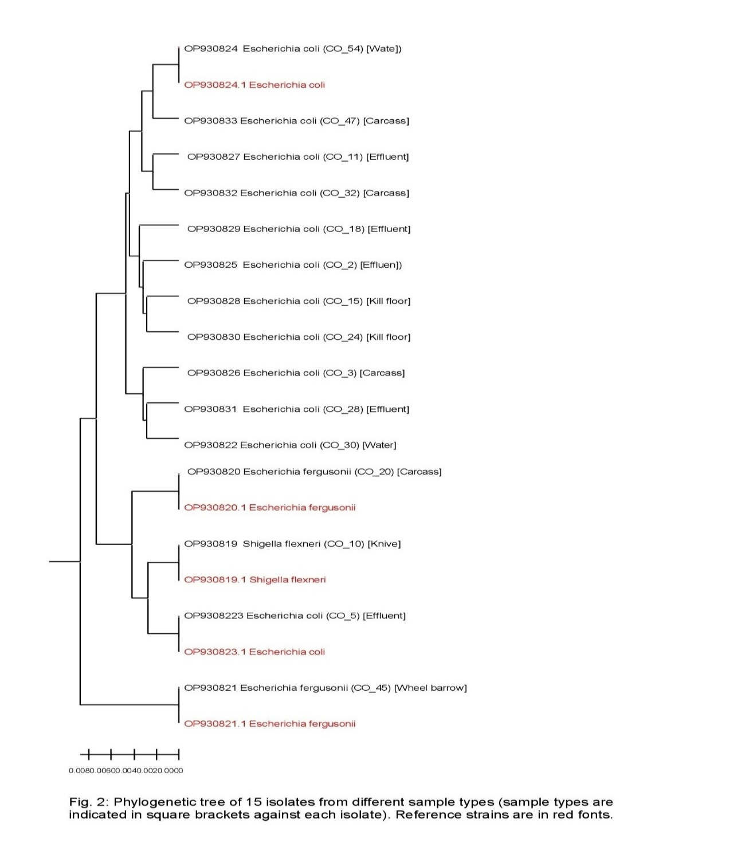
Figure 7. UPGMA dendrogram showing clustering of E. coli isolates from Gwagwalada and Dei-Dei slaughterhouses at 80% similarity cut-off.
3.7 Proposed Transmission Pathways in the Slaughterhouse
The schematic diagram (Fig 8) illustrates potential transmission pathways of Escherichia coli within the abattoir environment. Contamination likely originates from live animals and spreads to carcasses during processing. Subsequent cross-contamination occurs via contact with slaughterhouse workers’ hands, knives, and equipment, with further dissemination to environmental reservoirs such as floors, effluent systems, and water sources.

┌───────────────┐
│ LIVE CATTLE │
└──────┬────────┘
│
▼
┌───────────────┐
│ CARCASS │
└ ──────┬────────┘
│
┌───────────┼────────────┐
▼ ▼ ▼
┌────────┐ ┌────────┐ ┌────────────┐
│ HANDS │ │ KNIVES │ │ WHEELBARROW
└────┬───┘ └────┬───┘ └────┬───────┘
│ │ │
└──────┬─────┴─────┬──────┘
▼ ▼
┌───────────────┐
│ GROUND │
└──────┬────────┘
▼
┌───────────────┐
│ EFFLUENT │
└──────┬────────┘
▼
┌───────────────┐
│ WATER SOURCE │
└───────────────┘
Fig 8: Transmission Pathways in the Abattoir

DISCUSSION
This study provides comprehensive insights into the molecular epidemiology and virulence potential of Escherichia coli isolated from cattle carcasses and slaughterhouse environments in Abuja, Nigeria. By integrating phylogenetic classification with virulence gene profiling, the study offers a more nuanced understanding of the ecological distribution and pathogenic potential of E. coli within abattoir settings.
The predominance of phylogroups A and B1 observed in this study is consistent with previous reports identifying these groups as primarily commensal and environmentally associated strains (27, 28). However, the detection of virulence-associated phylogroups B2 and D, which together account for 21.9% of isolates, is of considerable public health importance. These phylogroups are well documented to be associated with extraintestinal pathogenic Escherichia coli (ExPEC), which can cause severe infections in humans, including urinary tract infections, septicemia, and neonatal meningitis (4, 29).
A key finding of this study is the widespread distribution of virulence genes across all phylogenetic groups, with no statistically significant association observed between phylogroup and virulence gene presence. This suggests that virulence determinants are not confined to traditionally pathogenic lineages. Rather, it supports the role of horizontal gene transfer in facilitating the dissemination of virulence factors across diverse E. coli populations within the slaughterhouse environment (30). Consequently, commensal and environmental strains may serve as reservoirs of virulent genes, thereby contributing to the emergence of pathogenic variants.
Of particular concern is the high prevalence of critical virulence genes, notably stx (72.7%), cnf (74.5%), and omp (96.4%). The detection of the stx gene at such a high frequency strongly suggests the potential presence of Shiga toxin-producing Escherichia coli (STEC) within the slaughterhouse environment. STEC strains are recognized as major foodborne pathogens responsible for severe clinical conditions, including hemorrhagic colitis and hemolytic uremic syndrome (31). The widespread occurrence of stx-positive isolates across carcasses, contact surfaces, and environmental samples indicates a substantial risk of contamination along the meat processing chain and subsequent transmission to consumers.
Similarly, the high prevalence of the cnf gene further underscores the virulence potential of isolates circulating within these environments. Cytotoxic necrotizing factors (CNF) are associated with enhanced bacterial invasiveness and tissue damage, particularly in extraintestinal infections (32). Although the observed higher occurrence of cnf among phylogroups B2 and D was not statistically significant, the trend may be biologically relevant and suggests a potential enrichment of virulence traits within these groups.
The near-universal detection of the omp gene highlights its fundamental role in bacterial physiology, including membrane integrity, environmental adaptation, and host interaction (30). Its consistent presence across isolates reflects its conserved nature and importance for bacterial survival in diverse ecological niches, including the abattoir environment.
Importantly, the detection of virulent genes in isolates recovered from multiple sources—including carcasses, slaughterhouse workers’ hands, knives, wheelbarrows, and effluent—demonstrates the extensive nature of cross-contamination within the slaughterhouse system. The clustering of genetically related isolates from different sample types further supports the existence of interconnected contamination pathways. These findings align with previous studies indicating that inadequate hygiene practices, poor sanitation, and improper handling significantly contribute to the dissemination of pathogenic bacteria during meat processing (30, 33).
The presence of virulent Escherichia coli in effluent and water sources also suggests environmental dissemination beyond the slaughterhouse, posing broader ecological and public health risks. Contaminated effluents may serve as reservoirs for pathogenic bacteria, facilitating their spread into surrounding communities and water systems.
Furthermore, the absence of a statistically significant association between sample type and virulence gene distribution does not diminish the epidemiological importance of the findings. Rather, it indicates that contamination is widespread and not restricted to specific points within the processing chain. This highlights the need for comprehensive control measures targeting all stages of slaughterhouse operations.
Overall, the findings of this study demonstrate that reliance on phylogenetic classification alone is insufficient to predict the pathogenic potential of Escherichia coli in environmental and food-associated contexts. Instead, integrated molecular approaches combining phylogrouping, virulence gene profiling, and antimicrobial resistance analysis are essential for accurate risk assessment.
This study underscores the role of abattoirs as critical hubs for the amplification and dissemination of potentially pathogenic Escherichia coli. The high prevalence of virulence genes, particularly stx, coupled with evidence of cross-contamination, highlights an urgent need for improved hygiene practices, strict sanitary controls, and effective monitoring systems within slaughterhouse environments. Such interventions are essential to interrupt contamination pathways, reduce foodborne risks, and safeguard public health
5. CONCLUSION
This study demonstrates that Escherichia coli isolates recovered from cattle carcasses and slaughterhouse environments in Abuja exhibit diverse phylogenetic backgrounds, with a predominance of commensal phylogroups A and B1. However, the detection of virulence-associated phylogroups B2 and D, coupled with the widespread distribution of key virulence genes, highlights a significant public health concern.
Notably, the high prevalence of critical virulence determinants, particularly stx (72.7%), indicates the potential circulation of Shiga toxin-producing Escherichia coli (STEC) within the slaughterhouse environment. This finding underscores a substantial risk of foodborne transmission to consumers, especially in settings with inadequate hygiene and meat handling practices.
The absence of a statistically significant association between phylogroups and virulence gene distribution suggests that virulence traits are widely disseminated among E. coli populations, likely driven by horizontal gene transfer. This implies that even commensal strains may act as reservoirs of virulence determinants, facilitating the emergence and persistence of pathogenic variants.
Furthermore, the recovery of virulent E. coli from carcasses, slaughterhouse workers’ hands, equipment, and environmental samples confirms the occurrence of extensive cross-contamination within the abattoir system. These findings highlight the critical role of slaughterhouse practices in the amplification and spread of potentially pathogenic bacteria.
Overall, this study emphasizes the need for continuous surveillance and the application of integrated molecular approaches in food production systems. Strengthening hygiene practices, improving sanitation infrastructure, and implementing effective monitoring strategies are essential to reduce contamination and safeguard public health.
ACKNOWLEDGMENTS
The authors acknowledge the staff of the Gwagwalada and Dei-Dei slaughterhouses for their cooperation during sample collection. The technical support provided by the Department of Public Health and Preventive Medicine Laboratory, University of Abuja, is also gratefully appreciated.
FUNDING
This research received no specific grant from any funding agency in the public, commercial, or not-for-profit sectors.
CONFLICT OF INTEREST
The authors declare no competing interests
- Do KH, Seo KW, Lee WK. (2022). Antimicrobial resistance, virulence genes, and phylogenetic characteristics of pathogenic Escherichia coli isolated from patients and swine. BMC Microbiol. 22:199. https://doi.org/10.1186/s12866-022-02604-z
- Mora A, Herrera A, López C, et al. (2011). Characteristics of Shiga toxin-producing enteroaggregative Escherichia coli O104:H4 German outbreak strain and STEC strains isolated in Spain. Int Microbiol. 14:121–141
- Croxen MA, Finlay BB. (2010). Molecular mechanisms of Escherichia coli pathogenicity. Nat Rev Microbiol. 8:26–38
- Kaper JB, Nataro JP, Mobley HL. (2004). Pathogenic Escherichia coli. Nat Rev Microbiol. 2:123–140
- Wellington EMH, van Elsas JD. (1992). Genetic interactions between microorganisms in the natural environment. Oxford: Pergamon Press
- Servin AL. (2005). Pathogenesis of Afa/Dr diffusely adhering Escherichia coli. Clin Microbiol Rev. 18:264–292
- Alteri CJ, Smith SN, Mobley HLT. (2009). Fitness of Escherichia coli during urinary tract infection requires gluconeogenesis and the TCA cycle. PLoS Pathog. 5:e1000448
- Wiles TJ, Kulesus RR, Mulvey MA. (2008). Origins and virulence mechanisms of uropathogenic Escherichia coli. Exp Mol Pathol. 85:11–19
- Ayoade F, Oguzie J, Eromon P, et al. (2021). Molecular surveillance of Shiga toxigenic Escherichia coli in selected beef abattoirs in Osun State, Nigeria. Sci Rep. 11:13966. https://doi.org/10.1038/s41598-021-93347-w
- Oluwafemi RA, Ayansina AD, Umeh CE. (2023). Detection of virulent and antibiotic-resistant Escherichia coli in abattoir effluents and surrounding environments in Nigeria. Int J Environ Res Public Health. 20(4):679. https://doi.org/10.3390/ijerph20040679
- Olaitan JO, et al. (2025). Surveillance and potential health risks of antibiotic-resistant Shiga toxigenic Escherichia coli isolated from beef sold in Nigeria. Afr J Microbiol Res. 19(2):55–68
- Balogun O. (2001). The Federal Capital of Nigeria: Geography of Its Development. Ibadan: University of Ibadan Press
- National Population Commission (NPC). (2010). The Population and People of Nigeria
- Abubakar MA, Hamzah E, Maher AA, Alev E. (2019). Knowledge management, decision-making style, and organizational performance. J Innov Knowl. 4:104–114
- Regassa A, Moje N, Megersa B, et al. (2013). Major causes of organ and carcass condemnation in small ruminants slaughtered at Luna export abattoir, Ethiopia. Prev Vet Med. 110:139–148
- Elmanama A, Abdelateef N. (2012). Antimicrobial resistance of enteric pathogens isolated from acute gastroenteritis patients in Gaza Strip, Palestine. Int Arab J Antimicrob Agents. 2:1–15
- Barrow GI, Feltham RKA. (1993). Cowan and Steel’s Manual for the Identification of Medical Bacteria. 3rd ed. Cambridge: Cambridge University Press
- Gillan DC, Speksnijder AGCL, Zwart G, De Ridder C. (1998). Genetic diversity of the biofilm covering Montacuta ferruginosa (Mollusca, Bivalvia). Appl Environ Microbiol. 64:3464–3472
- Fagan PK, Hornitzky MA, Bettelheim KA, Djordjevic SP. (1999). Detection of shiga-like toxin genes in animal feces by multiplex PCR. Appl Environ Microbiol. 65(2):868–872
- Afsharnia M, Naraghi B, Mardaneh J, et al. (2018). Data on Escherichia coli genes in different types of wastewaters. Data Brief. 21:763–766
- James EM, Kimera ZI, Mgaya FX, et al. (2025). Occurrence of virulence genes in multidrug-resistant Escherichia coli: One Health perspective. PLoS One. 20(1):e0317874
- Anjbar R, Farahani O. (2018). Prevalence of virulence genes of Escherichia coli in hospital wastewaters. Iran J Public Health. 47(5):713–719
- Song H, Bae Y, Jeon E, et al. (2019). Multiplex PCR analysis of virulence genes in Enterococcus spp. J Vet Sci. 20(3):e26
- Clermont O, Christenson JK, Denamur E, Gordon DM. (2013). The Clermont phylo-typing method revisited. Environ Microbiol Rep. 5(1):58–65
- Tauschek M, Gorrell RJ, Strugnell RA, Robins-Browne RM. (2002). Protein secretion pathway in enterotoxigenic Escherichia coli. Proc Natl Acad Sci USA. 99(10):7066–7071
- Kumar V, et al. (2017). Strategic framework for a profitable business model in the sharing economy. Ind Mark Manag. 69:147–160
- Tenaillon O, Skurnik D, Picard B, Denamur E. (2010). Population genetics of commensal Escherichia coli. Nat Rev Microbiol. 8(3):207–217
- Johnson JR, Russo TA. (2005). Molecular epidemiology of extraintestinal pathogenic Escherichia coli. EcoSal Plus. 1(1)
- Russo TA, McFadden CD, Carlino UB, et al. (2001). Siderophore receptor IroN in uropathogenic Escherichia coli. Infect Immun. 69(6):3883–3890
- Nataro JP, Kaper JB. (1998). Diarrheagenic Escherichia coli. Clin Microbiol Rev. 11(1):142–201
- Johnson JR, Stell AL, Delavari P. (2003). Escherichia coli virulence factors in urosepsis. J Infect Dis. 187(5):759–768
- Grace D, Omore A, Randolph T, et al. (2012). Risk assessment for Escherichia coli O157:H7 in milk. J Food Prot. 75(12):2173–2180
- Raji MA, Jamal W, Rotimi VO. (2016). Prevalence of Escherichia coli in retail meat products. Afr J Microbiol Res. 10(21):751–760

