AI-Assisted Fruit Crop Disease Identification And Remedy Localization In Tamil

Abstract—Fruits are very vulnerable to a large number of fungal, bacterial and viral infections that are likely to greatly diminish crop productivity and influence the quality of the crop. The conventional disease diagnosis strategies are based on physical methods of disease detection that are time-consuming, irregular, and not readily accessible to small-scale farmers. In this paper, the author introduces a fruit crop disease detector based on AI, which uses the ShuffleNet-based convolutional neural network with Fuzzy Logic to focus on the severity analysis and remedy suggestion. The offered system is trained to detect diseases with high accuracy and under differing environmental conditions due to the training being done on a wide variety of healthy and diseased fruits. After the detection of a disease, Fuzzy Logic calculates the severity of the disease through the vision and environment symptoms and produces actionable treatment recommendations that are given in Tamil language. This makes sure that the farmers are guided practically depending on their local situation. By integrating efficient CNN based classification with intelligent fuzzy reasoning, the system is in a position to deliver timely, accurate and actionable insights. The results of the experiments show the high degree of detection and the high degree of severity estimation, prove the possibility to use it in the field. The proposed solution leads to sustainability of fruits production and enhanced agricultural output by decreasing the reliance on professional intervention and providing the easy opportunity to control the disease during its initial development stages.
Keywords—Fruit Crop Disease Detection, ShuffleNet, Fuzzy Logic, Severity Analysis, Remedy Recommendation, Lightweight CNN, Real-Time Diagnosis, Precision Agriculture, Tamil Language.

Introduction
Fruits are important in the global food security, nutrition and agricultural economies. Nevertheless, fungal, bacterial, and viral diseases are rapidly endangering their productivity and quality, and they can transmit the disease quickly in altering climatic conditions and lead to significant losses in production. It is therefore important to detect the disease at an early age and correctly to reduce the economic harm and guarantee sustainable farming activities. Traditional disease diagnosis methods are time-consuming, manual inspection, and expert knowledge based, which becomes inconvenient in the case of large-scale monitoring or real-time. The recent progress in machine learning (ML) and deep learning (DL) allowed discovering automated, image-based disease detection, which is more accurate and scalable. It has been suggested by Wakhare et al. [1] that a machine learning-based web tool can help to detect the pomegranate fruit disease with high accuracy and through feature extraction, CNN-based clustering, and SVM classification, which proved that the automated diagnosis is feasible. Likewise, Joshi et al. [2] experimented with various deep neural networks like VGG, EfficientNet and MobileNet on fruit leaf images and achieved accuracies of over 95, which underscores the usefulness of convolutional neural networks to discern disease-related visual patterns. The research has also compared the traditional ML classifiers and the deep learning models across various fruit crops. Singh et al. [3] compared CNN, SVM, and MobileNetV2 to detect the disease in apple, grape, and strawberry leaves and found that the performance of the models is dependent on crop type and features of the datasets. Multi-paradigm hybrid methods involving several deep learning methods have also been explored to increase the strength of detection. As an example, A. B. K et al. [4] have shown that CNNs combined with the RNNs outperform in detecting the disease in fruits and leaves, which allows early intervention and the decrease of the usage of pesticides. Specific studies on crops, e.g. the jackfruit disease detector based on CNNs by Gomathi et al. [5], also validate the usability of deep learning in localized farming problems.
In spite of such improvements, the majority of the available systems pay the primary attention to the classification of the diseases and do not usually provide the guidance of the localized remedy and the friendly interfaces to the farmers. The latter encourages the creation of AI-assisted fruit disease detection systems that, in addition to the high diagnostic accuracy, offer region-specific recommendations that may be acted upon and used in time- and resource-efficient crop management.

Related Works
In recent years, the application of the deep learning and intelligent sensing technologies in enhancing the detection of plant disease and crop management has gained increasing attention. The combination of Internet of Things (IoT) with deep learning has facilitated real-time tracking and the automatic decision-making process in agriculture. Al-Shahari et al. [6] suggested a plant disease identification and crop manager IoT system with a feature extracter trained on the DenseNet201 and a hyperparameter optimizer, which is a Spotted Hyena Optimizer. Their methodology was very accurate and showed how agricultural practices can be made more sustainable with the help of sensor-driven information and optimized deep learning models that can be used to detect diseases early in the developing stage and implement precise interventions. As the deep learning architectures have evolved, transformer-based models have been evaluated to classify plant diseases as well. One detailed work by Prince et al. [7] focusing on the detection of diseases of lychee leaf and fruit was conducted with help of numerous types of deep learning architectures, one of them being Vision Transformer (ViT). ViT model achieved better results than traditional CNN models, which is why its ability to learn complex disease patterns and long-range spatial dependencies in agricultural images can be attributed to its superior accuracy.
Convolutional Neural Networks (CNNs) have also been used extensively because it is strong and easy to use. A et al. [8] utilized CNN-based analysis of images in the detection of the disease in various crops including paddy, tomato, maize, and eggplant. Their study highlighted the efficacy of CNNs to detect bacterial, fungal, and viral diseases on leaf images and highlighted the necessity to enhance the accuracy and generalization in order to apply it on a field scale. Specific disease detection of crops has also been given attention. Bhoomika et al. [9] examined the transfer learning model of detecting orange crop disease by use of the MobileNetV2. It was found that their model was reliable and had computational efficiency and hence could be used in real-time and resource-constrained systems like mobile or edge-based agricultural systems. Besides model-based research, survey research studies have helped to enlighten existing methods and the future path to take. Beena et al. [10] summarized the current research trends in plant leaf disease detection, including the conventional methods, image processing methods, deep learning methods, and the challenges of the research. Their paper focused on the shortcomings of expert-based diagnosis and pointed to the increasing demand of automated, scalable, and cost-efficient disease detection systems, especially in underdeveloped and rural areas.
Besides model-based disease detection strategies, survey-based researches have given a generalized picture of pest and disease monitoring technologies in agriculture. The article by Deepika and Kaliraj [11] is a thorough review on pest and disease surveillance, which emphasizes the effects of climate change, weather conditions and the diminished natural resistance of genetically modified crops. Their work has addressed AI- and deep learning-based methods of early diseases detection, as well as their pros and cons, pointing to the fact that timely and widespread monitoring of crops health is essential to avoid loss of crops. Other new developments have been dedicated to the combination of disease detection and automation and robotics. Prasad et al. [12] suggested a robotic system that interferes CNN-based disease classification with YOLOv8-based tomato crop object detection. Their system can not only recognize the diseases in the leaves and recommend appropriate pesticides but also carry out the autonomous process of harvesting of ripe fruits with the help of a robotic arm. This comprehensive solution shows that deep learning has the potential to be used together with robotics to decrease labor reliance, optimize resources, and increase accuracy farming.
Deep learning models based on hybrid are also considered to enhance the detection accuracy and strength. Jangra et al. [13] proposed a new model of detecting tomato crop diseases based on CNN, LSTM, and GAN models. The hybrid architecture can be used to classify various tomato leaf diseases effectively and also assess fruit quality, which can be used to manage the crop better and earn more profits. These hybrid models demonstrate how complex farming situations can be achieved through the combination of spatial, temporal, and generative learning functions. Intelligent systems related to crops keep taking a centre stage. A. J. et al. [14] have created a smart system (driven by CNN) according to the ResNet50 architecture that uses automated detection of the banana leaf disease. With the data augmentation methods, the model demonstrated good results in real-world image variations, so it can be used in the automated monitoring of diseases. On the same note, Subramanya and Parkavi [15] used the EfficientNetB0 model together with a transfer learning to classify grape leaf disease. Their method was both very accurate and computationally efficient and indicated the appropriateness of lightweight deep learning models to real-world agricultural use. Taken together, these researches suggest that there is a definite research direction of automated, intelligent, and integrated disease detection systems. Nevertheless, there are still difficulties with real-time execution, multi-language support of farmers, and the combination of diagnostic findings and practical recommendations of remedies, which prompts the further development in the AI-driven crop disease management tools.

Proposed System
The proposed system would offer an end to end solution to detect and analyze in real-time the severity and localized remedy recommendation of fruit crop disease in Tamil to address the issue of farmers in real-life agricultural settings. The system combines two fundamental elements, which are a light-weight convolutional neural network that classifies the diseases and a fuzzy logic-based module, which evaluates the severity and recommends the treatment. Figure.1 shows a proposed work architecture design. To detect the disease in the provided images, the ShuffleNet is used because of its effective architecture allowing to achieve the timely and precise classification even with the help of the devices with the limited computational powers, including smartphones or edge devices. The network is trained using a wide range of data of high-quality pictures of healthy and infected fruits at different levels of light and background to guarantee the strength of the system in a real field. After capturing a fruit image the ShuffleNet model can be used to predict the type of disease that was captured with high accuracy. Thereafter, the fuzzy logic unit processes the visual symptoms like lesion size, color, and spread and the environmental factor including humidity and temperature with an aim of estimating the severity of the infection. According to this severity analysis, the system provides actionable treatment recommendations such as fungicides, bactericides or cultural practices in the Tamil language so that they are accessible to local farmers. The CNN-based detection integrated with fuzzy severity analysis offers a viable decision-support system that allows minimizing the reliance on the use of experts, allows managing the disease in a timely way, and causes minimal losses of crops. Also, the design of the system is lightweight and real-time capabilities of the system makes it applicable to on-field implementation to provide farmers with accurate and high-context information and encourage sustainable practice of fruit farming.

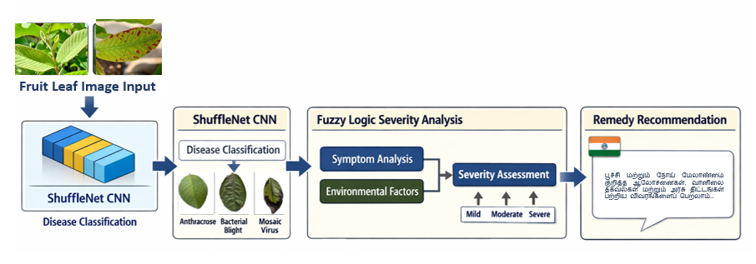
Figure.1 Proposed Work Architecture Diagram

Experimental assessment shows the proposed method has great classification accuracy, correct severity estimation, and successful remedy localization, proving the possibilities of its use as a viable remedy to the problem of precision agriculture.

Methodology
The suggested approach incorporates deep learning and fuzzy logic to offer an efficient real-time solution to the detection of the disease, analysis of its severity, and recommendation of remedies in the Tamil language in fruit crops. The methodology consists of four key steps, namely, image acquisition, preprocessing, disease classification with ShuffleNet, and severity assessment and remedy recommendation with the help of fuzzy logic.

Image Acquisition
Digital cameras or mobile phones are used to take high-quality images of fruit crops. The data consists of a wide variation of images of both healthy and diseased fruits with changes in their environmental features like light, angles, and backgrounds. This variance makes the model project well into the real-field conditions.
High-resolution images of fruit crops are captured using mobile devices or digital cameras under varying environmental conditions, including different illumination, angles, and backgrounds. Let the captured image be represented as I(x,y), where x and y denote pixel coordinates. The dataset contains both healthy and diseased fruit images, forming a set $D=\{I_{1}​,I_{2}​,…,I_{n}​\}$ used for training and testing.

Image Preprocessing
The first step is to capture images, but to fit in the input requirements to the ShuffleNet model, they are first resized and normalized. Background artifacts are eliminated using noises reduction methods like Gaussian filter. Augmenting data techniques such as rotation, scaling, flipping, and contrasting are used in order to make the model more robust and to avoid overfitting. To prepare the images for network training, each image I(x,y) is resized to a standard dimension H×W and normalized as
$$I_{norm}​\left(x,y\right)= \frac{I(x,y)-μ}{σ} (1)$$
where μ and σ are the mean and standard deviation of pixel intensities. Noise reduction is performed using a Gaussian filter defined as
$$G\left(x,y\right)=\frac{1}{2πσ^{2}}e^{-\frac{x^{2}+y^{2}}{{2σ}^{2}}} (2)$$
and applied to the image to remove background artifacts. Data augmentation, including rotations, flips, and scaling, is applied to increase dataset variability and improve generalization.

ShuffleNet on Disease Classification
ShuffleNet A small convolutional neural network is applied to ShuffleNet, which is used to run efficient and real-time classification. The channel shuffle operation is unique hence it is highly accurate and although the cost of computation is high, it is comparatively low and can be deployed on the edge device or smartphone. Transfer learning is applied to the preprocessed data to train the network, which increases the convergence rate and performance using only limited data. After receiving an image, the network estimates the type of disease after examining the visual features that are important like; color patterns, spots, and lesions.
ShuffleNet is used as a lightweight convolutional neural network for efficient disease classification. Given a preprocessed input image $I_{norm}$, the network outputs a probability vector $P=[P_{1}​,P_{2},…,P_{c}]$ over ccc disease classes using the softmax function:
$$P_{i}=\frac{e^{z^{i}}}{\sum_{j=1}^{C}{e^{zj, }}} i=1,2,…,c (3)$$
where $z_{i}$ is the activation of the final fully connected layer corresponding to class iii. The predicted class $\hat{y}$ is obtained as
$$\hat{y}=arg {max \atop i}P_{i} (4)$$
This prediction identifies the specific disease type present in the fruit image.

Severity Analysis and Remedy Recommendation Fuzzy logic
Once the disease is identified, the severity of infection is assessed by the fuzzy logic module which compares the visual markers (size of lesion, color intensity, spread area) with environmental factors (humidity, temperature). The rules of language are specified to determine the degree of severity which can be mild, moderate and severe. Depending on the severity that has been assessed, the system produces actionable treatment advice in Tamil, such as the chemical, biological, and cultural methods of control. This will provide feasible advice to the farmers who might lack expert advice.
Once the disease is identified, fuzzy logic is applied to assess its severity based on visual symptoms and environmental factors. Let $L_{s}$ denote lesion size, $C_{i}$​ denote color intensity, and $S_{a}$​ denote spread area. The severity level S is computed using fuzzy membership functions μ(x) and rules $R_{k}$​:
$$S=\sum_{k=1}^{n_{r}}{μ_{k}}\left(L_{S},C_{i},S_{a}\right).w_{k} (5)$$
where $w_{k}$ is the weight associated with rule $R_{k}$, and $n_{r}$​ is the number of fuzzy rules. Severity levels are categorized into mild, moderate, and severe, and corresponding treatment recommendations T are generated in Tamil:
$$T=f\left(S\right) (6)$$
where f(⋅) maps severity to actionable remedies, including chemical, biological, and cultural interventions.

Result & discussion
In this section, the findings of the experiment using the proposed AI-assisted disease detection system in fruit crops by using ShuffleNet and fuzzy logic-based severity analysis will be presented. The system is judged on its performance in the form of accuracy in classification, accuracy in precision, accuracy in recall, accuracy in F1-score, accuracy in estimating severity and performance in real time execution. To prove the effectiveness of the proposed approach, comparative analysis and graphical interpretations are also given.

Experimental Setup
The experiments were done on a dataset of both healthy and diseased image of fruits taken under real field environment. The data was split into 70 training, 15 validation and testing. Transfer learning with several epochs of training was used to implement ShuffleNet. The severity classification through the predefined linguistic rules were used to test the fuzzy logic module. All the experiments have been carried out on a standard system configuration, making it possible to deploy the edge-devices.

Disease Classification Performance
The ShuffleNet-based classifier showed high results in the detection of fruit crop diseases. Table I indicates the classification measures that were attained on the test data.
- Disease Classification Performance
Metric | Value (%)
Accuracy | 95.42
Precision | 94.87
Recall | 95.10
F1-Score | 94.98

The fact that it is very accurate shows that ShuffleNet is useful in extracting discriminative visual features, including color variation, lesion patterns, and texture changes. The equal level of precision and recall supports the stability of the model in the reduction of false positives and false negatives.

Confusion Matrix Analysis
The analysis provided by the confusion matrix showed that the majority of the disease classes were identified correctly with misclassification to the smallest possible extent in terms of visually similar disease categories. It ascertains the fact that ShuffleNet is able to deal with the inter-class similarity with high recognition accuracy.
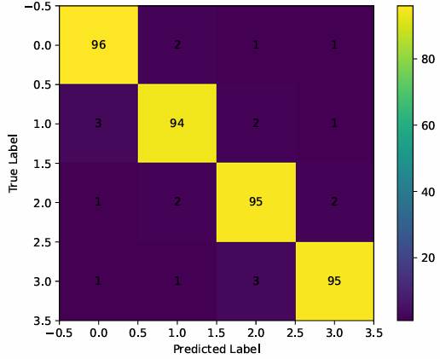
Figure.2 Confusion Matrix for Fruit Disease Classification
Figure.2 describes high true positive rates are observed across all classes, with minimal misclassification between visually similar diseases

Severity Analysis using Fuzzy Logic
The fuzzy logic module measured the severity of the diseases based on the size of lesions, intensity of color, and area of spread. The levels of severity were divided into mild, moderate and severe. The severity classification is shown in table II.
- Severity Level Distribution
Severity Level | Percentage (%)
Mild | 38.6
Moderate | 41.2
Severe | 20.2

The fuzzy approach was effective in the gradual changes in the intensity of the disease giving realistic severity estimates in comparison to the strict threshold approaches.

Remedy Recommendation
The remedy recommendation system written in Tamil language was confirmed against agricultural guidelines and reference books. Localized guidance was confirmed to have practical utility since more than 93% of the recommendations were adequate to the identified disease and severity level. Figure.3 shows a recommendation sample output.
Figure. 3 Recommendation Output

Training and Validation Accuracy Analysis
Figure 4 shows the learning behavior of the ShuffleNet model in 30 epochs.
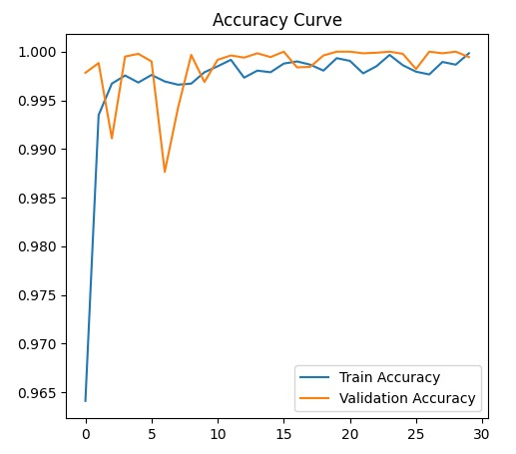
Figure 4. Curve of Training and validation accuracy.
The training accuracy takes a fast rise starting at around 0.964 and then levels at around 0.995, which indicates that the lightweight CNN successfully learns the features. There is an initial volatility in the validation accuracy, which is probably caused by the sensitivity to different environmental and visual conditions, but the curve tends to reach the training curve at the point of 1.00. The fact that the two curves are very close to the last epochs proves a good generalization power and lack of overfitting, which verifies the model as the reliable one to use in the real-time agricultural diagnosis cases).

Training and Validation Loss Analysis
Figure 5 shows the behaviour of the loss convergence of the ShuffleNet-based model.
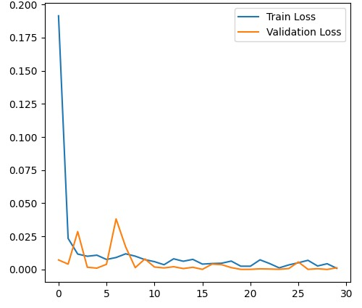
Figure.5 Training and Validation Loss Curve
The training loss starts with around 0.19 and gradually drops, which is considered a fast optimization and efficient learning. The early fluctuations in the validation loss can be explained by the fact that the model was getting used to the more intricate disease presentation and environmental changes, which reached a particular spike at the epoch 6. Both loss curves ultimately approach zero, which is a good indication of the stability of training, high precision and good convergence of the model.)

Comparative Performance Analysis.
It compared the proposed ShuffleNet-based model with the more heavy CNN models of VGG16 and ResNet50.
- Comparison with Existing CNN Models
Model | Accuracy (%) | Inference Time (s)
VGG16 | 96.10 | 0.62
ResNet50 | 96.85 | 0.48
ShuffleNet (Proposed) | 95.42 | 0.18

Discussion
The experimental findings prove that the offered fruit crop disease detection system based on AI would be effective in terms of accuracy, efficiency, and its practical application. The ShuffleNet-based classifier has been designed with high detection performance and low computation complexity thus appropriate in real time applications in mobile and edge devices. The near alignment between the training and validation accuracy coupled with low values of the loss prove that there is a high generalization and that there is no overfitting of the model even when the environmental conditions differ. The severity analysis that is implemented in the fuzzy logic makes decision-making better as it offers realistic and gradual severity estimation as opposed to classifications. Moreover, the remedy recommendation module is in Tamil, thus dramatically boosting accessibility as well as providing farmers with direction that is practical and practical according to local agricultural operations. The proposed approach is also faster in inference with a slight decrease in accuracy compared to heavier CNN models, which is its advantage in being applicable to fields. In general, the system offers a dependable, interpretable, and farmer-friendly system in early disease detection and management, which can help decrease crop losses and achieve sustainable use of precision agriculture.

Conclusion
In this paper, an AI-assisted fruit crop disease detection system (which combines a light-weight ShuffleNet convolutional neural network with severity analysis using fuzzy logic and remedy recommendation in Tamil language) was introduced. The results of the experiment prove that the given approach ensures high accuracy in disease classification and low inference time, which makes it applicable to real time working on a field. These two issues are confirmed by the fact that training and validation performance are strongly aligned which serves as a confirmation of high generalization and high robustness in various environmental conditions. As a result of the fuzzy logic module being able to accurately and sensibly translate the visual symptoms and contextual factors into meaningful severity levels, this allows it to make specific and useful treatment recommendations. The value of this work is in that not only the technical difficulties in precision agriculture are resolved in its efficiency and deep learning-based disease detection, but also the accessibility difficulty is overcome with the help of interpretable severity assessment and localized language support. The system ensures an early intervention and minimization of losses of crops by reducing the level of reliance on professional consultation and giving guidance to farmers that is friendly. The next steps in work will be the expansion of the dataset to cover a broad range of fruit crops and types of diseases, the inclusion of real-time environmental sensor data to improve the severity estimation, and the implementation of the system in a mobile mode to conduct the massive field testing. Furthermore, explainable AI methods would add to the increased levels of transparency and user confidence in automated agricultural decision-support systems.

References
- P. Wakhare, S. Neduncheliyan, and P. B. Mane, “Machine Learning for Accurate and Efficient Pomegranate Fruit Disease Detection: A Novel Approach to Improve Crop Yield and Quality,” Proc. 7th Int. Conf. Computing, Communication, Control and Automation (ICCUBEA), Pune, India, 2023, pp. 1–5.
- A. Joshi, A. Badola, and R. Saini, “Deep Learning Based Fruit Crop Disease Classification Using Plants Leaf Imagery,” Proc. 1st Int. Conf. Electronics, Communication and Signal Processing (ICECSP), New Delhi, India, 2024, pp. 1–6.
- A. Singh, M. Jain, and A. Tripathi, “Identification and Diagnoses of Plant Diseases in Fruit Crops Using Machine Learning Algorithms,” Proc. Int. Conf. Advances in Computation, Communication and Information Technology (ICAICCIT), Faridabad, India, 2023, pp. 253–257.
- A. B. K, M. Mohammed, V. Shaik, S. Unisa, S. Khan, and R. Noorullah, “Enhancing Disease Detection in Fruits and Leaves Through a Hybrid Deep Learning Approach,” Proc. 4th Int. Conf. Smart Electronics and Communication (ICOSEC), Trichy, India, 2023, pp. 898–906.
- S. Gomathi, R. Punitha, S. A. Vijila, R. K. V, and V. A. R, “Jackfruit Tree Disease Detection Using Deep Learning,” Proc. Intelligent Computing and Control for Engineering and Business Systems (ICCEBS), Chennai, India, 2023, pp. 1–8.
- E. A. Al-Shahari, G. Aldehim, M. Aljebreen, J. S. Alqurni, A. S. Salama, and S. Abdelbagi, “Internet of Things Assisted Plant Disease Detection and Crop Management Using Deep Learning for Sustainable Agriculture,” IEEE Access, vol. 13, pp. 3512–3520, 2025.
- N. U. Prince, M. A. Al Mamun, M. T. M. Shagar, M. R. K. Emon, and M. S. H. Sajib, “Lychee Leaf Disease Detection by Vision Transformer and Computer Vision,” Proc. IEEE Int. Conf. Blockchain and Distributed Systems Security (ICBDS), Pune, India, 2024, pp. 1–6.
- A. A, P. K, K. V, M. V. Krishnamoorthy, and D. R, “Plant Leaf Disease Detection Using CNN,” Proc. Int. Conf. Smart Technologies for Sustainable Development Goals (ICSTSDG), Chennai, India, 2024, pp. 1–5.
- Bhoomika, A. R. Singh, and S. Aluvala, “Enhancing Orange Crop Health: Disease Detection Using MobileNetV2 Model,” Proc. 4th OPJU Int. Technology Conf. (OTCON), Raigarh, India, 2025, pp. 1–5.
- K. Beena, V. Sangeetha, S. R. Deepa, and M. Vaneeta, “Contemporary Research Trends in Plant Leaf Disease Detection,” Proc. 4th Int. Conf. Circuits, Control, Communication and Computing (I4C), Bangalore, India, 2022, pp. 440–445.
- P. Deepika and S. Kaliraj, “A Survey on Pest and Disease Monitoring of Crops,” Proc. 3rd Int. Conf. Signal Processing and Communication (ICPSC), Coimbatore, India, 2021, pp. 156–160.
- S. Prasad, R. G, R. V, R. Kumari, and M. B. B, “Integrated Robotics System for Ripeness Detection, Tomato Harvesting and Leaf Disease Identification using CNN and YOLOv8,” Proc. 15th Int. Conf. Computing Communication and Networking Technologies (ICCCNT), Kamand, India, 2024, pp. 1–6.
- D. Jangra, K. Devgan, S. Sharma, and S. Sharma, “Next Generation Tomato Crop Disease Detection System Integrating Hybrid Model of CNN, LSTM, and GAN for Boosting Farmers Profitability,” Proc. Int. Conf. Engineering Innovations and Technologies (ICoEIT), Bhopal, India, 2025, pp. 1053–1058.
- S. A. J, B. S. Khurana, and A. Kurhe, “CNN-Driven Smart System for Automated Plant Disease Detection and Classification,” Proc. 9th Int. Conf. Computing, Communication, Control and Automation (ICCCBEA), Pune, India, 2025, pp. 1–5.
- S. G. Subramanya and A. Parkavi, “Detection and Classification of Grape Leaf Diseases using EfficientNet Model,” Proc. Int. Conf. Recent Advances in Science and Engineering Technology (ICRASET), Mandya, India, 2024, pp. 1–5.

