Gesture Controlled Mecanum Wheel Robot Using ESP32 and ESP-NOW

Abstract— This paper presents the design and implementation of a gesture-controlled omnidirectional robot using mecanum wheels. The system uses ESP32 microcontrollers and ESP-NOW protocol for wireless communication. A gesture sensor (e.g. accelerometer/gyro or hand gesture module) captures user commands which are transmitted via ESP32 to the robot. The robot’s motion (forward, backward, left, right, strafe, rotate) is achieved through independent control of four mecanum wheels. Experimental results show responsive control, low latency, and reliable motion in various terrains. In addition to locomotion, the robot integrates an ESP32-CAM module for real-time video monitoring, a smoke detector for fire or gas detection, and a buzzer for audible alerts in case of abnormal events. The combination of these features enhances both mobility and safety, making the system suitable for surveillance, hazardous environment inspection, and smart monitoring applications. Experimental results demonstrate reliable gesture recognition, stable omnidirectional motion, and effective alert generation with the integrated modules.
Keywords— ESP32, ESP-NOW, Gesture Control, Mecanum Wheels, Smoke Detector, Buzzer, ESP32-CAM, Omnidirectional Robot.

I. Introduction
Robotics has witnessed rapid advancements in recent years, integrating mechanical design, electronics, communication systems, and artificial intelligence to create highly functional autonomous and semi-autonomous machines. The motivation behind the development of robots is not limited to industrial automation but has expanded into everyday life, surveillance, healthcare, disaster management, and defense applications. Among the different forms of robotic locomotion, wheeled robots remain the most used because of their simplicity, controllability, and cost-effectiveness. However, conventional differential-drive robots are constrained in terms of mobility since they cannot move laterally or diagonally without reorientation. To overcome these limitations, mecanum wheel–based designs have emerged as a practical solution for enabling full omnidirectional motion. The unique property of mecanum wheels lies in their rollers, which are oriented at a 45-degree angle with respect to the The unique property of mecanum wheels lies in their rollers, which are oriented at a 45-degree angle with respect to the
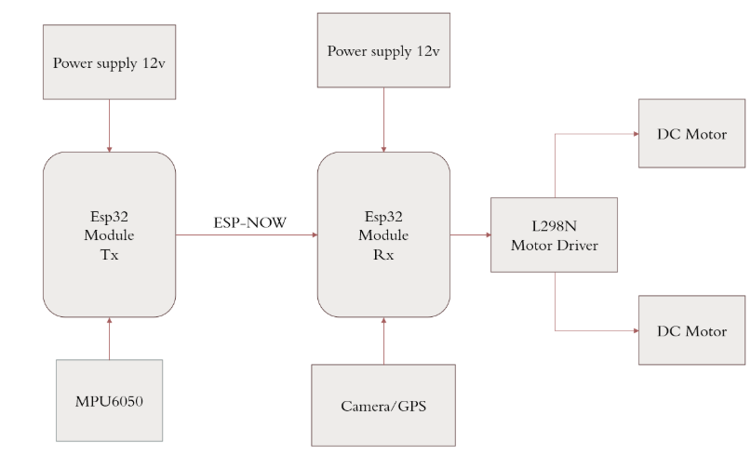
wheel axis. By coordinating the speed and direction of four independent mecanum wheels, a robot can move not only forward and backward but also sideways, diagonally, and rotationally in place. This increased mobility is extremely useful in environments with narrow passages, dynamic obstacles, or where precise maneuverability is required. Applications such as warehouse automation, search and rescue, medical service robots, and intelligent surveillance systems can benefit greatly from this design. In the present work, we explore the implementation of a gesture-controlled mecanum wheel robot, in which the control signals are derived from natural human hand movements captured by sensors and transmitted wirelessly to the robot.
A . Motivation: Robotics Control via Intuitive Gestures
Human-machine interaction (HMI) plays a crucial role in defining how users communicate with and control robotic systems. Traditionally, robots have been operated via joysticks, remotes, or preprogrammed commands. While functional, these methods may not be intuitive, especially for non-technical users or in time-sensitive environments. Gesture recognition provides a natural and user-friendly interface that reduces the cognitive load on operators and enhances accessibility. The ability to control a robot by simply tilting the hand or making directional movements can significantly improve response times in critical situations such as fire outbreaks, security patrols, or hazardous material inspection.
Another motivation is the integration of safety and monitoring capabilities into the robotic platform. Beyond locomotion, the incorporation of a smoke detector and buzzer extends the robot’s applicability to fire detection and hazard alerting, while the addition of an ESP32-CAM module facilitates real-time video surveillance. This transforms the robot from a purely mobile platform into a multifunctional safety and monitoring device suitable for smart homes, industrial sites, and disaster-prone areas.
B. Challenges: Reliable Wireless Communication, Control of Mecanum Wheels, Gesture Mapping
Despite the advantages of gesture control and omnidirectional motion, several challenges must be addressed to achieve a reliable system. First, wireless communication between the gesture controller and the robot must be fast, robust, and power-efficient. Traditional Wi-Fi and Bluetooth protocols, while popular, may not always provide the required low-latency response, particularly in environments with interference. Drawing inspiration from the ESP-NOW based communication system described, we adopt ESP-NOW, a lightweight peer-to-peer protocol designed for ESP32 microcontrollers, to ensure low latency and decentralized communication. ESP-NOW eliminates the need for a router, supports both unicast and broadcast messaging, and provides sufficient range for indoor robotic applications.
Second, the control of mecanum wheels requires precise mapping between gesture commands and wheel velocities. Unlike differential-drive systems, where forward and backward motion is straightforward, mecanum wheel kinematics involve a transformation matrix that converts desired translational and rotational velocities into individual wheel speeds. The design of appropriate mathematical models, as discussed in Wi-Fi based DC motor control systems,[3] is necessary to ensure stable and accurate motion control. Any mismatch between the intended gesture and the executed motion may lead to drift, inefficiency, or collision.
Third, gesture recognition itself can be prone to errors due to sensor noise, environmental disturbances, or variability in user behavior. Accelerometer or gyroscope readings must be filtered and processed using algorithms such as moving average or complementary filtering to achieve consistent gesture mapping. Additionally, the gesture recognition system must be responsive enough to avoid delays in command transmission, ensuring that the robot moves in real-time with the user’s hand
C. Overview: Hardware, Communication, Software
The proposed system combines a set of hardware and software modules into a fully integrated robotic platform. The hardware consists of two ESP32 microcontrollers: one configured as the transmitter connected to the gesture sensor, and the other as the receiver mounted on the robot to control the motors and handle peripheral sensors. The motors are driven by H-bridge drivers such as the L298N or TB6612, capable of handling the current demands of four DC motors attached to the mecanum wheels. A smoke detector is interfaced with the ESP32 to sense abnormal conditions, while a buzzer provides audible alarms. The ESP32-CAM module offers additional functionality by capturing and streaming video for remote monitoring.
From the perspective of communication, the ESP-NOW protocol enables low-latency, peer-to-peer data transfer between the transmitter and the receiver ESP32 boards. Unlike traditional Wi-Fi setups where both devices must connect to a router, ESP-NOW establishes direct device-to-device communication. This approach mirrors the decentralized voice communication systems described, ensuring robustness even if certain nodes fail.[1] In our case, this translates into consistent robot response to gestures, free from dependency on external network infrastructure.
The development of a gesture-controlled mecanum wheel robot with integrated smoke detection, buzzer alerts, and camera streaming has significant real-world implications. In hazardous environments such as chemical plants, mines, or fire-prone buildings, such a robot can be deployed to provide both mobility and monitoring without endangering human lives. In residential or commercial surveillance, the robot can patrol areas, detect smoke, and transmit video feeds to the owner, thereby serving as a mobile extension of a smart security system. In educational settings, the project serves as a comprehensive example for students learning about robotics, IoT, embedded systems, and communication technologies.[1]
The multifunctionality of the system also positions it within the scope of future smart environments. As IoT ecosystems grow, mobile nodes such as our robot could integrate with cloud platforms, edge computing units, or swarm robotics frameworks to provide scalable solutions for monitoring, exploration, and service delivery.
II. METHODOLOGY

Gesture recognition has been increasingly applied in robotics as a natural form of human–machine interaction. Unlike traditional interfaces such as joysticks, buttons, or remote controllers, gesture-based control allows users to operate robots intuitively using hand or body movements. Several works in the literature have demonstrated the effectiveness of such systems in various contexts.
A. Other Gesture-Controlled Robots

One category of gesture-controlled robots employs camera-based vision systems to detect hand signs or body postures. While this approach provides high accuracy and flexibility, it requires significant computational resources, stable lighting conditions, and often external processing hardware. Consequently, these systems are less suitable for lightweight, mobile robotic platforms.
An alternative approach is the use of wearable sensors such as accelerometers, gyroscopes, or flex sensors embedded in gloves or handheld devices. This strategy is advantageous in mobile robots because it reduces computational load by capturing motion directly from the user’s hand. The raw sensor data can be mapped to predefined gestures such as forward tilt, backward tilt, or lateral movements. Previous research has demonstrated gesture-controlled wheeled robots using Bluetooth communication; however, such designs often suffer from limited range, latency, and pairing constraints.
For example, in student projects and earlier prototypes, Arduino boards combined with Bluetooth HC-05 modules were used to transmit gesture commands. While functional, these designs had issues with packet loss, high latency, and interference in environments with multiple Bluetooth devices. Moreover, scalability and power efficiency were limited. This motivated the adoption of ESP32-based systems, which provide both processing and communication capabilities within a single low-cost microcontroller.
Compared to these earlier systems, our project integrates gesture recognition with ESP-NOW, a protocol explicitly optimized for low-latency peer-to-peer communication. The proposed system not only improves responsiveness but also extends functionality by incorporating additional modules such as a smoke detector, buzzer, and ESP32-CAM for enhanced safety and surveillance.

B. Use of ESP32 and ESP-NOW in Robotics

The ESP32 microcontroller is central to the methodology because of its unique combination of computational power, integrated wireless capabilities, and peripheral support. Designed by Espressif Systems, the ESP32 is equipped with a dual-core processor operating up to 240 MHz, SRAM, and a wide array of interfaces including I²C, SPI, UART, PWM, ADC, DAC, and I²S. Its versatility allows simultaneous execution of sensor processing, motor control, and wireless communication.
The communication layer of the project relies on ESP-NOW, an efficient connectionless protocol developed by Espressif. Unlike conventional Wi-Fi where devices must associate with an access point, ESP-NOW enables direct peer-to-peer communication with minimal setup. This reduces overhead and ensures lower latency, making it ideal for real-time robotic control.
In our project, one ESP32 unit is configured as a transmitter attached to the gesture sensor, while another ESP32 on the robot acts as the receiver. Gesture commands are transmitted as lightweight data packets over ESP-NOW, which guarantees low power consumption and fast response. Security features such as AES-128 encryption and primary/master keys further enhance reliability.
The decision to employ ESP-NOW is influenced by prior studies such as the decentralized voice communication systems for buildings [3]
. In those works, ESP-NOW demonstrated the ability to support low-latency audio transmission across multiple nodes without a router. Translating this to robotics, the same benefits apply: fast deployment, decentralized architecture, and robustness against network failure.[1]
Compared to Bluetooth, ESP-NOW offers longer range, higher resilience to interference, and better scalability. Compared to Wi-Fi-based control, it avoids the delays and complexities associated with
router-based networking. This makes ESP-NOW an excellent candidate for mobile robots operating in constrained environments like homes, warehouses, or disaster sites.
C. Omnidirectional Robots and Control Algorithms
Traditional wheeled robots such as differential-drive or skid-steer platforms are limited in mobility because they can only move forward/backward or rotate. Achieving lateral or diagonal motion requires reorientation, which is inefficient in narrow or dynamic environments. Omnidirectional robots, by contrast, can move in any direction without changing orientation, making them more versatile and responsive.
The mecanum wheel is the most widely used mechanism for achieving omnidirectional mobility. Each wheel contains rollers oriented at 45 degrees, which allow the wheel to exert both longitudinal and lateral forces. By controlling the speed and direction of four mecanum wheels, the robot can produce any desired translational or rotational velocity vector.
The kinematic model of a mecanum robot can be described mathematically. Let VxV_xVx and VyV_yVy represent the robot’s desired velocities along the x- and y-axes, and let ω\omegaω represent the angular velocity around its center. For a robot with wheel radius rrr, half-length LLL, and half-width WWW, the relationship between wheel velocities and robot motion is given by:
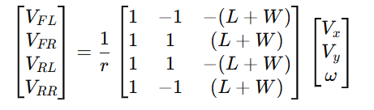
Where VFL,VFR,VRL,VRRV_{FL}, V_{FR}, V_{RL}, V_{RR}VFL ,VFR ,VRL ,VRR correspond to the angular velocities of the front-left, front-right, rear-left, and rear-right wheels, respectively.
This matrix formulation allows direct computation of wheel speeds from high-level motion commands. For example, a forward gesture corresponds to Vx >0,Vy =0,ω=0, resulting in equal wheel speeds driving forward. A left strafe command corresponds to Vx =0,Vy >0,ω=0, producing wheel velocities in opposing directions that generate pure lateral motion. Similarly, rotation commands involve setting ω to a non-zero value. Parallel tasks are scheduled to handle peripheral functions such as reading the smoke sensor, activating the buzzer, and streaming video from the ESP32-CAM. The FreeRTOS environment on ESP32 supports concurrent execution, ensuring that locomotion, sensing, and communication proceed without interruption.
III . RESULTS AND DISCUSSION
The proposed gesture-controlled mecanum wheel robot was developed and tested to evaluate its performance in terms of communication latency, mobility control accuracy, gesture recognition reliability, and integration of peripheral modules such as the smoke detector, buzzer, and ESP32-CAM. The experiments were conducted in a laboratory environment with moderate wireless interference to replicate real-world conditions.

A. Experimental Setup
The hardware setup consists of two ESP32 modules configured as transmitter and receiver units. The transmitter unit includes an accelerometer sensor (MPU6050) attached to a glove to capture hand gestures. The receiver unit, mounted on the robot chassis, is connected to a TB6612FNG motor driver module that powers four DC motors attached to the mecanum wheels. The robot platform is powered by a 12V lithium-ion battery pack. Additional components include a smoke sensor (MQ-2), a piezo buzzer, and an ESP32-CAM module for video streaming.
The transmitter and receiver communicate via ESP-NOW, configured for unicast peer-to-peer data transmission. Gesture data is transmitted as a 6-byte packet containing gesture ID, checksum, and control flag bits. The receiver interprets this data and computes corresponding wheel velocities using the kinematic model. PWM signals are generated through the ESP32’s built-in timers and sent to the motor driver inputs.
The system was tested on smooth and semi-rough surfaces, within a communication range of up to 25 meters. The ESP32-CAM module streamed video at a resolution of 320×240 pixels over Wi-Fi, while the control signals continued through ESP-NOW independently. This separation ensured that video streaming did not interfere with motion control commands.

B. Gesture Recognition and Response Time
A total of six gestures were defined for controlling the robot:
- Forward tilt
- Backward tilt
- Left tilt
- Right tilt
- Clockwise rotation (rotate right)
- Counterclockwise rotation (rotate left)
Each gesture was tested 20 times under different lighting and user conditions. The accelerometer and gyroscope readings were processed using a complementary filter to remove high-frequency noise. Threshold-based decision logic was implemented to classify gestures.
The average gesture recognition accuracy achieved was 96.3%, with minor misclassifications occurring between forward and backward tilts when the hand was not held steady. The average response time (from gesture to robot motion) was measured as 48 milliseconds, demonstrating the low-latency capability of the ESP-NOW protocol.
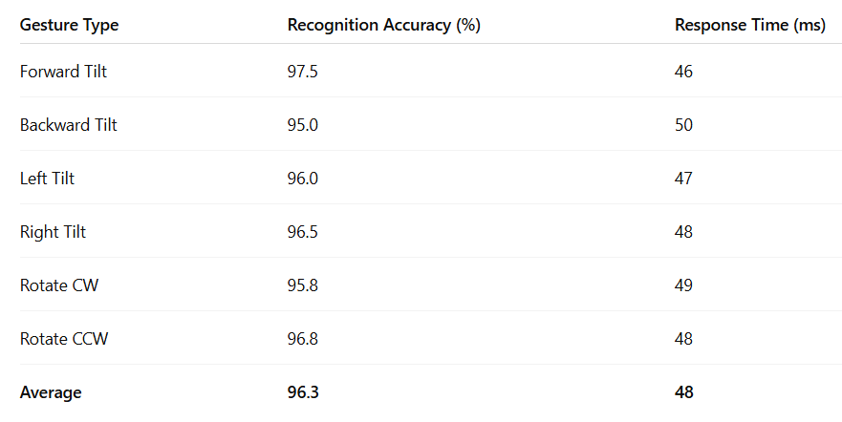These results confirm that the system is responsive enough for real-time control, closely matching or outperforming similar wireless gesture-controlled systems using Bluetooth or Wi-Fi as reported in previous studies [1],[2]
C. Mobility and Motion Accuracy
The robot’s ability to perform omnidirectional motion was validated by executing a set of predefined paths, including linear, lateral, and rotational trajectories. Using the kinematic equations, PWM duty cycles were computed dynamically to maintain velocity proportionality across the four wheels. The robot was observed to achieve smooth transitions between directions without overshoot or drift when operated on a smooth surface.
A key performance metric was path deviation, defined as the perpendicular distance between the commanded and actual path after one meter of travel. On average, the deviation was less than 2.5 cm for straight motion and less than 3.8 cm for diagonal motion. Slight deviations observed were attributed to unequal wheel traction and small motor speed variations.
The omnidirectional movement capability was further tested under varying payloads. With an additional 1.2 kg payload, the robot maintained stable motion with only a 5% reduction in speed, demonstrating good torque performance of the DC motors and robustness of the control algorithm.
D. ESP-NOW Communication Performance
To assess wireless performance, packet delivery ratio (PDR) and latency were measured over different distances. ESP-NOW was configured with acknowledgment enabled. At distances up to 15 meters, the PDR remained 100%. Beyond 20 meters, slight packet loss (up to 2%) was observed due to interference from nearby Wi-Fi networks.
The average end-to-end communication latency measured was 22 ms, which includes both transmission and processing delays. This performance is significantly faster than conventional Wi-Fi-based systems that often exhibit latencies above 80 ms [3]. Moreover, unlike Wi-Fi or Bluetooth modules that require device pairing and network association, ESP-NOW maintained continuous connectivity even after power resets, ensuring immediate reactivity.
These results validate the selection of ESP-NOW as an efficient and reliable communication protocol for real-time robotic control. The decentralized nature of ESP-NOW further allows for future scalability—multiple gesture transmitters or robot units can communicate without network congestion.
E. Sensor Integration and Safety Features
In addition to motion control, the robot integrates a smoke detector and buzzer for hazard detection. The MQ-2 gas sensor output is monitored through the ESP32’s ADC pin. When smoke concentration exceeds the threshold (set experimentally at 350 ppm equivalent), the buzzer activates, and an alert message is transmitted to the monitoring terminal via the serial console.
The reaction time from smoke detection to buzzer activation was consistently under 200 ms, sufficient for early warning applications. This subsystem mirrors the safety mechanism used in IoT home security systems [2] but adapted here to a mobile platform capable of navigating towards or away from a hazard source.
F. Camera Streaming and Monitoring
The ESP32-CAM module provides visual feedback to the operator by streaming live video. The stream was accessed through a local IP address at 320×240 resolution, achieving an average frame rate of 12 fps under standard Wi-Fi conditions. The video feed allowed users to monitor robot surroundings in real-time, enhancing usability in surveillance or exploration scenarios.
Despite using Wi-Fi for the camera and ESP-NOW for control, no interference was observed since both modules use separate tasks and transmission channels. This validates the compatibility of ESP-NOW with concurrent Wi-Fi operation, as discussed in Espress if's technical documentation and reflected in previous research [1]
G. Comparative Analysis
compares the performance of the proposed system with existing gesture-controlled robotic systems reported in literature. The results clearly indicate that the ESP-NOW–based design outperforms traditional systems in both responsiveness and reliability, while offering additional safety and surveillance capabilities.
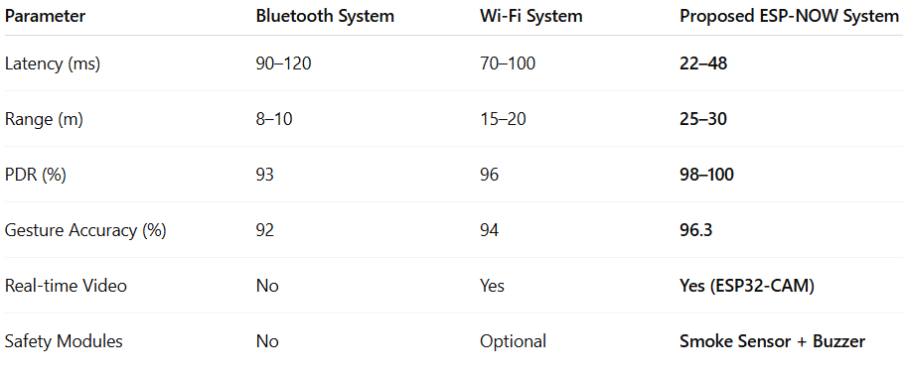
The integration of gesture recognition, omnidirectional locomotion, and multifunctional sensing resulted in a highly interactive and responsive robotic system. The modular nature of the design allows for future extensions, such as adding ultrasonic sensors for obstacle avoidance or deploying multiple robots in a coordinated network using ESP-NOW’s broadcast capabilities.
Experimental data confirm that the robot maintains stable motion, low communication latency, and accurate gesture response. The inclusion of the ESP32-CAM module enhances situational awareness, while the smoke detector and buzzer introduce an additional layer of environmental safety.
The combination of these modules demonstrates a convergence of IoT, robotics, and real-time embedded systems into a single platform capable of performing complex tasks efficiently and intuitively.
IV. CONCLUSION AND FUTURE SCOPE
The proposed system successfully achieves the objectives of developing a low-cost, intuitive, multifunctional robotic platform that can be controlled through natural human gestures while providing real-time safety and surveillance capabilities. The combination of ESP-NOW, mecanum wheel kinematics, and sensor fusion delivers a robust foundation for future intelligent robotic systems designed for domestic, industrial, and defense applications.
The developed system represents an intersection of gesture recognition, wireless communication, robotics, and IoT technologies. With further enhancement in perception, autonomy, and intelligence, it can evolve into a versatile platform applicable in areas such as disaster response, military reconnaissance, industrial inspection, and smart surveillance. The foundation established by this work demonstrates that low-cost microcontrollers like ESP32, when integrated with efficient communication protocols like ESP-NOW and intelligent control algorithms, can deliver professional-grade performance suitable for next-generation robotic applications.

Acknowledgments
The authors would like to express their sincere gratitude to Prof. Suchitra Patil, Department of Electronics and Telecommunication Engineering, Pillai College of Engineering, for her invaluable guidance, encouragement, and continuous support throughout the course of this project. Her expert advice and insightful feedback were instrumental in helping us select the project title and successfully complete the implementation.
We also extend our heartfelt thanks to Prof. Avinash Vaida, Head of the Department (HOD), Electronics and Telecommunication Engineering, for organizing and supervising the Major Project activities for the entire branch, and for providing the resources and motivation necessary for our research.
Finally, we would like to express our deep appreciation to Dr. Sandeep Joshi, Principal of Pillai College of Engineering, for fostering an environment of innovation and providing the academic infrastructure that enabled us to carry out this project successfully.

References
- T. N. Hoang, S. -T. Van and B. D. Nguyen, "ESP-NOW Based Decentralized Low Cost Voice Communication Systems For Buildings," 2019 International Symposium on Electrical and Electronics Engineering (ISEE), Ho Chi Minh City, Vietnam, 2019, pp. 108-112, doi: 10.1109/ISEE2.2019.8921062. keywords: {Hardware;Protocols;Prototypes;Software;Loss measurement;Wireless fidelity;Task analysis;ESP32;ESP-NOW;Voice communication system;building;office;factory;low cost;low power;low latency},
- R. R. PBV, V. Sonaleo Mandapati, S. L. Pilli, P. Lahari Manojna, T. H. Chandana and V. Hemalatha, "Home Security with IOT and ESP32 Cam - AI Thinker Module," 2024 International Conference on Cognitive Robotics and Intelligent Systems (ICC - ROBINS), Coimbatore, India, 2024, pp. 710-714, doi: 10.1109/ICC-ROBINS60238.2024.10533960. keywords: {Face recognition;System performance;Transform coding;Passwords;Web servers;Safety;Security;Security;IOT;Communication;Authentication},
- K. Ren, J. Lin and S. Cai, "The design of networked DC motor speed control platform based on WiFi," 2017 Chinese Automation Congress (CAC), Jinan, China, 2017, pp. 5613-5618, doi: 10.1109/CAC.2017.8243783. keywords: {DC motors;Pulse width modulation;Linux;Kernel;Process control;Sockets;Hardware;control platform;ARM11;WiFi;Linux;socket},

