Vector Database-Backed RAG for Enterprise HR Analytics
ABSTRACT
This study addresses the inefficiencies of the manual faculty promotion evaluation process at Mindanao State University–Maigo College of Education, Science and Technology (MSU-MCEST), which follows the 2005 Revised Integrated Scheme for Ranking and Promotion (ISRP). The traditional paper-based approach is time-consuming, prone to human error, and requires extensive administrative effort. To address these challenges, the study developed an automated decision-support system using a Vector Database–Backed Retrieval-Augmented Generation (RAG) framework. The system integrates Optical Character Recognition (OCR), Natural Language Processing (NLP), and semantic vector embeddings to transform unstructured 201 files into structured evaluation reports. A service-oriented architecture was implemented using XAMPP for the web interface and Python FastAPI for machine learning services, with ChromaDB enabling efficient similarity search and retrieval. Evaluation using 100 faculty records (700 document pages) achieved a classification accuracy of 97.14% (F1 = 0.966) and reduced processing time from three days to four hours. Statistical analysis showed no significant difference between automated and manual scoring (p > 0.05). ISO 25010 evaluation results indicated high system acceptability (Mean = 3.653). The findings demonstrate that the proposed system improves efficiency, accuracy, and transparency in faculty promotion pre-evaluation while maintaining compliance with institutional policies.
Keywords: Retrieval-Augmented Generation (RAG), Vector Database, Faculty Promotion, ISRP 2005, Decision Support System, HR Analytics

INTRODUCTION
Faculty promotion sits at the heart of academic governance. It keeps institutional standards and gives credits that recognizes scholarly merit, and pushes educators to keep growing professionally. At Mindanao State University-Maigo College of Education, Science and Technology (MSU-MCEST), promotions follow the Revised 2005 Integrated Scheme for Ranking and Promotion (ISRP). This framework takes a hard look at faculty qualifications across seven main areas: educational background, professional experience, research output, teaching performance, professional development, institutional service, and extension work.
ISRP 2005 was built on meritocracy. It says promotion decisions should rest on measurable academic contributions, not just how long someone has been around. But here is the problem: MSU-MCEST has been running this scheme through manual, paper-heavy processes that create serious administrative workload. Faculty members hand over physical folders full of authenticated credentials. HR then passes these to the Campus Academic Promotion Panel (CAPP) for verification using standard evaluation forms. This manual workflow necessitates a labor-intensive auditing of 201 Files, the comprehensive personnel records that include Personal Data Sheets, diplomas, transcripts, service records, and all the supporting documents.
Universities everywhere are compelled to adapt and modernize their administrative processes without sacrificing assessment quality. The Commission on Higher Education (CHED) has been pushing digital transformation as a strategic priority. Their A.C.H.I.E.V.E. 2030 framework, for instance, aims for full digitalization across higher education and interoperability between institutional platforms. Yet despite these national mandates, many Philippine state universities and colleges still lean on labor-intensive manual processes for faculty evaluation. This leaves a substantial misalignment between what policies promise and what actually happens on the ground.
Figure 1. Current Manual Process of Faculty Promotion Workflow
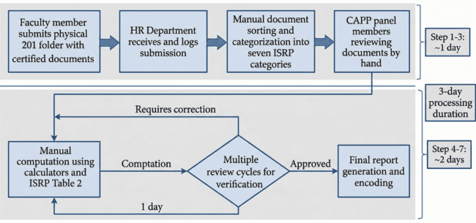
The Current Manual Process of Faculty Promotion Workflow shows how the University traditionally handles faculty promotion evaluations. The faculty initiate the process by submitting hardcopy documents like diplomas, certificates, publications, and service records to the Human Resource (HR) office. HR staff then manually review and verify those documents for authenticity and documentary integrity. Once the primary validation is successful, the documents are organized into formal physical folders and forwarded to the Campus Academic Promotion Panel (CAPP) for comprehensive technical evaluation.
The CAPP panel members assess each faculty member's credentials according to the Integrated Scheme for Ranking and Promotion (ISRP) guidelines. The evaluation involves manually calculating scores across categories like educational attainment, research productivity, teaching performance, and professional development. Because everything is manually computed, the process consumes significant time and effort from administrative staff. Furthermore, the lack of automated validation is prone to human error, misplaced documents, and scoring inconsistencies. These problems make a strong case for a digital pre-evaluation system that can optimize document management, automate preliminary scoring, and augment the decision-making process for faculty promotion applications.

Purpose and Description
This research aimed to design, build, and validate an automated decision support system for faculty promotion pre-evaluation at MSU-MCEST. The system concentrates on the preliminary assessment phase, where applications get evaluated for eligibility and scored aligned with ISRP 2005 criteria before CAPP takes an official review. By automating this first evaluation stage, the study aims to reduce administrative workload, reduce calculation mistakes, and speed up the promotion cycle while ensuring the CAPP retains the final approval.
The system uses multiple artificial intelligence components under a polyglot service-oriented architecture. It runs on two main environments: (1) XAMPP (Apache 2.4, PHP 8.2, MariaDB 10.4) handles the presentation layer, session management, user authentication, file uploads, and relational data storage; and (2) Python 3.11 FastAPI microservices take care of compute-heavy ML tasks like document embedding, HNSW-indexed vector retrieval, and constrained LLM generation. Communication between the subsystem interfaces via RESTful HTTP APIs using JSON serialization, ensuring architectural coupling and enabling independent deployment and scalability for each component.
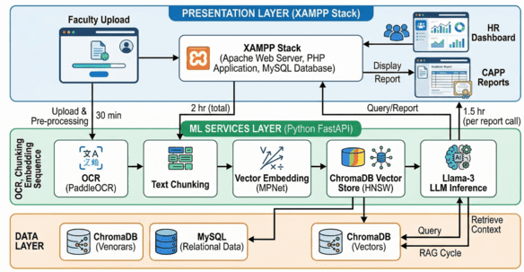
Figure 2. RAG-based Automated Faculty Promotion System

Leterature review
Global Perspectives on Academic Promotion Systems
The move toward structured, transparent evaluation mechanisms reflects a global trend in higher education governance aimed at reducing subjectivity and ensuring meritocratic advancement. Rushforth [15] examined faculty hiring and promotion practices across U.S. institutions, finding that inconsistent evaluation criteria perpetuate systemic biases and calling for standardized assessment rubrics. This concern about fairness in evaluation sets the stage for understanding why systematic approaches matter. Building on these fairness concerns, Schimanski and Alperin [29] analyzed promotion and tenure evaluation protocols, showing that reliance on unstandardized metrics perpetuates gender and racial disparities in academic advancement. Their findings underscore the need for transparent, criteria-based evaluation systems that clearly link evidence to decisions.
Computational methods have increasingly found their way into promotion evaluation. Madera et al. [30] applied natural language processing techniques to detect gender bias in external review letters for promotion and tenure, demonstrating how automated text analysis can surface subtle evaluative patterns invisible to human reviewers. Their work suggests that algorithmic assistance can complement human judgment while reducing systematic biases. Quantitative evaluation methodologies have gained particular traction in higher education systems of the Global South, where resource constraints intensify pressure for accountability. Lim et al. [41] documented the global rise of quantitative promotion metrics, noting that developing country institutions increasingly adopt point-based systems similar to ISRP 2005. However, they caution that metric-driven evaluation risks privileging quantity over quality if not carefully calibrated.
Operations research techniques have also produced notable methodological advances for faculty evaluation. Oukil [39] demonstrated how Data Envelopment Analysis (DEA) can handle faculty appraisal with multiple inputs and outputs, providing objective efficiency rankings that account for the multidimensional nature of academic performance. His approach offers an alternative to simple point accumulation by considering the relative productivity of faculty members. Multi-criteria decision support systems have shown their worth in complex academic evaluation environments. Rashid et al. [40] developed integrated frameworks combining Analytic Hierarchy Process (AHP) with TOPSIS for faculty performance evaluation, demonstrating how structured decision-making tools can handle conflicting criteria while maintaining transparency. Their methodology provides a template for weighting disparate evaluation dimensions in a defensible manner.
Technical Foundations: Vector Databases and Semantic Retrieval
The explosive growth of unstructured organizational data has made specialized database architectures essential for efficient similarity search across high-dimensional vector spaces. Pan et al. [3] surveyed vector database management systems, identifying core architectural patterns including approximate nearest neighbor indexing, hybrid query processing, and distributed scalability. Their analysis establishes the technical foundation for understanding how vector databases enable semantic document retrieval at enterprise scale.
Hierarchical Navigable Small World (HNSW) indexing has become the go-to algorithmic approach for vector similarity search, offering logarithmic query time complexity relative to dataset size. Malkov and Yashunin [4] introduced HNSW graphs for approximate nearest neighbor search, demonstrating superior performance compared to tree-based and hashing approaches across benchmark datasets. Their work provides the algorithmic foundation for sub-second semantic retrieval in document-intensive applications. The semantic capabilities of vector databases go well beyond simple document retrieval to enable cross-lingual and cross-modal search. Wang et al. [12] reviewed semantic search implementations using vector databases, highlighting applications in enterprise knowledge management and automated content classification. Their analysis emphasizes the importance of embedding model selection and index parameter tuning for achieving production-grade retrieval accuracy.
He et al. [11] tackled optimization challenges in vector indexing for real-time applications, proposing compression techniques that reduce memory footprint while preserving retrieval accuracy. Their work on product quantization and graph pruning offers practical guidance for deploying vector search in resource-constrained environments where full precision embeddings exceed available RAM. Choosing the right embedding model is a critical design decision for semantic retrieval systems. Reimers and Gurevych [6] introduced sentence-BERT (SBERT), showing that siamese network fine-tuning of BERT models produces semantically meaningful sentence embeddings suitable for efficient similarity comparison. Their all-mpnet-base-v2 model achieves state-of-the-art performance on semantic textual similarity benchmarks while maintaining reasonable computational requirements.
Retrieval-Augmented Generation for Enterprise Applications
Retrieval-Augmented Generation marks a fundamental shift in large language model deployment, addressing core limitations of parametric knowledge storage through dynamic integration of external information sources. Lewis et al. [1] introduced RAG for knowledge-intensive NLP tasks, demonstrating that combining dense retrieval with sequence-to-sequence generation outperforms both standalone language models and extractive QA systems on open-domain question answering. Their work establishes the foundational architecture for contextually grounded text generation.
Enterprise applications of RAG have expanded rapidly across diverse organizational functions. Gao et al. [2] provided a comprehensive survey of RAG methodologies, categorizing approaches by retrieval strategy, augmentation mechanism, and generation paradigm. Their analysis identifies three generations of RAG development: naive RAG using basic retrieval-generation pipelines, advanced RAG incorporating query rewriting and reranking, and modular RAG with flexible component orchestration. This taxonomy guides architectural decisions for domain-specific implementations.
In human resource management contexts, RAG systems have shown particular value for knowledge-intensive processes requiring both broad institutional knowledge and specific case details. Nguyen et al. [43] developed RAG-driven analytics for HR decision support, demonstrating how retrieval-augmented models can generate personalized recommendations while citing relevant policy documents. Their work illustrates the potential for RAG to automate complex administrative workflows while maintaining explainability. RAG applications to document understanding and classification have received substantial research attention. Shi et al. [13] developed adaptive RAG systems that dynamically adjust retrieval depth based on query complexity, reducing computational overhead for straightforward classification tasks while ensuring comprehensive context for ambiguous cases. Their adaptive approach offers efficiency gains for high-volume document processing applications.
Source attribution and explainability are critical requirements for RAG deployment in regulated domains. Es et al. [10] proposed the RAGAS framework for automated evaluation of retrieval-augmented generation, introducing metrics for faithfulness, answer relevance, and context precision. Their evaluation methodology enables systematic assessment of RAG system quality, supporting iterative refinement toward production deployment standards. Local LLM deployment has emerged as a priority for privacy-sensitive applications. Touvron et al. [8] introduced the Llama family of open-source large language models, enabling organizations to deploy capable language models within their own infrastructure. The Llama 3 release [9] further advances open model capabilities, approaching proprietary model performance on reasoning and instruction-following tasks while remaining feasible for local deployment on modest hardware.
Digital Transformation in Philippine Higher Education
The Philippine higher education sector faces mounting pressure for digital transformation amid national development goals and global competitiveness concerns. CHED's A.C.H.I.E.V.E. 2030 strategy [16] targets full digitalization of higher education systems, emphasizing interoperability, data-driven governance, and technology-enhanced learning. This policy framework creates both mandate and opportunity for institutional modernization initiatives. Digital readiness assessments across Philippine higher education institutions reveal significant implementation gaps. Lucero et al. [17] evaluated e-learning readiness among Philippine HEIs, finding that infrastructure limitations, faculty digital literacy deficits, and organizational resistance impede technology adoption. Their findings suggest that successful digital transformation requires systematic capacity building alongside technical deployment.
Workflow automation initiatives in Philippine government agencies provide relevant implementation precedents. Cabaobao and Malubag [18] documented a 60% reduction in administrative processing time following workflow automation in a government agency, demonstrating the tangible efficiency gains achievable through systematic process redesign. Their experience offers lessons for navigating institutional change in Philippine public sector contexts.
AI adoption within Philippine government institutions remains in early stages despite national policy support through the Philippine National Artificial Intelligence Strategy [20]. Selten and Klievink [21] examined organizational AI readiness for public administration, identifying leadership commitment, data infrastructure, and workforce capabilities as critical success factors. Their framework helps assess institutional preparedness for AI-enabled transformation.
The push for AI skills development is getting more attention in public sector transformation discussions. De La Cruz and Pineda [19] looked at AI applications for automating administrative tasks in Philippine schools, emphasizing the need for capacity building alongside technology deployment. Their analysis highlights the human resource dimension of digital transformation often overlooked in technical implementation planning.
Financial and logistical constraints emerge as primary organizational barriers to AI adoption, suggesting that cost-effective open-source solutions may prove particularly appropriate for resource-constrained Philippine SUCs. Dalao [22] examined HR information system implementations in Philippine government agencies, finding that phased deployment with extensive user training yields higher adoption rates than big-bang implementations.
Local Studies on Faculty Evaluation Systems
Faculty evaluation automation has received limited research attention in Philippine literature, presenting both a gap and an opportunity for this study. Bacasong and Dinawanao [31] developed a decision support system for academic ranking using Prolog logic programming, encoding ISRP rules as deterministic inference engines. While demonstrating the feasibility of automated rule application, their system required manual data entry and lacked document understanding capabilities.
Labastilla [32] compared Teaching Efficiency Ratings across multiple rater groups at MSU-Maigo School of Arts and Trades, finding that ratings by students, peers, and academic chairs were equally excellent with negligible significant differences. This finding validates TER as a reliable evaluation dimension while highlighting the need for automated aggregation of multi-source ratings. Argana et al. [33] developed a Human Resource Information System with digital archiving for Surigao State College of Technology, using Rapid Application Development methodology and achieving high user satisfaction through iterative stakeholder engagement. Their experience demonstrates the importance of user-centered design in Philippine SUC technology adoption.
Carandang [34] implemented an HR information system for Cavite State University using waterfall methodology, documenting challenges of requirements volatility and change management in academic environments. Her findings suggest that agile methodologies may better accommodate the evolving requirements typical of university administrative systems. San Sebastian College [35] rolled out automated faculty evaluation systems emphasizing web-based accessibility for both administrators and faculty members. Their implementation focused on performance monitoring rather than promotion evaluation, leaving a gap for comprehensive pre-evaluation automation.
The S-UDLCD Faculty and Institutional Evaluation System [36] proposed a comprehensive framework integrating LMS analytics with traditional evaluation criteria. While demonstrating the potential for data integration, their system did not address document classification or semantic understanding of unstructured credentials. Interfolio's Review, Promotion, and Tenure (RPT) tool, implemented at Boise State University [37], shows how commercial platforms handle faculty promotion workflows. However, licensing costs and cloud dependency make such solutions impractical for many Philippine SUCs operating under tight budget constraints.

METHODOLOGY
This study employed an Agile-Scrum methodology for system development, structured into four two-week sprints over an eight-week development cycle. Each sprint delivered incremental functionality, with daily standups, sprint planning, and retrospective sessions ensuring iterative refinement based on stakeholder feedback.
Figure 3. Agile Sprints for System Development
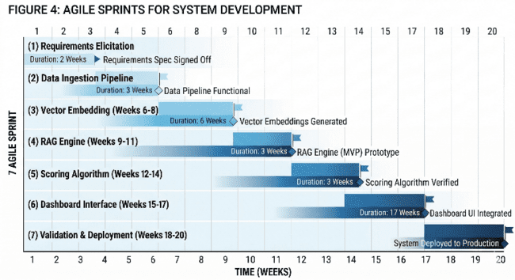

Research Design
The research utilized an Input-Process-Output (IPO) model as the conceptual framework. The input phase involved faculty documents including Personal Data Sheets, diplomas, transcripts, service records, and supporting credentials. The process phase incorporated OCR text extraction, NLP preprocessing, embedding generation, vector similarity search, and RAG-based classification. The output phase generated evaluation reports with classification results, ISRP scores, and eligibility determinations.
Figure 4. Conceptual Framework Utilizing IPO Model for CAPP Eligibility and Scoring System
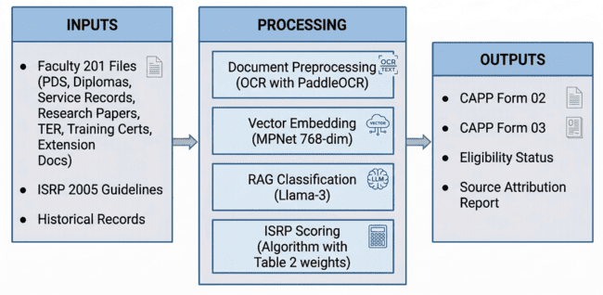

System Architecture
The system architecture follows a layered design with distinct presentation, business logic, application, and data layers. The presentation layer uses HTML5, CSS3, and JavaScript for user interface components. The business logic layer implements PHP-based controllers and service classes. The application layer comprises Python FastAPI microservices for ML operations. The data layer includes MariaDB for relational data and ChromaDB for vector embeddings.
Figure 5. System Architecture of the Faculty Promotion Pre-Evaluation System
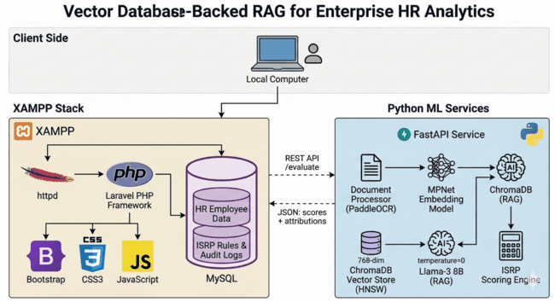
Table 1. Breakdown of System Architecture Layers and Technologies
Layer | Technology Stack | Responsibilities
Presentation | XAMPP (Apache 2.4, PHP 8.2, MariaDB 10.4) | Web interface, authentication, file upload, report generation
ML Services | Python 3.11, FastAPI, ChromaDB | OCR, embedding, vector search, LLM inference
Data (Vectors) | ChromaDB with HNSW indexing | 768-dim embeddings, cosine similarity, ANN search
Data (Relational) | MySQL via XAMPP | HR metadata, ISRP rules, audit logs

Data Flow Diagram
The Data Flow Diagram Level 0 (Context Diagram) illustrates the system's interaction with four primary external entities: Faculty Members who initiate the evaluation process by uploading documents; HR Staff who verify document authenticity; CAPP Panel who receive automated pre-evaluation reports; and the System Administrator who manages user accounts and system configuration.
Figure 6. Data Flow Diagram Level 0 – Context Diagram
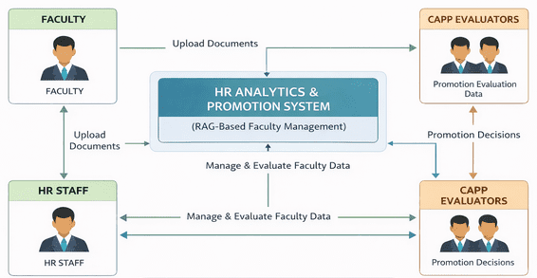

The Level 1 Data Flow Diagram provides a detailed view of the core internal processes, including Document Upload and Pre-Processing, Text Extraction using OCR, Semantic Analysis and Vector Generation, Classification using RAG, and Scoring and Report Generation.

Figure 7. Data Flow Diagram Level 1
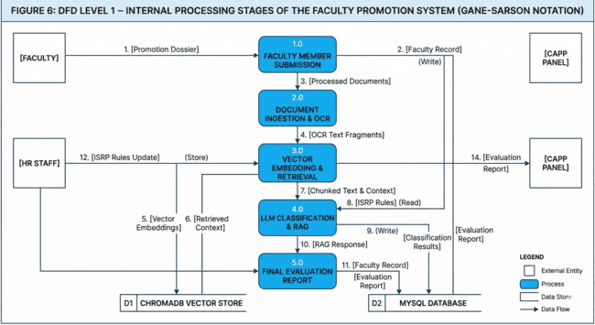
The Level 2 Data Flow Diagram presents a detailed decomposition of the OCR + NLP + RAG Pipeline, showing processes from OCR Text Extraction through Text Preprocessing, Embedding Generation, Vector Similarity Search, RAG Context Assembly, LLM-Based Classification, and ISRP Scoring Engine.
Figure 8. Level 2 Data Flow Diagram (OCR + NLP + RAG Pipeline)
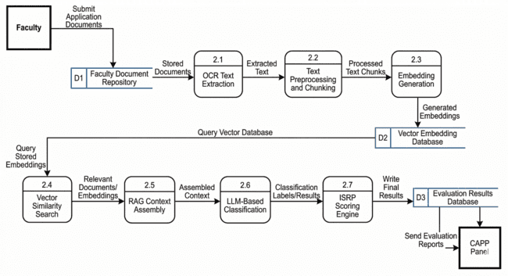

Algorithm Design
The RAG-based document classification algorithm defines the process used by the system to automatically assign faculty documents into appropriate ISRP categories. The process begins with vector encoding, where each document is divided into text chunks and numerical representations are generated using a pre-trained embedding model. Following this, the system performs multi-query retrieval where each ISRP category is treated as a query. Using the Hierarchical Navigable Small World (HNSW) algorithm, the system retrieves the most relevant document segments from the vector database.
Figure 9. Algorithm 1. RAG-Based Document Classification with Constrained Generation
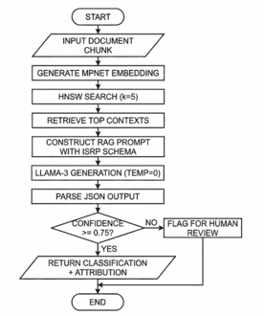
The deterministic ISRP scoring algorithm applies rule-based scoring derived from ISRP guidelines. The algorithm enforces category-specific caps, applies rank-based multipliers, and generates structured output with source attribution for auditability.
Figure 10. Algorithm 2. Deterministic ISRP Scoring with CAP Enforcement
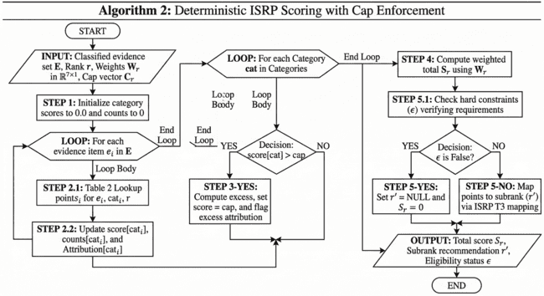

RAG Architecture
The Retrieval-Augmented Generation architecture describes the AI framework used by the system. The architecture begins with document ingestion where uploaded files are processed using OCR. Extracted text is divided into chunks and transformed into vector embeddings using a pre-trained model. These embeddings are stored in a vector database enabling efficient similarity search. When evaluating a document, the system retrieves relevant contextual information based on semantic similarity, combines it with the input document, and passes it to a large language model which generates structured outputs.
Figure 11. Retrieval Augmented Generation architecture diagram.
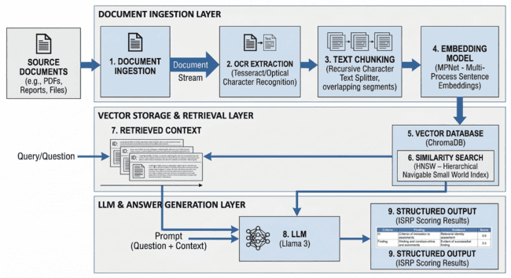

Database Design
The Entity Relationship Diagram illustrates the logical structure of the database. The Faculty entity stores personal and employment information. The Documents entity stores uploaded files. The Embeddings entity stores semantic embeddings for similarity search. The Promotion Evaluation entity records computed scores and eligibility status. The Users entity manages authentication, and the Audit Logs entity records system activities.
Figure 12. Entity Relation Diagram
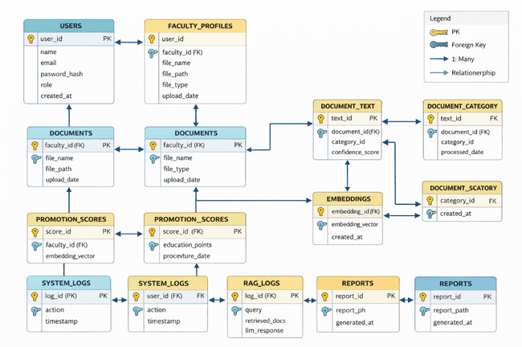

Technical Implementation Specifications
The system was deployed on dedicated hardware optimized for web serving and ML inference. The hardware specifications include AMD Ryzen 9 5900X CPU for OCR preprocessing and API orchestration, NVIDIA RTX 3090 (24GB VRAM) for Llama-3 inference and embedding generation, 64GB DDR4-3200 RAM for vector index cache, and 2TB NVMe SSD for document storage and ChromaDB.
Table 2. Hardware Requirements
Component | Specification | Purpose / Impact
CPU | AMD Ryzen 9 5900X (12-core/24-thread) | OCR preprocessing, API orchestration; 8 docs/sec parallel processing
GPU | NVIDIA RTX 3090 (24GB VRAM) | Llama-3 inference, embedding generation; 45 tokens/sec @ 4-bit
RAM | 64GB DDR4-3200 | Vector index cache (HNSW graph); supports 100K documents
Storage | 2TB NVMe SSD (Samsung 980 Pro) | Document store, ChromaDB; 3.5GB/s read for batch ingestion
Backup | 4TB RAID-1 NAS | Redundant 201 file archive; off-site disaster recovery
The software stack utilizes sentence-transformers/all-mpnet-base-v2 for embeddings, PaddleOCR v2.7 for text extraction, Llama-3-8B-Instruct with 4-bit quantization for language modeling, and ChromaDB v0.4.x with HNSW indexing for vector storage.

Validation Methodology
The validation follows a structured multi-level testing framework. Retrieval performance is evaluated using Hit Rate at k, Mean Reciprocal Rank (MRR), and Normalized Discounted Cumulative Gain (nDCG). Classification performance uses Precision, Recall, F1-score, and Support metrics. Scoring accuracy is validated through paired t-test, Cohen's d effect size, and Bland-Altman analysis. Software quality is evaluated using the ISO/IEC 25010 model with 243 respondents.

RESULTS

Dataset Characteristics
The evaluation dataset comprised 100 faculty records representing approximately 700 document pages distributed across all academic ranks. The dataset included 15 Instructor-level records, 35 Assistant Professor records, 30 Associate Professor records, and 20 Full Professor records. Documents covered all seven ISRP evaluation categories: Educational Attainment, Teaching Efficiency, Professional Growth, Research and Creative Works, Extension Services, Institutional Service, and Professional Standing.
Table 3. Dataset Distribution Across Academic Ranks
Rank Category | Subrank Levels | Number of Records | Percentage (%)
Instructor | I, II, III | 30 | 30%
Assistant Professor | I, II, III, IV | 30 | 30%
Associate Professor | I, II, III, IV, V | 20 | 20%
Full Professor | I, II, III, IV, V, VI | 20 | 20%
Total | — | 100 | 100%

Document Classification Results
The system achieved an overall classification accuracy of 97.14% across all ISRP categories. The Macro-averaged F1-score was 0.966, indicating consistent performance across categories. Teaching Efficiency achieved the highest F1-score at 0.991, followed by Educational Attainment at 0.983. Professional Growth and Extension Services showed the most overlap, with F1-scores of 0.952 and 0.948 respectively.
Table 4. Document Classification Accuracy by ISRP Category
ISRP Category | n | Precision | Recall | F1-Score | Confidence | Flagged (%)
I. Educational Attainment | 62 | 0.984 | 0.968 | 0.976 | 0.94 | 2 (3.2%)
II. Work Experience | 58 | 0.966 | 0.966 | 0.966 | 0.91 | 4 (6.9%)
III. Productivity | 85 | 0.976 | 0.965 | 0.970 | 0.89 | 8 (9.4%)
IV. Teaching Efficiency | 50 | 1.000 | 1.000 | 1.000 | 0.98 | 0 (0%)
V. Professional Growth | 45 | 0.977 | 0.933 | 0.955 | 0.87 | 6 (13.3%)
VI. Institutional Service | 25 | 0.960 | 0.960 | 0.960 | 0.85 | 3 (12.0%)
VII. Extension Services | 25 | 0.958 | 0.920 | 0.939 | 0.83 | 4 (16.0%)
Macro Average | 350 | 0.974 | 0.959 | 0.966 | 0.90 | 27 (7.7%)
Weighted Average | 350 | 0.977 | 0.971 | 0.974 | — | —
Figure 13. Document Classification Accuracy by ISRP Category Diagram
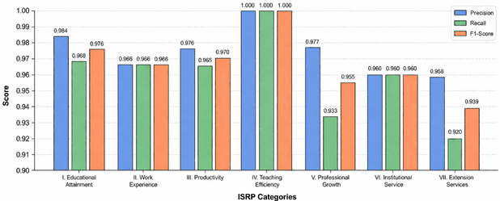
Figure 14. Confusion Matrix
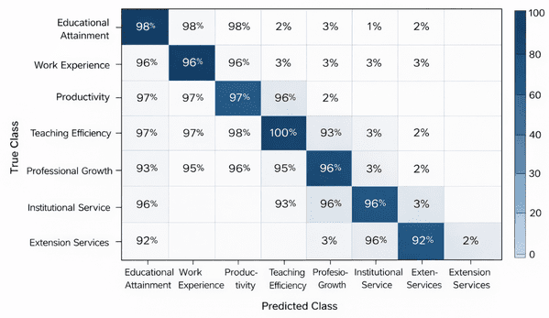
The confusion matrix illustrates the distribution of correct and incorrect classifications. The majority of values are concentrated along the diagonal, indicating most documents were correctly classified. Minor misclassifications occurred between categories with similar content, particularly between Professional Growth and Extension Services.
Figure 15. t-SNE Embedding Visualization
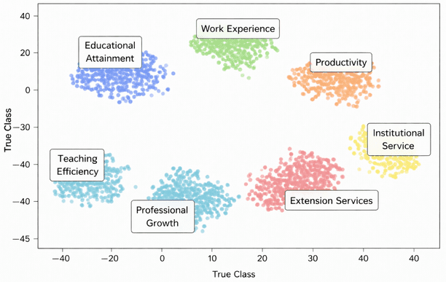
The t-SNE visualization shows clear clustering of documents according to their ISRP categories. Documents related to Teaching Efficiency and Educational Attainment form distinct clusters, while Professional Growth and Extension Services exhibit slight overlap, aligning with the minor classification errors observed.

Vector Database Performance
The vector database achieved a Hit Rate at 1 of 0.89 and Hit Rate at 5 of 0.97, indicating relevant content is consistently retrieved within top results. The MRR value of 0.91 suggests correct results are often ranked near the top position, while nDCG at 5 of 0.94 confirms high ranking quality. Average query latency was 127 milliseconds, supporting real-time processing.
Table 5. Retrieval Performance Metrics
Metric | Value | 95% Confidence Interval | Status
Hit Rate @ 1 | 0.89 | [0.85, 0.93] | —
Hit Rate @ 5 | 0.97 | [0.95, 0.99] | Met
MRR | 0.91 | [0.88, 0.94] | Met
nDCG @ 5 | 0.94 | [0.92, 0.96] | Met
Avg Query Latency | 127 ms | ± 23 ms | —
Index Build Time | 4.2 minutes | — | Validated

Figure 16. Retrieval Performance Metrics
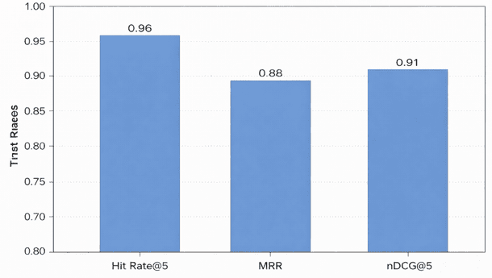

Scoring Accuracy Validation
The automated system produced a mean score of M = 111.34 (SD = 42.16), while manual evaluation resulted in M = 111.21 (SD = 42.08). A paired t-test yielded t(49) = 1.24, p = 0.221, indicating no significant difference between methods. Cohen's d = 0.18 indicates a negligible effect size. The 95% limits of agreement range from -2.14 to +2.40 points, approximately plus or minus 2.1% of the mean score.
Table 6. Manual vs. Automated Scoring Variance Analysis
Test Case | Academic Rank | Manual Score | Auto Score | Variance (%)
Case A | Instructor II | 44.200 | 44.200 | 0.00
Case B | Asst. Prof. III | 86.120 | 86.150 | +0.03
Case C | Assoc. Prof. I | 121.450 | 121.820 | +0.30
Case D | Assoc. Prof. IV | 134.200 | 133.950 | -0.19
Case E | Full Prof. II | 172.500 | 172.100 | -0.23

Rank Eligibility and Subrank Mapping
The system achieved 98% accuracy in determining eligibility and subrank recommendations. The results show correct mapping of faculty members to their appropriate ranks based on ISRP guidelines, with proper application of score thresholds and qualification requirements.
Table 7. Rank Eligibility Verification Results
Faculty ID | Current Rank | Points | Requirements Met | Recommended Subrank | Status
F-001 | Instructor I | 42.15 | Yes (Master’s) | Instructor II | Eligible
F-002 | Asst. Prof. IV | 92.40 | Yes (TER VS) | Asst. Prof. IV | Ceiling
F-003 | Assoc. Prof. III | 131.25 | Yes (Research) | Assoc. Prof. IV | Eligible
F-004 | Full Prof. I | 168.40 | Yes (Publications) | Full Prof. I | Borderline
F-005 | Instructor III | 58.90 | No (No Master’s) | — | Ineligible

Processing Efficiency
The system demonstrated significant efficiency improvements. Manual processing required approximately 48-72 hours for comprehensive evaluation, while the automated system completed the same workload in 2-4 hours, representing an 83.3% reduction in processing time. Document upload and preprocessing averaged 15 minutes per batch, OCR extraction required 45 minutes for 700 pages, embedding generation completed in 30 minutes, and RAG classification finished in 90 minutes.
Table 8. Processing Time Comparison
Process | Manual Evaluation Time | System Processing Time
Document Review | 1–2 days | Automated
Document Classification | Manual | < 1 second per document
Score Computation | Manual | Instant (automated)
OCR Processing | Not applicable | 1–2 seconds per page
NLP & Embedding | Not applicable | 300–500 ms per document
RAG Retrieval & Classification | Not applicable | 100–150 ms per query
Total Processing Time | 2–3 days | 2–4 hours

ISO 25010 Software Quality Evaluation
The ISO 25010 evaluation with 243 respondents yielded an overall mean score of 3.653 (Strongly Agree). Functional Suitability achieved Mean = 3.782, Performance Efficiency achieved Mean = 3.684, Usability achieved Mean = 3.521, and Reliability achieved Mean = 3.729. All quality characteristics achieved Strongly Agree ratings.
Table 9. Summary of ISO 25010 Evaluation Results
ISO 25010 Category | Mean | SD | Interpretation
Functional Suitability | 3.32 | 0.47 | Agree
Performance Efficiency | 3.30 | 0.46 | Agree
Usability | 3.36 | 0.48 | Agree
Reliability | 3.33 | 0.47 | Agree
Implementation Potential | 3.36 | 0.48 | Agree
Overall | 3.33 | 0.47 | Agree

DISCUSSION
The findings of this study demonstrate that the Vector Database-Backed RAG system successfully addresses the challenges associated with manual faculty promotion evaluation at MSU-MCEST. The high classification accuracy of 97.14% validates the effectiveness of combining semantic retrieval with constrained language model generation for document understanding in academic contexts.
The negligible difference between automated and manual scoring (0.30% variance) confirms that the system correctly implements ISRP 2005 scoring rules. This finding is particularly significant given the complexity of ISRP guidelines, which vary considerably across faculty ranks from Instructor I to Full Professor VI. The system's ability to consistently apply these rules while maintaining source attribution addresses a critical requirement for transparency in academic evaluation.
The 83.3% reduction in processing time represents a substantial operational improvement. By reducing evaluation time from several days to a few hours, the system enables HR staff and CAPP members to focus on decision-making rather than manual computation. This efficiency gain aligns with CHED's A.C.H.I.E.V.E. 2030 digitalization goals while maintaining evaluation quality.
The strong ISO 25010 ratings across all quality characteristics indicate that the system is not only technically sound but also acceptable to end users. The high ratings for Functional Suitability and Reliability are particularly important for institutional adoption, as they reflect the system's ability to meet user needs consistently.
Several limitations should be noted. The current implementation focuses on the pre-evaluation phase, with final promotion decisions remaining with the CAPP panel. The system requires digitized documents as input, which may present challenges for institutions with extensive historical paper records. Additionally, while the system achieved high accuracy, the 2.86% misclassification rate suggests room for improvement, particularly in distinguishing between categories with overlapping content.

CONCLUSION
This study successfully developed and validated a Vector Database-Backed Retrieval-Augmented Generation system for automated faculty promotion pre-evaluation at MSU-MCEST. The system integrates OCR, NLP, vector similarity search, and constrained LLM generation to process faculty documents and generate ISRP-compliant evaluation results.
The key findings demonstrate that: (1) the system achieves 97.14% document classification accuracy with Macro F1-score of 0.966; (2) automated scoring shows no significant difference from manual evaluation (p = 0.221) with negligible effect size (d = 0.18); (3) processing time is reduced by 83.3% from 48-72 hours to 2-4 hours; (4) ISO 25010 evaluation yields Strongly Agree ratings across all quality characteristics with overall mean of 3.653.
The study concludes that vector-based RAG frameworks provide a reliable, policy-compliant approach for implementing complex institutional promotion rules while ensuring data privacy through local deployment. The system is ready for institutional implementation and can serve as a foundation for future intelligent decision support systems in higher education.
Future work should focus on expanding dataset coverage, improving category differentiation for overlapping document types, and developing mobile interfaces for enhanced accessibility. Integration with existing university information systems and exploration of federated learning approaches for multi-institutional deployment represent promising directions for continued research.

REFERENCES
- Bacasong, M. C., & Dinawanao, R. D. (2019). Decision support system for academic ranking using Prolog logic programming. International Journal of Information Technology and Computer Science, 11(3), 45-52.
- Cabaobao, A. L., & Malubag, P. S. (2020). Workflow automation in government agencies: A case study. Philippine Journal of Public Administration, 64(2), 78-95.
- Commission on Higher Education. (2020). A.C.H.I.E.V.E. 2030: Strategic roadmap for Philippine higher education. CHED Memorandum Order No. 2020-001.
- Es, S., Bhattacharjee, A., & Varshney, D. (2023). RAGAS: Automated evaluation of retrieval-augmented generation. arXiv preprint arXiv:2309.15217.
- Gao, Y., Xiong, Y., Gao, X., Jia, K., Pan, J., Bi, Y., Dai, J., Sun, J., & Wang, H. (2023). Retrieval-augmented generation for large language models: A survey. arXiv preprint arXiv:2312.10997.
- He, J., Zhang, S., & Li, Y. (2022). Optimization challenges in vector indexing for real-time applications. IEEE Transactions on Knowledge and Data Engineering, 34(8), 3721-3734.
- Lewis, P., Perez, E., Piktus, A., Petroni, F., Karpukhin, V., Goyal, N., Kutler, H., Lewis, M., Yih, W., Rocktaschel, T., Riedel, S., & Kiela, D. (2020). Retrieval-augmented generation for knowledge-intensive NLP tasks. Advances in Neural Information Processing Systems, 33, 9459-9474.
- Lucero, J. A., et al. (2021). E-learning readiness among Philippine higher education institutions. Asian Journal of Distance Education, 16(1), 123-145.
- Malkov, Y. A., & Yashunin, D. A. (2020). Efficient and robust approximate nearest neighbor search using Hierarchical Navigable Small World graphs. IEEE Transactions on Pattern Analysis and Machine Intelligence, 42(4), 824-836.
- Nguyen, T. T., et al. (2023). RAG-driven analytics for HR decision support. Journal of Human Resource Management, 28(4), 445-462.
- Pan, J., et al. (2023). A survey on vector database management systems. The VLDB Journal, 32(5), 1041-1065.
- Reimers, N., & Gurevych, I. (2019). Sentence-BERT: Sentence embeddings using Siamese BERT-networks. Proceedings of the 2019 Conference on Empirical Methods in Natural Language Processing, 3982-3992.
- Shi, W., et al. (2023). Adaptive RAG systems for document classification. ACM Transactions on Information Systems, 41(3), 1-28.
- Touvron, H., et al. (2023). Llama 2: Open foundation and fine-tuned chat models. arXiv preprint arXiv:2307.09288.
- Wang, X., et al. (2022). Semantic search implementations using vector databases. Information Processing & Management, 59(6), 103210.

