Study Report on Affordable and Clean Energy (SDG 7) in Various Indian States

The Sustainable Development Goals Agenda 2030 is a universal call to end hunger and poverty, protect the environment and ensure fulfillment of needs of the future generations. Affordable and clean energy, SDG-7, holds an important place as energy is central to nearly every major challenge the world faces today. SDG – 7 clearly states its agenda as ensuring access to affordable, reliable, sustainable and modern energy to all by 2030.To protect the environment, clean energy is the front runner and the most essential precondition. It is widely recognized that energy services are important for the well-being of mankind, is quintessential-for the country’s economic prosperity and is essential for the fulfillment of various other SDGs including provision of clean water, sanitation, health care etc. The Indian approach to this goal takes into consideration the parameters of – access to electricity, renewable energy, clean cooking fuel and energy efficiency. The present study is based on purely secondary data. On the basis of various SDG reports, a comparison will be made among different states. The research paper aims to analyze the performance of Indian states on SDG- 7. A comparison has been made from the year to year basis i.e. 2018-19 to 2020-21 to analyze the improvement in the performance of states on various fronts under this goal. The researchers will analyze the performance of various Indian states on some parameters and also explore the improvement in their SDG index score.

Keywords: Sustainable development goals, clean energy, Indian states, SDG index , SDG-7.

- Introduction:
The Sustainable Development Goals Agenda 2030 are a universal call to end hunger and poverty, protect the environment and ensure the fulfillment of needs of the future generations. India, with nearly 17% of the world’s population holds the key to global SDG achievement. Keeping in mind the country’s federal structure, the various Indian states are crucial to India’s progress in meeting the sustainable development goals. States and local governments play a pivotal role in implementing development programmes by spending nearly 70% more than the Central government on SDGs and therefore becoming essential stakeholders for realization of the global agenda by 2030. Niti Aayog acts as the nodal institution to coordinate the SDG efforts at national and sub national levels and publishes the SDG index for a comprehensive analysis of various Indian states in regards to performance of the various set targets.
Affordable and clean energy, SDG-7, holds an important place as energy is central to nearly every major challenge the world faces today. SDG – 7 clearly states its agenda as ensuring access to affordable, reliable, sustainable and modern energy to all by 2030. Clean and affordable energy forms the backbone of various socio-economic developmental projects in the economy and therefore holds immense significance. To protect the environment, clean energy is the front runner and the most essential precondition. Renewable energy, which constitutes a significant part in shaping the shared future of the world, is a major subsection under this goal. It is widely recognised that energy services are important for the well-being of the mankind , is quintessential-for the country’s economic prosperity and is essential for the fulfillment of various other SDGs including Goal 1 (no poverty), Goal 2 (zero hunger), Goal 3 (good health and well-being) , Goal 4 (quality education), Goal 5 (gender equality), Goal 6 (clean water and sanitation) , Goal 8(decent work and economic growth), Goal 9 (industry, innovation and infrastructure), Goal 10 (reduced inequalities), Goal 11 (sustainable cities and communities), Goal 12 (sustainable consumption and production) and Goal 13 (climate action). The Indian approach to the goal (SDG-7) takes into consideration the crucial parameters of – access to electricity, renewable energy, clean cooking fuel and energy efficiency. The goal holds relevance as availability of uninterrupted clean energy is a necessity for the country to meet its ambitious target of double-digit economic growth. Multiple programmes and schemes have been implemented across national and sub national level, clearly showing the priority and importance of the goal.

Review of literature:
A brief review of the various studies has undertaken on the research topic under study include the following. Mall, Chandrakanta, and Prem Prakash Solanki(2021) studied about the potential and prospects of renewable energy in India. The study highlighted that India had made significant progress in shifting energy use mix from conventional to non-conventional. The results of the study stated that renewable energy accounted for only 18% of the total energy bag in the country and increasing this is the need of the hour. The study also highlighted the role of various government Of India policies and programmes aiming towards energy sustainability, efficiency, security and affordability.
Shahbaz, Muhammad, et al.(2021) Analysed the non-linear impact of economic growth diverse on CO2 emissions by designing and SDG framework for India. The study took into consideration the time frame from 1980 to 2019 and the results stated that positive variations in national output Significantly intensify see you to emissions in India. Energy accounted for a significant source of CO2 emissions .
Sharma, Hari Prapan, and Ashish Chaturvedi(2020) Added to a comparative study for SDG index 2018 and 2019 and threw light on issues that facilitated the formants in non-performance of India on various goals. The results of the paper primarily highlighted the areas which would help the policymakers to improve STG performance. It came to light that India had been showing significant progress but innovative strategies in adequate policy formulation in certain aspects had to be immediately implemented for better results. The study also highlighted the north-south gap in development.
Franco, Isabel B., Caitlin Power, and Josh Whereat. (2020) analysed and compared to case studies, Japan and Colombia, using qualitative methodology and highlighted that key stakeholders in energy sector, both renewable and fossil fuels, need to engage in enhancement of capacities towards achievement of SDG7. It also highlighted that the role of women needs to be in hands to foster overall sustainable development.
Pecci-Oviedo, M. E.(2020) undertook a study to highlight various good practises towards fulfillment of SDG – seven affordable and clean energy. The results highlighted that international cooperation to facilitate access to research in technology related to clean energy would have to be increased for achievement of the underlined agenda. The results stated that promotion of investment in energy infrastructure in clean technologies undoubtedly holds the centre stage.
Acharya, Rajesh H., and Anver C. Sadath (2019) undertook a study in regards to energy poverty and economic development in India. Estimates have been given for constructing multi dimensional energy poverty index and an index of development at the district level. Empirical results from the study showed that energy poverty was quite extensive in India with substantial variations across states. The study highlighted that energy poverty and social economic backwardness in India were highly correlated. The study also highlighted that energy poverty was lower in urban India in comparison to rural India.
Jagger, Pamela, et al.(2019) studied sustainable development goal 7 in context of its effect on forest and forest- based livelihood. The results highlighted that the rule of traditional fuel wood in energy provision would declined, though it is likely to persist in low and middle income countries. The study highlighted the fact that the achievement of SDG7 depended directly on the cost and innovation in storage capacity of renewable energy including solar, wind and micro hydro. The study also put two picture the fact that energy transition involved decreased reliance on traditional fuel food while on the other hand it meant an increase in the use of forest derived modern fuels.
Mehta, Simi, et al.(2018) in their study highlighted the shortcomings of the Millennium development goals and contended that both India and Bangladesh need to initiate a variety of measures to accelerate the process of growth and development with equity in sustainability. The study suggested that India and Bangladesh should collaborate to protect the shared ecology and learn from each other’s strengths and weaknesses for sustainable development in this region.
Prabhakar,M, et al.(2018) in their study highlighted the challenges in regards to sustainable development goals in India. The researchers clearly highlighted the various challenges including defining indicators, financing SDGs and monitoring and ownership besides providing certain suggestions in regards to the same . Elavarasan RM, Shafiullah GM, Manoj Kumar N, Padmanaban S.(2018) undertook an extensive research on the only present situation, barriers and the various future initiatives in regards to renewable energy in Gujarat. The study examined the actions and policies adopted by the Gujarat government to overcome the potential barriers so as to support non-conventional as well as renewable energy development. The study also accounted for the numerous techno- economic and social constraints with possible solutions in promoting the deployment of upcoming renewable energy resources across Gujarat.
Ackah, Ishmael.(2016) analysed the policy interventions in renewable energy for attaining sustainable development goal 7 in Ghana. The study highlighted the relationship between renewable energy investment and sustainable development along with providing policy recommendations to fast track renewable energy technology development in Ghana.

Objective of the study:
To undertake a comparative analysis of the various Indian states’ index scores for sustainable development goal seven – affordable and clean energy.

Database and research methodology:
Research design:
Research design is defined as a set of advance decisions that make up the master plan specify the methods and procedures for collecting, analyzing and interpreting the required data (Makwembere, 2014) . In the present study, an attempt has been made to analyse the SDG index score for goal-7 for the Indian states numbering 29(Jammu Kashmir has been taken as a state in reference to 2018-2019 SDG report).

Methodology:
The study takes into consideration secondary data from sustainable development goals reports published by NITI Aayog for 2018-2019, 2019-2020, and 202-2021.Tables, graphs, charts and figures have been used to highlight the comparison among different Indian Sates and make the study effective as well as representable . Time period of the study:
The time frame of the study is 2018–19 to 2020–21. The year 2018–19 marked the beginning of publishing of SDG index score reports by NITI Aayog for various Indian states.

Analysis and results:
This study aims to decode the pattern of achievement of SDG-7 targets by various Indian states. NITI Aayog has published the SDG index score for various Indian states and union territories beginning from 2018–19. The study takes into consideration the various sub categories as mentioned in the report. For the measurement of SDG-7 NITI Aayog has selected the indicator of percentage of households electrified, percentage of households using clean cooking fuel and renewable share of installed generating capacity for the year 2018-2019 and only the former 2 for the years 2019-2020 and 2020-2021.

TABLE 1 - THE SDG-7 AFFORDABLE AND CLEAN ENERGY INDEX SCORE FOR THE YEARS 2018-19, 2019-20 AND 2020-21
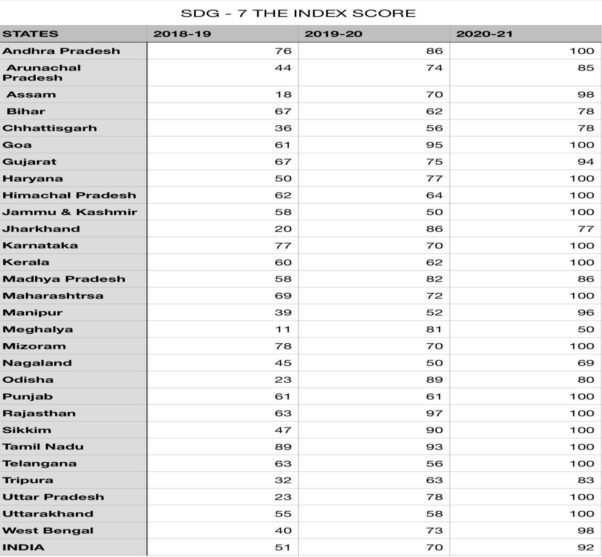

Table 1 shows SDG index scores for SDG – 7 (affordable and clean energy) for various Indian states from the period 2018–19 to 2020–21. The table highlights the fact that the SDG scores have improved for most of the Indian states. A number of states by the end of 2020–21 have also managed to portray the ideal score of 100.

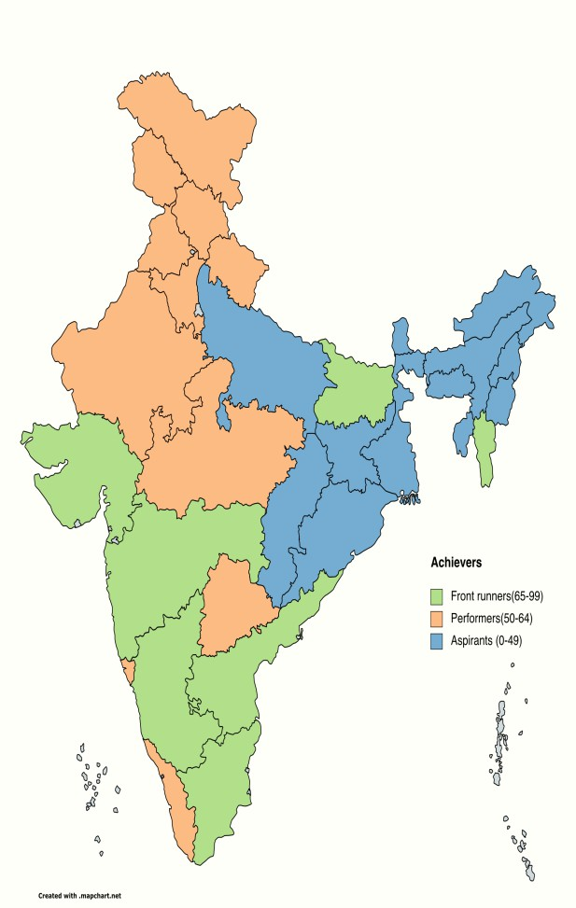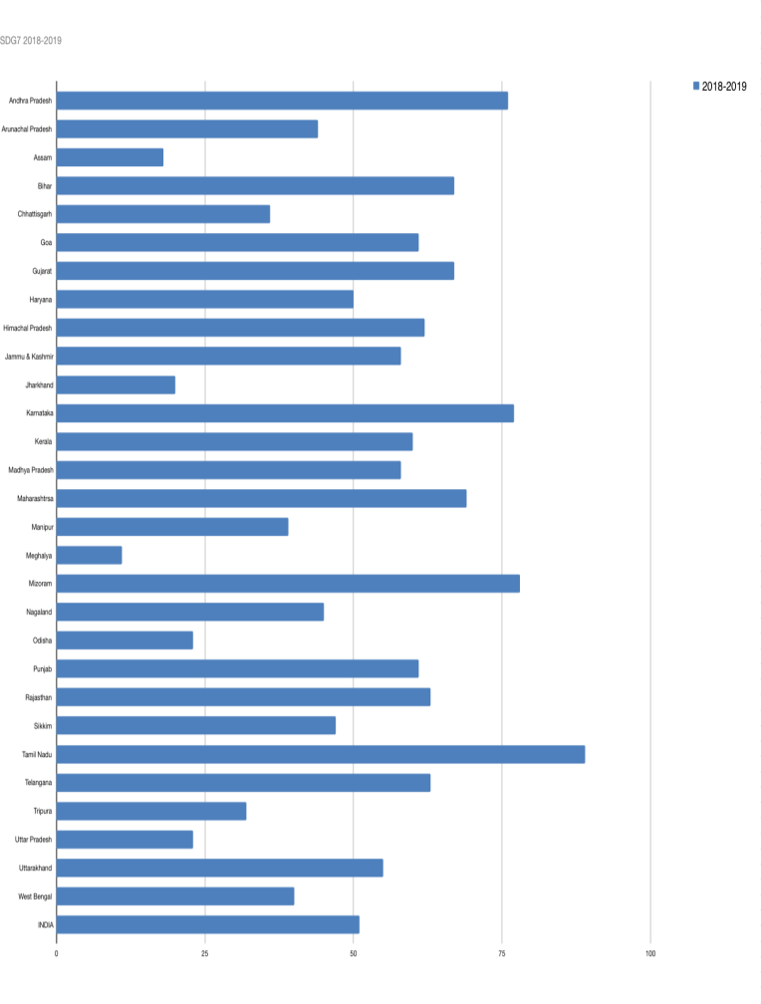

Figure 1 and chart 1 depict the SDG scores for various Indian states for 2018–20 19. It is clearly visible that only seven states have managed to score between 65 to 99 and that’s why these are called front-runners category states. These states include Tamil Nadu, Mizoram, Karnataka, Andhra Pradesh, Maharashtra, Bihar and Gujarat. Rajasthan, Telangana, Himachal Pradesh, Goa, Punjab, Kerala, Jammu Kashmir, Madhya Pradesh, Uttarakhand and Haryana fall in the category of performers with the score ranging between 50–64. All other states including Sikkim, Nagaland, Arunachal Pradesh, West Bengal, Manipur, Chhattisgarh, Tripura, Orissa, Uttar Pradesh, Jharkhand, Assam and Meghalaya constitute the lowest bracket of aspirants with the score ranging between 0 to
49. A fact that needs to be highlighted here is that there is no achiever (100 scorer) for the year 2018–19.

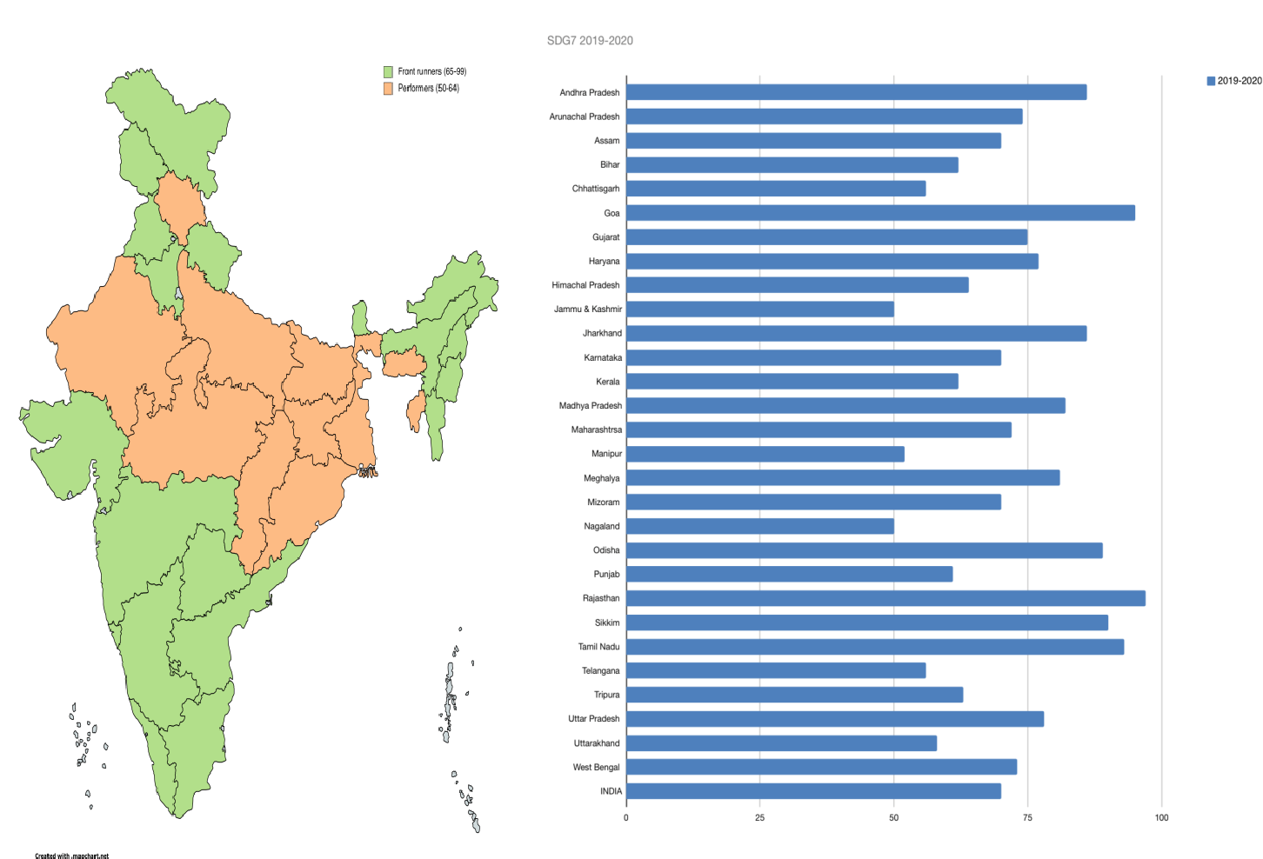

Diagram 2 and figure 2 shows the index score for various states for the year 2019-2020. All the Indian states in this year rank only in two categories namely front runners and performers. The states of Goa, Sikkim, Telangana, Tamil Nadu, Punjab, Andhra Pradesh, Karnataka, Maharashtra, Mizoram, Uttarakhand, Haryana, Gujarat, Arunachal Pradesh, Manipur, Assam, Kerala and Nagaland managed to score between 65-99, thus falling under the category of frontrunner. All other states had a score between 50–64 thus falling under the performer category. It is clearly highlighted that in one single year all states managed to come out from the last segment of aspirants. But no state could manage a perfect score of hundred and become an achiever.

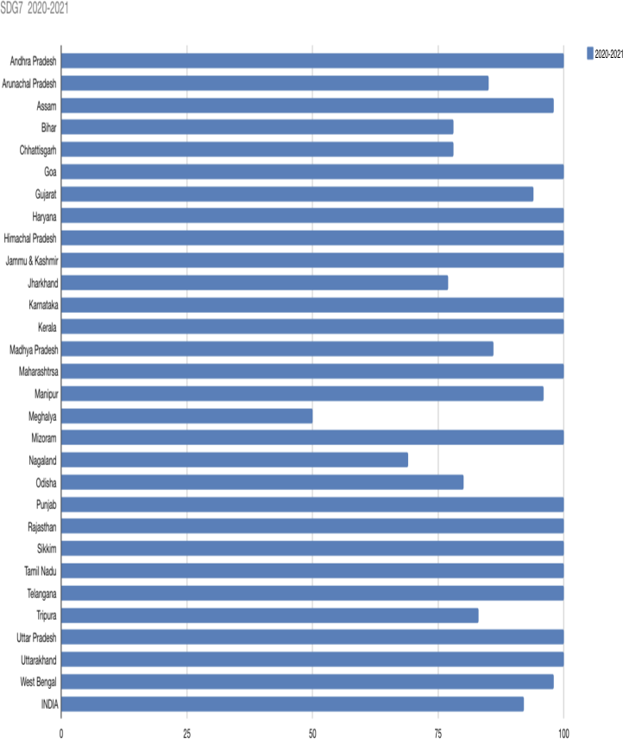
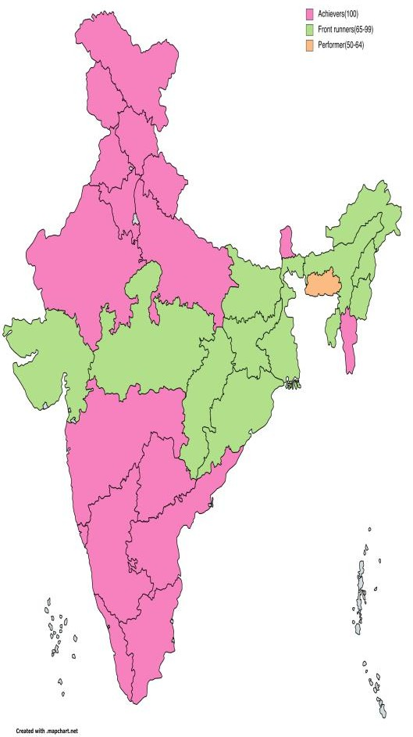

Diagram 3 and figure 3 pertain to the SDG scores for various states for the year 2020–21. The goal of affordable and clean energy achieved substantial gains in this particular year. A total of 16 states managed to make it to the achievers category with a score of 100. These included the Eastern states of Mizoram and Sikkim; the northern states of Jammu and Kashmir, Himachal Pradesh, Uttarakhand, Haryana, Punjab and Uttar Pradesh; the western states of Gujarat and Rajasthan; the southern states of Karnataka, Kerala, Tamil Nadu, Telangana and Andhra Pradesh along with Goa. All other states except Meghalaya lay in the category of front runner. The state of Meghalaya with a score of 50 stood as the sole state in the category of performer.

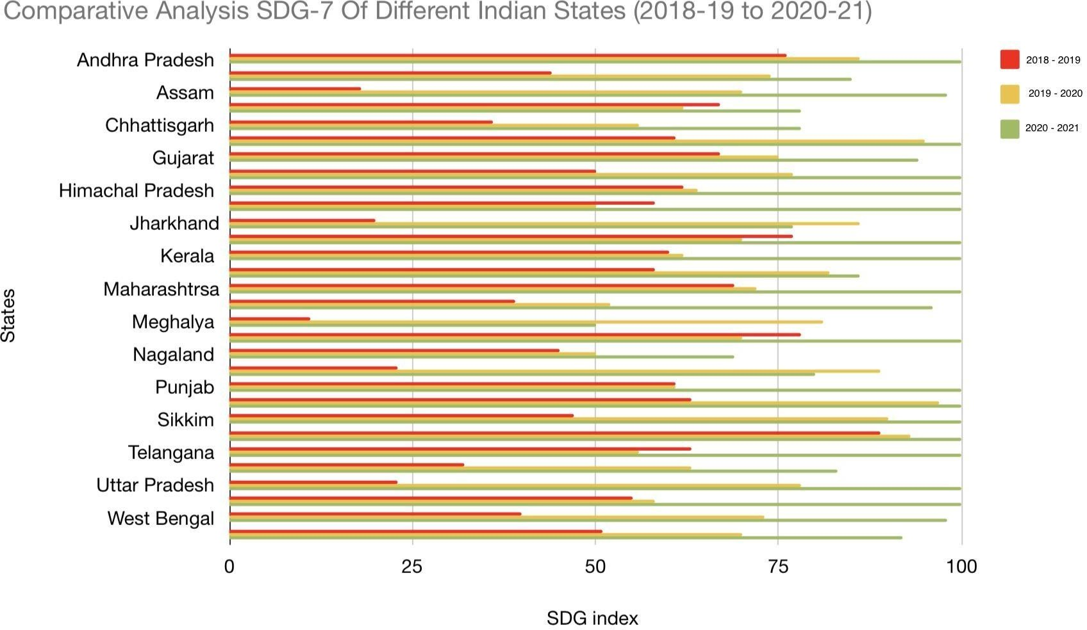

Figure 4 highlights the comparative analysis of various Indian states for SDG-7 (clean and affordable energy) index score. It helps in analyzing the performance of the states over the span of three years. The different color bars represent different years under study.

TABLE 2 - COMPARISON OF SDG-7 AFFORDABLE AND CLEAN ENERGY INDEX SCORE FOR THE YEARS 2018-19, 2019-20 AND 2020-21
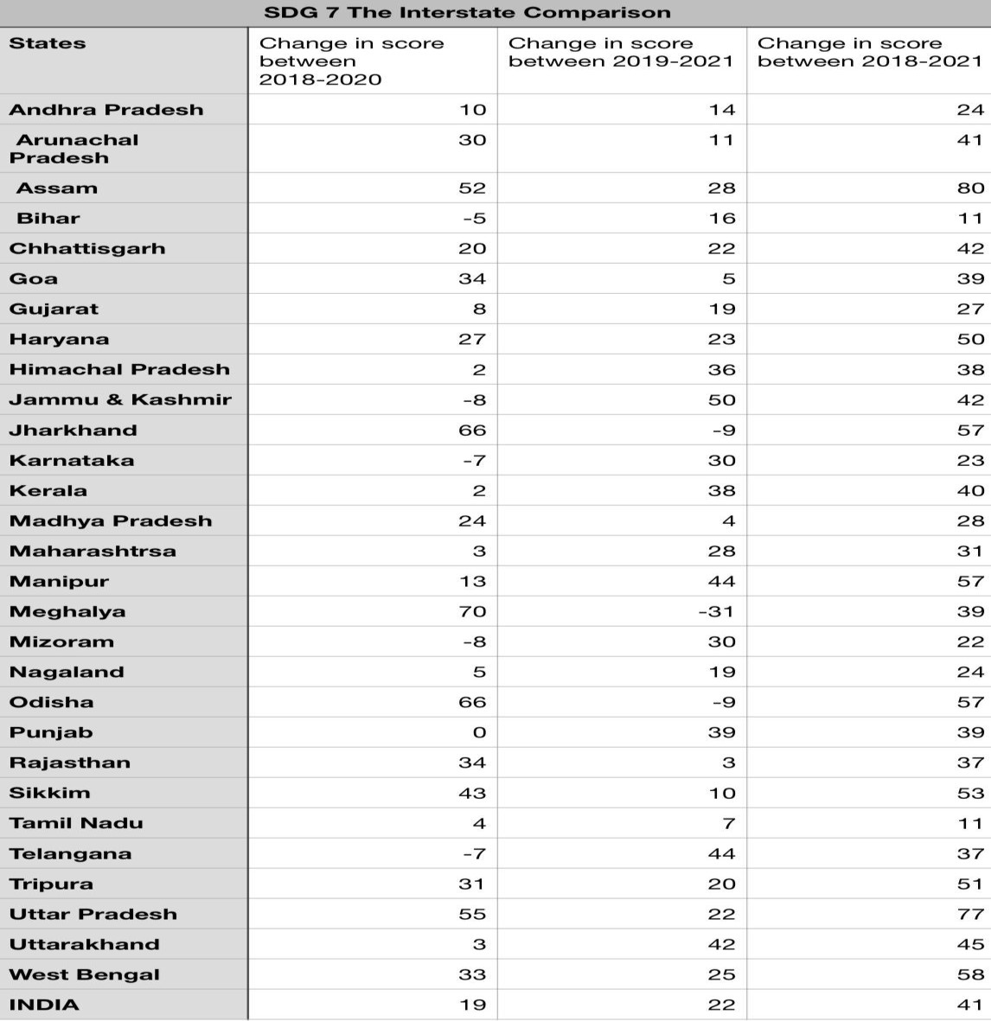

Table 2 portrays a comparative analysis in the form of change in score for the three years under study. The change in score between the year 2018–19 to 2019–20 shows improvement by most states except Bihar, Karnataka, Jammu and Kashmir, Mizoram and Telangana where a negative trend in scores is seen. The maximum increase has been registered by the state of Meghalaya followed by Jharkhand and Orissa. Considerable improvement or more than or equal to 30 has been registered by Arunachal Pradesh, Assam, Goa, Rajasthan, Sikkim, Tripura, Uttar Pradesh and West Bengal. For change in scores between 2019–22 and 2020–21, it is clearly visible that except for 2 states Jharkhand and Odisha, all other states have shown positive increase in scores. The states of Jammu and Kashmir, Manipur, Kerala, Mizoram, Punjab, Telangana and Uttarakhand have shown considerable improvement of more than 30 points.
Taking into consideration the change observed during the span of three years it is clearly visible that the maximum improvement has been shown by the state of Assam which has improved its score from 18 in 2018-
20 19 to 98 in 20 20–21. A number of states have shown an improvement of equal to or more than 50 scores including Haryana, Jharkhand, Manipur, Odisha, Sikkim, Uttar Pradesh and West Bengal.

FIGURE 5 THE COMPARATIVE ANAYSIS OF THE SDG7 SCORE INDEX
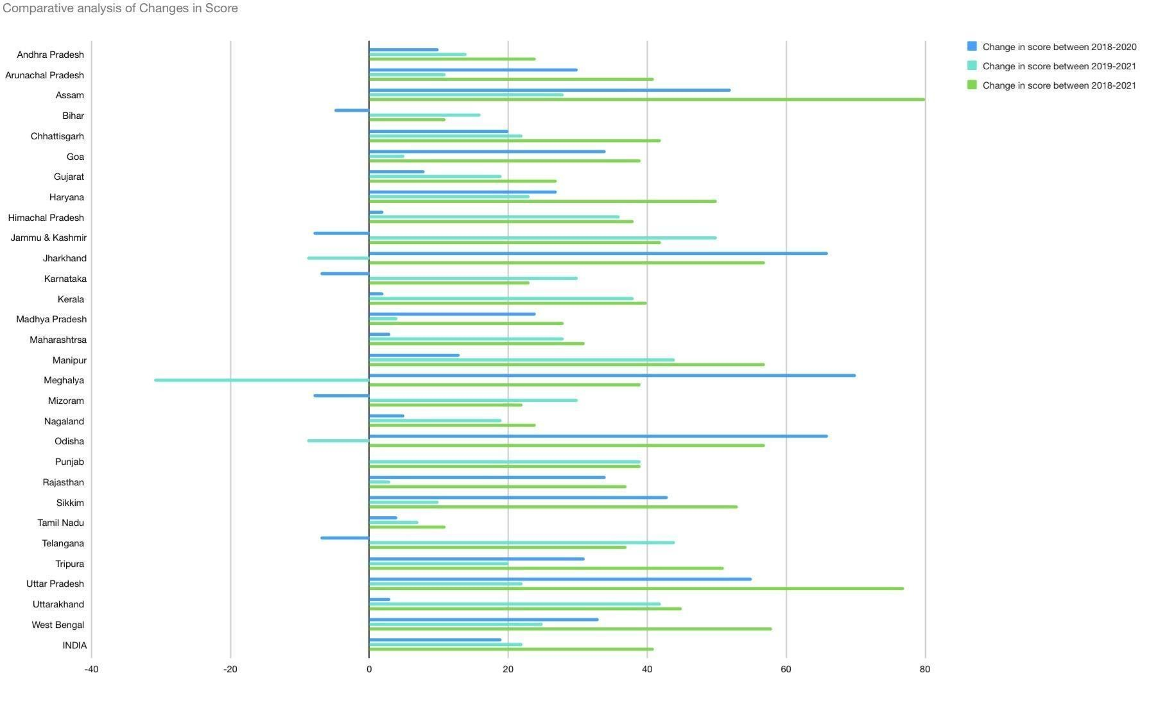

Figure 5 depicts the graphical presentation of the comparative analysis of the changes in index scores for the 3 years.

TABLE 3 SDG7 CRITERIA OF INDEX SCORES

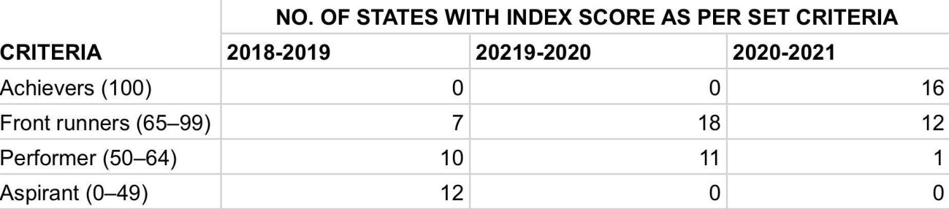
Table 3 states that from zero state having the Achievers (100) tag in 2018-19, 16 states out of 29 have achieved the goal in merely a span of 3 years in 202-2021 namely Andhra Pradesh, Goa, Haryana, Himachal Pradesh, Karnataka, Kerala, Maharashtra, Mizoram, Punjab, Rajasthan, Sikkim, Tamil Nadu, Telangana, Uttar Pradesh and Uttarakhand. The front runners’ 65–99 category showed an improvement from nearly 7 states in the first year to 18 in the second. The number of states in this category reduced for the year 2020-21 as the number of achievers increased. In the category of performer( 50–64) the number of states reduced from 19 in the initial year to 11 in 2019-20 and merely 1 in 2020-21 namely Meghalaya. Whereas in the year 2018–19 as many as 20 states ranked in the category of aspirants (0–49) this number reduced to 0 the very next year and this continued for 2020–21 as well.

The states in the achievers category include not only states with high per capita income like Goa, Haryana, Maharashtra etc, but also other states highlighting the fact that the right policies have been implemented in these to achieve these goals. The hill states of Himachal Pradesh and Uttarakhand have also achieved the target apart from the eastern state of Mizoram and Sikkim. It is pertinent to note that most of the southern states including Telangana, Andhra Pradesh, Tamil Nadu, Kerala and Karnataka have achieved the target.

Limitations:
- The study puts forward a comparative view for a limited time frame of 3 years only .
- The analysis has been undertaken for the states only and union territories have been excluded from the scope of the study.
- SDG reports by NITI Aayog have been used for analysis that include three criterion for measurement of SDG index score for 2018–19 but only 2 for 2019–2020 and 2020–21.

Findings and Conclusion:

A comparative analysis of various Indian states for the time period 2018–19 to 2020–21 clearly brings to picture the fact that clean, sustainable and affordable energy as stated under SDG-7 has been diligently achieved by almost all Indian states. A number of states have performed exceptionally well on the criteria and have managed to improve their SDG scores in a span of three years. A number of states including Assam, West Bengal, Jharkhand, Uttar Pradesh, Haryana, Sikkim and Tripura have shown improvement equal to or greater than 50 points in the SDG score between the three years. The analysis clearly brings to picture the fact that India has been marching steadily towards fulfilling its goals on the sustainability front. But a number of scores states still lack behind end government policies and measures need to be centred in these areas so that all Indian states can achieve the perfect score of hundred in near future. Various government schemes dedicated in this direction have played a major role in making the set targets a reality. By the end of 2020–21, various states including Andhra Pradesh,
Goa, Haryana, Himachal Pradesh, Jammu and Kashmir, Karnataka, Kerala, Maharashtra, Mizoram, Punjab, Rajasthan, Sikkim, Tamil Nadu, Telangana, Uttar Pradesh and Uttarakhand have managed to score a perfect 100. The overall score for the country stands at 92 which is far better than its score of 51 for the year 2018–19. By the end of 2020–21, Meghalaya had the lowest score index of 50. The analysis clearly brings to picture the fact that India is on track to accomplish SDG – seven target in near future. Various states in India have played a key role in making this target turn into reality by putting in efforts and directing policies towards the right goals. The right steps in this direction by various states can lead to the country as a whole achieving its SDG targets. Given the mammoth population, the achievement of the goals for the country holds immense significance. These small steps by various states would go a long way in making not only the country but also the world as a whole a better and sustainable place to live.

References:
- Aayog, N. I. T. I. (2021). SDG India index & dashboard 2020-21.
- Aayog, N. I. T. I. (2021). North Eastern Region District SDG Index & Dashboard Baseline Report 2021- 22.
- Aayog, N. I. T. I. (2020). SDG India index & dashboard 2019-20.
- Aayog, N. I. T. I. (2020). Localising SDG early lessons from India & dashboard 2020.
- Acharya, R. H., & Sadath, A. C. (2019). Energy poverty and economic development: Household-level evidence from India. Energy and Buildings, 183, 785-791.
- Ackah, I. (2016). Policy interventions in renewable energy for sustainable development: is Ghana on the right path to achieve SDG 7?. Available at SSRN 2799150.
- Andrijevic, M., Schleussner, C. F., Gidden, M. J., McCollum, D. L., & Rogelj, J. (2020). COVID-19 recovery funds dwarf clean energy investment needs. Science, 370(6514), 298-300
- Bizikova, L., & Pinter, L. (2017). Indicator preferences in national reporting of progress toward the Sustainable Development Goals. International Institute for Sustainable Development (IISD).
- Cai, Y., Sam, C. Y., & Chang, T. (2018). Nexus between clean energy consumption, economic growth and CO2 emissions. Journal of cleaner production, 182, 1001-1011.
- Cf, O. D. D. S. (2015). Transforming our world: the 2030 Agenda for Sustainable Development. United Nations: New York, NY, USA.

