Advanced Smart Materials: Design, Functional Mechanisms, and Future Technological Prospects

Abstract
Smart materials represent a class of advanced materials capable of sensing and responding dynamically to environmental stimuli such as temperature, mechanical stress, electric fields, magnetic fields, light, and chemical environments. These materials exhibit adaptive behaviours including shape change, electrical polarization, color variation, and mechanical deformation, enabling their use as sensors, actuators, and energy conversion systems. Recent developments in nanotechnology, additive manufacturing, and computational materials science have accelerated the development of smart materials with enhanced functionality and reliability. This review article presents a comprehensive overview of advanced smart materials with emphasis on their design principles, classification, fundamental functional mechanisms, and multidisciplinary applications. Special attention is given to shape memory alloys, piezoelectric materials, magnetostrictive materials, electroactive polymers, and self-healing materials. Emerging technologies such as 4D-printed smart structures and stimuli-responsive polymeric systems are also discussed. Furthermore, the challenges associated with large-scale manufacturing, durability, and environmental sustainability are critically examined. Finally, the paper outlines future technological prospects of smart materials in emerging domains including biomedical implants, intelligent infrastructure, soft robotics, and autonomous sensing systems.

Keywords: Smart materials, stimuli-responsive materials, shape memory alloys, piezoelectric materials, smart polymers, self-healing materials, intelligent systems, smart composites, adaptive systems, 4D printing.

1. Introduction
Smart materials, also known as intelligent or responsive materials, are materials capable of altering their physical or chemical properties in response to external stimuli such as temperature, stress, electric or magnetic fields, and chemical environments (Costa, 2025; Jain et al., 2023). These materials possess the inherent ability to sense environmental changes and respond accordingly, thereby integrating sensing, actuation, and control functions within the material structure itself.
The rapid advancement of modern technologies such as nanotechnology, additive manufacturing, and artificial intelligence has significantly enhanced the development of smart materials. These materials are increasingly being used in various technological fields including biomedical engineering, aerospace systems, robotics, structural health monitoring, energy harvesting devices, and wearable electronics (Kundiya et al., 2024).
Smart materials exhibit several unique characteristics that differentiate them from conventional materials. These include:
Stimulus sensitivity
Adaptive response
Reversibility
Self-actuation capability
Due to these properties, smart materials have become essential components in advanced engineering systems. They can be used as sensors to detect environmental changes, as actuators to produce mechanical motion, and as structural components that adapt to changing conditions (Gangele, 2021).

2. Classification of Smart Materials

Smart materials can be classified according to their response mechanism and the type of stimulus that activates their behavior. The most common categories include shape memory materials, piezoelectric materials, magnetostrictive materials, electrochromic materials, and stimuli-responsive polymers (Bahl et al., 2020; Jain et al., 2023).

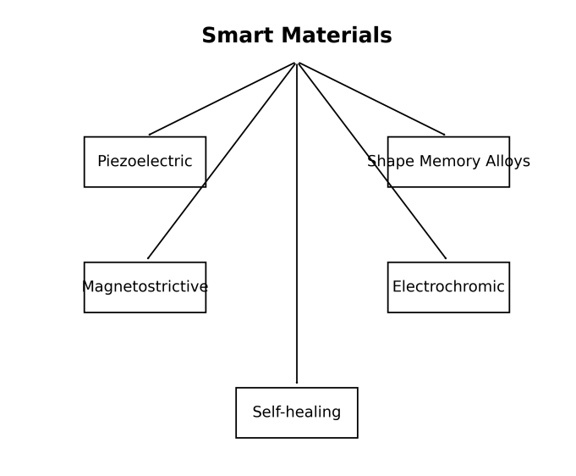
Figure 1. Classification of Smart Materials

2.1 Shape Memory Materials
Shape memory materials have the ability to return to their original shape after deformation when exposed to thermal or mechanical stimuli. Shape memory alloys (SMAs), particularly nickel–titanium (NiTi), exhibit reversible phase transformation between martensite and austenite phases, enabling shape recovery (Rodinò et al., 2024). These materials are widely used in biomedical stents, actuators, and aerospace components.

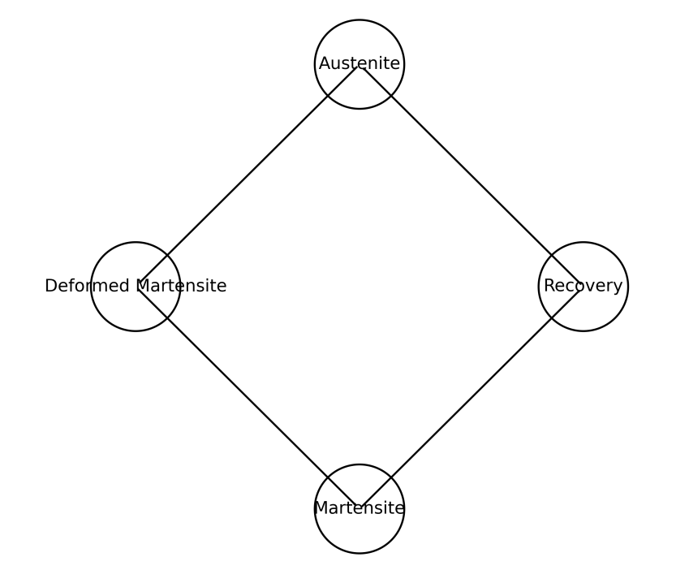

Figure 2. Shape Memory Alloy

2.2 Piezoelectric Materials
Piezoelectric materials generate electrical charge when subjected to mechanical stress and conversely deform when exposed to an electric field. This electromechanical coupling property allows them to function as both sensors and actuators in engineering systems (Zhou et al., 2024). Applications include ultrasound imaging, vibration sensors, energy harvesting systems, and microelectromechanical systems.

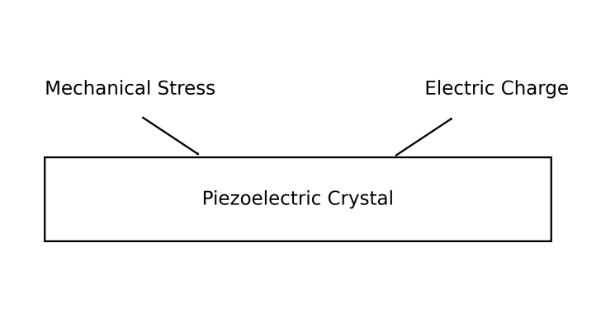
Figure 3. Piezoelectric Mechanism)
2.3 Magnetostrictive Materials
Magnetostrictive materials change their dimensions when subjected to magnetic fields. These materials are used in precision actuators, sonar systems, and vibration control devices.
2.4 Electroactive and Electrochromic Materials
Electrochromic materials exhibit reversible color changes when an electric field is applied. These materials are widely used in smart windows, display technologies, and optical devices.
2.5 Self-Healing Materials
Self-healing materials possess the ability to repair structural damage automatically without external intervention. Microcapsule-based healing systems and polymer networks have been developed to restore mechanical integrity after crack formation (Kontiza et al., 2024).

2.6 Stimuli-Responsive Polymers
Stimuli-responsive polymers respond to environmental changes such as temperature, pH, or ionic strength.

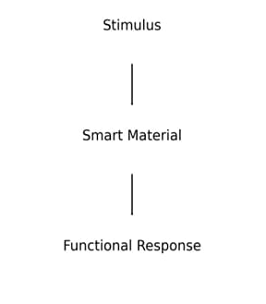
Figure 4. Stimuli Responsive Polymer Mechanism

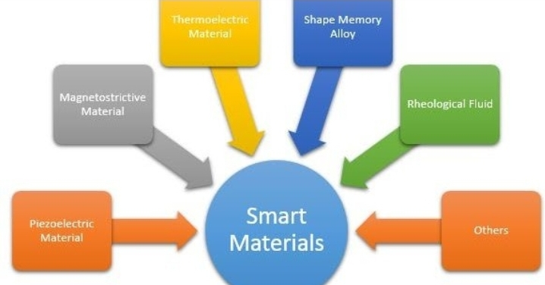

Figure 5. Diagrammatic Representation of Classification of Smart Materials

3. Design Strategies for Advanced Smart Materials
3.1 Molecular Engineering
The functionality of smart materials often originates from carefully designed molecular architectures. Polymer chain configuration, cross-linking density, and functional groups influence the responsiveness of materials to external stimuli.

3.2 Nanostructured Materials
Nanotechnology has significantly enhanced the performance of smart materials. Incorporating nanomaterials such as carbon nanotubes, graphene, and metal nanoparticles improves electrical conductivity, mechanical strength, and responsiveness.
3.3 Bio-Inspired Materials
Biological systems provide inspiration for designing adaptive materials. Researchers have developed materials mimicking biological muscles, plant movements, and self-healing skin structures.
3.4 Additive Manufacturing and 4D Printing
Additive manufacturing technologies have enabled the fabrication of smart structures with programmable properties. In 4D printing, the printed structure can change shape over time when exposed to environmental stimuli (Li et al., 2025).

4. Functional Mechanisms of Smart Materials

Piezoelectric materials operate based on electromechanical coupling, where mechanical stress generates electric charge and electrical signals produce mechanical deformation. This phenomenon enables conversion between mechanical and electrical energy, which is essential in sensors and actuators (Zhou et al., 2024).
Shape memory alloys exhibit reversible phase transformation between martensite and austenite phases. When heated above a specific transition temperature, the material returns to its original shape due to atomic rearrangement within the crystal structure (Thomas, 2025).

5. Applications of Smart Materials

5.1 Biomedical Engineering
Smart materials are extensively used in biomedical devices such as drug delivery systems, artificial muscles, and tissue engineering scaffolds. Stimuli-responsive polymers enable controlled drug release and targeted therapy (Lin et al., 2026).
5.2 Aerospace Engineering
Shape memory alloys and piezoelectric materials are used in adaptive aerospace structures for vibration control, morphing wings, and structural health monitoring systems.
5.3 Robotics and Soft Actuators
Smart materials enable the development of soft robots capable of mimicking biological movements. Shape memory alloys and electroactive polymers are widely used for artificial muscles and flexible robotic systems.
5.4 Civil Engineering and Infrastructure
Smart materials are used for structural monitoring of bridges and buildings. Sensors embedded in structures can detect cracks, stress, and deformation in real time.
5.5 Energy Harvesting
Piezoelectric materials can convert mechanical vibrations into electrical energy, enabling self-powered sensors and wearable electronic devices.

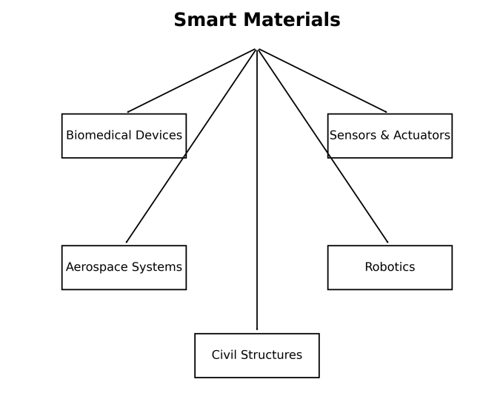
Figure 6. Applications of Smart Materials

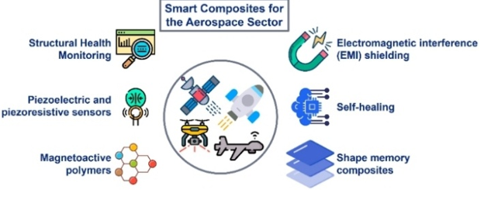

Figure 7. Technological Applications of Smart Materials

6. Mechanistic Pathway of Smart Materials
Smart materials generally operate through the following pathway:

Stimulus → Sensing → Structural Change → Functional Response → Application.

7. AI-Driven Discovery of Smart Materials
Recent advances in artificial intelligence and machine learning have accelerated the discovery of new smart materials.
AI-driven approaches allow rapid screening of thousands of material compositions to identify optimal candidates for smart material applications.

Table 1. Comparative Analysis of Major Smart Materials

Smart Material Type | Stimulus | Response Mechanism | Key Properties | Major Applications
Shape Memory Alloys (SMAs) | Temperature | Phase transformation between martensite and austenite phases | Shape recovery, superelasticity | Biomedical stents, actuators, aerospace structures
Piezoelectric Materials | Mechanical stress / Electric field | Electromechanical coupling producing electrical charge | High sensitivity, energy conversion capability | Sensors, ultrasound imaging, energy harvesting
Magnetostrictive Materials | Magnetic field | Change in material dimensions due to magnetic domain reorientation | High force generation, rapid response | Sonar systems, vibration control devices
Electrochromic Materials | Electric field | Reversible change in optical properties | Color change, light modulation | Smart windows, display technologies
Stimuli-Responsive Polymers | Temperature, pH, light, chemicals | Molecular rearrangement leading to swelling or contraction | Flexibility, biocompatibility | Drug delivery systems, biosensors
Self-Healing Materials | Mechanical damage | Release of healing agents from microcapsules | Crack repair, increased durability | Coatings, structural composites
Smart Nanocomposites | Multi-stimuli | Synergistic effects of nanoparticles and polymer matrix | High strength, conductivity | Flexible electronics, smart coatings

Table 2. Comparison of Properties of Major Smart Materials

Material | Response Speed | Durability | Sensitivity
Piezoelectric | High | High | High
Shape memory alloys | Moderate | High | Moderate
Smart polymers | Moderate | Moderate | High
Nanocomposites | High | High | High

Table 3. Major Application Sectors of Smart Materials

Sector | Example Applications
Biomedical | Drug delivery, implants
Aerospace | Morphing wings
Robotics | Artificial muscles
Energy | Energy harvesting
Civil Engineering | Structural monitoring

8. Emerging Trends in Smart Materials
Recent developments in smart materials focus on:
- Multi-stimuli responsive materials
- Smart nanocomposites
- Self-healing polymers
- AI-assisted materials discovery
- 4D printed adaptive materials
Recent research also explores stimuli-responsive materials integrated into intelligent electronic devices and advanced sensor systems (Chen et al., 2025).

9. Challenges and Limitations
Despite significant progress, smart materials face several challenges including:
- High production cost
- Limited durability in harsh environments
- Slow response time in some materials
- Scalability challenges for industrial production
- Environmental sustainability issues
Addressing these challenges requires interdisciplinary collaboration among chemists, materials scientists, engineers, and computational scientists.

10. Future Technological Prospects
The future of smart materials lies in the development of:
- Self-healing structural materials
- Programmable matter
- Intelligent biomedical implants
- Adaptive infrastructure systems
- Nano-engineered responsive materials
Smart materials are expected to play a critical role in next-generation technologies including wearable electronics, soft robotics, and intelligent healthcare systems.

11. Conclusion
Smart materials represent a transformative class of materials capable of sensing environmental changes and responding dynamically. Their multifunctional capabilities make them essential components in modern technological systems. Advances in nanotechnology, additive manufacturing, and computational modeling are accelerating the development of next-generation smart materials with enhanced performance and functionality. Continued research and interdisciplinary collaboration will be crucial for overcoming existing challenges and unlocking the full potential of smart materials in future technological applications.

References (APA Style)
- Bahl, S., Nagar, H., Singh, I., & Sehgal, S. (2020). Smart materials types, properties and applications: A review. Materials Today: Proceedings.
- Chen, S., Li, Y., & Zhang, L. (2025). Recent advances in stimuli-responsive materials for intelligent electronic devices. Advanced Functional Materials.
- Costa, C. M. (2025). Smart materials: Definition and physical-chemical characteristics. ACS Symposium Series.
- Gangele, A. (2021). A review on smart materials, types and modelling. Materials Today: Proceedings.
- Jain, N., Sharma, R., & Gupta, P. (2023). Smart materials – A state-of-the-art review. Materials Today: Proceedings.
- Kontiza, A., et al. (2024). Smart composite materials with self-healing properties. Polymers.
- Kundiya, R., Kadam, M., & Acharya, J. (2024). Applications of smart materials in mechanical engineering: A review. Journal of Mechanical Engineering.
- Li, L., Chen, H., & Wang, Y. (2025). Stimuli-responsive conductive hydrogels for smart sensing and actuation. Macromolecular Materials and Engineering.
- Lin, C., Zhang, J., & Wu, H. (2026). Stimuli-responsive biomaterials for biomedical engineering. Materials Science and Engineering C.
- Rodinò, S., et al. (2024). Design considerations and applications of shape memory alloy actuation. Materials & Design.
- Thomas, K. K. (2025). Integration of shape memory alloys into composite structures. Composite Structures.
- Trovato, V., et al. (2022). Stimuli-responsive smart materials for wearable sensors. Molecules.
- Zhou, X., Chen, H., & Wang, J. (2024). Review on piezoelectric actuators: Materials and classifications. Frontiers of Mechanical Engineering.
- Zhang, Y. (2024). Smart nanocomposites for advanced sensing applications. Advanced Materials.
- Singh, P. (2023). Self-healing polymers for smart infrastructure. Polymer Reviews.
- Gupta, R. (2024). Smart materials in aerospace engineering. Aerospace Science and Technology.
- Lee, K. (2025). Stimuli-responsive polymers for biomedical implants. Chemical Engineering Journal.
- Brown, T. (2022). Intelligent materials for robotics applications. Advanced Intelligent Systems.
- Kaur, H. (2025). Shape memory alloys in modern engineering systems. Evergreen Journal.
- Wang, L. (2024). Piezoelectric nanomaterials for energy harvesting. Nano Energy.
- Das, S. (2023). Smart materials for structural health monitoring. Sensors and Actuators A.
- Patel, A. (2024). Smart materials for wearable electronics. Journal of Materials Chemistry C.
- Sharma, V. (2023). Advances in smart polymeric materials. Progress in Polymer Science.
- Hossain, M. (2025). Shape memory materials and phase transformation mechanisms. RSC Advances.
- Dong, C. (2025). Stimuli-responsive materials in biomedical robotics. Advanced Healthcare Materials.

