DECODING SEPTIC ARTHRITIS: A COMPREHENSIVE REVIEW OF RISK PROFILES, PATHOGENESIS, AND CLINICAL MANAGEMENT

ABSTRACT:
Infections such as septic arthritis due to pathogens in the joint or maybe even in the body of the patient would cause an immediately associated emergency condition associated with that effusion. Septic arthritis is inflammation of the joint and severe pain in the joints; it threatens joint survival, requiring treatment. Triggers include infections by bacteria, fungi, or viruses, and among them is Staphylococcus aureus, the most common pathogen. Mainly affected are adults and geriatrics who tend to suffer greatly with comorbidities such as diabetes, immunosuppression, trauma to a joint, and having prosthetic joints. All of these have an age basis in the elderly common group. The main pathogens found to infect the younger individuals under 3 years include Kingella-kingae and Neisseria gonorrhoeae. Signs or symptoms of septic arthritis include pain at the sites of the joints, swelling, fever, and loss of function in joints at the later, knee, hip, and shoulder joints. It involves early detection through tests on synovial fluid, blood cultures, and imaging studies for diagnosis. Then, the treatment entails antimicrobial therapy, joint aspiration, and, on occasions, surgery for drainage of the joint or, if indicated, for removal of the prosthesis. Early commencement of process of antibiotic drug therapy, along with physiotherapy, greatly reduces the incidence of complications like destruction of joints or systemic infection. The advent of new mechanisms for diagnosis and therapy has been a great revolution in both prognosis and outcome in patients.
KEYWORDS: Septic arthritis, joint infection, Staphylococcus aureus, synovial fluid, diagnosis, antimicrobial therapy, risk factors, imaging, treatment, joint aspiration.
- INTRODUCTION:
Septic arthritis is a condition that threatens to destroy a joint and thus requires an urgent diagnosis and treatment to avoid destruction of the joint and complications at the systemic level^{[1]}. Septic arthritis arises from the invasion of bacteria, fungi, or viruses into the synovial fluid, thereby leading to inflammation and pain that usually causes irreparable damage if not treated early ^{[1].} This disease may present with any form of joint disease. After knee, it is hip and shoulder, mainly presenting through septicaemic arthritis in adults ^{[2]}. The risk factors for septic arthritis include advanced age, diabetes, immune suppression, and joint trauma; however, the condition can also present in apparently healthy persons. The most common causative organism continues to be Staphylococcus aureus, including methicillin-resistant Staphylococcus aureus (MRSA); however, the spectrum of pathogens varies according to the host's health status, geographic region, and type of joint.
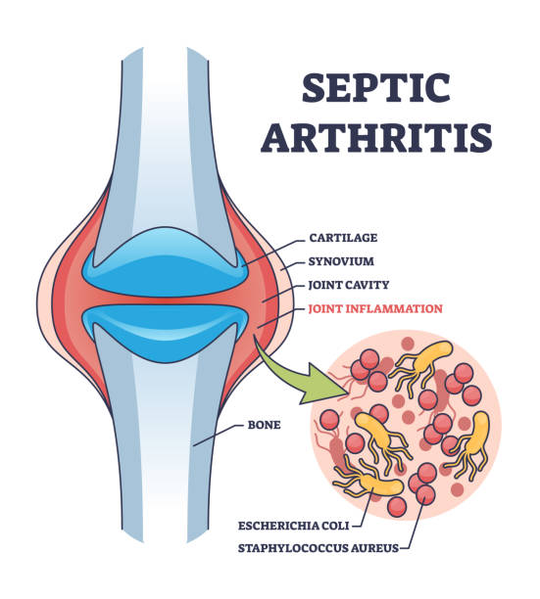
Figure 1.1: Describes the Septic Arthritis condition ^{[1]}
EPIDEMOLOGY:
Incidence of septic arthritis is between 2 and 6 cases per 100,000 population and increases with more risk factors ^{[3]}. It is a disease that is more common in children than adults, and it peaks at an incidence at the age of 2 to 3 years with males having about a 2:1 advantage over females ^{[4]}. Neonates, haemophilic with hemarthroses, immunocompromised patients such as those affected by sickle cell anaemia or human immunodeficiency virus infection, and patients receiving chemotherapy are other at-risk groups of children ^{[5]}. Adult risk at risk is those above 80 years, diabetes mellitus, rheumatoid arthritis, recent joint surgery, joint prosthesis, history of intra-articular injection, skin infections and cutaneous ulcers, human immunodeficiency virus, osteoarthritis, sexual activity particularly those with a suspected infection of gonococcal septic arthritis, and many more that may be causes of sepsis ^{[6]}.
ETIOLOGY:
Etiology in Children:
Paediatric joint arthritis has multifactorial causes. Most often, this will be bacterial infection ^{[7]}. There are a wide range of etiologic bacterial agents but, Staph aureus the most common bacterial pathogen as an entire. Bacterial agents Some of the agent is common underlaying, age and related associated disease in some ages Among the pediatric patient under the age group 2-3 yrs. Gram negative rods commonly found agent of this age, Kingella kingae. Bacterium; Staphylococcus aureus, Group B Streptococcus ^{[8]}. Gram negative Bacilli including, Neisseria gonorrhoea occurs, most common neonates ^{[9]}. Sexually active adolescents are at risk of Neisseria gonorrhoea. Sick cell disease is a condition with infection in Salmonella species ^{[10].} Patients on prolonged antibiotic therapy can become infected by fungi. Puncture wounds and injection drug use-associated joint infection due to Pseudomonas aeruginosa usually primarily affect the hip joint in children ^{[11,12].}
Etiology in Adults:
This would be the commonest infecting organism in adults, Staphylococcus aureus followed by Streptococcus pneumonia ^{[13].} Other less common special causes include Salmonella in patients suffering from sickle cell and Pseudomonas in trauma/wound punctures ^{[14].} In younger sexually active adults, non-traumatic acute mono-arthritis, the most frequent cause is gonorrhoea – Neisseria ^{[15].} In high-risk patients, Neisseria gonorrhoea should be cultured from other sites such as the oropharynx, vagina, cervix, urethra, or anus because the organism grows poorly from cultured synovial fluid. Fungal and mycobacterial organisms present insidiously and may be harder to diagnose. The acid-fast smear of synovial fluid is often negative, but a synovial biopsy is positive in 95% of cases. The knee is the most affected joint in adults, while the hip ranks second. The polymicrobial type comprises nearly 5% of the patients through trauma or abdominal infection. The Sternoclavicular and sacroiliac types occur most often in IV drug abusers. The former two are mainly Serratia and Pseudomonas. The organisms cause destruction to the articular cartilage along the sides of the joint. Effusions are common and most often associated with pain ^{[16,17]}.
RISK FACTORS
- History of joint: Those who had injury, surgical procedure, or medical condition including arthritis, gout, and lupus
- History of skin: Infected, ulcerative, and other dermatologic disease like eczema and psoriasis
- Documented weakened immune systems: HIV, diabetes, or any other kind of medication that weakens one's immune system
- Artificial Joints: Hip or knee replacements or an artificial joint that becomes infected
- Drug use: Heroin or any type of IV drugs or alcohol abuse
- Sexually transmitted infections: Whether they have gonorrhoea or not
- Age: Older than 80 years
- Other health conditions: Lung and liver disorders or cancer and many more chronic diseases.
- Ongoing infection: Bites from animals, punctures, or cuts over a joint
- Indwelling urinary catheter: Catheter in the bladder ^{[18,19,20 & 21]}
PATHOPHYSIOLOGY:
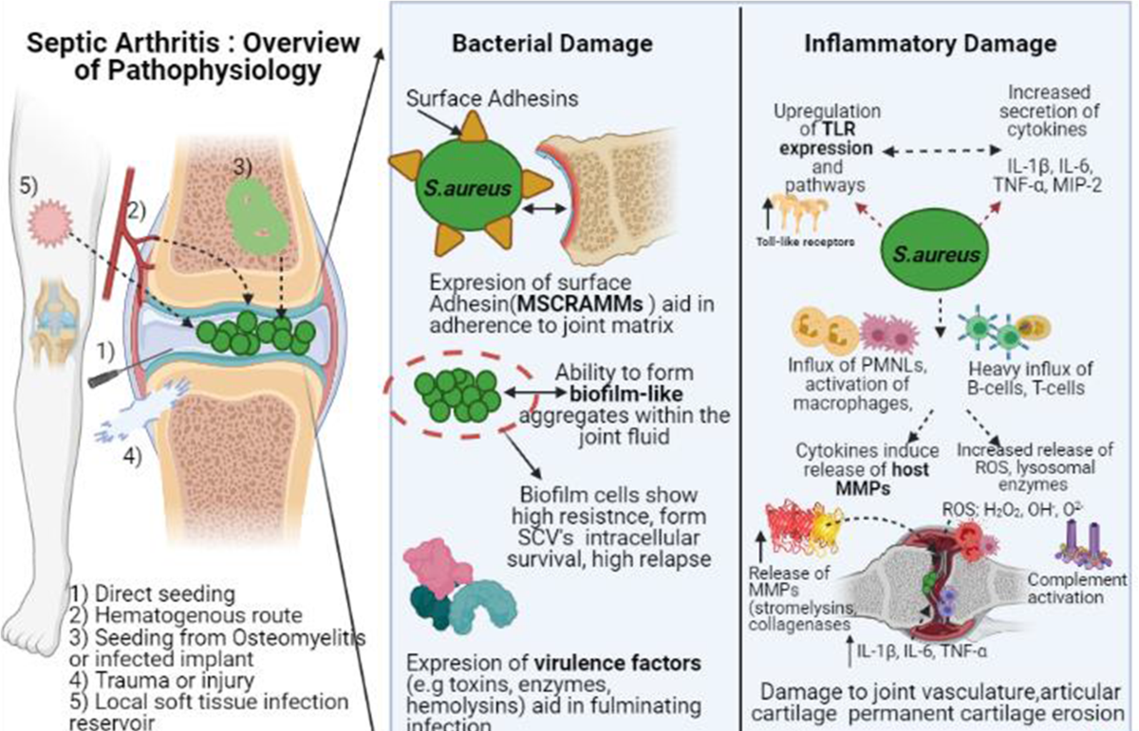
Figure 1.2: Describes the Pathophysiology of septic arthritis ^{[20]}
CLINICAL FEATURES:
The most common joints affected with septic arthritis are the knee, hip, shoulder, elbow, wrist, and finger. In general, only one joint is involved by the situation. Symptoms can occur somewhat differently in each person, but some common symptoms include:
- Fever
- Pain in the joint
- Swelling of the joint ^{[22,23]}
DIAGNOSIS:
The most helpful laboratory test in diagnosis is the synovial fluid of the affected joint, ie, culture, Gram stain, crystals analysis, and white blood cell count with differential. Having a WBC count more than 50,000 and having 90% neutrophil predominance would indicate it is of bacterial origin. Confirmation in the diagnosis takes place if one can identify any bacterial organism found in the synovial fluid. Other useful laboratory studies include complete blood count, erythrocyte sedimentation rate, C-reactive protein, and blood cultures. Usually, the peripheral blood WBC count is elevated with a left shift. ESR and CRP are supporting of the diagnosis but not diagnostic. Low synovial fluid WBC count is associated with peripheral leukopenia, early infection, disseminated gonococcal arthritis, and presence of joint prosthesis.
For prosthetic joint infections, a synovial fluid WBC count of 1100 with a neutrophil differential of 64% would suggest septic arthritis. Two sets of blood cultures should be obtained to rule out bacteraemia. If the pathogen is believed to be Neisseria, then cultures from the cervix, rectum, and throat should be performed. ^{[24,25 & 26]}
Imaging Studies:
- Widened joint spaces, soft tissue bulging, or subchondral bony alterations (late discovery) can all be shown on plain radiographs. Septic arthritis cannot be ruled out by a normal plain radiograph.
- Ultrasonography is useful in identifying and quantifying the joint effusion as well as aiding in needle aspiration of the joint.
- MRI is very sensitive in early diagnosis of joint fluid and might reveal abnormalities of soft tissue and bone surrounding the abnormality along with the intensity of cartilaginous involvement ^{[21,23].}
Bone scans cannot be specific as they fail to differentiate infection from a sterile process. Even then, it is quite helpful in case of localized infections like sacroiliac or hip joints.
- Infection: Bacterial, fungal, viral, spirochete, mycoplasma
- Crystalline-induced arthropathies: Acute gout, pseudogout, calcium oxalate, cholesterol, hydroxyapatite crystals
- Osteoarthritis
- Intra-articular injury: Fracture, meniscal tear, osteonecrosis, foreign body, plant thorn synovitis
- Inflammatory arthritis: Rheumatoid arthritis, Bechet syndrome, seronegative spondyloarthropathies such as ankylosing spondylitis, psoriatic arthritis, reactive arthritis, inflammatory bowel disease-related arthritis; Sarcoid, systemic Lupus erythematosus, still disease
- Systemic infection: Bacterial endocarditis, human immunodeficiency virus, Lyme arthritis
- Tumour: Metastasis, pigmented villonodular synovitis
- Other: Hemarthrosis, clotting disorders or anticoagulant therapy, neuropathic arthropathy, dialysis-related amyloidosis, avascular necrosis ^{[21,23]}
MANAGEMENT:
Septic arthritis is treated with antimicrobial therapy and joint aspirate mainly. Administer empiric intravenous antimicrobial therapy as soon as possible after joint aspiration is completed and cultures have been obtained. All age and risk categories should have antistaphylococcal coverage with nafcillin, oxacillin, or vancomycin. Empiric intravenous vancomycin would be standard for nongonococcal septic arthritis based on the emphasis on gram-positive organisms, especially in the context of a clinical suspicion of MRSA and community and institutional data. Immunocompromised patients, intravenous drug abusers, and individuals with negative gram stains should have adjunctive coverage with third-generation cephalosporins, like ceftriaxone, ceftazidime, or cefotaxime, to further cover gram-negative bacteria. Age, risk factors, and gram stain result should guide additional antibiotics (e.g., a third-generation cephalosporin for suspected Salmonella or N. gonorrhoea). Blood and synovial fluid cultures and sensitivities should guide prolonged antimicrobial treatment. Early involvement by an orthopaedic surgeon is essential. The procedure used to drain joint fluid depends on multiple factors and is determined by the orthopaedic surgeon ^{[13,15 &17].}
Nongonococcal septic arthritis is typically treated with intravenous antibiotics for 2 weeks, accompanied by an additional 1 to 2 weeks of oral antibiotic therapy, for a total of three to four weeks in duration. However, when it comes to Pseudomonas aeruginosa, longer antibiotic treatment courses are up to 4 to 6 weeks in duration. It responds well to intravenous ceftriaxone but is continued for 24 to 48 hours after clinical improvement and then switched to oral therapy for the rest of the treatment. Improvement should be noted by 5-6 days. This joint should be re-aspirated, and Lyme disease should be ruled out. Reactive arthritis or fungus should be taken into account.. Imaging studies are required in such cases to rule out osteomyelitis. The joint need not be immobilized anymore after 2-3 days. Aggressive physical therapy needs to be employed to treat the joint and prevent muscle atrophy. Most commonly, a prosthetic joint infection needs aggressive debridement and/or removal of the prosthesis. A newly implanted joint is replaced by a cement impregnated with antibiotics ^{[25,26].}
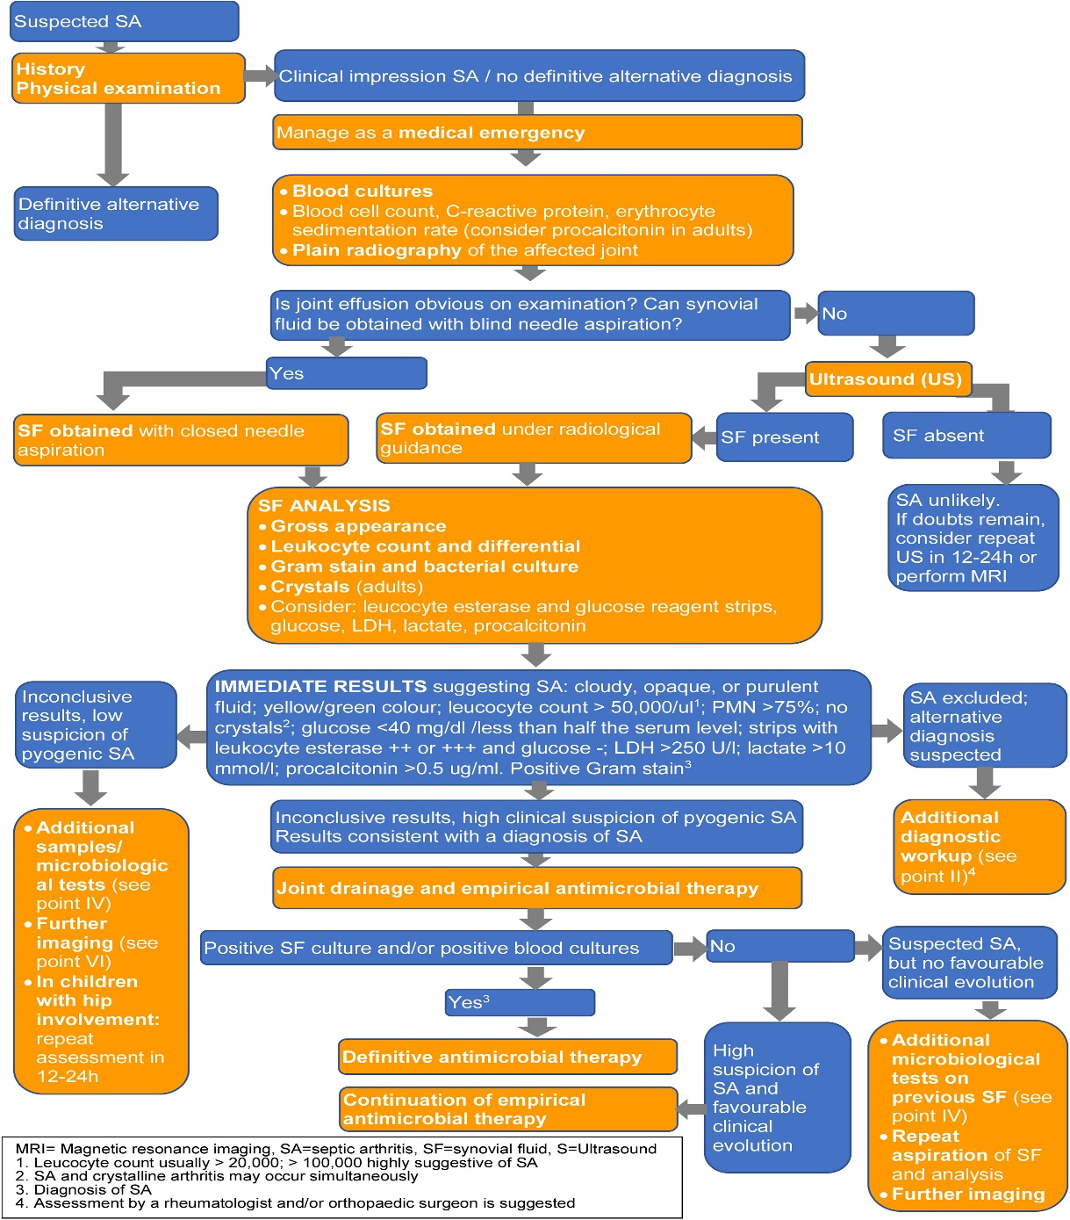
Figure 1.3: Shows the Treatment Algorithm of septic arthritis ^{[25]}
- DISCUSSION:
If septic arthritis is not treated correctly, it almost destroys joints and causes systemic complications. Epidemiological data show that the incidence is increasing with age and in people who are immunocompromised. The clinician should be very careful in assessing the risk factors for septic arthritis, as their focus can often be on otherwise healthy patients, particularly sexually active adults who may have gonococcal arthritis. The pathogenic organisms in septic arthritis are chiefly bacteria, fungi, and, at times, viruses, though Staphylococcus aureus frequently tops the list in adults and children. Classical manifestation by features like fever and tenderness with swelling and restricted movement of the joint is common. Synovial fluid analysis has great diagnostic value, especially in high white cell counts indicative of bacterial involvement. Early blood and joint culture must be done to isolate the organism and direct therapy. MRI and ultrasound imaging aid in isolating joint effusions or other structural abnormalities. The immediate application of broad-spectrum antibiotics remains to be done but must give way to narrow-targeted therapy very soon after, following organisms cultured from the sites of involvement. There will follow emphasis on physical therapy and joint aspiration. In cases of joint infections involving a prosthetic device or where drainage is inadequate, most likely, surgical intervention will be required. Prevention, along with timely diagnosis, will most certainly reduce morbidity and mortality associated with such a condition.
- CONCLUSION:
Septic arthritis is a life-threatening condition, and its management now focuses on preventing irreversible destruction of joints and systemic complications that usually result from delayed intervention. The highest possible suspicion, especially in at-risk populations, needs to ensure those highest possibilities of early detection and good outcomes. Optimal management then comprises a mixture of antimicrobial therapy, joint aspiration, and possibly surgical management as indicated. The advances of modern diagnostic methods and treatments benefit greatly the management and prognosis of patients. Timely and correct diagnosis will help prevent prolonged disability and restore normal joint function.
- REFRENCES:
- LalMohamed A, et al. Epidemiology of Septic Arthritis: A 10-year study in the UK. J Rheumatol. 2009;36(4):742–747.
- Reference 2: Zeng Y, et al. Septic arthritis in adults: diagnosis and treatment. Ortho Surg. 2019;11(6):931–937.
- Fitzgerald J, et al. Epidemiology of septic arthritis in a tertiary care hospital: a 10-year retrospective study. Clin Infect Dis. 2008;47(5):600-604.
- Ho A, et al. The incidence and risk factors of septic arthritis in adults: A systematic review. Semin Arthritis Rheum. 2016;46(3):325-333.
- Sampaio-Barros PD, et al. Septic arthritis in a cohort of 1,000 patients with rheumatoid arthritis: Clinical features and risk factors. Rheumatology (Oxford). 2014;53(3):504–510.
- Gonzalez G, et al. Risk factors for septic arthritis in adults: A systematic review. Infect Dis Clin North Am. 2014;28(3):573–589.
- Fernandez-Rodriguez A, et al. Infectious arthritis in children: Etiology and management. Clin Pediatr (Phila). 2015;54(8):787–793.
- Klinger G, et al. Bacterial infections in children with septic arthritis: A clinical review. Clin Microbiol Rev. 2012;25(2):204–222.
- Williams BG, et al. Etiology of pediatric septic arthritis: A systematic review of bacterial pathogens. Pediatr Infect Dis J. 2018;37(9):943–949.
- Williams BG, et al. Neisseria gonorrhoeae and septic arthritis in adolescents: A review. J Clin Infect Dis. 2017;64(3):391–398.
- Peled Y, et al. Infection and septic arthritis in children with sickle cell disease: A case study. Pediatr Hematol Oncol. 2016;33(6):450–455.
- Tuohy J, et al. Fungal infections in children with septic arthritis: A review of the literature. J Clin Rheumatol. 2019;25(6):337–342.
- Chakraborty B, et al. Septic arthritis in adults: Etiology and management. J Clin Rheumatol. 2016;22(3):140–146.
- Dufour JC, et al. Staphylococcus aureus in septic arthritis: An analysis of risk factors and outcomes. Clin Infect Dis. 2017;64(10):1407-1414.
- Yamada K, et al. Microbiological causes of septic arthritis in adults and treatment implications. Curr Opin Rheumatol. 2019;31(3):236–242.
- Dufour JC, et al. Management of gonococcal septic arthritis in adults: Diagnosis and treatment. J Infect Dis. 2015;213(4):590-595.
- Goldstein M, et al. Septic arthritis in the immunocompromised host: Diagnosis and management of fungal and mycobacterial infections. J Clin Rheumatol. 2018;24(3):154–159.
- Lee S, et al. Risk factors for septic arthritis: A prospective study in a high-risk cohort. Rheumatology (Oxford). 2020;59(1):123–130.
- González G, et al. Risk factors for septic arthritis in adults: A systematic review. Infect Dis Clin North Am. 2014;28(3):573–589.
- Choi JY, et al. Septic arthritis in adults: Risk factors and outcomes in the United States. Infect Dis Clin Pract. 2017;25(4):179–185.
- Falsetti P, et al. Acute septic arthritis: Diagnosis and management. J Clin Rheumatol. 2016;22(4):192-199.
- Mandell, GL, et al. Septic arthritis: Pathophysiology and clinical management. Clin Infect Dis. 2008;46(3):252–259.
- Zimmerli W, et al. Septic arthritis: Clinical features, etiology, and diagnosis. Clin Infect Dis. 2007;45(3):364-372.
- Peltola H, et al. Synovial fluid analysis in the diagnosis of septic arthritis: A comprehensive review. J Rheumatol. 2009;36(6):1274-1282.
- Lauterbach M, et al. The diagnostic role of white blood cell counts in synovial fluid in the management of septic arthritis. Eur J Clin Microbiol Infect Dis. 2011;30(8):961-965.
- Lindberg L, et al. Identification of pathogens in synovial fluid in septic arthritis: Diagnostic techniques and challenges. Clin Infect Dis. 2012;55(4):473-480.
- Kremers H, et al. Management of septic arthritis: A systematic approach. J Clin Orthop. 2018;45(7):1423-1429.
- Chambers HF, et al. Treatment of septic arthritis with empirical antimicrobial therapy: Recommendations and clinical outcomes. Clin Infect Dis. 2016;62(6):742-747.

