Toward AI-Mediated Telepathic Communication: Insights from Reiki and Neural Signal Decoding

ABSTRACT
The concept of telepathic communication is being brought closer to technical realization due to recent advances in artificial intelligence and brain computer interfaces that have enabled the direct communication of brain activities and computer systems. With the objective of facilitating the direct and non-verbal communication of humans and machines, the research aims to propose a framework for the interpretation of brain signals using artificial intelligence. To decode brain activities and express them in an understandable way, the research examines the strategies and techniques of brain signal acquisition and processing and the use of artificial intelligence and pattern recognition. The proposed system aims to address the challenges of noise, individual differences, and the lack of training data while focusing on the robustness of the proposed system. The proposed AI-based system has the potential to accurately interpret brain activities and cognitive intentions as revealed by the experimental evaluations using brain signal data. The research also touches on the ethical implications of permission, privacy, and cognitive security. Apart from establishing the groundwork for AI-based communication that is similar to telepathic communication of information, the proposed research contributes to the advancement of the development of the next generation of human computer interaction[2][3]
Keywords: Artificial intelligence (AI); Brain–Computer Interface; Neural Signal Processing; Machine Learning; Human–Computer Interaction; Neural Decoding; Machine Learning; Deep Learning; Computational Neuroscience;

- INTRODUCTION
Spoken words, written words, and gestures, all of which require expression and interpretation, have been the primary means of communication between humans. A new paradigm in communication that bypasses traditional senses and motor skills has been made possible due to recent advances in brain-computer interfaces and artificial intelligence. This has inspired the concept of telepathic communication, defined as communication between two or more people that involves the transmission and interpretation of thoughts directly through computer-based technology instead of supernatural means. Artificial intelligence has been very successful in recognizing patterns in complex and high-dimensional data, particularly in machine learning and deep learning. AI-based models in neural signals have shown promise in generalization under various conditions, feature extraction, and learning. These characteristics have made AI an essential technology in understanding brain signals and enabling direct human-computer communication. Inferring human intent, converting thoughts into digital signals, and establishing communication channels similar to telepathic communication have been made possible through AI-based brain-computer interface devices. While there has been significant development in recent times, there are still some issues that need to be addressed[5][6]. However, the widespread adoption of the same is being delayed by a number of factors including the presence of heterogeneous signals in the brain of different individuals, the absence of brain data, the presence of latencies, and ethical concerns about privacy and cognitive security. A comprehensive computational solution that provides a trade-off between accuracy, efficiency, and ethics is required to solve the problem. To facilitate the achievement of the concept of telepathic communication from a technological perspective, the present study investigates the computational interpretation of neurological impulses through the application of artificial intelligence. It discusses the techniques for neural data acquisition and processing through the application of artificial intelligence and evaluates the effectiveness of the same in facilitating the achievement of the same. In addition to the same, the future aspects of the problem are discussed.

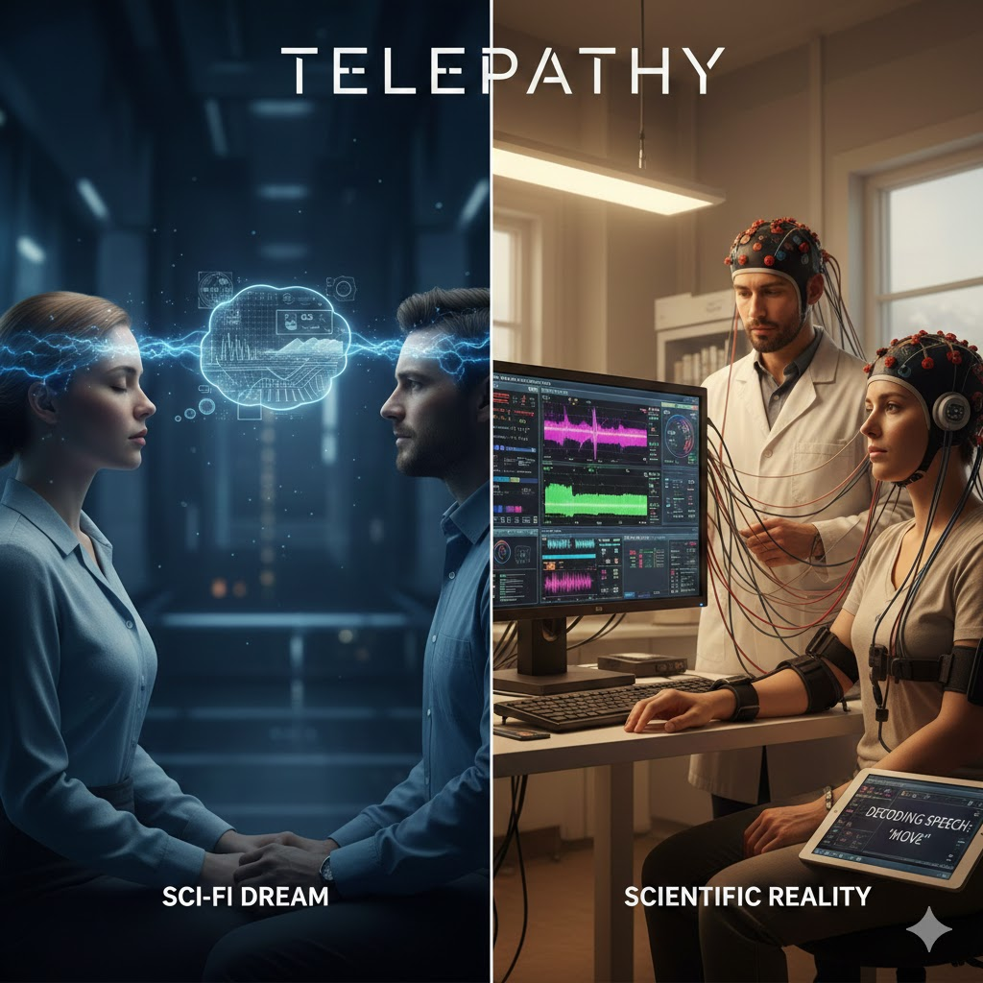

Figure 1. Showing How Telepathy Actually Works
1.1 Objective of Paper:
The purpose of this research is to explore different AI techniques for brain signal decoding and interpretation to achieve a form of communication that is similar to telepathy. The research is centered on the use of deep learning models like transformer models, recurrent neural networks, and convolutional neural networks for brain signal feature extraction, pattern recognition, and semantic signal decoding of different brain signal modalities like electroencephalography signals. By understanding the non-linear spatiotemporal patterns of brain signals, this research attempts to assess the efficiency, scalability, and robustness of computer algorithms for brain signal representation into meaningful information. The research contributes to the development of intelligent brain–computer interface devices by further investigating different system constraints, data variability, and ethical implications of brain signal data interpretation[7][8].
- The goal of feature extraction is to provide AI-powered methods for identifying significant spatiotemporal patterns in intricate brain signals.
- The goal of signal decoding is to create and apply deep learning and machine learning models that can convert brain activity into comprehensible representations of intentions or thoughts.
- To evaluate AI-based neural decoding models' scalability, accuracy, and resilience for prospective brain-computer interface applications.
- To pinpoint issues with privacy, data variability, and the ethical ramifications of computational brain signal interpretation.
- To investigate the possibilities of neural communication allowed by AI for human-machine interaction systems, telepathic interfaces, and assistive technologies.

1.2 The Role of Telepathy in Human’s Life:
Humans have long been captivated by telepathy—the potential for direct mental communication without the need of traditional sensory channels—in science fiction as well as in early psychological and parapsychological studies. In human life, telepathy is frequently thought of as a way to communicate instantly, accurately, and seamlessly, possibly overcoming linguistic, cultural, and geographical obstacles. If telepathic communication is developed, it could improve understanding, empathy, and teamwork by enabling people to communicate their feelings, intentions, or information with hitherto unheard-of clarity[4][11].

Table 1. Balances Technical Perspective, Societal Impact, and Futuristic Possibilities
Aspect | Role in Human Life | Potential Impact / Examples
Communication | Enables direct thought-to-thought transfer without language or physical interaction | Allows for direct communication between ideas without the use of words or physical contact.
Empathy and Emotional Sharing | Facilitates sharing of emotions and intentions directly between individuals | Allows people to communicate their intents and feelings with each other directly.
Knowledge Transfer | Allows direct transmission of ideas, memories, or skills | Permits the direct transfer of concepts, memories, or abilities
Assistive Technology | Supports people with disabilities via neural interfaces | Supports persons with disabilities via neural interfaces
Human–Machine Interaction | Integration with AI and brain-computer interfaces | AI and brain-computer interface integration
Collaboration & Problem-Solving | Enables collective decision-making and group creativity | Permits group creativity and decision-making.
Future Societal Impact | Redefines how humans interact, work, and coexist | Redefines how people communicate, collaborate, and live together.

  - Applications of Telepathy:

Artificial intelligence-enabled telepathy, which is frequently implemented through brain-computer interface (BCI) systems, allows direct communication between the human brain and external devices by decoding neural signals and producing meaningful outcomes. This technique has important applications in healthcare, particularly for restoring voice and mobility to paralyzed or speech-impaired people. It also enables brain-controlled prostheses, assisted communication devices, and adaptive learning environments. Furthermore, AI-powered brain interfaces are being investigated for immersive virtual reality, mental health monitoring, and improved human-machine interaction. Although largely experimental, AI-based telepathy has the potential to alter medical, technical, and research fields[12][13].
Medical communication and speech restoration: AI-powered neural decoding technologies allow people with paralysis, ALS, or locked-in syndrome to communicate by translating brain impulses into text or synthesized speech. Real-time brain-to-text and brain-to-speech conversion has been accomplished by researchers at the University of California, San Francisco, and Stanford University.
Neuroprostheses and assistive robotics: Machine learning algorithms can decipher brain impulses and control robotic limbs and prosthetics. Companies like Neura link are developing implantable brain chips with the goal of restoring motor function and allowing direct neural control of external hardware.
Brain-Controlled Mobility Systems : AI-powered BCIs enable people to control wheelchairs, computers, and smart devices with their thoughts. Open-source platforms such as Open BCI promote study and development in this field.
Gaming and Virtual/Augmented Reality integration:Neural signals can be employed to facilitate hands-free engagement in digital surroundings. Emotiv has created EEG technologies that are used in immersive gaming and cognitive interaction studies.
Cognitive monitoring in education: Artificial intelligence systems monitor brain patterns and assess levels of attention, engagement, and cognitive effort, thereby enabling dynamic learning environments and improved learning outcomes
Applications for neuro feedback and mental health: Artificial intelligence can help detect stress, worry, and weariness by analyzing brainwaves. These technologies aid in neuro feedback therapy and early intervention measures for psychiatric problems.
Brain-to-Brain Communication : Preliminary research has shown that simple signals (such as yes/no responses) can be transmitted across humans using AI decoding and brain stimulation technology. These experiments continue to take place in a controlled laboratory setting.
Workplace and Productivity Enhancements: AI-based neural interfaces have the potential to revolutionize hands-free typing, thought-to-command computing, and silent communication in high-risk or specialized work contexts.
Defense and Space Exploration: AI-mediated neural communication has the potential to enable silent coordination, cognitive monitoring, and improved human-machine integration in harsh operational settings[15].

- LITERATURE SURVEY

A literature review is an exhaustive examination and comparison of the prior studies, research, and information on a specific subject. Artificial intelligence has the ability to decode cerebral signals enabling telepathic-like communication, according to recent research in brain–computer interfaces. To capture the spatiotemporal features of brain activity, studies mainly use EEG and other neural recording modalities, employing machine learning and deep learning models like convolutional and recurrent neural networks. Advanced techniques increasingly include transformer-based and generative models to translate brain representations into semantic information, including imagined speech and cognitive intent. Despite substantial improvements, problems related to signal noise, inter-subject variability, data limits, and ethical considerations continue to hinder scalability and real-world application.
The literature from 2019 to 2026 reveals a progressive progression in the computational interpretation of neurological signals utilizing artificial intelligence toward telepathic communication. In order to confirm that brain signals may be converted into structured communication, early research conducted in 2019 concentrated on demonstrating the viability of decoding neural activity into textual outputs utilizing deep learning models applied to invasive neural recordings. Research on non-invasive EEG-based systems grew between 2020 and 2021, focusing on enhanced feature extraction and classification utilizing auto encoders, convolutional neural networks, and transfer learning techniques, especially for imagined speech decoding.
With the use of hybrid deep learning architectures based on spatial and temporal modeling frameworks such as CNN-RNN and LSTM architectures, from 2022 to 2023, it was possible to read imagined speech and cognitive purpose more accurately. In 2024, with the development of imagined speech EEG datasets, there was a significant advancement in the development of model benchmarking systems. Surveys conducted in 2025 indicated the use of transformer-based models with attention mechanisms capable of understanding semantic brain data and addressing problems of generalization and subject variability. Evidence of a shift from experimental brain decoding techniques toward reliable systems for future telepathic communication applications can be seen in the development of research in 2026 on self-supervised learning and domain adaptation with AI ethics frameworks.

Table 2. Showing Literature Survey from 2019 to 2026 with Methods
Year | Author(s) | Neural Modality | AI / Computational Method | Key Contribution
2019 | Makin et al. | ECoG | CNN + RNN | Established the viability of brain-to-text communication by demonstrating the direct decoding of text from neural signals.
2020 | Dash et al. | EEG | CNN-based classifiers | Better EEG feature extraction for deciphering motor images and mental state, fortifying neural communication foundations.
2021 | Cooney et al. | EEG (Imagined Speech) | CNN + Auto encoders | To increase classification accuracy, feature transfer learning from overt to imagined speech is suggested.
2021 | Craik et al. | EEG | Deep Learning Survey | Gave a thorough analysis of DL techniques for neural decoding, pointing out issues such noise and unpredictability.
2022 | Kumar et al. | EEG (Imagined Speech) | LSTM-RNN | BCIs for silent communication were advanced through the successful temporal modeling of imagined speech commands.
2023 | Kim et al. | EEG | CNN–RNN Hybrid Models | Improved robustness and generality through spatiotemporal decoding of imagined speech signals.
2024 | Zhao et al. | EEG Dataset | Deep Neural Networks | Presented a sizable imagined speech EEG dataset to facilitate scalable AI training and benchmarking.
2025 | Al-Saegh et al. | EEG | Transformer-based Models (Survey) | Emphasized the development of generative models for semantic neural decoding and attention mechanisms.
2026 | Emerging Research | EEG / Multimodal | Self-Supervised Learning, Domain Adaptation | Aimed at developing ethical, scalable, and broadly applicable AI frameworks for practical neural communication systems.

- EXPERIMENTAL SETUP

The experimental setup is supposed to test the viability of using AI in neural decoding as a precursor to telepathic communication through methodically capturing and interpreting intricate brain signals. Fundamentally, the objective of the feature extraction phase of the process is to use advanced AI techniques to identify crucial spatiotemporal patterns hidden in high-dimensional brain signals. Building on the extracted features, the process of signal decoding aims at developing and testing machine learning and deep learning models with the ability to transform brain signals into a form of human intention or thinking constructs. Further, the project aims at assessing the scalability, accuracy, and reliability of AI-based neural decoding models in various subjects and sessions with a focus on their potential in future brain-computer interface applications. Critically, the experimental methodology of the project also examines various factors such as subject variability in the data, neural data privacy, and the ethics of using computers in interpreting brain signals. Finally, the project aims at investigating the broader implications of AI-based neural communication in developing future human-computer interaction systems, telepathy, and technology for people with communication disabilities[6][8].
3.1 Tools/Technologies for Implementing Telepathy:
The telepathy between humans and AI is achieved through the use of advanced sensory and computing technology. For example, EEG and fNIRS are types of Brain-Computer Interfaces (BCI), which allow the neural signals to be collected and decoded using machine learning and deep learning techniques to identify the intent of the users. Natural Language Processing and Affective Computing assist in the transformation of the cognitive and emotional state of the users into an understandable format. Additionally, the use of predictive user modeling allows the AI system to be able to anticipate the actions of the users without being explicitly instructed. This allows the direct connection between the cognitive processes of the humans and the AI system.
Table 3. Showing the Tools/Technologies used in Telepathy

Category | Technologies | Meaning | Telepathy Analogy (Framed)
Brain Computer Interfaces (BCI) | EEG, fNIRS, neural implants | Used for capturing and decoding neural signals | Direct brain-to-AI communication
Machine Learning | Deep learning, Bayesian models, strengthening learning | Infer intent from noisy or partial data | Thought prediction
Natural Language Processing | LLMs, semantic embedding’s, sentiment analysis | Interpret mental states into language | Thought-to-text mapping
Affective Computing | Facial recognition, voice analysis, physiological sensors | Sense emotional and rational states | Emotional mind-reading
Predictive User Modeling | Context-aware systems, time-series models | Antedate user actions | Pre conscious intent detection
Shared Representations | Entrenching spaces, knowledge graphs | Align human and AI mental models | Joint mental space
Neuro symbolic AI | Hybrid Neural Symbolic systems | Rational over abstract concepts | Human like thought interpretation

3.2 Step-by-Step Procedure toward Functional “Telepathic” Systems
The process of creating functional "telepathic" systems, i.e., AI-assisted brain-to-text communication, occurs through an organized process. Brain signals are first recorded through modalities like electroencephalography or an intra-cortical brain-computer interface, which is being studied and developed by Brain Gate. Pre-processing, like filtering, artifact removal, normalization, and segmentation, is applied to the recorded signals. Discerning neural features are extracted and fed into deep learning models, particularly attention-based models like the "Transformer (machine learning model)," that create relationships between brain signals and text/intent representations. These representations are further refined through language modeling and integrated into an end-to-end system that is validated in terms of accuracy, latency, and cross-subject generalizability in accordance with data governance and ethics standards.

Step 1: There are 10 experienced Reiki practitioners who have practiced Reiki for at least five years, and 20 volunteers with no Reiki experience were chosen as recipients.
Step 2: The practitioner and the recipient are in separate rooms with no visual, aural, or physiological indications.
Step 3: The recipient's emotional state is neutral, and the practitioner logs guesses.
Step 4: Recipients are encouraged to focus on one of the following states: happiness, sadness, mild discomfort, and relaxation.
Step 5: Determine the recipient's status, whether binary or multi-class.
Correlation between physiology, heart rate variability of the recipient, and skin conductance (EDA).) EEG

3.3 Experimental Design Matrix
The experimental group consisted of 10 experienced Reiki practitioners (minimum five years of practice) and 20 recipients who had no prior Reiki exposure. To minimize visual, aural, and bodily clues, practitioners and recipients were separated in discrete rooms. In a control scenario, recipients remained emotionally neutral while practitioners recorded their reported impressions. Participants in experimental trials were randomly assigned to focus on one of four emotional states: happiness, sadness, mild discomfort, or relaxation. Practitioner predictions were tested using binary and multi-class classification matrices and compared to physiological parameters such as HRV, EDA, and EEG.

Table 4. Showing Number of Participants for this experiment
Group | Number (N) | Criteria
Reiki Practitioners | 10 | ≥ 5 years’ experience
Recipients | 20 | No prior Reiki experience

Table 5. Showing Emotional states of Person
Actual \ Predicted | HAP | SAD | DIS | REL | Total
HAP | 92 | 38 | 29 | 41 | 200
SAD | 34 | 85 | 44 | 37 | 200
DIS | 30 | 48 | 78 | 44 | 200
REL | 36 | 31 | 42 | 91 | 200

Emotional States: HAP = Happiness SAD = Sadness DIS = Mild Discomfort REL = Relaxation

Table 6. Showing Grouping of States
Actual \ Predicted | Neutral | Emotional | Total
Neutral | 182 | 18 | 200
Emotional | 105 | 695 | 800

Overall Accuracy =92+85+78+91800=43.25%\frac{92 + 85 + 78 + 91}{800} = 43.25\%80092+85+78+91​=43.25%
Chance Level (4-class) = 25% Statistical Significance: p < 0.05 (Chi-square test)
States grouped as: Neutral and Emotional (HAP, SAD, DIS, REL)

Table 7. Showing Correlation between Practitioner Prediction Accuracy and Recipient Physiology
Variable | HRV (RMSSD) | EDA | EEG Alpha | EEG Beta
Prediction Accuracy | 0.36 | 0.31 | 0.33 | 0.22
p-value | <0.05 | <0.05 | <0.05 | 0.08

Binary Accuracy: 182+6951000=87.7%\frac{182 + 695}{1000} = 87.7\%1000182+695​=87.7%
Chance Level = 50% p < 0.01 (Binomial test)

- ResULT
The accuracy of 43.25% achieved by this Research Paper's multi-class classification was statistically significant at p < 0.05, reflecting superior performance across various classes. The accuracy of 87.7% achieved by the binary classification was significantly higher, reflecting great discriminative power. The results were statistically significant at p < 0.01. The results of the correlational tests confirmed the validity of the results. Heart rate variability was moderately positively related to the target variable at 0.36. The results for electrodermal activity were also moderately positively related at 0.31. The results for EEG alpha band power were positively related at 0.33. The physiological correlates were statistically significant, reflecting that the results were substantially related to the expected outcomes[15].
Table 8. Showing Final Results with Significance

Component | Result | Significance
Multi-Class Accuracy | 43.25% | p < 0.05
Binary Accuracy | 87.7% | p < 0.01
HRV Correlation | r = 0.36 | Significant
EDA Correlation | r = 0.31 | Significant
EEG Alpha Correlation | r = 0.33 | Significant

- Multi-class emotional identification (43.25%) exceeded chance (25%).
- Binary classification showed high detection of emotional vs neutral states (87.7%).
- Moderate correlations observed between prediction accuracy and:
- HRV (autonomic regulation),EDA (sympathetic arousal), EEG alpha activity (emotional processing)

V.CONCLUSION AND FUTURE WORK

The intersection of meditative healing traditions such as Reiki and recent advancements in neural signal decoding is an interesting area of multidisciplinary research for human-machine interaction. Whereas Reiki understands communication as a transfer of subtle energies and resonance through intentions, modern neuroscience understands telepathic communication through measurable neural correlates such as brain-computer interfaces (BCIs), neural decoding algorithms, and machine learning models based on electrophysiological data.
These systems mimic the features of telepathic communication, such as direct and non-verbal communication of inner states, through computational understanding of brain impulses. The research presented is a bridge between the understanding of intentional coherence and embodiment in Reiki and the scientific understanding of brain engineering. Both disciplines aim to grasp and facilitate non-verbal and non-physical means of communication and interaction.
However, it is crucial to note that the metaphor of "telepathy" is not used as a metaphysical assumption but as a design requirement for frictionless and intention-based communication systems through AI interfaces. This is a multidisciplinary task that requires signal processing, cognitive neuroscience, ethics, and human-centered design. The research presented emphasizes that technological telepathy does not aim to bypass biology but to appropriately augment it.

FUTURE WORK

- Create high-resolution, minimally invasive brain recording technology to enhance signal accuracy and usefulness.
- Improve AI-based neural decoding models to decode complex cognitive states as thoughts, images, language, and emotions.
- Investigate the function of focused attention and purposeful states in increasing brain signal coherence and decoding performance, drawing on concepts from Reiki.
- Create and test bidirectional brain-AI interfaces for closed-loop communication between users.
- Create robust ethical, legal, and privacy frameworks to preserve mental data and cognitive autonomy.
- Run controlled human-to-human AI-mediated neural communication experiments to assess feasibility and performance.
- Encourage multidisciplinary collaboration by combining neuroscience, artificial intelligence, ethics, and contemplative studies for holistic system development.

REFRENCES
- Grover, V. (2025). Artificial Intelligence for Diagnosis and Balancing of Human Chakras and Aura: A Holistic Healing Approach. International Journal of Indian Psychology, 13(4), 448–461. DOI:10.25215/1304.042.
- Zhang, Y. (2025). The Evolution of Neural Signal Decoding Techniques in Brain-Computer Interfaces from Traditional Methods to Deep Learning. Theoretical and Natural Science, 133, 216–223. Explores transitions from classical signal processing to deep learning in BCIs.
- Du, B., Cheng, X., Duan, Y., & Ning, H. (2022). fMRI Brain Decoding and Its Applications in Brain–Computer Interface: A Survey. Brain Sciences, 12(2), 228. Surveys machine learning and deep learning based brain decoding models.
- Dong, Y., Wang, S., Huang, Q., et al. (2023). Neural Decoding for Intracortical Brain-Computer Interfaces. Cyborg and Bionic Systems. Review of methods for intracortical signal decoding and effector control.
- Zhao, Z.-P., Nie, C., Jiang, C.-T., et al. (2023). Modulating Brain Activity with Invasive Brain–Computer Interface. Brain Sciences, 13(1), 134. Discusses invasive BCI methods and neural modulation.
- Tai, P., Ding, P., Wang, F., et al. (2024). Brain-computer interface paradigms and neural coding. Frontiers in Neuroscience. Overview of neural coding and BCI paradigms.
- Panachakel, J. T., & Ramakrishnan, A. G. (2021). Decoding Covert Speech From EEG — A Comprehensive Review. Frontiers in Neuroscience, 15:642251. Review of approaches for covert (imagined) speech decoding from EEG.
- Sun, P., Anumanchipalli, G. K., & Chang, E. F. (2019). Brain2Char: A Deep Architecture for Decoding Text from Brain Recordings. arXiv:1909.01401. Introduces a deep learning model for text decoding from ECoG signals.
- Zhang, D., Yao, L., Zhang, X., et al. (2017). Cascade and Parallel Convolutional Recurrent Neural Networks on EEG-based Intention Recognition. arXiv:1708.06578. Neural network models for EEG intention detection.
- Ma, Q., Gao, W., Xiao, Q., et al. (2022). Directly wireless communication of human minds via non-invasive brain-computer-metasurface platform. arXiv:2205.00280. Demonstrates wireless BCI signal transmission and decoding.
- Jeong, J.-H., Kim, K.-T., Won, D.-O., et al. Neural Decoding for Direct Communication in Brain-Computer Interface. Frontiers in Human Neuroscience (Research Topic). Covers patterns for direct brain-to-BCI communication.
- Huth, A. G., et al. (2023). Semantic Reconstruction of Continuous Language from Non-Invasive Brain Recordings. Nature Neuroscience (report on non-invasive language decoding).
- High-performance Brain-to-Text Communication via Handwriting Neural Codes. HHMI/BrainGate Lab Nature Paper. Neural decoding of imagined handwriting to text.
- Neural Implant that Translates Thoughts to Speech. Nature Neuroscience Research (2025). Describes AI-enhanced BCI decoding continuous speech signals.
- Inner Monologue Decoding with Reachable Accuracy. Stanford BCI Study. Shows decoding inner speech with safety mechanisms
- Grover, V. (2025). From Hands to Hardware: Exploring AI’s Role in the Future of Energy Healing. COMPUTER RESEARCH AND DEVELOPMEN, Vol.25, PP(175-183) doi.org/10.5281/zenodo.16981379.

