Evolution, Future and Challenges of Electric Vehicles (EVs) in India

Abstract
Electric Vehicles (EVs) are transforming India’s transportation sector by providing a sustainable alternative to conventional internal combustion engine (ICE) vehicles. This paper examines the evolution of EVs in India, analyzes future growth prospects, and highlights key challenges hindering widespread adoption. The study is based on secondary data from government reports, research papers, and industry publications. Findings indicate that while India’s EV market is growing rapidly due to policy support and technological advancements, significant challenges such as infrastructure gaps, high costs, and supply chain constraints must be addressed to achieve national targets. The study highlights the environmental, economic, and technological factors driving the shift from internal combustion engine vehicles to electric alternatives. It examines both the enablers and barriers to EV adoption and reflects on policy frameworks and industry responses. This synthesis offers a comprehensive understanding of India's EV transition, aiming to guide stakeholders in aligning strategies for sustainable mobility.

Keywords

Electric Vehicles, India, Sustainable Mobility, FAME Scheme, Charging Infrastructure, Battery Technology

1. Introduction

India is one of the fastest-growing automobile markets in the world, but it faces major issues such as air pollution, fuel dependency, and greenhouse gas emissions. EVs have emerged as a viable solution to these challenges by offering cleaner and more energy-efficient mobility. The transition to EVs is supported by government initiatives, technological innovation, and increasing environmental awareness.

India is the fifth largest car market in the world and has the potential to become one of the top three in the near future with about 40 crore customers in need of mobility solutions by the year 2030.However, as per the Paris agreement, the increasing number of automobile customers shall not imply an increase in the consumption of conventional fuels. To ensure a positive growth rate towards achieving India’s Net Zero Emissions by 2070, a transportation revolution is required in India which will lead to better “walkability”, public transportation; railways, roads and better cars. Solution of “better cars” is likely to be electric.

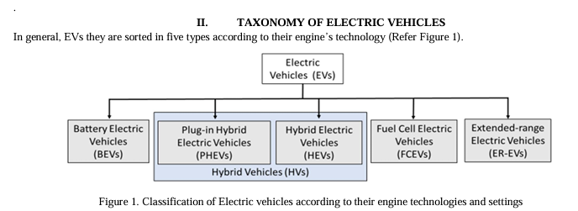

Ref. by. ISSN: 2321-9653; IC Value: 45.98; SJ Impact Factor: 7.538

Types of Electric Vehicles
1. Battery Electric Vehicles (BEVs):
Battery Electric Vehicles (BEVs) are fully powered by electricity, with 100% propulsion coming from an electric motor. They do not have an internal combustion engine and do not use any liquid fuel. To achieve acceptable driving range, BEVs are equipped with large battery packs. Typically, a BEV can travel between 160 km and 250 km on a single charge, although some models can reach up to 500 km. For example, the Nissan Leaf is a fully electric vehicle equipped with a 62 kWh battery, offering a range of approximately 360 km.
2. Plug-in Hybrid Electric Vehicles (PHEVs):
Plug-in Hybrid Electric Vehicles (PHEVs) are powered by both a conventional internal combustion engine and an electric motor. The electric battery can be charged using an external power source. These vehicles can store sufficient electrical energy from the grid to significantly reduce fuel consumption during normal driving conditions. For instance, the Mitsubishi Outlander PHEV has a 12 kWh battery that allows it to travel around 50 km in electric-only mode. However, actual fuel consumption may be higher than the values indicated by manufacturers.
3. Hybrid Electric Vehicles (HEVs):
Hybrid Electric Vehicles (HEVs) also use a combination of an internal combustion engine and an electric motor. Unlike PHEVs, HEVs cannot be plugged into an external power source. Instead, the battery is charged through the engine and regenerative braking, which converts kinetic energy into electrical energy. For example, the Toyota Prius (4th generation) is equipped with a 1.3 kWh battery, allowing it to travel up to 25 km in electric-only mode under ideal conditions.

2. Market of EV
Growth of the Electric Vehicle Market in India
The electric vehicle (EV) market in India has experienced significant growth, particularly after the implementation of the FAME (Faster Adoption and Manufacturing of Hybrid and Electric Vehicles) scheme in 2015 by the Ministry of Heavy Industry and Public Enterprises. The Indian EV market was valued at USD 5.47 billion in 2020 and is projected to reach USD 17.01 billion by 2026, growing at a compound annual growth rate (CAGR) of 23.47% during the forecast period (2021–2026) [7].To support this growth, the Government of India has introduced several initiatives aimed at promoting the manufacturing and adoption of electric vehicles, reducing emissions in line with international commitments, and encouraging e-mobility amid rapid urbanization.
Key Government Initiatives:
- The government has provided tax exemptions and subsidies to both EV manufacturers and consumers to encourage the growth of the domestic electric vehicle industry.
- The Ministry of Power clarified that no license is required to operate EV charging stations in India, as charging is considered a service rather than the sale of electricity.
- The Ministry of Road Transport and Highways announced that battery-operated, ethanol-powered, and methanol-powered vehicles are exempt from permit requirements.
- Under the phased manufacturing programme, the government has imposed a 15% customs duty on EV components and a 10% duty on imported lithium-ion cells to promote domestic manufacturing.
The Indian electric vehicle market is broadly classified based on vehicle type and power source. By vehicle type, it includes passenger cars, commercial vehicles, two-wheelers, and three-wheelers.

3. EV Sales in INDIA
1) Origin and Increasing Scope:
The growth of Electric Vehicles (EVs) is largely driven by the global climate agenda established under the Paris Agreement, which aims to reduce carbon emissions and limit global warming. Today, the global electric mobility revolution is marked by the rapid increase in EV adoption. In 2020, EV sales reached 2.1 million units, with approximately two out of every hundred cars sold being electric. The global EV fleet reached 8.0 million in 2020, accounting for 1% of the total vehicle stock and 2.6% of global car sales [8]. Additionally, declining battery costs and improved performance efficiencies are further accelerating the global demand for EVs.
2) Need for Electric Vehicles:
India urgently requires a transformation in its transportation sector. The current trend of increasing dependence on vehicles powered by expensive imported fuels, combined with overcrowded urban infrastructure and severe air pollution, is unsustainable. Transitioning to electric mobility offers a viable and effective solution for decarbonizing the transport sector and addressing these challenges.
3) India’s Support to EVs:
India is one of the key countries supporting the global EV30@30 campaign, which targets at least 30% of new vehicle sales to be electric by 2030. At the Glasgow Summit, India proposed several initiatives, including meeting 50% of its energy needs through renewable sources, reducing carbon emissions by 1 billion tons by 2030, and achieving net-zero emissions by 2070 [8].
The Government of India has undertaken several initiatives to develop and promote the electric vehicle (EV) ecosystem in the country. These include:
- The revamped Faster Adoption and Manufacturing of Electric Vehicles (FAME II) scheme.
- The Production Linked Incentive (PLI) scheme for Advanced Chemistry Cells (ACC), aimed at strengthening the supply side.
- The recently introduced PLI scheme for the automobile and automotive components sector, which supports electric vehicle manufacturers.

India EV Sales FY 2026: 83% Growth & Market Trends

The Indian electric vehicle industry reached a significant milestone in the 2026 fiscal year. Total retail sales climbed to 1,99,923 units, marking a massive 83.63% year-on-year growth. This surge proves that the transition from internal combustion engines is gaining momentum. Brands like Tata, MG, and Mahindra have expanded their portfolios to meet demand. The entry of Maruti and Hyundai into the budget EV space accelerated this trend. The driving experience in modern EVs has evolved significantly by early 2026. Instant torque provides swift acceleration, making city overtakes effortless and quiet. Regenerative braking systems are now more intuitive across all major manufacturer brands. Battery thermal management ensures consistent performance even in harsh Indian summer conditions. Most mid-range electric cars now offer a real-world range exceeding 350 kilometers.

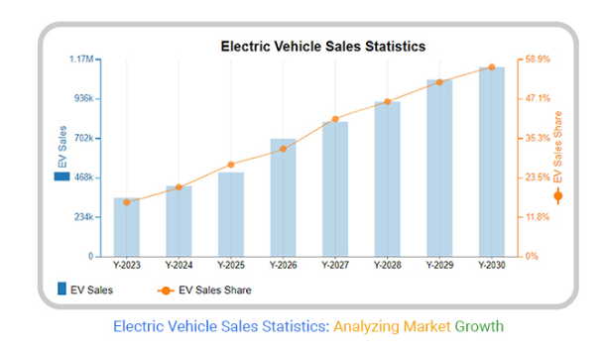

4. Challenges with EV

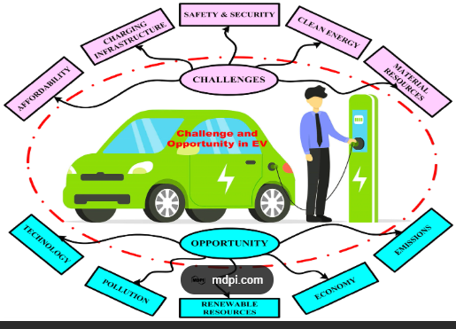
Electric vehicles (EVs) face several significant challenges, including limited charging infrastructure, grid capacity issues, high upfront costs, and consumer adoption barriers.

Key Challenges
- Limited Charging Infrastructure:
A major hurdle for EV adoption is the insufficient number of charging stations, particularly in rural and semi-urban areas. Many regions lack adequate coverage, leading to "range anxiety" among potential users who fear running out of battery without access to a charging point.
The concentration of charging stations in urban areas means that long-distance travel can be problematic, as drivers may struggle to find charging options along highways.
- Grid Capacity Issues:
The transition to electric vehicles increases demand on existing electrical grids, which may not be equipped to handle the additional load. This can lead to outages and insufficient power supply for charging stations.
Upgrading grid infrastructure to support EV charging is essential, but it requires significant investment and planning.

- High Upfront Costs:
Although the long-term savings on fuel and maintenance can be substantial, the initial purchase price of EVs is often higher than that of traditional internal combustion engine vehicles. This can deter potential buyers, especially in regions with lower average incomes.
Government incentives and subsidies play a crucial role in making EVs more affordable, but the absence of these can slow down adoption.
- Long Charging Times:
Charging an EV can take several hours, especially with standard home chargers. While fast chargers are available, they are not yet widespread, and not all EVs are compatible with them.
This can be inconvenient for users who are accustomed to the quick refueling times of gasoline vehicles.
- Consumer Adoption Barriers:
Many potential buyers are hesitant to switch to EVs due to concerns about charging availability, battery range, and the overall reliability of electric vehicles.
Education and awareness campaigns are needed to address these concerns and promote the benefits of EVs.

Conclusion
The challenges facing electric vehicles are multifaceted and require coordinated efforts from governments, manufacturers, and consumers to overcome. Addressing these issues is crucial for the widespread adoption of EVs and the transition to a more sustainable transportation system. Solutions may include expanding charging infrastructure, upgrading grid capacity, providing financial incentives, and enhancing public awareness about the benefits of electric mobility.

5. OPPORTUNITIES IN EV

1. Electric Vehicles as a Way Forward:
Electric vehicles (EVs) can significantly improve the country’s energy security, as India currently imports over 80% of its crude oil requirements, costing approximately $100 billion. The adoption of EVs is also expected to boost the domestic manufacturing sector and create employment opportunities. Furthermore, EVs can provide valuable grid support services, helping to integrate higher levels of renewable energy while ensuring stable and secure grid operations.
2) Opportunities for Battery Manufacturing and Storage:
Recent technological advancements have created significant opportunities in battery storage, which can play a vital role in promoting sustainable development in the country. This is further supported by government initiatives aimed at advancing e-mobility and achieving a renewable energy capacity target of 450 GW by 2030 [11]. Additionally, rising per capita income has led to increased demand for consumer electronics such as mobile phones, UPS systems, laptops, and power banks, all of which require advanced chemistry batteries. As a result, battery manufacturing has emerged as one of the largest economic opportunities of the 21st century.
3) EV Charging Infrastructure:
A robust EV charging infrastructure can be developed by utilizing local electricity supply at various locations, including private residences, petrol and CNG stations, and parking facilities in commercial areas such as malls, railway stations, and bus depots. The Ministry of Power has recommended the installation of at least one charging station within every 3 km grid in urban areas and at intervals of 25 km on both sides of highways. Furthermore, under the Model Building Bye-Laws, 2016 (MBBL), the Ministry of Housing and Urban Affairs has mandated that 20% of parking spaces in residential and commercial buildings be allocated for EV charging facilities [12]. Implementation of these provisions requires state governments to amend their respective building regulations.
4) Increasing R&D in EVs:
To strengthen the EV ecosystem, India must promote the development of indigenous technologies tailored to its specific needs from both strategic and economic perspectives. Increased investment in local research and development is essential to reduce costs and enhance innovation. Leveraging the capabilities of local universities and existing industrial hubs can accelerate progress. Additionally, collaboration with countries such as the UK can help India achieve synergies in EV development.

6. CONCLUSION
Electric vehicles (EVs) have significant potential to replace internal combustion engine vehicles (ICEVs) in many on-road applications. They offer numerous advantages, including reduced dependence on petroleum, improved local air quality, lower greenhouse gas (GHG) emissions, and enhanced driving experience.
Vehicle electrification is closely aligned with broader trends of electrification and decarbonization, and it integrates effectively with emerging mobility solutions such as urban micro-mobility, automation, and mobility-as-a-service.
Furthermore, the integration of EVs into power systems presents several opportunities to enhance both efficiency and economic performance. EVs can support power system planning and operations, contributing to a more reliable and optimized energy ecosystem.

REFERENCES

- R.T. Doucette, M.D. McCulloch, Modeling the prospects of plug-in hybrid electric vehicles to reduce CO₂ emissions, Appl. Energy 88 (2011) 2315–2323.
- https:www.goldmansachs.com/insights
- https://en.wikipedia.org/wiki/Electric_vehicle_industry_in_India
- https://www.climatelinks.org/resources/greenhouse-gas-emissions-factsheet-india
- W. Kempton, J. Tomić, Vehicle-to-grid power implementation: from stabilizing the grid to supporting large-scale renewable energy, J. Power Sources 144 (1) (2005) 280–294.
- R.J. Bessa, M.A. Matos, Economic and technical management of an aggregation agent for electric vehicles: a literature survey, Eur. Trans. Electr. Power 22 (3) (2012) 334–350.
- N. Daina, A. Sivakumar, J.W. Polak, Modelling electric vehicles use: a survey on the methods, Renew. Sustain. Energy Rev. 68 (2017) 447–460.
- F. Koyanagi, Y. Uriu, Modeling power consumption by electric vehicles and its impact on power demand, Electr. Eng. Jpn. 120 (4) (1997) 40–47.
- J.E. Kang, W.W. Recker, An activity-based assessment of the potential impacts of plug-in hybrid electric vehicles on energy and emissions using 1-day travel data, Transp. Res. Part D: Transp. Environ. 14 (8) (2009) 541–556.
- J. Dong, C. Liu, Z. Lin, Charging infrastructure planning for promoting battery electric vehicles: an activity-based approach using multiday travel data, Transp. Res. Part C: Emerg. Technol. 38 (2014) 44–55.
- C. Weiller, Plug-in hybrid electric vehicle impacts on hourly electricity demand in the United States, Energy Policy 39 (6) (2011) 3766–3778.
- J. Axsen, K.S. Kurani, Anticipating plug-in hybrid vehicle energy impacts in Califor- nia: constructing consumer-informed recharge profiles, Transp. Res. Part D: Transp. Environ. 15 (4) (2010) 212–219.
- O. Sundström, C. Binding, Charging service elements for an electric vehicle charg- ing service provider, in: Proceedings of the Power and Energy Society General Meet- ing, 2011, IEEEIEEE, 2011, pp. 1–6.
- M.D. Galus, M.G. Vayá, T. Krause, G. Andersson, The role of electric vehicles in smart grids, Wiley Interdiscip. Rev.: Energy Environ. 2 (4) (2013) 384–400.
- J. Brady, M O’Mahony, Modelling charging profiles of electric vehicles based on real-world electric vehicle charging data, Sustain. Cities Soc. 26 (2016) 203–216.
- P. Morrissey, P. Weldon, M. O Mahony, Future standard and fast charging infras- tructure planning: an analysis of electric vehicle charging behaviour, Energy Policy 89 (2016) 257–270.
- A. Foley, B. Tyther, P. Calnan, B.O. Gallachoir, Impacts of electric vehicle charging under electricity market operations, Appl. Energy 101 (2013) 93–102.
- S. Steinhilber, P. Wells, S. Thankappan, Socio-technical inertia: understanding the barriers to electric vehicles, Energy Policy 60 (2013) 531–539.
- Y. Hai, T. Finn, M. Ryan, Driving pattern identification for EV range estimation, in: Proceedings of the IEEE International Electric Vehicle Conference (IEVC), 2012,
pp. 1–7.
- G. Hayes John, R.P.R. Oliveira de, V. Sean, G Egan Michael, Simplified electric ve- hicle power train models and range estimation, in: Proceedings of the IEEE Vehicle Power and Propulsion Conference (VPPC), 2011, pp. 1–5.
- F. Salah, J.P. Ilg, C.M. Flath, H. Basse, C. Van Dinther, Impact of electric vehicles on distribution substations: a Swiss case study, Appl. Energy 137 (2015) 88–96.
- N. Hartmann, E.D. Ozdemir, Impact of different utilization scenarios of electric vehicles on the German grid in 2030, J. Power Sources 196 (4) (2011) 2311–2318.
- F. Yang, Y. Sun, T. Shen, Nonlinear torque estimation for vehicular electrical ma- chines and its application in engine speed control, in: Proceedings of the 2007 IEEE International Conference on Control Applications, IEEE, 2007, pp. 1382–1387.
- X. Yu, T. Shen, G. Li, K. Hikiri, Regenerative braking torque estimation and con- trol approaches for a hybrid electric truck, in: Proceedings of the 2010 American Control Conference, IEEE, 2010, pp. 5832–5837.
- X. Yu, T. Shen, G. Li, K. Hikiri, Model-based drive shaft torque estimation and control of a hybrid electric vehicle in energy regeneration mode, in: Proceedings of the 2009 ICCAS-SICE, IEEE, 2009, pp. 3543–3548.
- D. Yin, Y. Hori, A novel traction control of EV based on maximum effective torque estimation, in: Proceedings of the 2008 IEEE Vehicle Power and Propulsion Con- ference, IEEE, 2008, pp. 1–6.D. Yin, Y. Hori, A new approach to traction control of EV based on maximum effective torque estimation, in: Proceedings of the 2008 34th Annual Conference of IEEE Industrial Electronics, IEEE, 2008, pp. 2764–2769.

