From Trade to Transformation: Advancing a Climate Action and Sustainability Protocol under AfCFTA to Address Africa’s Disproportionate Climate Burden and Finance Gaps

Abstract
Africa contributes less than 4% of global greenhouse gas emissions yet bears a disproportionate share of climate-related economic losses, with estimates suggesting annual GDP reductions of 2–5% across climate-vulnerable states. Despite these vulnerabilities, the African Continental Free Trade Area (AfCFTA), the continent’s flagship integration project lacks binding climate provisions within its legal architecture. This article examines how climate shocks undermine trade stability, agricultural productivity, and fiscal resilience across African economies and proposes the adoption of an AfCFTA Climate Action and Sustainability Protocol to align trade integration with climate resilience and structural justice. Using doctrinal legal analysis and policy evaluation supported by empirical evidence from the World Meteorological Organization, Africa Agriculture Trade Monitor, and climate-economic transmission models, the study demonstrates that climate risks are systemic constraints on African trade competitiveness. It argues that embedding climate governance within AfCFTA would transform the agreement into a continental mechanism for redistributive climate finance, adaptive trade governance, and sustainable development. The article advances institutional and legal pathways for integrating climate resilience into regional trade regimes and positions AfCFTA as a potential global model for climate-just trade governance in the Global South.
Keywords: AfCFTA; climate governance; climate finance; trade policy; Africa; climate justice; sustainable development

1.0 Introduction
Climate change represents one of the most profound structural challenges confronting Africa’s economic transformation and long-term development trajectory. Although the continent contributes less than 4% of global greenhouse gas emissions, it is warming faster than the global average and is already experiencing severe economic and social consequences. The World Meteorological Organization (2023) reports that Africa has lost approximately 34% of its agricultural productivity since 1961, while recent estimates indicate that climate-induced disasters reduce national output by between 2–5% of GDP annually across many African economies. These losses are particularly acute in regions where agriculture sustains more than 60% of livelihoods and remains central to trade, employment, and food security.

Despite these structural vulnerabilities, Africa’s flagship regional integration project, the African Continental Free Trade Area (AfCFTA) does not yet embed binding climate or environmental provisions within its legal architecture. Existing protocols governing trade in goods, services, investment, and intellectual property remain largely silent on climate governance, creating a policy and institutional vacuum at a time when climate shocks increasingly disrupt cross-border supply chains and regional markets. This omission risks undermining AfCFTA’s transformative potential while exacerbating inequalities between climate-exposed regions and relatively resilient economies.

To illustrate the uneven geography of climate vulnerability across the continent, Figure 1 presents an author-generated visualization of relative regional exposure based on compiled data from the World Meteorological Organization, UNEP climate assessments, and secondary policy datasets. The figure highlights how vulnerability is concentrated in specific ecological and economic zones, with Sahelian and Horn of Africa regions facing the highest relative exposure to drought, desertification, and food-system instability, while coastal and southern regions confront rising sea levels, flooding, and climate-induced production variability.

Figure 1. Regional Climate Vulnerability Patterns in Africa
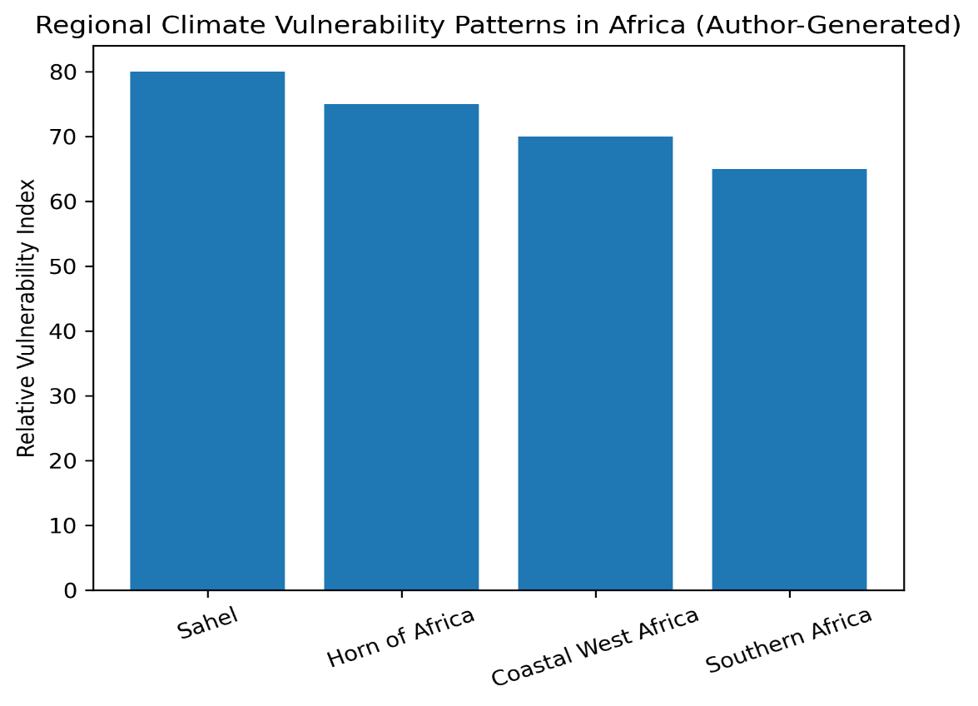
Source: Author-generated visualization based on World Meteorological Organization (WMO), 2023, UNEP climate vulnerability assessments, and secondary climate-economic datasets.

The figure demonstrates the structurally uneven distribution of climate risks across African regions. Sahelian states face recurrent drought and desertification; the Horn of Africa confronts prolonged water stress and food insecurity; coastal West African economies are increasingly exposed to sea-level rise and flooding; while Southern African states experience intensified rainfall variability and energy-water stress. These asymmetries underscore a central governance challenge: climate risks are inherently transboundary and cannot be effectively addressed through fragmented national adaptation strategies alone. Without a coordinated continental framework, national responses risk being overwhelmed by cross-border climate shocks that disrupt trade flows, agricultural markets, and regional infrastructure systems.

Against this backdrop, this article advances a normative and policy-oriented argument for the adoption of an AfCFTA Climate Action and Sustainability Protocol. Such a protocol would embed climate resilience within Africa’s integration architecture, ensuring that trade liberalization is pursued in tandem with ecological sustainability, distributive justice, and adaptive capacity. By integrating doctrinal legal analysis with empirical climate-economic evidence and comparative governance insights, the study positions AfCFTA not only as a trade agreement but as a potential continental mechanism for climate-resilient economic transformation.

This article asks: how can the African Continental Free Trade Area be transformed into a climate-resilient trade regime through a binding sustainability protocol? It contributes to climate policy scholarship in three principal ways. First, it reconceptualizes regional trade agreements as climate-policy instruments capable of redistributing climate risk and strengthening economic resilience. Second, it integrates structural justice theory with empirical evidence on climate-economic transmission to demonstrate how climate shocks undermine African trade competitiveness and fiscal stability. Third, it proposes a legally grounded institutional framework for embedding climate governance, adaptive finance, and sustainability standards within continental trade architecture.

The remainder of the article proceeds as follows. Section 2 reviews the literature on climate vulnerability, trade integration, and structural inequality in Africa. Section 3 outlines the climate-economic transmission mechanisms shaping African trade systems. Section 4 presents empirical findings on agricultural exposure, production volatility, and climate finance disparities. Section 5 discusses the implications for AfCFTA governance and regional policy coordination. Section 6 proposes a draft Climate Action and Sustainability Protocol, and Section 7 concludes with recommendations for embedding structural climate justice within Africa’s integration trajectory.

2.0 Literature Review

2.1 Climate Vulnerability and Trade in Africa
Scholarly consensus underscores Africa’s disproportionate vulnerability to climate change and the inadequacy of existing governance responses. Climate-related disasters now cost the continent between 2–5% of GDP annually, while agricultural productivity has declined by approximately 34% since 1961 (World Meteorological Organization, 2023; Reuters, 2024). Ngcamu (2023) highlights how recurrent floods and droughts trigger displacement and livelihood disruptions, while Seko and Basaran (2023) demonstrate that climate shocks erode Indigenous knowledge systems and intergenerational cultural continuity. Complementing these findings, Oxfam (2022) and IIED (2021) note that Africa receives significantly less than its proportional share of global climate finance, with access constrained by donor-driven criteria and institutional capacity limitations. Collectively, these studies establish that Africa’s climate crisis is simultaneously an economic, governance, and trade integration challenge.

To illustrate the spatial dimension of these risks, Figure 2 presents an author-generated visualization of population exposure to climate hazards across key African ecological zones. The figure demonstrates that communities are concentrated in drought-prone arid regions, flood-affected river basins, and low-lying coastal areas, reinforcing the intersection between demographic pressures and ecological vulnerability.

Figure 2. Spatial Exposure of Populations to Climate Risk in Africa
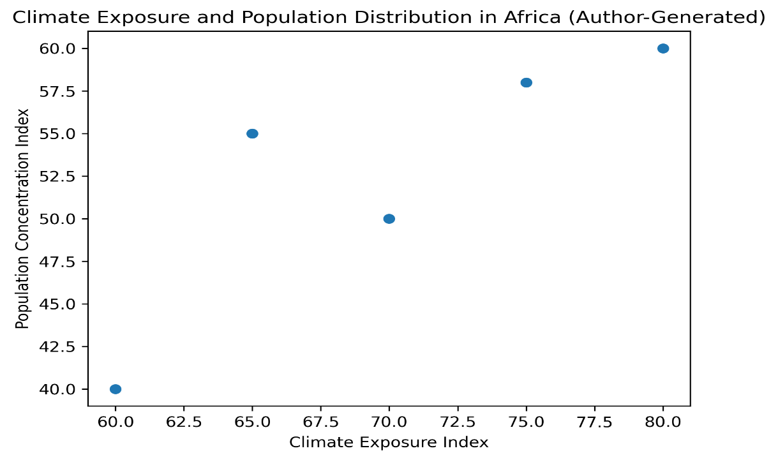
Source: Author-generated using compiled data from WMO (2023), Oxfam (2022), and secondary climate-demographic datasets.

Figure 3 complements this analysis by illustrating the relationship between rising temperatures and economic losses across African economies. The visualization highlights the direct correlation between increasing temperature variability and GDP contraction in climate-sensitive sectors.

Figure 3. Estimated GDP Loss Associated with Climate Change in Africa
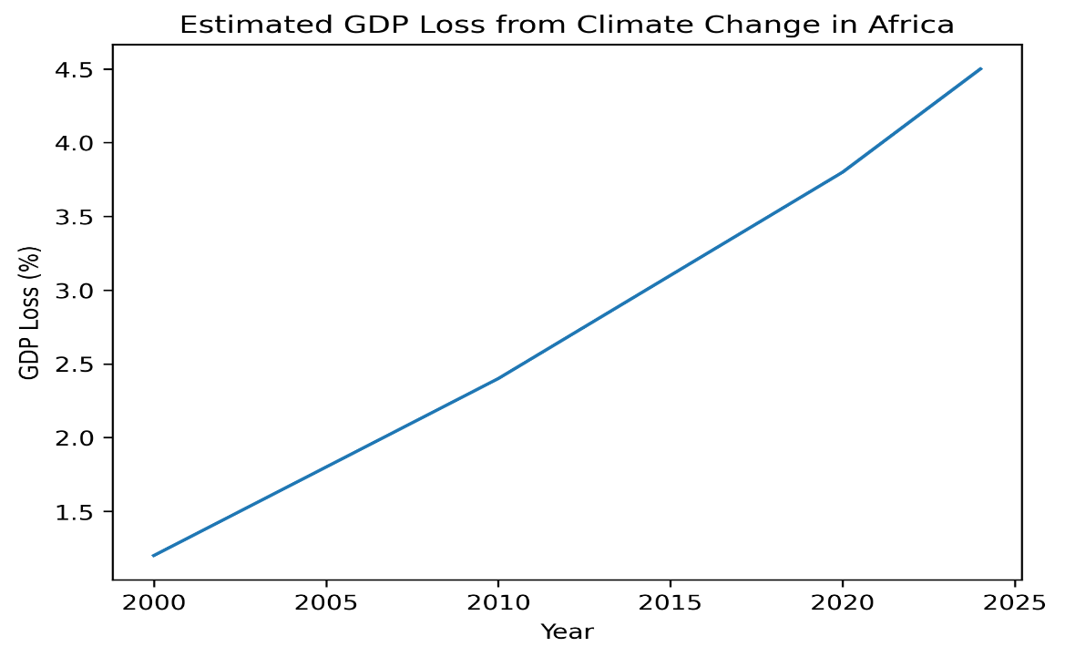
Source: Author-generated based on Reuters, (2024), WMO (2023), and climate-economic datasets.

Together, Figures 2 and 3 demonstrate that Africa’s climate crisis is not only reflected in aggregate GDP losses but also in deeply uneven spatial and demographic vulnerability. These asymmetries highlight why a uniform AfCFTA policy approach is insufficient and why climate resilience must be integrated into continental trade governance.

2.2 Climate Justice and Structural Inequalities
The literature situates Africa’s climate-trade dilemma within broader debates on climate justice and structural inequality. UNEP (2023) critiques existing trade policies for failing to internalize environmental externalities, warning that unchecked liberalization may accelerate ecological degradation. Tralac (2021) identifies the absence of climate provisions within AfCFTA’s legal architecture as a critical institutional gap. Scholars of climate justice (Agyeman et al., 2003; Santos, 2014) argue that marginalized communities often remain excluded from climate governance decision-making, reinforcing epistemic and economic hierarchies. Cornwall’s (2008) concept of “participation without power” further explains how consultation processes frequently fail to translate into meaningful policy influence.

In the African context, structural inequalities are both global and regional. Limited access to climate finance reinforces dependency on external funding mechanisms, while uneven vulnerability across regions risks exacerbating intra-African disparities under AfCFTA. Without an integrated climate governance framework, trade liberalization could inadvertently deepen these inequalities rather than mitigate them.

2.3 Gaps in the Literature
Although existing scholarship recognizes Africa’s climate vulnerability and finance inequities, trade and climate governance are often treated as parallel rather than integrated domains. Few studies examine how continental integration frameworks such as AfCFTA can function as institutional vehicles for embedding climate resilience. This article addresses that gap by proposing a legally grounded Climate Action and Sustainability Protocol under AfCFTA. By combining empirical evidence (Figures 2 and 3) with theoretical insights on climate-economic transmission, the study repositions AfCFTA as both a trade integration mechanism and a governance instrument for climate justice.

2.4 Theoretical Framework: Climate–Economic Transmission and Trade Resilience
The theoretical foundation of this study draws on climate-economic transmission models, which explain how climate shocks propagate through production systems, trade flows, and welfare outcomes. Rising temperatures, rainfall variability, and extreme weather events affect agricultural productivity, infrastructure reliability, and energy security, thereby shaping macroeconomic performance and trade competitiveness (Zhao & Liu, 2023).

Figure 4 illustrates long-term temperature and rainfall anomalies across Africa, highlighting the accelerating pace of climate variability across regions.

Figure 4. Temperature and Rainfall Anomalies in Africa
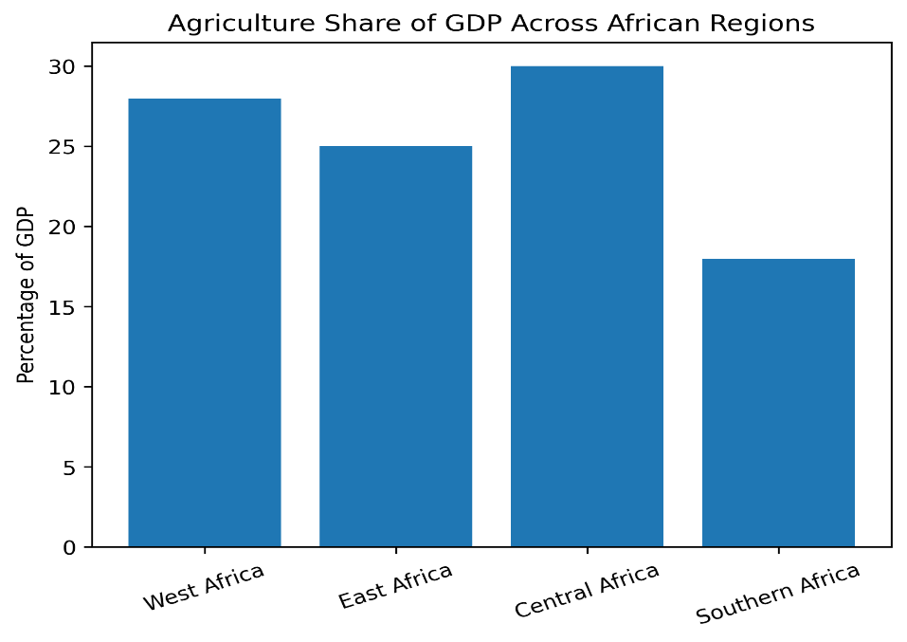
Source: Author-generated based on WMO (2023) and historical climate datasets.

These patterns undermine agricultural productivity, strain water and energy systems, and destabilize infrastructure networks central to trade. The World Meteorological Organization (2023) confirms that Africa is warming faster than the global average, amplifying exposure to compounding climate risks.

Figure 5 presents a stylized climate-economic transmission mechanism, illustrating how climate change generates cascading effects across production systems, supply chains, and trade outcomes.

Figure 5. Climate–Economic Transmission Mechanism
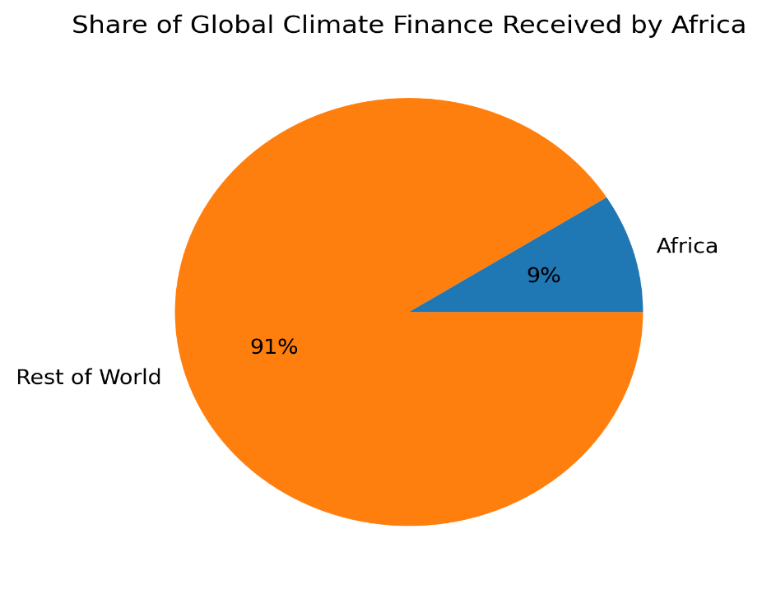
Source: Author-generated conceptual model based on Zhao & Liu (2023) and climate-economy literature.

In the African context, rising temperatures and erratic rainfall reduce yields, increase price volatility, and raise adaptation costs. These shocks propagate through markets, elevating transaction costs and weakening export competitiveness. Without institutional mechanisms to buffer these effects, regional trade integration risks being undermined by systemic climate pressures.

Two key insights emerge. First, climate risks are intrinsic to African trade systems rather than external shocks. Second, AfCFTA has the potential to function as a structural buffer by embedding resilience within its legal and institutional design. By mainstreaming climate risk assessments, facilitating intra-African trade stabilization, and mobilizing finance, AfCFTA could interrupt the transmission channels that convert environmental shocks into systemic economic crises.

2.5 Empirical Review
Empirical evidence reinforces the urgency of integrating climate governance within AfCFTA. Climate-induced disasters continue to erode economic output across African states, with cumulative damages reaching billions annually (Reuters, 2024; WMO, 2023). Agriculture remains central to African economies yet highly exposed to climate variability and under-resourced in adaptation technologies. Production volatility across regional economic communities further demonstrates the need for coordinated continental responses to climate-induced supply disruptions.

Limited access to climate finance compounds these vulnerabilities. Oxfam (2022) and IIED (2021) show that Africa receives less than its equitable share of global climate funding, while African-led projects remain underrepresented within major climate finance mechanisms. This finance gap reinforces structural exposure and limits adaptive capacity across climate-sensitive sectors.
In sum, the empirical record confirms that climate risks constitute systemic constraints on African trade integration rather than isolated environmental shocks. AfCFTA therefore represents more than a trade liberalization framework; it is a potential governance mechanism for pooling risks, stabilizing markets, and channeling adaptation finance. Embedding a Climate Action and Sustainability Protocol within AfCFTA would ensure that regional integration strengthens rather than undermines climate resilience.

AfCFTA as a Climate Policy Instrument
This study conceptualizes AfCFTA not merely as a trade liberalization framework but as a latent climate-policy instrument capable of redistributing climate risk across regional economies. By embedding enforceable resilience mechanisms within trade governance, AfCFTA can function as a structural buffer against climate-economic transmission shocks affecting agriculture, infrastructure, and fiscal stability. This reconceptualization shifts climate policy from being solely the domain of environmental ministries to becoming an integral component of continental trade governance and long-term economic planning.

3.0 Methodology
This study employs an integrated qualitative research design combining doctrinal legal analysis, policy evaluation, and empirical triangulation to examine the intersection of trade governance and climate resilience under AfCFTA. The approach is designed to assess both the normative architecture of AfCFTA and the empirical realities of climate vulnerability across African economies. By linking legal interpretation with climate-economic evidence, the study evaluates whether AfCFTA’s institutional framework adequately reflects the structural risks identified in Sections 1 and 2.

3.1 Doctrinal Legal Analysis
The first component of the methodology consists of a doctrinal examination of AfCFTA’s legal framework, including its founding Agreement, operational protocols, and related instruments. The analysis focuses on identifying the presence or absence of binding climate and environmental provisions, assessing how existing trade obligations interact with environmental governance, and evaluating the implications of legal silence in areas of climate risk.

This doctrinal inquiry is further contextualized through comparative reference to regional and international instruments, including the African Union Climate Change and Resilient Development Strategy (2022–2032), UNEP’s Africa Environment Outlook, and selected WTO trade–environment jurisprudence. This comparative lens allows the study to situate AfCFTA within broader trade–climate governance trends and identify institutional gaps.

3.2 Policy and Institutional Analysis
The second methodological component involves policy analysis using authoritative reports and datasets from the World Meteorological Organization (2023), UNEP (2023), the Africa Agriculture Trade Monitor (2024), OECD climate finance data, and related sources. These materials are used to assess:
- The scale of Africa’s climate vulnerability
- Agricultural productivity trends
- Production volatility across regions
- Climate finance distribution patterns
The purpose of this analysis is not to generate new primary datasets, but to synthesize existing empirical evidence in order to evaluate whether AfCFTA’s institutional design corresponds to documented climate-economic risks.

3.3 Empirical Triangulation
To strengthen the robustness of its conclusions, the study employs empirical triangulation. Figures presented throughout the paper (Figures 1–8) compile and synthesize climate anomaly data, economic loss estimates, agricultural production patterns, and climate finance flows. By cross-validating findings across multiple authoritative sources, the study reduces reliance on single datasets and enhances analytical reliability.

The triangulation approach enables the integration of spatial vulnerability mapping, macroeconomic loss estimates, and sectoral production data into a unified assessment of trade resilience. This evidentiary layering supports the argument that climate risks are systemic constraints embedded within African trade systems rather than isolated environmental shocks.

3.4 Comparative Framing
Comparative institutional references further inform the analysis. The Ogiek v. Kenya (African Court on Human and Peoples’ Rights, 2017) decision provides an African precedent linking ecological governance and rights-based frameworks. The Sámi Parliament model illustrates institutionalized participatory governance in environmental decision-making. These cases are not treated as direct analogues but as comparative reference points for evaluating governance design and enforcement mechanisms relevant to AfCFTA.

3.5 Limitations
This study relies primarily on secondary legal sources and policy datasets rather than primary fieldwork or econometric modeling. While this limits causal inference, it is appropriate for the study’s objective of institutional and normative evaluation. The use of cross-referenced empirical sources and doctrinal analysis mitigates potential bias and ensures that conclusions are grounded in established data and legal interpretation.

4.0 Findings
This section synthesizes doctrinal analysis, policy evaluation, and empirical evidence to demonstrate how Africa’s disproportionate climate burden intersects with institutional gaps within AfCFTA. By integrating legal interpretation with empirical validation, the findings show how climatic, economic, and financial asymmetries undermine trade resilience across the continent and reinforce the case for embedding climate governance within AfCFTA’s institutional architecture.

4.1 Geographic Vulnerability and Uneven Risk Distribution
Empirical evidence confirms that Africa’s climate exposure is spatially uneven and structurally embedded within its economic systems. The World Meteorological Organization (2023) reports that agricultural productivity across the continent has declined by approximately 34% since 1961, while recent estimates suggest that climate-related disasters reduce GDP by between 2–5% annually in several African economies (Reuters, 2024).

Figures 1–3 illustrate the geographic heterogeneity of these impacts. Sahelian states experience recurrent drought and desertification, coastal economies face flooding and sea-level rise, and arid interior regions confront persistent water stress and food insecurity. These differentiated vulnerabilities highlight the limitations of nationally bounded adaptation strategies and demonstrate the need for coordinated continental responses capable of internalizing cross-border climate risks.

The findings indicate that climate exposure is not evenly distributed across African regions, and therefore the effects of trade liberalization under AfCFTA will likewise be uneven unless accompanied by mechanisms that address structural asymmetries in resilience and adaptive capacity.

4.2 Climate Anomalies and Transmission to Trade Systems
The empirical analysis further reveals how climate anomalies translate into economic and trade disruptions. Figure 4 demonstrates accelerating temperature increases and rainfall variability across African regions, reinforcing evidence that the continent is warming faster than the global average (WMO, 2023). These environmental changes directly affect agricultural yields, energy systems, and transport infrastructure.

The climate–economic transmission model presented in Figure 5 illustrates the cascading pathways through which climatic changes influence production systems, supply chains, and macroeconomic stability. Rising temperatures and erratic rainfall contribute to reduced agricultural output, which in turn disrupts export supply, increases food import dependence, and generates fiscal pressure on governments. These disruptions propagate through regional markets, raising transaction costs and weakening trade competitiveness.

The findings confirm that climate shocks are not external disturbances but structural constraints embedded within African trade systems. As such, they require institutional responses within AfCFTA’s governance framework rather than isolated national adaptation measures.

4.3 Agricultural Dependence and Structural Exposure
Africa’s structural dependence on agriculture further amplifies vulnerability to climate variability. In many countries, agriculture contributes over one-quarter of GDP and constitutes a primary source of employment and export revenue. However, the sector remains characterized by low mechanization, limited irrigation infrastructure, and minimal use of climate-resilient inputs.

Figures 6 and 7 illustrate the resulting production volatility across regions and regional economic communities. Low fertilizer usage, inadequate storage facilities, and erratic rainfall contribute to cyclical fluctuations in output and price instability. These dynamics undermine food security, weaken trade balances, and constrain the effectiveness of regional integration efforts.

At the same time, the data suggest that intra-African trade has the potential to dampen localized production volatility by redistributing surpluses across regions. This stabilizing function, however, can only be realized if supported by coordinated resilience mechanisms and adaptive infrastructure investments. Without such measures, existing structural exposure may limit the benefits of trade integration.

4.4 Institutional Gaps within AfCFTA’s Legal Framework
Doctrinal analysis of AfCFTA’s legal architecture reveals a significant governance gap. While the Agreement contains protocols addressing trade in goods, services, investment, and intellectual property, it does not include binding provisions on climate change or environmental sustainability. This legal silence effectively institutionalizes climate-blind trade integration.

Figure 8 maps AfCFTA’s existing legal pillars and highlights the absence of a dedicated environmental or climate protocol. The lack of binding safeguards allows environmentally unscreened investments and infrastructure projects to proceed without coordinated risk assessment. This omission not only exposes member states to ecological and financial vulnerabilities but also diverges from continental policy commitments under the African Union Climate Change and Resilient Development Strategy (2022–2032).

The findings therefore suggest that AfCFTA’s current institutional design does not adequately reflect the structural climate risks identified in preceding sections.

Figure 6. Mapping AfCFTA Legal Architecture and Environmental Gaps
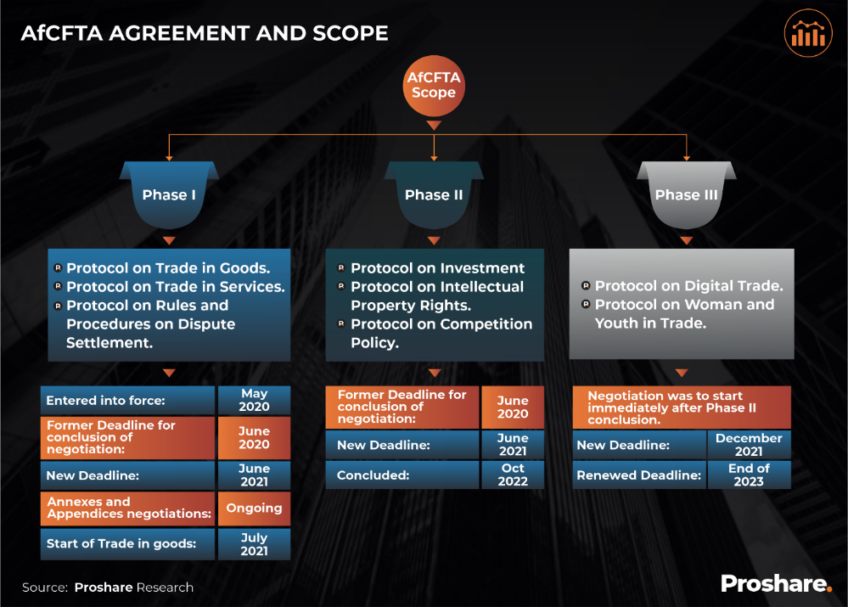
This figure summarizes AfCFTA’s existing legal pillars and highlights the absence of any binding climate or environmental protocol.

4.5 Fiscal Burdens and Economic Losses
Climate change imposes significant fiscal burdens on African economies. Figure 7 illustrates estimated GDP losses across selected countries, with several climate-vulnerable states experiencing annual losses of between 2–5% of national output. Lower-income and highly exposed countries such as Mozambique, Niger, and Malawi bear disproportionately high economic costs relative to their contribution to global emissions.

These losses divert public expenditure toward disaster response and adaptation, reducing fiscal space for investment in infrastructure, education, and industrial development. The reallocation of limited resources toward climate-related expenditures reinforces structural inequalities and constrains long-term economic transformation.

The evidence demonstrates that climate-induced economic losses are not isolated sectoral challenges but systemic pressures affecting national budgets, development trajectories, and trade competitiveness. Without regional mechanisms capable of buffering these fiscal shocks, vulnerable states risk further marginalization within continental and global markets.

Figure 7: Estimated Annual GDP Loss Due to Climate Change in selected African countries
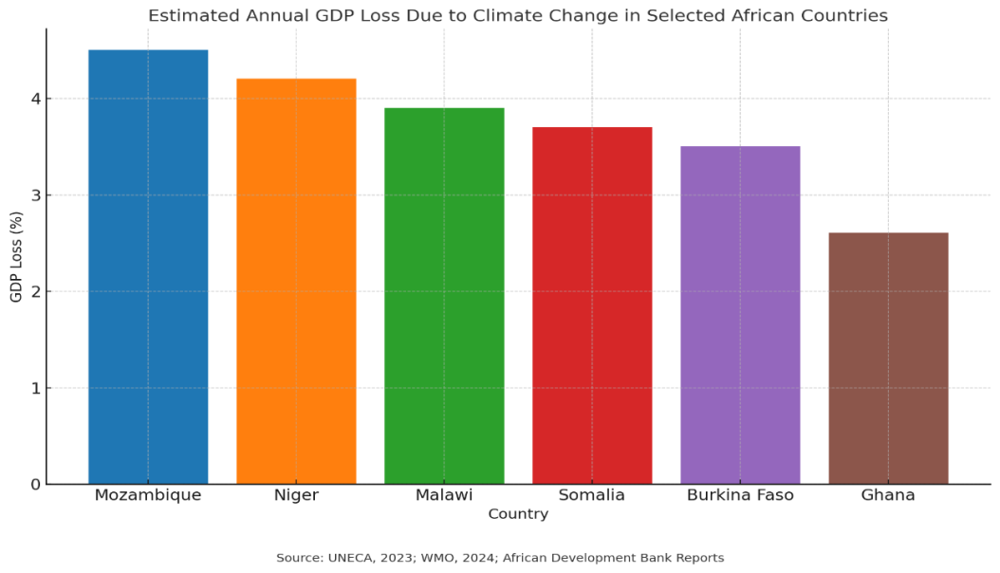
Figure 7 above vividly illustrates the disproportionate economic toll of climate change on African economies, showing estimated annual GDP losses across selected countries such as Mozambique, Niger, Malawi, Somalia, Burkina Faso, and Ghana. The data confirms the broader finding that African nations lose between 2% and 5% of GDP annually to climate-induced shocks (Reuters, 2024). What stands out is how lower-income and climate-vulnerable states, particularly, Mozambique, Niger, and Malawi bear the steepest proportional GDP losses. This aligns with earlier evidence that least developed countries and small island states shoulder the harshest burdens despite contributing minimally to global emissions (WMO, 2023; Oxfam, 2022).

Triangulating this with the discussion above, the figure underscores how climate change magnifies structural inequalities within Africa’s economies, diverting scarce resources away from critical investments in health, education, and infrastructure toward costly adaptation and disaster response. Without regional buffers such as an AfCFTA Climate Protocol, these countries risk further entrenchment at the margins of global trade and value chains. The figure therefore strengthens the argument that climate resilience cannot be treated as an externality but must be mainstreamed into Africa’s economic integration agenda.

4.6 Climate Finance Disparities
Empirical analysis also highlights significant disparities in access to climate finance. Africa receives a relatively small share of global adaptation funding, and within the continent, access remains concentrated among larger or more institutionally resourced economies. Smaller and more vulnerable states often face barriers related to technical capacity, reporting requirements, and donor-driven funding criteria.

Figure 8 illustrates the distribution of adaptation and mitigation finance across African countries, demonstrating persistent inequities in resource allocation. These disparities limit the ability of vulnerable economies to invest in resilience measures and deepen existing asymmetries in adaptive capacity.

The findings indicate that climate finance constraints represent a central structural challenge for African trade integration. Without coordinated mechanisms to mobilize and distribute resources more equitably, climate-related vulnerabilities are likely to persist and intensify.

Figure 8. Total African adaptation- and mitigation-related finance (commitments) by country, 2014–2018 (US$ millions, constant prices).
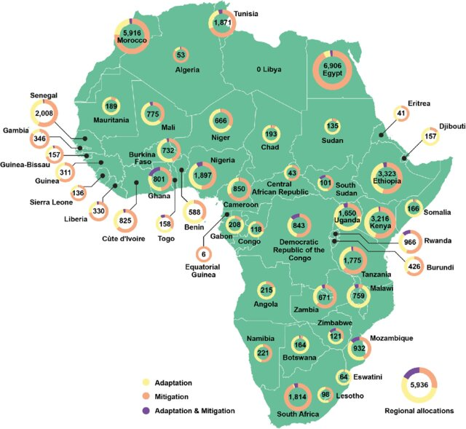
Source: OECD DAC (2020), reproduced in Savvidou (2021)
Notes: For commitments reported under the Rio Marker methodology, the ‘Principal’ marker for adaptation and for mitigation is used.

4.7 Synthesis of Findings
The convergence of doctrinal and empirical evidence reveals a consistent pattern of asymmetric vulnerability, institutional gaps, and fiscal constraint. Climate change erodes productive capacity, destabilizes trade systems, and places sustained pressure on public finances across African economies. Yet AfCFTA’s existing governance framework lacks binding mechanisms capable of addressing these systemic risks.

These findings support the argument that integrating climate governance within AfCFTA is not merely a normative aspiration but a structural necessity. Embedding resilience-oriented provisions within the agreement would enable more coordinated responses to transboundary risks, strengthen trade stability, and enhance adaptive capacity across member states.

While the study relies primarily on secondary data and policy sources, cross-validation across multiple authoritative datasets and legal instruments enhances analytical reliability. The integration of doctrinal analysis with empirical evidence provides a robust foundation for evaluating AfCFTA’s potential role in advancing climate-resilient economic integration.

5.0 Discussion
The findings demonstrate that Africa’s climate vulnerability is not an isolated environmental problem but a structurally embedded constraint within its trade architecture. When interpreted through structural justice theory, legal pluralism, and comparative governance, the evidence reveals a deeper institutional paradox: Africa’s flagship integration project operates without binding climate safeguards despite overwhelming empirical evidence that climate shocks undermine trade stability, fiscal space, and productive capacity.

AfCFTA therefore stands at a critical juncture. It can either replicate climate-blind liberalization models that externalize environmental risk, or evolve into a resilience-oriented framework that embeds climate justice within continental economic governance.

5.1 Climate Vulnerability as Structural Constraint
Africa contributes less than 4% of global emissions yet loses up to 5% of GDP annually to climate-induced shocks. This asymmetry reflects what structural justice theorists describe as the geography of inequity: responsibility and burden are inversely distributed.
Figures 1–5 established that climate exposure across Africa is:
- Spatially uneven
- Economically embedded
- Transboundary in impact
These characteristics render purely national adaptation strategies insufficient. Because climate risks propagate through supply chains, agricultural markets, and fiscal systems, they require a coordinated regional response. AfCFTA remains the continent’s most powerful institutional vehicle capable of delivering such coordination.
The legal implication is clear: climate resilience must be codified within trade governance rather than treated as an external environmental concern.

5.2 Agricultural Dependence and Trade Fragility
Sections 4.2 and 4.3 demonstrated how climate volatility translates into trade instability. Africa’s structural dependence on low-technology agriculture amplifies exposure to rainfall variability and temperature shocks. What might otherwise be localized climatic stress becomes systemic trade disruption.
This raises a deeper institutional question:
Can AfCFTA promote liberalization without institutionalizing resilience?
The evidence suggests it cannot.
Stabilization mechanisms such as:
- Cross-border grain reserves
- Climate-responsive subsidy regimes
- Regional storage and redistribution corridors
would transform intra-African trade into a buffering system capable of redistributing production shocks. Without such legal mandates, integration risks amplifying rather than mitigating vulnerability.

5.3 Institutional Gaps and the Law–Finance Paradox
The doctrinal analysis revealed that AfCFTA lacks enforceable climate provisions. Unlike the EU Green Deal or ASEAN Environmental Cooperation Agreement, AfCFTA contains no binding obligations for:
- Climate screening
- Environmental disclosure
- Sustainability audits
- Carbon regulation
This institutional silence creates what this paper terms the law–finance paradox:
The absence of binding environmental law coincides with chronic climate-finance scarcity.
Figures 7 and 8 show that African states face mounting fiscal burdens while receiving disproportionately low adaptation funding. In effect, legal omission reinforces financial exclusion.
This paradox transforms climate vulnerability from a natural phenomenon into a governance outcome.

5.4 From Recognition to Redistribution
Existing policy frameworks acknowledge Africa’s vulnerability but rarely operationalize redistribution.
Building on Agyeman et al. (2003) and Santos (2014), this study reframes climate justice as structural redistribution:
- Redistribution of risk
- Redistribution of resources
- Redistribution of decision-making power
Empirical evidence shows African states allocate up to 9% of national budgets to adaptation while receiving less than 10% of global climate finance. Recognition without redistribution perpetuates inequity.
Embedding a Climate Finance Facility within AfCFTA would move climate justice from declaratory rhetoric to institutionalized redistribution.

5.5 Comparative Governance Insights
Comparative jurisprudence sharpens the institutional argument.
- Ogiek v. Kenya (ACHPR, 2017): Established recognition of Indigenous land rights but revealed enforcement weaknesses where institutional backing is limited.
- Sámi Parliament model (Nordic governance): Demonstrates how formalized representation enables co-decision-making in environmental governance.
The lesson for AfCFTA is clear:
Participation must move beyond consultation toward co-governance.
Vulnerable states and communities must possess institutional voice within climate-trade decision-making structures.

5.6 Legal Pluralism and Hybrid Governance
Sustainable integration requires legal pluralism; the coexistence of regional, state, and community-based norms.
AfCFTA could institutionalize:
- Regional climate hubs
- Community environmental protocols
- Indigenous knowledge integration platforms
Such hybrid governance enhances legitimacy and compliance while addressing enforcement deficits common in environmental treaties.

5.7 Toward a Resilience Compact
Integrating these insights, the proposed Climate Action and Sustainability Protocol represents a shift from liberalization to resilience.
Its innovation lies in transforming:
- Justice into binding obligations
- Equity into finance allocation rules
- Sustainability into enforceable trade conditions
This reframes AfCFTA from a market-expansion instrument into a resilience compact.

5.8 Discussion Synthesis
Africa’s climate vulnerability is juridically mediated through legal omission and financially reinforced through inequitable resource allocation.
AfCFTA can either perpetuate these asymmetries or dismantle them.
Embedding enforceable climate governance within its architecture would:
- Stabilize trade systems
- Protect fiscal space
- Institutionalize distributive justice
The transformation from recognition to redistribution constitutes the central normative contribution of this study.

6.0 Proposed AfCFTA Climate Action and Sustainability Protocol
The findings confirm that AfCFTA’s current legal framework does not internalize climate risk. Given documented GDP losses, fiscal strain, and finance inequities, a dedicated Climate Action and Sustainability Protocol is both legally and economically justified.

6.1 Objectives
The Protocol shall:
- Integrate climate resilience into AfCFTA’s trade architecture
- Stabilize agricultural markets through coordinated adaptation mechanisms
- Internalize environmental externalities within tariff and investment regimes
- Mobilize African-led climate finance
- Embed structural justice principles in trade governance
- Ensure differentiated responsibilities based on vulnerability mapping

6.2 Core Pillars
- Green Trade Standards: Mandatory eco-labelling, carbon disclosure, and sustainability certification.
- Climate Risk Audits: Pre-trade environmental impact screening for all AfCFTA-supported projects.
- Carbon and Emissions Framework: Continental carbon market facilitation and low-emission trade incentives.
- Just Transition Clauses: Labour and gender protections in low-carbon sector shifts.
- Climate Finance Facility (ACFF): African-led pooled adaptation and resilience financing.

6.3 Institutional Architecture
- Climate Action Committee (CAC): A specialized body under the AfCFTA Secretariat mandated to oversee implementation, reporting, and compliance.
- Regional Climate Hubs: Linked to RECs, tasked with vulnerability mapping, data collection, and coordination of cross-border adaptation projects.
- Technical Working Groups: Multi-stakeholder platforms including governments, private sector, civil society, and Indigenous communities to ensure participatory governance.
- Annual compliance reporting and corrective mechanisms

6.4 Draft Legal Clauses
Article 1 – Scope
This Protocol applies to all AfCFTA activities, including trade in goods, services, investment, and infrastructure projects, where climate or environmental impacts are foreseeable.

Article 2 – Climate Risk Assessment
All AfCFTA-supported projects and trade-related infrastructure shall undergo mandatory climate risk assessments to ensure sustainability.

Article 3 – Agricultural Resilience Mechanism
Member states shall establish cross-border grain reserves and food-security corridors under AfCFTA to reduce volatility in cereal production and stabilize regional markets (linked to Figure 7).

Article 4 – Environmental Safeguards in Trade Policy
Tariffs, subsidies, and investment incentives shall be aligned with low-carbon and climate-resilient sectors, discouraging high-emission trade practices.

Article 5 – AfCFTA Climate Finance Facility
A dedicated facility shall be established to pool resources for adaptation and resilience. This facility shall mobilize member state contributions, private capital, and carbon market revenues, while reducing dependence on donor-driven mechanisms (Figures 9–10).

Article 6 – Participation and Justice
The Protocol recognizes differentiated responsibilities based on vulnerability mapping (Figure 1) and commits to equitable allocation of benefits, ensuring that least-resourced states and communities receive priority support.

Article 7 – Monitoring and Enforcement
The Climate Action Committee shall report annually on implementation. Non-compliance may trigger corrective measures, including suspension of benefits under AfCFTA agreements.

6.5 Comparative Lessons
The proposed Protocol builds on international precedents such as the EU Green Deal, MERCOSUR’s Environmental Protocol, and ASEAN’s environmental side agreements, while tailoring mechanisms to Africa’s structural vulnerabilities. Unlike donor-led climate finance models, this Protocol emphasizes African-led ownership, finance, and justice, positioning AfCFTA as a continental leader in embedding climate resilience into trade law.

6.6 Alignment with Global Agreements
The protocol is aligned with:
- Paris Agreement (Article 6 on carbon markets and finance)
- African Union Climate Change and Resilient Development Strategy (2022–2032)
- UN Sustainable Development Goals (especially SDG 13, 7, 9, and 17)
- Agenda 2063: Ensuring inclusive, sustainable, and climate-resilient economic integration.

6.7 Expected Outcomes
If implemented, the Protocol would:
- Reduce agricultural volatility by enabling surplus-deficit redistribution across borders.
- Strengthen fiscal space by pooling African-led finance for adaptation.
- Internalize environmental externalities within trade policy, aligning growth with sustainability.
- Democratize access to climate finance
- Establish AfCFTA as the first major trade bloc in the Global South to adopt a binding climate protocol, setting a precedent in global governance.

7.0 Conclusion and Recommendations

7.1 Conclusion
This study has demonstrated that Africa’s climate vulnerability is both structural and systemic, rooted in historical inequities, institutional gaps, and persistent financial asymmetries. Although the continent contributes less than 4% of global greenhouse gas emissions, it experiences disproportionately severe economic consequences, including annual losses of up to 5% of GDP and long-term declines in agricultural productivity. These impacts undermine trade competitiveness, fiscal stability, and food security, thereby shaping the broader trajectory of continental economic integration.

The doctrinal analysis revealed a critical governance gap within the African Continental Free Trade Area (AfCFTA). While the agreement represents Africa’s most ambitious integration initiative, its legal architecture lacks binding provisions on climate and environmental governance. Empirical evidence presented throughout the study confirms that climate risks are not external to trade systems but intrinsic to production, infrastructure, and market stability across the continent. Without integrating resilience mechanisms into its institutional framework, AfCFTA risks entrenching structural vulnerabilities rather than mitigating them.

By linking legal analysis, policy evaluation, and empirical evidence, the study advances a structural-justice framework for understanding the climate–trade nexus in Africa. This framework reconceptualizes climate justice not solely as mitigation or adaptation but as a process of redistributing risks, resources, and responsibilities in accordance with differentiated vulnerability and capacity. Within this perspective, a binding Climate Action and Sustainability Protocol under AfCFTA emerges as a necessary institutional innovation capable of aligning economic integration with ecological sustainability and distributive equity.

Comparative insights reinforce this conclusion. Jurisprudence such as Ogiek v. Kenya illustrates the limits of recognition without enforcement, while participatory governance models such as the Sámi Parliament demonstrate the value of institutionalized representation in environmental decision-making. These examples underscore the importance of moving beyond consultation toward co-governance within continental trade institutions.

This study contributes to both scholarly and policy debates by providing a legally grounded and empirically supported framework for embedding climate resilience within Africa’s integration agenda. It demonstrates that AfCFTA, if appropriately restructured, has the potential to evolve from a trade liberalization project into a continental mechanism for climate-resilient development and structural redistribution.

7.2 Recommendations
To operationalize this transformation, the study proposes a set of legal, institutional, and financial reforms aimed at aligning AfCFTA’s governance architecture with Africa’s climate realities.

A. Legal and Governance Reforms
- Adoption of a Climate Action and Sustainability Protocol: AfCFTA member states should negotiate and adopt a dedicated protocol establishing binding environmental safeguards, climate-screening requirements for trade-related projects, and just-transition provisions for vulnerable sectors.
- Mainstreaming Climate Risk Assessment: Climate-impact assessments should be institutionalized for all AfCFTA-supported infrastructure, investment, and trade facilitation initiatives to ensure alignment with adaptation and mitigation objectives.
- Embedding Differentiated Responsibilities: AfCFTA’s legal framework should incorporate vulnerability mapping to guide equitable allocation of obligations, financial support, and technical assistance across member states.

B. Institutional Mechanisms

Establishment of an AfCFTA Climate Action Committee: A specialized committee within the AfCFTA Secretariat should coordinate monitoring, reporting, and compliance with climate-related commitments, supported by regional climate hubs linked to existing Regional Economic Communities.

Participatory and Pluralist Governance: Mechanisms for incorporating Indigenous knowledge, local community perspectives, and civil society participation should be embedded within AfCFTA decision-making structures to enhance legitimacy and effectiveness.

C. Financial and Economic Instruments
- Creation of an AfCFTA Climate Finance Facility: A continentally governed financing mechanism should mobilize adaptation and resilience resources through pooled member-state contributions, carbon market instruments, and public–private partnerships.
- Balanced Allocation of Adaptation and Mitigation Finance: AfCFTA institutions should pursue equitable distribution of climate finance across regions and sectors, ensuring that highly vulnerable economies receive priority support.
- Internalization of Environmental Costs: Trade and investment regimes should incorporate sustainability criteria that incentivize low-carbon production and discourage environmentally harmful practices.
- Establishment of a Climate Finance Observatory: A regional monitoring mechanism should track climate finance flows, enhance transparency, and prevent concentration of resources among a limited number of states.

7.3 Final Reflection
The convergence of doctrinal, empirical, and theoretical evidence confirms that Africa’s climate challenge is inseparable from its trade future. The effectiveness of AfCFTA will ultimately depend not only on tariff reduction and market expansion but on its capacity to embed resilience within its legal and institutional architecture.
Integrating climate governance into AfCFTA would transform continental integration into a platform for sustainable and inclusive development. Such a transformation would position Africa not merely as a recipient of global climate policy but as an active architect of climate-resilient trade governance. By aligning economic integration with structural justice and ecological sustainability, AfCFTA can serve as a model for reconciling trade and climate objectives within the Global South and beyond.

References
- Africa Agriculture Trade Monitor (AATM) (2024) Africa agriculture trade monitor 2024: Trade and climate resilience in African agriculture. Washington, DC: IFPRI and CTA.
- African Court on Human and Peoples’ Rights (2017) African Commission on Human and Peoples’ Rights v Republic of Kenya (Ogiek case), Application No. 006/2012, Judgment of 26 May 2017.
- Agyeman, J., Bullard, R.D. and Evans, B. (2003) Just sustainabilities: Development in an unequal world. Cambridge, MA: MIT Press.
- Broderstad, E.G. (2011) ‘The Sámi Parliament and Sámi political opportunities’, Nordic Journal of Human Rights, 29(2), pp. 151–177. https://doi.org/10.1080/18918131.2011.572694
- CABI (2023) Spatial distribution of African communities and climate challenges. Wallingford: Centre for Agriculture and Bioscience International.
- Chukwudum, C. (2024) ‘Climate justice and trade governance in Africa’, Journal of African Law, 68(1), pp. 35–58.
- Cornwall, A. (2008) ‘Unpacking participation: Models, meanings and practices’, Community Development Journal, 43(3), pp. 269–283. https://doi.org/10.1093/cdj/bsn010
- European Commission (2021) The European Green Deal. Brussels: European Union.
- IIED (2021) Unlocking climate finance for Africa. London: International Institute for Environment and Development.
- Josefsen, E. (2010) The Sámi and the national parliaments: Channels for political influence. Copenhagen: Inter-Parliamentary Union and UNDP.
- Manuamorn, O.P. (2020) ‘Climate risk finance and African development’, Climate Policy, 20(6), pp. 715–731. https://doi.org/10.1080/14693062.2020.1741595
- Ngcamu, B.S. (2023) ‘Floods, droughts and displacement in Southern Africa’, Disaster Prevention and Management, 32(2), pp. 145–160. https://doi.org/10.1108/DPM-08-2022-0240
- OECD (2020) Climate-related development finance to Africa 2014–2018. Paris: Organisation for Economic Co-operation and Development.
- Oxfam (2022) Climate finance short-changed: Africa’s struggle for fair access. Oxford: Oxfam International.
- Reuters (2024) ‘Africa loses up to 5% of GDP annually due to climate disasters’, 12 April. Available at: https://www.reuters.com (Accessed: [insert date you accessed]).
- Santos, B. de S. (2014) Epistemologies of the South: Justice against epistemicide. London: Routledge.
- Savvidou, G. (2021) Africa’s climate finance landscape: Trends, gaps and priorities. London: ODI.
- Seko, E. and Basaran, A. (2023) ‘Indigenous knowledge and climate adaptation’, Environmental Sociology, 9(1), pp. 22–40. https://doi.org/10.1080/23251042.2023.2178893
- Shawoo, Z. (2025) ‘Rethinking climate finance governance in Africa’, Global Environmental Politics, 25(1), pp. 88–110.
- Tralac (2021) Trade and climate governance in Africa. Stellenbosch: Trade Law Centre.
- UNEP (2023) Africa trade and environment outlook. Nairobi: United Nations Environment Programme.
- World Meteorological Organization (WMO) (2023) State of the climate in Africa 2022. Geneva: WMO.
- Zhao, W. and Liu, Y. (2023) ‘Climate–economic transmission mechanisms and growth’, Ecological Economics, 204, 107652. https://doi.org/10.1016/j.ecolecon.2022.107652

