AI Driven Cloud Honeypot Network

Abstract – This project presents the development of a cloud-based honeypot system and uses the data collected by the honeypot to create comprehensive machine learning models and understand patterns and fingerprints to eventually categorize this data into a potential threat or a malicious activity. By utilizing cloud services, the system can be scaled up and down as required, the architecture integrates advanced data capturing techniques and date pipelining for proper isolation of the data collected and also the machine learning models, the architecture is comprised of capturing services, machine learning service, dashboard and a data pipeline to help isolate the individual components and services, data captured through the capturing services is uploaded to the machine learning service for data classification and model making. The research addresses the critical issue of lack of data for machine learning models in security and attack patterns including cloud environments.

Keywords—Cybersecurity, Artificial Intelligence, Cloud, Honeypot, Virtual machine, Machine Learning

INTRODUCTION
Traditional security measures are often lacking in nature with respect to dynamic detection and fast processing. Honeypots have been used in the industry for a long amount of time to capture data on malicious and threat actors in order to collect and understand attack patterns from real hackers to understand attacker behavior and capture real IOCs (Indicators of Compromise). Deploying cloud honeypots requires addressing unique challenges including scalability, integration with cloud services and maintaining realistic deceptions. This project develops an intelligent cloud honeypot system that combines traditional deception techniques with Artificial intelligence to create an adaptive mechanism and collect threat patterns, fingerprints and intent.

- Literature Survey
- The research paper uses Hybrid intrusion detection system combining artificial neural networks (ANN) with honeypot intelligence. The hybrid intrusion detection system combining ANN with honeypot intelligence provides intelligent threat classification with 98.09% accuracy while using honeypots to collect real attack data for continuous learning. It uses Apache Flink for real-time big data processing instead of the traditional batch processing. The hybrid system automatically redirects threats to honeypots while protecting actual systems, enabling both deception-based security and real-time pattern recognition. The project provides real-time processing capabilities and scalable solutions for big data environments with precise attack
filtering capabilities. The MQTT Honeypot integrated with Decision and Redirection Engines are used for intelligent traffic filtering and automated threat management which enhances the security.

- The study presents a comparative analysis of seven honeypot systems (Dionaea, Cowrie, Honeyd, Kippo, Amun, Glastopf, and Thug). It evaluates them by detection range, scalability, reliability, and data integrity. The research proposes a structured framework for assessing honeypots and recommends machine learning and cloud integration for adaptive detection.
- This paper introduces AI-driven adaptive honeypots as a novel solution for capturing and analyzing advanced cyber threats that bypass less-effective traditional static honeypots. These systems use artificial intelligence to dynamically modify their configurations and behaviors based on real-time threat intelligence. By adapting to attacker tactics in real time, they provide deeper insights into attacker methods and enhance security analysts' ability to develop countermeasures. Experiments demonstrate their superior effectiveness, especially against dynamic and evolving threats.

- This research introduces an approach to enhance Honeypot systems using the Apache Spark Big Data technique. Honeypots are designed to be compromised to lure and study invaders, but they can be obtuse and sluggish. By integrating Apache Spark, which is known for its speed and ability to process large-scale data quickly, the proposed system aims to improve network security utilization and processing speed. This change would also reduce the number of physical Honeypots needed, saving cost and finance.

- The paper proposes a Particle Swarm Optimization (PSO)-based method for detecting malicious hubs and determining the cluster head in a Wireless Sensor Network (WSN). The goal is to select a high-potential node as the group leader while simultaneously detecting and removing malicious nodes. This strategy enhances energy proficiency and prevents rogue nodes from becoming the cluster head.

- This paper presents a systematic review of honeypot data collection, threat intelligence sharing platforms, and the application of AI/ML in cybersecurity. Honeypots (ranging from low to high interaction) are analyzed for effectiveness in capturing attacker behavior and generating actionable threat intelligence. Collaborative threat intelligence frameworks like MISP and STIX are examined for facilitating data sharing. AI techniques, including deep learning and large language models (LLMs), are explored for their potential to improve honeypot performance and real-

time anomaly detection. The findings emphasize the transformative potential of integrating AI with honeypots and threat intelligence to create adaptive, automated, and resilient cybersecurity solutions

- This article proposes a High-Interaction Honeypot system using Docker containers for detecting network-level and host-level attacks. The system uses open-source tools to ensure it is scalable, dynamic, and secure. It was tested in a real environment and proved effective in capturing malicious data for subsequent analysis using tools like VirusTotal. This solution aims to create more robust, harder-to-detect honeypots compared to easily bypassed low interaction systems.
- This paper explores how honeypots enhance Network Intrusion Detection Systems (NIDS) by acting as deception-based tools that attract attackers and collect intelligence on their behavior. It provides a detailed review of honeypot classifications, integrations, and implementation challenges, emphasizing their use in modern cybersecurity and IoT environments

- This research explores AI-powered honeypots as a transformative solution to combat sophisticated cyber threats that bypass traditional security. Traditional, static honeypots have limitations in detecting advanced persistent threats (APTs), automated botnets, and adaptive adversarial tactics. AI-powered systems use machine learning, behavioral analytics, and automated response to dynamically adapt to evolving threats, improve attack attribution, and provide real-time threat intelligence. The findings suggest AI-driven deception technologies offer significant improvements in identifying and neutralizing sophisticated cyber adversaries

- Problem Statement
Traditional honeypot systems in cloud environments suffer from several critical limitations that reduce their effectiveness against cyber threats. To develop dynamic detection mechanisms, ample amount of proper data is not usually readily available or requires a lot of preprocessing and cleaning, often times the correct parameters or data features are not available to develop dynamic detection systems. Static rule-matching based detection mechanisms lack the capability and processing to adapt in the AI-driven world of cyberattacks.

PROPOSED SYSTEM
new data.

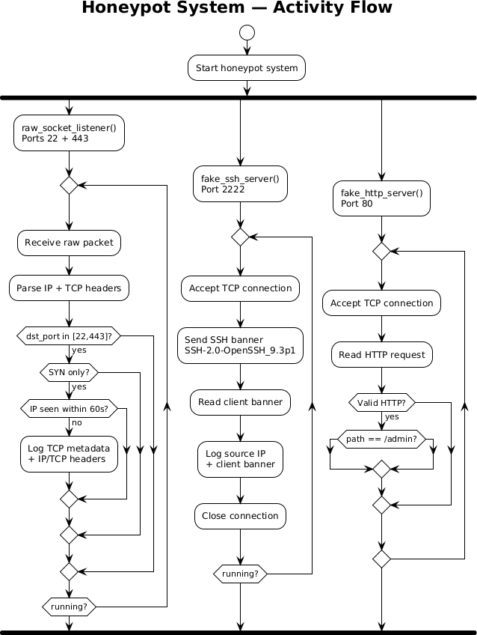
Fig. Activity Diagram

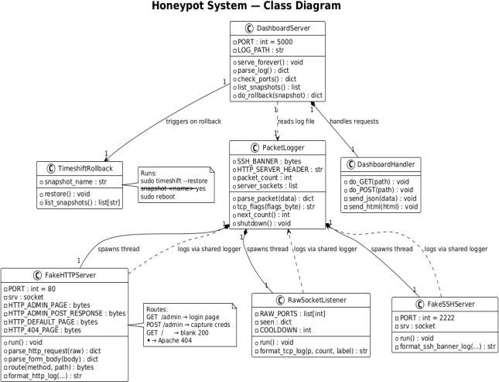
- Process flow

Based on the literature survey and research, traditional systems are lacking and falling behind where AI-driven cyberattacks are becoming increasingly common.
The system begins by listening on the ports (22,2222,80,443) which are the standard ports for ssh and http/https servers to capture incoming connection attempts and session metadata including IP addresses, ports, payloads, protocol and timestamps. All captured data is logged on the honeypot machine for persistence then sent to the machine learning service through the data pipeline, as logs are accumulated with each update the log file is updated and sent to the machine learning service for classification. Logs are preprocessed for feature extraction and stored for training purposes. The system employs the Random Forest Machine Learning that undergoes scheduled training cycles after some accumulation period to train on

Fig. Class Diagram

SYSTEM ARCHITECTURE
The system architecture is comprised of various components working together, each component either deployed on a different system or combined on a single system. (Even though the whole system is majorly developed in python, some components like the dashboard may make use of HTML, CSS and JavaScript)

- RawSocketListener: The socket listener monitors all the packets going through the ports 22 and 443, even though binding is a good option binding the honeypot program to the port disables ssh access into the server

- FakeSSHServer: SSH is mainly the primary utility used to get access into server environments or systems, thus a fake ssh server is bound to the port 2222 which accepts the tcp connection, reads and logs the client banner and other required data without actually giving access to anyone

- PacketLogger: The logger service is a secondary component of the honeypot allowing the system to log all the packet which come through the ports being actively monitored

- DashboardServer: The dashboard server makes use of Python Flask to display the metrics of how many unique IP addresses have interacted with the system, which ports are open and also a rollback function to provide a rollback for the honeypot to its previous state in case of compromise

- Data Pipeline: The data pipeline makes use of SSH and SCP to send the packet logs to the machine hosting the machine learning model, each time the logs are updated
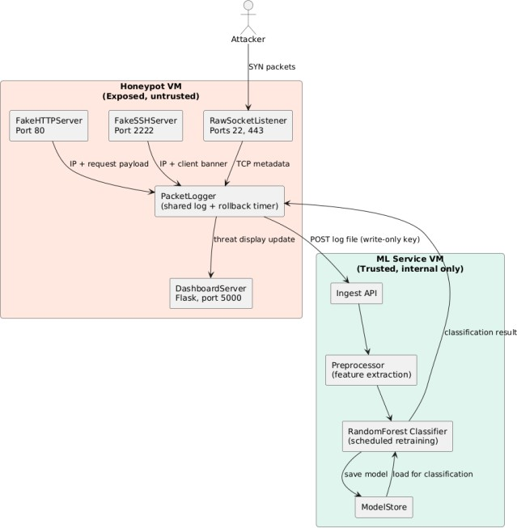

Fig. Component Diagram

IMPLEMENTATION DETAILS

Tech stack: Python, Python Libraries (Scapy, Paramiko, Flask, scikit-learn, pandas, numpy etc.)

Port binding: 22, 443 are the ports used for SSH and HTTPS respectively by default, no programs are bound to these port for ease of access however each scan and handshake is logged and captured, ports 2222 and 80 are ports where the program binds to send fake banners and data to the malicious actor since 2222 is a general port and 80 is the port for HTTP which is an unencrypted protocol

Rollback Mechanism: The roll back mechanism is a safety measure used to ensure the safe rollback of the entire system incase of compromise or malicious activity outside the scope of the system, since the honeypot exists as a virtual machine on the VMware platform after the complete build and test a snapshot of the image of the virtual machine is taken and saved thus allowing easy and safe rollback of the system through the dashboard by entering the snapshot number provided

Isolation: Lateral movements are attack patterns when the malicious actor will move latterly and gain access to other systems associated or connected with the honeypot to avoid this problem components are isolated and kept separate from the attack surface, root access is protected by a strong password. The ML system exists on a completely different system all the data is parsed and cleaned on the ML system separate from the honeypot and attack surface

SCP/Upload mechanism: Upload mechanism is authenticated via SSH key and restricted permissions, which restricts SSH to only run the SCP commands required for the uploading of log files, with limited access a malicious actor can’t SSH directly into the ML system and since all the data is cleaned after being received malicious data cannot be sent through to compromise the system
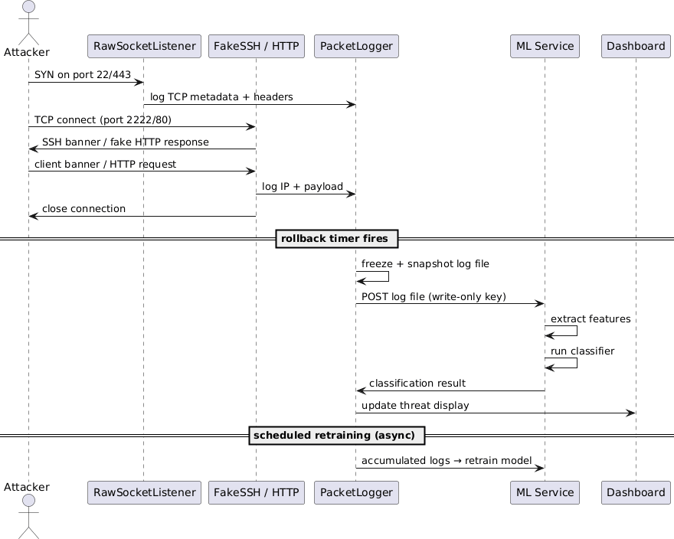
Fig. Sequence Diagram

MACHINE LEARNING

Feature Engineering: Features are extracted from the log files on the Machine Learning system, features such as destination port, TCP flags, payload-size, time, client banner, HTTP method, User-Agent are important for the ML model to accurately classify different packets as malicious or friendly

Label Definition: Each data point is primarily defined by a label for training as malicious or verified at the early stages while training, for the purpose of development another machine is being used as an attack vector to simulate attacks on the honeypot and ML system for the purpose of testing and identification

Training Schedule: Training happens in timed intervals as data is accumulated on the system with different simulations and tests, frequent training or training with each log data update can waste compute and overfit the model, however missing training or training on less data can cause the model to lose accuracy or underfit

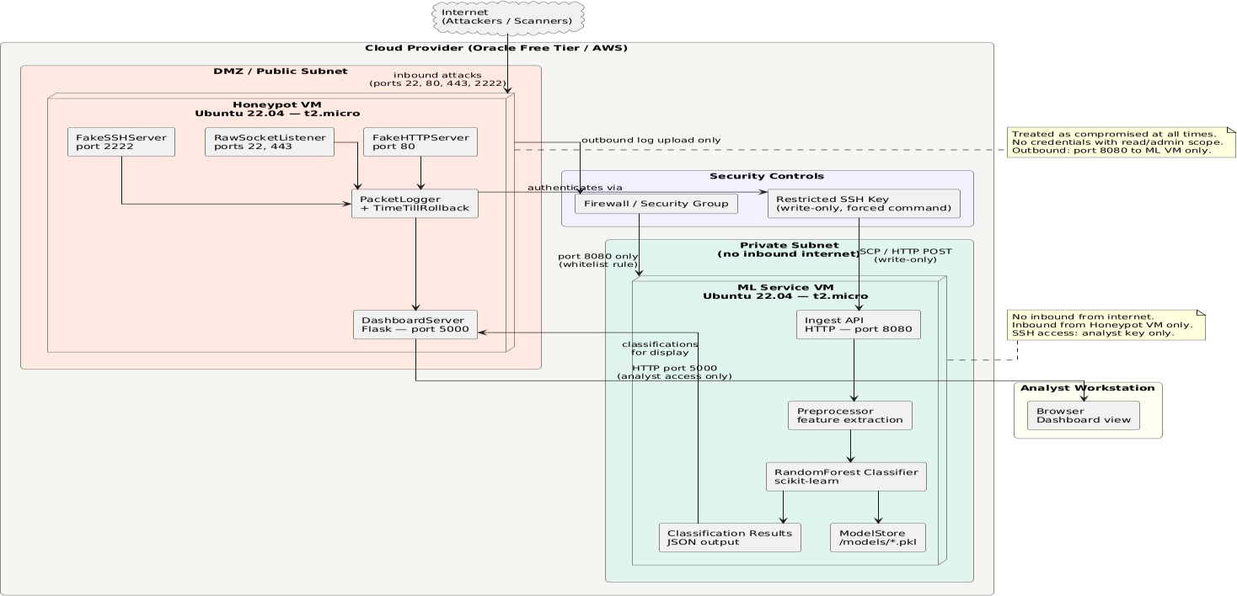
Feature Importance: Random Forest classifiers give out the importance of features in the data or which feature contributed the most in drawing out a classification

Fig. Deployment Diagram

CHALLENGES AND LIMITATIONS

Honeypot Realism: Sophisticated malicious attackers can easily detect a low interaction honeypot which allows them to exploit the honeypot itself or alert other attack vectors preventing the honeypot from collecting important data

Data Volume: Continuous collection of data, collecting and storing every packet can not only overwhelm the compute but also cause the model to lose accuracy and predictability due to imbalance of meaningful data

Feature Quality: Understanding the features is the most important step to help improve the machine learning model and retain accuracy and precision

Evasion: Threat actors can understand the honeypot environment as mentioned previously and gain lateral access to the entire system causing the compromise of the entire honeypot and data pipeline even though a rollback system is provided the sophistication and advancement of a malicious actor can never be know

MITRE ATT&CK MAPPING

Observed Behavior | ATT&C K  Techniq ue ID | Technique Name | Tactic
Automated SYN probes across  multiple ports | T1046 | Network Service  Discovery | Reconnaissa nce
SSH banner grabbing and  version fingerprinting | T1592.00 2 | Gather Victim Host  Information: Software | Reconnaissa nce
Repeated SSH credential attempts | T1110.00 1 | Brute Force: Password Guessing | Credential Access
Credential stuffing via common  username/passw ord pairs | T1110.00 4 | Brute Force: Credential Stuffing | Credential Access
HTTP User-Agent spoofing (masquerading as browsers) | T1036 | Masqueradi ng | Defense Evasion

FUTURE WORK

Future work will focus on four primary directions. First, expanding the deception surface to medium-interaction services that simulate fuller protocol stacks will increase realism and reduce fingerprinting risk. Second, integrating deep learning approaches such as LSTM-based sequence models for session-level behavioral analysis will improve detection of slow, multi-stage attack patterns that the current Random Forest model struggles to classify reliably. Third, extending the system to IoT protocol honeypots targeting MQTT and Modbus will address the growing attack surface of industrial and embedded environments. Fourth, implementing automated self-healing capabilities that rotate honeypot configurations in response to detected fingerprinting attempts will increase longevity and deception fidelity in long-term deployments.

Collectively, this work establishes a foundation for adaptive, data-driven deception systems that move beyond static rule matching toward genuinely intelligent threat detection — a necessary evolution in an environment where AI-assisted attacks are becoming the norm rather than the exception.

CONCLUSION

The AI-Driven Cloud Honeypot system presented in this paper demonstrates a practical and scalable approach to modern threat intelligence collection and automated attack classification. By combining low-interaction deception services with a machine learning pipeline built on the Random Forest algorithm, the system addresses a fundamental limitation of traditional honeypot deployments — the inability to derive actionable, structured intelligence from raw captured data without significant manual analysis.

The architecture was deliberately designed around a zero-trust boundary between the exposed honeypot machine and the protected ML service. The honeypot is treated as compromised by design, with credentials scoped exclusively to write-only log delivery via restricted SSH keys, ensuring that a full honeypot compromise does not pivot into ML service compromise. This trust boundary, formalized through subnet separation and firewall policy, represents a meaningful contribution to the practical security engineering of honeypot systems, which existing literature rarely addresses at the implementation level.

The system successfully captures session metadata across SSH and HTTP attack vectors, extracts structured features including IP reputation scores, TCP flag patterns, request rates, payload sizes, and client banners, and feeds this data into a scheduled Random Forest training cycle. The MITRE ATT&CK mapping presented in Section VII confirms that the observed traffic aligns with real-world attacker behavior across Reconnaissance, Credential Access, and Defense Evasion tactics, validating the realism of the deployment environment.

Several limitations remain. Low-interaction honeypots are detectable by sufficiently sophisticated adversaries who probe for behavioral inconsistencies such as the absence of genuine SSH key negotiation. Label quality is constrained by the heuristic and threat intelligence feed approach used for ground truth generation, introducing noise into the training dataset. Additionally, the system is susceptible to data poisoning attacks in which an adversary aware of the honeypot deliberately generates benign-looking traffic to degrade model accuracy over successive retraining cycles

REFRENCES

- A. Mudgal and S. Bhatia, “Big data with machine learning enabled intrusion detection with honeypot intelligence system on Apache Flink (BDML-IDHIS),” Springer, 2024.

- J. Buzzio-Garcia, “Creation of a high-interaction honeypot system based on Docker containers,” in Proc.5th World Conf. on Smart Trends in Systems, Security and Sustainability (WorldS4), 2021.

- S. A. Kareem, R. C. Sachan, and R. K. Malviya, “AI-driven adaptive honeypots for dynamic cyber threats,” IEEE, 2024.

- A. A. Kubba, O. M. Al Mutasim, M. Abu Talib, and Q.Nasir, "A Systematic Review of Honeypot Data Collection, Threat Intelligence Platforms, and AI/ML Techniques," SSRN Electronic Journal, 2024.

- Z. Morić, V. Dakić, and D. Regvart, "Advancing Cybersecurity with Honeypots and Deception Strategies," 2024.

- P. Čisar, "The Place and Role of Honeypot Solutions in Network Intrusion Detection Systems," 2025.

