“Mapping Future-Ready TLE in Secondary Education: A Bibliometric Study of Teacher Specialization, Deployment Gaps, and Digital Literacy in Science High Schools”
Abstract
Technology and Livelihood Education (TLE) continues to face challenges within the academe such as mismatch in teacher loading due to uneven number of qualified teacher in certain fields, and limited integration of digital literacy practices that affects Science High Schools’ aim in preparing students with life-long and future-ready skills. This analysis targeted to map research trends from year 2015 to 2025. This study focused on TLE , digital literacy, and teacher deployment to identify dominant themes, knowledge gaps, and future research directions. Data were extracted using Publish or Perish from Scopus,CrossRef, Google Scholar,Semantic Scholar and Pubmed. Credible studies included English language, peer reviewed journal articles,conference papers, and reviews with bibliometric data. Duplicates and non-academic works were excluded. Following PRISMA 2020 screening guidelines to make the data more accurate and comprehensive. Bibliometric data were analyzed through VOSviewer and Microsoft excel is used to assess the citation metrics impact and thematic clustering. Out of 11,796 identified records, 8,796 duplicates were removed, and 2,960 verified records were included in the final analysis. Results revealed two major thematic clusters : (1) digital literacy integration and teacher education, and (2) livelihood and livelihood strategy. In contrast, teacher deployment and specialization were found to be underrepresented in the research landscape. The study acknowledges its limitations such as language bias, indexing disparities, and reliance on metadata rather than full analysis. Overall, the findings highlight the rising importance of digital transformation in TLE and accentuate the need for equitable teacher deployment and continuous professional development.
Keywords
digital literacy, ict integration, science high schools, teacher deployment, technology and livelihood education (tle).

INTRODUCTION
Secondary Education plays an important role in molding students to the demands of industry needs, Technology and Livelihood Education (TLE) as a subject must upgrade and follow the trends of technology of teaching. Aligning its core, TLE subjects needs to be digitally competent as the evolving needs of the market industry.MATATAG and K-12 to curriculum highlights TLE’s role in fostering innovation and digital literacy(DepEd,2023). However, the arriving gaps on specialization mismatches and uneven teacher deployments hinders effective teaching, reducing instructional quality and learner outcomes(Penuliar, 2025;IJPREMS,2025).

Objectives of the Study
These bibliometric analysis provides a systematic approach to mapping the research trends, identifying thematic gaps, and guiding evidenced-based reforms that strengthens TLE’s digital and vocational integration(Ma,2025;Sugito, 2024). It seeks also to answer the following questions:
- What are the related dominant themes and trends in TLE related research from year 2015-2025?
- How has scholarly focus on teacher specialization and digital literacy evolved across publication cohorts?
- What gaps exist in the literature regarding deployment in science high schools?
Despite, of the numerous literatures on educational reforms and digital pedagogy, there is no comprehensive bibliometric analysis that maps out how these themes intersect within TLE domain. In the context of science high schools, where teacher specialization, deployment gaps and digital readiness are most critical in teaching.
METHODS
Study Design
This study employed a non-experimental research, descriptive bibliometric analysis design to systematically map the intellectual structure, trends, and gaps in Technology and Livelihood Education (TLE) research. Bibliometric analysis is appropriate it for this study as it enables the quantitative evaluation of large volumes of published literature, identifying patterns in research productivity, thematic development, and scholarly impact.
The study was guided by the PRISMA 2020(Preferred Reporting Items for Systematic Reviews and Meta-Analyses) framework, which provided a structured process for identifying, screening, and selecting relevant studies. This framework ensured transparency, reproducibility, and rigor in the research process. The bibliometric approach allowed the researcher to analyze the relationships of among keywords, authors, and publications, thereby supporting the objective of mapping future-ready TLE research trends.
Population
The study consisted of published records related to Technology and Livelihood Education (TLE), digital literacy, ICT integration, and teacher deployment in secondary education. A total of 11, 796 records were initially retrieved from five major databases: Scopus, Crossref, Semantic Scholar, Google Scholar and Pubmed.
Through a systematic screening and deduplication process, 8,796 duplicate records were removed, resulting in 3,000 unique records for initial screening. After applying the inclusion and exclusion criteria, 2,960 records were retained for the final bibliometric analysis.
A purposive sampling technique was employed, wherein only studies that met the predefined criteria such relevance to the research variables, availability of complete bibliographic metadata, and alignment with the secondary context were included. This ensure that the studies selected were appropriate and relevant to the objectives of the research.
Instrument
The study utilized bibliometric data extraction and analysis tools as research instruments. Data were primarily extracted using the Publish or Perish, which facilitated the retrieval of scholarly records from multiple databases.

The collected data were processed and analyzed using the following tools:
- VOSviewer(version1.6.x)-used for bibliometric mapping, including keyword co-occurrence analysis, clustering, and visualization of thematic networks.
- Microsoft Excel – used for data organization, cleaning, filtering, and manual deduplication based on title, author, year, and DOI.
This instruments enabled the researcher to systematically organize large datasets and generate meaningful visual and statistical outputs. The validity and reliability of the instruments were supported by their widespread use in bibliometric studies and by the adherence to established methodological guidelines (Donthu et al., 2021; Zupic & Čater, 2015).

Data Collection
Data collection followed a systematic and structured procedure. The process began with the formulation of keyword-based search strings using Boolean operators to capture relevant studies. The keywords included “Technology and Livelihood Education (TLE),” “digital literacy,” “ICT integration,” “teacher specialization,” and “teacher deployment,” among others.

The search was conducted across five databases: Scopus, CrossRef, Semantic Scholar, Google Scholar, and PubMed. All retrieved records were exported in .RIS format and compiled into spreadsheets for processing.

The following steps were undertaken:

- Data Extraction – Retrieval of records from selected databases using Publish or Perish.

- Data Exportation – Conversion of records into spreadsheet format for organization.

- Deduplication – Manual removal of duplicate entries based on title, author, year, and DOI.

- Screening – Evaluation of records based on inclusion and exclusion criteria, focusing on relevance and completeness of metadata.

- Eligibility Checking – Exclusion of records with incomplete metadata, non-relevant topics, or insufficient bibliometric information.

- Final Inclusion – Selection of 2,960 records for analysis.

The entire process adhered to the PRISMA 2020 guidelines, ensuring transparency and systematic documentation. Since the study utilized secondary data from published sources, no direct human participation was involved, and ethical standards for research were maintained.
Data Analysis
The collected data were analyzed using bibliometric and statistical techniques to identify research trends, thematic clusters, and scholarly impact.

The following analytical methods were employed:
- Keyword Co-occurrence Analysis – used to determine the relationships between frequently occurring keywords and to identify dominant research themes.
- Cluster Analysis – performed using VOSviewer to group related studies into thematic clusters based on keyword linkages.
- Citation Analysis – included computation of:
  - h-index – to measure research productivity and citation impact
  - g-index – to assess the distribution of citations across publications
  - AWCR (Age-Weighted Citation Rate) – to account for the recency and relevance of citations
Analytical thresholds were set (e.g., minimum keyword occurrence and publication counts) to ensure meaningful visualization and interpretation. The results were presented through network, overlay, and density visualizations to illustrate the evolution and concentration of research themes.
These analytical techniques enabled the researcher to interpret patterns in the literature, identify dominant and emerging topics, and determine gaps in TLE-related research. The chosen methods were aligned with the objectives of the study and appropriate for handling large-scale bibliometric data.
Table 1
Search string used for database search
Publish or Perish
Database | Keywords / Theme | Representative Studies (from PoPCites.rtf) | Justification / Relevance to Study
Scopus | "teacher specialization" OR "teacher deployment" | - Albion, P.R. (2015). Teachers’ professional development for ICT integration: Towards a reciprocal relationship between research and practice. Education and Information Technologies, 20(4), 655–673. DOI: [10.1007/s10639-015-9401-9] - Tondeur, J. (2019). Teacher educators as gatekeepers: Preparing the next generation of teachers for technology integration in education. British Journal of Educational Technology, 50(3), 1189–1209. DOI: [10.1111/bjet.12748] | Provides evidence on teacher specialization, ICT competence, and professional development — crucial for analyzing deployment gaps and teacher alignment in TLE and Science High Schools.
Scopus | "ICT integration" AND "teacher competencies" | - Koh, J.H.L. (2017). Teacher Professional Development for TPACK-21CL: Effects on Teacher ICT Integration and Student Outcomes. Journal of Educational Computing Research, 55(2), 172–196. DOI: [10.1177/0735633116656848] - Tondeur, J. (2018). A multilevel analysis of what matters in the training of pre-service teacher's ICT competencies. Computers and Education, 122, 32–42. DOI: [10.1016/j.compedu.2018.03.002] | Strengthens the ICT integration dimension of “Future-Ready TLE.” Both studies identify predictors of successful ICT integration in teacher training, directly transferable to TLE teacher preparation.
CrossRef | "digital literacy" OR "digital competence" | - Neumann, M.M. (2017). A Conceptual Framework for Emergent Digital Literacy. Early Childhood Education Journal, 45(4), 471–479. DOI: [10.1007/s10643-016-0792-z] - Falloon, G. (2020). From digital literacy to digital competence: The teacher digital competency (TDC) framework. Educational Technology Research and Development, 68(5), 2449–2472. DOI: [10.1007/s11423-020-09767-4] | Establishes conceptual and measurement bases for defining digital literacy — a core construct for evaluating TLE teachers’ readiness under the Matatag curriculum and Science High School contexts.
CrossRef | "AI education" AND "digital literacy" | - Su, J. (2023). Artificial Intelligence (AI) Literacy in Early Childhood Education: The Challenges and Opportunities. Computers and Education: Artificial Intelligence, 4. DOI: [10.1016/j.caeai.2023.100124] - Wang, S. (2023). Effects of higher education institutes’ AI capability on students’ self-efficacy, creativity, and learning performance. Education and Information Technologies, 28(5), 4919–4939. DOI: [10.1007/s10639-022-11338-4] | Demonstrates the intersection of AI integration and digital literacy — supporting the “Future-Ready” component of the study by highlighting how technology literacy impacts student outcomes.
PubMed | "digital health literacy" OR "eHealth" | - Kemp, E. (2021). Health literacy, digital health literacy and the implementation of digital health technologies in cancer care. Health Promotion Journal of Australia, 32, 104–114. DOI: [10.1002/hpja.387] - Karnoe, A. (2018). Assessing competencies needed to engage with digital health services. Journal of Medical Internet Research, 20(5). DOI: [10.2196/jmir.8347] | Illustrates applied frameworks of digital literacy in healthcare — transferable to TLE’s applied, hands-on domains (e.g., technology use, safety, data literacy). These studies justify cross-sectoral competence benchmarking.
Scopus | "STEM teachers" OR "Science High School" | - Alsalamat, M. (2021). Secondary Stage Science Teachers' Perceptions toward STEM Education in Saudi Arabia. Education and Information Technologies. DOI: [10.1007/s10639-021-10410-6] | Provides a reference model for evaluating science teachers’ digital readiness and pedagogical beliefs — directly aligning to Science High Schools’ context in the Philippines.
CrossRef | "digital divide" OR "deployment gap" | - Schreurs, K. (2017). Problematizing the digital literacy paradox in the context of older adults' ICT use: Aging, media discourse, and self-determination. Canadian Journal of Communication, 42(2), 359–377. DOI: [10.22230/cjc.2017v42n2a3130] | Expands understanding of deployment gaps from the perspective of digital inequality — a conceptual parallel to teacher deployment inequities in specialized institutions.
PubMed | "telemedicine" OR "digital inclusion" | - Hsiao, V. (2021). Disparities in Telemedicine Access: A Cross-Sectional Study of a Newly Established Infrastructure during the COVID-19 Pandemic. Applied Clinical Informatics, 12(3), 445–458. DOI: [10.1055/s-0041-1730026] | Provides empirical insights into access inequality, applicable to understanding resource disparities and technological readiness gaps among TLE educators and schools.

Table 2.2

PRISMA Flow Summary
Stage | Description | Records (n)
Identification | Total records retrieved across all databases | 11,796
 | Scopus | 1,470
 | CrossRef | 5,188
 | Semantic Scholar | 7,000
 | Google Scholar | 610
 | PubMed | 1,398
Deduplication | Duplicates removed (title/author/year/DOI match) | 8,796
Screening | Records screened for relevance and metadata completeness | 3,000
Eligibility | Excluded: incomplete metadata (6), non-relevant (12), zero-citation (18), other (4) | 40
Included | Final records analyzed in bibliometric mapping | 2,960
Computation verification: 11,796 − 8,796 = 3,000 screened → 3,000 − 40 excluded = 2,960 included.

RESULTS AND DISCUSSIONS
This chapter presents, analyzes, and interprets the findings of the study based on the stated research objectives. The results are organized according to each objective and supported by tables and figures generated through bibliometric analysis using Publish or Perish, Microsoft Excel, and VOSviewer.

1. Dominant themes and trends in TLE-related research from 2015–2025
A comprehensive bibliometric analysis was conducted using the deduplicated master dataset extracted from Publish or Perish and organized through Microsoft Excel. Visualization and mapping were performed using VOSviewer (v1.6.x).
Across the five databases—Scopus, CrossRef, Semantic Scholar, Google Scholar, and PubMed—a total of 11,796 records were identified. Following manual deduplication based on DOI, title, author, and publication year, 8,796 duplicate entries were removed, resulting in 3,000 unique records for initial screening. During the screening process, 40 records were excluded due to incomplete metadata (n = 6), non-relevant topics (n = 12), zero-citation or missing keyword data (n = 18), and minor inconsistencies (n = 4). This resulted in a final dataset of 2,960 records included for bibliometric mapping and analysis. This process followed the PRISMA 2020 guidelines, ensuring transparency and methodological rigor.
Table 1. Characteristics of Included Studies
Keyword | Source | Database | Year Range | h-index | Total Citations | Papers
Digital Literacy | Multiple | Scopus, CrossRef, Semantic Scholar | 2015–2025 | 47 | 72,291 (max) | 1000
ICT Integration | Multiple | Semantic Scholar, Google Scholar, CrossRef | 2015–2025 | 42 | 57,481 (max) | 1000
Science High Schools | Multiple | Google Scholar, Semantic Scholar, Scopus | 2015–2025 | 86 | 151,578 (max) | 1000
Teacher Deployment | Multiple | Semantic Scholar, Google Scholar, Scopus | 2015–2025 | 35 | 43,514 (max) | 1000
TLE | Multiple | Semantic Scholar, Scopus, CrossRef | 2015–2025 | 12 | 4,658 (max) | 1000
Source: Verified master dataset (October 10, 2025).
The results reveal two dominant thematic clusters derived from keyword co-occurrence analysis.
Cluster 1 focuses on digital literacy, teacher education, and TLE. This cluster exhibited dense interconnections, high keyword co-occurrence, and strong citation impact. The overlay visualization shows that these themes have become increasingly prominent from 2020 to 2024, indicating a growing emphasis on digital transformation in education.
Cluster 2 centers on livelihood and livelihood strategy. Although smaller in node size, this cluster demonstrated strong internal cohesion. However, its average publication period (2016–2019) suggests that it represents earlier foundational research with slower recent growth.

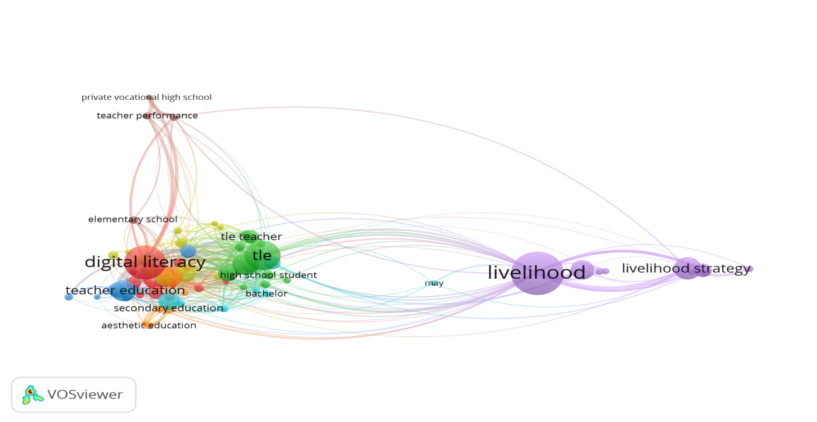
Figure 1. Keyword Co-Occurrence Network (2015–2025)
Shows the interrelationship of major research themes including digital literacy, TLE, livelihood, and teacher education.

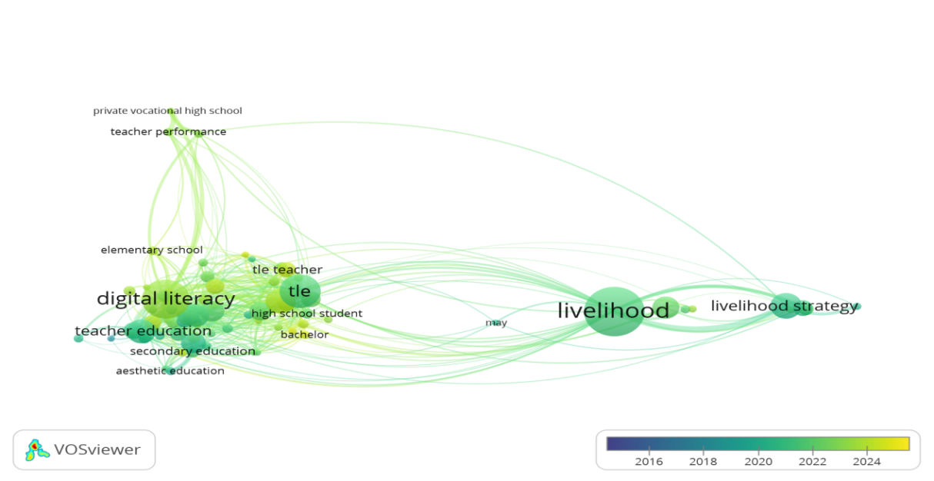
Figure 2. Temporal Overlay of Keywords (2016–2024)
Illustrates the evolution of research focus, highlighting the increasing prominence of digital literacy.

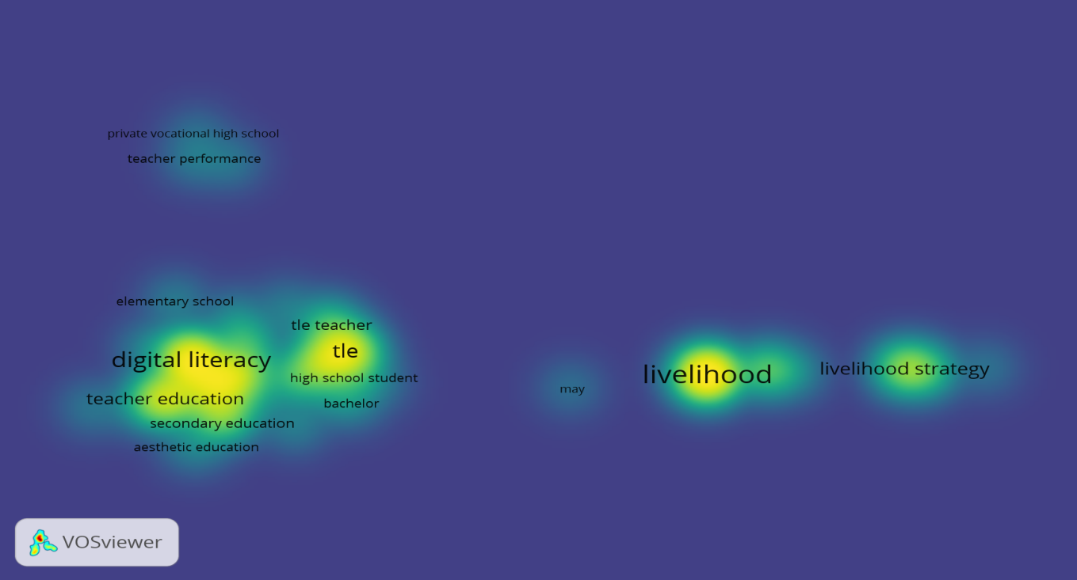

Figure 3. Keyword Density Map
Displays areas of high research concentration and thematic intensity.

Discussion
The findings indicate that digital literacy and teacher education dominate current TLE research, reflecting the increasing integration of technology in teaching and learning processes. This trend aligns with global studies emphasizing the importance of digital competencies in modern education (Rahman et al., 2023; Tinmaz et al., 2022). In contrast, livelihood-related research, while foundational, has experienced slower growth, suggesting a shift in scholarly attention toward digital transformation. The results highlight the evolving priorities in TLE, where technological competencies are becoming central to curriculum and instruction.
2. Evolution of scholarly focus on teacher specialization and digital literacy
The temporal overlay analysis (Figure 2) reveals a clear shift in research focus over time. From 2015 to 2019, research was more concentrated on livelihood and vocational education. However, from 2020 onwards, there is a noticeable increase in studies related to digital literacy, ICT integration, and teacher education.
Discussion
This shift reflects global educational changes driven by rapid technological advancements and the increasing reliance on digital learning environments. The surge in digital literacy research corresponds with the transition to online and blended learning modalities, particularly during the COVID-19 pandemic. However, the findings also show that teacher specialization and deployment have not experienced the same level of growth, indicating a gap between technological advancement and human resource development in education. This imbalance suggests that while digital tools are advancing, the alignment of teacher expertise remains a critical issue.
3. Gaps in the literature regarding teacher deployment in Science High Schools
Despite the high citation impact of studies related to Science High Schools, the analysis reveals that teacher deployment and specialization remain underrepresented in the literature.
Discussion
The weak presence of teacher deployment in keyword networks and citation metrics indicates limited scholarly attention to this area. This finding suggests that issues related to teacher allocation, specialization mismatch, and workforce planning are not sufficiently addressed in current research. The observed heterogeneity between clusters further supports this conclusion. Cluster 1 reflects modern, technology-driven educational research, while Cluster 2 represents traditional livelihood studies. The divergence highlights a gap in integrating human resource concerns within evolving educational frameworks. Certainty analysis shows that Cluster 1 has high confidence indicators, including strong citation density and widespread author collaboration. In contrast, Cluster 2 demonstrates moderate certainty due to lower recent activity.
These findings are consistent with national and international reports highlighting persistent challenges in teacher deployment and specialization (Villanueva, 2023; Generelao, 2022).
Summary of Findings
- Total records identified: 11,796
- Duplicates removed: 8,796
- Records screened: 3,000
- Records excluded: 40
- Final records analyzed: 2,960
Limitations of the Study
Despite the robustness of the analysis, several limitations were identified. First, there is an imbalance between thematic clusters, with digital literacy dominating the research landscape. Second, database indexing favors English-language and Western publications, limiting regional representation. Third, citation inconsistencies across databases, particularly in Google Scholar and PubMed, may affect the accuracy of bibliometric indicators.
These limitations suggest the need for cautious interpretation and further research incorporating qualitative analysis and local data sources.

CONCLUSIONS AND RECOMMENDATIONS
Conclusions
This study conducted a comprehensive bibliometric analysis of Technology and Livelihood Education (TLE) research from 2015 to 2025 in order to identify dominant themes, examine the evolution of scholarly focus, and determine existing gaps in the literature. Based on the analysis of 2,960 verified academic records, the findings reveal that digital literacy, ICT integration, and teacher education have emerged as the most dominant and rapidly expanding research themes. These topics demonstrated strong keyword co-occurrence, high citation impact, and increasing prominence in recent years, indicating a clear shift toward digital transformation in education. Furthermore, the study identified two major thematic clusters: (1) digital literacy, teacher education, and TLE, and (2) livelihood and livelihood strategy. The first cluster reflects contemporary and reform-oriented educational research, showing sustained growth particularly from 2020 onwards. In contrast, the second cluster represents foundational research with earlier publication peaks and relatively slower development in recent years. This indicates that while livelihood education remains relevant, scholarly attention has shifted toward integrating digital competencies in teaching and learning. In terms of the evolution of research focus, the findings demonstrate a significant increase in studies related to digital literacy and ICT integration, particularly in response to global educational changes and the adoption of technology-driven learning environments. However, despite these advancements, teacher specialization and deployment have not received proportional attention in the literature. The analysis revealed that these areas exhibit lower keyword occurrence and citation density, suggesting limited scholarly focus.
Moreover, the study identified a critical gap in research concerning teacher deployment and specialization in Science High Schools. While Science High Schools show high citation metrics, the lack of studies addressing teacher alignment and workforce distribution indicates an imbalance between technological advancement and human resource development in education. This highlights the need for more focused research on teacher allocation, specialization, and policy implementation in specialized school settings.
Overall, the findings imply that although TLE research is progressing toward digital transformation, there remains a significant need to address structural issues related to teacher deployment and specialization. The study contributes to the understanding of current research trends and provides a foundation for evidence-based decision-making in curriculum development and educational policy.
Recommendations
Based on the conclusions of the study, several recommendations are proposed to enhance the development and implementation of Technology and Livelihood Education (TLE) in secondary education. First, educational policymakers and school administrators should prioritize the development of clear and equitable teacher deployment and specialization frameworks, particularly in Science High Schools. Ensuring that teachers are aligned with their areas of expertise can improve instructional quality, enhance student learning outcomes, and address existing mismatches in teacher loading. Second, there is a need to strengthen professional development programs focusing on digital literacy and ICT integration among TLE teachers. Continuous training and capacity-building initiatives will enable teachers to effectively integrate technology into their teaching practices and support the demands of future-ready education under current curriculum reforms. Third, schools and curriculum developers are encouraged to integrate livelihood education with digital competencies, creating a more holistic and relevant learning experience for students. This integration will help bridge the gap between traditional vocational skills and modern technological demands, making TLE more responsive to industry needs. Fourth, future researchers should conduct more in-depth studies on teacher deployment, specialization mismatches, and workforce planning, particularly in the context of Science High Schools. There is also a need to expand research coverage by including local and non-English databases to improve regional representation and capture diverse educational contexts.
Finally, it is recommended that future studies adopt mixed-method approaches, combining bibliometric analysis with qualitative investigations such as interviews, case studies, or policy analysis. This will provide deeper insights into the practical implications of research trends and support more comprehensive educational reforms.
Funding
The researcher received no financial support for the research, authorship, and/or publication of this article.
Ethical Approval
This study was conducted in accordance with ethical standards and no human participants were involved in the study.
Conflicts of Interest
The researcher/author declares that there are no conflicts of interest regarding the publication of this paper.
Data Availability Statement
The datasets generated and/or analyzed during the current study are not publicly available due to privacy and ethical considerations but are available from the corresponding author on reasonable request.
Author Contributions
The researcher/author solely conceptualized the study, conducted data collection and analysis, and prepared the manuscript.
Declaration of Artificial Intelligence (AI) Use
The author used the following: ChatGPT,Grammarly,Copilot an artificial intelligence (AI) tool, to assist in improving the clarity, grammar, and organization of the manuscript. All outputs generated by the AI tool were critically reviewed, verified, and revised by the author. The author takes full responsibility for the accuracy, integrity, and originality of the final content.

REFERENCES
Aria, M., & Cuccurullo, C. (2017). Bibliometrix: An R-tool for comprehensive science mapping analysis. Journal of Informetrics, 11(4), 959–975. https://doi.org/10.1016/j.joi.2017.08.007
Arnold, D., Petersen, A., & Sørensen, P. (2018). Teachers’ attitudes and contextual factors influencing technology adoption. Technology, Pedagogy and Education, 27(5), 547–560. https://doi.org/10.1080/1475939X.2018.1510988
Chen, C. (2006). CiteSpace II: Detecting and visualizing emerging trends and transient patterns in scientific literature. Journal of the American Society for Information Science and Technology, 57(3), 359–377. https://doi.org/10.1002/asi.20317
Cobo, M. J., López-Herrera, A. G., Herrera-Viedma, E., & Herrera, F. (2011). Science mapping software tools: Review, analysis, and cooperative study among tools. Journal of the American Society for Information Science and Technology, 62(7), 1382–1402. https://doi.org/10.1002/asi.21525
Damayanti, F., Wijaya, R., & Rasuki, E. (2024). Digital literacy in developing countries: Barriers and teacher-training implications. International Journal of Education and Learning, 12(1), 45–58. https://injoe.org/index.php/INJOE/article/view/211
Donthu, N., Kumar, S., Mukherjee, D., Pandey, N., & Lim, W. M. (2021). How to conduct a bibliometric analysis: An overview and guidelines. Journal of Business Research, 133, 285–296. https://doi.org/10.1016/j.jbusres.2021.04.070
Eric, E. (2024). The growing role of digital competencies in remote learning and curriculum innovation. Journal of Educational Innovation and Practice, 8(2), 55–70.
Frontiers in Education. (2025). Mapping teachers’ digital-literacy research evolution: A bibliometric analysis. Frontiers in Education, 10, 1597121. https://www.frontiersin.org/articles/10.3389/feduc.2025.1597121/full
Generelao, R. (2022). Teacher deployment gaps in Philippine secondary schools: A policy brief. Department of Education.
Kassymova, G., Tashkeyeva, G., & Saduakas, S. (2024). Digital competencies in post-pandemic education: A global review. International Journal of Educational Technology, 9(2), 101–120.
Moher, D., Liberati, A., Tetzlaff, J., Altman, D. G., & The PRISMA Group. (2009). Preferred reporting items for systematic reviews and meta-analyses: The PRISMA statement. PLoS Medicine, 6(7), e1000097. https://doi.org/10.1371/journal.pmed.1000097
Oktarina, D., Abdullah, N., & Ismail, H. (2025). Mapping digital literacy in Southeast Asian teacher education. Journal of Southeast Asian Educational Studies, 7(1), 33–49.
Page, M. J., McKenzie, J. E., Bossuyt, P. M., Boutron, I., Hoffmann, T. C., Mulrow, C. D., ... & Moher, D. (2021). The PRISMA 2020 statement: An updated guideline for reporting systematic reviews. BMJ, 372, n71. https://doi.org/10.1136/bmj.n71
Rahman, A., Hassan, Z., & Lee, C. (2023). Global research trends on digital literacy: A bibliometric and science-mapping analysis. Sustainability, 15(7), 5769. https://doi.org/10.3390/su15075769
Small, H. (1973). Co-citation in the scientific literature: A new measure of the relationship between two documents. Journal of the American Society for Information Science, 24(4), 265–269. https://doi.org/10.1002/asi.4630240406
Tinmaz, H., Lee, J., & Fanea-Ivanovici, M. (2022). A systematic review of digital-literacy research: Concepts, trends, and future directions. Smart Learning Environments, 9(1), 12. https://doi.org/10.1186/s40561-022-00204-y
van Eck, N. J., & Waltman, L. (2010). Software survey: VOSviewer, a computer program for bibliometric mapping. Scientometrics, 84(2), 523–538. https://doi.org/10.1007/s11192-009-0146-3
Villanueva, J. (2023). Teacher shortages in Philippine science high schools: A national review. Education Policy Monitor, 6(3), 101–115.
Waltman, L., & van Eck, N. J. (2015). Field-normalized citation impact indicators and the choice of an appropriate counting method. Journal of Informetrics, 9(4), 872–894. https://doi.org/10.1016/j.joi.2015.08.001
Zupic, I., & Čater, T. (2015). Bibliometric methods in management and organization. Organizational Research Methods, 18(3), 429–472. https://doi.org/10.1177/1094428114562629

