Belt and Road Initiative Participation and Bilateral Trade with China: Evidence from Six Partner Economies, 2010–2023

Abstract
Using panel data for six partner economies participating in China’s Belt and Road Initiative from 2010 to 2023, this study examines whether formal participation increases bilateral trade with China. We estimate gravity-style two-way fixed effects models and a Poisson pseudo-maximum likelihood specification for exports, imports, and net exports. The results show no consistent average trade effect from participation. Instead, gains depend on partner economic size, infrastructure capacity, and broader macroeconomic conditions. These findings caution against assuming automatic trade expansion and highlight the importance of complementary domestic policies to realize meaningful and sustainable benefits.
Keywords: Africa–China trade; Belt and Road Initiative; Bilateral trade; Gravity model; Middle East trade; Poisson pseudo-maximum likelihood

Introduction
China’s Belt and Road Initiative (BRI) has become one of the country’s most influential economic policies in modern times. Since its launch in 2013, the BRI has expanded to include more than 150 partner economies with the goal of improving connectivity and trade through large-scale infrastructure projects. It is mainly organized through two major corridors: the Silk Road Economic Belt, which follows land routes toward Europe, and the 21st Century Maritime Silk Road, linking China with Asia, the Middle East, Africa, and even Europe by sea. These projects combine several ambitions, including trade facilitation, better infrastructure links, financial cooperation, and stronger international relationships.
By 2023, more than 3,000 cooperative projects had been recorded under the initiative, with investments close to USD 1 trillion. Several studies associate these investments with lower transportation costs and quicker shipment times. François de Soyres et al. (2018), for example, found that transport improvements related to the BRI could reduce trade costs by around 10.2 percent for corridor economies. Chen and Li (2021) reached similar conclusions for selected African and Asian countries, showing potential increases in GDP and employment. Still, a key question remains: do these projects lead to sustained bilateral trade growth with China for all partners, or only for specific types of economies?
Trade plays a major role in economic development, especially for countries seeking to overcome structural constraints. It can support productivity gains, technology transfer, and better access to capital. Okenna and Adesanya (2020) also highlight how trade can reduce poverty through job creation and higher income levels. These outcomes are particularly relevant for the countries examined in this study, many of which rely heavily on external markets and investment to promote growth.
This paper focuses on six BRI members, Morocco, Egypt, Kenya, Ethiopia, Pakistan, and the United Arab Emirates (UAE). These countries differ in size, geographic position, and logistics capacity. Morocco benefits from proximity to Europe and West Africa, Egypt controls the Suez Canal, Kenya and Ethiopia form major transport nodes in East Africa, Pakistan hosts the flagship China–Pakistan Economic Corridor (CPEC), and the UAE has a strong re-export and finance base. This diversity allows us to explore how much outcomes depend on a country’s characteristics rather than the BRI label alone.

Although many studies examine the impact of the BRI on trade, there are still noticeable gaps. Some focus only on Asia, and others use global datasets that may hide regional differences (Amani & Kaci, 2022). A smaller number look at whether exports and imports react differently to BRI participation, even though recent findings suggest this might be the case (Wang et al., 2024; Zhao et al., 2024). In addition, the interaction between BRI participation and traditional gravity factors like GDP, population, and distance is still not well explored for African and Middle Eastern economies.

Therefore, this study asks four research questions:
(1) Has BRI participation significantly increased bilateral trade with China?
(2) Does it affect exports and imports in the same way?
(3) Are trade effects the same across all partner economies, or do they depend on size and structure?
(4) How do key trade determinants interact with BRI participation?

To answer these questions, we apply a panel two-way fixed effects model for the period 2010–2023, and we supplement it with Poisson pseudo-maximum likelihood estimation. By combining a focused regional approach with robust econometric techniques, this study provides new evidence on the effectiveness and fairness of the BRI in Africa and the Arab world. Despite these insights, several important issues remain insufficiently examined.
For research gaps and contributions, despite the rapidly expanding literature on the Belt and Road Initiative (BRI), several blind spots remain. First, most studies treat trade flows in the aggregate, without distinguishing clearly between exports and imports. This makes it harder to see important differences, especially for partners that already face trade deficit problems. Whether BRI participation boosts exports more than imports, or vice versa, remains empirically underexplored
Second, trade balance effects are rarely examined in detail. While Amani and Kaci (2022) and Li, Lu, and Chen (2020) touch on directional dynamics, neither systematically assesses the sustainability of trade balances over time, so we still don’t know if BRI makes trade balances more stable or actually worsens them for developing economies.
Third, existing studies often rely on large global samples, treating BRI partners as a homogeneous group. This approach downplays regional heterogeneity and overlooks the particular constraints of African and Middle Eastern economies, which differ sharply in infrastructure, industrial capacity, and institutional depth.

Finally, although infrastructure and logistics performance are frequently cited as BRI mechanisms, their interaction with trade directionality and balance remains undertheorized. In reality, smaller economies with limited capacity or resource-based exports might not experience the same effects on exports and imports.
This study contributes by directly addressing these gaps. Using a focused panel dataset of six strategically important BRI economies, Morocco, Egypt, Kenya, Ethiopia, Pakistan, and the UAE, we disaggregate exports, imports, and trade balances over 2010–2023. Our fixed-effects gravity framework, complemented with interaction terms and robustness checks, allows us to test whether corridor participation delivers consistent gains or whether outcomes depend on partner size and macroeconomic conditions.
Our findings differ from many optimistic studies, showing no strong average trade boost from BRI. Instead, gains are conditional and skewed toward larger economies with stronger infrastructure capacity. The contribution is both empirical and conceptual: it provides regional evidence on the limits of BRI’s trade effects, and it questions the common belief that corridor agreements by themselves lead to more trade.
Table 1 Gaps and contributions

2. Materials and Methods

2.1 Study Design
This study examines how participation in the Belt and Road Initiative (BRI) has influenced trade between China and six partner economies, Morocco, Egypt, Kenya, Ethiopia, Pakistan, and the United Arab Emirates (UAE),from 2010 to 2023. We analyze three trade outcomes:
China’s exports to each partner
China’s imports from each partner
Bilateral trade balance (exports − imports, in USD)
A gravity-style two-way fixed effects (FE) specification is employed to control for both:
Country-specific characteristics that do not vary over time (e.g., geography, culture, institutional quality)
Year-specific shocks affecting all countries (e.g., global commodity prices, COVID-19)
This framework follows standard practice in empirical trade analysis (Anderson & van Wincoop, 2003) and recent BRI literature (Amani & Kaci, 2022; Di Stefano et al., 2021).

2.2 Model Specification
For exports and imports, we estimate the following baseline equation:
$$\ln\left(\text{Trad}{\text{e}}_{\text{it}}\right)=α+β \text{corridor}\text{_}\text{dumm}{\text{y}}_{\text{it}}+γ_{1} \ln\left(\text{GD}{\text{P}}_{\text{it}}\right)+γ_{2} \ln\left(\text{Populatio}{\text{n}}_{\text{it}}\right)+γ_{3} \ln\left(\text{Distanc}{\text{e}}_{\text{i}}\right)+γ_{4} \text{Tarif}{\text{f}}_{\text{it}}+γ_{5} \text{ExchangeRat}{\text{e}}_{\text{it}}+γ_{6} \ln\left(\text{CP}{\text{I}}_{\text{it}}\right)+μ_{i}+λ_{t}+ε_{it}$$
Where:
BRI_{it} = 1 in the year the country becomes an official BRI partner, 0 otherwise
μ_i = country fixed effects
λ_t = year fixed effects
Trade balance models use levels instead of logs.
Standard errors are clustered at the country level to correct for heteroskedasticity and serial correlation.

2.3 Estimation Strategy
The primary estimation approach applies a two-way fixed effects (FE) model. Country fixed effects are used to remove time-invariant factors such as geography, historical ties, or institutional settings that could bias the association between BRI participation and trade flows. Year fixed effects control for global shocks that simultaneously affect all countries in a given year, such as world demand fluctuations, variations in commodity prices, or disruptions arising from the COVID-19 pandemic. Standard errors are clustered at the country level to account for heteroskedasticity and serial correlation. This specification improves the credibility of coefficient estimates by ensuring that unobserved heterogeneity is not incorrectly attributed to the BRI indicator.

2.4 Model Extensions
Given that BRI infrastructure and policy changes often take several years before influencing economic outcomes, additional regressions include lagged BRI participation indicators. To test whether economic size conditions the responsiveness to the initiative, interaction terms between GDP and the BRI dummy are incorporated into the model. Where data are available, the analysis also examines interactions between BRI participation and indicators of logistics performance or infrastructure capacity, allowing evaluation of whether domestic preparedness moderates the effects of BRI involvement.

2.5 Robustness Checks
To examine the stability of the results, multiple sensitivity tests are performed. Trade flows are deflated using constant U.S. dollars to ensure that the outcomes are not driven by global inflationary pressures. The Poisson Pseudo-Maximum Likelihood (PPML) estimator is used as an alternative to the log-linear specification to address concerns related to the presence of zero trade values and heteroskedasticity. Additional robustness checks include excluding countries one at a time to ensure findings are not driven by a single partner, and simplifying the model to evaluate whether results depend on variables with missing observations.

2.6 Limitations
While the two-way FE design offers considerable control over confounding influences, several limitations persist. The dataset includes only six partner economies, reducing statistical power and limiting generalizability. Missing values in logistics-related variables restrict the investigation of mechanisms behind trade effects. Finally, because BRI participation does not occur randomly and the analysis relies on observational data, results should be interpreted as associations rather than definitive causal effects.

3. Data

3.1 Data Coverage and Key Variables
This study uses an unbalanced panel dataset covering six Belt and Road Initiative (BRI) partner countries: Morocco, Egypt, Kenya, Ethiopia, Pakistan, and the United Arab Emirates. The period of analysis is 2010–2023, with China as the constant trade partner in all observations.
These countries were selected for their strategic relevance to the BRI and the availability of consistent trade and macroeconomic data. They also provide a diverse regional representation, the sample covers North Africa (Morocco and Egypt), Sub-Saharan Africa (Kenya and Ethiopia), South Asia (Pakistan), and the Gulf region (UAE), allowing meaningful comparisons across different geographic contexts.
Figure 1 illustrates the year in which each country formally joined the BRI, showing variation in participation timing across the sample. This staggered entry pattern is an important feature of the dataset, as it allows the analysis to exploit differences in treatment timing when estimating the model.
Figure 1 BRI Participation Timeline (2010–2023)

The dataset combines information from multiple sources, including trade statistics, macroeconomic indicators, and infrastructure and logistics metrics. While most variables are available for all country–year pairs, some data gaps remain; the treatment of missing values is discussed in Section 3.4.
3.2 Variable Construction, Coding, and Data Sources
Table 2 provides detailed definitions, units of measurement, and primary data sources for all variables used in the analysis.
The dependent variables include the logarithm of China’s annual exports to each partner, the logarithm of imports from each partner, and the trade balance measured as the difference between the two.
The main independent variable of interest is the BRI participation dummy, labelled corridor_dummy in the dataset, which equals 1 from the year a country formally joined the BRI onward, and 0 otherwise.
Control variables follow standard gravity‐model practice and include GDP, population, distance, tariffs, exchange rates, CPI, infrastructure investment, and the Logistics Performance Index (LPI). Data are sourced primarily from international databases such as the World Bank’s World Development Indicators, CEPII’s GeoDist database, the World Trade Organization, and official national statistical agencies. Where multiple sources were available for the same variable, preference was given to the dataset with the most complete time coverage and methodological consistency.
Table 2 presents the complete list of variables, their definitions, measurement units, and data sources.
Table 2 Variable Definitions and Data Sources
As shown in Table 2, core macroeconomic variables such as GDP and population are available for all country–year pairs, ensuring complete coverage for these measures. In contrast, variables such as LPI and infrastructure investment have partial coverage, reflecting limitations in data availability for certain years or countries. These gaps are addressed in the data preparation process described in Section 4.4.
All monetary values are reported in current USD unless otherwise noted. For variables with skewed distributions, natural logarithmic transformations are applied to facilitate interpretation in elasticity terms and to reduce the influence of extreme values in regression analysis.

3.3 Descriptive Statistics
Table 3 presents summary statistics for the main variables over the 2010–2023 sample period, covering six BRI partner countries: Morocco, Egypt, Kenya, Ethiopia, Pakistan, and the United Arab Emirates. The statistics provide an overview of the central tendency and dispersion of trade, macroeconomic, and institutional indicators in the dataset.
Exports from China to partner countries average around US$3.53 billion per year, with a substantial range (from about US$31 million up to US$42.6 billion), reflecting differences in country size and economic integration with China. Imports to China are, on average, even higher (US$12.08 billion), while the net exports variable (exports minus imports) highlights diverse trade balance patterns within the panel.
Key country characteristics such as GDP and population display considerable dispersion, ranging from smaller, less-populated economies to major emerging markets. The “distance to Beijing” variable is constant within each country but varies across the sample. The BRI corridor dummy indicates that, on average, just over half of the country-year observations fall within the BRI participation period. Infrastructure investment amounts and tariff rates also display high variability, with the latter unavailable for some country-years due to limited publication of official statistics. Exchange rates and consumer price indices show patterns typical of developing and emerging economies during the sample period.
Some variables, such as logistics services quality and the World Bank Logistics Performance Index (LPI), are only available for select survey years, resulting in a large proportion of missing data for these measures.
Table 3 Descriptive Statistics (2010–2023)
The descriptive statistics reveal considerable heterogeneity across countries and variables. For example, the UAE records the highest mean GDP in the sample, reflecting its high‐income status, whereas Ethiopia’s GDP is an order of magnitude smaller. Tariff rates vary widely, with some countries maintaining average applied tariffs below 5%, while others exceed 10%, potentially influencing trade volumes and composition.
Trade volumes are also unevenly distributed: average imports from China are highest for the UAE and Pakistan, while exports to China are relatively modest for several African economies. Population size ranges from under 10 million in the UAE to over 230 million in Pakistan, underscoring demographic diversity that could shape market size effects in the gravity model.
Institutional and infrastructure indicators, such as the Logistics Performance Index (LPI), display both cross‐country differences and within‐country variation over time, offering scope to explore whether improvements in these dimensions translate into measurable changes in bilateral trade flows.
These patterns justify the inclusion of the control variables in the empirical specification (see Section 3.3) and suggest that the impact of BRI participation may be conditioned by initial economic size, tariff policy, and logistical capacity.

3.4 Data Limitations
While the dataset covers key countries and variables relevant to the Belt and Road Initiative (BRI), it has several limitations. First, the small sample size of six partner countries limits statistical power and the generalizability of results. Second, missing data for certain variables, notably the Logistics Performance Index and infrastructure investment, reduces the number of complete observations and may introduce sample selection bias. Third, some tariff data are incomplete or reported with delays, which could affect the precision of trade policy controls. Fourth, the use of current USD rather than constant USD for some variables may introduce inflation-related distortions; this is addressed through robustness checks with deflated trade flows in later analyzes. Finally, the staggered timing of BRI participation complicates causal inference, necessitating careful model specification and interpretation.

4. Empirical Results and Discussion
This section investigates whether participation in the Belt and Road Initiative (BRI) is associated with changes in bilateral trade between China and its six partner economies during 2010–2023. Trade outcomes are examined using two complementary estimators: a two-way fixed effects gravity model and a Poisson pseudo-maximum likelihood (PPML) specification. The analysis focuses on exports from China, imports to China, and net exports, all expressed in constant US dollars. We also explore whether the results depend on partner economic size, vary over time, or are driven by any particular country.
Overall trends in real exports and imports are shown in Figure 2. Both flows rise steadily throughout the sample period, but there are no clear shifts around the timing of BRI participation, suggesting that any gains are gradual rather than linked to the signing of cooperation agreements.
Figure 2 Trends in deflated exports from China and deflated imports to China, 2010–2023 (six BRI partners)

4.1 Brief Roadmap of Estimators and Measurement Choices
The empirical analysis begins with a two-way fixed-effects gravity framework, where unobserved factors specific to each country and common global shocks across years are absorbed by country and year fixed effects. Standard errors are clustered at the country level to account for potential serial correlation within panels.
Because bilateral trade data often exhibit heteroskedasticity and occasional zero-value observations, the fixed-effects models are complemented with Poisson pseudo-maximum likelihood (PPML) estimation using the same fixed-effects structure. PPML maintains the multiplicative form of the gravity model and allows coefficients to be interpreted as semi-elasticities.
Trade variables (exports, imports, and net exports) are deflated to constant USD values to remove the influence of inflation and changes in price levels. Control variables include partner GDP, the consumer price index (CPI), and a proxy for infrastructure investment. BRI participation enters as a binary indicator from the year the country formally signed a memorandum of understanding or joined a designated corridor.
Unless otherwise stated, all results are presented using the following standard table note format:
This setup allows for consistent comparison across model forms and robustness checks while maintaining the core gravity-style interpretation.

4.2 Baseline Two-Way FE Results
The baseline estimates examine whether joining the Belt and Road Initiative (BRI) is associated with higher real trade between China and the six partner economies. The results are reported in Table 4 for deflated exports, imports, and the bilateral trade balance over 2010–2023. Across all three specifications, the coefficient on the BRI participation dummy remains statistically indistinguishable from zero for exports and imports, and only marginally significant in the trade balance model at the 10 percent level. In other words, there is no strong evidence of an average increase in bilateral trade flows after formal BRI engagement.
The control variables generally behave in line with expectations. Partner country GDP is positively signed, although the magnitude is modest given scaling. Higher domestic consumer prices (CPI) are associated with lower real trade values, particularly for net exports, which suggests that inflation weakens competitiveness and purchasing capacity. Meanwhile, the coefficient on infrastructure investment is positive in all cases, although significance levels are limited in this initial specification.
Overall, the baseline results show stable upward trends in predicted trade flows driven mainly by macroeconomic fundamentals rather than by corridor membership alone. The lack of a clear shift around the timing of BRI participation indicates that affiliation, by itself, has not translated into statistically meaningful trade gains during the period observed.
Table 4 Baseline two-way fixed-effects estimates for deflated exports, imports, and net exports (2010–2023)
Figure 3 plots the predicted values from the baseline FE models for each trade flow. The trajectories show a steady upward trend in predicted exports and imports, with net exports positive but relatively stable. The absence of any pronounced shift around the timing of BRI participation reinforces the regression finding that affiliation alone has not produced a significant average effect.
Figure 3 Predicted bilateral trade outcomes from baseline fixed-effects models (deflated values, 2010
2023)

4.3 Heterogeneity by Partner Economic Size
The effects of BRI participation may depend on a country’s economic scale. Larger markets may have greater capacity to leverage new infrastructure, diversify exports, and integrate with supply chains. To explore this possibility, we include an interaction term between the BRI participation indicator and the natural logarithm of partner GDP. The results appear in Table 5.
The interaction coefficient is positive for all three trade outcomes and reaches statistical significance for exports in the fixed-effects specification. This pattern implies that BRI participation becomes more trade-enhancing as a country’s economic size increases. At low or average GDP levels, however, the estimated BRI effect remains small and sometimes slightly negative. In other words, smaller and less diversified economies do not appear to convert BRI affiliation into additional trade flows to the same extent.
The control variables continue to align with prior expectations: higher inflation is associated with weaker real trade flows, while the infrastructure variable carries a positive sign, though significance is limited. These results suggest that structural and macroeconomic conditions shape the nature of BRI-related trade effects.
Table 5 reports the interaction estimates between BRI participation and partner GDP. The interaction term is positive across all specifications but does not reach conventional significance levels, indicating that any BRI-related trade gains are conditional rather than universal. The main effect of GDP remains strongly positive for exports and net exports, while imports display weaker and sometimes negative associations with partner size, suggesting asymmetries in how economic scale shapes different trade dimensions..
Table 5 Interaction of BRI Participation and Partner GDP (Two-Way FE, 2010–2023)
Figure 4 visualizes the fitted values from these models. For exports (Panel A), the BRI and non-BRI lines diverge at higher GDP levels, with the BRI line exhibiting a noticeably steeper slope—consistent with the idea that larger partners are more capable of translating participation into export expansion. Imports (Panel B) show subtler differences, with only mild separation between BRI and non-BRI predictions. Net exports (Panel C) tilt upward for BRI countries primarily at the upper end of the GDP distribution, reinforcing that any net trade improvements are concentrated among larger economies. At lower GDP levels, the predicted differences are minimal or even slightly negative, underscoring that political participation alone is insufficient to generate measurable trade gains without adequate market scale and capacity.
Figure 4 Predicted bilateral trade from interaction models (BRI × ln(GDP), 2010–2023)

4.4 PPML Robustness for Interaction Models
To check whether the initial findings depend on estimation choice, the interaction model was re-estimated using Poisson pseudo-maximum likelihood (PPML) with the same two-way fixed effect’s structure. This estimator maintains the multiplicative gravity form, accommodates heteroskedasticity, and avoids issues caused by log-transforming small or zero values. The results are reported in Table 6.
Overall, the PPML estimates closely resemble those from the fixed-effects regressions. The interaction term between BRI participation and partner GDP remains positive, although still statistically weak across all trade measures. GDP is positively associated with exports and net exports, consistent with stronger real trade flows toward larger economies, while imports show a mildly negative association. Inflation continues to reduce real trade values, and the infrastructure proxy retains a small positive coefficient.
To visualize these dynamics, Figure 5 plots the predicted bilateral trade values across the range of partner GDP levels. The fitted curves diverge more noticeably at higher GDP, but remain nearly overlapping for smaller economies, reinforcing the conclusion that economic scale plays a much larger role in shaping trade performance than BRI membership alone.
Table 6 PPML Interaction of BRI Participation and Partner GDP (Two-Way FE, 2010–2023)
Figure 5 Predicted bilateral trade from PPML interaction models (BRI × ln GDP, 2010–2023)

4.5 Leave-One-Out Sensitivity Analysis
To assess whether the estimated BRI–GDP interaction effects are driven by any single country in our sample, we perform a leave-one-out sensitivity analysis. In each iteration, one partner country is excluded, and the interaction model from Section 4.3 is re-estimated with two-way fixed effects. This approach checks robustness to outliers or influential observations in a small-N panel.
Table 7 reports the resulting coefficients for the BRI dummy evaluated at mean partner GDP (“BRI@mean ln(GDP)”) and for the interaction term (“BRI × ln(GDP)”), for exports, imports, and net exports. Standard errors are clustered by country. Across exclusions, the interaction term generally retains its sign and order of magnitude, although precision varies unsurprisingly, when high-leverage partners such as Ethiopia or Pakistan are dropped. The UAE case shows the most attenuated interaction effect, suggesting its large trade flows exert disproportionate influence on the baseline slope.
Table 7 Leave-One-Out Estimates for BRI × ln(GDP) Interaction (Two-Way FE, 2010–2023)
Figure 6 visualizes these patterns, plotting fitted BRI effects across GDP for each exclusion scenario. The visual confirms that while slopes vary modestly, the qualitative shape of the relationship remains stable, indicating that our main conclusions are not artifacts of a single partner’s inclusion.
Figure 6 Predicted BRI effects across GDP levels under leave-one-out exclusions (2010–2023)

4.6 Synthesis of Robustness Checks
The robustness exercises in Sections 4.2–4.5 demonstrate that our core findings remain stable when subjected to different estimation strategies and sample variations. The PPML models confirm that the absence of a systematic BRI effect is not driven by the log-linear specification, while the interaction results indicate only modest differences by partner economic size. The leave-one-out analysis further shows that no single country dominates the pattern of results, despite the UAE exerting some influence due to its much larger trade volumes.
Taken together, these checks reinforce the conclusion that, across the six partner economies examined from 2010 to 2023, formal BRI participation has not been associated with a statistically robust or consistently positive shift in bilateral trade with China. Where improvements occur, they tend to favor larger economies with stronger underlying capacity. Overall, the evidence suggests that BRI membership alone is insufficient to generate trade gains without complementary domestic conditions.

5. Conclusion

5.1 Summary of Key Findings
This study set out to evaluate whether participation in China’s Belt and Road Initiative (BRI) has strengthened bilateral trade with China for six partner economies, Morocco, Egypt, Kenya, Ethiopia, Pakistan, and the United Arab Emirates, over the period 2010–2023. Using two-way fixed effects and complementary PPML estimation, we examined exports, imports, and trade balances separately. Across all specifications, the results show no statistically reliable average increase in trade associated with BRI participation. Where improvements are visible, they are mostly concentrated among larger economies that have stronger infrastructure capacity and more diversified economic bases.
In short, formal participation in the BRI has not guaranteed higher trade flows. Gains, when they appear, seem conditional rather than universal.

5.2 Policy Implications
The findings carry a practical message for policymakers. Signing cooperation agreements or joining a BRI corridor does not, on its own, translate into stronger trade engagement. Instead, benefits appear to depend on whether countries have the domestic capacity to make use of new connectivity. Strengthening logistics performance, investing in productive industries, and reducing trade bottlenecks may be necessary before any substantial export response emerges.

For China, this suggests that more targeted cooperation, aligned with the structural characteristics of partner economies, may be more effective than broad bilateral commitments. For smaller economies, the results indicate that BRI projects should be complemented with policies that expand industrial capacity and improve competitiveness so that greater openness does not simply widen existing trade deficits.

5.3 Limitations and Future Research
Although the evidence contributes to understanding the early trade consequences of BRI participation, several limitations remain. The sample includes only six economies and a timeframe in which many flagship projects are still progressing. The study also focuses on merchandise trade only, leaving aside potentially important channels such as services trade, investment, and technology transfers. Additionally, while fixed-effects methods improve internal validity, the observational nature of the data limits the ability to draw strong causal conclusions.
Future work with broader country coverage, longer post-participation horizons, and richer measures of infrastructure and services could help clarify whether the conditional trade effects observed here persist, or evolve, as BRI projects mature.

Statements and Declarations

Acknowledgements
The authors thank all individuals who provided constructive comments on earlier stages of this research. We also acknowledge the availability of open-access economic datasets that made this analysis possible.

Funding
This research received no specific grant from any funding agency, commercial entity, or not-for-profit organization.

Declaration of Conflicting Interests
The authors declare that there are no potential conflicts of interest with respect to the research, authorship, and/or publication of this article.

Author Contributions
Conceptualization, methodology, data analysis, and writing – original draft: Mohamed Ichou.
Literature review and data collection: Saad Ichou.
Both authors read and approved the final manuscript.

Data Availability Statement
The data used in this study are derived from publicly accessible sources, including UN Comtrade, the World Bank, CEPII, and the World Trade Organization. Processed datasets are available from the corresponding author upon reasonable request.

Use of Generative Artificial Intelligence
The authors used ChatGPT (OpenAI GPT-5.1) to assist in language refinement, editing, and formatting during manuscript preparation. All analytical decisions, interpretations, and conclusions are solely those of the authors. The authors take full responsibility for the content of the article.

References
Amani, S., & Kaci, M. (2022). The Belt and Road Initiative and trade performance: Evidence from panel data analysis. Journal of Economic Integration, 37(1), 102–131. https://doi.org/10.11130/jei2022.37.1.102
Anderson, J. E., & van Wincoop, E. (2003). Gravity with gravitas: A solution to the border puzzle. American Economic Review, 93(1), 170–192. https://doi.org/10.1257/000282803321455214
Baier, S. L., & Bergstrand, J. H. (2007). Do free trade agreements actually increase members' international trade? Journal of International Economics, 71(1), 72–95. https://doi.org/10.1016/j.jinteco.2006.02.005
Buys, P., Deichmann, U., & Wheeler, D. (2010). Road network upgrading and overland trade expansion in Sub-Saharan Africa. Journal of African Economies, 19(3), 399–432. https://doi.org/10.1093/jae/ejp033
Chen, X., & Lin, S. (2018). Belt and Road Initiative and trade expansion: Evidence from global value chains. China Economic Review, 53, 19–33. https://doi.org/10.1016/j.chieco.2018.07.002
Djankov, S., Freund, C., & Pham, C. S. (2010). Trading on time. Review of Economics and Statistics, 92(1), 166–173. https://doi.org/10.1162/rest.2009.11498
Dollar, D. (2019). Understanding China’s Belt and Road infrastructure projects. Brookings Institution. https://www.brookings.edu
Dollar, D., & Kraay, A. (2003). Institutions, trade, and growth. Journal of Monetary Economics, 50(1), 133–162. https://doi.org/10.1016/S0304-3932(02)00206-4
Du, J., & Zhang, Y. (2018). Does the Belt and Road Initiative promote bilateral trade? China Economic Review, 47, 189–205. https://doi.org/10.1016/j.chieco.2017.05.009
Fan, Z., Wang, Y., & Chen, Y. (2018). GIS-based accessibility analysis of the Belt and Road Initiative. Journal of Geographical Sciences, 28(9), 1283–1298. https://doi.org/10.1007/s11442-018-1536-0
Feenstra, R. C. (2004). Advanced international trade: Theory and evidence. Princeton University Press.
Frankel, J. A., & Romer, J. (1999). Does trade cause growth? American Economic Review, 89(3), 379–399. https://doi.org/10.1257/aer.89.3.379
Herrero, A. G., & Xu, J. (2017). China’s Belt and Road Initiative: Can Europe expect trade gains? China & World Economy, 25(6), 84–99. https://doi.org/10.1111/cwe.12226
Huang, Y. (2016). Understanding China’s Belt and Road Initiative: Motivation, framework and assessment. China Economic Review, 40, 314–321. https://doi.org/10.1016/j.chieco.2016.07.007
Li, B., Lu, Y., & Chen, C. (2020). Asymmetric trade effects of the Belt and Road Initiative: Evidence from bilateral export and import flows. World Economy, 43(8), 2163–2185. https://doi.org/10.1111/twec.12935
Limao, N., & Venables, A. J. (2001). Infrastructure, geographical disadvantage, transport costs, and trade. World Bank Economic Review, 15(3), 451–479. https://doi.org/10.1093/wber/15.3.451
Ruta, M. (2019). Belt and Road economics: Opportunities and risks of transport corridors. World Bank. https://doi.org/10.1596/978-1-4648-1392-4
Santos Silva, J. M. C., & Tenreyro, S. (2006). The log of gravity. Review of Economics and Statistics, 88(4), 641–658. https://doi.org/10.1162/rest.88.4.641
Shepherd, B. (2013). The gravity model of international trade: A user guide. United Nations ESCAP.
Tinbergen, J. (1962). Shaping the world economy: Suggestions for an international economic policy. Twentieth Century Fund.
World Bank. (2020). Connecting to compete 2020: Trade logistics in the global economy. World Bank.
Zhai, F. (2018). China’s Belt and Road Initiative: A macroeconomic analysis. Asian Economic Policy Review, 13(2), 282–300. https://doi.org/10.1111/aepr.12247

Tables:
Table 1 Gaps and contributions
Identified Gap | This Study’s Contribution
Most studies do not differentiate between export and import effects | Separately estimate export and import impacts using a panel data gravity‐style framework
Limited analysis of trade balance sustainability | Measure trade balance variations over time and across countries
Lack of region‐specific analysis in BRI trade studies | Focus on six countries across Africa, the Middle East, and South Asia for regional comparison
Underexplored link between infrastructure/logistics and trade directionality | Include infrastructure investment and logistics performance variables, and examine their interaction with trade flows
Scarce combined approach to structural, directional, and regional trade dimensions | Provide a multidimensional analysis linking trade volume, trade balance, and regional differences in one framework

Table 2 Variable Definitions and Data Sources
Variable | Definition | Measurement Unit | Data Source
Log of exports | Natural log of annual exports from China to the partner country | USD (current, millions) | UN Comtrade; WITS
Log of imports | Natural log of annual imports from the partner country to China | USD (current, millions) | UN Comtrade; WITS
Trade balance | Annual exports minus imports between China and the partner country (not logged) | USD (current, millions) | UN Comtrade; WITS
BRI participation dummy (corridor_dummy) | Equals 1 from the year the partner country formally joined the BRI, 0 otherwise | Binary (0/1) | Official BRI agreements; government releases
GDP | Gross Domestic Product of partner country | USD (current, billions) | World Bank – WDI
Population | Total mid‐year population of partner country | Millions of people | World Bank – WDI
Distance | Great‐circle distance between Beijing and the partner country’s capital city | Kilometres | CEPII – GeoDist
Tariff rate | Weighted average applied tariff on Chinese goods | Percentage (%) | WTO; TRAINS
Exchange rate | Official exchange rate (local currency per USD) | Local currency per USD | World Bank – WDI
CPI | Consumer Price Index (base year 2010) | Index | World Bank – WDI
Infrastructure investment | Annual expenditure on infrastructure projects, including BRI‐linked projects where available | USD (current, millions) | National statistical agencies; project databases
LPI | Logistics Performance Index | Score (1–5) | World Bank – LPI database
Notes: LPI = Logistics Performance Index; GDP = Gross Domestic Product; WTO = World Trade Organization; WDI = World Development Indicators. Sources are detailed in Section 4.2 and Appendix A.

Table 3 Descriptive Statistics (2010–2023)
Variable | Mean | Std. Dev. | Min | Max | N
Exports from China (USD millions, log) | 3,530.00 | 7, 910.22 | 30.54 | 42, 598.08 | 90
Imports to China (USD millions, log) | 12,081.60 | 15, 819.45 | 1, 429.80 | 86, 182.36 | 90
Net Exports from China (USD millions) | 8,465.22 | 6, 411.84 | 1, 348.38 | 32, 049.09 | 84
BRI participation dummy | 0.54 | 0.50 | 0.00 | 1.00 | 90
GDP (current USD millions, log) | 220,353 | 140, 526 | 29, 934 | 537, 000 | 88
Population (total, log) | 80,724,464 | 66,682,387 | 6,869,838 | 24,504,495 | 90
Distance to Beijing (km, log) | 7, 189.83 | 2, 139.38 | 3, 952.00 | 10, 627.00 | 90
Tariff rate (%) | 10.35 | 4.71 | 3.99 | 18.49 | 61
Exchange rate (LCU/USD, avg.) | 50.56 | 60.32 | 3.67 | 280.36 | 89
CPI (2010 = 100, log) | 201.01 | 158.82 | 100.00 | 1, 039.02 | 90
Infrastructure investment (USD millions) | 1, 394.22 | 2, 677.76 | 0.00 | 21, 140.00 | 90
Logistics services quality (1–5) | 2.90 | 0.53 | 2.14 | 4.00 | 29
Logistics Performance Index (1–5) | 2.96 | 0.51 | 2.24 | 4.00 | 29
Notes: N refers to the number of country–year observations with available data. All monetary values are in current USD unless otherwise specified. LCU = local currency unit.

Table 4 Baseline two-way fixed-effects estimates for deflated exports, imports, and net exports (2010–2023)
Variable | Exports (deflated) | Imports (deflated) | Net exports (deflated)
Corridor dummy | 1579.606 (1319.651) | 645.165 (1106.323) | 934.442* (551.371)
GDP (current USD) | 0.000 (0.000) | 0.000 (0.000) | 0.000 (0.000)
CPI (2010 base) | -43.828 (30.500) | -28.111 (25.499) | -15.717** (7.369)
Infrastructure investment (million USD) | 0.312 (0.217) | 0.153 (0.117) | 0.160 (0.115)
Country FE | Yes | Yes | Yes
Year FE | Yes | Yes | Yes
Observations | 83 | 83 | 83
R-squared | R² | R² | R²
Notes: Robust standard errors in parentheses, clustered by country. Dependent variables are measured in constant 2010 USD. Exports and imports are from China’s perspective. The corridor_dummy equals 1 from the year of BRI MoU signing onward. Significance levels: p < 0.10 (), p < 0.05 (), p < 0.01 ().

Table 5 Interaction of BRI Participation and Partner GDP (Two-Way FE, 2010–2023)
Variable | Exports (deflated) | Imports (deflated) | Net exports (deflated)
BRI corridor (dummy) | −146, 490.966 (109, 405.518) | −106, 473.815 (95, 423.292) | −40, 017.151 (27, 834.153)
Partner GDP (ln) | 5, 426.471 (3, 857.653) | 1, 220.771 (4, 351.074) | 4, 205.699** (2, 037.826)
BRI × GDP (ln) | 5, 750.212 (4, 254.096) | 4, 162.632 (3, 715.328) | 1, 587.580 (1, 086.477)
CPI (2010 base) | −46.000* (27.791) | −26.421 (22.257) | −19.578*** (7.491)
Infrastructure investment (USD m) | 0.135* (0.081) | 0.032 (0.088) | 0.103 (0.098)
Observations | 83 | 83 | 83
R² (overall) | 0.917 | 0.830 | 0.920
Notes: Dependent variables are deflated (constant USD) exports, imports, and net exports. All models include country and year fixed effects. Robust standard errors clustered by country are in parentheses. Partner GDP enters as ln(GDP). ***, **, * denote significance at 1%, 5%, and 10% levels, respectively.

Table 6 PPML Interaction of BRI Participation and Partner GDP (Two-Way FE, 2010–2023)
Variable | Exports (deflated) | Imports (deflated) | Net exports (deflated)
BRI corridor (dummy) | −3.701 (3.117) | −7.677 (6.213) | −1.295 (6.060)
Partner GDP (ln) | 0.535*** (0.156) | −0.767* (0.425) | 0.802** (0.399)
BRI × GDP (ln) | 0.146 (0.119) | 0.288 (0.239) | 0.054 (0.232)
CPI (2010 base) | −0.006*** (0.001) | −0.008*** (0.001) | −0.004*** (0.001)
Infrastructure investment (USD m) | 0.000 (0.000) | 0.000 (0.000) | 0.000 (0.000)
Observations | 83 | 83 | 83
Pseudo R² | Not reported | Not reported | Not reported
Notes: Poisson Pseudo-Maximum Likelihood (PPML) regressions with country and year fixed effects. Robust standard errors clustered by country are in parentheses. Dependent variables are deflated (constant USD). Partner GDP enters as ln(GDP). ***, **, * denote significance at the 1%, 5%, and 10% levels. Pseudo R² values are not directly comparable to OLS R².

Table 7 Leave-One-Out Estimates for BRI × ln(GDP) Interaction (Two-Way FE, 2010–2023)
Exclusion | Exports: BRI@mean ln(GDP) | Exports: BRI×ln(GDP) | Imports: BRI@mean ln(GDP) | Imports: BRI×ln(GDP) | Net exp.: BRI@mean ln(GDP) | Net exp.: BRI×ln(GDP) | Obs.
All | 2, 123.803 (1, 062.375) | 5, 750.212 (4, 254.096) | 1, 109.799 (918.088) | 4, 162.632 (3, 715.328) | 1, 014.004 (468.810) | 1, 587.580 (1, 086.477) | 83
Drop Egypt | 2, 237.323 (1, 858.730) | 8, 190.008 (5, 038.758) | 1, 005.624 (1, 737.405) | 5, 794.995 (4, 730.534) | 1, 231.699 (757.788) | 2, 395.012 (896.493) | 69
Drop Ethiopia | 2, 170.960 (2, 018.071) | 8, 868.977 (3, 997.018) | 1, 277.582 (1, 266.514) | 6, 496.349 (4, 040.590) | 893.378 (768.545) | 2, 372.628 (610.272) | 70
Drop Kenya | 2, 835.343 (1, 080.211) | 4, 755.441 (4, 693.642) | 1, 707.076 (1, 237.708) | 3, 909.935 (4, 371.935) | 1, 128.267 (528.993) | 845.507 (730.383) | 69
Drop Morocco | 2, 818.240 (1, 069.970) | 4, 430.641 (4, 021.930) | 1, 510.805 (1, 340.096) | 2, 087.911 (3, 153.172) | 1, 307.434 (543.249) | 2, 342.730 (1, 151.818) | 69
Drop Pakistan | 2, 431.888 (2, 284.005) | 7, 712.410 (5, 263.562) | 1, 686.137 (2, 240.804) | 6, 557.960 (4, 201.430) | 745.751 (232.067) | 1, 154.450 (1, 388.018) | 69
Drop UAE | 618.928 (722.606) | 92.227 (1, 065.746) | −115.243 (102.097) | −540.911 (77.048) | 734.171 (662.965) | 633.138 (1, 104.173) | 69
Notes: Dependent variables are deflated (constant USD) exports, imports, and net exports. Coefficients are from the OLS fixed effects interaction specification in Section 5.3. “BRI@mean ln(GDP)” evaluates the BRI effect at the sample mean of ln(GDP). Robust standard errors clustered by country are in parentheses. ***, **, * denote significance at the 1%, 5%, and 10% levels.

Figures:
Figure 1 BRI Participation Timeline (2010–2023)
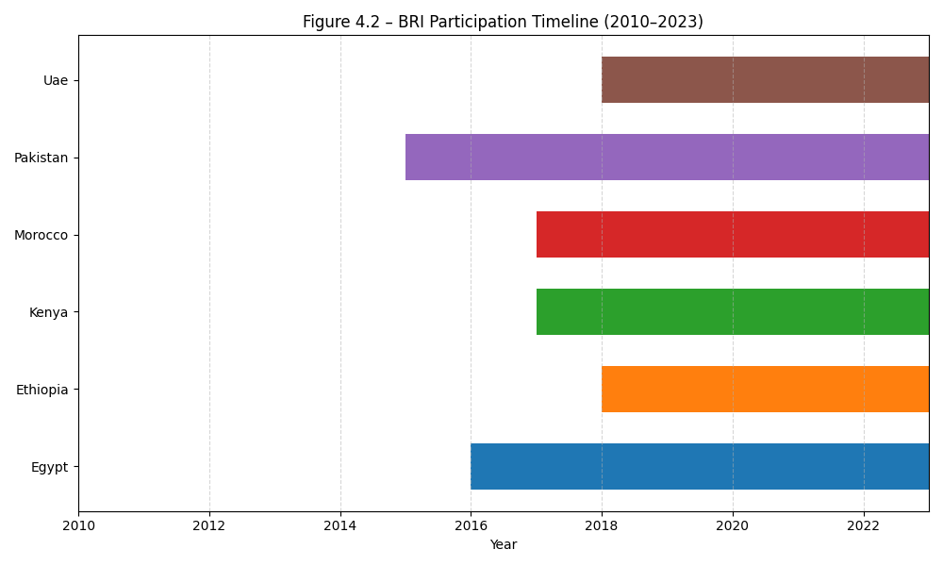
Notes: The dataset combines information from multiple sources, including trade statistics, macroeconomic indicators, and infrastructure and logistics metrics. While most variables are available for all country–year pairs, some data gaps remain; the treatment of missing values is discussed in Section 4.4.

Figure 2 Trends in deflated exports from China and deflated imports to China, 2010–2023 (six BRI partners)
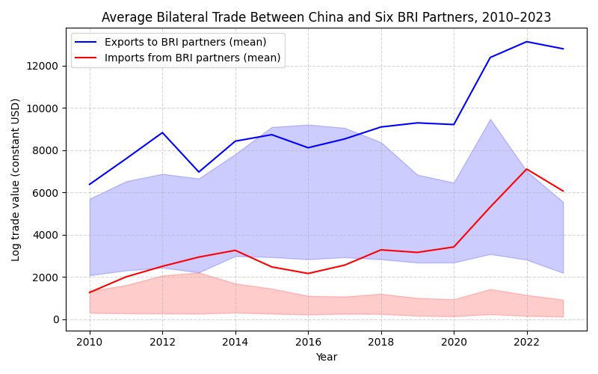
Notes: Values are expressed in constant USD. Solid lines show yearly means across countries; shaded bands represent the interquartile range.
Deflated series are in constant USD (base year as defined in Section 4). Yearly means and interquartile ranges are computed across the six BRI partner countries (Morocco, Egypt, Kenya, Ethiopia, Pakistan, UAE).

Figure 3 Predicted bilateral trade outcomes from baseline fixed-effects models (deflated values, 2010
2023)
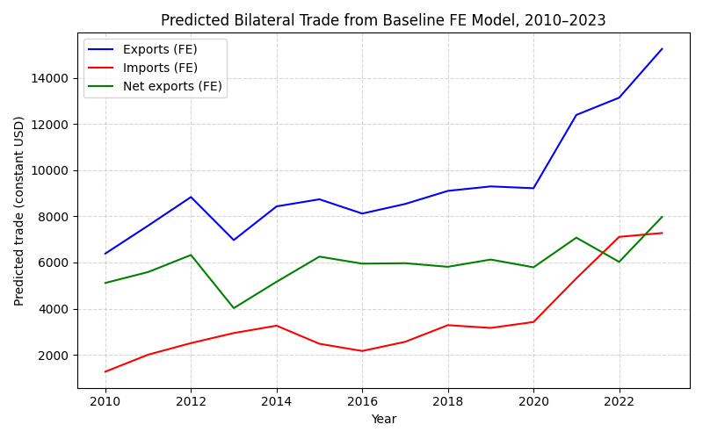
Notes: Predicted values from regressions in Table 4. Solid lines show fitted means; shaded areas represent ±1 standard error. Flows are expressed in constant 2010 USD.

Figure 4 Predicted bilateral trade from interaction models (BRI × ln(GDP), 2010–2023)
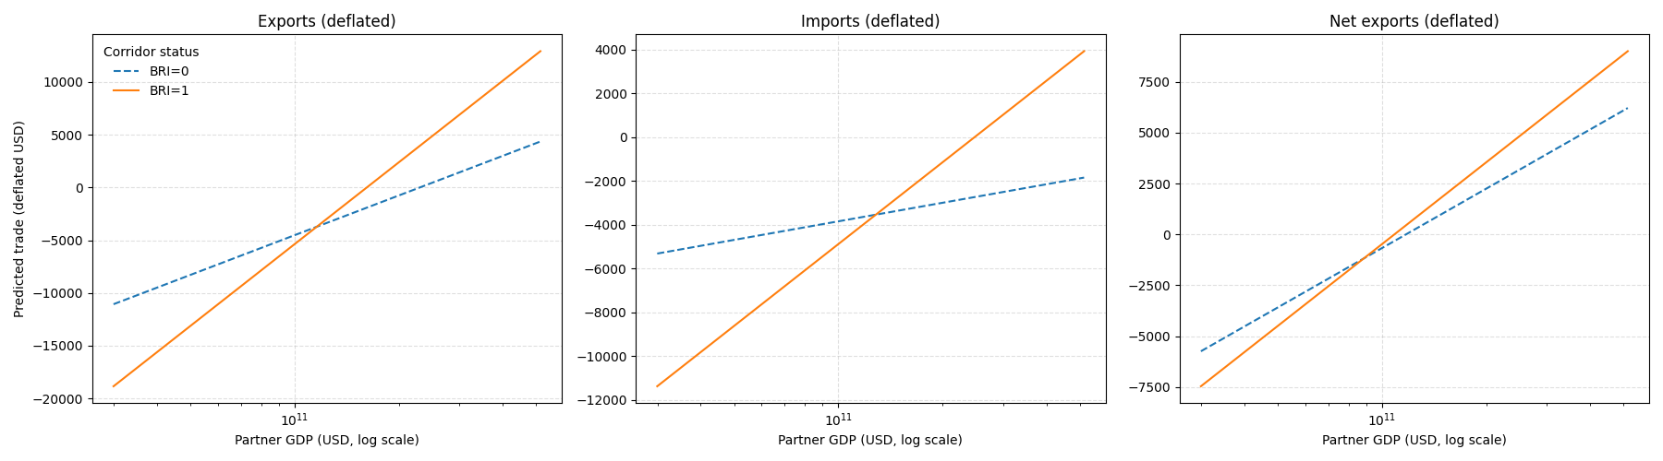
Notes: Fitted values from the OLS fixed effects interaction specifications in Table 5. Panels show (A) exports, (B) imports, and (C) net exports. X-axis is log GDP. Solid lines: BRI = 1; dashed: BRI = 0. Other covariates held at sample means; baseline country/year fixed at the modal country and median year. PPML counterparts are reported in Section 5.4.

Figure 5 Predicted bilateral trade from PPML interaction models (BRI × ln GDP, 2010–2023)
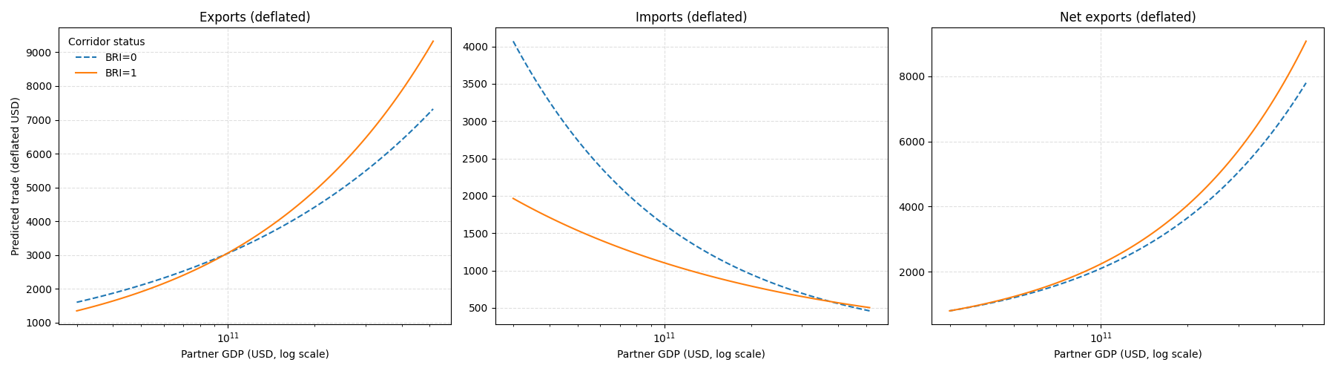
Notes: Fitted values from the PPML fixed effects interaction specifications in Table 6. Panels show (A) exports, (B) imports, and (C) net exports. X-axis is partner GDP in USD (log scale). Solid lines: BRI = 1; dashed: BRI = 0. Other covariates held at sample means; baseline country/year fixed at the modal country and median year.

Figure 6 Predicted BRI effects across GDP levels under leave-one-out exclusions (2010–2023)
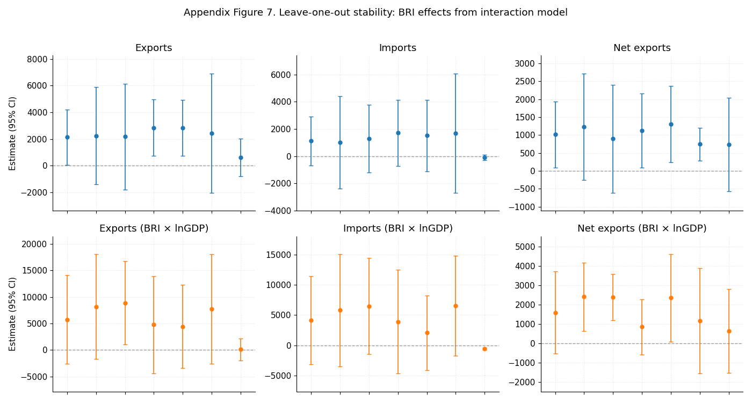
Notes: Each panel shows fitted BRI effects (evaluated at the sample mean and across partner GDP levels) from the interaction specification in Section 5.3, re-estimated while excluding one partner country at a time. Shaded areas indicate 95% confidence intervals. The stability of slopes across exclusions suggests that no single country drives the qualitative pattern of results.

