Consumer Preference And Experience In E-commerce Platforms: A Comparative Study Of Amazon And Flipkart

Abstract:
This study presents a comparative analysis of consumer preferences and experiences between Amazon and Flipkart, two dominant e-commerce giants in India. This research have used mixed method approach, through structured Google form questionnaires data were collected from 106 respondents, compassing both quantitative ratings and qualitative feedback. Most of the respondents belong to 25-34 age group and majority participates are Female. Descriptive statistics and Chi- square test were utilized to assess platform usability, innovation, technological perception and customer overall satisfaction, while Thematic analysis pointed out some key factors influencing customer platform preferences. Findings of the study revel that Amazon slightly outperform over Flipkart on innovation and customer’s future shopping platform preference, though customer satisfaction levels toward both platform remain generally high. Customer reported some issues, suggesting for improvement on time on delivery, product quality, sustainability, cash on delivery system and pricing strategies. Limitation include a smaller sample size than intended. This research offers valuable insights for e-commerce stakeholders aiming to enhance service quality and customer experience.

Keywords- E-commerce, Customer Preference, Customer Experience, Customer Satisfaction, Amazon, Flipkart, Online Shopping.

Introduction
The rapid growth of e-commerce has revolutionized consumer shopping behavior globally, especially in emerging market like India where digital penetration is rising significantly. Among many competitors, Amazon and Flipkart are the leading e-commerce giants in India. Consumer prefer these platforms for some factors such as pricing, convenience shopping, product variety, on time delivery and customer service (Sharma & Bhal, 2019). For business it’s very crucial to understand customer preferences which helps create strategies effectively. Beyond preferences, the overall customer experiences with platforms plays an important role to shape customer satisfaction and royalty. The experiential components plays an equally vital role in understanding customer behavior on e-commerce platforms. Factors like apps or website usability, smooth and secure payment process, quality full products, true and authentic customer review, personalized recommendations, on time delivery and customer care service significantly influence customer experiences and platforms preference. For service improvement and retain customers, identifying these factors are important.
This study aims to compare customer platforms preference and experiences with Amazon and Flipkart, based on Indian market. By focusing on Amazon and Flipkart, prominent e-commerce giants in India with distinct competitive strategies, this research gives a nuanced perspective on the factors driving customer preferences and satisfaction in the digital competitive environment. The finding of this study will not only increase the literature on e-commerce consumer behavior but also guide e-commerce sites, how they can enhance offers to meet customer expectations and support the strategic development of user centric online shopping platforms.

Literature Review
Vidani (2024) conducted a comparative research of Amazon and Flipkart, highlighting key differences in customer satisfaction, service quality and products pricing. The study reveled that Amazon excels in on time delivery and reliability and Flipkart performs good in adopting localization and competitive pricing strategies. The research provides valuable insights into factors influence consumer platforms preference in India’s competitive e-commerce market.
Mishra et al. (2022) examined customer perceptions of Amazon and Flipkart emphasizing on factors such as product quality and verity, competitive pricing, delivery spread and customer care service. This comparative study found nuanced differences in customer satisfaction levels, mentioning Amazon’s strengths in product quality and verity while Flipkart performing good in pricing strategies. The result of the study contribute for understanding the dynamic preferences influence India’s e-commerce market.
Kumar and Ramadas (2022) highlighted the importance of online ratings, especially in emerging market like India, where consumer strongly depends on customer reviews for making purchase decision. Aims of the study is to design a scale to access online reviews, influence customer behavior, identifying factors such as quality, source credibility, language and topic relevance.
Sharma and Bhal (2019) conducted a comparative study to investigate how service quality dimensions such as assurance, reliability and responsiveness impact consumer preferences between Amazon and Flipkart, major Indian e-commerce platforms. The study found that customer satisfaction get significantly influenced by service efficiency and trustworthiness, which shapes customer e-commerce platform preferences. This study gives valuable insights into consumer behavior, highlighting the importance of maintaining high service quality to competitive in the evolving digital e-commerce landscape.
Bharadwaj (2019), this study focused on e-commerce sector in India and to analyze the competitiveness in e-commerce sector between two e-commerce giants Amazon and Flipkart. In India, though there are many e-commerce companies, Amazon and Flipkart are highly competing and leading in the market. According to the study, Amazon outperforms Flipkart based on considering some factors such as stock availability, delivery spread, discount, pricing and product quality. This study found that Male are more interested in online shopping compared to Female and consumer get interested in buying goods online when they are vulnerable to offers, discounts etc.

Research Gap
While several research have examined e-commerce platform’s service quality and customer satisfaction, limited study has focused on customer e-commerce platform preference between Amazon and Flipkart in terms of key influencing factors and overall satisfaction. Moreover, most of the existing research emphasized on either one platform or general e-commerce trends but there is a lack of research on comparison of how specific factors shape consumer preference between these two platforms, who dominant in Indian e-commerce market. This research aim to fill this gap by identifying and comparing the key factors influencing customer preferences and their relationship with overall satisfaction and giving actionable insights for businesses and marketers.

Research Objective
Following are the primary objectives of the study:
- To compare customer e-commerce platform preference between Amazon and Flipkart.
- To identify the key factors influence customer preference between Amazon and Flipkart.

Research Hypothesis
These are research hypotheses based on objectives:
- $H_{01}$: There is no significant difference in consumer preference between Amazon and Flipkart.

$H_{1}$: There exists a statistically significant difference in customer platform preference between Amazon and Flipkart.

Scope Of The Study
This research focuses on exploring and comparing consumer e-commerce platform’s preferences and online shopping experiences on two leading e-commerce giants in India- Amazon and Flipkart. This study is obstructed to identifying key factors that influence consumer preferences, behavioral patterns and satisfaction levels while interacting with these selected platforms. It also investigated how user experience, product variety, platforms usability, customer care service and advertisement strategies contribute to shaping consumer shopping decision and perceptions.
This research is limited to Indian consumers and is based on primary data collected through structured questionnaires. For e-commerce marketers, business strategists and platforms designers, this study is particularly pertinent to align their services with evolving consumer expectations. Moreover, it also important for academicians and researchers interested in consumer online shopping behavior and e-commerce platform competition. Though this study does not cover all the e-commerce platforms but it gives strong insights for understanding comparative consumer dynamic in rapidly evolving digital marketplace.

Research Methodology
This study adopts mixed method descriptive and comparative research design aims to systematically examine customer preferences and the determinants influencing their preferences between Amazon and Flipkart, leading e-commerce players in India.
Data Collection Method: Primary data were collected through structured Google form questionnaire, distributed to online shoppers through e-mail and social media. Questionnaire designed by the researcher.
Google form link- https://docs.google.com/forms/d/e/1FAIpQLSceQkj3etiuFROxtqosdDYL-mpKwIXJUF9wCXgpF3kQ9i7coA/viewform?usp=header
Data Type: Mixed method approach, integrating both quantitative and qualitative data to give a comprehensive analysis of customer preferences and experiences on e-commerce platforms.
Sampling Method: Non probability convenience sampling method will be used to select respondents who have prior shopping experience from Amazon and Flipkart.
Sample Size: A sample size of 150 respondents will be targeted to ensure efficient representation and statistical validity.
Target Population: Individuals aged 18 and above who have made at least one purchase from Amazon and Flipkart in the past 6 months.
Data Analysis: Collected data will be exported to Microsoft excel software for preliminary cleaning and descriptive analysis. Frequency, Percentage and cumulative percentage will be calculated to summarize demographic and preferences data.
Chi- square test will be employed to analyze the association between categorical factors such as gender, age and platform preference.
Qualitative data from open ended questions will be analyzed using Thematic analysis to identify key themes related to platform usability, innovation and challenges.
Ethical Consideration:
- Participation will be voluntary and anonymous and their confidentiality will be maintained.
- Respondents will be prior informed about the purpose of the study and they have right to withdraw at any time.
- Data will be used purely for academic purpose.

Data Analysis and Interpretation
- Age
Table- 1 Age Of Respondents
Valid | Particular | Frequency (f) | Percent (%) | Valid Percent | Cumulative Percent
Valid | 18-24 | 29 | 27.4% | 27.4% | 27.4%
Valid | 25-34 | 60 | 56.6% | 56.6% | 84%
Valid | 35-44 | 14 | 13.2% | 13.2% | 97.2%
Valid | 45 and above | 3 | 2.8% | 2.8% | 100
Valid | Total | 106 | 100% | 100% | -

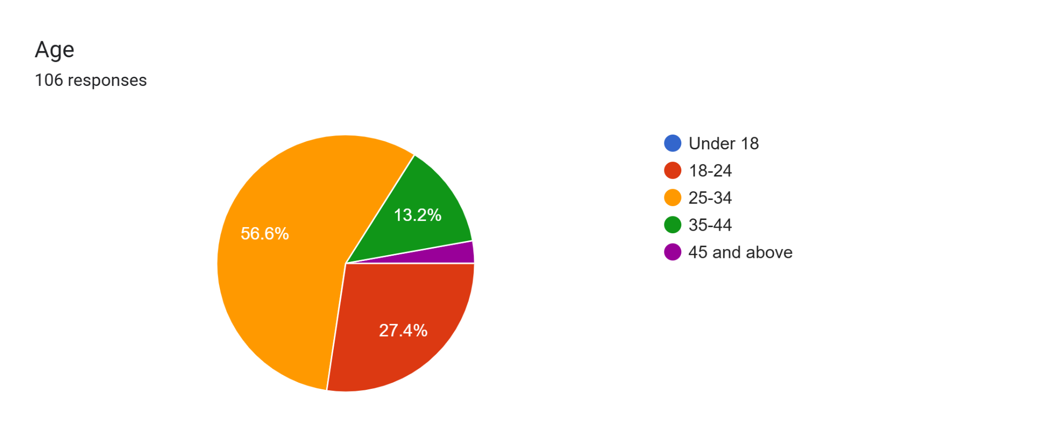
Interpretation: Table 1 displays the age distribution of the respondents, summarizing data analysis for a total number of 106 respondents. The majority of the respondents come under 25-34 age range, 56.6%. It’s indicate a mature sample population. Second major respondents are from 18-24 age range with 27.4% and than relatively smaller proportions are 35-44 age range with 13.2% than 45 and above age range having 2.8%. The finding of this table suggesting to give concentration on 18-34 age demographic. These findings are very important for understanding age composition of the respondents group and can be valuable for marketers for tailoring research or formulating strategies accordingly.

- Gender
Table- 2 Gender Of Respondents
Valid | Particular | Frequency(f) | Percent(%) | Valid Percent | Cumulative Percent
Valid | Female | 64 | 60.4% | 60.4% | 60.4%
Valid | Male | 41 | 38.7% | 38.7% | 99.1%
Valid | Other | 1 | 0.9% | 0.9% | 100
Valid | Total | 106 | 100% | 100% | -

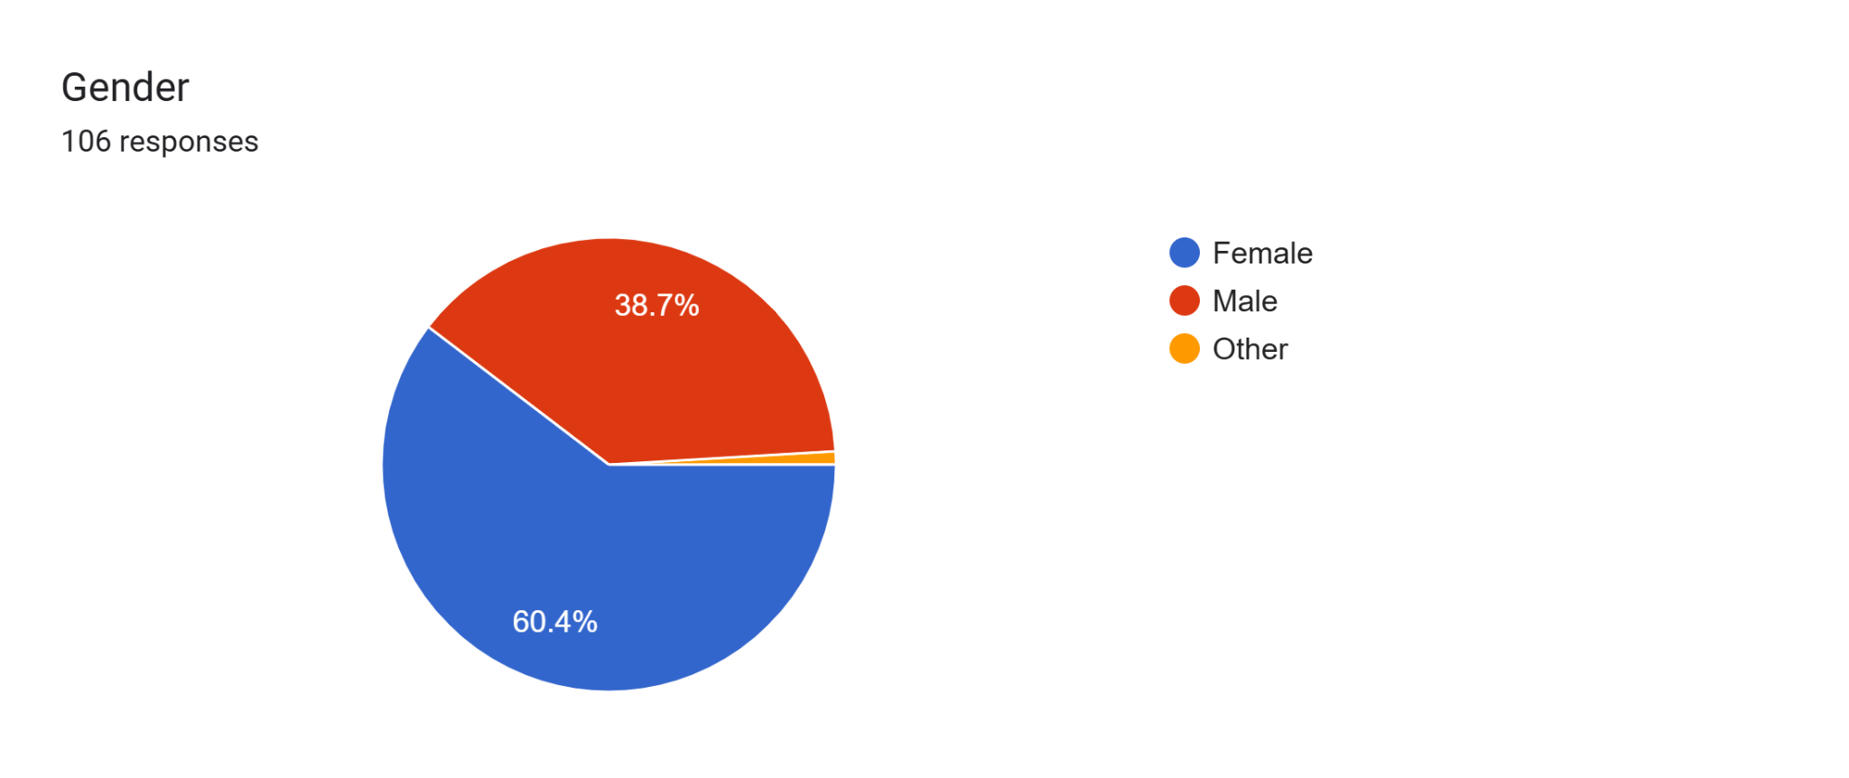
Interpretation: Table 2 gives an overview of gender distribution among the respondents comprising a total of 106 respondents. The data found a significant gender difference, with majority of respondents identifying as women, accounting for 60.4% of the sample while male and other gender respondents are respectively 38.7% & 0.9%. This gender disparity is noteworthy, as it could potentially change the study’s result and conclusions. To engage both Male and Female it is crucial to understand the gender composition of the sample for tailoring communication, marketing or research approaches also to make sure the findings are representative and relevant to both gender.
- Occupation
Table- 3 Occupation Of Respondents
Valid | Particular | Frequency (f) | Percent (%) | Valid Percent | Cumulative Percent
Valid | Student | 48 | 45.3% | 45.3% | 45.3
Valid | Working Professional | 40 | 37.7% | 37.7% | 83%
Valid | Self employed | 12 | 11.3% | 11.3% | 94.3%
Valid | Home maker | 4 | 3.7% | 3.7% | 98%
Valid | Others | 2 | 2% | 2% | 100%
Valid | Total | 106 | 100% | 100% | -

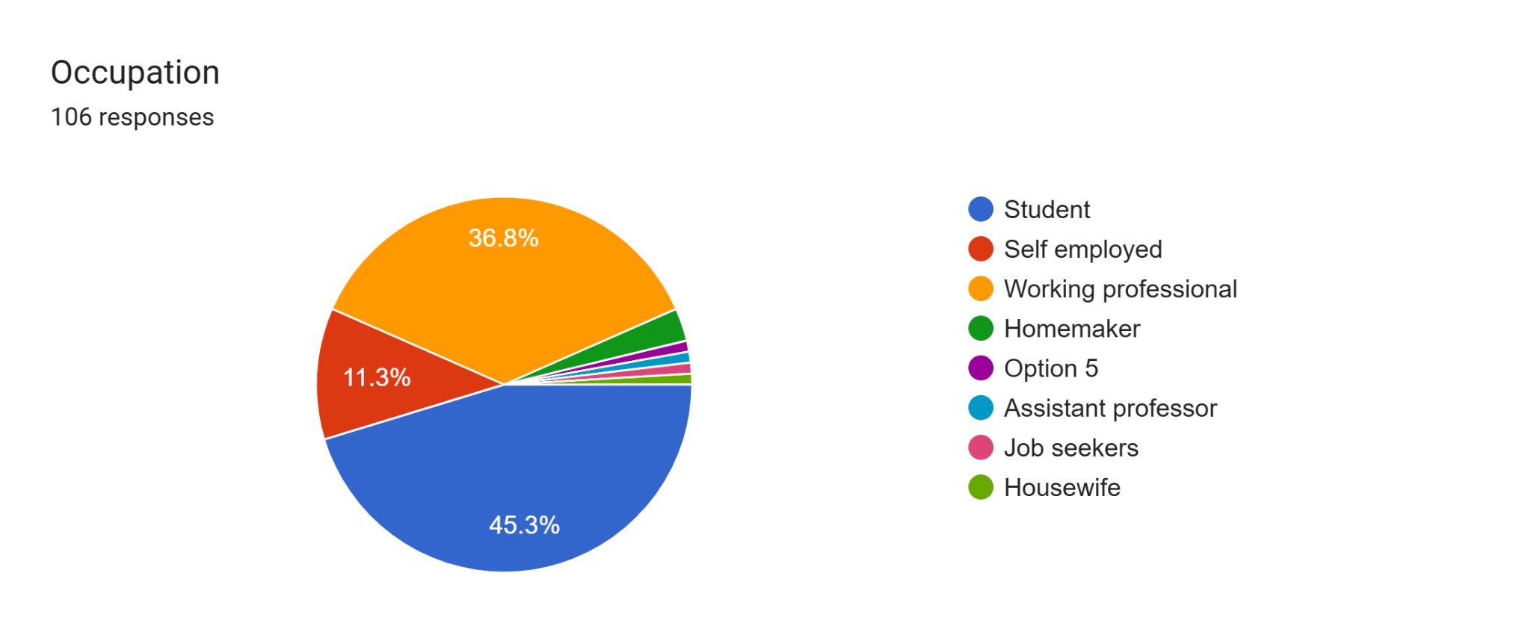
Interpretation: Table 3 provides occupational distribution of the respondents. The majority respondents are student 45.3%, followed by working professional 37.3%, and a smaller representation of self individuals 11.3%, respectively home marker 3.7% and other occupation are 2%. This finding reveals that students are the majority user of e-commerce, business should focus on them and create strategies accordingly.
- Frequency Of Online Shopping
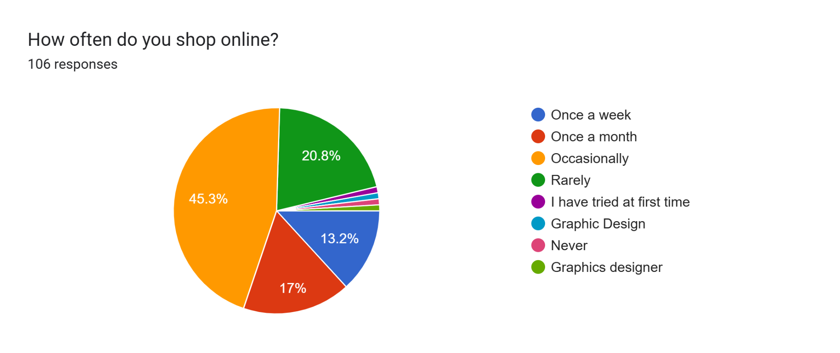
Valid | Particular | Frequency (f) | Percent (%) | Valid percent | Cumulative Percent
Valid | Occasionally | 48 | 45.3% | 45.3% | 45.3%
Valid | Once a month | 18 | 17% | 17% | 62.3%
Valid | Once a week | 14 | 13.2% | 13.2% | 75.5%
Valid | Rarely | 22 | 20.8% | 20.8% | 96.3%
Valid | Never | 1 | 0.9% | 0.9% | 97.2%
Valid | Other | 3 | 2.8% | 2.8% | 100%
Valid | Total | 106 | 100% | 100% | -

Table- 4 Frequency Of Online Shopping
Interpretation: Table 4 revels how often respondents engage in online shopping. The most common frequency is Occasionally 45.3% followed by Once a month 17%, Rarely 20.8%, Once a week 13.2%, Never 0.9% and Other 2.8%. The most responses is having occasionally where e-commerce platforms should work to convert it on daily customer engagement.
- Frequently Used Online Platform
Table-5 Frequently Used Online Platform
Valid | Particular | Frequency (f) | Percent (%) | Valid Percent | Cumulative Percent
Valid | Both | 48 | 45.3% | 45.3% | 45.3%
Valid | Amazon | 23 | 21.7% | 21.7% | 67%
Valid | Flipkart | 22 | 20.8% | 20.8% | 87.8%
Valid | Others | 13 | 12.2% | 12.2% | 100%
Valid | Total | 106 | 100% | 100% | -

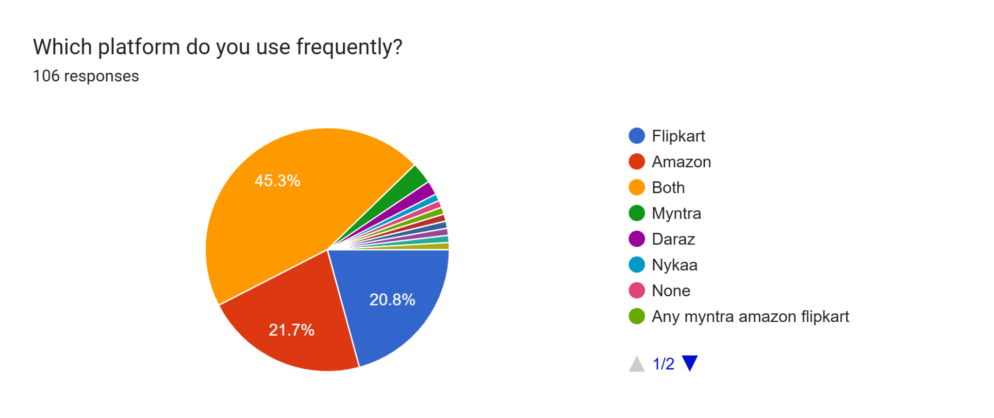
Interpretation: Table 5 shows comparative difference between Amazon and Flipkart. Maximum user preferred both the platform 45.3% respondents for their online purchase but when they specifically choice between two platform very intense competition exists. Amazon preferred by 21.7% respondents and Flipkart preferred by 20.8%. Noteworthy difference come only 0.9% also other platforms like preferred by 12.% also a indicate a high competition between e-commerce platforms where Amazon & Flipkart should give focus for competitive advantage & to hold market position.
- Perception Of Innovation and Technology
Table-6 Perception Of Innovation and Technology
Valid | Particular | Frequency (f) | Percent (%) | Valid Percent | Cumulative Percent
Valid | Both | 44 | 41.5% | 41.5% | 41.5%
Valid | Amazon | 29 | 27.4% | 27.4% | 68.9%
Valid | Flipkart | 18 | 17% | 17% | 85.9%
Valid | Not Sure | 15 | 14.1% | 14.1% | 100
Valid | Total | 106 | 100% | 100% | -

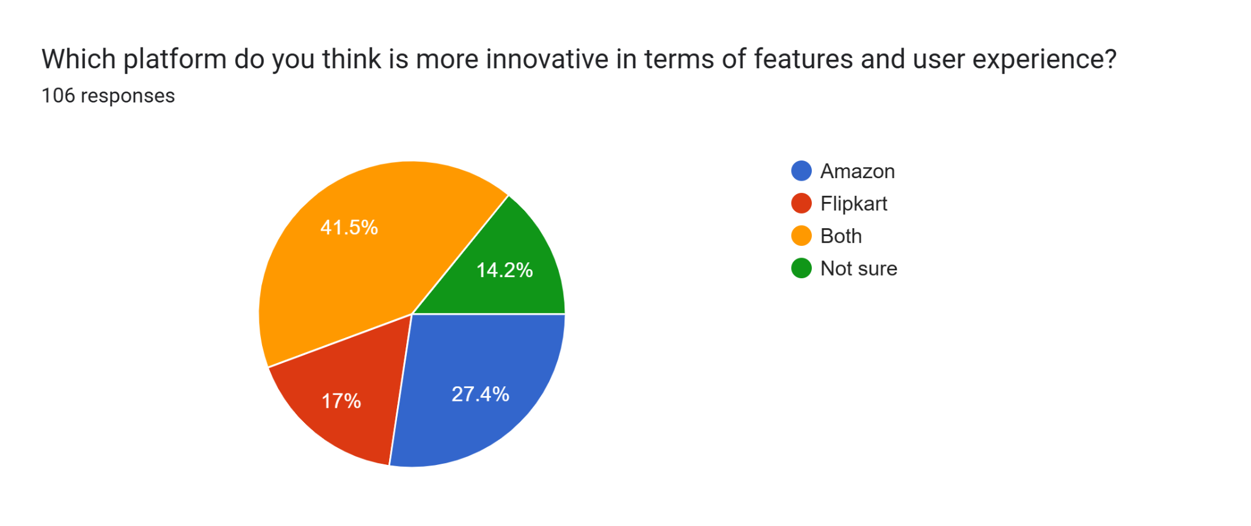
Interpretation: Most respondents (41.5%) felt both the platforms are equally innovative. Amazon lead (27.4%) among them who preferred one platform, Flipkart had moderate share (17%) and 14.1% respondents were not sure, indicating a potential knowledge gap or perception parity. This finding suggest Flipkart to give focus on innovation.
- Experience On Platform Usability
Table- 7 Experience On Platform Usability
Valid | Particular | Frequency (f) | Percent (%) | Valid Percent | Cumulative Percent
Valid | Very Poor | 14 | 13.2% | 13.2% | 13.2%
Valid | Poor | 12 | 11.3% | 11.3% | 24.5%
Valid | Average | 30 | 28.3% | 28.3% | 52.8%
Valid | Good | 29 | 27.4% | 27.4% | 80.2%
Valid | Excellent | 21 | 19.8% | 19.8% | 100%
Valid | Total | 106 | 100% | 100% | -

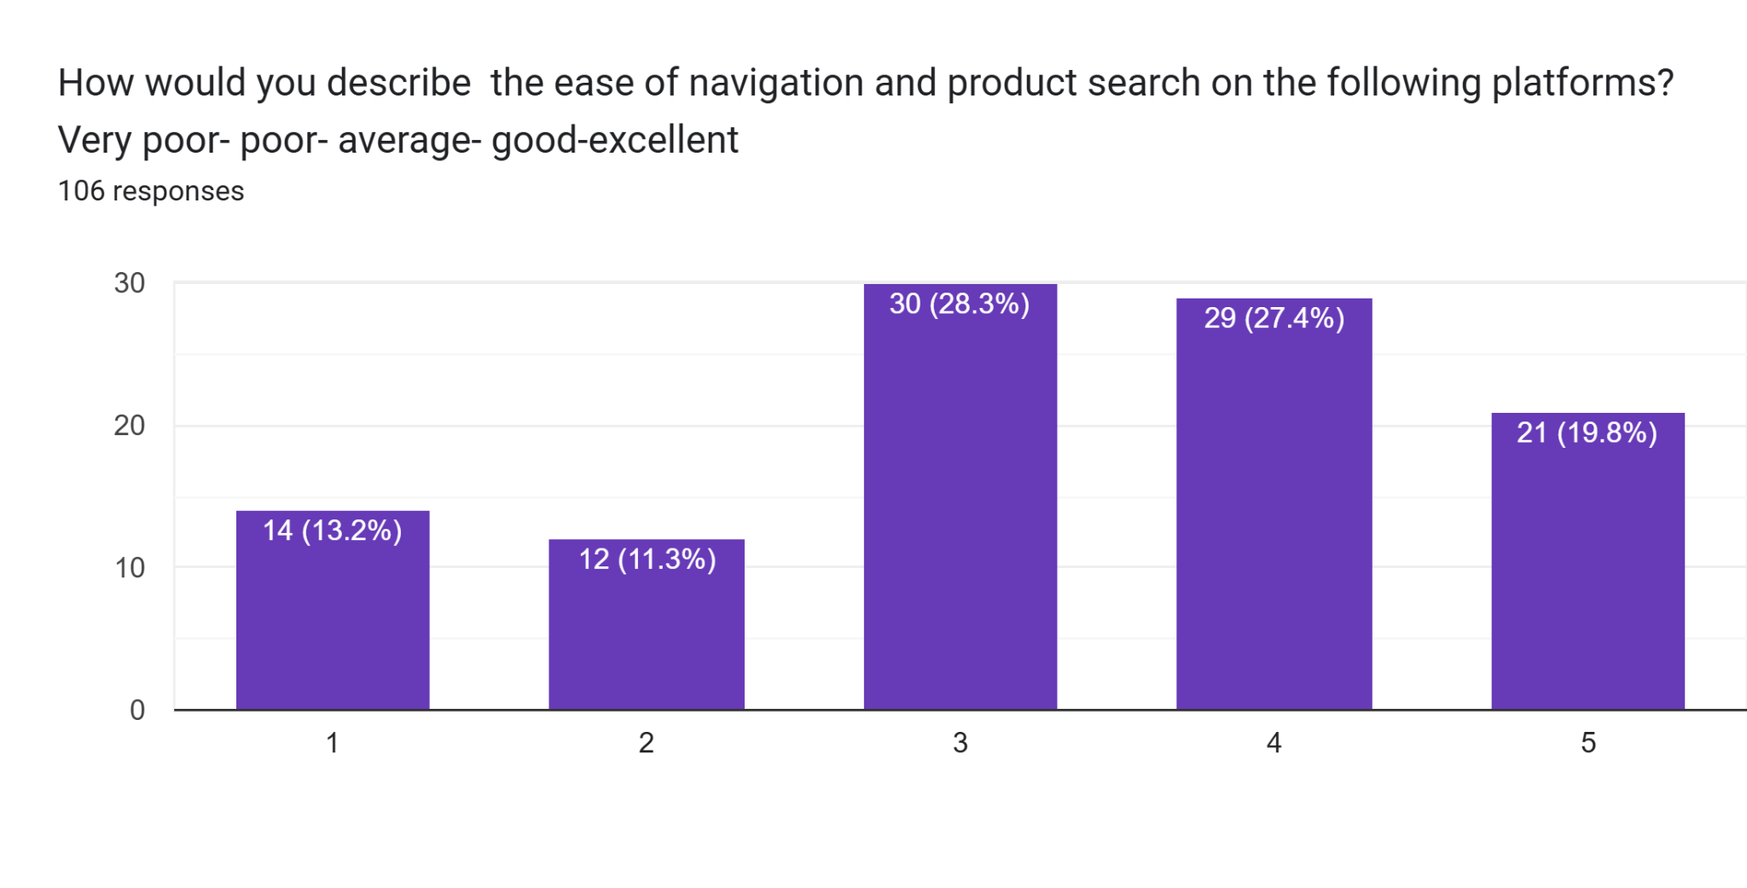
Interpretation: Table 7 is showing that consumer is having experience on platform usability like navigation and product search is average 28.3%. Maximum respondents felt that. Respectively 27.4% user said it’s Good & 19.8% user said its excellent. A smaller proportion respondents experienced these platforms are very poor (13.2%) and poor (11.3). Overall platform has to be user friendly and easily accessible.
- Overall Satisfaction With Amazon
Table- 8 Overall Satisfaction With Amazon
Valid | Rating | Frequency(f) | Percent (%) | Valid Percent | Cumulative Percent
Valid | 1 | 10 | 9.4% | 9.4% | 9.4%
Valid | 2 | 5 | 4.7% | 4.7% | 14.1%
Valid | 3 | 28 | 26.4% | 26.4% | 40.5%
Valid | 4 | 39 | 36.8% | 36.8% | 77.3%
Valid | 5 | 24 | 22.7% | 22.7% | 100%

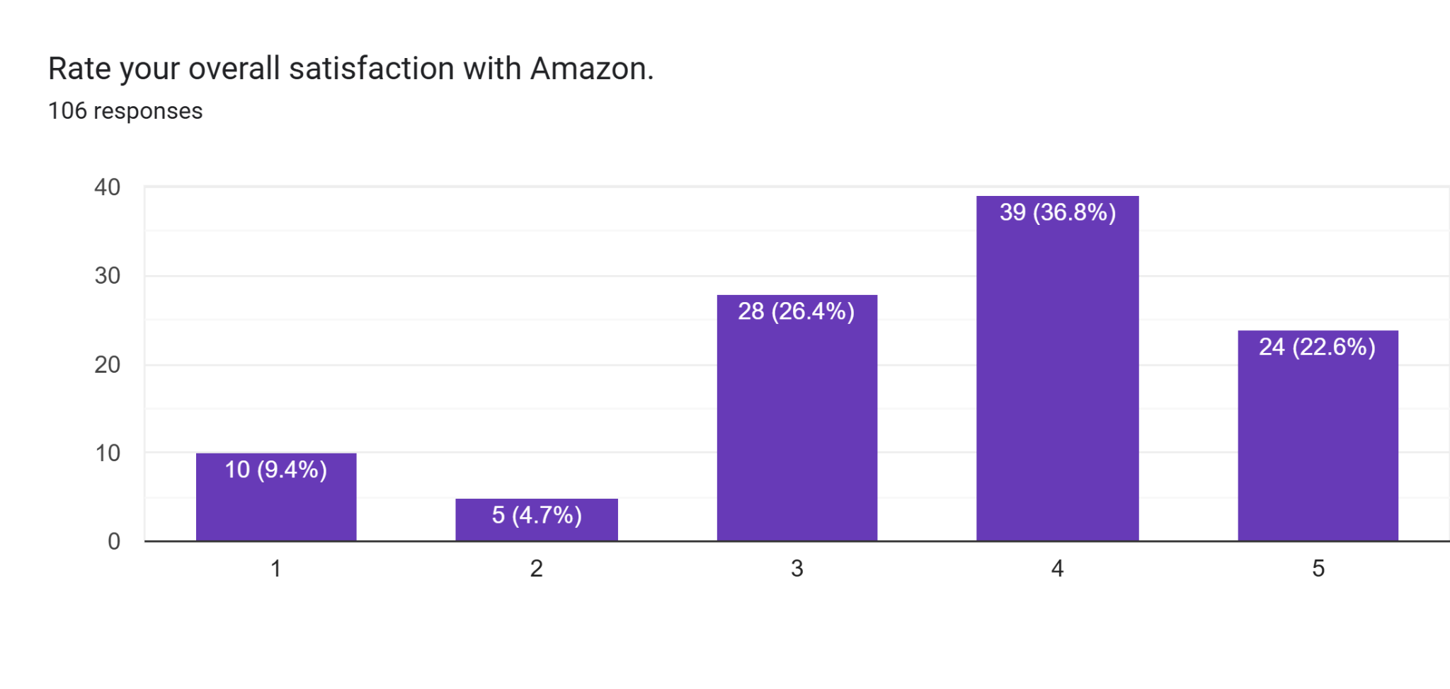
Interpretation: Amazon enjoy a high overall satisfaction rating among users. About 59.5% user rated it either 4 or 5 start. Meanwhile, 26.4% gave a neutral rating and only 14.1% expressed dissatisfaction (rating 1 or 2). This findings revel Amazon is performing well in most areas such as service, delivery and experience.

- Overall Satisfaction With Flipkart

Table- 9 Overall Satisfaction With Flipkart
Valid | Rating | Frequency(f) | Percent (%) | Valid Percent | Cumulative Percent
Valid | 1 | 13 | 12.3% | 12.3% | 12.3%
Valid | 2 | 3 | 2.8% | 2.8% | 15.1%
Valid | 3 | 33 | 31.1% | 31.1% | 46.2%
Valid | 4 | 33 | 31.1% | 31.1% | 77.3%
Valid | 5 | 24 | 22.6% | 22.6% | 100%

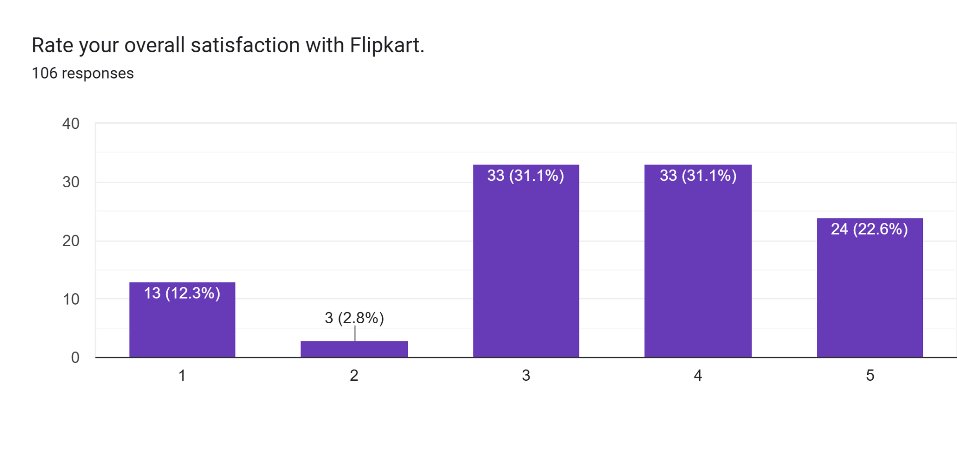
Interpretation: Flipkart satisfaction ratings are generally positive over 53.7% respondents are rating it for 4 or 5 start, indicating a strong but compared to Amazon it has slightly lower satisfaction level. A notable 31.1% respondents rated it neutral, suggesting for improvement. Around 15% showed gave lower rating (1 or 2), which may cause of service or delivery inconsistencies.

- Customer Challenges Faced With Platforms
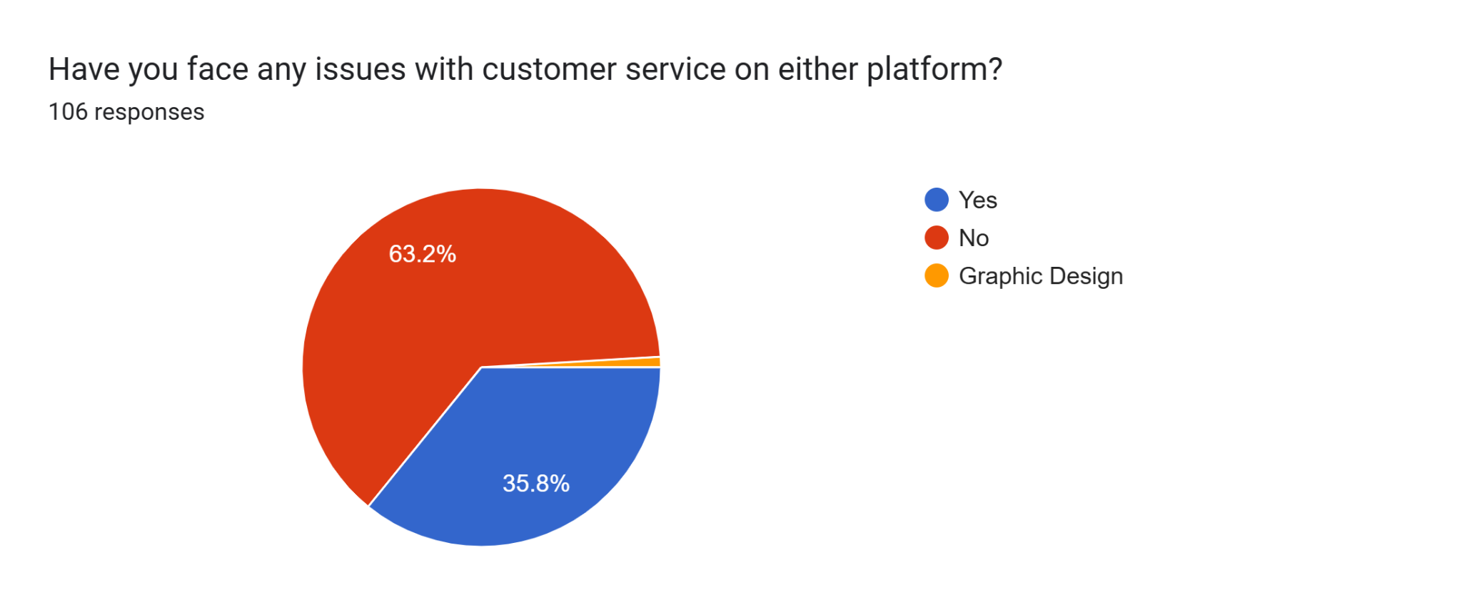

Table- 10 Customer Challenges Faced With Platforms
Valid | Particular | Frequency(f) | Percent(%) | Valid Percent | Cumulative Percent
Valid | Yes | 38 | 35.9% | 35.9% | 35.9%
Valid | No | 67 | 63.2% | 63.2% | 99.1%
Valid | Other | 1 | 0.9% | 0.9% | 100%
Valid | Total | 106 | 100% | 100% | -

Interpretation: The finding of this table revels that maximum respondents (63.2%) have not faced any issues or challenges with these selected platforms while shopping but a noticeable figure 35.9% respondents claimed that they face challenges with these platform. Which will help e-commerce platform to find out these challenges and taking action on that.
- Respondents Platform Recommendation
Respondents Platform Recommendation
Valid | Particular | Frequency(f) | Percent (%) | Valid Percent | Cumulative Percent
Valid | Amazon | 49 | 46.2% | 46.2% | 46.2%
Valid | Flipkart | 40 | 37.7% | 37.7% | 83.9%
Valid | Both | 6 | 5.7% | 5.7% | 89.6%
Valid | None | 1 | 0.9% | 0.9% | 90.5%
Valid | Others | 10 | 9.5% | 9.5% | 100%
Valid | Total | 106 | 100% | 100% | -

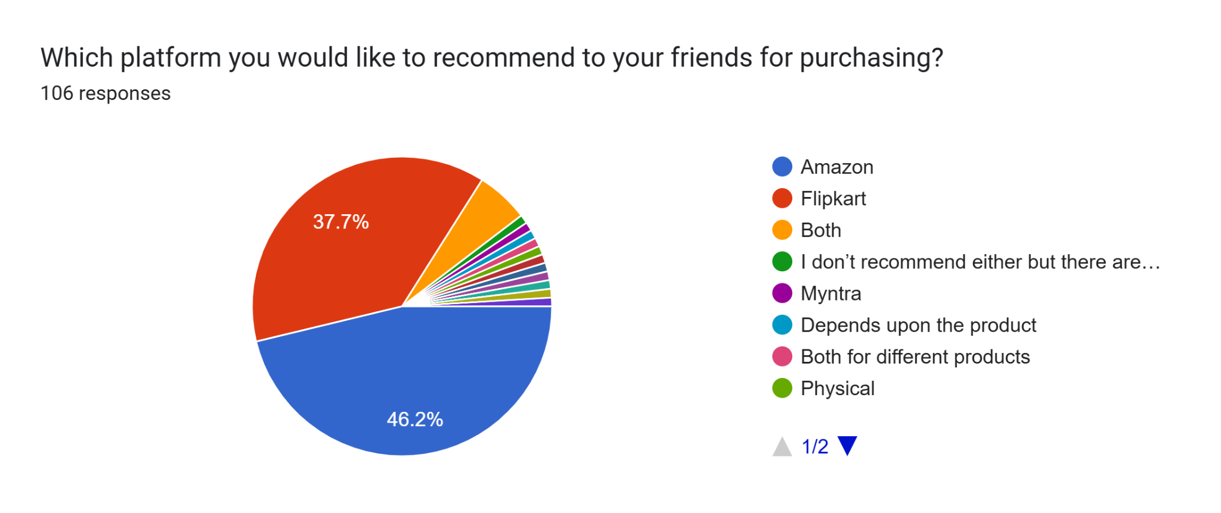
Interpretation: Findings of this table is saying that majority of the respondents (46.2%) will recommend “Amazon” to their friends & family for online shopping according to their experience. Also 37.7% respondents will recommends “Flipkart” to their friends and family. A smaller proportion (5.7%) will recommend both the platforms and 0.9% respondent will not recommend any of them respectively 9.5% respondents will recommend other e-commerce platforms like Meesho, Myntra and others.
- Future Shopping Preference
Table- 12 Future Shopping Preference
Valid | Particular | Frequency(f) | Percent (%) | Valid Percent | Cumulative Percent
Valid | Amazon | 28 | 26.4% | 26.4% | 26.4%
Valid | Flipkart | 14 | 13.4% | 13.4% | 39.8%
Valid | Both | 53 | 50% | 50% | 89.8%
Valid | None | 10 | 9.4% | 9.4% | 99.2%
Valid | Others | 1 | 0.9% | 0.9% | 100%
Valid | Total | 106 | 100% | 100% | -

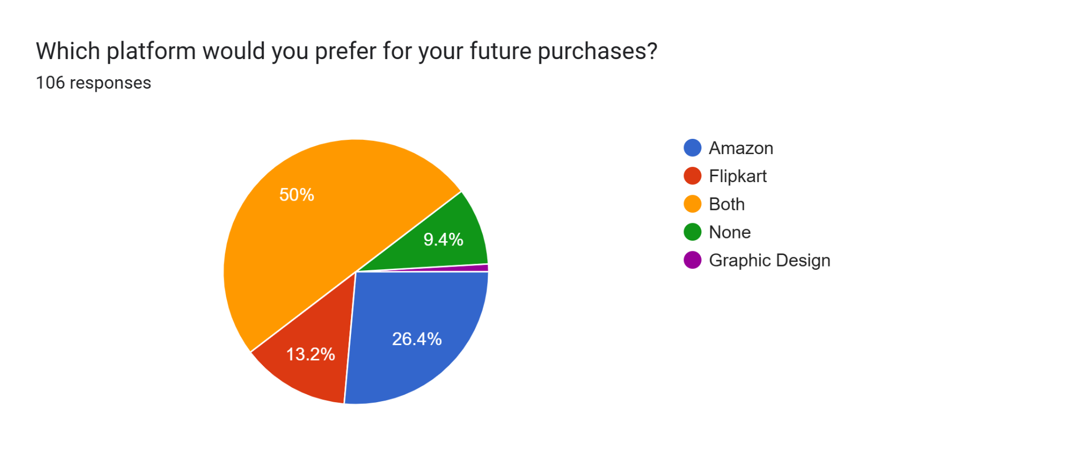
Interpretation: Both the platform preferred by half of the population (50%) for their future shopping. But if consider platform specific than Amazon emerge as the most recommended platform, 26.4% respondents. But Flipkart is having lower preference, only 13.4% respondents prefer it, where suggesting Flipkart for improvement. And a smaller proportion (9.4%) prefer none of the platforms for their future shopping & other (0.9%) prefer other shopping platforms.

Statistical Analysis
Chi- Square test for platform preference
To test whether there is a significant difference between customer platform preferences among leading e-commerce platform Amazon and Flipkart, a Chi- square goodness of fit test was conducted.
Hypothesis:
- $H_{01}$: There is no significant difference in consumer preference between Amazon and Flipkart.

$H_{1}$: There exists a statistically significant difference in customer platform preference between Amazon and Flipkart.

Platform Preferences | Observed Frequency | Expected Frequency(assuming equal preferences)
Both | 48 | 26.5
Amazon | 23 | 26.5
Flipkart | 22 | 26.5
Others | 13 | 26.5
Total | 106 | 106

Chi Square Test Calculation:
$x^{2}$= ∑(O- E)^2/ E

Both= (48- 26.5)^2/ 26.5 Amazon= (23-26.5)^2/ 26.5
= (21.5)^2/ 26.5 = (-3.5)^2/ 26.5
=17.4433962 ≈ 0.46
≈ 17.45
Flipkart= (22-26.5)^2/ 26.5 Others= (13-26.5)^2/26.5
= (-4.5)^2/ 26.5 = (-13.5)^2/ 26.5
≈ 0.76 ≈ 6.88
$x^{2}$= (17.45+ 0.46+ 0.76+ 6.88)
= 25.55
Degree Of Freedom (df) = Categories – 1
= 4-1
= 3
Critical Value ( ɑ= 0.05)
From Chi square table, $X^{2}$ Critical (3,df, 0.05) ≈ 7.815
Result: Since $X^{2}$ = 25.55> 7.815, the null hypothesis is rejected
Interpretation: There exists significant difference in customer platform preference between Amazon and Flipkart.

Thematic Analysis:
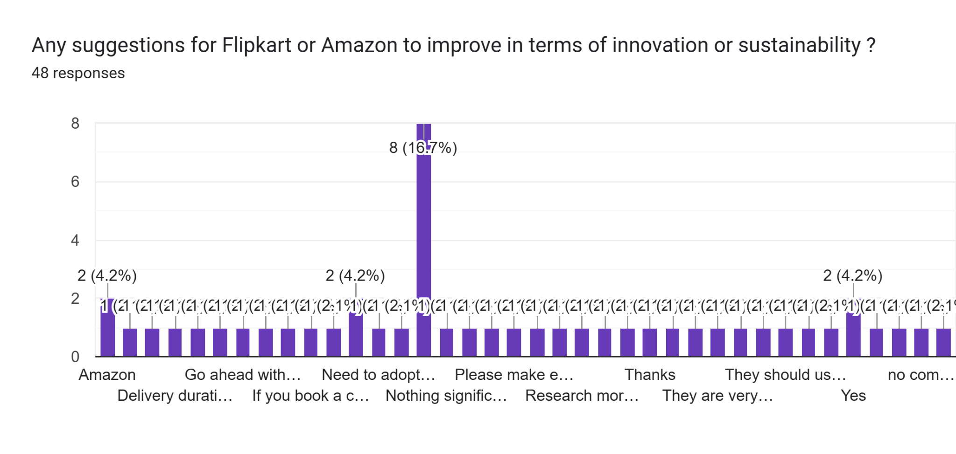
Thematic analysis of customer suggestions for Amazon and Flipkart.
- Product Quality and Authenticity: Suggestions include stopping the sale of fake products, improving overall product quality (as some products are very poor), and ensuring the customer receives the real order.
- Sustainability and Packaging: Recommendations were made to use recyclable and eco-friendly packing material and stop wasting packing material. Packaging for delicate items should also be improved to avoid breakage.
- Customer Service and Policy: There is a need for faster response to customer needs, taking action on complaints, and improving the return policy.
- Platform Functionality and Pricing: Improvement suggestions include adopting more technical matters, improving product search, efficiency in changing addresses and dates, clearly mentioning prices with tax included, and charging less for COD and delivery.
- Innovation and Market Expansion: Suggestions involve researching current technology trends and Flipkart expanding to other international markets.
Each of these themes represents a specific area that customers consider important when forming preferences for one platform over another. Like: customer concerns on Product quality and authenticity directly affect trust and satisfaction, influencing repeat usage and preference.
Issues related Platform functionality, pricing and COD charges may shift customer choice towards the platform perceived as more cost efficient.
Suggestions about Sustainability and Packaging seems customer awareness is growing also they are concern about the environment that can shape brand loyalty and platform alignment.

Findings
Demographic Profile: The majority of respondents belonged to the 25-34 age group. Female respondents (60.4%) slightly outnumbered male respondents (38.7%), expressing strong engagement of Youth and Female in online shopping.
Occupational Background: Most of the respondents were students (45.3%) and working professional (37.7%). Indicating that online active and economically contribute individuals are the dominant users of e-commerce platforms.
Shopping Frequency: A majority number of respondents (45.3%) do online shopping occasionally, reveling that although online shopping is popular still for many users it’s still situational where e-commerce platforms should focus.
Perception Of Innovation and Technology: Respondents perceived Amazon (27.4%) as more innovative than Flipkart (17%). However, many users recognized both the platforms (41.5%) are offering innovative features and services.
Platform Usability: Platform usability experience was average to good range (28.3% and 27.4%). Showing as generally positive but more improvement required.
Overall Customer Satisfaction: For both the platforms Amazon and Flipkart, most users rated their satisfaction levels 3 and 4 mostly, showing moderate to high satisfaction levels.
Platform Preference: Compared customer platform preference between Amazon and Flipkart, where Amazon preferred by customer mostly (21.7%) also many users preferred both the platforms (45.3%). And according to Chi-Square test: Chi-square vales- 25.55, Degree of freedom- 3 and significance level is 0.05 and Critical value ≈ 7.815. Since, 25.55> 7.815, the null hypothesis is rejected. This indicate a statistically significant difference in consumer platform preferences, with clear users preference towards both platforms, followed by Amazon.
Challenges Faced: A majority of respondents (63.2%) reported no major issues or challenges faced with either platform. Some users (35.9%) reported some issues mainly related to product quality, delivery and pricing policy.
Platform Recommendation: Respondents were willing to recommend both Amazon (46.2%), Flipkart (37.7%) to their friends and family, reflecting a positive perception and trust in both platforms.
Future Shopping Preference: Despite recommending both e-commerce platforms, more users preferred Amazon (26.4%) as their future shopping platform where Flipkart preferred by only 13.4% users. Indicating Amazon’s stronger brand appeal and service satisfaction.

Conclusion
This study aimed to investigate and compare consumer preferences and experiences on Amazon and Flipkart- two lead e-commerce company in India. The findings demonstrate that both the platform are widely popular and used but Amazon slightly leads in terms of innovation and technology, platform usability and respondents future shopping preference. Most of the participate showed average to good satisfaction levels toward both platforms, indicating comparable service performance and through Chi- Square test it has confirmed that there exists a significant difference in customer platform preference between selected platforms, where respondents selected Amazon as their frequently used and future shopping preference platform.
The study also reveled that the majority of respondents belong to the 25-34 age group, with higher proportion of Female participates. Online shopping frequency for maximum users is occasional which indicating potential for growth through appropriate engagement strategies. Thematic analysis based on open ended questions uncovered consumer expectations such as product quality improvement, competitive pricing, reduce COD charges, efficient service, eco friendly packaging, and transparent policy- these are crucial areas where both platforms should focus for improvement to enhance customer satisfaction and loyalty. Overall, this research offers valuable insights into consumer behavior in India’s competitive e-commerce landscape and suggests actionable data for platform improvement. The combination of quantitative and qualitative analysis offers a holistic understanding, for practitioners, marketers, platform designers and scholars this study become a meaningful reference.

Limitations
Despite the valuable insights reveled through this present study, certain limitations must be acknowledged.
- The study aimed to collected data from 150 respondents, however, only 106 valid responses were collected due to time constraints and limited access to respondents. Which can affect the representativeness and statistical power of the analysis.
- Secondly the research was limited to specific demographic and geographical location, which may not fully represent the whole Indian e-commerce consumer reality.
- Additionally, qualitative analysis was based on open ended question, more comprehensive qualitative methods like focus groups or interviews could have enhanced the understanding of consumer perceptions and experiences
These limitations suggest areas for future research to build upon and gives a more strong and widely applicable perspective, also these limitations should consider while interpreting the research result.
References
- Bharadwaj, S. (2019). The War Between Flipkart and Amazon India: A Study On Customer Perception. International Journal Of Research In Humanities, Arts and Literature,7(5), 2347-4564. https://impactjournals.us
- Gobbilla, U., & Teja, V. (2025). A Study On Impact Of Customer Reviews On Online Purchase Decision With Amazon. International Journal Of Engineering, Business and Management (IJEBM), 9(3), 45-51. https://dx.doi.org/10.22161/ijebm.9.3.5
- Kumar, V., & Ramadas, K.V. (2022). The Impact Of Customer Reviews On Online Purchase Decision. Journal Of Emerging Technologies and Innovative Research (JETIR), 11 (4), 2349- 5162. https://www.jetir.org/papers/JETIR2404679.pdf
- Mishra, S. J., Rout, D., Kantha, R., Majhi, B. (2022). Customer Perception Towards Amazon and Flipkart: A Comparative Analysis. International Journal Of Science Engineering & Technology (IJRASET), 10(5), 2147-215 https://doi.org/10.22214/ijraset.2022.42770
- Sharma, A., & Bhal, S. (2019). Customer Preferences For Different Service Quality Dimensions In Selected E-Commerce Websites In India. Journal Of Management (JOM), 6(3), 77-95. https://doi.org/10.34218/jom.6.3.2019.010

Vidani, J. (2024). Comparative Analysis Between Flipkart and Amazon With The Reference Of E-commerce Sector. International Journal Business and Management Practices, 2(1), 121-136. https://doi.org/10.22214/i jraset.2022.4277

