Customer Churn Prediction on Telecommunication

ABSTRACT
Customer churn occurs when customers stop doing business with a company. This is a major challenge for industries like telecommunications and finance because losing customers leads to reduced profitability and damage to a brand's reputation. Because it is more expensive to find new customers than to keep existing ones, companies now use machine learning to predict who might leave. This study explores how advanced computer models, such as XGBOOST, and CATBOOST, can analyse customer data—including how long they have been with the company (tenure), their payment methods, and their monthly charges. Customer churn prediction in the telecommunication sector has become a critical area of research due to its direct impact on revenue, profitability, and long-term business sustainability. Customer churn refers to the phenomenon where customers discontinue their services with a company, often due to factors such as poor service quality, high pricing, lack of customer satisfaction, or attractive competitive offers. These "intelligent" tools are more effective than old manual methods because they can handle large amounts of data and find complex patterns in customer behavior. The results show that these models can accurately predict churn, allowing businesses to take proactive steps, such as offering discounts or personalized service, to keep their high-value customers. By using these data-driven insights, companies can save revenue, improve customer satisfaction, and maintain a competitive edge in the market. analyze customer behavior using historical data such as call records, billing information, service usage patterns, and customer demographics. Advanced data analytics and machine learning techniques, including logistic regression, decision trees, random forests, and neural networks, are commonly used to build predictive models. These models help telecom companies identify high-risk customers in advance and take proactive measures such as personalized offers, improved customer service, and loyalty programs to reduce churn.
Keywords:
Gradient Boosting (XGBoost/CatBoost), Customer Retention Strategy, Predictive Analytics, Telecommunications and Finance, Customer Relationship Management (CRM).

INTRODUCTION
Customers are an important resource of a company, and it is the key to the sustainable operation of enterprises, which can bring a large number of profits to the company.[1] Predicting customer churn holds significant research value for businesses, as it aids in gaining a better understanding of future expected revenue and identifying weaknesses in customer service.[2]Effective modeling of churn data is particularly advantageous in that organizations are able to approach customers who are most likely to stop doing business with the firm thus leading to protection of revenues and support of customer loyalty.[3]The customer churn rate refers to the proportion of customers who cease using a company's products or services within a specific period. This metric directly impacts a company's revenue stability and long-term growth potential.[4]To focus on customer retention organizations dedicatedly form Customer Relationship Manager (CRM). The primary role of CRM is to pay attention on the services and offers presented to cus- tomers of organization. Despite so many efforts offers and services due to behaviour expectancy acuity and latest offers by competitors provoke customers to churn.[5]Customer churn is a major issue in the ever-changing telecommunications sector since it has a direct effect on longterm viability and profitability. This study follows sophisticated ensemble techniques, including Random Forest (RF), Gradient Boosting (GB), and Extreme Gradient Boosting (XGBoot), to address the important problem of predicting customer churn.[6]With the advancement of computing technology and availability of large data, currently machine learning (ML) techniques have become powerful tools for data analytics and prediction like customer churn prediction. Data science as well as machine learning can potentially provide powerful insights and better prediction by handling complex patterns of data than normal manual review. These approaches may quickly uncover.[7]Thus, minimization of churning is very important in order to ensure saving of all the revenues and subsequently sustaining the growth of business.[8]Customer churn refers to the problem where customers stop doing business with a company or organization. Losing customers can result in a significant loss of revenue. Due to the high customer churn rate, industries have to face problems like loss of revenue, reduced profitability, and damage to the brand’s reputation.[9]The new setup addresses these issues by using smart number-crunching tools to improve turnover management. Instead of relying on manual steps, it automatically pulls data, cleans it, builds models, and provides live forecasts based on purchase history, user actions, and personal details. Rather than depending on guesswork, it applies methods like Logistic Regression and Random Forest to better predict who might leave.[10]This is where Customer Churn Prediction Systems play a crucial role. A Customer Churn Prediction System leverages machine learning algorithms to predict the likelihood of a customer leaving a service or product. By utilizing historical customer data, the system can forecast churn probabilities, enabling companies to take proactive measures and implement targeted retention strategies.[11]As a result, building effective and stable customer churn prediction models has gained significant attention among companies aiming to enhance targeted retention strategies and improve customer satisfaction. Various machine learning models such as Random Forest, Gradient Boosted Trees, k-Nearest Neighbors, and Decision Trees are effective in identifying customer behaviors and predicting churn.[12]The field of customer churn prediction receives much less emphasis in business-tobusiness contexts while it is well-researched in the customer-to-business context. The frequency of customers is often substantially lower in B2B businesses, but their transactional values are usually a lot higher.[13]Companies who do not predict consumers who are leaving the business early tend to lose these consumers and obtaining new customers may be time consuming and expensive . Modern companies no longer use traditional-based marketing model to obtain customers, they have also outgrown the use of reports about the past instead the companies now use their acquired data to generate good prediction models with the capacity to supply them with better awareness into the future.[14]Historically, investigations into customer churn originated from Customer Relationship Management (CRM) . CRM serves as a corporate management methodology initially devised to enhance organizational efficiency and customer value functions across retail, marketing, sales, customer service, and supply chain management domains.[15]

OBJECTIVES
Businesses can develop more effective strategies to mitigate customer churn and gain a more profound comprehension of the factors driving it by utilizing a variety of ML algorithms. The purpose of this paper is to address this lacuna by conducting a comprehensive analysis of customer churn prediction using machine learning techniques.(5)
This serves to reduce the pain points that will lead to decreasing churn. Retain the high-value customers who are generating the highest revenue. (8)
Reducing the cost of finding new customers by keeping the ones we already have.
Identifying the specific reasons customers are unhappy so the business can fix those problems.
Using customer behavior and billing patterns to predict who will stop their subscription

SCOPE
Future enhancements may include integrating realtime data pipelines for continuous churn monitoring, using advanced deep learning or hybrid ensemble models to improve accuracy, and incorporating explainable AI for greater decision transparency.(10)
Customer churn prediction has strong scope in:
- Machine learning advancement
- Business strategy improvement
- Real-time analytics
- Revenue optimization
It is a high-demand, practical, and research-worthy topic with future growth potential.

LITERATURE REVIEW
Customer churn prediction has been a concern for managers trying to tackle customer retention and lifetime value. Conventional approaches such as logistic regression and decision trees had been some of the first methods adopted for churn prediction with the consumer’s demographic data, service usage, and transactions record. (3) Jaehyun Ahn et al. proposed churn prediction in internet services, games, insurance, and management. They differentiated between churn definitions by collecting it from various business fields like administration, marketing, IT, telecom, newspapers, insurance, and psychology. Based on this definition, churn loss, feature engineering, and prediction models have been classified. The significance of this work is directly giving benefits to researchers as they can select the definition of churn and its associated model they are interested in. (5)In DT, XGBOOST, RF, and Gradient Boosting Machine (GBM) were put into service to predict customer attrition or turnover in the telecommunication industry, with XGBOOST yielding the most effective results. The algorithms were trained and tested on a Syriatel dataset. (6) Churn prediction Real World Applications Bank and financial services: churn prediction from balance, tenure and credit score perspective. Telecom and retail: prediction based on transactional and behavioral patterns of churn. (8)Micheal Olaolu Arowolo , in 2022 study compared CNN and Random Forest classifiers, reporting prediction accuracies of 94% and 91 %, for forecasting the churn rate in telecom companies. (9)Artificial intelligence and its approaches including neural networks, decision trees etc. are majorly used in online buying selling for purposes like recommendation systems, detecting fake or fraudulent account and analyzing customer sentiments. Identifying and addressing such issues and risks as data imbalance and overfitting and improving personalization and user experience remains research priorities necessitating innovation within the field (12). Zhang et al. proposed a churn prediction model for the telecom industry. Three chinese telecommunication companies were used for data collection. Their predicion model was built using logistic regression and Fisher’s discriminant equation. Their results showed that logistic regression outperformed the other model compared with a prediction accuracy of 94%.(14)Churn research aims to optimize business outcomes by understanding customer behavior. Therefore, defining the churn period is crucial in most churn prediction scenarios to regain customer trust. Opting for a period where customers completely disengage exponentially increases the churn duration, offering no tangible business benefits as it’s deemed improbable to change the minds of departing consumers.(15)

MODEL XGBOOTS AND CATBOOTS
Supervised machine learning techniques like XGBoost are commonly used for tackling classification, regression, and rank-based problems.It is a Gradient Boosting implementation using Decision Trees. The decision trees are used sequentially in this method.(1)In XGBC Extreme Gradient Boosting Classifier (XGBoost) , decision trees are built off sequentially and each tree tries to correct the errors done by previous trees. It is very adaptive and it works well with large datasets. XGBC is used in various classification tasks such as fraud detection, recommendation systems and predictive analytics.(7)XGBoost which denotes “Extreme Gradient Boosting”. XGBoost is an optimized distributed gradient boosting library designed to be highly efficient, flexible and portable.(14)

XGBoost (Extreme Gradient Boosting) is an advanced ensemble machine learning algorithm based on decision trees. It improves prediction accuracy using boosting, where models are built sequentially to correct previous errors.
It is widely used in churn prediction because of:
- High accuracy
- Fast performance
- Ability to handle imbalanced data
- Strong feature importance analysis
Example Use
If a telecom company uses XGBoost:
- It predicts which customers may leave next month.
- Company can offer discounts or retention offers.
- This reduces revenue loss.

Advantages in Research
- High predictive performance
- Suitable for large datasets
- Supports cross-validation
- Strong baseline model for comparison
- Publishable-quality results

XGBOOTS is a powerful and efficient machine learning algorithm for customer churn prediction.
It provides high accuracy, handles imbalance effectively, and offers interpretability through feature importance, making it ideal for academic and industrial research.
XGBOOST is a powerful and accurate model for customer churn prediction.
It helps companies identify risky customers early and improve customer retention.

CATBOOTS MODEL
CATBOOTS is a machine learning algorithm used for classification and prediction problems.
It is developed by Yandex.
It is especially good for datasets that have categorical data like:
- Gender
- Contract type
- Payment method

How CATBOOTS is Used in Customer Churn Prediction
- It takes customer data (tenure, monthly charges, usage, complaints, etc.).
- The model learns patterns from past customers.
- It predicts:
  - 0 → Customer will stay
  - 1 → Customer will churn (leave)

Why CATBOOTS is Good for Churn Prediction
- Handles categorical features automatically
- Gives high prediction accuracy
- Reduces overfitting
- Works well with imbalanced data
- Provides feature importance

Output of the Model
- Churn / Not Churn
- Or churn probability (example: 0.75 = 75% chance of leaving)

CatBoost is a powerful machine learning model that predicts whether a customer will leave a company by learning from past customer data. It is easy to use and works very well when data contains many categorical features.Customer churn prediction is the process of identifying customers who are likely to leave a company. CatBoost is a gradient boosting algorithm that is very effective for churn prediction. It handles categorical features automatically and reduces overfitting. The model learns patterns from customer data such as tenure, usage, and payment type. It predicts whether a customer will stay or churn. CatBoost provides high accuracy and helps businesses take early action to retain customers.
In both model working whenever customer leave or not. In that case prediction level giving probability result and giving particular reason when customer leave or not.

Table 1. Dataset Feature Description.
https://www.kaggle.com/datasets/blastchar/telco-customer-churn/data

Feature Name | Description | Data Type | Example Values
Gender | Customer Gender | Categorical | Male, Female
SeniorCitizen | Senior citizen (65+) | Binary | 1, 0
Partner | Has a partner? | Binary | Yes, No
Dependents | Has dependents? | Binary | Yes, No
Tenure | Customer tenure (months) | Numeric | 1, 34, 72
Contract | Contract Type | Categorical | Month-to-month, One year, Twoyear
Payment Method | Payment Method | Categorical | e.h., Electronic check, Mailed check
Internet Service | Type of Internet Service | Categorical | DSL, Fiber optic, No
Online Security | Subscribes to online security services? | Binary | Yes, No, No internet service
TechSupport | Subscribe to technical support services? | Binary | Yes, No, No internet service
Monthly Charges | Monthly billing charges | Numeric | 29.85, 56.95, 108.15
Total Charges | Total bill charges | Numeric | 29.85, 1889.5, 8684.8
Churn | Churn status (target variable) | Binary | Yes, No

RESULT TEST ACCURACY
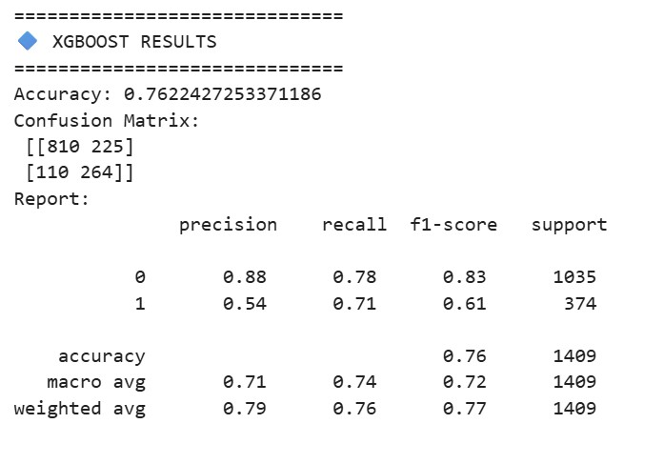

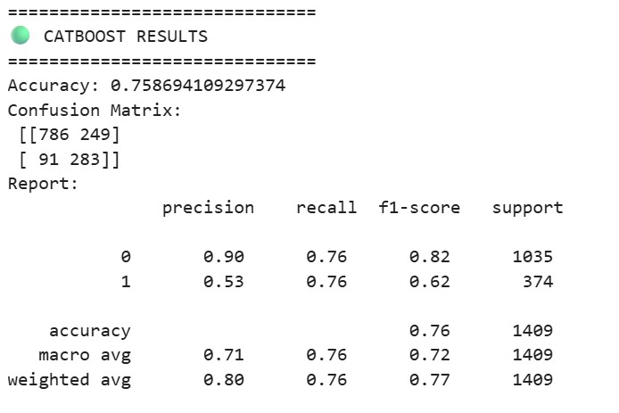

CHART OF DATASETS

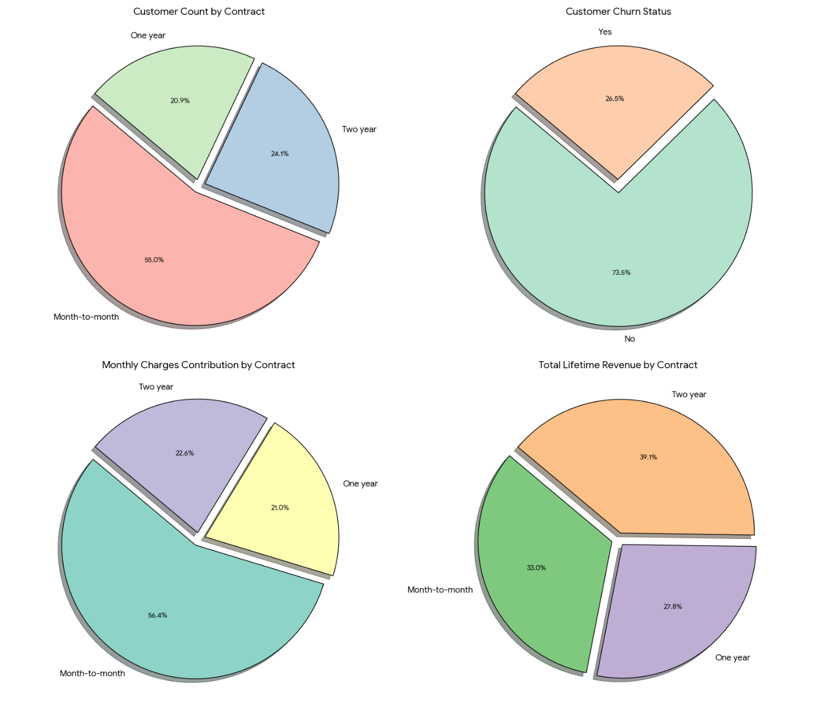

Fig 1 Chart of dataset column

CHURN STATUS

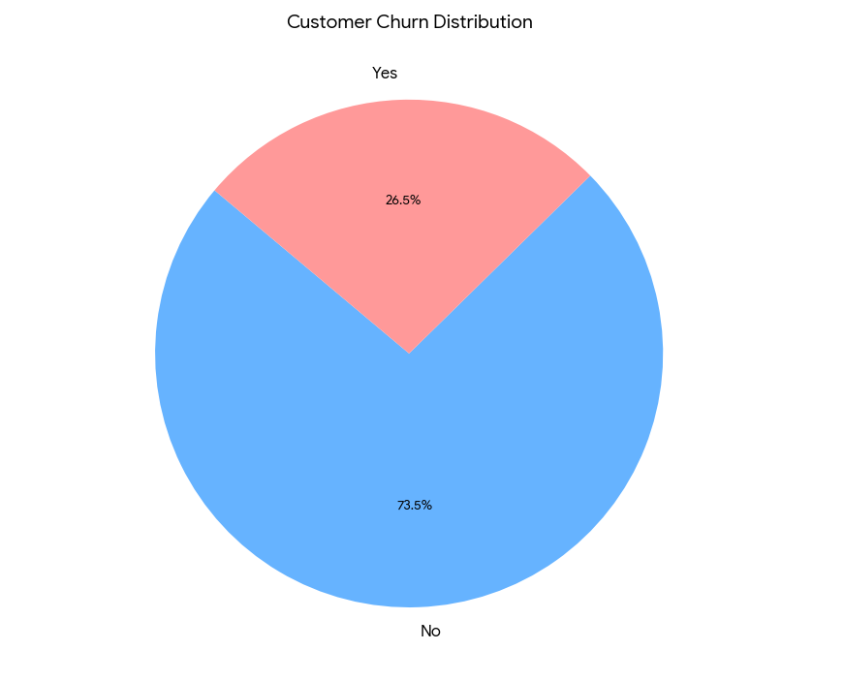
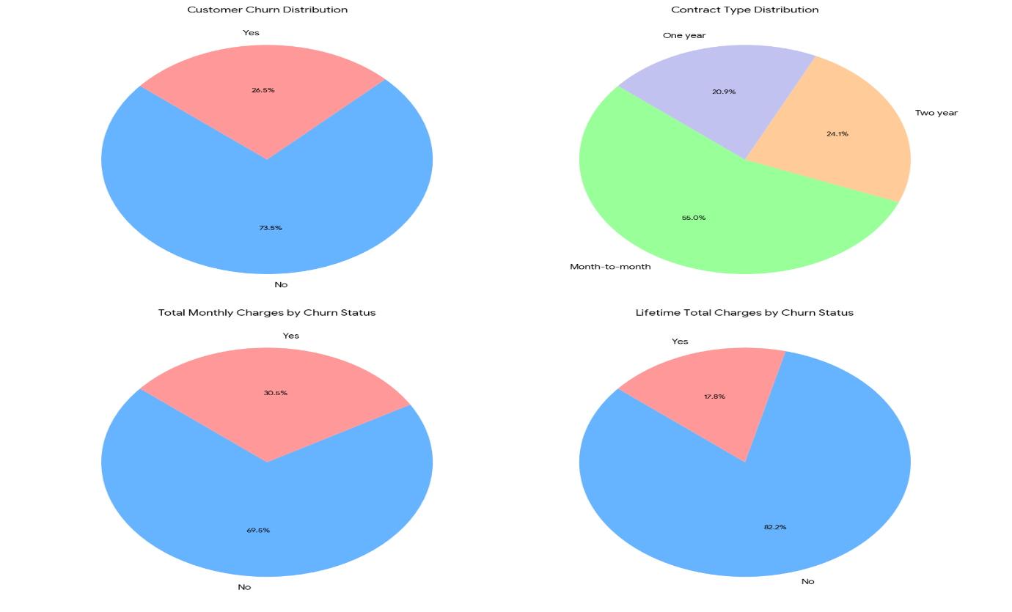
Fig 2 Churn Status

FUTURE SCOPE

The future of customer churn prediction is moving toward smarter, faster, and more personalized systems to help businesses keep their customers happy. Based on recent research, here is the future scope in simple terms:
1. Smarter Brains for AI (Advanced Modeling)
Current models are good, but the future will use even more "intelligent" tools:
- Deep Learning: Instead of basic formulas, companies will use advanced "Deep Learning" to find hidden patterns in how customers behave.
- Explainable AI: Future systems won't just say "this customer might leave"; they will explain why they are leaving so managers can fix the specific problem.
- Hybrid Models: Combining different types of AI to get the most accurate predictions possible.
2. Seeing the Future in Real-Time
Instead of looking at old data from last month, companies will react instantly:
- Live Monitoring: Systems will watch customer actions as they happen through "real-time data pipelines".
- Instant Alerts: If a customer shows signs of frustration, the system can provide a "live forecast" immediately.
- Automatic Cleaning: The software will automatically pull and clean data, so humans don't have to do the "boring" manual work.

CONCLUSION
Customer churn prediction has become an essential strategy for modern businesses aiming to sustain revenue, enhance customer satisfaction, and maintain long-term growth. As discussed throughout this study, customer attrition directly affects profitability, brand reputation, and competitive stability—especially in highly dynamic sectors such as telecommunications and financial services. The application of machine learning techniques such as Random Forest, Gradient Boosting, XGBoost, and CatBoost significantly improves the accuracy and efficiency of churn prediction compared to traditional statistical methods. Advanced models like XGBoost provide high predictive performance, handle large and imbalanced datasets effectively, and offer strong feature importance analysis. Similarly, CatBoost, developed by Yandex, is highly effective in managing categorical data and reducing overfitting, making it particularly suitable for real-world churn datasets. Models like CatBoost offer specialized advantages by automatically handling categorical features (such as gender and payment methods) and reducing the risk of overfitting This research demonstrates that predictive analytics enables organizations to proactively identify high-risk customers and implement targeted retention strategies such as personalized offers, improved service quality, and loyalty programs. Rather than reacting after customer loss, companies can now take preventive action based on data-driven insights. Furthermore, the future of churn prediction lies in integrating real-time analytics, deep learning models, hybrid ensemble approaches, and explainable AI systems. These advancements will enhance transparency, decision-making accuracy, and automation in customer relationship management systems.In conclusion, customer churn prediction using machine learning is not only a research-worthy domain but also a highly practical business solution. By leveraging intelligent predictive models, organizations can reduce revenue loss, retain high-value customers, strengthen customer relationships, and achieve sustainable competitive advantage in the evolving digital marketplace.

REFERENCES
- Yankai Wang, Advancements of Customer Churn in the Telecommunications and Financial Industries Based on Machine Learning
- Shiyang Li, Zelin Shen, Explainable Customer Churn Prediction Model Based on Deep Learning, 22 March 2024
- Roy Okonkwo and kuceli susan englama, AI – Enhanced Real -Time Customer Churn Prediction via Federated Learning for privacy-preserving and Optimized Marketing Decision, July 14, 2025
- Yixiang Zhang, Machine Learning- Based Prediction of Telecom Customer churn: Comparative Model Analysis
- Anurag Bhatnagar, Sumit Srivastava, Customer Churn Prediction using Machine Learning Approach: A Comprehensive Study, 22 Feb 2025
- Muteb Zarraq Alotaibi, Mohd Anul Haq, Customer Churn Prediction for Telecommunication Companies using Machine Learning and Ensemble Methods
- Mohammad Raquibul Hossain, Predicting Customer Churn in Telecommunications With Machine Learning Models, 06 Jan 2025
- Billa Varsha, Maddela Pranitha, Sallam Preetham, Customer Churn Rate Prediction Using Machine Learning, 4 April 2025
- Lavina Anand Parulekar and Sanika Abasaheb sardesai, Prajkta Shriram Jamsandekar and Sampada Sanjay parkar, Customer Churn Prediction, 3, March – 2024
- Meghana B K, Kumara N, Predictive Analytics For E- Commerce Customer Churn In India, 12, December 2025
- Prof. S. U. Mali, Mr. Sushant Bagul, Mr. Swarajsinh Shingan, Mr. Vijay Bande, Mr. Anuj Tannirwar, Customer Churn Prediction System, 10, May 2025
- Mohsin Ali and Manzoor Hussain, Machine Learning -Based Customer Churn Prediction for E-Commerce Businesses, 10 November 2025
- Arwa A. Jamjoom, The use of Knowledge extraction in prediction customer churn in B2B
- Glory Sam, Philip Asuquo, and Bliss Stephen, Customer Churn Prediction using Machine Learning Models, 06 Feb 2024
- Isiri p and Nikhil D, Customer Churn Prediction

