The Role of Medical Physicists in Combating Cancer in Nigeria: The Imperative for Advanced Training and Sponsorship

Abstract
Cancer remains a leading cause of mortality in Nigeria, exacerbated by a critical shortage of specialized healthcare professionals. Medical physicists play a pivotal role in the safe and effective delivery of radiotherapy and diagnostic imaging, yet Nigeria currently faces a deficit of over 400 certified professionals. This paper reviews the current status of medical physics in Nigeria, compares local staffing levels with international benchmarks, and argues for a national sponsorship framework to facilitate advanced clinical training and sub-specialization.
Keywords: Medical Physicists, low- and middle-income countries (LMICs), Directing treatment planning, complex dose calculations, treatment verification
1. Introduction
Cancer has emerged as a significant public health crisis in Nigeria, accounting for thousands of deaths annually. According to the World Health Organization (WHO, 2023), low- and middle-income countries (LMICs) face increasing incidence rates due to delayed diagnosis and inadequate treatment infrastructure.
Central to the oncology team is the Medical Physicist (MP). These professionals are responsible for the technical foundation of radiotherapy, ensuring that radiation doses are delivered precisely to tumors while sparing healthy tissue. Despite their importance, the number of certified medical physicists in Nigeria is alarmingly low, with fewer than 100 currently active in clinical settings. As noted by Agba (2023), this shortfall poses a direct threat to national cancer control strategies.
2. The Multi-Faceted Role of Medical Physicists
The contribution of medical physicists to the oncology workflow is categorized into five primary domains:
Radiotherapy Planning and Delivery: Directing treatment planning, complex dose calculations, and treatment verification (Obed et al., 2021).
Quality Assurance (QA): Calibration and performance testing of Linear Accelerators (LINACs), CT simulators, and brachytherapy units (IAEA, 2022).
Radiation Safety: Developing protocols to protect patients, staff, and the public from ionizing radiation (Adeyemi et al., 2020).
Research and Innovation: Advancing new treatment methodologies and protocols tailored to the local population.
Capacity Building: Training the next generation of residents and clinical interns.

3. Current Status of Medical Physics in Nigeria
Nigeria’s healthcare system currently operates far below the minimum requirements for medical physics staffing. For a population exceeding 200 million, the gap between current assets and WHO recommendations is stark.
Table 1: Comparative Analysis of Medical Physics Assets in Nigeria (2024)
Parameter | Nigeria (Current) | WHO/IAEA Recommended | Deficit/Gap
Certified Medical Physicists | 80 | 500+ | -420
Radiotherapy Centers | 16 | 1 per 500,000 people | ~384 Centers
Active LINAC Machines | 30 | >100 | >70
Accredited Training Centers | 2 | 6+ | 4
Source: Compiled from IAEA DIRAC Database (2024) and NAMP (2023).
The concentration of these professionals is also highly skewed toward a few federal institutions, leaving many tertiary hospitals without adequate coverage.
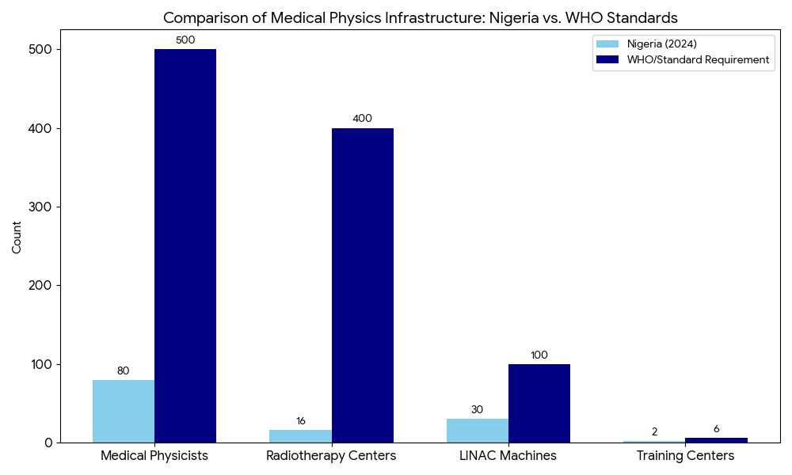
Key
Personnel Deficit: Nigeria currently has only about 16% of the certified medical physicists required for its population (80 active vs. 500 required).
Infrastructure Gap: The most critical shortage is in the number of Radiotherapy Centers; based on a recommendation of 1 center per 500,000 people, Nigeria requires approximately 400 centers but currently operates only 16.
Equipment Shortfall: There is a deficit of over 70 LINAC machines needed to reach the baseline of 100 machines for effective national cancer treatment.
Training Bottleneck: With only 2 fully accredited training centers, it is mathematically difficult to produce the 420 additional physicists needed without the sponsorship and expansion programs proposed in your paper.

Table 2: Institutional Distribution of Qualified Medical Physicists
Institution | Number of Physicists
National Hospital Abuja | 6
University College Hospital (UCH), Ibadan | 5
Ahmadu Bello University Teaching Hospital | 4
Others (30+ Tertiary Hospitals) | <30 (Total)
Source: IAEA DIRAC Database (2024), Nigerian Association of Medical Physicists (NAMP, 2024)
This shortage leads to: Delayed cancer treatment, Poor machine maintenance and higher breakdown rates, Burnout among existing professionals and Increased treatment risks and lower patient outcomes

4. International Comparisons
In countries like South Africa and Egypt, where training of medical physicists is prioritized, cancer care systems are more robust. For instance, South Africa has about 4.5 medical physicists per million people, while Nigeria lags behind with 0.3 per million (IAEA, 2023). When comparing Medical Physics scenarios around the world to Nigeria, similar themes emerge. There is a high number of patients and not enough MPs in most LINAC. There are few examples of countries with enough MPs to meet their workload demands.
In Nepal, as of 2018, there were 11 medical physicists working and five LINACs, three Cobalt Teletherapy, four Simulators, five HDR brachytherapy, one Orthovoltage, 18 MRI, 45 CT, over a thousand (1000+) x-ray, 12 Mammography, one PET and three Gamma Camera devices (Adhikari, 2018, Adhikari and Chaurasia 2016). According to their analysis, they need a minimum of twenty-five (25) Medical Physicists to manage their workload, more than double the current number.
In Cuba, as of 2014, there are 53 Medical Physicists working in Healthcare. This group is tasked with managing eight LINACs, 12 Cobalt Teletherapy, five HDR brachytherapy, three Superficial radiotherapy, 21 SPECT, two Nuclear Medicine therapy, two PET/CT,
over a thousand (1000+) X-ray units, 40 CT, 31 Mammography and 535 Ultrasound devices (Rosales and Laguardia 2015). Cuba is one of the few examples where the number of Medical Physicists is enough to meet the workload demand.

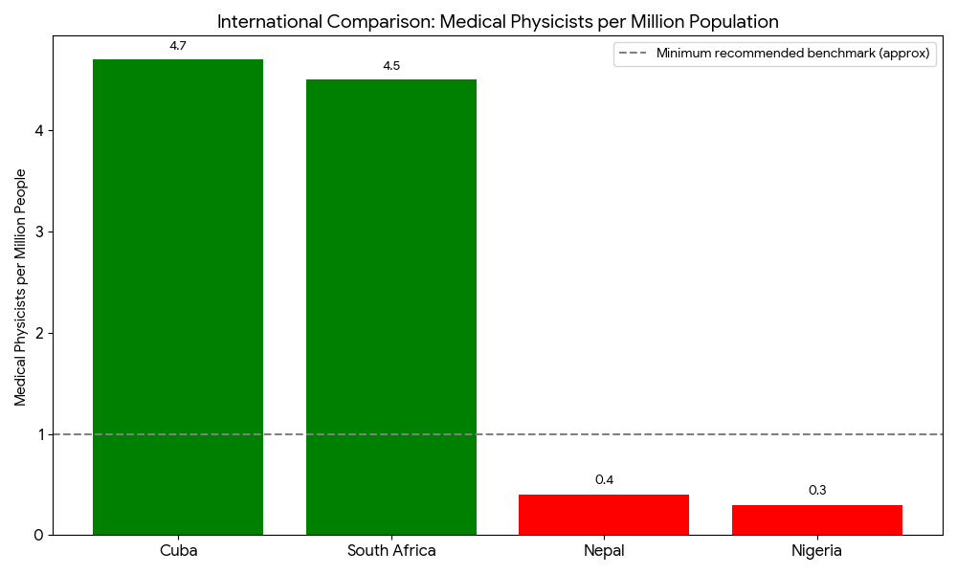
Key: Nigeria (0.3 per million) is significantly outperformed by Cuba (4.7) and South Africa (4.5). This visual helps justify your call for government intervention by showing that a robust cancer care system is directly correlated with higher physicist density.

5. Challenges and the Case for Sponsorship
The primary barriers to the growth of the profession in Nigeria include:
- High Cost of Training: Advanced training in sub-specialties (e.g., PET/CT optimization, Proton Therapy) often requires expensive overseas clinical residencies.
- Infrastructure Deficit: Outdated equipment limits the ability of physicists to practice modern techniques.
- Brain Drain: As J.K. (2024) noted, many talented physicists emigrate because they cannot afford the high costs of specialized postgraduate programs abroad.
To build a resilient health system, the CEFTER (World Bank African Center of Excellence) emphasizes that capacity development must be prioritized to meet international standards.
As Prof. E.H. Agba (Benue State University) and Dr. J.K (National Hospital Abuja) have emphasized in their works, these limitations hinder effective cancer treatment and call for urgent attention by policymakers.
According to Prof. Ikyo Barnabas, Center Leader of CEFTER (World Bank African Center of Excellence), capacity development is key to building resilient health systems that meet international standards.

The Case for Sponsorship
Advanced training of medical physicists is capital-intensive and usually requires overseas exposure, especially for sub-specialties like brachytherapy physics, PET/CT optimization, and proton therapy. Unfortunately, government scholarships or sponsored programs for these training opportunities remain rare in Nigeria.
As Dr. J.K emphasizes, “We lose many good brains because they cannot afford MSc or PhD programs abroad. A national sponsorship program will transform oncology services across the country” (J.K, 2024). Prof. Agba (2021) advocates for the establishment of regional training centers in Nigeria, in collaboration with the Federal Ministry of Health and tertiary institutions. Dr. J.K. also recommends compulsory internships for physics graduates in teaching hospitals equipped with radiotherapy units.
A robust cancer care system requires continuous training and development of medical physicists. Countries like South Africa, Egypt, and Ghana have established postgraduate programs with international partnerships (IAEA, 2021). Nigeria must urgently follow suit by:
- Sponsoring postgraduate fellowships and clinical residencies
- Equipping teaching hospitals with modern radiotherapy and imaging tools
- Engaging in international collaborations for research and exchange programs

Table 3: Clinical Impact of Medical Physicists on Cancer Outcomes
Core Responsibility | Clinical Description | Impact on Patient Outcome
Treatment Planning | Calculating and verifying 3D/IMRT dose delivery. | Maximizes tumor control while minimizing side effects.
Machine Calibration | Regular QA of LINACs and brachytherapy units. | Ensures safe, accurate, and reproducible radiation doses.
Radiation Safety | Protecting patients, staff, and the environment. | Reduces radiation accidents and institutional legal risks.
Imaging Optimization | Balancing image quality with radiation dose. | Improves early diagnosis and treatment tracking accuracy.
Research & Innovation | Developing new local protocols and devices. | Enhances overall survival rates through innovation.
Source: IAEA DIRAC Database (2024), Nigerian Association of Medical Physicists (NAMP, 2023)

The Need for Government-Sponsored Advanced Training
To address these challenges, there is an urgent need for government intervention in the training and certification of medical physicists. Key recommendations include:
- Establishment of Training Programs: Expanding postgraduate programs in medical physics beyond the University of Lagos to other institutions across the country.
- Certification and Regulation: Forming a national certifying body to standardize training and practice, reducing reliance on international agencies.
- Continuous Professional Development: Implementing programs for ongoing education to keep professionals abreast of technological advancements.
- Public-Private Partnerships: Encouraging collaborations to enhance infrastructure and training opportunities.​
These initiatives will not only enhance the quality of cancer care but also contribute to the development of a sustainable healthcare system.​
By sponsoring 100 medical physicists by 2030, Nigeria could:
- Ensure at least one qualified physicist per tertiary hospital
- Reduce machine downtimes
- Improve treatment outcomes and patient safety
- Build local training capacity
6. Strategic Recommendations
To bridge the current gap and ensure at least one qualified physicist per tertiary hospital by 2030, the Nigerian government and the National Universities Commission (NUC) should:
- Establish a National Certifying Body: Standardize local clinical training to reduce reliance on international certification.
- Fund Overseas Fellowships: Provide targeted scholarships for MSc/PhD and clinical residency programs in high-demand sub-specialties.
- Mandatory Internships: Implement a structured, paid internship program for physics graduates in accredited radiotherapy units.
- Policy Recognition: Formally recognize medical physicists as essential clinical staff with competitive remuneration to curb the "brain drain."
7. Conclusion
The fight against cancer in Nigeria cannot be won without the technical expertise of medical physicists. Investing in their training is not merely an academic exercise but a strategic healthcare necessity. Through government-led sponsorship and international collaboration, Nigeria can transform its oncology services and significantly improve patient outcomes.

Reference
Agba, P. O. (2023). Training gaps and radiotherapy service delivery in Nigeria. Benue State University Journal of Radiation Physics.
J.K, A. M. (2024). Interview on challenges of radiotherapy at the National Hospital. Abuja, Nigeria.
WHO (2023). Cancer Fact Sheet. World Health Organization.
IAEA (2022). Human Health Series: Medical Physics Staffing. Vienna: International Atomic Energy Agency.
Obed, R. I. (2021). Medical Physics in Africa: Challenges and Progress. Journal of Medical Physics and Applied Radiation.
Adeyemi, B., et al. (2020). Occupational radiation safety in Nigeria: The role of medical physicists. Nigerian Journal of Radiological Sciences.
NAMP (2023). Annual Report of the Nigerian Association of Medical Physicists. Abuja, Nigeria.
Adhikari, K. (2018). Medical Physics International, p. 3, 2018.
Adhikari M.P & Chaurasia P.P (2016). Status of Medical Physics professional development and education in Nepal p. 2
Obed, R. I. (2021). Medical Physics in Africa: Challenges and Progress. Journal of Medical Physics and Applied Radiation.

