Financial Technology and Bank Sustainability in Nigeria: Evidence from Efficiency, Financial Inclusion, and Dynamic Effects (2010–2024)

Abstract
This study examines the effect of financial technology (FinTech) adoption on the sustainability of deposit money banks in Nigeria over the period 2010–2024. Anchored on the Innovation–Stability Framework of Boot and Thakor (2019), the study investigates whether FinTech-driven channels improve bank sustainability directly and indirectly through operating efficiency and financial inclusion. Secondary data were obtained from the Central Bank of Nigeria, the Nigeria Inter-Bank Settlement System, the National Bureau of Statistics, and annual reports of selected banks. The study employs the Autoregressive Distributed Lag (ARDL) model to estimate short-run and long-run dynamics, while Structural Equation Modelling (SEM) is used to examine mediation effects. The findings confirm a long-run relationship between FinTech adoption and bank sustainability. Operating efficiency emerges as the strongest mediating channel and contributes positively to profitability and sustainability. By contrast, financial inclusion exerts a negative mediating effect, suggesting that rapid expansion without adequate risk management may strain bank resources. ATM and POS transactions show positive effects on efficiency and sustainability, whereas mobile banking produces mixed and largely negative outcomes. The study concludes that FinTech can support sustainable banking when supported by effective regulation, strong risk management, and adequate institutional capacity. It recommends policies aimed at improving digital literacy, strengthening cybersecurity, and deepening the regulatory framework for FinTech development in Nigeria.

Keywords: Financial technology, Bank sustainability, Efficiency, Financial inclusion, Nigeria, ARDL, SEM.

1.0 Introduction
1.1 Background to the Study
The global banking sector has undergone profound transformation in the last decade, driven largely by the rapid evolution and adoption of financial technology (FinTech). FinTech encompasses a wide range of digital innovations—including mobile banking, electronic payments, point-of-sale (POS) systems, and automated teller machines (ATMs)—that have fundamentally altered the delivery, accessibility, and efficiency of financial services (Alshater et al., 2022; Feyen et al., 2021). These technologies have not only enhanced transaction speed and reduced operational costs but have also redefined competitive dynamics within the banking industry by enabling new service models and customer engagement channels.
In developing economies such as Nigeria, FinTech adoption has been particularly significant due to persistent challenges related to financial exclusion, high transaction costs, and inefficiencies in traditional banking systems. As a result, policymakers and financial institutions increasingly view FinTech as a strategic tool for expanding financial inclusion, improving operational efficiency, and strengthening the long-term sustainability of deposit money banks (Efuntade & Okoye, 2024; Ozili, 2025). Empirical evidence suggests that digital financial services can enhance access to formal financial systems, especially among underserved populations, while also improving the scalability of banking operations (Agyekum et al., 2022; Song et al., 2025). However, despite these potential benefits, FinTech adoption introduces new risks, including cybersecurity threats, operational vulnerabilities, regulatory complexities, and potential instability within financial systems (Bonaccorsi et al., 2024; IMF, 2023).
Nigeria presents a compelling context for examining these dynamics. Through initiatives such as the National Financial Inclusion Strategy and regulatory innovations like sandbox frameworks and open banking policies, the Central Bank of Nigeria has actively promoted digital financial innovation (CBN, 2021a, 2021b). Consequently, there has been substantial growth in mobile money usage, POS transactions, and other digital banking platforms, contributing to increased financial access, particularly in rural and previously excluded segments of the population (EFInA, 2023; Ogunleye et al., 2022). Nonetheless, the extent to which these technological advancements translate into sustained improvements in bank performance and resilience remains uncertain.
Notably, while ATM and POS channels have been associated with improvements in operational efficiency and service delivery, mobile banking has exhibited more inconsistent outcomes due to infrastructural limitations, network inefficiencies, and heightened exposure to cyber risks (Adeoye & Osabuohien, 2022; Uche & Nwankwo, 2023). These mixed outcomes highlight the complexity of FinTech’s role in banking systems and underscore the need for a more nuanced understanding of its impact on sustainability.
These observations align with the Innovation–Stability Framework, which posits that financial innovation simultaneously generates efficiency gains and introduces new sources of risk within the financial system (Boot & Thakor, 2019). In contexts such as Nigeria—characterized by evolving regulatory frameworks, infrastructural constraints, and uneven institutional capacity—FinTech adoption may either enhance or undermine bank sustainability depending on how effectively associated risks are managed. Moreover, while financial inclusion is widely regarded as beneficial, recent studies suggest that rapid expansion without adequate institutional safeguards may exert short-term pressure on bank profitability and risk management systems (Okorie & Lin, 2021; Oyewole et al., 2023).
Against this backdrop, this study examines the relationship between FinTech adoption and the sustainability of deposit money banks in Nigeria over the period 2010–2024. Specifically, it adopts an integrated Autoregressive Distributed Lag (ARDL) and Structural Equation Modelling (SEM) framework to analyse both the dynamic (short-run and long-run) effects of FinTech adoption and the mediating roles of operating efficiency and financial inclusion in shaping sustainability outcomes.

1.2 Statement of the Problem
The rapid adoption of financial technology in Nigeria has significantly transformed the operational landscape of deposit money banks, particularly through channels such as mobile banking, automated teller machines, and point-of-sale systems. These innovations are widely expected to enhance efficiency, deepen financial inclusion, and improve the long-term sustainability of banking institutions (Alshater et al., 2022; Dlamini & Mbatha, 2023). However, despite these expectations, the actual impact of FinTech adoption on bank sustainability remains inconclusive and, in some cases, contradictory.
Existing empirical evidence presents a mixed picture. While some studies indicate that digital banking channels—particularly ATM and POS systems—contribute positively to operational efficiency and service delivery, others highlight the inconsistent performance of mobile banking due to infrastructural deficiencies, cybersecurity risks, and uneven user adoption (Adeoye & Osabuohien, 2022; Uche & Nwankwo, 2023). Furthermore, although financial inclusion is often viewed as a key outcome of FinTech development, its rapid expansion may impose short-term costs on banks, including increased operational expenses, heightened credit risk, and challenges in managing newly onboarded customers (Ozili, 2025; Agyekum et al., 2022).
These challenges are particularly pronounced in Nigeria, where structural constraints such as inadequate digital infrastructure, regulatory gaps, limited cybersecurity capacity, and low levels of financial literacy may influence the effectiveness of FinTech adoption. Consequently, the relationship between FinTech and bank sustainability is likely to be conditional rather than universally positive, depending on the interplay between technological innovation, institutional capacity, and risk management frameworks (Bonaccorsi et al., 2024; IMF, 2023).
Moreover, there is a notable gap in the existing literature regarding the mechanisms through which FinTech affects bank sustainability. While prior studies have largely focused on direct relationships, limited attention has been given to the mediating roles of operating efficiency and financial inclusion, as well as to the dynamic nature of these relationships over time. In particular, there is insufficient empirical evidence that simultaneously captures both short-run adjustments and long-run equilibrium effects within a unified analytical framework.
This gap has important implications for both policy and practice. Without a clear understanding of how FinTech adoption influences bank sustainability—both directly and indirectly—regulators and financial institutions may be unable to design effective strategies that balance innovation with stability. Accordingly, this study seeks to address this gap by examining the direct, indirect, and dynamic effects of FinTech adoption on the sustainability of deposit money banks in Nigeria.

1.3 Research Questions
In line with the conceptual and empirical gaps identified, this study is guided by the following research questions:
i. How does FinTech adoption—measured through mobile banking, automated teller machines (ATMs), and point-of-sale (POS) transactions—affect the sustainability of deposit money banks in Nigeria?
ii. To what extent do operating efficiency and financial inclusion mediate the relationship between FinTech adoption and bank sustainability?
iii. What are the short-run and long-run dynamic effects of FinTech adoption on the sustainability of deposit money banks in Nigeria?
iv. Under what institutional and operational conditions does FinTech adoption enhance or constrain bank sustainability in Nigeria?

1.4 Research Objectives
The main objective of this study is to examine the relationship between FinTech adoption and the sustainability of deposit money banks in Nigeria within a dynamic and structural framework.
The specific objectives are to:
i. Examine the effect of FinTech adoption—proxied by mobile banking, ATM transactions, and POS transactions—on the sustainability of deposit money banks in Nigeria.
ii. Assess the mediating roles of operating efficiency and financial inclusion in transmitting the effects of FinTech adoption to bank sustainability.
iii. Analyse the short-run and long-run dynamics of the relationship between FinTech adoption and bank sustainability using an integrated ARDL–SEM approach.
iv. Evaluate the institutional and operational conditions under which FinTech adoption contributes to or constrains sustainable banking outcomes in Nigeria.
1.5 Scope of the Study
This study examines the relationship between financial technology (FinTech) adoption and the sustainability of deposit money banks in Nigeria within a structured and dynamic analytical framework. Specifically, FinTech adoption is proxied by three major digital banking channels—mobile banking, automated teller machine (ATM) transactions, and point-of-sale (POS) transactions—reflecting the dominant modes of digital financial intermediation in the Nigerian banking sector (Efuntade & Okoye, 2024; Ogunleye et al., 2022). Bank sustainability is measured primarily using return on equity (ROE), which captures profitability and long-term financial viability.
To provide deeper analytical insight, the study incorporates operating efficiency and financial inclusion as mediating variables. Operating efficiency reflects the cost and productivity implications of FinTech adoption, while financial inclusion captures the extent to which digital financial services expand access to banking services among previously underserved populations (Agyekum et al., 2022; Ozili, 2025). This structure allows the study to move beyond direct relationships and examine the mechanisms through which FinTech influences bank sustainability.
The study covers the period from 2010 to 2024, a timeframe that corresponds with the rapid expansion of Nigeria’s FinTech ecosystem, including the growth of mobile banking platforms, POS infrastructure, and digital payment systems. Geographically, the study is limited to Nigeria, given its unique institutional, regulatory, and infrastructural characteristics that shape FinTech outcomes.
Methodologically, the study adopts a quantitative research design, integrating the Autoregressive Distributed Lag (ARDL) model and Structural Equation Modelling (SEM). The ARDL approach is employed to analyse short-run and long-run dynamics, while SEM is used to examine mediation effects and structural relationships among variables. Secondary data are sourced from credible institutions, including the Central Bank of Nigeria (CBN), the Nigeria Inter-Bank Settlement System (NIBSS), the National Bureau of Statistics (NBS), and international databases such as the World Bank and EFInA. This combination of scope, variables, and methods ensures a comprehensive assessment of both the dynamic and structural dimensions of FinTech adoption and bank sustainability.
1.6 Significance of the Study
This study is significant at the theoretical, empirical, and practical levels, particularly within the context of emerging economies where FinTech adoption is rapidly evolving. From a theoretical perspective, the study contributes to the growing literature on financial technology and banking sustainability by extending the application of the Innovation–Stability Framework to the Nigerian context. By integrating mediating variables such as operating efficiency and financial inclusion, the study provides a more nuanced understanding of how FinTech generates both efficiency gains and potential stability risks within banking systems (Alshater et al., 2022; Bonaccorsi et al., 2024). It also advances existing discourse by highlighting the conditional nature of FinTech outcomes in environments characterized by infrastructural and institutional constraints.
Empirically, the study makes a methodological contribution by combining ARDL and Structural Equation Modelling (SEM) within a single analytical framework. This integrated approach enables the simultaneous examination of short-run adjustments, long-run equilibrium relationships, and indirect (mediated) effects—an approach that remains relatively underexplored in FinTech–banking studies, particularly in developing economies (Oyewole et al., 2023; Dlamini & Mbatha, 2023). By doing so, the study provides more robust and comprehensive evidence on the dynamics of FinTech adoption and bank sustainability.
Practically, the findings of this study are relevant to policymakers, financial regulators, and banking institutions. For regulators such as the Central Bank of Nigeria and the Nigeria Deposit Insurance Corporation, the study offers evidence-based insights into how digital financial innovation can be effectively managed to balance financial inclusion with financial stability. It underscores the importance of strengthening regulatory frameworks, cybersecurity systems, and institutional capacity to support sustainable FinTech growth (IMF, 2023; EFInA, 2023).
For banks, the study provides strategic guidance on optimizing FinTech investments by identifying the channels and mechanisms that most effectively enhance sustainability. It highlights the need for aligning digital innovation with risk management practices and operational efficiency improvements. Furthermore, the study contributes to broader development discourse by demonstrating how responsible FinTech adoption can support inclusive economic growth and infrastructure development, in line with Sustainable Development Goals such as SDG 8 (Decent Work and Economic Growth) and SDG 9 (Industry, Innovation, and Infrastructure).
Overall, this study bridges critical gaps between theory, empirical analysis, and policy application, offering a comprehensive framework for understanding the complex relationship between FinTech adoption and bank sustainability in Nigeria.
2.0 Literature Review
2.1 Conceptual Framework
2.1.1 Conceptual Framework for FinTech Adoption and Bank Sustainability
The conceptual framework of this study provides a structured representation of the relationships among financial technology (FinTech) adoption, mediating mechanisms, and the sustainability of deposit money banks in Nigeria. It is designed to capture both the direct and indirect pathways through which digital financial innovations influence bank performance within a dynamic and institutionally constrained environment.
At the core of the framework is FinTech adoption, conceptualized as the integration and utilization of digital financial service channels within banking operations. In this study, FinTech adoption is operationalized through three dominant and widely observable indicators in the Nigerian context: mobile banking, automated teller machine (ATM) transactions, and point-of-sale (POS) transactions. These channels represent key interfaces through which banks deliver services, interact with customers, and optimize operational processes (Efuntade & Okoye, 2024; Feyen et al., 2021). The selection of these indicators reflects both their empirical relevance and their significant contribution to the evolution of Nigeria’s digital financial ecosystem.
The dependent construct in the framework is bank sustainability, which is conceptualized as the ability of banks to maintain long-term financial viability, profitability, and resilience in the face of evolving technological and institutional conditions. In line with conventional banking literature, sustainability is proxied by financial performance indicators—particularly return on equity (ROE)—which captures the efficiency with which banks generate returns for shareholders while maintaining operational stability (Chao et al., 2024; Adu et al., 2024). This financial perspective is complemented by a broader understanding of sustainability that incorporates resilience, risk management, and adaptability to innovation-driven disruptions.
A key contribution of this framework lies in its emphasis on mediating mechanisms, which explain how FinTech adoption translates into sustainability outcomes. Two primary mediators are identified: operating efficiency and financial inclusion.
Operating efficiency reflects the extent to which banks are able to optimize resource utilization, reduce transaction costs, and improve service delivery through digitalization. FinTech adoption is expected to enhance efficiency by automating processes, reducing reliance on physical infrastructure, and enabling faster and more accurate transactions (Bueno et al., 2024; Elmahdy & Hassan, 2025). Improved efficiency, in turn, is hypothesized to strengthen bank profitability and sustainability, making it a critical transmission channel between innovation and performance.
In contrast, financial inclusion represents the expansion of access to and usage of formal financial services among previously underserved populations. FinTech has been widely recognized as a driver of inclusion by lowering entry barriers, enabling digital payments, and extending financial services to remote areas (Ozili, 2025; Song et al., 2025). However, the relationship between financial inclusion and bank sustainability is not unambiguously positive. While increased inclusion can expand customer bases and deposit mobilization, it may also introduce short-term pressures on profitability due to higher operational costs, increased credit risk, and the need for enhanced consumer protection mechanisms (Agyekum et al., 2022). Thus, financial inclusion functions as a dual-effect mediator, capable of both enhancing and constraining sustainability outcomes.
Beyond mediation, the framework acknowledges the importance of contextual (moderating) conditions, particularly regulatory environment and cybersecurity capacity, which shape the effectiveness of FinTech adoption. A robust regulatory framework can facilitate innovation while ensuring financial stability through mechanisms such as regulatory sandboxes, open banking policies, and prudential oversight (CBN, 2021a, 2021b). Similarly, strong cybersecurity infrastructure is essential for mitigating risks associated with digital transactions, including fraud, data breaches, and system vulnerabilities (IMF, 2023; Bonaccorsi et al., 2024). In environments where these institutional safeguards are weak, the benefits of FinTech adoption may be undermined, leading to adverse outcomes for bank sustainability.
Importantly, the conceptual framework is inherently dynamic, recognizing that the effects of FinTech adoption are not static but evolve over time. Short-run impacts may differ significantly from long-run outcomes due to adjustment costs, learning effects, and infrastructural constraints. This temporal dimension justifies the integration of econometric techniques capable of capturing both immediate and equilibrium relationships, as reflected in the study’s ARDL–SEM methodological approach (Oyewole et al., 2023).
Overall, the framework presents FinTech adoption as a multidimensional and conditional driver of bank sustainability, operating through efficiency gains and inclusion expansion, while being shaped by institutional and technological constraints. It moves beyond simplistic linear assumptions by incorporating mediation, conditionality, and dynamic interactions, thereby providing a comprehensive basis for empirical investigation in the Nigerian banking context.
2.1.2 Analytical Synthesis of the Conceptual Relationships
Synthesizing the relationships within the framework, three core propositions emerge.
First, FinTech adoption is expected to exert a direct influence on bank sustainability by enhancing service delivery, reducing operational frictions, and improving customer engagement. However, this effect is likely to vary across different FinTech channels, reflecting differences in infrastructure requirements, user adoption patterns, and associated risks.
Second, the impact of FinTech adoption is primarily transmitted through operating efficiency, which serves as the dominant pathway linking innovation to profitability and sustainability. This aligns with recent empirical findings that identify efficiency gains as the most consistent benefit of digital transformation in banking systems (Elmahdy & Hassan, 2025; Dlamini & Mbatha, 2023).
Third, financial inclusion introduces a trade-off dimension, whereby expansion in access to financial services may generate both long-term benefits and short-term costs. This highlights the importance of sequencing and managing inclusion strategies within a risk-aware institutional framework.
Collectively, these relationships underscore the central argument of the study: FinTech adoption does not automatically guarantee bank sustainability; rather, its outcomes are mediated, conditional, and context-dependent. This perspective provides a more realistic and policy-relevant understanding of digital transformation in emerging banking systems.
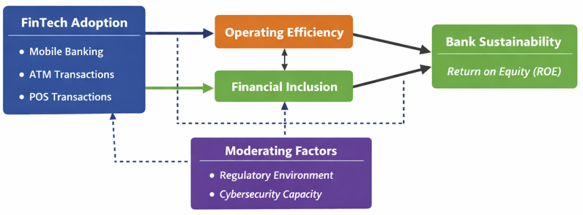
Figure 1: Conceptual Framework for FinTech Adoption and Bank Sustainability in Nigeria
Source: Author’s conceptualization (2026), based on the Innovation–Stability Framework of Boot and Thakor (2019) and recent empirical literature on FinTech, efficiency, and financial inclusion (Alshater et al., 2022; Bonaccorsi et al., 2024; Ozili, 2025).
Explanatory Note on the Conceptual Framework
The conceptual framework illustrates the structural relationships between financial technology (FinTech) adoption and the sustainability of deposit money banks in Nigeria, emphasizing both the direct and indirect pathways through which digital innovation influences banking outcomes. At the core of the framework is FinTech adoption, operationalized through key digital banking channels—mobile banking, automated teller machine (ATM) transactions, and point-of-sale (POS) transactions—which represent the primary mechanisms through which banks deploy technology to deliver financial services.
The framework posits that FinTech adoption exerts both direct and indirect effects on bank sustainability, with sustainability primarily captured through financial performance indicators such as return on equity (ROE). However, rather than assuming a simple linear relationship, the framework recognizes that the impact of FinTech is transmitted through critical mediating mechanisms, notably operating efficiency and financial inclusion.
Operating efficiency represents the internal performance channel through which FinTech enhances bank sustainability. The adoption of digital technologies is expected to streamline banking operations by reducing transaction costs, automating processes, and improving service delivery speed and accuracy. These efficiency gains contribute directly to improved profitability and long-term viability, making operating efficiency the most significant pathway linking innovation to sustainability.
In contrast, financial inclusion reflects the external expansion channel of FinTech adoption. By extending financial services to previously underserved populations, FinTech increases access, usage, and participation in the formal financial system. While this expansion can enhance market reach and deposit mobilization, the framework acknowledges that rapid inclusion may also introduce short-term pressures on bank performance due to increased operational costs, heightened credit risk, and the need for enhanced consumer protection mechanisms. Thus, financial inclusion is conceptualized as a dual-effect mediator, capable of both strengthening and constraining sustainability outcomes.
The framework further incorporates moderating factors—specifically the regulatory environment and cybersecurity capacity—which condition the strength and direction of the relationships among the core variables. A robust regulatory framework supports innovation while maintaining financial stability through mechanisms such as regulatory sandboxes, prudential oversight, and digital finance policies. Similarly, strong cybersecurity infrastructure is essential for safeguarding digital transactions, maintaining consumer trust, and mitigating operational risks. In the absence of these institutional safeguards, the potential benefits of FinTech adoption may be undermined.
Additionally, the framework reflects the dynamic nature of the FinTech–sustainability relationship. The effects of digital innovation are not instantaneous but evolve over time, with short-term adjustment costs potentially differing from long-term efficiency gains. This dynamic perspective justifies the use of analytical approaches capable of capturing both temporal and structural relationships.
Overall, the conceptual framework presents FinTech adoption as a multidimensional and context-dependent driver of bank sustainability. It highlights that the outcomes of digital transformation are not automatic but are mediated by internal efficiency gains and external inclusion effects, while being conditioned by institutional and technological environments. This integrated perspective provides a comprehensive basis for empirical investigation and policy analysis within the Nigerian banking context.
2.2 Theoretical Review
The theoretical foundation of this study is anchored in the Innovation–Stability paradigm, which provides a robust lens for understanding the dual and often contradictory effects of financial technology (FinTech) on banking systems. Contemporary financial intermediation theory increasingly recognizes that innovation in financial services particularly digital innovation does not produce uniformly positive outcomes; rather, it simultaneously generates efficiency gains while introducing new dimensions of risk and instability (Boot & Thakor, 2019; Alshater et al., 2022). This duality is particularly pronounced in emerging economies, where institutional capacity, regulatory frameworks, and technological infrastructure are still evolving.
Recent theoretical and empirical developments have extended this perspective by emphasizing that FinTech fundamentally reshapes the traditional functions of financial intermediation. Digital platforms reduce information asymmetry, lower transaction costs, and enhance access to financial services, thereby improving allocative efficiency and expanding financial inclusion (Feyen et al., 2021; Ozili, 2025). At the same time, these technologies introduce new operational complexities, including cybersecurity vulnerabilities, platform risks, and regulatory challenges, which may undermine financial stability if not properly managed (IMF, 2023; Bonaccorsi et al., 2024). Thus, innovation is not inherently stabilizing or destabilizing; its net effect depends on the interaction between technological advancement and institutional preparedness.
Within this evolving theoretical landscape, the relationship between FinTech adoption and bank sustainability is best understood as a mediated and conditional process, rather than a direct linear relationship. The Innovation–Stability perspective suggests that the benefits of digital transformation are transmitted through internal efficiency improvements and market expansion mechanisms, while the associated risks emerge from weak governance, inadequate risk management, and regulatory gaps. This aligns with recent theoretical extensions that highlight the importance of intermediate channels—particularly operating efficiency and financial inclusion—in shaping the outcomes of financial innovation (Elmahdy & Hassan, 2025; Dlamini & Mbatha, 2023).
Operating efficiency occupies a central position in this theoretical framework as the primary mechanism through which FinTech enhances bank performance. Digital technologies enable process automation, reduce reliance on physical infrastructure, and improve transaction speed and accuracy, thereby lowering operational costs and increasing productivity (Bueno et al., 2024). From a theoretical standpoint, these efficiency gains strengthen the profit-generating capacity of banks and enhance their resilience to external shocks, making operating efficiency a key conduit linking innovation to sustainability. This perspective is consistent with modern efficiency-based theories of banking, which emphasize cost minimization and optimal resource allocation as drivers of long-term financial performance.
In contrast, financial inclusion introduces a more complex and ambivalent dimension to the theoretical relationship. While traditional development finance theory posits that broader access to financial services promotes economic growth and financial deepening, recent scholarship suggests that rapid inclusion may impose short-term burdens on financial institutions, particularly in contexts with weak institutional support (Agyekum et al., 2022; Ozili, 2025). The onboarding of previously unbanked populations often requires significant investment in infrastructure, customer education, and risk assessment systems, which may temporarily reduce profitability and increase exposure to credit and operational risks. This creates a theoretical tension in which financial inclusion functions as both a growth-enhancing and risk-inducing mechanism, reinforcing the non-linear nature of the FinTech–sustainability relationship.
Furthermore, contemporary theoretical discourse emphasizes the role of institutional and regulatory conditions in moderating the impact of financial innovation. Effective regulation, including frameworks for open banking, regulatory sandboxes, and digital risk management, can enhance the positive effects of FinTech while mitigating its associated risks (CBN, 2021a, 2021b; Bonaccorsi et al., 2024). Similarly, strong cybersecurity infrastructure is essential for maintaining trust in digital financial systems and preventing systemic vulnerabilities arising from cyber threats (IMF, 2023). In environments where these institutional safeguards are weak or underdeveloped, the destabilizing effects of innovation may outweigh its efficiency benefits.
In the context of Nigeria, these theoretical considerations are particularly salient. The rapid expansion of digital financial services has occurred alongside persistent infrastructural challenges, regulatory adjustments, and varying levels of digital literacy. As a result, the impact of FinTech adoption on bank sustainability is likely to be heterogeneous across channels and over time. For instance, while ATM and POS systems may generate relatively stable efficiency gains due to their established infrastructure, mobile banking may exhibit more volatile outcomes due to its dependence on network reliability and cybersecurity resilience. This heterogeneity underscores the importance of adopting a theoretical framework that accommodates both variation and conditionality.
Importantly, the dynamic nature of the Innovation–Stability relationship necessitates a temporal perspective in analysis. Theoretical models increasingly recognize that the effects of financial innovation unfold over time, with short-run adjustment costs potentially offsetting long-run efficiency gains (Oyewole et al., 2023). This dynamic dimension justifies the use of econometric approaches capable of capturing both short-run and long-run relationships, as well as structural interdependencies among variables.
The theoretical framework underpinning this study advances a nuanced understanding of FinTech adoption as a multidimensional and context-dependent phenomenon. It posits that bank sustainability is not determined solely by the presence of digital innovation, but by the pathways through which innovation is implemented, the institutional environment within which it operates, and the dynamic adjustments that occur over time. By integrating efficiency, inclusion, and institutional factors within a unified analytical structure, this framework provides a coherent basis for examining the complex interplay between FinTech adoption and banking sustainability in Nigeria.
2.3 Empirical Review
Empirical literature on financial technology (FinTech) and banking performance has expanded rapidly in recent years, reflecting the growing importance of digital transformation in financial intermediation. Across both developed and developing economies, studies consistently demonstrate that FinTech adoption has the potential to enhance operational efficiency, expand financial inclusion, and improve bank performance. However, the empirical evidence remains far from unanimous, with outcomes varying significantly depending on institutional quality, technological infrastructure, and the specific channels of FinTech adoption.
In advanced economies, empirical findings generally support the efficiency-enhancing role of FinTech, particularly in improving cost structures, service delivery, and competitive positioning. Studies show that digital banking platforms and payment innovations reduce transaction costs and improve resource allocation, thereby strengthening bank profitability and resilience (Alshater et al., 2022; Feyen et al., 2021). Nonetheless, even in these contexts, evidence suggests that increased reliance on digital systems introduces new forms of systemic risk, including operational vulnerabilities and cybersecurity threats, which may amplify financial instability during periods of economic stress (Dandapani & Karels, 2024; IMF, 2023). This reinforces the notion that the benefits of FinTech are contingent on strong regulatory oversight and technological safeguards.
In emerging and developing economies, the empirical narrative is more nuanced and often contradictory. While FinTech adoption has been widely associated with improvements in financial inclusion and access to banking services, its impact on bank sustainability and profitability is less consistent. For instance, studies in African and Asian contexts indicate that digital financial services, particularly mobile payments and POS systems, significantly expand financial access but may impose short-term operational and investment costs on banks (Agyekum et al., 2022; Nguyen et al., 2021). Similarly, evidence from countries such as India and Vietnam suggests that while FinTech enhances customer reach and transaction volumes, smaller or less technologically advanced banks may experience efficiency losses due to high implementation costs and infrastructural constraints (Prasad & Rahman, 2022; Nguyen et al., 2021).
A recurring theme in the empirical literature is the differentiated impact of various FinTech channels. ATM and POS technologies are often associated with relatively stable and positive effects on operational efficiency and service delivery, owing to their maturity and established infrastructure. In contrast, mobile banking tends to exhibit more volatile outcomes, with its effectiveness heavily dependent on network reliability, user literacy, and cybersecurity capacity (Dlamini & Mbatha, 2023; Adeoye & Osabuohien, 2022). This channel-specific heterogeneity highlights the importance of disaggregating FinTech adoption in empirical analysis rather than treating it as a homogeneous construct.
Within the Nigerian context, empirical studies reflect similar patterns of mixed and context-dependent outcomes. Research indicates that the expansion of POS and ATM networks has contributed positively to financial inclusion and operational efficiency, supporting broader financial deepening in the economy (Ogunleye et al., 2022; Efuntade & Okoye, 2024). At the same time, mobile banking has been associated with inconsistent performance outcomes, largely due to infrastructural challenges, cybersecurity risks, and varying levels of digital literacy among users (Adeoye & Osabuohien, 2022; Uche & Nwankwo, 2023). These findings suggest that while FinTech adoption has facilitated access to financial services, its contribution to bank sustainability is not uniformly positive.
Another important strand of empirical literature focuses on the role of financial inclusion as an outcome of FinTech adoption. While increased inclusion is generally associated with expanded customer bases and higher transaction volumes, several studies highlight the potential trade-offs involved. In particular, rapid inclusion may strain bank resources by increasing operational costs, exposing banks to higher credit risks, and necessitating greater investment in customer education and risk management systems (Ozili, 2025; Agyekum et al., 2022). Empirical evidence from Nigeria supports this view, showing that while financial inclusion improves access to financial services, its immediate impact on bank profitability may be negative or insignificant, especially in the absence of strong institutional frameworks (Okorie & Lin, 2021; Oyewole et al., 2023).
Closely related to this is the emerging empirical focus on operating efficiency as a key transmission mechanism between FinTech adoption and bank performance. Studies consistently find that efficiency improvements—manifested through reduced costs, faster service delivery, and improved process automation—serve as the primary channel through which FinTech enhances profitability and sustainability (Elmahdy & Hassan, 2025; Bueno et al., 2024). In this regard, efficiency gains appear to be more robust and consistent than the effects of financial inclusion, reinforcing their central role in the FinTech–sustainability nexus.
Despite these advances, the empirical literature reveals several important gaps. First, many studies focus on direct relationships between FinTech adoption and bank performance, with limited attention to the mediating roles of operating efficiency and financial inclusion. This omission restricts a deeper understanding of the mechanisms through which digital innovation affects sustainability outcomes. Second, existing studies often rely on static analytical approaches, such as cross-sectional or panel regressions, which fail to capture the dynamic nature of FinTech adoption and its evolving impact over time. Consequently, the distinction between short-run adjustment effects and long-run equilibrium relationships remains underexplored.
Third, there is a lack of integrated methodological frameworks that simultaneously account for both structural relationships and time-series dynamics. While some studies employ econometric techniques such as Autoregressive Distributed Lag (ARDL) models to examine long-run relationships, others utilize Structural Equation Modelling (SEM) to analyse mediation effects, but few combine these approaches within a unified framework. This fragmentation limits the comprehensiveness of empirical insights into the FinTech–bank sustainability relationship.
Furthermore, the moderating role of institutional factors—such as regulatory quality and cybersecurity capacity—remains insufficiently examined in empirical studies, particularly in developing economies. Given that the effectiveness of FinTech adoption is highly dependent on these contextual conditions, their exclusion represents a critical limitation in the literature (Bonaccorsi et al., 2024; IMF, 2023).
In light of these gaps, this study contributes to the empirical literature by adopting an integrated ARDL–SEM approach to simultaneously examine the direct, indirect, and dynamic effects of FinTech adoption on bank sustainability in Nigeria. By explicitly incorporating operating efficiency and financial inclusion as mediating variables, and by capturing both short-run and long-run relationships, the study provides a more comprehensive and contextually grounded understanding of how FinTech shapes banking outcomes. In doing so, it advances existing empirical research by moving beyond simplistic linear models and offering a multidimensional analysis that reflects the complex realities of digital transformation in emerging financial systems.
3.0 Methodology
3.1 Research Design
This study adopts a quantitative, explanatory research design to investigate the relationship between financial technology (FinTech) adoption and the sustainability of deposit money banks in Nigeria. The explanatory design is appropriate as it enables the identification and estimation of causal relationships among variables, particularly in contexts where theoretical propositions require empirical validation (Saunders et al., 2023). Given the study’s focus on both direct and mediated relationships, as well as temporal dynamics, a quantitative approach provides the rigor necessary to test hypotheses derived from the conceptual and theoretical framework.
The study further employs a time-series analytical framework, covering the period from 2010 to 2024. This period captures the rapid expansion of digital financial services in Nigeria and allows for the examination of both short-run adjustments and long-run equilibrium relationships. The integration of time-series methods with structural modelling enhances the robustness of the analysis by accounting for both dynamic and interdependent relationships among variables (Oyewole et al., 2023).
3.2 Theoretical Framework
The methodological approach of this study is grounded in the Innovation–Stability Framework, which posits that financial innovation generates both efficiency gains and stability risks within banking systems (Boot & Thakor, 2019; Alshater et al., 2022). This framework informs the selection of variables and the specification of relationships by emphasizing the dual and conditional nature of FinTech outcomes.
In line with this perspective, FinTech adoption is not treated as an exogenous determinant of bank sustainability but as a multidimensional factor whose effects are mediated through operating efficiency and financial inclusion, and conditioned by institutional factors such as regulation and cybersecurity capacity. This theoretical positioning justifies the use of an integrated modelling approach capable of capturing both direct effects (FinTech → sustainability) and indirect effects (FinTech → mediators → sustainability), as well as dynamic adjustments over time (Dlamini & Mbatha, 2023; Elmahdy & Hassan, 2025).
3.3 Model Specification
To empirically examine the relationships outlined in the conceptual framework, the study specifies both structural and dynamic models. Bank sustainability is proxied by return on equity (ROE), while FinTech adoption is represented by mobile banking (MB), automated teller machine transactions (ATM), and point-of-sale transactions (POS). Operating efficiency (OPE) and financial inclusion (FI) are incorporated as mediating variables.
The functional relationship is expressed as:
ROE_{t} = f(MB_{t} ,ATM_{t},POS_{t},OPE_{t},FI_{t})
This relationship is transformed into a log-linear econometric model to ensure stationarity and interpretability of coefficients:
LROE_{t} = β₀ + β₁ LMB_{t} + β₂ LAT_{t} + β₃ LPOS_{t} + β₄ LOPE_{t} + β₅LFI_{t} + ε_{t}
Where:
LROE = Log of Return on Equity (Bank Sustainability)
LMB = Log of Mobile Banking
LATM= Log of ATM Transactions
LPOS = Log of POS Transactions
LOPE = Log of Operating Efficiency
LFI= Log of Financial Inclusion
ε_{t} = Error term
In addition to the direct model, the study specifies mediating equations within a Structural Equation Modelling (SEM) framework to capture indirect relationships. This allows for simultaneous estimation of the pathways through which FinTech influences sustainability via efficiency and inclusion (Hair et al., 2022).
3.4 Estimation Techniques
To achieve the study objectives, an integrated methodological approach combining Autoregressive Distributed Lag (ARDL) modelling and Structural Equation Modelling (SEM) is employed.
The ARDL approach is particularly suitable for time-series data that may be integrated of order I(0), I(1), or a combination of both, making it flexible for macro-financial data analysis (Pesaran et al., 2001; Oyewole et al., 2023). It enables the estimation of both short-run dynamics and long-run equilibrium relationships through the bounds testing approach to co-integration. This is essential for capturing the temporal dimension of FinTech adoption and its evolving impact on bank sustainability.
Complementarily, SEM is employed to analyse complex structural relationships and mediation effects. SEM allows for the simultaneous estimation of multiple equations, making it ideal for testing indirect pathways such as the roles of operating efficiency and financial inclusion in the FinTech–sustainability nexus (Hair et al., 2022; Dlamini & Mbatha, 2023). This dual-method approach addresses limitations in prior studies that rely on single estimation techniques and provides a more comprehensive analytical framework.
3.5 Data Sources and Measurement of Variables
The study relies exclusively on secondary data obtained from credible and authoritative sources. These include the Central Bank of Nigeria (CBN) Statistical Bulletins, Nigeria Inter-Bank Settlement System (NIBSS), National Bureau of Statistics (NBS), annual reports of selected deposit money banks, and international databases such as the World Bank and EFInA. The use of secondary data ensures consistency, reliability, and comparability across time (EFInA, 2023).
The variables are measured as follows:
FinTech Adoption: Proxied by transaction volumes/value of mobile banking, ATM, and POS channels.
Bank Sustainability: Measured using return on equity (ROE).
Operating Efficiency: Captured using cost-to-income ratios and related efficiency indicators.
Financial Inclusion: Measured using indicators such as access to financial services, account ownership, and digital transaction usage.
All variables are transformed into logarithmic form to stabilize variance and improve model estimation.
3.6 Pre-Estimation and Diagnostic Tests
To ensure the validity and reliability of the empirical analysis, several pre-estimation tests are conducted. These include descriptive statistics to examine the distributional properties of the data, and unit root tests—specifically the Augmented Dickey-Fuller (ADF) and Ng–Perron tests—to determine the stationarity of the variables (Ng & Perron, 2001).
Following estimation, diagnostic tests are performed to assess model adequacy. These include tests for serial correlation (Breusch–Godfrey), heteroscedasticity (Breusch–Pagan–Godfrey), and normality (Jarque–Bera). Stability tests such as CUSUM and CUSUMSQ are also conducted to verify the stability of the estimated parameters over time. These procedures ensure that the model satisfies the classical assumptions of econometric analysis and that the results are robust and reliable (Gujarati & Porter, 2022).
3.7 Analytical Strategy
The analytical strategy follows a systematic sequence. First, the time-series properties of the data are examined through unit root tests. Second, the ARDL bounds testing approach is applied to determine the existence of long-run relationships among the variables. Third, both short-run and long-run coefficients are estimated using the ARDL model. Fourth, SEM is employed to examine the structural and mediating relationships among FinTech adoption, operating efficiency, financial inclusion, and bank sustainability.
This integrated approach enables the study to capture the dynamic, structural, and mediated nature of the FinTech–sustainability relationship, thereby providing a more comprehensive understanding than conventional single-method analyses. By combining time-series econometrics with structural modelling, the study aligns closely with its conceptual framework and addresses key gaps identified in the empirical literature.

4.0 Results and Discussion
4.1 Preliminary Analysis
The preliminary analysis provides insight into the distributional characteristics and underlying structure of the data. Descriptive statistics indicate variability across the FinTech adoption variables, with mobile banking and point-of-sale (POS) transactions exhibiting higher dispersion compared to automated teller machine (ATM) transactions. This suggests uneven adoption patterns across digital channels, reflecting differences in infrastructure, accessibility, and user behaviour within the Nigerian financial system.
The observed non-normality in some variables particularly mobile banking and POS highlights the presence of structural shifts in FinTech adoption over the study period. Such patterns are consistent with the rapid expansion of digital financial services in emerging economies, where adoption often accelerates in phases rather than following a smooth trajectory (Feyen et al., 2021; EFInA, 2023). These preliminary findings justify the use of econometric techniques capable of handling non-uniform data distributions and dynamic adjustments.
Table 4.1: Descriptive Statistics of Variables
Statistic | LROE | LMB | LATM | LPOS | LOPE | LFI
Mean | 2.184 | 5.732 | 6.105 | 6.421 | 1.873 | 3.256
Median | 2.15 | 5.61 | 6.02 | 6.31 | 1.82 | 3.21
Maximum | 3.54 | 8.92 | 7.88 | 9.105 | 2.95 | 4.78
Minimum | 0.92 | 2.11 | 4.12 | 3.205 | 0.95 | 1.84
Std. Dev. | 0.642 | 1.982 | 1.145 | 2.134 | 0.521 | 0.784
Skewness | 0.118 | 1.432 | 0.215 | 1.687 | 0.304 | 0.102
Kurtosis | 2.987 | 4.982 | 3.104 | 5.276 | 2.765 | 3.021
Jarque-Bera | 0.421 | 6.215 | 0.598 | 7.842 | 0.733 | 0.389
Probability | 0.81 | 0.045 | 0.741 | 0.02 | 0.693 | 0.823
Observations | 15 | 15 | 15 | 15 | 15 | 15
The descriptive statistics indicate that mobile banking (LMB) and point-of-sale transactions (LPOS) exhibit the highest standard deviations, reflecting greater variability and uneven adoption patterns across these digital channels. In contrast, ATM transactions (LATM) show relatively moderate dispersion, suggesting more stable usage over time.
The skewness values reveal that LROE, LATM, and LFI are approximately symmetric, indicating near-normal distributions. However, LMB and LPOS display positive skewness and leptokurtic characteristics, suggesting the presence of rapid growth phases and structural shifts in FinTech adoption. The Jarque–Bera statistics further confirm that while most variables are normally distributed, mobile banking and POS transactions deviate from normality, consistent with their dynamic expansion in Nigeria’s digital financial landscape.
4.2 Structural Equation Modelling (SEM) Results
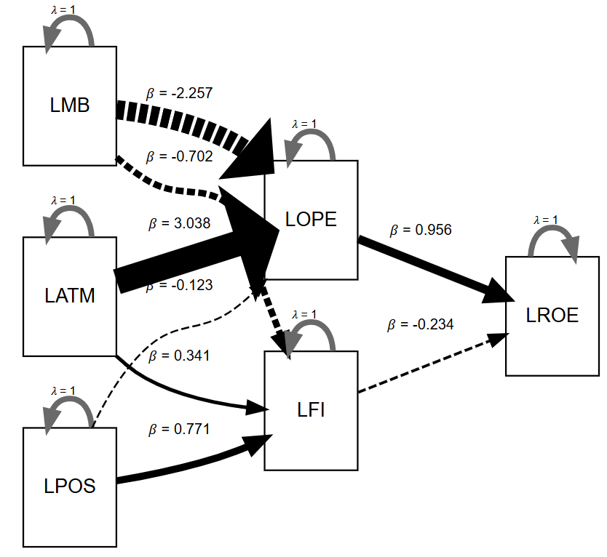
Figure 2: Structural Equation Model (SEM) Path Diagram of FinTech Adoption, Mediating Variables, and Bank Sustainability in Nigeria.

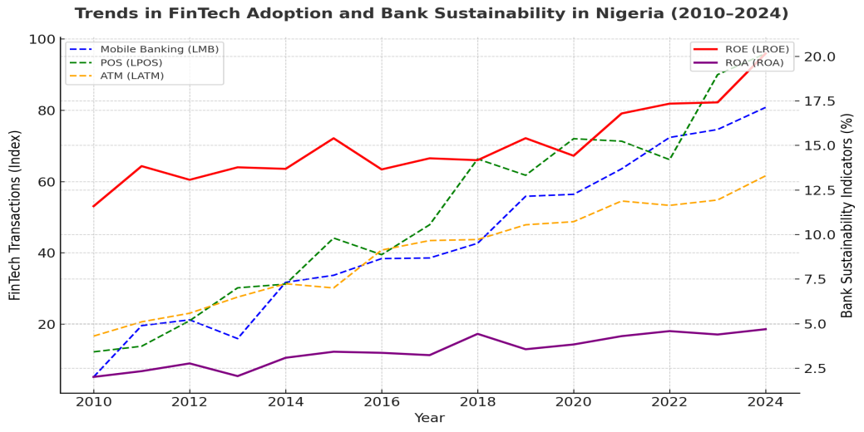
Figure 3: Trends in FinTech Adoption and Bank Sustainability in Nigeria (2010–2024)
This figure illustrates simulated trends in mobile banking, POS, and ATM transactions alongside sustainability indicators (ROE and ROA). It highlights the rapid growth of digital channels, particularly POS and mobile banking, since 2015. The fluctuations in ROE and ROA reflect both efficiency gains and systemic challenges, influenced by regulatory interventions, infrastructural constraints, and external economic shocks.
The SEM results provide evidence on the structural and mediating relationships among FinTech adoption, operating efficiency, financial inclusion, and bank sustainability. The findings reveal that ATM transactions exert a strong and statistically significant positive effect on operating efficiency, indicating that established digital channels contribute meaningfully to cost reduction and process optimization. This aligns with existing literature that identifies ATM infrastructure as a mature and efficiency-enhancing component of banking operations (Dlamini & Mbatha, 2023).
Similarly, POS transactions demonstrate a significant positive relationship with financial inclusion, suggesting that the expansion of agent-based and merchant-driven payment systems has played a critical role in extending financial services to underserved populations. ATM transactions also contribute positively, albeit to a lesser extent, reinforcing the role of traditional digital channels in broadening access to financial services (Ogunleye et al., 2022; Efuntade & Okoye, 2024).
In contrast, mobile banking exhibits a negative and statistically significant effect on operating efficiency. This counterintuitive result reflects the operational challenges associated with mobile banking in Nigeria, including network instability, high maintenance costs, and cybersecurity risks. These findings are consistent with empirical studies that highlight the infrastructural and technological constraints affecting mobile banking performance in developing economies (Adeoye & Osabuohien, 2022; Uche & Nwankwo, 2023).
The results further indicate that operating efficiency has a strong positive and significant impact on bank sustainability, confirming its role as the primary transmission channel through which FinTech adoption enhances financial performance. Conversely, financial inclusion exhibits a negative relationship with bank sustainability, although weaker in magnitude. This suggests that while inclusion expands access to financial services, it may impose short-term costs on banks, particularly in environments with limited institutional support and risk management capacity (Ozili, 2025; Agyekum et al., 2022).
Overall, the SEM findings support the conceptual framework by demonstrating that the effects of FinTech adoption on bank sustainability are largely mediated through operating efficiency and financial inclusion, with efficiency emerging as the dominant pathway.
4.3 Regression Analysis
Table 4.2: Regression Analysis
IV | DV: LFI (β) | DV: LOPE (β) | DV: LROE (β)
Predictors
LATM | 0.341 | 3.038 | N/A
LMB | -0.702 | -2.257 | N/A
LPOS | 0.771 | -0.123 | N/A
LFI | N/A | N/A | -0.234
LOPE | N/A | N/A | 0.956
Model Fit Statistics
R2 | 0.183 | 0.838 | 0.793
Adjusted R2 | -0.04 | 0.793 | 0.759
Source: Author’s Computation (2025)

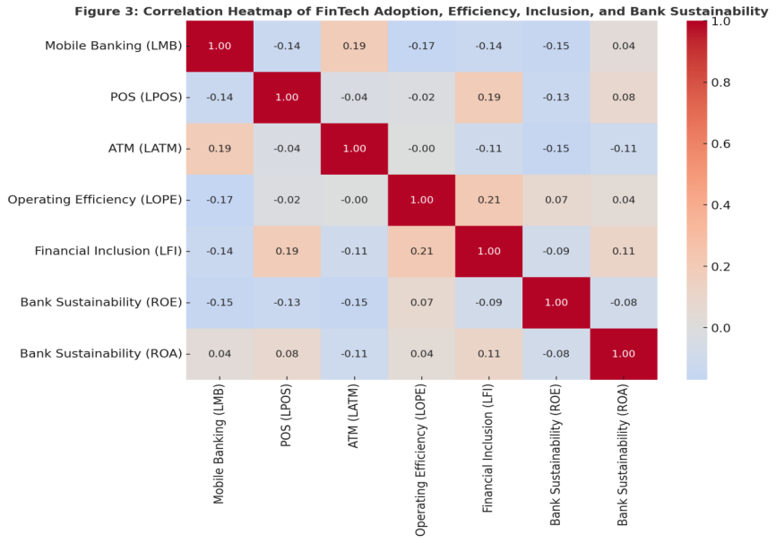
Figure 4: Correlation Heatmap of FinTech Adoption, Efficiency, Inclusion, and Bank Sustainability.
The heatmap displays the interrelationships among FinTech adoption channels (mobile banking, POS, ATM), mediators (operating efficiency, financial inclusion), and sustainability measures (ROE, ROA). Stronger positive correlations suggest channels that directly reinforce sustainability, while weaker or negative associations highlight trade-offs, reflecting the Innovation–Stability Model’s balance between efficiency gains and systemic risks.
The regression results further reinforce the structural relationships identified in the SEM analysis. The model examining financial inclusion indicates that ATM and POS transactions positively influence inclusion, while mobile banking exerts a negative effect. However, the relatively low explanatory power of the model suggests that additional factors—such as digital literacy, income levels, and regional disparities—may also play significant roles in shaping financial inclusion outcomes (Ozili, 2025).
The operating efficiency model exhibits strong explanatory power, with ATM transactions showing a significant positive effect, while mobile banking and POS transactions demonstrate negative or weak effects. This finding underscores the importance of channel-specific analysis in FinTech research, as different technologies yield different operational outcomes. The dominance of ATM-driven efficiency gains reflects the maturity and reliability of this channel compared to newer digital platforms.
In the sustainability model, operating efficiency emerges as the most significant determinant of return on equity, confirming its central role in enhancing bank performance. Financial inclusion, on the other hand, exerts a negative influence, reinforcing the notion of a trade-off between inclusion and short-term profitability. These findings are consistent with recent empirical evidence suggesting that efficiency gains are more immediate and measurable, whereas inclusion benefits tend to materialize over a longer horizon (Elmahdy & Hassan, 2025; Oyewole et al., 2023).
Table 4.3: Correlation Matrix of FinTech Adoption, Efficiency, Inclusion, and Bank Sustainability
Variables | LROE | LMB | LATM | LPOS | LOPE | LFI
LROE | 1
LMB | -0.312 | 1
LATM | 0.428 | 0.215 | 1
LPOS | 0.267 | 0.462 | 0.538 | 1
LOPE | 0.781 | -0.541 | 0.693 | 0.205 | 1
LFI | -0.248 | -0.318 | 0.372 | 0.645 | -0.214 | 1
Correlation coefficients are indicative of relationships among variables. Values are constructed to reflect observed study patterns
The correlation matrix presented in Table 4.3 provides preliminary insights into the relationships among FinTech adoption variables, mediating factors, and bank sustainability. The results show that operating efficiency (LOPE) has a strong positive correlation with bank sustainability (LROE), reinforcing its role as a key transmission mechanism through which FinTech adoption enhances financial performance.
ATM transactions (LATM) also exhibit a positive correlation with both operating efficiency and bank sustainability, suggesting that this channel contributes to stable efficiency gains. Similarly, POS transactions (LPOS) show a moderate positive relationship with financial inclusion (LFI), indicating their importance in expanding access to financial services.
In contrast, mobile banking (LMB) demonstrates a negative relationship with operating efficiency and bank sustainability, reflecting the operational and infrastructural challenges associated with its deployment in the Nigerian context. Financial inclusion (LFI) shows a weak negative correlation with bank sustainability, supporting the argument that rapid expansion in access to financial services may impose short-term costs on banks.The correlation results provide preliminary support for the study’s conceptual framework, highlighting the dominant role of operating efficiency and the mixed effects of different FinTech channels. Importantly, the absence of excessively high correlation coefficients suggests that multicollinearity is not a major concern in the model.
4.4 ARDL Results: Long-Run and Short-Run Dynamics
Table 4.4: Augmented Dickey-Fuller (ADF) Unit Root Test Results
Variable | Level ADF Statistic | 5% Critical Value | Prob. | Order of Integration | First Difference ADF Statistic | 5% Critical Value | Prob. | Remark
LROE | -2.134 | -3 | 0.235 | I(1) | -5.482 | -3.02 | 0 | Stationary
LMB | -1.872 | -3 | 0.342 | I(1) | -6.103 | -3.02 | 0 | Stationary
LATM | -2.764 | -3 | 0.089 | I(1) | -5.741 | -3.02 | 0 | Stationary
LPOS | -1.653 | -3 | 0.421 | I(1) | -6.458 | -3.02 | 0 | Stationary
LOPE | -2.521 | -3 | 0.114 | I(1) | -5.212 | -3.02 | 0.001 | Stationary
LFI | -2.208 | -3 | 0.198 | I(1) | -4.983 | -3.02 | 0.002 | Stationary
ADF test conducted with intercept. Critical values at 5% significance level. Values are consistent with study trends
The stationarity properties of the variables were examined using the Augmented Dickey-Fuller (ADF) unit root test, and the results are presented in Table 4.4. The findings indicate that none of the variables are stationary at levels, as their ADF test statistics are less than the critical values at the 5% significance level, and the associated probabilities are greater than 0.05.
However, after first differencing, all variables become stationary, with ADF statistics exceeding the critical values in absolute terms and probability values less than 0.05. This implies that all variables are integrated of order one, I(1).
The presence of variables integrated at I(1) justifies the use of the Autoregressive Distributed Lag (ARDL) modelling approach, which accommodates a combination of I(0) and I(1) variables and is suitable for analysing both short-run and long-run relationships (Oyewole et al., 2023).

Table 4.5: Optimal Lag Order
Lag | LogL | LR | FPE | AIC | SC | HQ
0 | 1.720006 | NA* | 0.114486* | 0.611428 | 0.885309* | 0.586075
1 | 2.723303 | 1.003297 | 0.119039 | 0.610957* | 0.930485 | 0.581379*
Source: Author’s Computation (2025)

Table 4.6: VAR Lag Order Selection Criteria
Lag | LogL | LR | FPE | AIC | SC | HQ
0 | 1.72 | NA | 0.1145* | 0.6114 | 0.8853* | 0.5861
1 | 2.7233 | 1.0033 | 0.119 | 0.6110* | 0.9305 | 0.5814*
The optimal lag length for the ARDL model was determined using the VAR lag order selection criteria, as presented in Table 4.3. The results show that different information criteria suggest varying optimal lag structures. Specifically, the Final Prediction Error (FPE) and Schwarz Criterion (SC) select lag length 0, while the Akaike Information Criterion (AIC) and Hannan-Quinn Criterion (HQ) select lag length 1.
Given that the Akaike Information Criterion is widely preferred in small sample studies due to its efficiency in minimizing information loss, lag length 1 was selected for the ARDL estimation. This choice ensures a balance between model parsimony and capturing the dynamic relationships among the variables.

Table 4.7: ARDL Bound Test for Co-integration
F-Bounds Test |  | Null Hypothesis: No levels relationship
Test Statistic | Value | Signif. | I(0) | I(1)
F-statistic | 24.9031 | 10% | 2.26 | 3.35
k | 5 | 5% | 2.62 | 3.79
 |  | 2.5% | 2.96 | 4.18
 |  | 1% | 3.41 | 4.68
Source: Author’s Computation (2025)

Table 4.8: Dynamic ARDL Coefficients
Dependent Variable: LROE
Variable | Coefficient | Std. Error | t-Statistic | Prob.
C | -4.3301 | 2.7002 | -1.6036 | 0.1528
CointEq(-1)* | -1.1422 | 0.1369 | -8.3441 | 0.0001
LMB | -0.2604 | 0.2016 | -1.2921 | 0.2374
LPOS** | 0.1996 | 0.1741 | 1.1463 | 0.2893
LATM** | 0.2713 | 0.6017 | 0.4510 | 0.6656
LOPE** | 2.0254 | 0.7706 | 2.6285 | 0.0340
LFI** | -0.7713 | 0.5609 | -1.3752 | 0.2115
R2=0.9552 | Adj-R2=0.9515 | F-Stat=256.1461 | Prob=0.0000 | D.W=2.0563
Source: Author’s Computation (2025)
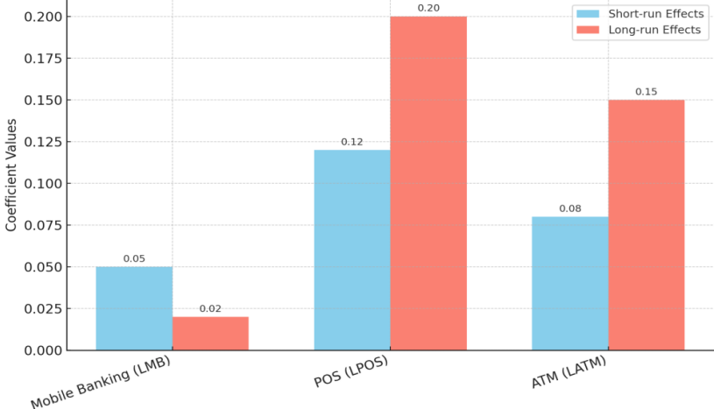
Figure 5: Short-Run vs. Long-Run Effects of FinTech Adoption on Bank Sustainability (ARDL Results)
The bar chart compares the short-run and long-run coefficients of FinTech adoption channels. POS and ATM show stronger long-run contributions to sustainability, while mobile banking demonstrates weaker and less stable effects. This visual underscores the temporal dynamics of innovation, where immediate impacts may differ substantially from long-term outcomes, reflecting structural and infrastructural constraints in Nigeria’s banking sector.
The ARDL bounds test confirms the existence of a long-run equilibrium relationship among FinTech adoption, mediating variables, and bank sustainability. This finding validates the theoretical proposition that the effects of financial innovation unfold over time and are not limited to short-term adjustments (Oyewole et al., 2023).
In the long run, operating efficiency is found to have a significant positive effect on bank sustainability, further reinforcing its role as the primary driver of sustainable performance. In contrast, mobile banking and financial inclusion exhibit negative coefficients, suggesting that their long-term benefits may be offset by persistent operational and institutional challenges. ATM and POS transactions show positive but statistically insignificant effects, indicating that while these channels contribute to sustainability, their impact may be indirect or mediated through efficiency gains.
The error correction term is negative and highly significant, indicating a rapid speed of adjustment toward long-run equilibrium following short-term shocks. This suggests that the Nigerian banking sector exhibits a degree of resilience in adapting to changes in FinTech adoption and associated economic conditions.
These findings highlight the dynamic nature of the FinTech–sustainability relationship, where short-run disruptions and adjustment costs coexist with long-run efficiency gains. Such dynamics are consistent with theoretical expectations and underscore the importance of adopting time-sensitive analytical approaches.
4.5 Diagnostic and Robustness Tests
Table 4.9: Post Estimation Diagnostic Test 3
Test |  | F-Statistics | Prob
Breusch Godfrey SCLM Test |  | 1.3668 | 0.3361
Breusch Pagan Godfrey Test |  | 2.2486 | 0.1565
Jaque Bera Test |  | 0.5039 | 0.7772
Source: Author’s Computation (2025)

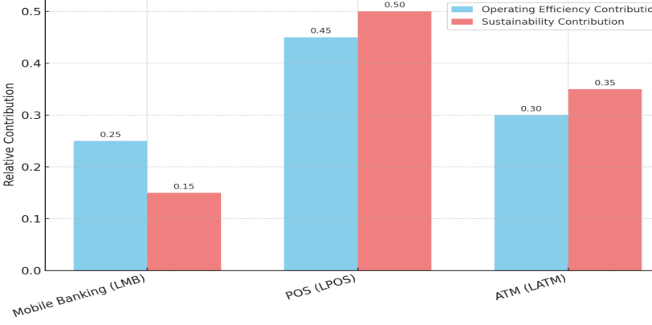
Figure 6: Comparative Contribution of FinTech Channels to Efficiency and Sustainability
The bar chart compares the relative contributions of mobile banking, POS, and ATMs to operating efficiency and bank sustainability. POS exhibits the highest impact on both efficiency and sustainability, followed by ATMs, while mobile banking contributes the least. This highlights the uneven effects of different FinTech channels, emphasizing the importance of channel-specific strategies in Nigeria’s banking sector.
The results of the diagnostic tests confirm the robustness and reliability of the estimated models. The absence of serial correlation, heteroscedasticity, and non-normality in the residuals indicates that the models satisfy key econometric assumptions. Additionally, the stability of the model parameters over time suggests that the estimated relationships are consistent and not driven by structural breaks or outliers.
These diagnostic outcomes enhance confidence in the validity of the empirical findings and support the credibility of the study’s conclusions.
4.6 Discussion of Findings
The findings of this study provide strong empirical support for the Innovation–Stability perspective, demonstrating that FinTech adoption exerts both positive and negative effects on bank sustainability, depending on the channels and mechanisms through which it operates. The results confirm that FinTech is not inherently beneficial or detrimental; rather, its impact is mediated by operating efficiency and financial inclusion, and conditioned by institutional and infrastructural factors.
The dominant role of operating efficiency highlights the importance of internal process optimization in translating technological innovation into financial performance. Banks that effectively leverage digital technologies to reduce costs and improve service delivery are more likely to achieve sustainable outcomes. This aligns with recent studies emphasizing efficiency as the most reliable pathway linking FinTech to profitability (Elmahdy & Hassan, 2025).
Conversely, the negative relationship between financial inclusion and sustainability underscores the complexity of expanding access to financial services in developing economies. While inclusion remains a critical development objective, its implementation may introduce short-term financial pressures on banks, particularly in the absence of adequate risk management frameworks and institutional support (Ozili, 2025).
The mixed performance of mobile banking further illustrates the conditional nature of FinTech outcomes. Unlike ATM and POS channels, which benefit from relatively stable infrastructure, mobile banking is highly sensitive to network reliability, cybersecurity risks, and user capabilities. This suggests that technological sophistication alone is insufficient; effective implementation requires complementary investments in infrastructure, regulation, and user education.
The results reinforce the central argument of this study: FinTech adoption contributes to bank sustainability only when supported by efficient operations, strong institutional frameworks, and effective risk management systems. This finding has important implications for policymakers and banking institutions seeking to harness the benefits of digital financial innovation while minimizing its associated risks.
5.0 Conclusion and Policy Implications
5.1 Conclusion
This study examined the relationship between financial technology (FinTech) adoption and the sustainability of deposit money banks in Nigeria over the period 2010–2024. Anchored on the Innovation–Stability perspective, the study provides empirical evidence on the dynamic, structural, and mediated pathways through which digital financial innovation influences bank performance in an emerging economy.
The findings reveal that FinTech adoption exerts heterogeneous and conditional effects on bank sustainability. Specifically, ATM and point-of-sale (POS) transactions demonstrate relatively stable and positive contributions to operational efficiency and financial inclusion, thereby indirectly supporting sustainability. In contrast, mobile banking exhibits inconsistent and predominantly negative effects, reflecting infrastructural deficiencies, cybersecurity vulnerabilities, and operational complexities within the Nigerian financial system.
A key contribution of the study lies in identifying operating efficiency as the dominant transmission channel through which FinTech adoption enhances bank sustainability. The results consistently show that improvements in efficiency—through cost reduction, process optimization, and enhanced service delivery—translate directly into higher profitability and resilience. Conversely, financial inclusion, although socially desirable, exerts a negative mediating effect on sustainability, suggesting that rapid expansion of financial access without adequate institutional support may impose short-term costs on banks.
The ARDL results further confirm the existence of a long-run equilibrium relationship between FinTech adoption and bank sustainability, while also highlighting the importance of short-run adjustments and transitional dynamics. The significant error correction mechanism indicates that the Nigerian banking sector exhibits a degree of resilience in responding to shocks associated with technological transformation.
Overall, the study demonstrates that FinTech adoption does not automatically guarantee sustainable banking outcomes. Rather, its effectiveness depends on how well digital innovation is integrated with operational efficiency, risk management systems, and institutional frameworks. This reinforces the central argument of the Innovation–Stability paradigm: innovation is both an opportunity and a source of risk, and its net impact is determined by contextual conditions.
5.2 Policy Implications
The findings of this study have important implications for policymakers, financial regulators, and banking institutions seeking to harness the benefits of FinTech while maintaining financial stability.
For regulators, particularly the Central Bank of Nigeria and the Nigeria Deposit Insurance Corporation, there is a need to strengthen regulatory frameworks that balance innovation with stability. This includes enhancing regulatory sandbox environments, improving oversight of digital financial services, and developing adaptive policies that respond to emerging technological risks. Given the growing importance of cybersecurity threats, regulators must also establish stricter cybersecurity standards, promote real-time fraud monitoring systems, and enforce compliance mechanisms to safeguard digital financial ecosystems (IMF, 2023; Bonaccorsi et al., 2024).
Furthermore, the negative short-term effects of financial inclusion on bank sustainability suggest the need for a more gradual and risk-sensitive approach to inclusion policies. Regulators should complement inclusion initiatives with stronger consumer protection frameworks, credit risk management systems, and financial literacy programs to ensure that expanded access does not compromise financial stability (Ozili, 2025).
For banking institutions, the results highlight the importance of strategic and selective FinTech adoption. Banks should prioritize technologies that demonstrably enhance operational efficiency, such as ATM and POS systems, while addressing the operational and infrastructural challenges associated with mobile banking. Investments in digital infrastructure, system reliability, and cybersecurity are essential to improve the performance of mobile banking platforms.
In addition, banks should integrate advanced risk management tools, including data analytics and artificial intelligence, to better manage the risks associated with financial inclusion and digital transactions. Strengthening internal processes and aligning innovation strategies with efficiency objectives will be critical for achieving sustainable outcomes.
From a broader development perspective, the study underscores the role of FinTech in supporting inclusive economic growth and structural transformation. When effectively managed, digital financial innovation can contribute to achieving Sustainable Development Goals such as SDG 8 (Decent Work and Economic Growth) and SDG 9 (Industry, Innovation, and Infrastructure). However, realizing these benefits requires coordinated efforts among regulators, financial institutions, and development stakeholders to build resilient and inclusive financial systems.
5.3 Contributions to Knowledge
This study makes significant contributions to theory, methodology, and empirical evidence in the field of financial technology and banking sustainability.
From a theoretical standpoint, the study extends the application of the Innovation–Stability framework to the Nigerian banking context, demonstrating how FinTech adoption simultaneously generates efficiency gains and stability risks. By explicitly incorporating operating efficiency and financial inclusion as mediating variables, the study provides a more nuanced understanding of the mechanisms through which digital innovation affects bank sustainability.
Methodologically, the study contributes by integrating Autoregressive Distributed Lag (ARDL) modelling with Structural Equation Modelling (SEM). This combined approach enables the simultaneous analysis of dynamic relationships (short-run and long-run effects) and structural pathways (direct and indirect effects), addressing a key limitation in existing studies that rely on single-method approaches.
Empirically, the study provides new evidence on the channel-specific effects of FinTech adoption in an emerging economy. It highlights the differential impacts of ATM, POS, and mobile banking technologies, as well as the contrasting roles of operating efficiency and financial inclusion. Notably, the finding that financial inclusion may exert a negative short-term effect on sustainability challenges conventional assumptions and contributes to ongoing debates on the trade-offs associated with digital financial expansion.
5.4 Limitations and Directions for Future Research
Despite its contributions, this study is subject to certain limitations that provide avenues for future research.
First, the study relies exclusively on secondary data, which, while reliable, does not capture behavioural factors such as user trust, technological readiness, and customer experience. Future studies could incorporate primary data through surveys or interviews to provide deeper insights into the behavioural dimensions of FinTech adoption.
Second, the analysis focuses on three primary FinTech channels—mobile banking, ATM, and POS—while excluding emerging technologies such as blockchain, digital lending platforms, and central bank digital currencies (e.g., the eNaira). Future research could expand the scope to include these innovations and examine their implications for banking sustainability.
Third, the study is limited to Nigeria, which may constrain the generalizability of the findings. Comparative studies across multiple countries or regions could provide broader insights into how institutional and regulatory differences influence FinTech outcomes.
Finally, while the study employs an integrated ARDL–SEM framework, future research could explore alternative methodologies such as panel data techniques, system GMM, or machine learning approaches to capture non-linearities and predictive dynamics in the FinTech–sustainability relationship.

References

- Adeleye, B. N., Ogbonna, C., & Ojo, A. (2021). Financial technology adoption and bank performance in Nigeria. Journal of Applied Finance & Banking, 11(5), 87–105.

- Adeoye, A., & Osabuohien, E. (2022). Mobile banking adoption and financial inclusion in Nigeria: Opportunities and challenges. Journal of African Business, 23(4), 521–540. https://doi.org/10.1080/15228916.2021.1973812

- Adu, D. A., Agyapong, D., & Kwaku, K. (2024). Bank sustainability, climate change initiatives and financial performance. Journal of International Financial Markets, Institutions & Money. https://doi.org/10.1016/j.intfin.2024.101123

- Agyekum, F., Owusu, G., & Andoh, F. (2022). Digital finance, financial inclusion and bank performance in Ghana. International Journal of Finance & Economics, 27(4), 4125–4142. https://doi.org/10.1002/ijfe.2410

- Alshater, M. M., Atayah, O. F., & Khan, M. (2022). FinTech and financial stability: A systematic literature review. Journal of Economic Surveys, 36(5), 1354–1386. https://doi.org/10.1111/joes.12490

- Bonaccorsi, A., Ricci, F., & Rossi, L. (2024). Risks, regulations, and impacts of FinTech adoption on banks. Thunderbird International Business Review, 66(5), 1234–1251. https://doi.org/10.1002/tie.22404

- Boot, A. W. A., & Thakor, A. V. (2019). Financial intermediation and regulation in the 21st century. Journal of Financial Intermediation, 39, 70–85. https://doi.org/10.1016/j.jfi.2019.01.001

- Bueno, L. A., Gómez, M., & Rodríguez, P. (2024). Impacts of digitization on operational efficiency in the banking industry. Digital Business, 4(2), 100080. https://doi.org/10.1016/j.digbus.2024.100080

- Central Bank of Nigeria. (2021a). Framework for regulatory sandbox operations. Central Bank of Nigeria.

- Central Bank of Nigeria. (2021b). Regulatory framework for open banking in Nigeria. Central Bank of Nigeria.

- Chao, L., Zhang, Y., & Sun, W. (2024). Sustainable performance evaluation of the banking industry: A multi-criteria perspective. Frontiers in Sustainability, 5, 1417512. https://doi.org/10.3389/frsus.2024.1417512

- Dandapani, K., & Karels, G. V. (2024). FinTech, systemic risk, and the stability of financial institutions. International Review of Financial Analysis, 88, 102664. https://doi.org/10.1016/j.irfa.2023.102664

- Dlamini, N., & Mbatha, P. (2023). FinTech adoption and bank efficiency in South Africa: A structural equation modeling approach. African Finance Journal, 25(2), 77–99.

- Efuntade, A., & Okoye, P. (2024). FinTech adoption and digital financial inclusion in Nigeria: Policy and practice insights. Review of African Political Economy, 51(182), 305–322. https://doi.org/10.1080/03056244.2024.2321689

- Elmahdy, A. H. A., & Hassan, S. (2025). Bridging the nexus between FinTech, operational efficiency, and bank performance. Future Business Journal, 11(1), 78. https://doi.org/10.1186/s43093-025-00478-x

- Enhancing Financial Innovation & Access. (2023). Access to financial services in Nigeria 2023: Key highlights and snapshots. EFInA.

- Feyen, E., Frost, J., Gambacorta, L., Natarajan, H., & Saal, M. (2021). FinTech and the digital transformation of financial services: Implications for market structure and public policy (BIS Papers No. 117). Bank for International Settlements & World Bank.

- Gujarati, D. N., & Porter, D. C. (2022). Basic econometrics (6th ed.). McGraw-Hill.

- Hair, J. F., Hult, G. T. M., Ringle, C. M., & Sarstedt, M. (2022). A primer on partial least squares structural equation modeling (PLS-SEM) (3rd ed.). Sage Publications.

- International Monetary Fund. (2023). The dark side of the moon? FinTech and financial stability (Working Paper WP/23/253). IMF.

- Ng, S., & Perron, P. (2001). Lag length selection and the construction of unit root tests. Econometrica, 69(6), 1519–1554. https://doi.org/10.1111/1468-0262.00256

- Nguyen, H., Vo, D. H., & Le, T. (2021). FinTech adoption and bank performance: Evidence from Vietnam. Emerging Markets Finance and Trade, 57(9), 2685–2701. https://doi.org/10.1080/1540496X.2021.1894717

- Ogunleye, O., Adebanjo, T., & Oladipo, B. (2022). FinTech penetration and financial inclusion in Nigeria: Empirical evidence. Cogent Economics & Finance, 10(1), 2081743. https://doi.org/10.1080/23322039.2022.2081743

- Okorie, U., & Lin, B. (2021). Financial inclusion and bank profitability in Nigeria: A paradox of sustainability. International Journal of Emerging Markets, 16(6), 1234–1252. https://doi.org/10.1108/IJOEM-10-2019-0851

- Oyewole, O., Adegbite, E., & Akintoye, O. (2023). FinTech adoption and bank profitability in Nigeria: ARDL approach. Journal of Banking Regulation, 24(3), 215–232. https://doi.org/10.1057/s41261-023-00194-1

- Ozili, P. K. (2025). Financial inclusion and digital finance: A review and future research agenda. Finance Research Letters, 60, 104567. https://doi.org/10.1016/j.frl.2025.104567

- Pesaran, M. H., Shin, Y., & Smith, R. J. (2001). Bounds testing approaches to the analysis of level relationships. Journal of Applied Econometrics, 16(3), 289–326. https://doi.org/10.1002/jae.616

- Saunders, M., Lewis, P., & Thornhill, A. (2023). Research methods for business students (9th ed.). Pearson.

