Innovated Gear Reduction Starting System Simulator: A Training Device for Automotive Electrical Instruction

ABSTRACT

This study was conducted at Iligan City National School of Fisheries to address the shortage of effective, context-based instructional materials in teaching automotive electrical systems. To improve students’ practical understanding of the gear reduction starting system, an Innovated Gear Reduction Starting System Simulator was developed and assessed for its instructional value during the school year 2024–2025. Using a descriptive research design, the study employed researchers-made survey questionnaire to evaluate both the simulator’s effectiveness and student performance. Thirty-one (31) Senior High School students enrolled in the Technical-Vocational-Livelihood (TVL) Automotive strand and seven (7) Senior High School teachers participated as respondents. Data analysis involved frequency counts, weighted means, and descriptive interpretation. The findings revealed that the simulator was highly effective as an instructional device, with a weighted mean of 5.0 across function, operation, and diagnostic features. Student performance also showed strong results: 3.9 in identifying parts, 3.7 in explaining functions, 3.67 in analyzing the circuit, and 3.7 in diagnosing faults (all out of 4.0). These figures indicate that the device significantly enhanced students' competencies in servicing gear reduction starting systems. The study recommends the integration of the simulator into the automotive curriculum and encourages replication of its design in other technical-vocational institutions to support skills-based learning.

Keywords: Automotive Technician Education, Gear Reduction Starting System Simulator, Senior High School, Student Performance, Instructional device

INTRODUCTION

The implementation of the K to 12 Basic Education Program in the Philippines has reinforced the importance of the Technical-Vocational-Livelihood (TVL) track in equipping Senior High School learners with industry-relevant competencies. Within this framework, the Industrial Arts specialization in Automotive Servicing emphasizes hands-on skills such as system maintenance, repair, and diagnostics, aligned with national mandates for competency-based and employment-oriented education (Republic Act No. 10533, 2013; TESDA, 2018). The development of technical skills in this context is not merely the acquisition of knowledge but the ability to perform tasks effectively through practice and experience, encompassing cognitive, psychomotor, and problem-solving abilities.

Despite these policy directions, many public secondary schools continue to experience significant shortages of context-based instructional devices, particularly in specialized areas such as automotive electrical systems. At Iligan City National School of Fisheries, this limitation constrains the delivery of practical instruction and reduces students’ opportunities to engage in authentic, skill-based learning. While prior studies affirm the effectiveness of instructional trainers in enhancing technical competencies, there remains a lack of localized, low-cost, and curriculum-aligned simulation devices specifically designed for teaching gear reduction starting systems in secondary-level TVL programs. This gap underscores the need for innovative instructional solutions that are both pedagogically effective and contextually adaptable.

Simulation-based learning has been widely recognized as an effective pedagogical approach in technical education. It serves as a method for replicating real-world processes in controlled environments, allowing learners to practice, experiment, and refine their skills through guided experience. By engaging learners in interactive and immersive tasks, simulation supports the integration of theoretical knowledge with practical application. Studies have shown that such approaches improve both understanding and performance, particularly in technical and engineering-related fields (de Jong, Linn, & Zacharia, 2013).

Grounded in constructivist and experiential learning theories, simulation-based instruction promotes knowledge construction through active engagement and reflection (Bruner, 1960; Kolb, 1984; Dewey, 1938). Empirical studies further demonstrate that the use of instructional trainers significantly enhances students’ conceptual understanding and technical performance in automotive education (Ramdi & Omar, 2020; Balbin & Abrigo, 2019).

In response to these challenges, this study developed an Innovated Gear Reduction Starting System Simulator designed to replicate the structure, operation, and troubleshooting processes of an actual automotive starting system. The device aims to support competency-based instruction by providing an interactive and practical learning tool that enhances both theoretical understanding and technical proficiency.

Accordingly, this study addresses the following research questions:

- How can an innovated gear reduction starting system simulator be developed in terms of design, materials, construction, and safety requirements?
- To what extent is the developed simulator perceived as effective in terms of function, operation, and diagnostic features?
- How does the use of the simulator influence students’ performance in key automotive servicing competencies, including component identification, functional explanation, circuit analysis, and fault diagnosis?

By addressing the gap in instructional resources, this study contributes to the advancement of simulation-based learning in technical-vocational education and provides a replicable model for enhancing skills development in automotive training contexts.

METHODOLOGY

Research Design
This study employed a descriptive research design to develop and evaluate the Innovated Gear Reduction Starting System Simulator. The design was appropriate for systematically describing the simulator’s technical characteristics, specifically its design, materials, construction, and safety features, and for assessing its instructional effectiveness. A survey-based approach was used to gather evaluative data from both teachers and students.

Research Setting and Participants

The study was conducted at Iligan City National School of Fisheries in Iligan City, during the academic year 2024–2025. The participants consisted of thirty-one (31) Senior High School students enrolled in the Technical-Vocational-Livelihood (TVL) track, specializing in Automotive Servicing; and seven (7) Senior High School teachers from the same school. The students served as primary users of the simulator, while the teachers acted as expert evaluators of its instructional effectiveness.

Research Instrument

Data for the study were collected using a researchers-developed questionnaire composed of two complementary sets designed to capture both evaluative and performance-based measures. The first set, administered to the teachers, focused on assessing the instructional effectiveness of the developed simulator, particularly in terms of its functional reliability, operational usability, and diagnostic capabilities. These dimensions were selected to reflect the essential features required of a training device intended for competency-based automotive instruction.

The second set of the questionnaire was administered to student participants and was designed to measure their level of performance in key automotive starting system competencies. Specifically, the instrument evaluated students’ ability to identify system components, explain their functions and operational processes, analyze electrical circuits, and diagnose faults within the gear reduction starting system. These competencies were aligned with the expected learning outcomes of the Automotive Servicing curriculum.
All questionnaire items were structured using a Likert-scale format to allow for the quantification of responses and facilitate statistical analysis. This approach enabled the systematic measurement of both perceived effectiveness and observed performance levels.

The instrument was subjected to expert validation prior to administration to ensure content relevance and clarity.

Data Gathering Procedure

The study followed a structured procedure to ensure the systematic collection of data. Prior to the conduct of the study, formal approval was secured from the school administration to carry out the research within the institution. This step ensured that all activities were conducted in accordance with institutional policies and guidelines.

Following approval, the developed Gear Reduction Starting System Simulator was presented to both student and teacher participants. The technical design of the simulator, including its layout and component arrangement, is shown in Figure 1. The figure illustrates multiple views of the device and served as a guide for its fabrication and assembly. The researchers then conducted a demonstration of the simulator, explaining its design, operational mechanisms, and diagnostic functions. Participants were also provided with clear instructions regarding the proper use of the simulator and the procedures for completing the questionnaire.

Figure 1. Technical Drawing of the Gear Reduction Starting System Simulator

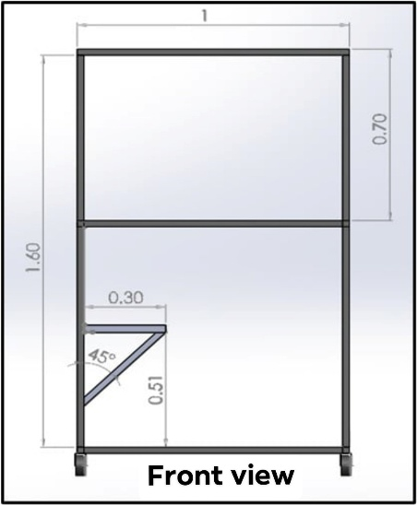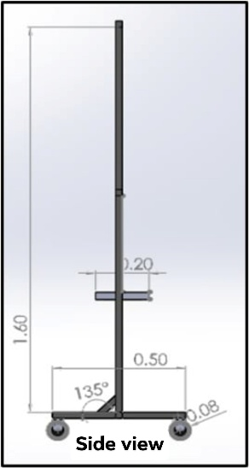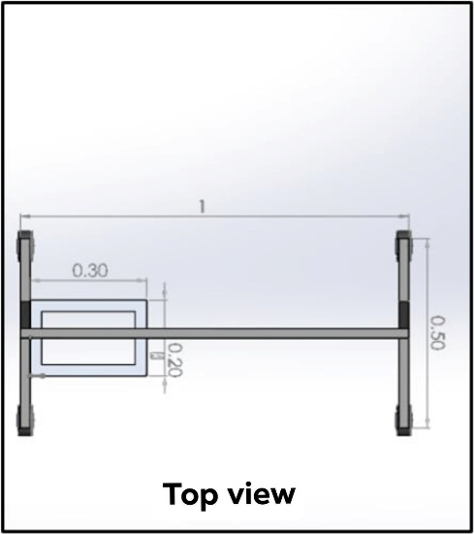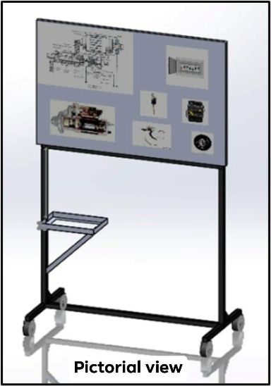

After engaging with the simulator, participants were asked to accomplish the corresponding survey instruments. The questionnaires were administered immediately following the interaction to capture direct responses based on actual experience with the device. Completed questionnaires were collected on-site to ensure completeness and accuracy of the data.

Data Analysis

Data were analyzed using descriptive statistics, particularly the weighted mean, to determine the perceived effectiveness of the simulator and the students’ performance across four competency domains: component identification, functional explanation, circuit analysis, and fault diagnosis.

A Likert-scale rating system was employed to quantify responses. The computed weighted means were interpreted using a four-point scale for student performance and a five-point scale for effectiveness evaluation. Descriptive equivalents were assigned to each range to classify levels of effectiveness and performance.

Development of the Gear Reduction Starting System Simulator

The Innovated Gear Reduction Starting System Simulator was developed to replicate the structure, operation, and diagnostic functions of an actual automotive starting system. The design phase involved the preparation of detailed technical drawings, including multiple views of the simulator, to ensure accuracy in component layout and assembly. The simulator was modeled after industry-standard systems to maintain relevance to current automotive practices and to support competency-based instruction.

The construction of the simulator utilized commonly available fabrication tools and automotive components, including electrical wiring, relays, switches, and a gear reduction starter motor. Structural materials such as metal framing and mounting boards were used to provide stability and durability. The selection of tools and materials was guided by their availability, cost-efficiency, and suitability for replicating real-world automotive systems within an educational setting.

The fabrication process followed a systematic sequence, including layout preparation, disassembly and modification of the starter motor for instructional visibility, assembly of mechanical and electrical components, and installation of the wiring system. A cut-away design was incorporated to allow students to observe internal components and better understand system operation. The simulator was also equipped with functional controls and fault simulation features to support hands-on learning and diagnostic practice.

Safety considerations were integrated throughout the development process. Personal protective equipment was used during fabrication, and built-in safety features such as circuit protection devices, properly rated fuses, and clearly labeled components were incorporated into the simulator. These measures ensured safe operation during instructional use and aligned with standard safety practices in technical-vocational education.

The completed Gear Reduction Starting System Simulator is presented in Figure 2. The device integrates mechanical and electrical components arranged to replicate the actual starting system, including the starter motor, wiring connections, control switches, and diagnostic features. Its design allows for hands-on interaction and facilitates the development of practical skills in system operation and troubleshooting.

Figure 2. Actual Gear Reduction Starting System Simulator

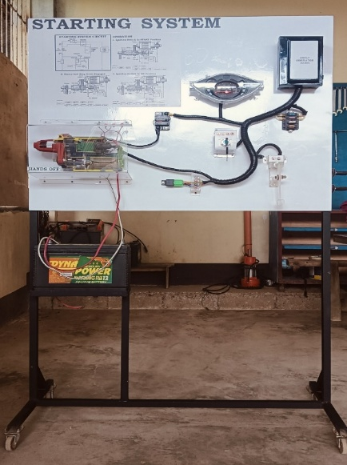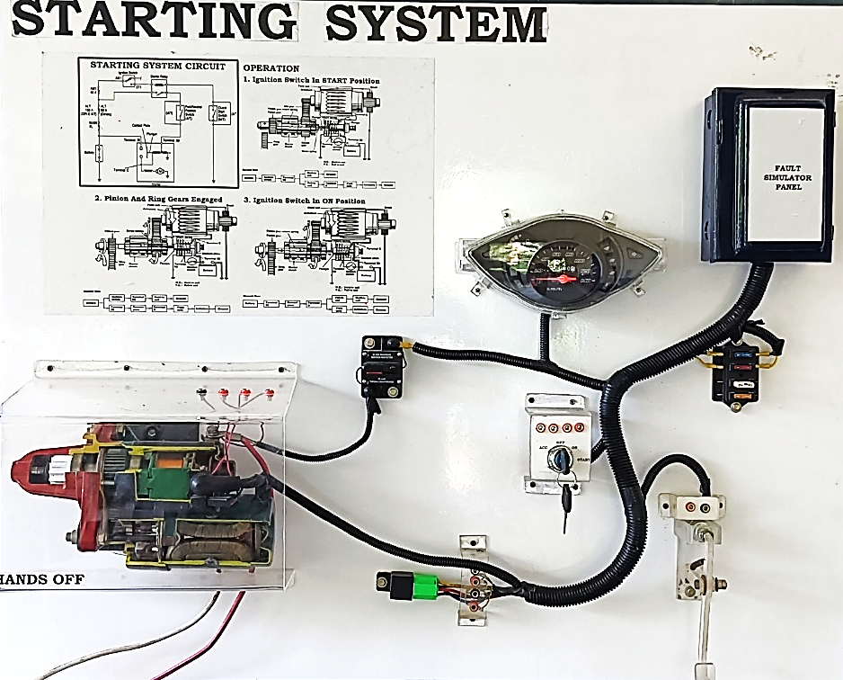

RESULTS

Effectiveness of the Gear Reduction Starting System Simulator

The effectiveness ratings were interpreted using a five-point scale, while student performance was interpreted using a four-point competency scale.

Table 1. Effectiveness of the Gear Reduction Starting System Simulator

Dimension | Weighted Mean | Description
Function | 5.00 | Very Effective
Operation | 5.00 | Very Effective
Diagnostic Features | 5.00 | Very Effective

Table 1 presents the expert evaluation of the developed simulator in terms of function, operation, and diagnostic features. All three dimensions obtained a weighted mean of 5.00, corresponding to a very effective rating. This indicates that the simulator consistently met the expected standards in functionality, operational performance, and diagnostic capability.

Student Performance Using the Simulator
Component Identification

Table 2. Student Performance in Identifying Components

Category | Frequency | Percentage
Competent | 29 | 93.5%
Satisfactory | 2 | 6.5%
Beginner | 0 | 0%
Not Yet Competent | 0 | 0%
Weighted Mean | 3.90

Table 2 shows that the majority of students were classified as competent in identifying the components of the gear reduction starting system, with a weighted mean of 3.90.

Functional Explanation and Operation

Table 3. Student Performance in Explaining Functions and Operation

Category | Frequency | Percentage
Competent | 22 | 70.9%
Satisfactory | 9 | 29.1%
Beginner | 0 | 0%
Not Yet Competent | 0 | 0%
Weighted Mean | 3.70

Table 3 indicates that most students demonstrated a competent level of performance in explaining the functions and operation of the system, with a weighted mean of 3.70.

Circuit Analysis

Table 4. Student Performance in Circuit Analysis

Category | Frequency | Percentage
Competent | 21 | 67.74%
Satisfactory | 10 | 32.26%
Beginner | 0 | 0%
Not Yet Competent | 0 | 0%
Weighted Mean | 3.67

As shown in Table 4, students generally achieved a competent level in circuit analysis, with a weighted mean of 3.67.

Fault Diagnosis

Table 5. Student Performance in Diagnosing Faults

Category | Frequency | Percentage
Competent | 22 | 70.9%
Satisfactory | 9 | 29.1%
Beginner | 0 | 0%
Not Yet Competent | 0 | 0%
Weighted Mean | 3.70

Table 5 presents the results for fault diagnosis, where most students were rated as competent, yielding a weighted mean of 3.70.

DISCUSSION

The findings of this study demonstrate that the Innovated Gear Reduction Starting System Simulator is highly effective as an instructional device, as evidenced by the consistently high ratings across function, operation, and diagnostic features, all of which obtained a weighted mean of 5.00. These results indicate that the simulator successfully replicates real-world automotive systems and provides reliable functionality for instructional use. This supports the premise that well-designed training devices can enhance the delivery of competency-based education in technical-vocational settings.

Student performance outcomes further reinforce the effectiveness of the simulator. Learners achieved competent levels across all four competency domains, with weighted means ranging from 3.67 to 3.90 in component identification, functional explanation, circuit analysis, and fault diagnosis. These results suggest that the simulator not only supports conceptual understanding but also facilitates the development of practical and diagnostic skills. This highlights the role of hands-on instructional tools in bridging the gap between theoretical knowledge and real-world application.

These findings are consistent with previous studies that emphasize the effectiveness of instructional trainers in automotive education. Ramdi and Omar (2020) reported that students exposed to automotive electrical system trainers demonstrated improved comprehension and performance compared to those taught using traditional methods. Similarly, Balbin and Abrigo (2019) found that the use of a hydro-pneumatic brake system trainer significantly enhanced students’ performance. The present study extends these findings by demonstrating comparable outcomes using a simulator specifically designed for gear reduction starting systems.

In contrast to earlier instructional devices developed by Andabon (2005) and Lacson (2007), which focused on ignition and braking systems, the current study introduces a simulator tailored to gear reduction starting systems—an area with limited instructional resources. This highlights the study’s contribution in addressing a specific gap in automotive training materials and expanding the scope of simulation-based learning tools in technical-vocational education.

The effectiveness of the simulator can also be explained through experiential and constructivist learning theories. Kolb (1984) posits that learning is enhanced through direct experience and active engagement, while Dewey (1938) emphasizes learning through practical interaction. Similarly, Bruner (1960) argues that learners construct knowledge through active involvement. The simulator operationalizes these principles by providing an interactive environment where students can manipulate components, analyze circuits, and diagnose faults, thereby promoting deeper learning and skill acquisition.

Finally, the successful development of the simulator, encompassing its design, materials, construction, and safety features, further demonstrates its feasibility as a context-based instructional tool. This underscores its potential for adoption in similar technical-vocational settings where access to commercial training equipment is limited.

CONCLUSION

This study developed and evaluated an Innovated Gear Reduction Starting System Simulator as an instructional device for automotive electrical education. The findings demonstrate that the simulator is highly effective in terms of function, operation, and diagnostic features, as reflected in consistently high evaluation scores.

Student performance results further confirm its instructional value, with learners achieving competent levels across key domains, including component identification, functional explanation, circuit analysis, and fault diagnosis. These outcomes indicate that the simulator effectively enhances both conceptual understanding and practical skills in automotive servicing.

The study also highlights the feasibility of developing cost-efficient and context-based instructional tools using locally available materials. This approach supports the delivery of accessible, competency-based technical education and provides an alternative to commercially available training devices.

Overall, the Innovated Gear Reduction Starting System Simulator serves as a valuable instructional resource that can improve teaching and learning in automotive education. Its integration into the curriculum is recommended, and similar simulation-based instructional devices may be developed and applied in other areas of technical-vocational education to further enhance skills-based learning and industry readiness.

ACKNOWLEDGEMENTS

The researchers give all glory and honor to their Savior, the everlasting God, for granting them the knowledge, wisdom, and strength to accomplish this study.

They extend deepest gratitude to their family for their unwavering support throughout the completion of this work. They also sincerely thankful to their colleagues for their assistance and encouragement during the research process.
The researchers express their heartfelt appreciation to Dr. Joseph C. Pepito, University President, for his support and approval; to Dr. Nolasco K. Malabago, Dean of the Graduate School, for his leadership and encouragement; and to Dr. Larry C. Gantalao, his adviser, for his invaluable guidance, expertise, and generosity in sharing his knowledge. They likewise extend their sincere thanks to the committee members and staff of Cebu Technological University for their assistance and support throughout the study.

They were deeply grateful to the distinguished panel members—Dr. Gerwine J. Medio, Dr. Jeonel S. Lumbab, Dr. Redjie D. Ancadio, Dr. Joecyn N. Archival, and Dr. Mary Jane C. Sim—for their insightful evaluation and constructive feedback, which significantly contributed to the improvement of this study.

Finally, the researchers extend their sincere appreciation to all individuals who, in one way or another, contributed to the completion of this endeavor.

REFERENCES

- Abelsson, A. (2017). Learning through simulation. Disaster and Emergency Medicine Journal, 2(3), 125-128.
- Aloraini, S. (2012). The impact of using multimedia on students’ academic achievement. International Interdisciplinary Journal of Education, 1(2), 1–7.
- Andabon, M. A. (2005). Development of automotive engine ignition system circuit trainer. (Unpublished Master’s Thesis).
- Balbin, N. B., & Abrigo, J. L. (2019). Development and Evaluation of Hydro-pneumatic Power Brake System Trainer. Bicol University R & D Journal, 22(1).
- Bruner, J. S. (1960). The process of education. Harvard University Press.
- Cardino, P., & Namoco, C. S. (2016). Development and Evaluation of Schematic Simulation Board for Automotive EFI System Trainer. Indian Journal of Science and Technology, 9, 47.
- De Jong, T., Linn, M. C., & Zacharia, Z. C. (2013). Physical and virtual laboratories in science and engineering education. Science, 340(6130), 305–308. https://doi.org/10.1126/science.1230579
- Department of Education. (2012). DepEd Order No. 40, s. 2012: Child protection policy. https://www.deped.gov.ph
- Department of Education. (2019, August 22). DepEd Order No. 021 s.2019. Policy Guidelines on the K to 12 Basic Education Program.
- Department of Labor and Employment. (n.d.). Occupational safety and health standards (OSHS). https://www.dole.gov.ph
- Dewey, J. (1938). Experience and education. Macmillan.
- Halderman, J. D. (2020). Automotive electricity and electronics (6th ed.). Pearson Education.
- Kolb, D. A. (2015). Experiential learning: Experience as the source of learning and development (2nd ed.). Pearson Education.
- Lacson, M. M. (2007). Design and evaluation of hydraulic brake master cylinder tester and trainer. (Unpublished Master’s Thesis).
- Lateef F. Simulation-based learning: Just like the real thing. J Emerg Trauma Shock. 2010 Oct;3(4):348-52. doi: 10.4103/0974-2700.70743. PMID: 21063557; PMCID: PMC2966567.
- Mohd Hajaraih, Syahidatul Khafizah. (2012). Skill Development Theory and Educational Game Design: An Integrated Design Framework.
- National Fire Protection Association. (2020). NFPA 70: National electrical code. NFPA.
- Ramdi, O. D. (2020). DEVELOPMENT OF AUTOMOTIVE ENGINE ELECTRICAL SYSTEMS TRAINER FOR AUTOMOTIVE TECHNOLOGY STUDENTS. DEVELOPMENT, 2(12).
- Republic Act No. 10533 | GOVPH. (2013, May 15). An act enhancing the Philippine basic education system by strengthening its curriculum and increasing the number of years for basic education, appropriating funds therefor and for other purposes. Republic Act No. 10533 | Official Gazette of the Republic of the Philippines.
- Republic Act No. 11856 | GOVPH. (2022, June 18). An act converting the Iligan City National School of Fisheries (ICNSF) in barangay Buru-un, Iligan City, province of Lanao del Norte, into a polytechnic state college, to be known as the Iligan City Polytechnic State College (ICPSC), and appropriating funds therefor. Republic Act No. 111856 | Official Gazette of the Republic of the Philippines.
- Republic Act No. 7796, Technical Education and Skills Development Act of 1994. (1994). https://lawphil.net
- Republic Act No. 11058, An Act Strengthening Compliance with Occupational Safety and Health Standards. (2018). https://lawphil.net
- Republic Act No. 11293, Philippine Innovation Act. (2019). https://lawphil.net
- Republic Act No. 11861, Expanded Solo Parents Welfare Act. (2022). https://lawphil.net
- Simon Fraser University. (2010). Lesson 5 - Theories of Learning. Lesson 5 - Theories of Learning.
- Technical Education and Skills Development Authority. (2004, January 2). Competency-based learning materials: Service starting system. TESDA.
- Technical Education and Skills Development Authority. (2018). Training regulations for automotive servicing NC II. https://tesda.gov.ph
- Terano, Harold Jan. (2015). Development and acceptabillity of the simplified text with workbook in differential equations as instructional material for engineering.
- UNESCO. (2017). Education for sustainable development goals: Learning objectives. United Nations Educational, Scientific and Cultural Organization. https://unesdoc.unesco.org/ark:/48223/pf0000247444

