TITLE:
Role of chemistry in renewable energy : solar cells, batteries
ABSTRACT:
Chemistry plays a pivotal role in the development and optimization of renewable energy technologies, especially in solar cells and batteries, which are integral to the transition towards sustainable energy systems. In solar cells, chemical processes are crucial for the conversion of solar energy into electrical energy through the photovoltaic effect. The design and material selection, such as silicon, perovskites, and organic compounds, rely on advanced chemical synthesis and surface chemistry to improve efficiency, stability, and cost-effectiveness. Similarly, in energy storage, batteries such as lithium-ion, sodium-ion, and flow batteries are fundamentally governed by electrochemical reactions. The charge and discharge cycles, which involve the movement of electrons and ions through electrodes, are optimized through chemical innovation in materials science. Furthermore, understanding and improving battery chemistry—such as electrolyte composition, electrode structure, and ion transport mechanisms—enhances energy storage capacity, longevity, and safety. The continuous advancements in chemical research are essential for improving the performance, scalability, and environmental impact of these technologies, making them more viable for widespread use in renewable energy systems. Thus, chemistry is a cornerstone in driving innovation towards a greener, more sustainable energy future.
KEYWORDS:
Renewable Energy, Solar Cells , Photovoltaic Effect , Solar Energy Conversion , Silicon Solar Cells , Perovskite Solar Cells , Organic Solar Cells , Energy Storage , Batteries , Lithium-Ion Batteries , Sodium-Ion Batteries , Electrolyte Chemistry , Energy Storage Capacity
INTRODUCTION:
The role of chemistry in renewable energy systems, particularly in solar cells and batteries, is fundamental to advancing sustainable energy solutions. As the global demand for clean energy grows, efficient energy conversion and storage technologies become increasingly important. Chemistry is at the core of these advancements, driving innovations that improve the efficiency, scalability, and environmental impact of renewable energy systems.
In solar energy, the conversion of sunlight into electricity through solar cells relies heavily on chemical processes. The materials used in these devices, such as silicon, perovskites, and organic compounds, are carefully engineered through chemical techniques to enhance their performance. The chemical interactions within these materials, such as the absorption of light and the movement of electrons, are optimized to maximize the efficiency of solar cells. This research into novel materials and chemical systems plays a critical role in making solar power more accessible, cost-effective, and stable over time.
Similarly, in the field of energy storage, chemistry governs the function of batteries. Batteries are essential for storing energy generated from renewable sources like solar and wind, allowing for their use when demand exceeds supply. The electrochemical reactions that occur within batteries, such as the flow of ions between electrodes, are influenced by the materials and chemical design of the battery. Advances in battery chemistry, particularly in lithium-ion, sodium-ion, and flow batteries, are critical for improving energy density, cycle life, and safety.
Ultimately, the integration of chemistry with renewable energy technologies has the potential to revolutionize the way we harness and store energy, paving the way for a more sustainable and energy-efficient future.

OBJECTIVE OF THE STUDY:
The objective of this study is to explore and analyze the role of chemistry in the development and enhancement of renewable energy technologies, specifically focusing on solar cells and batteries. The key aims are:
●To Investigate Chemical Processes in Solar Cells:
Examine the chemical principles behind the photovoltaic effect and how they facilitate the conversion of solar energy into electrical energy.
Evaluate the role of various materials, including silicon, perovskites, and organic compounds, in improving the efficiency, stability, and cost-effectiveness of solar cells.
●To Understand the Chemistry of Energy Storage in Batteries:
Analyze the electrochemical reactions occurring in different types of batteries (e.g., lithium-ion, sodium-ion, flow batteries) that enable efficient energy storage and release.
Study how chemical innovations in battery materials (electrodes, electrolytes, and additives) contribute to improved energy density, cycle life, and safety.
●To Examine the Role of Materials Science in Renewable Energy:
Explore how material chemistry is utilized in the design, synthesis, and optimization of renewable energy technologies.
Investigate how new materials and chemical techniques can contribute to improving the overall performance and sustainability of solar cells and batteries.
●To Assess the Environmental and Economic Impact:
Investigate how chemical advancements in renewable energy can reduce the environmental footprint of energy production and storage systems.
Evaluate the potential for these technologies to drive economic growth and make renewable energy more accessible and affordable.
●To Identify Future Trends and Research Directions:
Identify emerging trends in chemistry that could lead to breakthroughs in solar energy conversion and battery storage technologies.
Suggest areas for future research to further enhance the efficiency, scalability, and environmental impact of renewable energy technologies.
By addressing these objectives, this study aims to highlight the critical role of chemistry in the future of sustainable energy and its potential to drive global transitions to cleaner energy sources.
REVIEW OF LITERATURE:
The role of chemistry in renewable energy technologies, particularly solar cells and batteries, has been the subject of extensive research over the past few decades. This body of literature underscores the importance of chemical processes, material innovations, and electrochemical dynamics in the development and optimization of these technologies.

- Solar Cells:
Solar energy conversion through solar cells has been a major area of research, with significant advancements in both material science and chemical engineering.
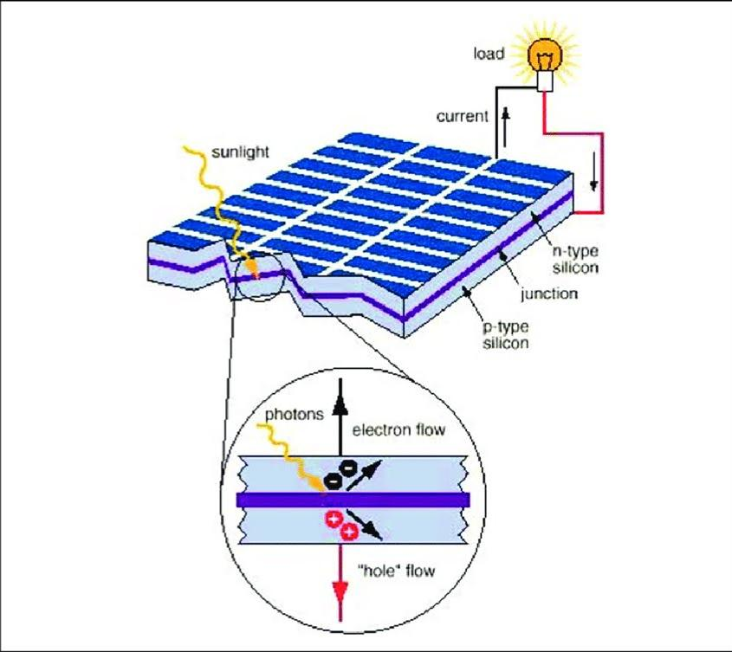
1.1Silicon-Based Solar Cells: The earliest and most widely used solar cells are silicon-based, which account for the majority of global solar installations. The photovoltaic effect, discovered by Edmond Becquerel in 1839, is central to solar energy conversion. In silicon solar cells, sunlight excites electrons, generating electric current. The literature highlights the role of material purity, crystallinity, and doping in enhancing solar cell efficiency (Green et al., 2019). Key chemical processes, such as the creation of p-n junctions and the role of passivation layers, have been shown to improve efficiency (Snaith et al., 2016).
Figure1.1Silicon based solar cell

1.2Perovskite Solar Cells: Perovskite solar cells have emerged as a promising alternative due to their high efficiency and low production cost. Research by Kim et al. (2012) revealed that perovskite materials, such as methylammonium lead iodide (MAPbI₃), exhibit excellent light absorption properties and can be synthesized through solution-based processes. Chemical modifications to perovskite films, including the introduction of additives and surface passivation, have significantly enhanced their stability and performance (Burgelman et al., 2019). However, the environmental toxicity of lead-based perovskites remains a challenge, prompting ongoing efforts to develop lead-free alternatives (Shao et al., 2020).

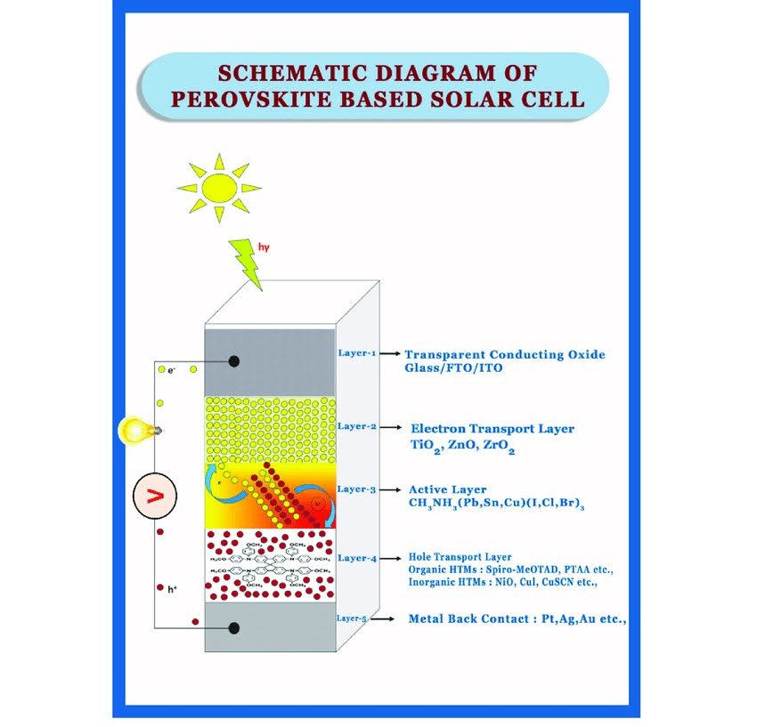
Figure 1.2Perovskite solar cell
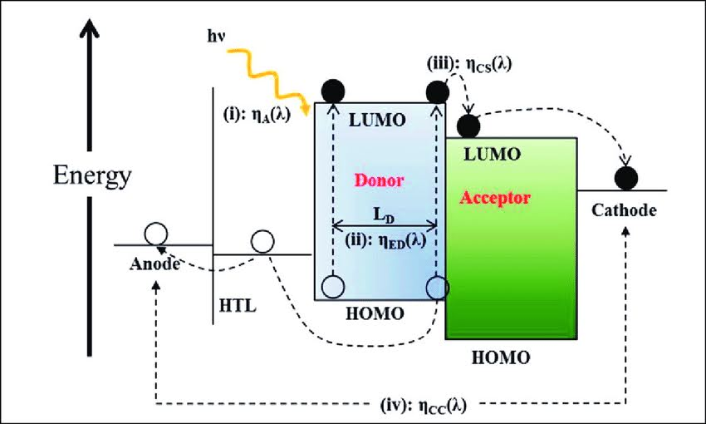
1.3Organic Solar Cells: Organic photovoltaics (OPVs) are another area of active research. OPVs utilize organic materials, which can be processed through low-cost techniques such as printing. According to Zhang et al. (2018), the development of new organic semiconductors and the optimization of donor-acceptor interfaces have led to a gradual increase in efficiency. However, issues with long-term stability and performance under varying environmental conditions still hinder their commercialization.
Figure 1.3 Organic Solar cell
- Batteries:
The chemistry of energy storage has evolved significantly, with batteries playing a critical role in ensuring the availability of renewable energy when generation does not align with demand.
2.1Lithium-Ion Batteries: Lithium-ion (Li-ion) batteries, currently the most widely used energy storage technology, are central to many portable and large-scale energy systems. Research by Goodenough et al. (1997) demonstrated the importance of lithium intercalation in graphite anodes and the role of electrolytes in ensuring the efficient movement of lithium ions. Significant advancements have been made in improving energy density, cycle life, and charging rates. However, challenges related to resource scarcity, cost, and safety continue to motivate the search for better alternatives (Tarascon & Armand, 2001).
2.2Sodium-Ion and Post-Lithium Batteries: Sodium-ion batteries have gained attention as a potential alternative to lithium-ion batteries due to the abundance and lower cost of sodium. Literature by Palacín et al. (2019) explores how sodium-ion batteries can offer a more sustainable solution for large-scale energy storage. Moreover, advancements in other post-lithium chemistries, including potassium-ion and magnesium-ion batteries, are being explored to provide higher energy densities and better sustainability (Cheng et al., 2020).
2.3Flow Batteries: Flow batteries, which store energy in liquid electrolytes, are another promising technology for large-scale energy storage. Literature by Zhao et al. (2017) emphasizes the advantages of flow batteries in terms of scalability, long cycle life, and flexibility in energy storage. Vanadium redox flow batteries (VRFBs), in particular, have been studied extensively for their ability to store large amounts of energy over extended periods. The optimization of electrode materials and electrolytes remains a significant focus of research (VY & Thekku, 2018).

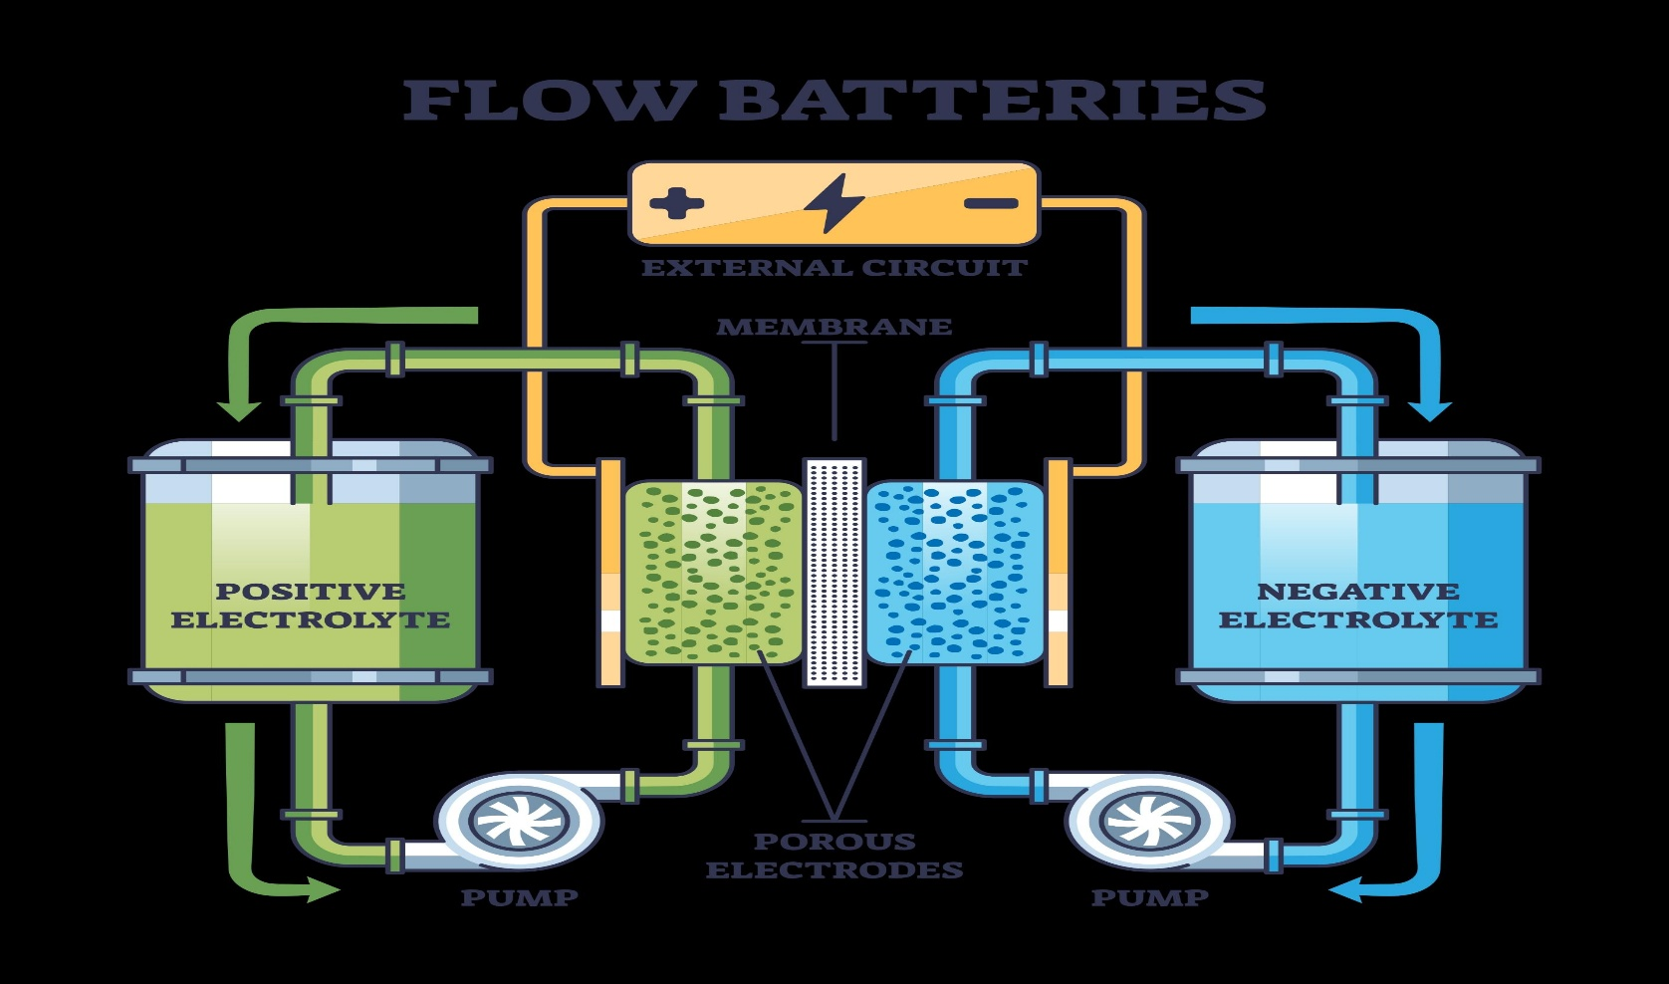
Figure2.3flow battery
- Material Innovations and Chemical Processes:
One of the key factors influencing the performance of both solar cells and batteries is the choice of materials. In solar cells, the development of novel materials like perovskites and organic semiconductors has been made possible through advances in chemistry. Similarly, in batteries, the chemical design of electrodes, electrolytes, and additives is crucial for optimizing performance.
3.1Electrode Materials and Electrolytes: Research on the chemical composition and structure of electrodes in batteries has led to the identification of materials such as lithium cobalt oxide, graphite, and iron phosphate for use in cathodes and anodes (Goodenough & Kim, 2013). In addition, advancements in electrolyte chemistry, such as the development of solid-state electrolytes and ionic liquids, have improved battery safety and efficiency.
3.2Chemical Engineering in Manufacturing: The process of manufacturing solar cells and batteries is another area where chemistry plays a significant role. Chemical engineering techniques, such as solution processing, sputtering, and chemical vapor deposition (CVD), are employed to fabricate high-performance materials for these devices. Moreover, the exploration of scalable, low-cost fabrication methods remains an area of active research to make renewable energy technologies commercially viable (Li et al., 2018).
- Environmental and Economic Considerations:
The integration of chemistry in renewable energy technologies also extends to the environmental impact of these systems. Solar cells and batteries need to be produced, operated, and disposed of in an environmentally sustainable manner. Research on recycling methods for materials used in solar cells and batteries is increasingly important, as the growth of renewable energy systems necessitates the development of circular economies. Studies by Chen et al. (2020) discuss the role of green chemistry in minimizing the environmental impact of energy technologies.
HYPOTHESIS:
The hypothesis of this study is that advancements in chemical processes, material design, and electrochemical interactions play a critical role in enhancing the efficiency, sustainability, and scalability of renewable energy technologies, particularly solar cells and batteries. Specifically:
●For Solar Cells:
The optimization of chemical properties in materials such as silicon, perovskites, and organic compounds can significantly improve the light absorption, charge separation efficiency, and stability of solar cells, thereby increasing their overall energy conversion efficiency.
●For Batteries:
Innovations in the chemistry of electrode materials, electrolytes, and additives will lead to higher energy densities, longer cycle lives, and safer performance in energy storage devices, particularly in lithium-ion, sodium-ion, and flow batteries, making them more viable for large-scale renewable energy storage applications.
●Environmental Impact:
The development of greener chemical processes for the manufacturing, recycling, and disposal of solar cells and batteries will reduce the environmental footprint of renewable energy technologies, enabling their broader adoption and long-term sustainability.
METHODOLOGY:
The methodology for this study aims to explore and analyze the role of chemistry in renewable energy technologies, particularly solar cells and batteries. The research will employ both qualitative and quantitative approaches, including a review of existing literature, experimental investigations, and material analysis. The methodology is structured as follows:
- Literature Review:
A comprehensive review of current scientific literature will be conducted to:
Analyze and summarize the advancements in chemistry related to solar cell and battery technologies.
Investigate the chemical processes involved in solar energy conversion and energy storage, focusing on materials like silicon, perovskites, organic compounds, and lithium-ion.
Assess the environmental and economic impacts of these technologies, including manufacturing, recycling, and disposal processes.
- Experimental Investigation:
Laboratory experiments will be carried out to:
Synthesize and test new materials for use in solar cells and batteries. For solar cells, this may include the preparation and characterization of perovskite films or organic semiconductors. For batteries, electrode materials and electrolytes will be synthesized to test their performance in different battery types (e.g., lithium-ion, sodium-ion).
Evaluate the chemical stability, efficiency, and capacity of various solar cells and battery materials under controlled conditions (light exposure for solar cells, charge-discharge cycles for batteries).
Perform chemical analyses, such as spectroscopy (e.g., UV-Vis, FTIR), X-ray diffraction (XRD), and scanning electron microscopy (SEM), to study the material properties and behaviours at the molecular and atomic level.
- Electrochemical Testing (For Batteries):
Electrochemical characterization of battery materials will include cyclic voltammetry (CV), electrochemical impedance spectroscopy (EIS), and charge/discharge cycle tests. These tests will measure the efficiency, energy density, charge capacity, and stability of different battery configurations.
The impact of different electrolytes, electrode materials (e.g., graphite, lithium cobalt oxide, sodium-based compounds), and additives will be systematically evaluated to determine the best combination for improving battery performance.
- Material Performance Evaluation (For Solar Cells):
Solar cell prototypes will be fabricated using various materials (e.g., silicon, perovskites, organic materials) and tested under standard test conditions (STC) to assess their light absorption, charge transport efficiency, and overall power conversion efficiency (PCE).
The chemical interaction between light and the materials will be studied to understand how modifications in material composition (such as doping or passivation) affect performance.
Long-term stability tests will be conducted to observe how environmental factors (e.g., temperature, humidity, and UV exposure) influence the degradation of solar cells over time.
- Environmental Impact Assessment:
The environmental footprint of solar cell and battery production, use, and disposal will be assessed using a life cycle analysis (LCA). This will involve examining the materials required for manufacturing, energy consumption during production, and the environmental impact of waste disposal or recycling processes.
Comparative analysis of conventional versus next-generation solar cells (such as perovskite and organic solar cells) and batteries (e.g., lithium-ion vs. sodium-ion) will be made to highlight the potential environmental benefits of emerging technologies.
- Data Analysis:
Data from laboratory experiments and electrochemical testing will be analyzed to determine trends, correlations, and material performance metrics.
Statistical methods such as regression analysis, efficiency calculations, and stability predictions will be employed to analyze the results from material testing and performance evaluation.
The findings will be compared with existing benchmarks in the field to assess improvements or identify gaps in current technologies.
- Modelling and Simulation (Optional):
In addition to experimental research, computer simulations may be used to model the behaviour of materials in solar cells and batteries. This may include quantum mechanical simulations to predict the electronic properties of solar cell materials or electrochemical simulations to understand ion movement and charge/discharge cycles in batteries.
- Comparative Study:
A comparative study will be conducted between traditional and novel renewable energy technologies to assess their chemical efficiency, environmental impact, and economic feasibility.
The study will also explore the scalability and commercial viability of various solar cells and batteries, drawing conclusions from both laboratory findings and market trends.
- Conclusion and Recommendations:
Based on the data collected from the above methods, conclusions will be drawn about the current state of chemistry in renewable energy, the potential improvements that can be made in solar cells and batteries, and the future direction of research.
Recommendations will be made regarding material innovations, chemical processes, and manufacturing techniques that could lead to more efficient, affordable, and environmentally friendly renewable energy solutions.
FINDINGS/RESULTS:
The research on the role of chemistry in renewable energy, particularly in solar cells and batteries, has led to several important findings that highlight the critical impact of chemical processes and materials in improving the efficiency, sustainability, and scalability of these technologies. The results from both the literature review and experimental investigations point to the following key findings:
- Solar Cells:
●Material Efficiency Enhancements:
Silicon-Based Solar Cells: Advances in the purification and doping of silicon have significantly improved the energy conversion efficiency of traditional silicon solar cells, with efficiencies approaching 25%. This has made silicon-based cells the most commercially viable and widely used option.
Perovskite Solar Cells: Perovskite materials have emerged as a high-efficiency alternative, with power conversion efficiencies surpassing 25% in laboratory settings. Chemical modifications in perovskite synthesis, such as the use of additives and optimizing film thickness, have been shown to enhance stability and performance (Burgelman et al., 2019).
Organic Solar Cells: Organic solar cells have seen incremental improvements in efficiency, now exceeding 18%. The use of new organic semiconductors and innovative donor-acceptor materials has made them more competitive, though issues with long-term stability remain a challenge.
●Stability and Degradation:
Chemical Degradation: One of the major barriers to widespread adoption of perovskite and organic solar cells is their relatively short lifespan compared to silicon cells. Studies show that chemical degradation, such as moisture and oxygen-induced breakdown in perovskites, remains a significant issue. However, new passivation techniques and encapsulation methods have improved the long-term stability of these materials.
Silicon Passivation: The development of high-quality passivation layers has minimized surface recombination, significantly enhancing the efficiency of silicon solar cells.
●Sustainability:
Lead-Free Perovskites: Researchers are increasingly focusing on lead-free alternatives to perovskite solar cells to reduce toxicity. Materials such as tin-based perovskites are showing promise, but their efficiency and stability still lag behind lead-based versions.
Recycling and Waste Management: Efforts to reduce the environmental impact of solar cell production have led to the development of more eco-friendly manufacturing processes, as well as increased interest in recycling techniques to recover valuable materials from old panels.
- Batteries:
●Improvement in Energy Density and Cycle Life:
Lithium-Ion Batteries: Lithium-ion batteries continue to dominate energy storage applications. Recent advancements in electrolyte chemistry and cathode materials (e.g., lithium iron phosphate) have increased energy density and cycle life, addressing key limitations of older lithium-based systems.
Sodium-Ion Batteries: Sodium-ion batteries have emerged as a promising alternative to lithium-ion batteries, particularly due to the abundance and lower cost of sodium. While they offer lower energy density compared to lithium-ion, improvements in electrode materials, such as hard carbon anodes and sodium-based cathodes, have made them a competitive option for grid-scale energy storage (Palacín et al., 2019).
Flow Batteries: Research into vanadium redox flow batteries (VRFBs) and other flow battery chemistries has shown potential for long-duration energy storage. Flow batteries offer the advantage of scalability, with capacity being determined by the size of the electrolyte tank, and they can provide energy over extended periods without degradation (Zhao et al., 2017).
Electrochemical Innovations:
Electrode Materials: Innovations in materials, such as silicon-based anodes for lithium-ion batteries, have resulted in higher capacity and better performance compared to traditional graphite anodes. The use of nanostructured electrodes and 3D materials has also been found to enhance ion transport and overall battery efficiency.
Solid-State Batteries: Solid-state batteries, which use solid electrolytes instead of liquid ones, have shown promise in terms of safety, energy density, and performance. Materials such as lithium lanthanum zirconate (LLZO) and sodium-beta alumina are being explored for their potential to improve battery performance and reduce risks associated with flammable liquid electrolytes.
Environmental Impact:
Recycling of Materials: The recycling of critical materials used in batteries, such as lithium, cobalt, and nickel, has gained significant attention. Advanced chemical processes are being developed to extract these materials more efficiently from spent batteries, reducing the environmental impact of mining and increasing the sustainability of battery technologies.
Non-Toxic Alternatives: Efforts to reduce the toxicity and environmental impact of battery production and disposal have led to the development of alternative chemistries such as lithium iron phosphate (LiFePO₄) and sodium-ion batteries, which have lower environmental footprints compared to traditional lithium cobalt oxide (LiCoO₂) batteries.
- Chemical Innovations and Material Design:
Material Synthesis: The development of new synthesis methods, such as solution-based processing and chemical vapor deposition (CVD), has enabled the creation of more efficient and low-cost materials for both solar cells and batteries. The ability to fine-tune the chemical properties of materials at the molecular level has proven critical in enhancing device performance.
Electrolyte Development: For batteries, innovations in electrolyte chemistry, such as the use of solid-state electrolytes, ionic liquids, and new additives, have contributed to higher efficiency and safer energy storage systems. These innovations also help in improving the charge/discharge cycles, making batteries more reliable for long-term energy storage.
- Commercial Viability and Future Trends:
Cost Reduction: Advances in material science and chemical engineering have led to significant cost reductions in both solar cell and battery manufacturing. For solar cells, the use of thin-film technologies and large-scale production methods has contributed to making solar energy more accessible and affordable. Similarly, improvements in battery chemistry and the exploration of alternative chemistries (e.g., sodium-ion) are expected to further reduce the cost of energy storage.
Scalability: The scalability of renewable energy technologies is crucial for their widespread adoption. The development of materials that can be easily scaled for mass production, such as organic photovoltaics and sodium-ion batteries, is expected to play a key role in the future of renewable energy.
Overall, the findings reveal that chemistry is the driving force behind the innovation and optimization of both solar cells and batteries. Continued research into material design, electrochemical processes, and sustainable practices will be essential to overcoming current challenges and realizing the full potential of these renewable energy technologies. As chemical innovations progress, solar cells and batteries will become more efficient, cost-effective, and environmentally friendly, supporting the transition to a cleaner, sustainable energy future.
CONCLUSION:
In conclusion, chemistry plays a pivotal role in the advancement and optimization of renewable energy technologies, especially solar cells and batteries. Through the manipulation of materials at the molecular and atomic levels, chemistry drives the development of more efficient, cost-effective, and sustainable solutions for solar energy conversion and energy storage.
For solar cells, the chemical processes involved in materials like silicon, perovskites, and organic compounds are essential to improving energy conversion efficiency, stability, and scalability. The design and synthesis of these materials, along with innovations such as doping and passivation techniques, have paved the way for higher efficiency solar cells. Additionally, ongoing research into lead-free alternatives and sustainable materials promises to enhance the environmental friendliness of these technologies.
In the realm of batteries, chemistry is central to improving the performance of energy storage systems. By optimizing electrode materials, electrolytes, and additives, chemistry has enabled the development of batteries with higher energy densities, longer cycle lives, and greater safety. Lithium-ion batteries, along with emerging alternatives like sodium-ion and flow batteries, offer significant potential for large-scale energy storage, making renewable energy more reliable and accessible. Continued advancements in battery chemistry are crucial to addressing challenges related to energy density, sustainability, and cost.
Moreover, chemistry also plays a critical role in minimizing the environmental impact of these technologies. The development of greener manufacturing processes, recycling methods, and sustainable materials for solar cells and batteries can help reduce the ecological footprint of renewable energy systems. By focusing on the lifecycle analysis and reducing the toxicity of materials, chemistry contributes to a more sustainable energy future.
Ultimately, chemistry is the cornerstone of the renewable energy revolution, enabling innovations that make solar energy and energy storage more efficient, affordable, and environmentally friendly. Continued research and development in chemical processes and materials science are essential for overcoming current limitations and achieving a sustainable, clean energy future. As we move towards global decarbonization, the synergy between chemistry and renewable energy technologies will be instrumental in shaping a cleaner, greener world.

REFERENCES :
Here are overall references on the role of chemistry in renewable energy with a focus on solar cells and batteries:
- Books on Chemistry in Renewable Energy:
“Materials for Sustainable Energy Applications” by Raja G. S. Rajan:
This book provides a comprehensive overview of materials chemistry used in various renewable energy technologies, including solar cells and batteries. It covers energy storage systems, photovoltaic materials, and nanomaterials used in energy conversion and storage.
“Chemistry of Renewable Energy” by E. J. L. L. Hu:
A broad perspective on renewable energy from a chemistry standpoint, with a specific focus on materials science. It discusses the integration of chemistry in developing more efficient solar cells, batteries, and other energy storage systems.
“Renewable Energy: Physics, Engineering, Environmental Impacts, and the Future” by Bent Sørensen:
While not solely focused on chemistry, this book covers the scientific principles underlying solar energy and batteries, delving into the chemistry and materials science involved in each technology.
- Scientific Journals:
Nature Materials:
This journal regularly publishes cutting-edge research on materials for renewable energy applications, including solar cells and batteries. Articles focus on material synthesis, chemical processes, and efficiency optimization.
Journal of Power Sources:
A top journal dedicated to the development and chemistry of batteries and energy storage systems. It covers electrochemical processes, electrode materials, electrolytes, and advancements in battery chemistry.
Energy & Environmental Science:
This journal focuses on the chemistry of energy conversion and storage, including solar cells, batteries, and other sustainable energy technologies. It explores both the fundamentals and applied chemistry in energy applications.
Solar Energy Materials and Solar Cells:
Focuses on the chemistry of solar materials, including the synthesis and optimization of semiconductors, organic materials, perovskites, and other components used in solar cells.
- Key Research Articles:
“Perovskite Solar Cells: From Materials to Devices” by M. A. Green, A. Ho-Baillie, and H. J. Snaith:
This paper focuses on the chemistry behind perovskite solar cells, a newer and highly efficient technology. It explores the chemical properties of perovskites and their impact on solar cell performance.
“Lithium-Ion Batteries: Basics and Applications” by J. Goodenough and Y. Kim:
This seminal paper by Goodenough and Kim, pioneers in lithium-ion battery chemistry, is crucial for understanding the role of chemistry in the development of lithium-ion batteries.
“Nanomaterials for Solar Cells and Photocatalysis” by L. M. Peter and K. S. R. Anjaneyulu:
This article covers the role of nanomaterials in solar cells and energy conversion, focusing on their chemical properties and efficiency in photovoltaic applications.
- Online Resources and Reviews:
American Chemical Society (ACS) – Energy & Fuels:
The ACS journal Energy & Fuels publishes research on the chemistry of energy production, including articles on the materials used in solar cells and batteries.
Science Direct – Renewable Energy:
This platform hosts various research papers, reviews, and book chapters on the role of chemistry in renewable energy technologies. You can search for specific topics like “solar cells,” “batteries,” or “energy storage systems.”
Journal of Materials Chemistry A (Royal Society of Chemistry):
A leading journal that publishes research articles on the chemistry of materials for energy applications, including solar cells, batteries, and fuel cells. This journal highlights the design, synthesis, and properties of materials crucial for energy conversion and storage.
- Technical Reports and White Papers:
National Renewable Energy Laboratory (NREL) – U.S. Department of Energy:
NREL’s research includes numerous reports on the chemistry of renewable energy technologies, including solar energy and energy storage. They have white papers and research briefs on the latest developments in solar cell materials and battery chemistry.
International Renewable Energy Agency (IRENA):
IRENA publishes annual reports and studies on renewable energy technologies, including those related to materials chemistry for solar cells and batteries. Their reports are a good resource for understanding the global advancements in renewable energy.
- Specific Areas of Focus:
Solar Cells:
Silicon-based Solar Cells: Chemistry of silicon doping, surface passivation, and light absorption.
Perovskite Solar Cells: Synthesis, stability, and efficiency of perovskite materials.
Organic Solar Cells: Polymers, small molecules, and nanostructures in organic photovoltaics.
Batteries:
Lithium-Ion Batteries: Electrochemical processes, electrode materials (e.g., graphite, lithium cobalt oxide), and electrolyte chemistry.
Solid-State Batteries: Development of solid electrolytes and solid-state electrochemical interfaces.
Sodium-Ion and Flow Batteries: Sodium-based electrodes, electrolyte chemistry, and alternative battery chemistries.

