Quantitative estimation of leaf of Ricinus communis (Linn), from marketed formulation using HPTLC method.
ABSTRACT
Ayurvedic medicines have a lot of potential because of their comprehensive approach to illness care. Yet there is a need for sufficient standardization before they can be used in modern medicine. Nevertheless, there is a lack of work efforts directed towards the concurrent assessment of biomarkers in polyherbal formulation using HPTLC fingerprinting.
Quality Control (QC) in herbal medicine is essential to ensure the safety, efficacy and consistency of products, protecting consumers from harmful adulterants and inconsistent active compound levels. It also involves testing for botanical authenticity, heavy metals, pesticides and concentration of plant parts in the drug. The drug to be administered should adhere to WHO standards to validate medicinal potential and ensure reliable therapeutics.
It is relatively easy to trace the percentage of a drug in the modern medicines. In the case of herbal medicines most of the products over counter are polyherbal. To detect the percentage of a specific herb, or part of the herb like leaf stem etc., some phytochemical marker has to be developed. This marker may not be an active component of that herb. In the present study, a marker was developed from Ricinus communis leaf extract by HPTLC, after scanning at 310nm, at RF 0.68, by calculating the AUC of markers from leaf extract and the polyherbal formulation. The concentration of Ricinus communis in the formulation was calculated.
Key words: markers, Ricinus communis, WHO, HPTLC, RF, AUC.

INTRODUCTION
Herbs and herbal medicines have been utilised for the treatment of various ailments since ancient times. As per the WHO, around 80% of the global population depends on herbs and other traditional therapies, citing their safety, effectiveness, cultural acceptance, and minimal side effects. The therapeutic effectiveness on plant-based drugs relies on the authenticity and purity of the plant material. (Hiremath et al 2016, Dodakallanvar et al 2022). Polyherbal formulations have been found to possess superior and prolonged therapeutic potential compared to single herbs. They enhance the therapeutic activity while reducing the concentrations of individual herbs. (Parasuraman et al 2014). The efficacy of herbal products is inherently linked to guaranteeing their safety and quality. Therefore, the need for phytochemical standardization and evaluation is very important. The WHO and other regulatory bodies are concerned with the effectiveness and safety of the herbal medicines. Therefore, there is a constant demand for simple, reproducible and cost-effective methods (Parab Gaonkar V, et al 2022).
Various analytical approaches, such as TLC, HPTLC, and HPLC have been employed for the determination and standardization of phytoconstituents. HPTLC allows the simultaneous detection and quantification of various phytoconstituents from the polyherbal formulations. As a result, HPTLC has emerged as a rapid, straightforward, and reliable analytical technique in numerous phytochemical investigations and standardization process (Patel AA, et al. 2017 and Saundelgekar S et al. 2021).
Estimation of the concentration of parts of the herb used in the polyherbal formulation play an important role in finding out its efficacy in the drug. Herbal medicine finds vast application in clinical studies. It is necessary to device a series of experiments, which are capable of determining the concentration of the herb used in the formulation. HPTLC is essential in herbal medicine for ensuring quality, safety and efficacy through rapid, cost effective and precise standardization.
The study focuses on a routine quality control of a polyherbal formulation-a syrup, by developing a marker using HPTLC accompanied with HPLC for linearity study.
MATERIALS AND METHODS
Ricinus communis (Linn), of family Euphorbiaceae, have been used in traditional medicine for abdominal pain, arthritis, backache, sciatica, constipation, gall bladder pain etc. (S. Khan et al. 2017). Leaves of Ricinus communis were collected from Thane district of Maharashtra. Leaves were washed thoroughly with water to remove dust and extraneous matter, the excess of water was absorbed by spreading the plant material over filter paper for three days in shade, away from sunlight. The filter paper was replaced daily. Herbaria were prepared and were send to NBRI Lucknow for authentication. After drying, it was powdered by using an electric grinder and sieved through a BSS mesh NO.85 sieve. The sieved powdered was stored in commercially available airtight container with date and time of collection. This powdered plant material was used for further work.
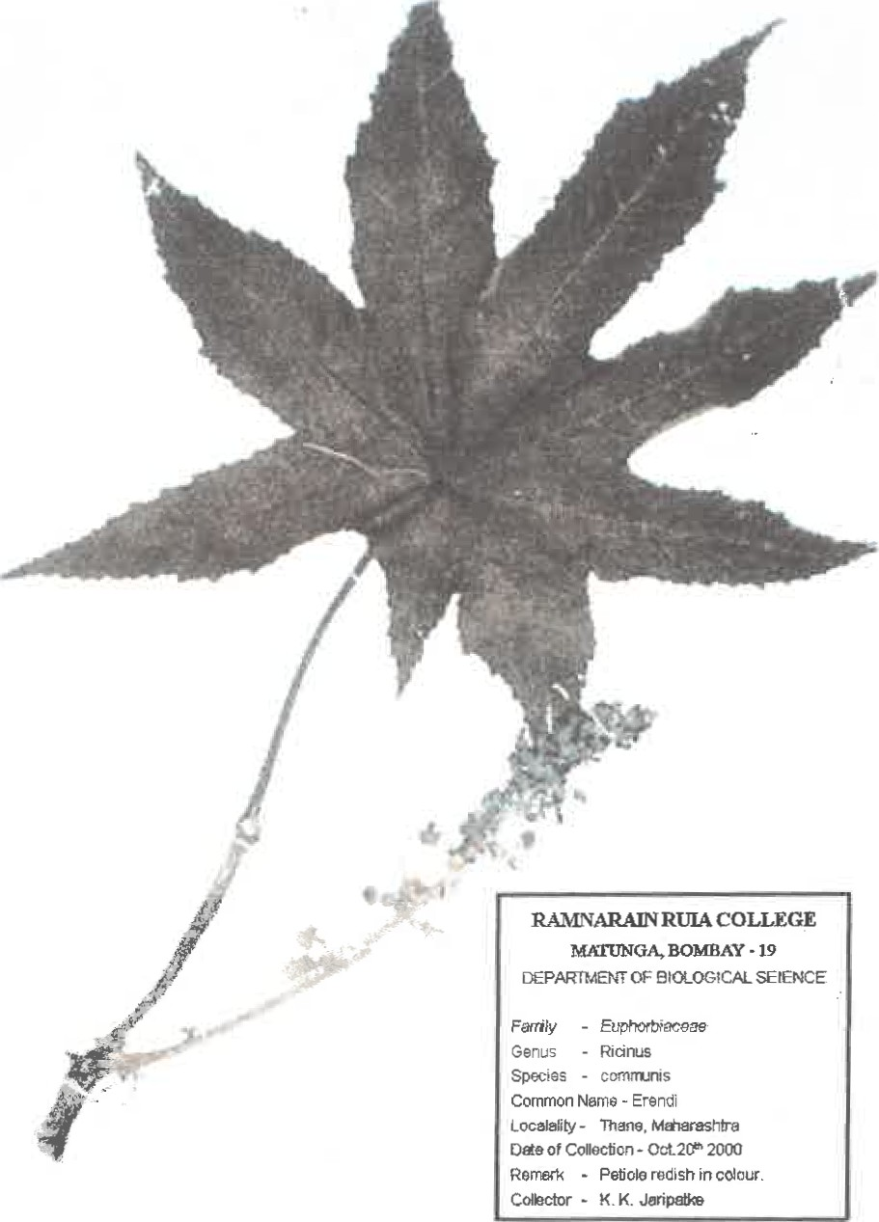
Fig:1
MAIN STUDY
The present research work describes a normal phase high performance thin layer chromatography method for establishing the marker compound of leaf powder of Ricinus communis (Linn).
Preparation of extracts of Ricinus communis leaf powder.
Chloroform was used as a solvent in the present study, as it showed maximum percentage extraction. 0.5 g of Ricinus communis leaf powder was taken in a stoppered conical flask. To it 10 ml of chloroform was added. The powder was mixed thoroughly. The flask was stirred and allowed to stand overnight. The extract was filtered through Whatman filter paper 41. The filtrate thus prepared was used for developing the marker of Ricinus communis leaf by HPTLC method.
Chromatographic conditions for detection of marker from leaf of Ricinus communis (Linn).
PARAMETERS | SPECIFICATIONS
Stationary phase | Silica gel 60 F 254 per coated TLC plates
Mobile Phase | Chloroform: Methanol: Glacial Acetic Acid  (8:0.3:0.1 :: v/v)
Development Chamber | CAMAG TWIN TROUGH CHAMBER
Sample applicator | CAMAG LINOMAT IV
Scanner | CAMAG TLC SCANNER II equipped with Cats 3.0- version software.
Saturation time | 1.00 Hr
Amount spotted | 10μl
Wavelength for detection | 254nm (UV)

HPTLC Method Development
Chloroform extract of Ricinus communis was applied on precoated HPTLC plates in the form of thin bands using nitrogen gas. Mobile phase consisting of Chloroform: Methanol: Glacial Acetic acid in the ratio of 8:0.3:0.1 (v/v/v) was used. A distinct marker was observed at Rf 0.68, showing maximum absorbance at 310nm.Linearity of this marker was found out by using HPLC method.
The market sample used for comparison:-
Name of the formulation: A polyherbal syrup
Formulation : Syrup containing 11 herbs.
Manufacturer claim : 625mg of Ruipatra (leaf of Ricinus communis) in 5ml of syrup.
- Sample preparation:
4ml of sample syrup was taken in a clean dry test tube. 10ml of Chloroform is added to it. The test tube was shaken on a cyclomixer continuously for 10minutes and is allowed to stand for 30minutes. The aqueous layer from the test tube was removed and 8ml of chloroform layer was filtered through sodium sulphate, placed on a Whatman filter paper no.41. It was then transferred to a clean dry test tube. Chloroform layer was evaporated to dryness in a water bath, preset at 60⁰C. After evaporation of chloroform, 500μl of chloroform was added to the test tube and the contents were vortexed. 10μl was spotted on HPTLC plate.

- Standard preparation:
0.5g of Ricinus communis leaf powder was taken in a clean, dry test tube. 10ml of chloroform was added to it. The test tube was shaken well on a cyclomixer for 10 minutes and was allowed to stand for 30minutes. The aqueous layer was removed and chloroform was filtered through sodium sulphate, placed on a Whatman filter paper no 41. 8ml of chloroform was taken in a test tube and was evaporated to dryness. It was then reconstituted in 500μl of chloroform. 10μl of the standard was spotted on HPTLC plate.
After scanning the plate under UVlight a single band was observed at Rf 0.68 under 310nm.
Linearity of this marker was ascertained by subjecting the samples of concentrations ranging from 5, 10, 30,100, 200 and 500µg/ml, by using HPLC method. HPLC system used in the present study was JASCO PU-1580 with JASCO MD- 1510 PDA detector. Column used was COSMOSIL 5C-18-MS, size 4.6X 150mm. manufacture No K01016.

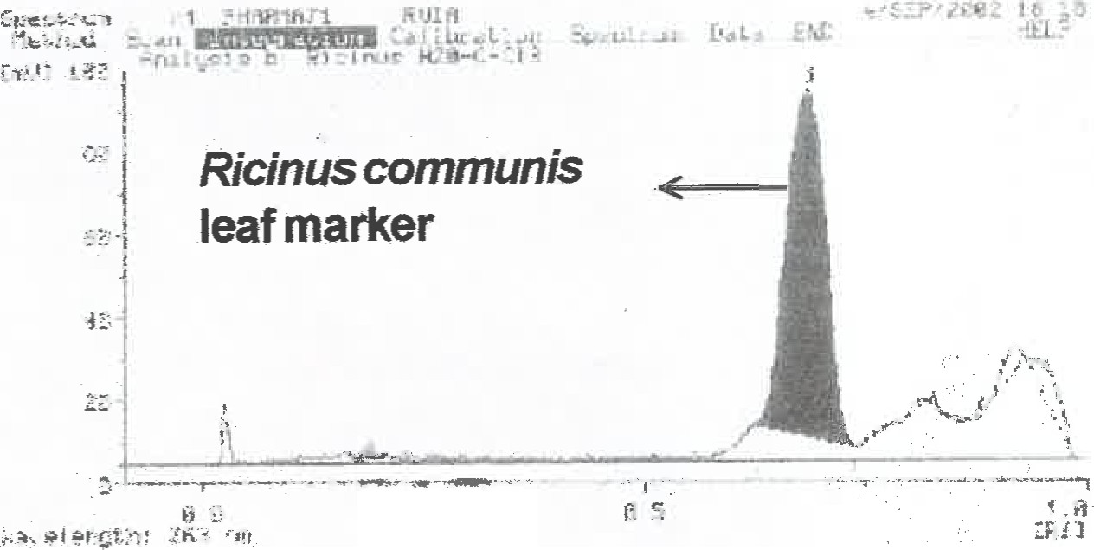
Fig: 2 HPTLC chromatogram showing marker at Rf 0.68

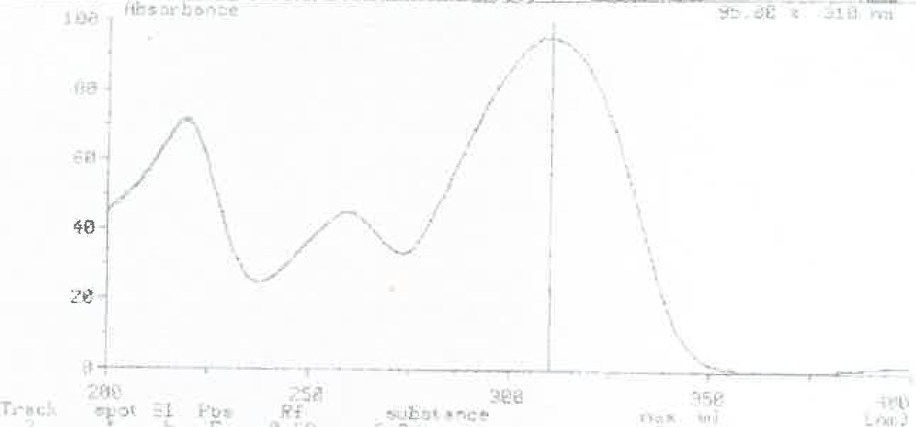
Fig: 3 Spectrum of Ricinus communis leaf Marker
showing maximum absorbance (max) at 310nm

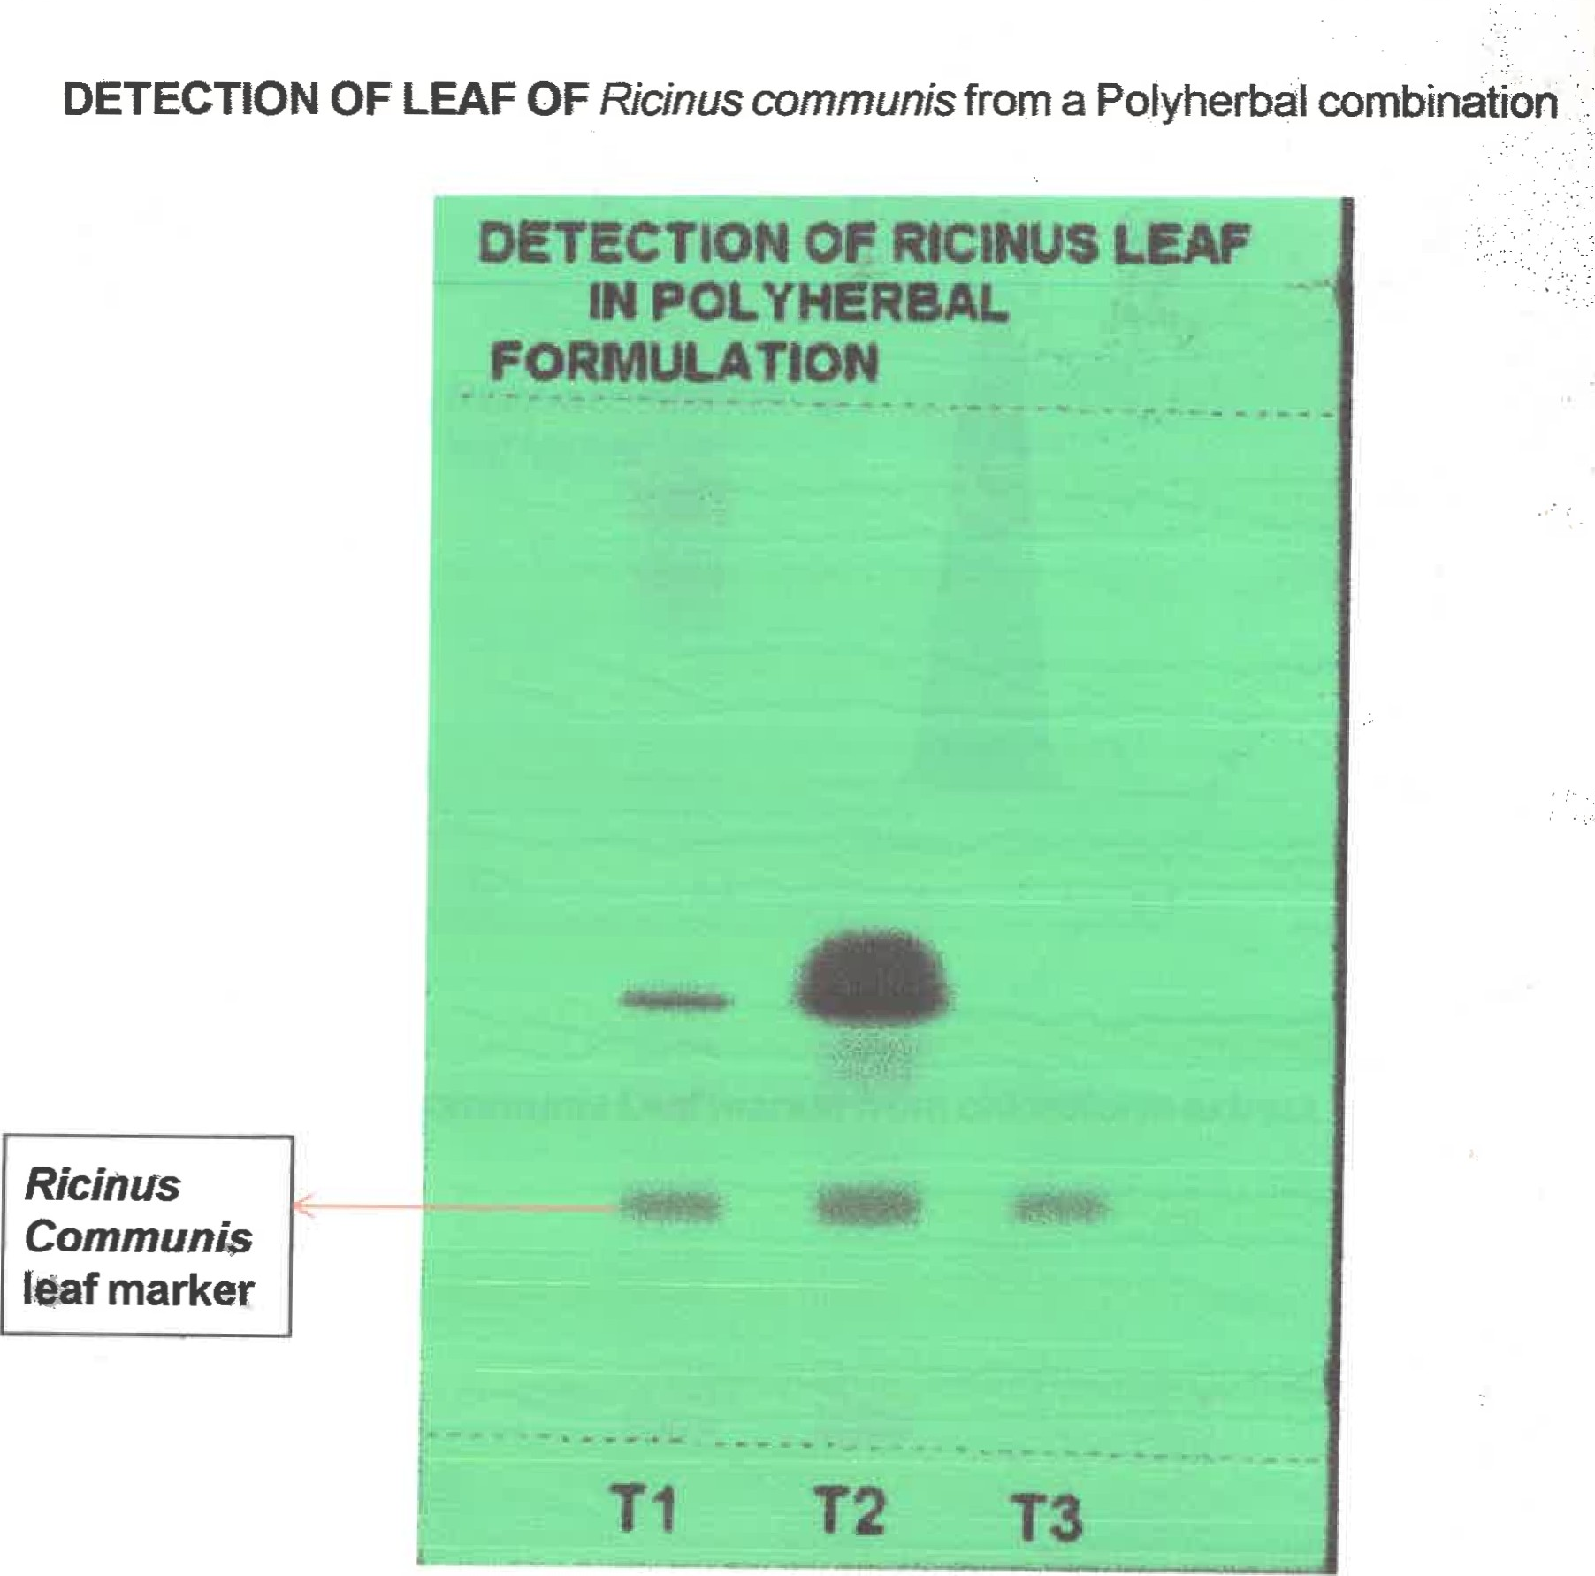
Fig: 4 HPTLC plate observed under UV.
Tl = Chloroform extract of Ricinus communis leaf.
T2 = Chloroform extract of Polyherbal formulation.
T3 = Standard (in house preparation)

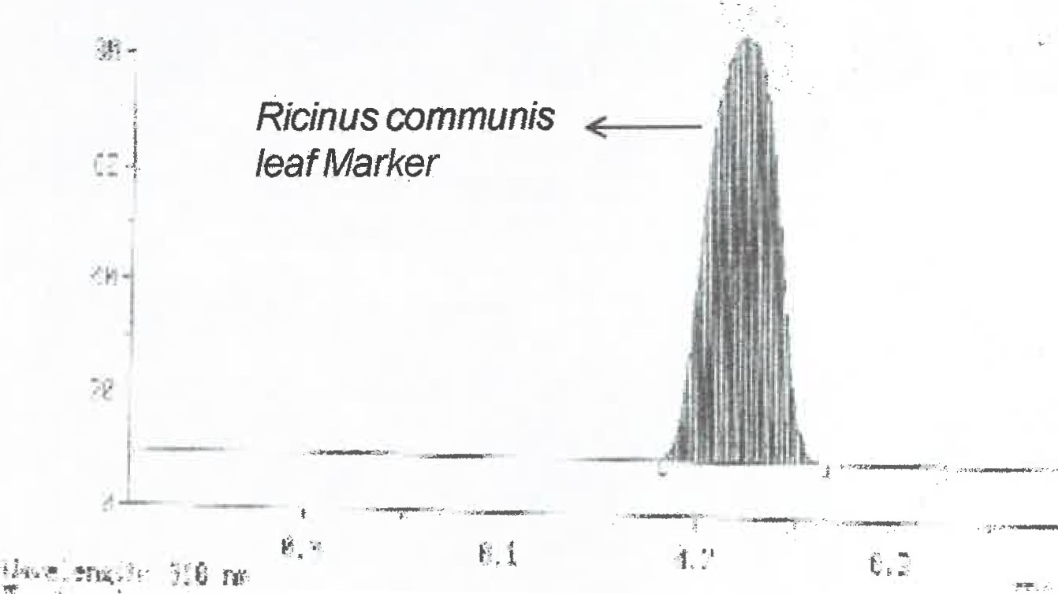

Fig: 5 Chromatogram of Ricinus communis Leaf marker (T1) from chloroform extract.

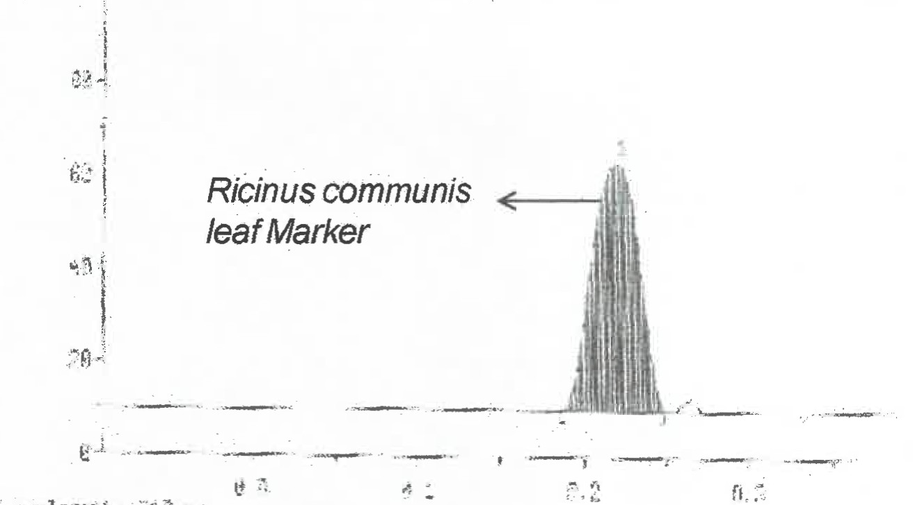
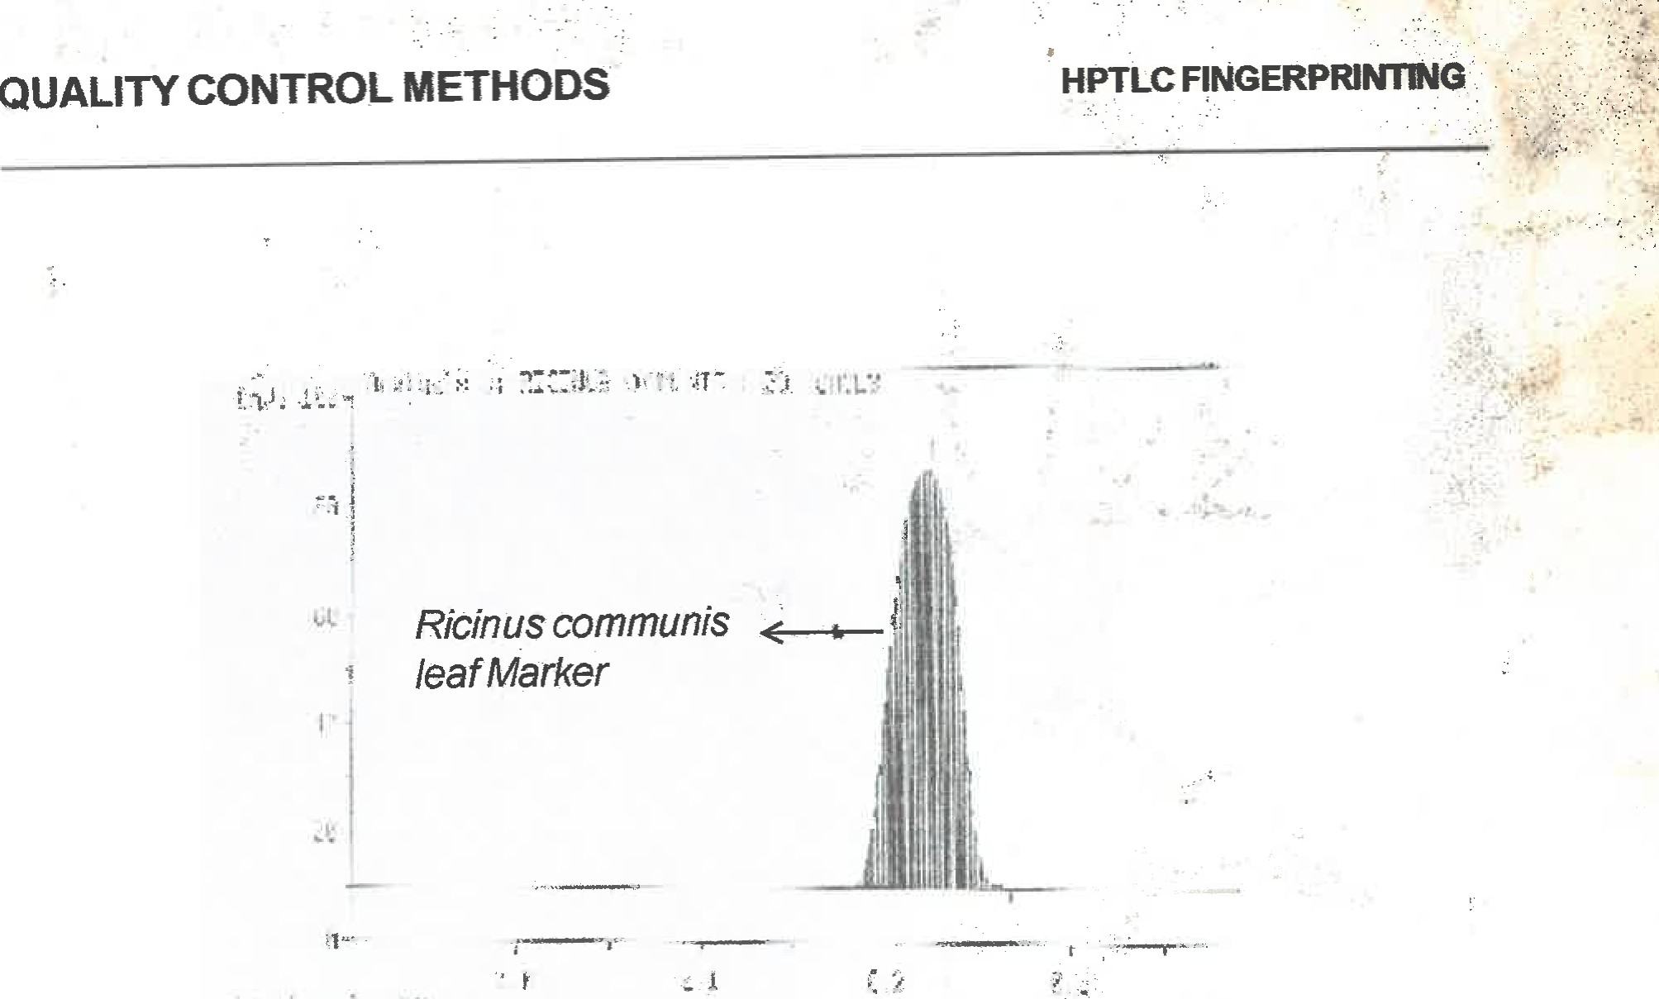
Fig: 6 Chromatogram of Ricinus communis Leaf marker (T2) from Polyherbal formulation.

Fig: 7 Chromatogram of Ricinus communis leaf marker (T3) (standard) in-house preparation

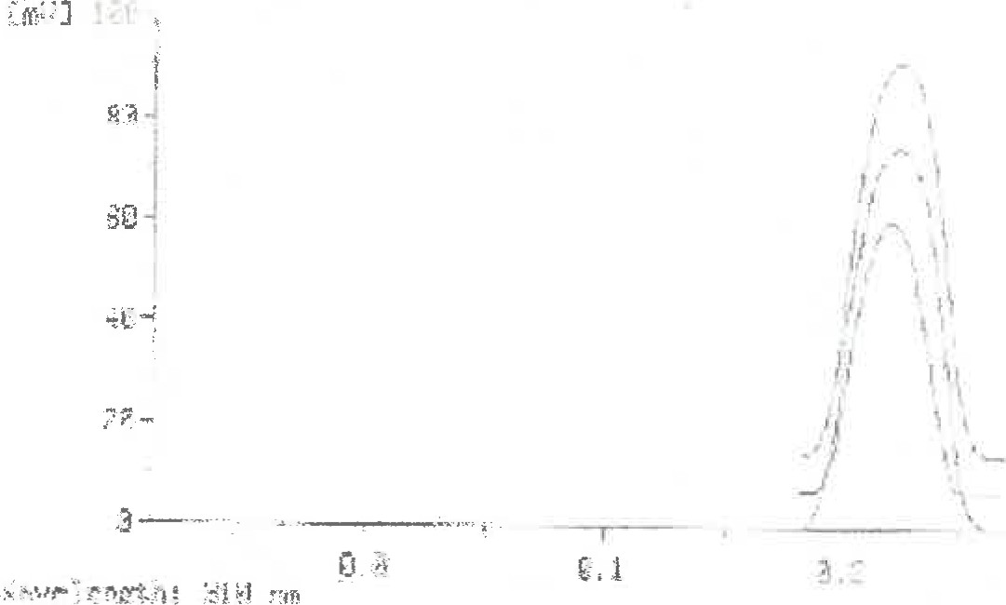
Fig: 8 Overlay of spectra of Ricinus communis leaf marker from T1, T2 and T3.

OBSERVATIONS
- After developing and scanning the HPTLC plate at 310nm, a single, distinct band was observed at Rf 0.68, track 1. This was a Ricinus communis leaf marker.

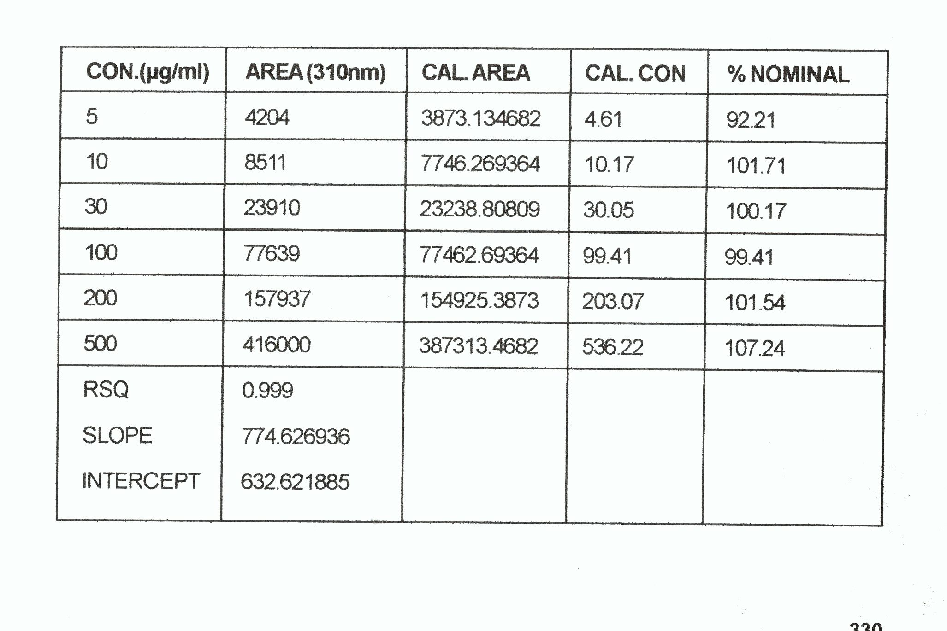
Table: 1 Linearity of Ricinus communis leaf marker by HPLC

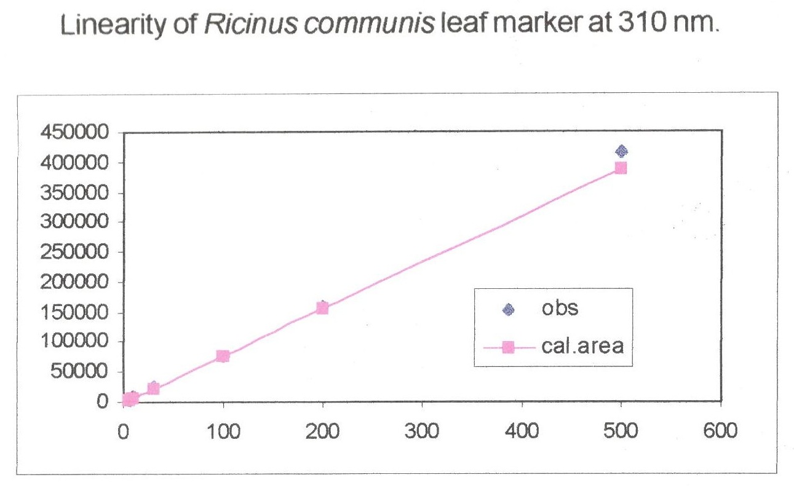
X-axis -Concentration of solutions
Y-axis -AUC
Fig: 9 Linearity of Ricinus communis leaf marker
Quantitation of Ricinus communis leaf from poly herbal formulation.
Calculations for standard:-
By applying simple mathematical equations, calculations were carried out.
As 500mg of Ricinus communis leaf powder was added to 10ml of Chloroform and 8ml of chloroform was evaporated to dryness.
Therefore, 8ml of chloroform contains 400 mg of Ricinus communis leaf powder.
The residue was reconstituted in 500μl of chloroform and 10μl of this was spotted on the HPTLC plate. After scanning the spots, the average AUC (Area Under Curvature) was found to be 1609. 9.
The area of standard was 1609.9 which contain 8mg of Ricinus communis leaf powder.
Calculations for sample :-
4 ml of sample was added to 10ml of chloroform. 8ml of this was evaporated to dryness.
Therefore, 8ml of CHCl₃ contain 3.2ml of sample.
The chloroform extract was reconstituted in 500μl. 10μl of this spotted on HPTLC plate. Area of the sample is 1967.7.
As 1609.9 AUC is equivalent to 8mg of the standard.
1967.7 AUC is equivalent to 9.777mg of Ricinus communis leaf.
As 10μl of the sample, having area of 1967.7 is equivalent to 9.777mg of Ricinus communis leaf.
Therefore, 500μl will contain 488.65mg of Ricinus communis leaf.
As 3.2ml of sample corresponds to 488.65mg of Ricinus communis leaf.
5ml of sample contains 763.51 mg of Ricinus communis leaf.
RESULT
The labelled claim is less than the calculated claim, as there is a probability that the manufacturers are adding overages. It can be an intentional addition of an extra amount of an active pharmaceutical ingredient or excipient beyond the label claim during manufacturing. This practice compensates for expected degradation, loss of potency over shelf life, or manufacturing process losses to ensure therapeutic efficacy, typically justified with documentations.
The aim of this work was to generate baseline study for developing in house markers which can be used as standard by small scale herbal pharma industries.
REFERENCES
- A. Douglas Kinghorn, Eun-kyoung (yuny) Seo, Chromatographic/Chromatographic Spectroscopic Combination Methods For The Analysis Of The Botanical Drugs, Drug Information Journal, Vol.32, (1998), 487-495.
- Dodakallanavar J, Hiremath K, Patil KS. Pharmacognostic evaluation and invitro antioxidanat potential of Bhovara Ipomoea cairica (L.) crude extract using various solvents. IJAM .2022; 13(3):661-6. Doi :10.447552/ijam.v13i3.3017.
- Hiremath R Jalapure S, Pethkar S. Chromatographic fingerprint analysis of medicinally important plants Elephantopus scaber L. using HPTLC technique. Indian J Pharma Educ Res. 2016; 50(4):689-94, doi10.5530/ijper. 50.4.21.
- Parsuram S, Thing GS, Dhanaraj SA, Polyherbal formulation :concept of Ayurveda.PharmacognRev. 2014; 8(16):73-80. Doi:10.4103/0973-7847.134229. PMID25125878.
- Patel AA, Amin AA, Patwari AH, Shah MB. Validated high performance thin layer chromatography method for simultaneous determination of quercetin and gallic acid in Leea indica. Rev Bras Farmacognosia. 2017; 27(1): 50-3. Doi:10.1016/j.bjp20 16.05.017.
- Parab Gaonkar V,Mannur VK, Hullati K, Quality assessment and Analytical Quality by Design - Based RP-HPLC method development for quantification of piperine in PIPER NIGRUM L. Future J Pharm Sci.2022;8(1):16.doi:10.1186/s43094-022-00405-9.
- Sethi (1994). High Performance Liquid Chromatography- Quantitative Analysis Of Pharmaceutical Formulations, CBS Publishers and Distributors.
- Sethi P. D., Charegaonkar, D. (1999) Identification Of Drugs In Pharmaceutical Formulations By Thin Layer Chromatography, CBS Publishers and Distributors, New Delhi, 2nd Edition.
- Sherma. J (2000) Chapter- “A Thin Layer Chromatography Cited in Encyclopedia of Analytical Chemistry”; Vol 13; Application: Theory and instrumentation edited by R-A-meyess, RAMTECH Ltd.; Tarzana, LA, USA; John Wiley and Sons.
- Touchstones and Sharma J. (1992), “Techniques and Application of Thin Layer Chromatography”, John Wiley and Sons, inc, USA; (1980).
- Zaltkis, A., Kaiser R.E. (1997); HPTLC – High Performance Thin Layer Chromatography.

