VOTIGEN: A Biometric-Based Secure Electronic Voting System

Abstract

The growing need for transparent, secure, and efficient voting systems has driven the adoption and implementation of biometric authentication techniques in electronic voting systems. VOTIGEN is a secure electronic voting system designed to implement the one-person-one-vote principle by using fingerprint authentication to address the limitations of traditional voting systems. This paper describes the system design, architecture, and implementation of the VOTIGEN electronic voting system with a focus on securing the system to eliminate voter impersonation and to improve efficiency for voter convenience. The proposed system has been implemented using various biometric authentication techniques, encrypted storage, and role-based access control to ensure the integrity of the electronic voting system and voter convenience and trust in electronic voting. The experimental evaluation of the system showed satisfactory results with respect to the efficiency of the system and the accuracy of biometric authentication techniques.
Keywords—Biometric Authentication, Electronic Voting, Fingerprint Recognition, Data Security, Electoral Systems, E-Governance.

INTRODUCTION

Democracy really depends on elections that people can trust, where everything is open and works well enough. Traditional ways of voting, like using paper ballots and checking IDs by hand, run into all sorts of issues. Things like someone pretending to be another voter, or messing with the ballots, or even voting more than once, plus just how slow it all is. Electronic systems came along to make it better, but then there are these ongoing worries about hacking the data or not being sure who is who, which makes folks hesitant to fully go for it.

One big challenge in elections today is making sure each eligible person gets to vote exactly once, no more, no less. Regular ID checks with cards or people looking things over can get faked easily, or stolen, or just messed up by human error. It seems like biometrics could fix a lot of that, since they are based on things unique to each person. Fingerprints stand out because they do not change and are hard to fake, I think that makes them a good fit for verifying voters securely.

Fingerprint tech is already used in places like banks for security, or at borders to check people, and even for controlling access to buildings. It is accurate, not too expensive, and straightforward to set up. Bringing that into electronic voting should cut down on impersonation a ton, stop duplicates, and help build more confidence in the whole digital process. Public trust is key, and this might get us there.

This paper looks at VOTIGEN, which is an electronic voting setup that uses biometrics for security. It ties fingerprint checks to a central database and keeps votes stored safely. The design follows a client-server approach, with controls based on roles so only the right people get in, plus secure ways to communicate and automatic counting of votes. By linking the biometric part with good database handling, it makes sure voters are real without giving away vote secrets or letting anything get tampered with.

The main things this work brings are a fingerprint-based design for secure voting. It mixes in the verification with encryption for storage and handles votes automatically. There is role-based stuff to keep admins from unauthorized entry. Tests show it works reliably, authenticates accurately, and runs effectively. Some parts of this might overlap a bit, but overall, it addresses the core problems. I am not totally sure if every detail scales perfectly, but the basics seem solid.

II. LITERATURE REVIEW

Biometric electronic voting systems have been thoroughly examined as a means to address the weaknesses found in traditional voting systems. Numerous researchers have recommended the use of fingerprint and multi-modal biometric technologies to enhance voter verification, prevent duplicate voting, and improve the clarity of the electoral process.

Elumalai (2023) [1] suggested a fingerprint-based voting approach intended to overcome the shortcomings of standard Electronic Voting Machines (EVMs). The research points out security issues related to the current EVM setup and proposes using biometric fingerprint checks to guarantee individual voter identification. This system validates the voter’s identity with unique ID numbers and fingerprint information to avoid multiple voting attempts. While the approach enhances fairness and transparency, it mainly centers on biometric verification without thoroughly exploring security for databases or complex threat prevention methods.

Khalde et al. [2] developed a biometric voting framework aimed at fighting voter fraud, impersonation, ballot tampering, and incorrect vote tallying. Their plan employs a central biometric database for all registered voters and biometric scanners set up at polling places. This system boosts the trustworthiness of the identification process; however, issues related to securing the central database and protecting data privacy still need more investigation.

Prabhakara et al. [3] suggested a smart voting system that combines fingerprint and facial recognition technologies. By integrating Aadhaar-based identity validation with both facial and fingerprint scanning, the system enhances the accuracy of identification and diminishes the chances of duplicate or fraudulent voting. Although this multi-modal biometric strategy improves security, it adds more complexity to the infrastructure and relies on national identity databases, which might lead to privacy and regulatory challenges.

Sharath Kumar [4] introduced a voting machine enhanced with biometric features that focuses on maintaining the integrity of elections through fingerprint registration and verification. The research includes logs of authentication, timestamps, and systematic management of vote data to improve traceability and accountability. While this system shows better identity verification, it does not thoroughly examine possible attack pathways such as threats from within the organization or database manipulation.

Kasliwal et al. [5] presented an Aadhaar-centered election voting system that incorporates fingerprint verification within an online voting portal. This system seeks to eliminate unauthorized voting and minimize the mistakes common in manual methods. Despite being effective in reducing duplicate entries, the dependence on Aadhaar raises legal and privacy issues that need thorough consideration within data protection laws.

Research Gap
Current research mainly examines biometric verification to prevent impersonation and repeated voting. However, there has been little focus on:
• Comprehensive security threat modeling
• Separation of biometric authentication data from vote records
• Role-based access control for administrative security
• Mitigation of insider threats and database compromise

III. SYSTEM DESIGN AND METHODOLOGY

- System Architecture
The VOTIGEN system utilizes a secure client-server framework that combines biometric authentication devices with a centralized database management system. This design aims to facilitate safe voter verification, controlled access for administrators, and dependable vote recording, all while ensuring the confidentiality and integrity of the data.
The system consists of four main modules:
1) Voter Authentication Module
This module captures and verifies the biometric information of voters. A Morpho CBM-E2 fingerprint scanner collects fingerprint impressions during both the registration and voting stages. The obtained fingerprint undergoes processing and is transformed into a biometric template, which is securely held in the database. For authentication, the live fingerprint scan is matched with stored templates via the device's SDK to confirm the voter's identity.
2) Admin Control Panel
The administration module allows designated election officials to set up and manage the election process. This encompasses approving voter registrations, managing candidates, scheduling elections, and overseeing results. Access to this module is limited by role-based authentication systems to safeguard against unauthorized changes.
3) Voting Interface
The voting interface offers a secure and intuitive platform where authenticated voters can submit their ballots. Access to the ballot is permitted only after successful biometric verification. This interface ensures that voters can select their candidates discreetly, and once the vote is cast, it is immediately recorded in the database.
4) Database Management System
The centralized database contains voter information, biometric templates, candidate details, and encrypted voting data. To uphold ballot privacy, biometric authentication information is logically separated from voting records. This division guarantees that votes remain untraceable back to individual voters, thus maintaining anonymity.

- System Workflow
The operational flow of VOTIGEN is categorized into four distinct steps:
1) Registration Phase
Eligible voters input their personal information along with their fingerprint data. The fingerprint is collected using the biometric device and transformed into a digital template. This template is securely stored in the database alongside a unique identifier for each voter.
2) Authentication Phase
During the election phase, voters verify their identities by scanning their fingerprints. The system conducts a one-to-one or one-to-many template matching process to confirm identity. If verification is successful, the system checks if the voter has already cast their ballot.
3) Voting Phase
After authentication and confirmation, the voter can access the electronic ballot. The voter chooses their preferred candidate, and the vote is securely registered. The system then automatically updates the voter's status to prevent any duplicate voting.
4) Result Compilation Phase
Votes are automatically counted within the database. The system produces real-time or post-election results that are only accessible to authorized administrators. Since the counting is automated, the possibility of errors from manual counting is reduced.

- Data Security and Protection Mechanisms
Due to the sensitive nature of biometric and election data, several security measures are incorporated into the system:
Encrypted Storage: Sensitive information, such as biometric templates and voter credentials, is safeguarded using secure hashing and encryption methods.
Role-Based Access Control (RBAC): Administrative access is categorized to limit unauthorized access to voter information and election data.
Network Security Layers: Firewalls and safe server setups shield the system from outside attack efforts.
Duplicate Vote Prevention Mechanism: After a vote is made, the system marks the voter record, stopping duplicate or repeated voting efforts.
Data Separation Principle: Biometric authentication information is kept apart from voting data to maintain the secrecy of ballots.
Together, these methods improve the system's strength against identity theft, illegal entry, and data alteration.
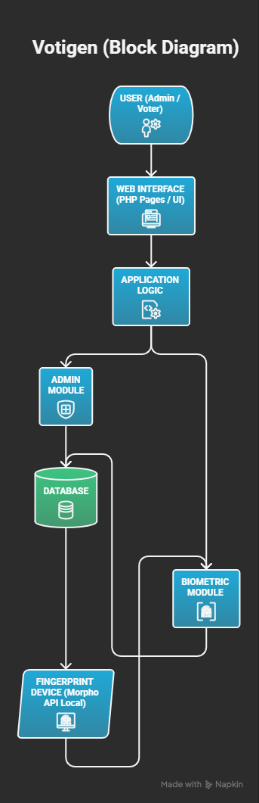

IV. IMPLEMENTATION OVERVIEW

The VOTIGEN platform was established as an online electronic voting system that utilizes biometric verification alongside a centralized data management process. This setup merges hardware-based fingerprint collection with application logic on the server side to guarantee secure validation of voters and accurate recording of votes.

- Development Environment
The software was created with PHP for server-side coding, and MySQL served as the relational database management system. The user interface was crafted using common web technologies to ensure it is easy to access and user-friendly. The client-server architecture allows for centralized data oversight while providing secure remote access through validated sessions.
For biometric functionality, the Morpho CBM-E2 fingerprint scanner was employed. This device was integrated with the system via its exclusive Software Development Kit (SDK), which supports fingerprint capturing, template creation, and matching tasks. The SDK ensures dependable extraction and verification of templates by adhering to established biometric matching standards.

- Functional Implementation
The system consists of several essential functional elements:
Secure Fingerprint Authentication:
During the registration process, a fingerprint is taken and transformed into a digital template using the Morpho SDK, which is kept safely in the database. When voting occurs, live fingerprint matching verifies the voter's identity prior to granting access to the ballot.
Role-Based Access Control (RBAC):
The system establishes specific access levels for both administrators and voters. Administrator rights are limited to managing election setups, overseeing voters, and monitoring results. Any unauthorized access attempts are blocked through session checks and validation steps.
Automated Vote Recording and Counting:
As soon as a validated voter casts their ballot, it is instantly recorded in the database. The system updates vote counts automatically, which removes the need for manual tallying and lowers the chance of calculation mistakes.

Duplicate Vote Prevention Mechanism:
After a voter successfully submits their ballot, their status is changed in the database to prevent any further voting attempts. This mechanism upholds the principle of one person, one vote.

C. System Testing and Performance Evaluation
The system underwent testing in a controlled setting to assess its reliability, response times, and accuracy in authentication. The performance assessment centered on the success rate of biometric verification, system responsiveness during high-demand periods, and the consistency of the database.
Observations from the experiments showed that the fingerprint verification success rate exceeded 95%, indicating a trustworthy ability for voter identification. Minor delays were noted during high volumes of authentication requests, yet the system maintained performance within acceptable limits. No occurrences of duplicate voting or unauthorized access were identified during the testing phase.
The findings indicate that the combination of biometric verification with web-based voting frameworks significantly improves both security and efficiency over conventional voting methods.

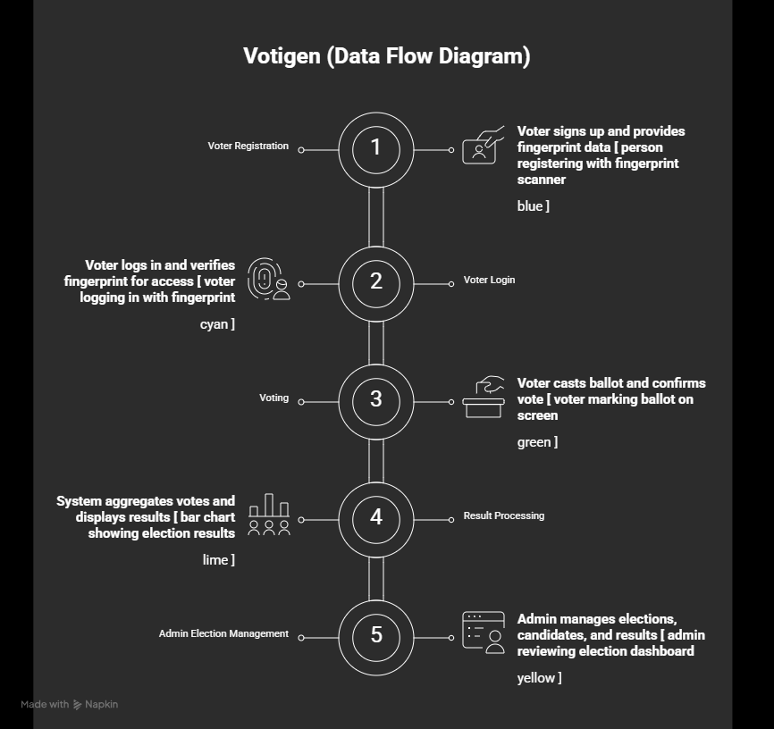

V. RESULTS AND DISCUSSION

The first-hand experience with the implementation and systematical evaluation of VOTIGEN demonstrated that the adoption of new technology in voting with biometrics, has brought substantial improvements in authentication trustworthiness, operations efficiency, and system security when compared to conventional voting systems.

A. AUTHENTICATION PERFORMANCE
Detailed studies revealed that the rate of successful fingerprint verification was more than 95%, determining the reliability of biometric methods to establish identity. The system also efficiently prevented multiple voting by automatically changing the status of the voter after submitting the ballot.
Alteration in the identity of the voter through unauthorized access demonstrated the effectiveness of role-based access control and session validation mechanisms, which are features of the system.

B. Operations Efficiency
The automation of the recording and tallying of the votes through the mechanization has totally done away with the errors coming from the manual counting and also extensively curtailed the period during which the outcome of the voting ballot has been given.
VOTIGEN was capable of speeding up the voting procedure and the instantaneous announcement of the results as opposed to the traditional paper system that needed physical verification and manual counting.

C. Security Evaluation
By separating the biometric images from the election data, the system ensured the anonymity of the voters while perfectly securing the verification process. Besides, data encryption and limited administration access have significantly reduced the opportunities of data being changed by unauthorized personnel.
Out of the myriads of operational problems, a few major ones were identified:
Hardware Dependency: Since a biometric system works by using device and sensor drivers through Software Development Kits, the system will inherently operate on the compatibility of those drivers and thereby, that it limits the portability of apps across different platforms.
Authentication Latency: During instances when the authentication requests had a high volume, there were slight delays in response which indicates that server scaling needs to be improved during large-scale implementation.
Data Privacy Concerns: Due to the fact that biometric information is highly sensitive, it is of paramount importance to comply strictly with data protection laws and secure storage practices when actually implementing.

D. Discussion of Comparisons
Compared to traditional voting systems that might not be equipped with the latest technologies such as biometrics, VOTIGEN not only increases the accuracy of authentication of voters but also significantly reduces manual work, thus, resulting in transparency of the outcomes. Modern e-voting solutions, as a matter of fact, are capable of addressing solely the issue of efficiency in voting mechanisms, yet with the help of biometric verification, identity checks can be heavily reinforced thus drastically reducing the possibility of election frauds
In a nutshell, the results from this research provide strong evidence that an electronic voting system using biometric as the main method of verification is able to enhance the electoral integrity level, as long as the issues of scalability, legislative compliance, and infrastructure security are marginally covered.

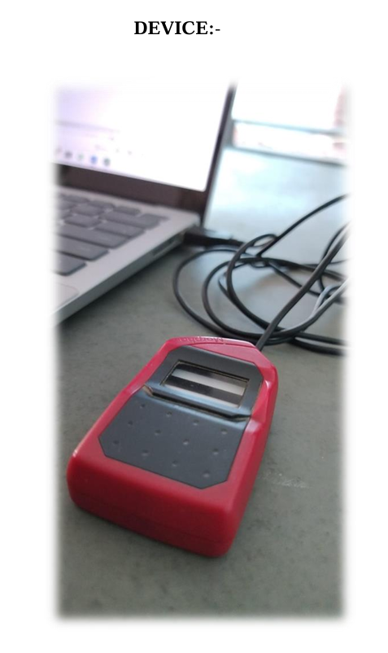

Device details: -

Device Make: Morpho

Device Model: CBM-E2

Device Serial: 293633765-1526I014564

Device driver: MorphoSmart USB Driver x86

VI. CHALLENGES AND MITIGATIONS

Even with the encouraging results of VOTIGEN, a number of technical, operational, and regulatory challenges were uncovered during the design and testing of the system. Overcoming these obstacles is essential for the large-scale real-world implementation.
A. Privacy and Data Safety
Biometric information, especially fingerprint templates, belong to the very sensitive personal data. If such data is accessed or leaked without permission, it could lead to serious privacy violations.
Solution Approach:
To lessen the danger, the system uses data encryption and secure hashing to store credentials. Client-server interaction is secured by encrypted communication channels. Besides, biometric templates are logically separated from voting records to preserve ballot confidentiality and avoid voter tracking.
B. System Failures and Reliability Issues
Dependence on biometric hardware entails certain risks as the devices may break down, drivers may be incompatible, or servers may be down. The electoral process may lose credibility if the system is inaccessible even once during an election.
Solution Approach:
To reduce the probability of service failures, redundant server setups and backup authentication procedures have been implemented. Regular system maintenance and compatibility checks are recommended to keep the system reliable.
C. Public Trust and Acceptance
There might be suspicion when using electronic biometric voting systems because of the potential for manipulation, violation of privacy, and the technology being too complex.
Solution Approach:
Transparency, audit trails, and clear documentation of procedures improve accountability. Public awareness-raising and demonstration events can help to restore confidence in the system's reliability and trustworthiness.
D. Costs and Infrastructure Requirements
Biometric gadgets, secure servers, and qualified personnel required for a large-scale rollout may increase the company's expenses.
Solution Approach:
The modular software architecture makes it possible to have an expandable implementation. Use of shared biometric kiosks and gradual infrastructure improvement can increase the efficiency of hardware utilization.
E. Compliance with Legal and Regulatory Standards
It is necessary to comply both with national laws on data protection and with election regulations when processing biometric data. Otherwise, one may face legal and ethical problems.
Solution Approach:
The system's architecture complies with data minimization principles and implements secure storage requirements. Any link to the national ID database must strictly follow regulatory guidelines and privacy governance rules.

VII. FUTURE SCOPE

While VOTIGEN demonstrates the feasibility of fingerprint-based electronic voting, a few enhancements could be made to further increase the system's robustness, scalability, and reliability.
A. Combining Different Biometric Methods
The next versions may consider integrating various biometric authentication methods together whereby fingerprint verification is accompanied by facial or iris recognition. Multimodal ones have the advantage of reducing false acceptances and rejections, thus increasing overall accuracy and resistance to spoofing attempts.
B. Linking with National Identity Frameworks
Establishing a connection between the system and national identity databases such as Aadhaar may solidify the identity of the voters thus prevent multiple registrations. However, such a linkage must be carried out under strict regulatory control to safeguard data privacy and avoid misuse.
C. Utilizing Blockchain for Vote Recording
It is believed that the use of blockchain technology to store votes could increase the transparency of the voting process and limit tampering. A distributed ledger system would guarantee tamper-proof vote records, verifiable audit trails, and decentralized validation processes, thus increasing public trust in electronic elections.
D. Enhanced Scalability and Cloud-Based Deployment
Future studies may focus on cloud deployment options with load balancing features to cater to large national elections. Moreover, performance enhancement and the use of distributed authentication nodes may allow voters to experience less waiting time during the peak voting hours.

VIII. CONCLUSION

electronic voting system with biometric technology for the purpose of ensuring voting results integrity and operational transparency in elections. Making use of fingerprint verification coupled with a centralized database management and encryption methods, the system facilitates the principle of one-person-one-vote while reducing the possibility of voter impersonation, duplication, and errors during manual processes. Furthermore, this system has tremendously improved the reliability of authentication through biometric verification as well as the ease of recording and compiling votes.
Since biometric data is stored separately from the voting data, the confidentiality of the votes is ensured. Also, the security of the system is increased by the use of administration role-based controls. The testing phase of this system has revealed that it can authenticate users with a high level of accuracy and it can likewise perform reliably under controlled conditions.
This proposed architectural design structure is a feasible foundation for a secure digital voting platform although there are still some challenges to be addressed such as scalability, dependence on specific hardware, and meeting regulatory requirements which makes the place of this proposed architectural design as a feasible foundation for a safe digital voting platform.
Through further enhancements such as the use of multiple biometrics and blockchain-based voting storage, VOTIGEN may become a pioneering factor for electronic governance systems.
In essence, this paper has demonstrated that biometrics as an authentication mechanism provides an effective e-voting solution which could safeguard the democratic process in today's world where digital forms of communication and access are rapidly increasing.

