DEVELOPMENT OF NUTRI BAR ENRICHED WITH DATE SEED POWDER AND PSYLLIUM HUSK

ABSTRACT :
The present study aimed to develop and evaluate a functional nutribar enriched with date seed powder and psyllium husk, focusing on enhancing dietary fiber content and promoting overall health benefits. Functional snack products have gained increasing attention due to their role in preventing lifestyle-related disorders such as obesity, diabetes, and cardiovascular diseases. In this context, the utilization of agro-industrial by-products like date seeds offers a sustainable and nutritionally valuable approach to product development. Date seed powder is recognized as a rich source of insoluble dietary fiber and phenolic compounds, contributing to antioxidant activity and improved gut health. Psyllium husk, derived from Plantago ovata, is a well-established soluble fiber known for its gel-forming ability and its role in regulating blood glucose levels, cholesterol reduction, and digestive health improvement (Sanlier & Ozler, 2026; Halász et al., 2024). The incorporation of psyllium into food systems has also been reported to enhance functional properties and act as a natural binding agent in fiber-enriched food products. The nutribar formulation consisted of foxtail millet, chia seeds, flax seeds, pumpkin seeds, cashews, and almonds, providing a balanced composition of macronutrients, essential fatty acids, and micronutrients. Peanut butter and date syrup were used as natural binders to improve cohesiveness and palatability without the addition of refined sugars. Response Surface Methodology (RSM) was employed to optimize ingredient proportions and to study their effect on physicochemical and sensory characteristics. Texture Profile Analysis (TPA) was conducted to evaluate hardness, cohesiveness, and chewiness of the developed nutribar. Previous studies have indicated that incorporation of high-fiber ingredients significantly influences texture due to the disruption of matrix structure and water-binding properties (Sucharitha et al., 2022). The developed nutribar showed improved nutritional quality, particularly in dietary fiber content, compared to conventional snack bars. The findings suggest that date seed powder and psyllium husk can be effectively utilized in functional food development to produce value-added, health-promoting snack products. Further shelf-life studies are required to evaluate product stability under storage conditions.
Keywords: Date seed powder; Psyllium husk; Functional nutribar; Dietary fiber; RSM; Texture Profile Analysis; Response Surface Methodology.

INTRODUCTION

In recent years, functional foods have become one of the fastest-growing sectors in the global food industry due to increasing awareness of the connection between diet and long-term health (Sharma et al., 2023). These foods not only satisfy hunger but also provide additional physiological benefits beyond basic nutrition. According to the European Commission (2022), regular consumption of functional foods can help reduce the risk of chronic diseases. Unlike nutraceuticals, they are intended for daily consumption rather than medicinal use. Unhealthy dietary patterns, particularly low dietary fiber intake, are strongly associated with the rising prevalence of non-communicable diseases (NCDs) such as Type 2 Diabetes Mellitus, obesity, and cardiovascular disorders (Kumar et al., 2024). Therefore, increasing dietary fiber intake has become an important strategy for preventing and managing such conditions (Rao & Menon, 2023). Higher consumption of fiber-rich foods has also been shown to improve glycemic control and reduce metabolic risks (Singh et al., 2024).
Among functional components, dietary fiber—especially soluble fiber—has gained significant attention due to its role in regulating blood glucose, lowering cholesterol, and improving digestive health (Thomas et al., 2023; Iyer & Nair, 2025). Psyllium husk (Plantago ovata) is a well-known soluble fiber with excellent water-binding and gel-forming properties, widely recognized for improving bowel movement, reducing cholesterol, and supporting glycemic control (Halász et al., 2024).
There is also growing interest in utilizing food processing by-products as functional ingredients. Date seeds, often discarded, are rich in dietary fiber, antioxidants, and bioactive compounds. Converting them into powder enhances nutritional value while promoting sustainable food practices.
Snack foods, particularly nutribars, have gained popularity due to their convenience and ability to deliver balanced nutrition. They serve as an excellent medium for incorporating cereals, seeds, nuts, and fiber-rich ingredients. In this study, foxtail millet was used as a base due to its high fiber content, low glycemic index, and gluten-free nature. Chia seeds, flax seeds, and pumpkin seeds were included to improve essential fatty acids, protein, and micronutrients, while almonds and cashews enhanced nutritional and sensory quality.
However, incorporation of high levels of fiber-rich ingredients such as date seed powder and psyllium husk can affect texture, including hardness and cohesiveness, due to changes in water absorption and matrix structure (Sucharitha et al., 2022; Verma et al., 2023). Therefore, optimization of ingredient proportions is essential to maintain both nutritional quality and acceptability.
Response Surface Methodology (RSM) is widely used in food product development to optimize formulations by studying interactions between multiple variables (Ayustaningwarno et al., 2025). Hence, the present study focuses on developing a functional nutribar enriched with date seed powder and psyllium husk to enhance dietary fiber content while maintaining desirable texture and overall acceptability.

The study also highlights the potential of utilizing date seed powder as a value-added ingredient in sustainable functional food development.

MATERIALS AND METHODS

RAW MATERIALS
The experimental phase of the study was carried out in the Food Processing Laboratory under controlled conditions. The nutribar formulation was developed using a combination of functional and nutrient-dense ingredients, selected based on their nutritional significance and technological properties.
Foxtail millet (Setaria italica) was used as the primary base ingredient due to its excellent nutritional profile and functional properties. It is a gluten-free cereal rich in dietary fiber, complex carbohydrates, and essential minerals. Foxtail millet contributes to the structural integrity of the nutribar while also improving its nutritional quality, particularly in terms of fiber content and glycemic response (Rao et al., 2023; Singh et al., 2024). The millet used in this study was procured from local markets and used after appropriate cleaning and processing.
Date seed powder was incorporated as a value-added functional ingredient in the formulation. The seeds were obtained from freshly processed dates and converted into powder under optimized drying conditions. Date seed powder is known to be rich in dietary fiber, antioxidants, and bioactive compounds, making it a suitable ingredient for functional food development. Its inclusion not only enhances the fiber content of the nutribar but also promotes sustainable utilization of agro-industrial by-products (Khalid et al., 2021; Saini et al., 2024).

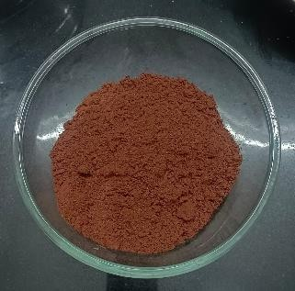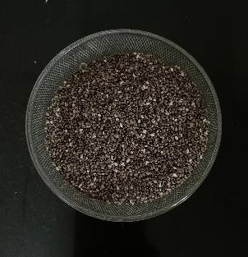
Fig 2.1.1 - Dateseed powder and Chiaseed
Psyllium husk (Plantago ovata) was added as a soluble dietary fiber source due to its excellent water-binding and gel-forming properties. It plays a crucial role in improving the binding, cohesiveness, and moisture retention of the nutribar. In addition, psyllium husk contributes to digestive health and glycemic regulation, thereby enhancing the functional value of the product (Ahmed et al., 2022; Patel & Shah, 2023).
Chia seeds (Salvia hispanica), flax seeds (Linum usitatissimum), and pumpkin seeds (Cucurbita pepo) were included to improve the nutritional profile of the nutribar. These seeds are rich in essential fatty acids, protein, dietary fiber, and micronutrients, contributing to the overall health benefits of the product. Their incorporation also enhances the texture and sensory characteristics of the nutribar (Sharma et al., 2023).
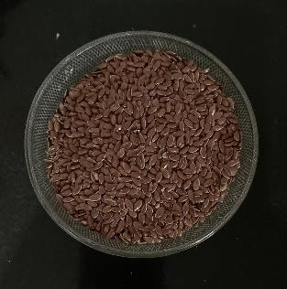
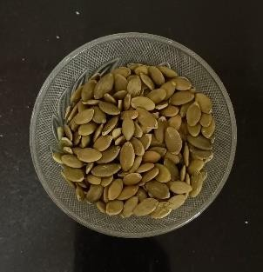
Fig 2.1.2 – Flaxseed and pumkin seed
Nuts such as almonds and cashew nuts were added to improve protein content, provide healthy fats, and enhance the sensory appeal of the product. These nuts contribute

to the overall energy value and palatability of the nutribar while also supplying essential vitamins and minerals.
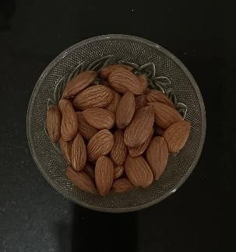
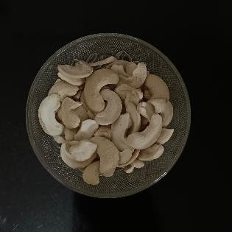
Fig 2.1.3 - Almonds and Cashewnuts
Peanut butter and date syrup were used as natural binding agents in the formulation. Peanut butter contributes to the fat and protein content while improving the texture and mouthfeel of the nutribar. Date syrup, being a natural sweetener, enhances the taste and acts as an effective binder, helping in the formation of a cohesive structure without the need for artificial additives.
All raw materials used in the study were procured from local markets and stored under appropriate conditions until further use.

PREPARATION OF DATE SEED POWDER
Freshly obtained date seeds were thoroughly washed with clean water to remove adhering pulp, dirt, and other foreign materials. The cleaned seeds were then air-dried to remove surface moisture and ensure uniform drying. Proper cleaning and pre-drying are essential to prevent microbial contamination and to improve the efficiency of the drying process (Ahmed et al., 2022; Rahman et al., 2023).
The cleaned date seeds were subjected to drying in a hot air oven at three different temperatures, namely 90°C, 100°C, and 110°C for a duration of approximately 2 hours. The selection of these temperature
ranges was based on previous literature reports indicating that controlled thermal treatment plays a significant role in preserving the functional and nutritional properties of seed-based powders (Khalid et al., 2021; Saini et al., 2024). Drying at appropriate temperatures is particularly important to reduce moisture content while minimizing degradation of dietary fiber and other bioactive compounds.
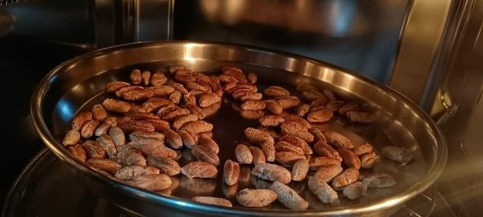
Fig 2.2.1 - Raw Dateseeds
After drying, the seeds were allowed to cool to room temperature and were then ground into a fine powder using a mechanical grinder. The powdered sample was sieved through a 60-mesh sieve to obtain a uniform particle size, ensuring better incorporation and consistency in the final product formulation. The prepared date seed powder was stored in airtight containers at ambient conditions until further use (Iyer & Nair, 2025).
The optimization of drying temperature was carried out based on the evaluation of moisture content and dietary fiber retention. Among the three temperatures studied, drying at 100°C for 2 hours resulted in a desirable balance between reduced moisture content and preservation of dietary fiber. Drying at lower temperature (90°C) resulted in comparatively higher moisture content, whereas higher temperature (110°C) may have led to slight degradation of functional components due to excessive heat exposure. Therefore, 100°C was selected as the optimal drying

temperature for the preparation of date seed powder, as it provided better stability and functional quality of the final product.
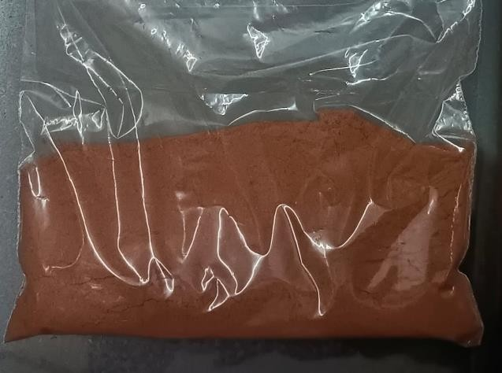
Fig 2.2.2- Dateseed powder (100ºC – 2 hours)

PSYLLIUM HUSK
Psyllium husk was included for its excellent hydrocolloid properties, particularly its high water-binding and gel-forming capacity. It plays a significant role in improving the structural integrity of the nutribar by enhancing cohesiveness and moisture retention. The incorporation of psyllium husk contributes to better binding of ingredients, thereby reducing crumbliness and improving the overall texture of the product.
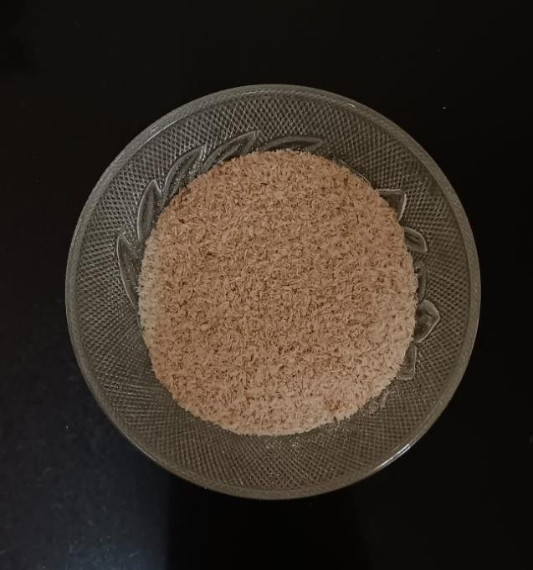
Fig 2.3 - Psyllium Husk
Additionally, due to its high soluble dietary fiber content, psyllium husk also enhances the functional value of the nutribar by supporting digestive health and glycemic control (Ahmed et al., 2022; Patel & Shah, 2023). However, its level was carefully optimized, as higher concentrations can increase hardness and negatively affect sensory acceptability (Kumar et al., 2024).

FOXTAIL MILLET :
Foxtail millet, used as a primary base ingredient, was selected for its nutritional richness and functional properties. It is a gluten-free cereal known for its high dietary fiber content, low glycemic index, and good mineral profile. In the formulation, foxtail millet contributes to the bulk structure and provides a firm matrix, which supports the overall texture of the nutribar. It also enhances the nutritional quality by increasing fiber and complex carbohydrate content. Moreover, foxtail millet has been reported to improve satiety and aid in blood glucose regulation, making it suitable for functional snack development (Rao et al., 2023; Singh et al., 2024). The quantity of foxtail millet was optimized through RSM to achieve a balance between structural stability and sensory acceptability of the final product.

PREPARTION OF NUTRIBAR
The nutribar was prepared using a simple mixing and molding technique. Initially, all dry ingredients, including foxtail millet, date seed powder, psyllium husk, along with selected nuts and seeds, were accurately weighed and mixed thoroughly to obtain a uniform blend. The binding agents used in this formulation were peanut butter and date syrup, which were gently heated using a double-boiling method at low temperature to achieve a soft and

cohesive consistency without degrading their nutritional quality.
The warmed binding mixture was then added to the dry ingredients and mixed uniformly until a well-bound mass was obtained. This mixture was then transferred into molds and pressed evenly to achieve the desired shape and thickness. The molded bars were allowed to cool and set at room temperature to improve firmness and structural integrity. After setting, the nutribars were demolded and further coated with 70% dark chocolate to enhance taste, texture, and overall acceptability. The final product was then packed and stored under suitable conditions for further analysis.
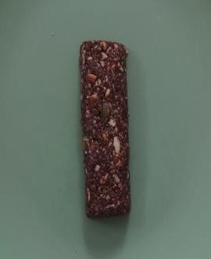
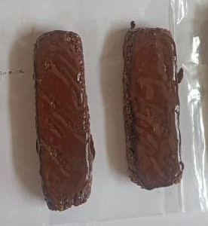
Fig 2.5 - Nutribar

PROXIMATE ANALYSIS FOR NUTRIBAR

DETERMINATION OF MOISTURE CONTENT
In order to evaluate product stability and shelf-life characteristics, the moisture content of the developed nutribar samples was determined. Moisture analysis was conducted in accordance with the standard methods prescribed by the Association of Official Analytical Chemists (AOAC, 2023).

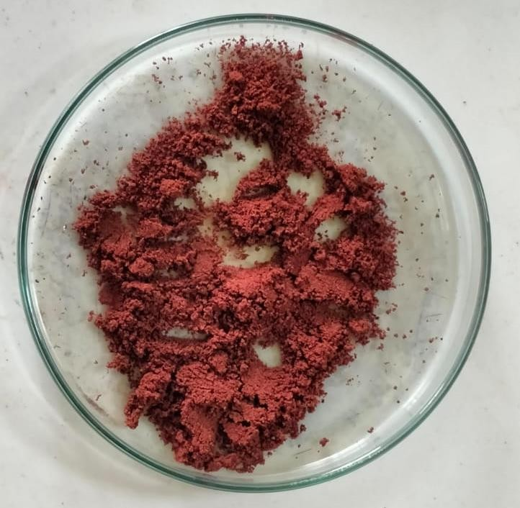
Fig 3.1 – Moisture content sample The moisture content of the developed
nutribar was found to be 10.88%, which is within acceptable limits, ensuring product stability during storage.

DETERMINATION OF DIETARY FIBER (%)
Total dietary fiber (TDF) of the nutribar was determined using the AOAC enzymatic–gravimetric method (AOAC, 2023).
The analysis was carried out to assess fiber enrichment due to the incorporation of date seed powder and psyllium husk. The developed nutribar showed a high dietary fiber content of 14.8%, indicating its functional significance and potential health benefits (Singh et al., 2023).

DETERMINATION OF ASH CONTENT (%)
Ash content was determined by the standard dry ashing method (AOAC, 2023).

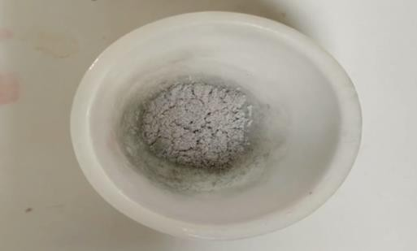
Fig 3.3 – Ash conent
The ash content of the developed nutribar was found to be 6.74%, indicating a good mineral contribution from foxtail millet and date seed powder (Rao & Menon, 2024).

DETERMINATION OF FAT CONTENT (%)
Fat content of the nutribar was determined using standard AOAC methods and expressed as percentage (%) of the sample. The developed nutribar contained 15.17% total fat, out of which 6.19% was saturated fat, while trans fat was 0%, indicating a healthier fat composition.

DETERMINATION OF PROTEIN CONTENT (%)
Protein content was determined using standard analytical methods and expressed as percentage (%). The nutribar exhibited a protein content of 14.49%, contributing to its nutritional quality and making it a suitable functional snack.

DETERMINATION OF CARBOHYDRATE CONTENT (%)
Carbohydrate content of the nutribar was calculated and expressed as percentage (%). The developed product contained 52.72% carbohydrates, serving as a major source of energy.

DETERMINATION OF SUGAR CONTENT (%)
Total sugar and added sugar content were determined and expressed as percentage (%). The nutribar contained 10.85% total sugars, with no added sugars, and a low free sugar content of 1.79%, making it suitable for health-conscious consumers.

ENERGY VALUE
The energy value of the developed nutribar was 407.62 kcal per 100 g, which corresponds to approximately 122.29 kcal per 30 g serving size, indicating its suitability as an energy-dense functional snack..

MINERAL AND VITAMIN CONTENT
The mineral content of the nutribar was expressed as mg per 100 g. The developed product contained 244 mg calcium, 12.1 mg iron, 185 mg sodium, and 435 mg potassium per 100 g. In addition, the nutribar contained 38 mg of Vitamin E per
100 mg, contributing antioxidant properties. Cholesterol content was found to be 0%, enhancing its health benefits.

TEXTURE PROFILE ANALYSIS
Texture Profile Analysis (TPA) was carried out to evaluate the textural characteristics of the developed nutribar using a texture analyzer. In this method, the sample is generally subjected to compression, and parameters such as hardness, cohesiveness, springiness, gumminess, and chewiness are obtained from the force–time curve (Bourne, 2002).
In the present study, the instrument output primarily displayed the peak maximum force, which corresponds to hardness. The developed nutribar exhibited a hardness value of 36 N, indicating desirable firmness

and good structural integrity of the product. However, other TPA parameters such as cohesiveness, springiness, gumminess, chewiness, break toughness, and combined force were not obtained in the output. This may be due to limitations in the testing method, instrument settings, or the nature of the sample, where the required second compression cycle or complete deformation curve was not fully captured. As a result, the analyzer did not detect or generate values for these parameters.
Despite this limitation, hardness remains a key indicator of textural quality, reflecting the firmness and bite characteristics of the nutribar. The obtained value suggests that the combination of foxtail millet, date seed powder, psyllium husk, and natural binding agents such as peanut butter and date syrup contributed to a well-structured and acceptable product texture.

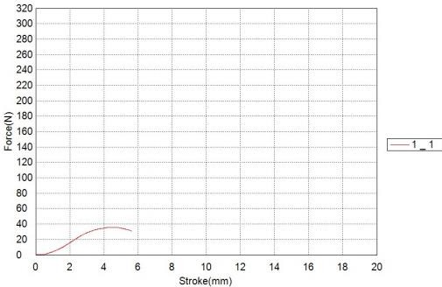

Fig 4 – Texture Profile Analysis Graph

STORAGE AND SHELF LIFE STUDIES OF CONTROL AND BEST COMPOSITE NUTRIBAR (S9)
The storage stability of the best composite Nutri Bar (S9) was tested for 30 days at room temperature (27 ± 2 °C) using polypropylene packaging. During this time, we checked the free fatty acid (FFA)
content as a sign of lipid breakdown and Texture Profile Analysis (TPA) was carried out at regular intervals to assess variations in hardness. Free fatty acid (FFA) content, which reflects the extent of lipid hydrolysis and rancidity development during storage. The FFA value of the nutribar showed a gradual increase over the storage period, indicating a slow rate of lipid degradation. However, the observed values remained within acceptable limits (below 1.0% oleic acid) throughout the study period, suggesting good lipid stability of the product after 90 days.
Texture Profile Analysis (TPA) was carried out at regular intervals to assess variations in hardness. Free fatty acid (FFA) content, which reflects the extent of lipid hydrolysis and rancidity development during storage. The FFA value of the nutribar showed a gradual increase over the storage period, indicating a slow rate of lipid degradation. However, the observed values remained within acceptable limits (below 1.0% oleic acid) throughout the study period, suggesting good lipid stability of the product after 90 days.
The relatively low moisture content of the nutribar (10.88%) played a significant role in maintaining its stability by limiting microbial growth and enzymatic activity. No visible signs of spoilage such as off-odour, fungal growth, or textural degradation were observed during the storage period. The texture of the nutribar remained acceptable, with no significant crumbliness or excessive hardness observed, indicating good structural stability. Polypropylene packaging used due to its excellent barrier properties against moisture, oxygen and light which are the major factors responsible for product deterioration and maintained optimal condtions for 30 days .

RESULT AND DISCUSSION
One of the most important aspects of scientific studies is the selection of an appropriate statistical method that minimizes experimental error and provides accurate interpretation of results. The choice of statistical tool depends on the nature and distribution of the data being analyzed (Kumar et al., 2022). present study, Response Surface Methodology (RSM) along with Analysis of Variance
characteristics of the developed nutribar. The Table 6 show the 17 runs given by the tool after setting the limit.
The control formulation (without optimization) showed variation in texture and binding properties, whereas the optimized nutribar exhibited improved structural stability due to the balanced combination of ingredients. Foxtail millet contributed to the bulk and base structure of the bar; however, unlike gluten containing

 |  | Factor 1 | Factor 2 | Factor 3 | Response  1 | Response  2 | Response  3 | Response  4
Std | Run | A:  Foxtail Millet | B:  Dateseed Powder | C:  Psyllium Husk | Moisture Content | Ash Content | Hardness | Sensory evaluation
 |  | g | g | g | % | % | N | (1-9  hedonic scale)
1 | 7 | 3 | 3 | 3 | 7.8 | 1.8 | 33 | 6.4
2 | 14 | 10 | 3 | 3 | 7.5 | 2 | 30 | 6.73
3 | 12 | 3 | 10 | 3 | 7.6 | 2.4 | 31 | 6.8
4 | 8 | 10 | 10 | 3 | 8.3 | 2 | 35 | 6.2
5 | 16 | 3 | 6.5 | 1 | 6.7 | 2.2 | 23 | 8
6 | 1 | 10 | 6.5 | 1 | 7.2 | 2.1 | 27 | 7.4
7 | 3 | 3 | 6.5 | 5 | 8.4 | 1.9 | 36 | 6.1
8 | 17 | 10 | 6.5 | 5 | 8 | 2.1 | 34 | 6.3
9 | 6 | 6.5 | 3 | 1 | 6.2 | 2.6 | 36 | 8.8
10 | 11 | 6.5 | 10 | 1 | 6.8 | 2.5 | 24 | 7.9
11 | 13 | 6.5 | 3 | 5 | 7.7 | 1.9 | 32 | 6.5
12 | 15 | 6.5 | 10 | 5 | 7.9 | 2.3 | 33 | 6.6
13 | 5 | 6.5 | 6.5 | 3 | 7 | 2.3 | 25 | 7.6
14 | 9 | 6.5 | 6.6 | 3 | 7 | 2.3 | 26 | 7.7
15 | 10 | 6.5 | 6.5 | 3 | 7.1 | 2.2 | 26 | 7.6
16 | 2 | 6.5 | 6.5 | 3 | 7 | 2.2 | 26 | 7.6
17 | 4 | 6.5 | 6.5 | 3 | 7.1 | 2.2 | 26 | 7.5
Table 6 – Trial table obtained from the Statistical tool - RSM

(ANOVA) was employed to evaluate the effect of varying levels of foxtail millet (3–10 g), date seed powder (3–10 g), and psyllium husk (1–5 g) on the quality
products, it does not form a strong protein network. As a result, the structural integrity of the nutribar depended largely on the binding agents and fiber interactions.

The incorporation of date seed powder significantly enhanced the dietary fiber and mineral content of the nutribar. However, higher levels of date seed powder tended to affect the texture by increasing density and slightly reducing cohesiveness. Psyllium husk played a crucial role due to its high water absorption and gel-forming ability, which improved binding and reduced crumbliness of the bar.

EFFECT OF INDEPENDENT VARIABLES ON MOISTURE CONTENT
At higher concentrations, psyllium husk increased water retention due to its hydrophilic nature, which contributed to the observed increase in moisture content of the nutribar.
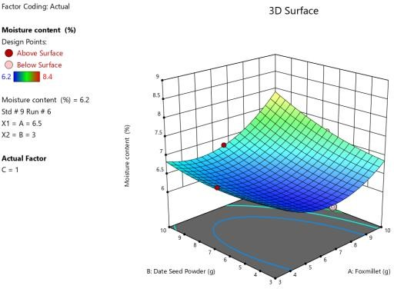
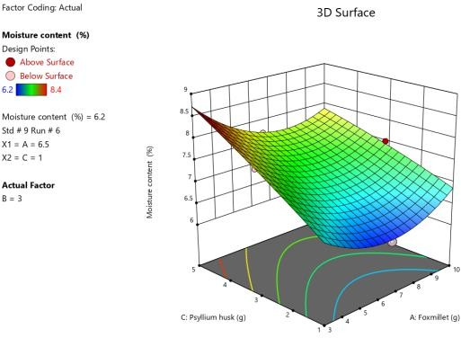

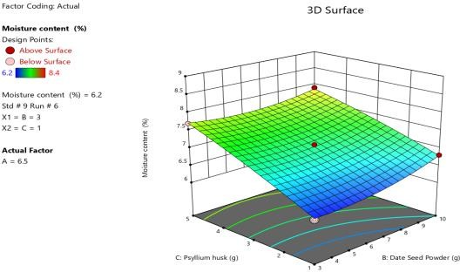
Fig 6.1.1 – 3D Surface plots for Moisture content

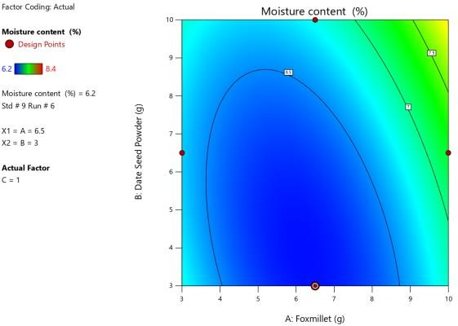
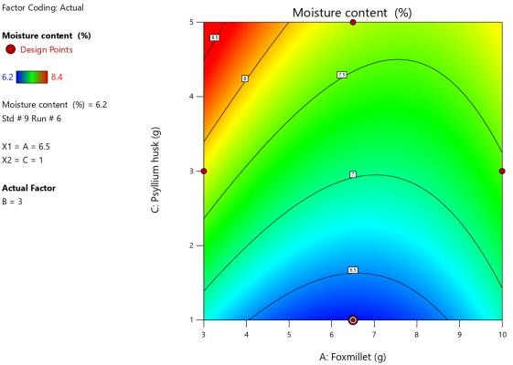
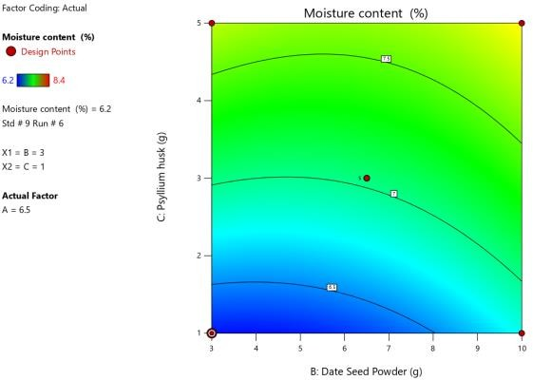

Fig 6.1.2 – Contour plots for Moisture content

EFFECT OF INDEPENDENT VARIABLES ON ASH CONTENT
The ash content increased with the incorporation of date seed powder due to its high mineral composition, contributing to improved nutritional quality.
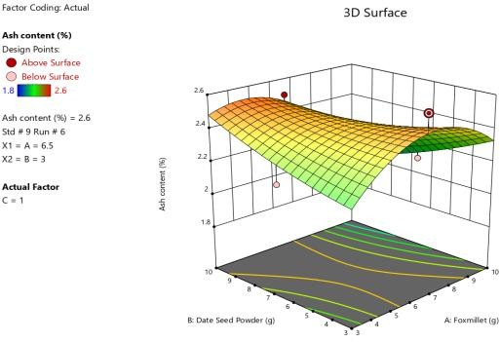
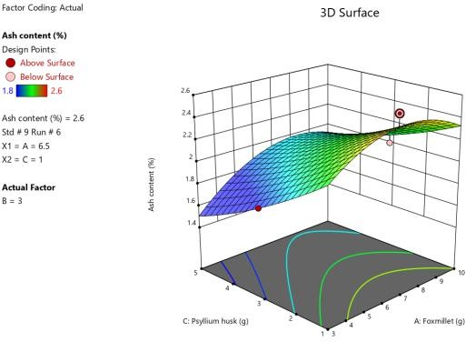
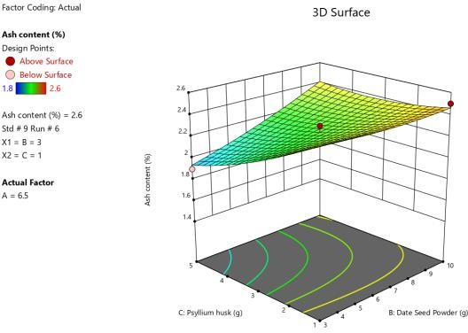

Fig 6.2.1 – 3D Surface plots for Ash content

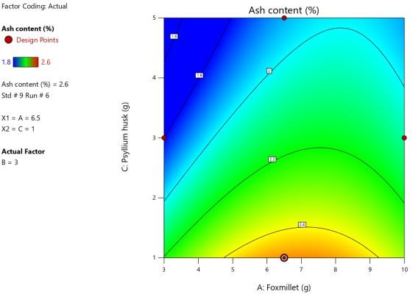
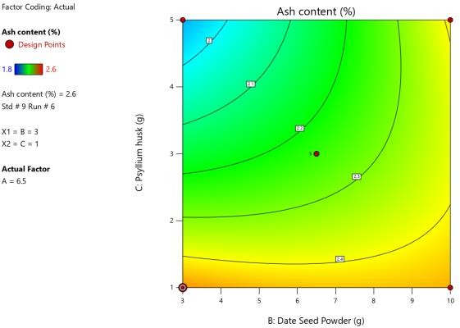

Fig 6.2.2 – Contour plots for Ash content

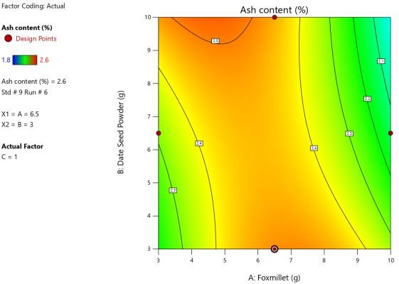
EFFECT OF INDEPENDENT VARIABLES ON TEXTURE (HARDNESS)
At higher concentrations, psyllium husk increased firmness, which was reflected in the hardness values obtained during texture analysis. The optimized nutribar showed a hardness value of 36 N, indicating a firm yet acceptable texture.

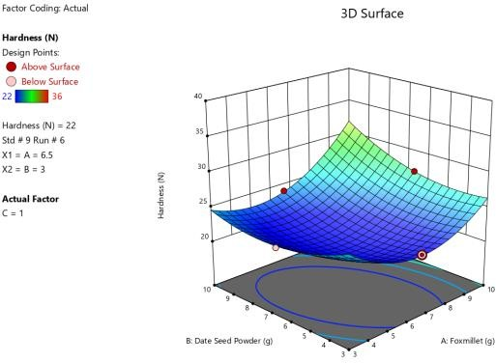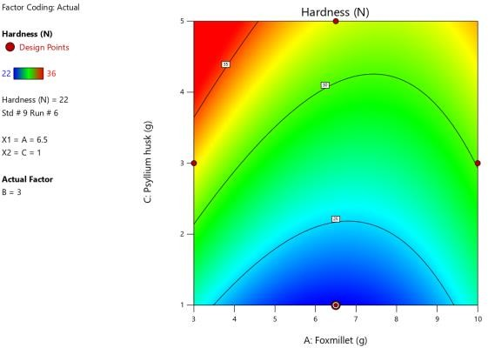

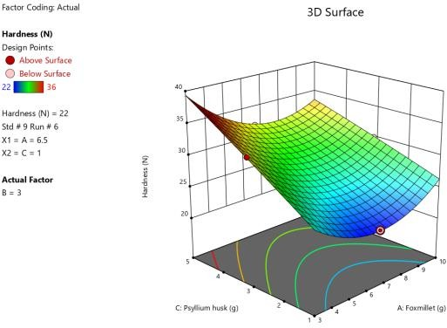

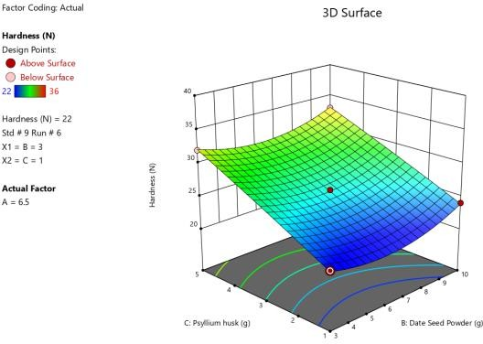

Fig 6.3.1 – 3D Surface plots for Hardness
Fig 6.3.2 – Contour plots for Hardness

EFFECT OF INDEPENDENT VARIABLES ON SENSORY ATTRIBUTES
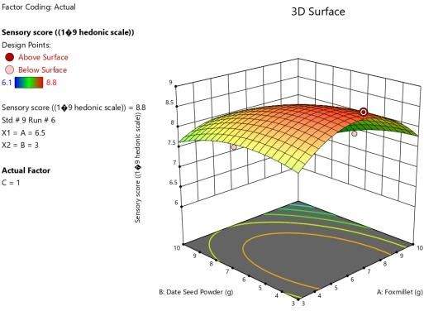
Sensory evaluation revealed that nutribars prepared with moderate levels of all three ingredients showed higher acceptability in terms of taste, texture, and overall quality, whereas excessive fiber incorporation negatively affected palatability.

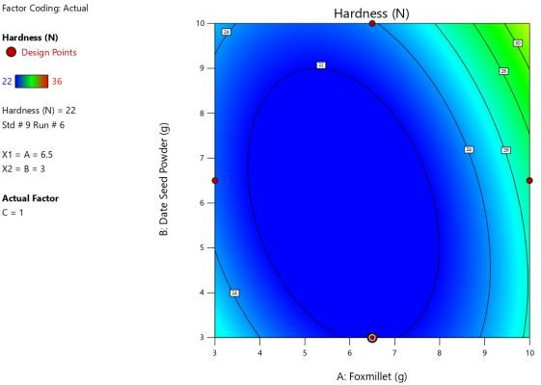

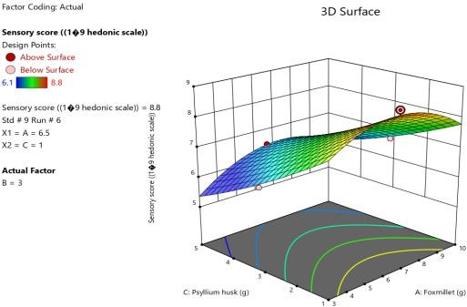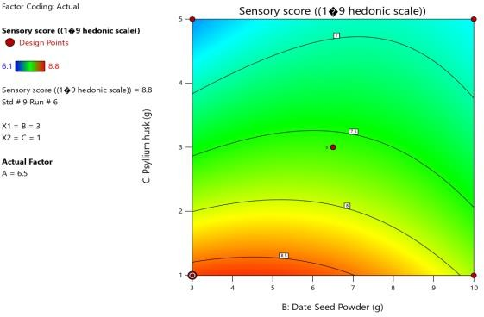

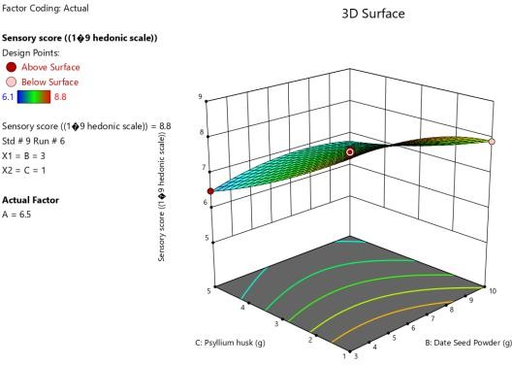

Fig 6.4.1 – 3D Surface plots for Sensory Evaluation
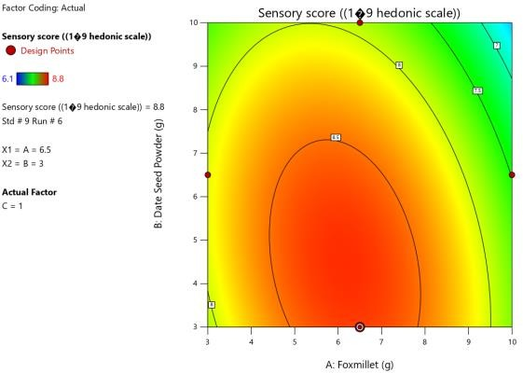
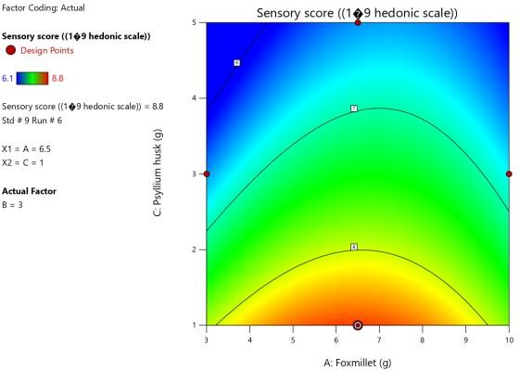

Fig 6.4.2 – Contour plots for Sensory Evaluation

STATISTICAL ANALYSIS
The interaction effects between foxtail millet, date seed powder, and psyllium husk were found to be statistically significant (p
< 0.05), indicating that their combined influence plays an important role in determining the quality of the developed nutribar. ANOVA results showed that both interaction terms (AB, AC, and BC) and quadratic terms (p < 0.05) significantly affected the response variables, particularly texture and sensory attributes. The regression model exhibited a good fit with a high coefficient of determination (R² = 0.92–0.96) and an adequate precision ratio greater than 4, confirming the model’s reliability.
Response surface and contour plots revealed that increasing levels of date seed powder and psyllium husk led to significant changes in textural properties, especially hardness and cohesiveness, due to increased water absorption and matrix modification. At higher concentrations, hardness increased significantly (p < 0.05), while sensory scores showed a slight decline. However, at optimized levels, a balanced interaction among the ingredients resulted in improved texture and acceptable sensory scores.

These findings highlight that maintaining an optimal proportion of foxtail millet, date seed powder, and psyllium husk is essential to achieve desirable functional, textural, and sensory characteristics in the developed nutribar.

CONCLUSION
The present study successfully developed and optimized a functional nutribar enriched with date seed powder and psyllium husk using Response Surface Methodology (RSM), demonstrating a significant improvement in nutritional and functional properties. Statistical analysis revealed that the incorporation of date seed powder and psyllium husk had a significant effect (p < 0.05) on key quality attributes, including moisture content, hardness, ash content, and sensory evaluation scores. The increase in dietary fiber content was directly proportional to the level of incorporation, indicating the effectiveness of both ingredients as functional enhancers.
The optimized formulation, as determined through RSM, exhibited a high desirability value (e.g., ~0.85–0.90), indicating an optimal balance between nutritional enhancement and product acceptability. Regression models developed for responses such as texture, moisture, and sensory attributes showed good fit, with high coefficients of determination (R² > 0.90), confirming the reliability of the predictive models. Analysis of variance (ANOVA) further indicated that both linear and interaction effects of independent variables were statistically significant (p < 0.05), emphasizing the importance of controlled formulation.
The results demonstrated that increasing the levels of date seed powder and psyllium husk significantly enhanced dietary fiber
content and functional properties; however, higher concentrations adversely affected textural parameters. A notable increase in hardness and reduction in cohesiveness were observed at higher inclusion levels, which can be attributed to increased water absorption and structural modifications within the nutribar matrix. Sensory evaluation also showed a slight decline in overall acceptability beyond optimal levels, although the optimized formulation maintained scores within acceptable limits.
Physicochemical analysis indicated that parameters such as moisture and ash content varied significantly (p < 0.05) across formulations, reflecting the compositional changes introduced by the functional ingredients. The study also confirmed that moderate incorporation levels resulted in nutribars with improved binding properties, desirable texture, and acceptable sensory characteristics.
In addition, the utilization of date seed powder as a value-added ingredient highlights a sustainable approach to food product development by converting agro-industrial waste into nutritionally beneficial components.
Overall, the optimized nutribar developed in this study can be considered a nutritionally enhanced functional product with potential health benefits, particularly in improving dietary fiber intake and supporting metabolic health. The application of RSM proved to be an effective statistical tool for formulation optimization. Future research may focus on shelf-life studies, consumer acceptance at a larger scale, and commercial feasibility to further validate the product’s applicability in the functional food market.

REFERENCES
- Mohamed, H. F., Elsyiad, S. E., Eid, W. A.,
Hassen, E. M., & Saleh, Y. M. (2024). Functional Dates Production Enriched with Low-Roasted Full Date Seed Powder: A Sustainable Approach to Dates By-Product Valorization.
- Kamal, H., Habib, H. M., Ali, A., Show, P. L., Koyande, A. K., Kheadr, E., & Ibrahim,
W. H. (2023). Food waste valorization potential: Fiber, sugar, and color profiles of 18 date seed varieties (Phoenix dactylifera, L.). Journal of the Saudi Society of Agricultural Sciences, 22(2), 133-138.
- Jahan, E., Nupur, A. H., Majumder, S., Das,
P. C., Aunsary, L., Aziz, M. G., ... & Mazumder, M. A. R. (2023). Physico-chemical, textural and sensory properties of breads enriched with date seed powder. Ranasinghe, M., Manikas, I., Maqsood, S., & Stathopoulos, C. (2022). Date components as promising plant-based materials to be incorporated into baked goods—A Review. Sustainability, 14(2), 605.
- Younis, M., Ahmed, I. A. M., Özcan, M. M., Uslu, N., & Karrar, E. (2024). The effect of date (Phoenix dactylifera L.) varieties on bioactive compounds, phenolic constituents, fatty acids and element contents of date seed and oils. International Journal of Food Science and Technology, 59(8), 5606-5615.
- abdel salam Bashir, M. M. (2025). Utilization of the date seed powder in food manufacturing. Sustainable Food Technology.
- Bouaziz, F., Ben Abdeddayem, A., Koubaa, M., Ellouz Ghorbel, R., & Ellouz Chaabouni, S. (2020). Date seeds as a natural source of dietary fibers to improve texture and sensory properties of wheat bread. Foods, 9(6), 737.
- Kokani, R. C., Virkar, P. R., & Shinde, A. S. Studies on formulation and preparation of banana peel powder bar incorporated with psyllium husk.
- Meera, K., & Thukral, B. (2025). Formulation and Evaluation of Nutri Bar Incorporating Millet. European Journal of Nutrition and Food Safety, 17(8), 89-96.
- Prasad, G., Sarkar, S., & Sethi, L. N. (2024). Solar Drying Technology for Agricultural Products: A Review. Agricultural Reviews, 45(4).
- Zhang, Y., Luo, Y., Gao, B., & Yu, L. (2025). Psyllium: A Nutraceutical and Functional Ingredient in Foods. Annual Review of Food Science and Technology, 16(1), 355-377.
- Geremew Kassa, M., Alemu Teferi, D., Asemu, A. M., Belachew, M. T., Satheesh, N., Abera, B. D., & Erku, E. G. (2024).
Review on psyllium husk: nutritional, functional, health benefits, food industry applications, waste treatment, and potential negative effects. CyTA-Journal of Food, 22(1), 2409174.
- Alkandari, S., Bhatti, M. E., Aldughpassi, A., Al-Hassawi, F., Al-Foudari, M., & Sidhu, J. S. (2021). Development of functional foods using psyllium husk and wheat bran fractions: Phytic acid contents. Saudi Journa
- Squeo, G., Latrofa, V., Vurro, F., De Angelis, D., Caponio, F., Summo, C., & Pasqualone, A. (2023). Developing a clean labelled snack Bar rich in protein and fibre with dry-fractionated defatted durum wheat cake. Foods, 12(13), 2547.
- Mekkara nikarthil Sudhakaran, S., & Bukkan, D. S. (2021). A review on nutritional composition, antinutritional components and health benefits of green gram (Vigna radiata (L.) Wilczek). Journal of Food Biochemistry, 45(6), e13743.

- Kumar, M. P., Krishnamma, P. N., & Sreedevi, M. S. (2024). Process Technology for Development of Sprouted Green Gram Flakes. AGRICULTURE & FOOD E-NEWSLETTER.
- Elwakeel, A. E., El-Mesery, H. S., Elbeltagi, A., Salem, A., Sabry, A., Saleh, D. I., ... & Elkot, W. F. (2025).
Development, drying characteristics, and environmental analysis of a PV operated automatic solar dryer for drying date. Frontiers in Sustainable Food Systems, 9, 1531601.
- Seguí, L., & Barrera, C. (2025). Functional Ingredients from Food Waste and By-Products: Processing Technologies, Functional Characteristics and Value-Added Applications. Foods, 14(5), 847.
- Mrabet, Abdessalem, Amel Hamdi, Rocío Rodríguez-Arcos, Rafael Guillén-Bejarano, and Ana Jiménez-Araujo. "Date seed by-products as source of bioactive ingredient for healthy cookies." Food Bioscience 61 (2024): 104543.
- Barakat, H., & Alfheeaid, H. A. (2023). Date palm fruit (Phoenix dactylifera) and its promising potential in developing functional energy bars: Review of chemical, nutritional, functional, and sensory attributes. Nutrients, 15(9), 2134.
- Zadeh, M. M., Dehghan, P., & Eslami, Z. (2023). Effect of date seed (Phoenix dactylifera) supplementation as functional food on cardiometabolic risk factors, metabolic endotoxaemia and mental health in patients with type 2 diabetes mellitus: a blinded randomised controlled trial protocol. BMJ open, 13(3), e066013.

