“EMOTIONAL VS RATIONAL DECISION MAKING IN ULTRA-FAST GROCERY SHOPPING.”
ABSTRACT
10-minute grocery apps have undergone a tremendous change in terms of influencing consumer buying habits with respect to their focus on speed and convenience. The present study aims to analyse how the relationship between emotion and reason exists among consumers using these apps for fast deliveries within 10 minutes. Data collection involved surveying 70 individuals using a structured questionnaire containing questions related to demographic characteristics, motivations, emotional triggers, and purchasing behaviour.
The results indicate that the majority of customers fall into the 18–24 age range and are mostly students, suggesting high penetration among young digital consumers. In terms of rational motivators, convenience and saving time ranked top, with more than 75% of participants considering them as primary factors driving their decisions to use these platforms. Most consumers also evaluated their product necessities and compared prices, implying the presence of reasonable decisions.
However, emotions still affect consumers' choices to some extent. Almost half of the sample purchased items impulsively without prior planning, and many were satisfied with their actions after purchasing something. Discounts and promotions heavily influenced their decisions, whereas advertising played a minor role emotionally.
Key words – rational, rapid, emotional, ultra-fast, grocery
INTRODUCTION
E-commerce has evolved drastically in recent years and the availability of instant grocery orders through online shopping apps such as Blinkit, Zepto and Instamart have brought an era of ultra-fast delivery. These mobile applications have revolutionized the way people buy groceries in a few clicks while putting emphasis on the importance of speedy, accessible and convenient services. This phenomenon has not only affected shopping behaviour of consumers but also altered their thinking process.
The contemporary market is flooded with various stimuli for the shoppers which range from push notifications to flash sales and advertisements to limited period deals. All these elements trigger excitement and happiness among the consumers causing them to purchase items spontaneously without prior thought and consideration. On the other hand, consumers also adopt a rational approach when making a decision about their purchases as they analyse the necessity of the item, compare the prices and prefer convenience over everything else.
The current study will focus on determining the extent to which both the emotional and rational factors affect the consumer behaviour while placing an order for 10-minute delivery platforms such as Blinkit, Zepto, Instamart.
The shift from conventional e-commerce to fast e-commerce is an entirely different psychological process. The conventional model necessitated that shopping be done with planned and high involvement activities; however, when it comes to fast shipping services, the level of involvement becomes minimal. As a result, there arises a dichotomy where, on one hand, there exists a logical aspect such as convenience while on the other hand, it facilitates impulsive behaviour.
LITERATURE REVIEW
Yeh, L., wang, E.M.Y., and huang, S.L. (2007) have researched the relationship between emotions and rationales as drivers of online buying behaviour by analysing primary data collected from people interacting with various website interfaces. Their study demonstrated that although website aesthetics and usability affect the likelihood of purchases, emotions generated by websites do not change consumers' thought processes and do not increase purchasing intentions substantially, thus calling for new approaches to website interface development.
Spanjaard, D., and Freeman, L. (2012) analysed emotions in food shopping through observation and video recording. The result has been that prolonged shelf time correlates with increased bodily interaction with products and heightened negative emotional expressions, while quick decision-making is associated with reduced visibility of emotions.
Kalnikaitė, v., Bird, J., and Rogers, Y. (2013) observed supermarket customers' shopping behaviors and found out that people use heuristics, which are "fast and frugal." Their research has revealed that such decisions are based primarily on health benefits and price. They have found that too much information, especially unreasonable, from smartphones hampers the decision-making process, therefore, suggesting simplification of the technology.
Conducted by Hollis-Hansen, K., Seidman, J., O’Donnell, S., & Epstein, L. H. (2019), the experiment examined the effect of episodic future thinking (EFT) in online grocery shopping. It showed that those who used their imagination to see future results bought less food, demonstrating that psychological methods could lead people to make wiser decisions regarding food.
The study carried out by Ewerhard, A. C., Sisovsky, K., & Johansson, U. (2019) focused on consumer decision making in multi-channel selling of slow-moving consumer goods by means of observation and interviewing. They observed that consumers use multiple channels throughout their shopping process, which is supplementary to one another and emphasizes omni-channelling importance.
Analysing the issue of panic buying during COVID-19 by means of secondary data and theoretical analysis, Dickins, T. E., & Schalz, S. (2020) explained the phenomenon of panic buying as a behavior of adaptation to risks and uncertainty.
Kim, H. (2021) conducted a study on the usage of mobile grocery shopping applications by south korean customers via quantitative survey design method. This study found that utilitarian motivation had a substantial influence on attitudes, in addition to subjective norms, on the purchase intentions and behaviour, as well as being more pronounced in users rather than non-users.
Kumar, A., Chaudhuri, D. S., Bhardwaj, D. A., & Mishra, P. (2021) examined the phenomenon of impulse buying and post-purchase regret amongst grocery buyers of reliance fresh and big bazaar. They observed a positive yet very low correlation between impulse buying and regret, where regret was dependent on income levels.
Wadhawan, K., & Wadhawan, D. (2024) have examined the issue of decision fatigue in online grocery buyers via secondary research. Decision fatigue leads to mental weariness, bad decisions, and dissatisfaction with choices made in the digital shopping interface.
Goswami, A., & Kumari, R. (2024) have analysed the role of quick commerce in the consumer decision making process by collecting primary data and doing statistical analysis. This quick commerce affects the satisfaction, impulsiveness and brand loyalty of consumers.
RESEARCH METHODOLOGY
The quantitative research design is adopted in this study to examine the polarity of emotions and rationality among consumers. The data was gathered using an online questionnaire survey administered to 70 current users of Blinkit, Zepto, and Instamart (rapid delivery companies).
Sampling procedure: the convenient sampling technique was applied by targeting the residents of the urban areas and the youth population aged 18 to 24 years because they constitute the early adopters of fast commerce.
Instrumentation: a structured questionnaire with multiple-choice questions was developed to elicit standard answers for the quantitative analysis, while a five-point Likert scale ('strongly disagree', 'disagree', 'neutral', 'agree', 'strongly agree') was utilized to assess various variables such as demographic composition, impulsive purchasing behaviour, price sensitivity, and post-acquisition satisfaction.
Data analysis: The gathered data was subjected to descriptive statistics for analysing the trends regarding demographic involvement, purchase usage rate, and psychological stimuli leading to purchase decision-making.
OBJECTIVES
- To study the emotional factors like mood, excitement, satisfaction, and advertisements which influence consumer decision making.
- To study the rational factors like convenience, necessity of product, comparison of prices, and planning involved in decision making process.
- To study the impact of marketing mix (promotions, discounts, colours, alerts) on impulsive and rational decision making.
- To study if emotional or rational decisions play an important role in influencing consumer choice in ultra-fast delivery applications.
DATA ANALYSIS

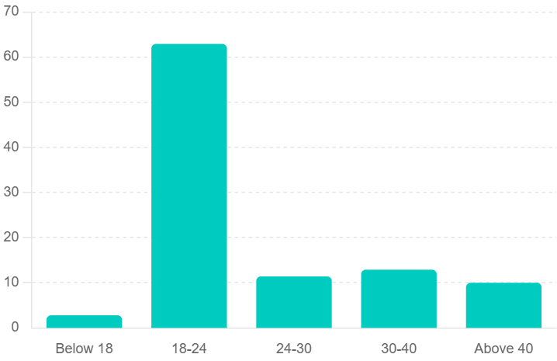
FIGURE 1: AGE DISTRIBUTION
From figure 1, we can conclude that the major responses are from ages between 18 to 24 years (62.9%). The next largest group is those between 30 to 40 years (12.9%), which shows that the primary audience for this research is the youth, followed by 24 to 30 years (11.4%). However, the least engagement is by the is by the audience of age group of above 40 years (10%) and below 18 years (2.8%) who are mainly school going youngsters.
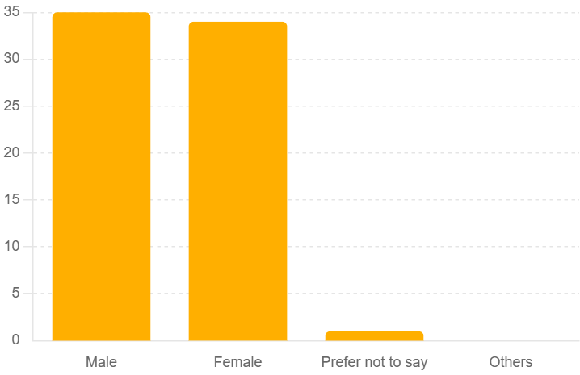
FIGURE 2: GENDER DISTRIBUTION
The chart in the figure 2 depicts the gender distribution among the respondents. The data shows that 50% of the respondents are male, while 48.6% are female. A very small portion, 1.4%, chose ‘prefer not to say’, and none identified as ‘others.
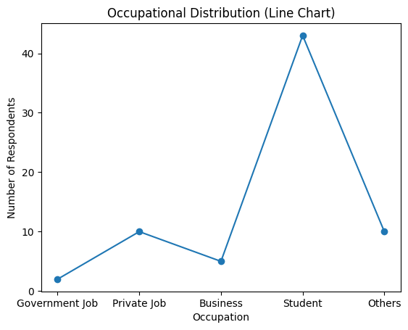
FIGURE 3: OCCUPATIONAL DISTRIBUTION
From figure 3, we can conclude that the maximum number of responses are from students (61.4%) followed by private job (14.3%) and other categories (14.3%). Followed by business professionals (7.1%) and government jobs (2.9%)
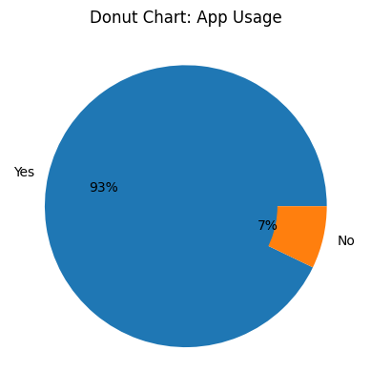
FIGURE 4:APP USAGE
From figure 4 we can see that 92.9% of respondents stated that they use 10-minute grocery delivery apps such as Blinkit, Zepto, or Instamart, whereas 7.1% reported that they do not use them.
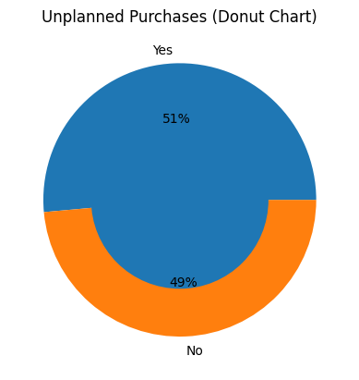
FIGURE 5: UNPLANNED PURCHASES
From the above figure data shows that 51.4% of the respondents do make unplanned purchases, while 48.6% stated that they do not make unplanned changes from the 10-min grocery apps (Blinkit, Zepto, Instamart).
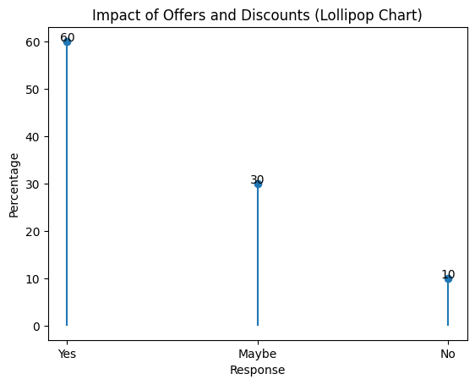
FIGURE 6: IMPACT OF OFFERS AND DISCOUNT
Figure 6 represents that whether offers and discounts affect their purchase decision. A majority of 60% of respondents answered ‘yes’, indicating that such promotions influence their buying behaviour. While 30% said ‘maybe’, suggesting partial influence and 10% responds ‘no’, showing they are not affected by these marketing tactics.
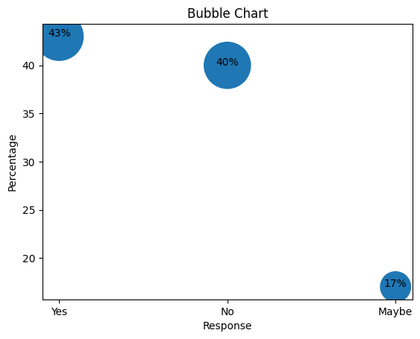
FIGURE 7: EXCITEMENT WHILE ORDERING
Figure 7 shows that 42.9% of respondents answered ‘yes’, 40% said ‘no’ and 17.1% responded ‘maybe’. It represents the responses of the participants regarding whether they feel a sense of excitement while placing an instant grocery shopping
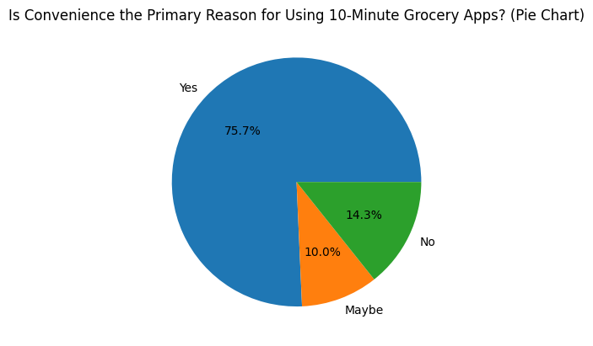
FIGURE 8: CONVENIENCE AS PRIMARY REASON
From figure 8 we can understand that a large majority of 75.7% respondents said ’yes’, 10% answered ‘maybe’, and only 14.3% responded ‘no’ about whether convenience is the primary reason for using 10-minute grocery delivery apps.
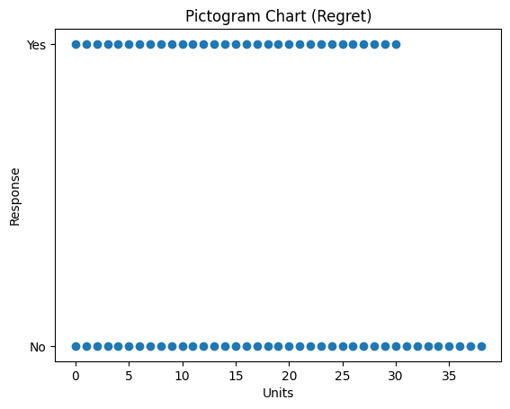
FIGURE 9: IMPULSIVE PURCHASE REGRET
From figure 9 we can conclude that 55.7% of respondents answered ‘no’ while 44.3% of respondents ‘yes’, regarding whether they have regretted making impulsive purchases through 10-minute delivery apps.
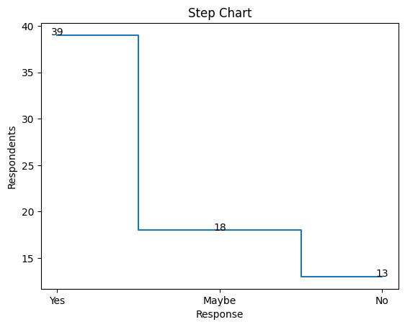
FIGURE 10: LOGICAL THINKING
From the above chart we can conclude that 55.7% people said ‘yes’, 25.7% responded ‘maybe’, and 18.6% said ‘no’, about whether they believe they think logically before every purchase on quick delivery apps.
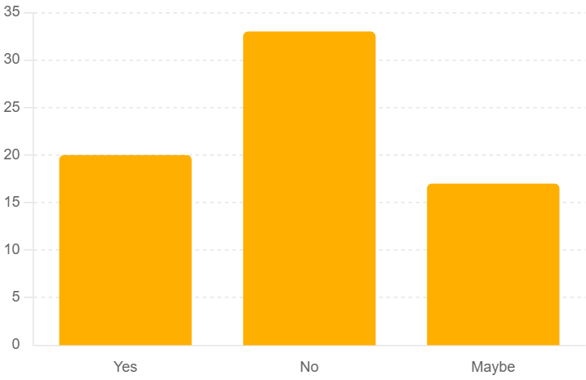
FIGURE 11: EFFECTS OF ADS AND IMAGES

From the above charts we can understand whether advertisements or product images on 10-minute delivery apps affect their buying choices. The data shows that 28.6% of the respondents answered ‘yes’, whereas 47.1% said ‘no’ and 24.3% responded with ‘maybe’.
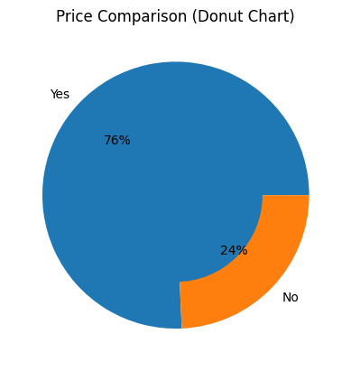
FIGURE 12: PRICE COMPARISON
Here, from the above figure we can conclude that a large majority of 75.7% people say ‘yes’, while 24.3% said ‘no’ regarding whether they compare prices with other apps before purchasing through 10-minute delivery platforms.
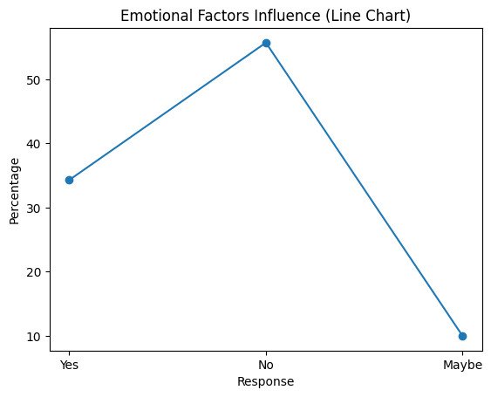
FIGURE 13: EMOTIONAL INFLUENCE
Figure 13 here represents responses from the participants about whether emotional factors such as mood or stress influence their decision to buying through instant grocery delivery apps. The data shows that 34.3% of respondents said ‘yes’, 55.7% said ‘no’, and 10% responded ‘maybe’.
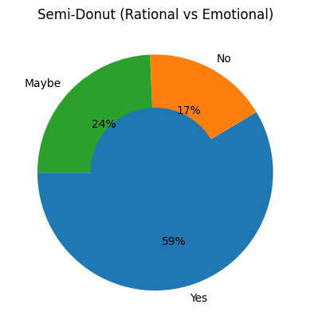
FIGURE 14: RATIONAL VS EMOTIONAL
From the above figure we can understand that whether participants consider themselves as a rational shopper rather than emotional ones. Here we can see that 58.6% people responded with ‘yes’, whereas 17.1% people responded with ‘no’, and 24.3% people responded with ‘maybe’.
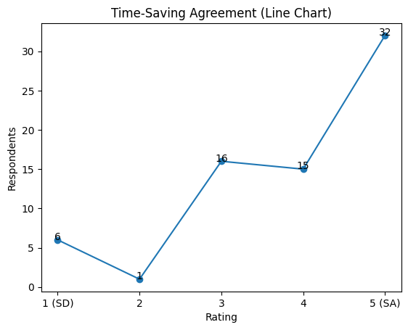
FIGURE15: TIME-SAVING AGREEMENT
The results reveal that 45.7% respondent agree that use of 10-minute grocery apps save their time, while 21.4% respondents indicate agreement. Additionally, 22.9% respondents reflected a neutral opinion. On the other hand, 8.6% and 1.4% respondents indicated disagreement with the statement. Overall, the findings suggest that most participants use 10-minute grocery apps mainly because they save time.
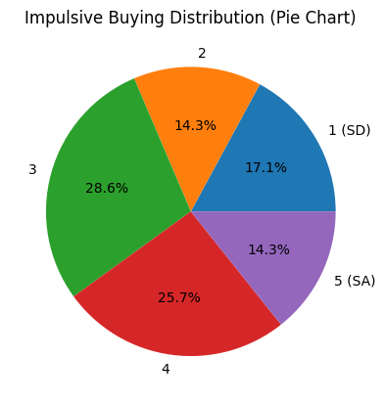
FIGURE 16: IMPULSIVE BUYING
The respondents are neutral (28.6%) if whether they impulsively buy items when they see limited time offers. Followed by 25.7% respondents, suggesting agreement. Whereas 14.3% people show strong agreement. On the other hand, 17.1% and 14.3% respondents indicated disagreement.
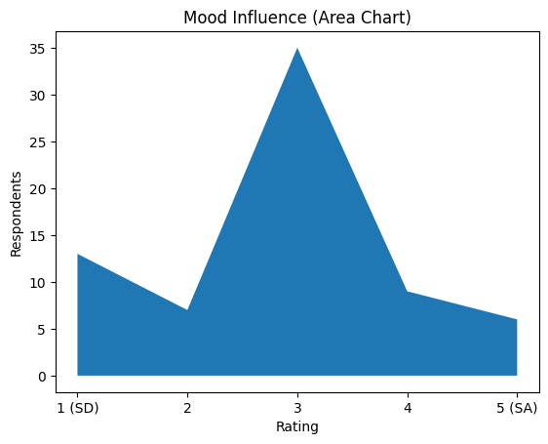
FIGURE 17: MOOD INFLUENCE
50% people showed neutrality that their mood is strongly affected when they buy from these apps. Followed by 18.6% of the people strongly disagreeing and 10% also indicating disagreement. 12.9% and 8.6% people showing agreeing and strongly agreeing respectively.
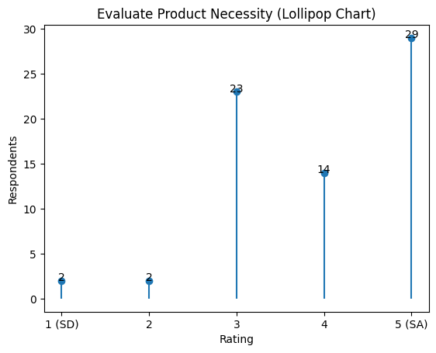
FIGURE 18: EVALUATING PRODUCT NECESSITY
Here, 41.4% people responded showing strong agreement that they carefully evaluate product necessity before adding it to their car, followed by 20% respondent indicating agreement. 32.9 respondents showed neutrality regarding the statement, whereas only 2.9% each show disagreement.
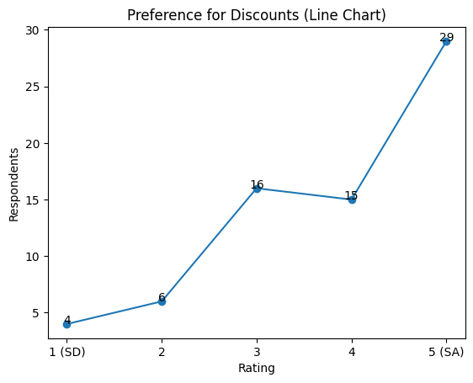
FIGURE 19: PREFERENCE FOR DISCOUNTS
The figure here shows 41.4% people strongly agree that they prefer buying from apps that offer free delivery and discounts, followed by 21.4% people agreeing. 22.9 people remain neutral and 8.6% and 5.7% people disagree and strongly disagree respectively.
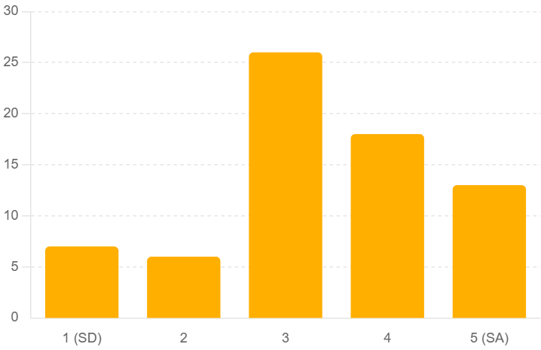
FIGURE 20: SATISFACTION AFTER ORDERING
37.1% people show neutrality that they feel satisfaction or happiness immediately after placing an order, 25.7% respondents show agreement and 18.6% are strongly agreeing to the statement. 10% and 8.6% people strong disagreement and disagreement respectively.
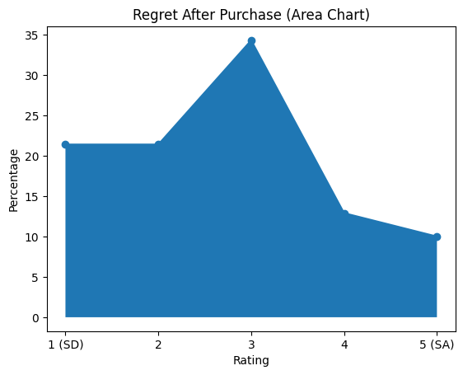
FIGURE 21: REGRET AFTER PURCHASE
34.3% people show neutrality that sometimes they regret their purchases after delivery, followed by 21.4% strong disagreement and 12.9% and 10% respondents show agreement and strong agreement respectively.
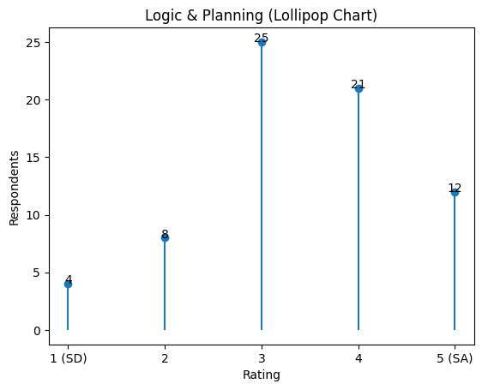
FIGURE 22: LOGIC AND PLANNING
Here, 35.7% respondents showing neutrality that they rely on logic and planning while shopping on ultra-fast apps, followed by 30% respondents agreeing with the statement. 17.1% respondents are strongly agreeing that they rely. 11.4% respondent and 5.7% respondents showing disagreement and strong disagreement respectively.
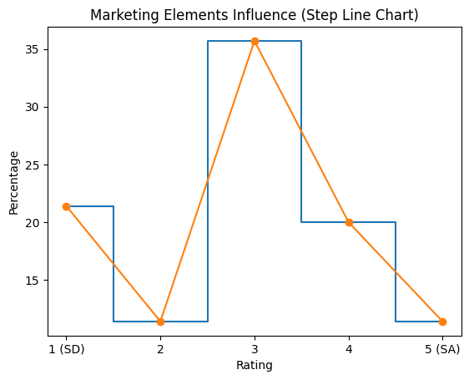
FIGURE 23: MARKETING INFLUENCE
35.7% respondents show neutrality that marketing elements like colours, notifications, banners trigger their interest to shop, whereas 21.4% respondent show strong disagreement and 11.4% respondents indicate disagreement.20% respondents show strong agreement, and 11.4 respondents

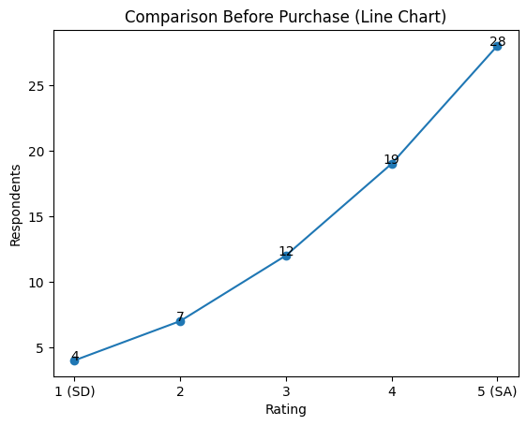
FIGURE 24: COMPARISON BEFORE PURCHASE
The figure above shows responses about whether they compare multiple options before finalizing a product, where 40% respondent strongly agree and 27.1% respondents agree with the statement.17.1% respondents are neutral.10% respondents and 5.7% respondents are showing disagreement and strong disagreement respectively.
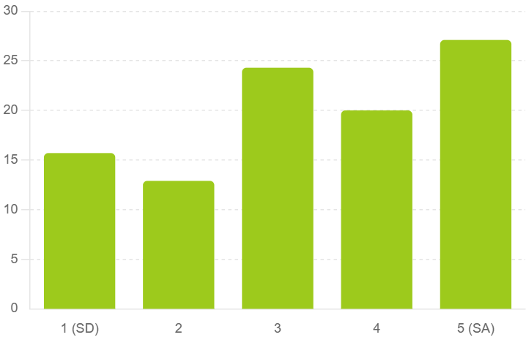
FIGURE 25: SPENDING BEHAVIOUR
27.1% respondents are strongly agreeing and 20% respondents are agreeing that they believe quick delivery apps make them spend more than traditional shopping. 24.3% respondents are, neutral. 12.9% respondents and 15.7% respondents show disagreement and strong disagreement respectively.
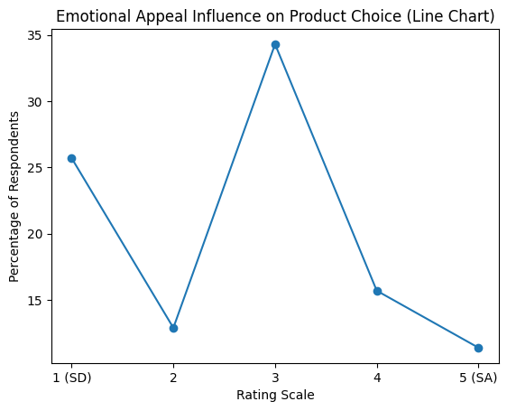
FIGURE 26: EMOTIONAL APPEAL INFLUENCE ON PRODUCT CHOICE
The chart presents 34.3% respondents remain neutral that emotional appeal in advertisements influences their product choices, 25.7% respondents show strong disagreement and 12.9% respondents indicated disagreement.15.7% respondents are agreeing and 11.4%respondents are strongly agreeing that they get influenced by emotional appeal in advertisements.
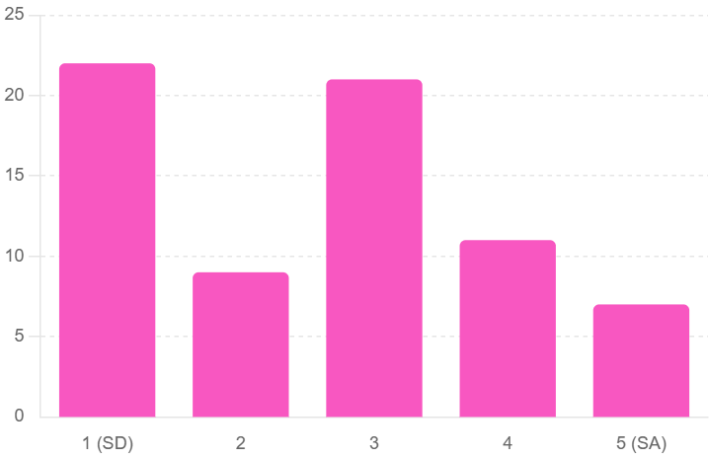
FIGURE 27: EMOTIONAL VS LOGIC
The chart shows 31.4% respondents are strongly disagreeing that overall, they make grocery decisions based on more on emotions than logic, followed by 12.9% disagreement, 30% respondents are neutral, 15.7%respondents are agreeing and10% respondents are strongly agreeing that they buy logically and not emotionally.
RECOMMENDATIONS FOR PLATFORMS
As per Marketers, being "Convenience" as the core rational motivator, apps must pay attention to features such as "One-Click" reordering. For Consumer Protection, a Budget Tracker can be considered within platforms to monitor their unplanned expenses, promoting trust and eliminating any buyer's remorse detected through this research. Research on "Subscription Effect," i.e., Zepto pass or Blinkit VIP, should be conducted to identify whether loyalty cards increase rationality or encourage even more impulsive decisions. Considering convenience to be the leading rational motivator, app designers might consider incorporating features such as "one-click" reordering. The platform can incorporate a budget tracker feature, allowing tracking of their impulsive purchases to build trust while eliminating any buyer's remorse that was revealed during this study. Additional research should be conducted on the effect of subscriptions like Zepto pass or Blinkit VIP to determine their influence on rational vs impulsive behaviours.
LIMITATIONS OF THE STUDY
The findings are based on a narrow outlook as compared to a broad outlook for the entire country with a sample size of 70 people. There are a very high number of respondents in the 18-24 age group, which makes it hard to understand the interaction of middle-aged and elderly people who manage household budgets. Respondents may think that they are logical beings; therefore, there may be a slight inclination towards understatement of any impulsive behaviour.
CONCLUSION
The study shows how people make choices when using 10-minute grocery delivery apps. It finds that people use their heads and hearts to decide.
* Convenience, saving time and comparing prices are reasons people use these apps.
*. Feelings also play a part in what people buy.
Most users, younger ones like these apps because they are easy to use and quick.
They also buy things on impulse when they see discounts or limited-time offers.
Even though they sometimes make buys most people do not feel bad about it later.
This suggests that they are okay with their choices.
Ads do not have big of an impact as special deals.
This means that offering benefits works better than just trying to make people feel a certain way.
People think they make choices but they are also influenced by their feelings especially when they are in a hurry and want things to be easy.
In the end people make choices based on a mix of logic and feelings when using grocery delivery apps.
Understanding this mix is important, for marketers app developers and researchers who want to make the app experience better and promote shopping habits.
The study shows how people make choices when using 10-minute grocery delivery apps. It finds that people use their heads and hearts to decide. Convenience, saving time and comparing prices are reasons people use these apps. Feelings also play a part in what people buy. Most users, younger ones like these apps because they are easy to use and quick. They also buy things on impulse when they see discounts or limited-time offers. Even though they sometimes make buys most people do not feel bad about it later. This suggests that they are okay with their choices. Ads do not have big of an impact as special deals. This means that offering benefits works better than just trying to make people feel a certain way. People think they make choices but they are also influenced by their feelings especially when they are in a hurry and want things to be easy. In the end people make choices based on a mix of logic and feelings when using grocery delivery apps. Understanding this mix is important, for marketer’s app developers and researchers who want to make the app experience better and promote shopping habits.
The present study highlights the dynamic interplay between rational and emotional factors influencing consumer behaviour in the context of 10-minute grocery delivery applications. The findings clearly indicate that while rational considerations such as convenience, time-saving, and price comparison remain the dominant drivers of usage, emotional triggers still play a significant supporting role in shaping purchasing decisions.
A majority of respondents, particularly from the younger demographic, rely on these platforms primarily for their efficiency and ease of use. At the same time, the presence of impulsive buying behaviour, influenced by discounts, limited-time offers, and momentary excitement, demonstrates that emotional responses cannot be overlooked. Interestingly, despite engaging in occasional impulsive purchases, most consumers do not report significant regret, suggesting a level of post-purchase justification or satisfaction.
Furthermore, the relatively low impact of advertisements compared to promotional offers indicates that practical incentives are more effective than purely emotional appeals in this fast-paced shopping environment. Consumers tend to perceive themselves as rational decision-makers; however, their behaviour reflects a blend of logic and emotion, especially under time-sensitive and convenience-driven conditions.
In conclusion, consumer decision-making in ultra-fast grocery delivery platforms is not purely rational or emotional but rather a hybrid process. While rationality forms the foundation of usage, emotional elements subtly influence final purchase decisions. Understanding this balance is crucial for marketers, platform developers, and researchers aiming to enhance user experience and promote responsible consumption patterns.
REFERENCES
Yeh, l., wang, e. M. Y., & huang, s. L. (2007, july). A study of emotional and rational purchasing behaviour for online shopping. In international conference on online communities and social computing (pp. 222-227). Berlin, heidelberg: springer berlin heidelberg.
Kalnikaitė, v., bird, j., & rogers, y. (2013). Decision-making in the aisles: informing, overwhelming or nudging supermarket shoppers? Personal and ubiquitous computing, 17(6), 1247-1259.
Spanjaard, d., & freeman, l. (2012). The hidden agenda: emotions in grocery shopping. The international review of retail, distribution and consumer research, 22(5), 439-457.
Hollis-hansen, k., seidman, j., o'donnell, s., & epstein, l. H. (2019). Episodic future thinking and grocery shopping online. Appetite, 133, 1-9.
Ewerhard, a. C., sisovsky, k., & johansson, u. (2019). Consumer decision-making of slow-moving consumer goods in the age of multi-channels. The international review of retail, distribution and consumer research, 29(1), 1-22.
Dickins, t. E., & schalz, s. (2020). Food shopping under risk and uncertainty. Learning and motivation, 72, 101681.
Kim, h. (2021). Use of mobile grocery shopping application: motivation and decision-making process among south korean consumers. Journal of theoretical and applied electronic commerce research, 16(7), 2672-2693.
Kumar, a., chaudhuri, d. S., bhardwaj, d. A., & mishra, p. (2021). Impulse buying and post-purchase regret: a study of shopping behaviour for the purchase of grocery products. Abhishek kumar, sumana chaudhuri, aparna bhardwaj and pallavi mishra, emotional intelligence and its impact on team building through mediation of leadership effectiveness, international journal of management, 11(12), 2020.
Wadhawan, k., & wadhawan, d. (2024). Decision fatigue for the online/digital shoppers: a challenge for survival in the e-marketplace for the grocery brands in india. Partners universal international research journal, 3(4), 14-23.
Goswami, a., & kumari, r. (2024). A study on impact of quick commerce on consumer decision making process. Bmsjmr: journal of management research, 1(2), 1-11.

