Web-Oriented Machine Learning System for News Authenticity Detection

Abstract - The rapid growth of online news platforms and social media has significantly increased the spread of fake news, leading to misinformation, public confusion, and societal harm. Manual verification of news authenticity is time-consuming and impractical given the large volume of content generated daily. Automated fake-news detection systems are therefore essential to ensure the credibility of information and support informed decision-making. This project presents a machine-learning–based fake-news detection system that automatically classifies news articles as real or fake using Natural Language Processing (NLP) techniques. The proposed system utilises text preprocessing and vectorisation methods to transform raw news content into numerical representations, which are then classified using a trained machine learning model. The model is trained on a labelled dataset containing both real and fake news articles, enabling effective binary classification. A web-based application is developed to provide a user-friendly interface for real-time prediction. The trained model and text vectorizer are deployed in the backend, allowing users to input news content and instantly receive classification results. The proposed system assists in reducing the spread of misinformation and contributes to improving trust and reliability in digital news platforms.
Keywords: Fake News Detection, Natural Language Processing, Machine Learning, Text Classification, Misinformation

INTRODUCTION
The internet and social media are growing fast. This means people can share information quickly from around the world. While it is good that we can talk to each other faster, it also means that false information can spread easily. This false information, also known as news, can confuse people, change what the public thinks and cause problems for society, politics and the economy. Checking news stories by hand to see if they are true is taking a lot of time. It is not practical because of the huge amount of information that is posted online every day. Fake news is information that is made up on purpose to fool people. It is presented as news. Sometimes it is hard to tell what is real and what is not because fake news looks like it comes from sources. We get a lot of our news from the internet and social media. This means we really need systems that can automatically figure out what is news and what is not. Fake news detection systems are very important. They help us find out what is real and what is news. Machine Learning and Natural Language Processing techniques are really good at helping us understand what is written in news articles. They can find patterns. Figure out what the words really mean. Machine Learning can even look at news articles. Say if they are true or not. It does this by looking at lots of news articles that people have already labelled as true or false. Then, Machine Learning models can use this information to classify news content as real or fake. It is usually very accurate. Machine Learning is very good at this because it can learn from all the news articles it has seen before. This project presents a web-based Fake News Detection system that allows users to input news text and receive instant authenticity analysis. The system combines a user-friendly frontend interface with a robust backend powered by machine learning models, enabling real-time detection and decision support. The proposed solution aims to

improve trust in digital information and assist users in verifying the credibility of news content efficiently.

LITERATURE SURVEY

The rapid growth of online news platforms and social media has significantly increased the spread of misinformation and fake news, making automated detection an important research problem. Prior studies have explored fake news detection from multiple perspectives, including content-based analysis, social context modelling, user behaviour analysis, and machine learning–based classification techniques.

Fake News Definition, Impact, and Social Aspects
Early research focused on defining fake news and understanding its societal impact. Tandoc et al. [6] provided a comprehensive typology of fake news definitions used in academic literature, highlighting the ambiguity in distinguishing misinformation from satire and propaganda. Lazer et al. [38] emphasised the large-scale social consequences of fake news and called for interdisciplinary solutions. Studies such as Rubin et al. [20] and Conroy et al. [13] categorised different types of fake news and deception strategies used in online media. The psychological and cognitive factors influencing susceptibility to fake news were explored by Gaillard et al. [4], particularly considering age and digital literacy.

Content-Based and Linguistic Approaches
Several works utilised linguistic and textual features to detect fake news. Rashkin et al. [14] analysed language patterns in fake and real news, identifying stylistic and emotional differences. Pérez-Rosas et al. [15] and Kim [7] applied natural language processing and topic modelling techniques to extract discriminative features from news content. Clickbait and misleading headlines were studied by Chen et al. [17], showing their strong correlation with fake news propagation.

Machine Learning and Classification Techniques
Machine learning methods have been widely adopted for fake news detection. Granik and Mesyura [16] demonstrated the effectiveness of Naïve Bayes classifiers for binary fake news
classification. Cybenko and Cybenko [8] discussed the broader role of AI in combating misinformation. More advanced models, such as XGBoost [40], were reviewed in later works [39], [41], showing improved performance over traditional classifiers. Feature selection and its impact on classification accuracy were examined by Khan et al. [44].

Hybrid and Knowledge-Based Models
To improve detection accuracy, hybrid approaches combining linguistic, semantic, and knowledge- based features were proposed. Vedova et al. [5] integrated content-based features with social signals, achieving better robustness. Seddari et al. [9] proposed a hybrid linguistic and knowledge-based framework for social media fake news detection. Benchmark datasets and comparative evaluations were provided by Galli et al. [10], enabling standardised performance comparison across models.

Social Network and Propagation-Based Analysis
Fake news dissemination patterns have been studied using social network analysis. Jin et al. [19] proposed a hierarchical propagation model to evaluate news credibility on microblog platforms. Studies on user influence and retweet behaviour [28], [29], [30], [35] highlighted how influential users accelerate fake news spread. Social capital theory [23]–[27] was applied to explain why users share unverified information. Network centrality and behavioural modelling approaches [31]–[34] further contributed to understanding misinformation diffusion.

Datasets, Benchmarks, and Evaluation
Public datasets play a critical role in fake news research. Wang [51] introduced a benchmark dataset for fake news classification, while Shu et al. [52] presented FakeNewsNet, which integrates news content with social context and temporal information. Cross-validation and evaluation challenges were discussed by Bengio and Grandvalet [43], emphasising the limitations of unbiased performance estimation.

Recent Trends and Emerging Challenges
Recent studies have highlighted emerging threats such as AI-generated content and deepfakes. Botha and Pieterse [50] discussed fake news and deepfakes as major information security threats. Ahmed et al.
[49] presented a systematic literature review

summarising trends, challenges, and future directions in machine learning–based fake news detection. Trust, credibility, and cross-cultural aspects were analysed in works such as Pentina et al.
[46] and Kim et al. [12].

PROPOSED SYSTEM

The existing system does everything it needs to do for automated analysis and information processing. It has a website that people can use. The system provides a website where people can log in and use the application in a way. The existing system accepts what users type in. It goes through some steps to analyse this information. The existing system has some predefined steps that it follows to look at the data that users give it. The system does a lot of things to get the data ready, like getting the parts out and looking at them. It does all of this one step at a time and, on its own. The data system shows us what it finds out both while it is working and when it is all done, using a page that is easy to look at. This page has numbers that tell us how well it is doing and what it has learned. The system is careful to get the information by using rules and special computer programs that can learn and help with the data analysis. The data system uses these programs to make sure it gets the data just right. Furthermore, the system efficiently manages user requests, minimises manual intervention, and delivers results with high accuracy and reduced processing time. Overall, the existing system is capable of performing all required activities effectively while providing reliable, accurate, and efficient information to the end user.

System Architecture Components:
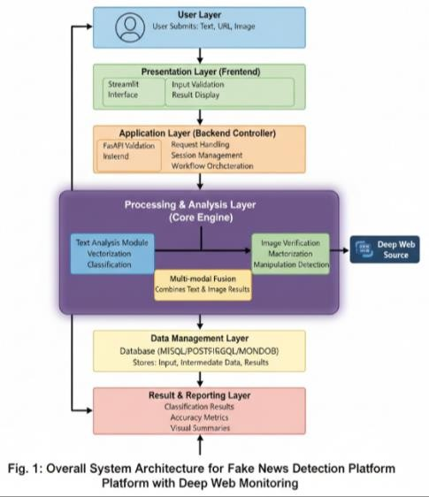

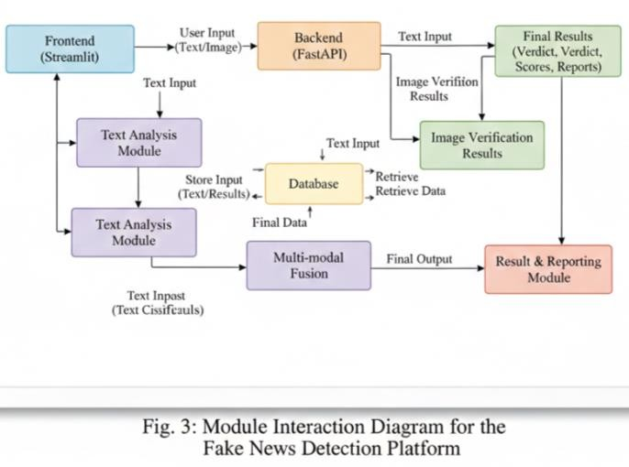

Presentation Layer (Frontend)
This component manages every interaction made by users. Screens showcased within the video pertain to this level. Essential features encompass data entry, verification processes, and visualisation through charts, textual outputs, or feedback indicators. Various tools, including HTML, CSS, and JavaScript, along with framework options like React or Angular,

may be utilised in projects (Figure). Surely?

Application Layer (Backend Controller)
tier handles incoming requests from the user interface and executes processing functions. Key responsibilities encompass processing requests, verifying identities, managing sessions, and coordinating workflows. Common software tools encompass Spring Boot, Flask, FastAPI, or JavaScript frameworks like Node. js. The symbol js represents Fig. Surely?

Processing and Analysis Layer (Core Engine)
Herein lies the foundational component through which major organisational functions transpire. The tool conducts data cleaning, identifies features, evaluates patterns, detects anomalies, verifies correctness, and optimises performance metrics. This tier guarantees superior performance by minimising manual involvement and delivering dependable outcomes (Figure). Two.

Data Management Layer
This tier handles input storage, interim data management, and output retrieval tasks. Critical responsibilities encompass storing information, accessing it upon request, recording transactions for verification purposes, and monitoring activities through audits. Databases like MySQL, PostgreSQL, or MongoDB may be chosen based on whether they support relational structures; these include systems such as SQLite for simpler needs. Surely?

Result and Reporting Layer
Outputs for users are displayed in an easily readable manner. This tier is responsible for generating results, computing accuracy measures, and producing reports or graphical representations (see Fig.). Certainly! Here's an appropriate version of your input:

System Workflow

Workflow starts when users submit inputs; these are then validated on the front end. Subsequently, the backend transmits the query to the processor module. The
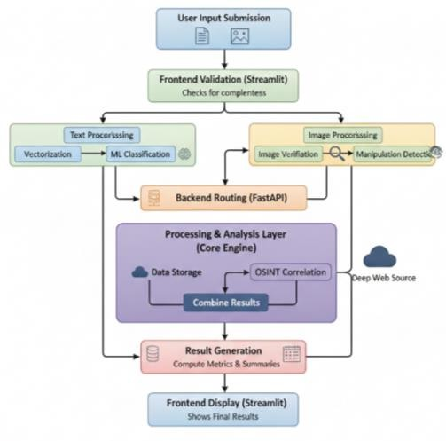
analytical component oversees every

operation within the system by persisting information into the repository and subsequently displaying precise outcomes for the end-user (see Fig.). Two.

  - Users submit news content (text and/or images).
  - The front end checks data inputs before sending them to the back end for processing.
  - The intermediate stage applies initial data cleaning, identifies relevant features, and classifies outcomes through an applied artificial intelligence algorithm.

- Information and interim outcomes are archived within the database system.
- Data culminates in being transmitted to the front end for presentation to the client.

METHODOLOGY

The fake news detection system follows a structured pipeline consisting of data preprocessing, feature extraction, model training, and backend deployment for real-time inference.

Dataset Collection and Preprocessing:
The dataset used in this project consists of labeled news articles categorized as real or fake. Text preprocessing is performed to clean and normalize the raw news content. This includes converting text to lowercase, removing punctuation and special characters, and eliminating unnecessary whitespace to ensure consistent input representation.

Text Vectorization:
Natural Language Processing techniques are applied to convert textual data into numerical feature vectors. A text vectorizer is trained on the dataset vocabulary to extract meaningful features from the news content. The trained vectorizer is saved and reused during inference to ensure consistent feature mapping between training and prediction stages.

Machine Learning Model Training:
A supervised machine learning classifier is trained using the vectorized text features. The model learns patterns and linguistic characteristics that differentiate fake news from real news. After training, the model is serialized and stored as a pickle file for deployment.

Backend Inference System:
The backend system loads the trained machine learning model and the corresponding text vectorizer. When a user submits news content through the frontend interface, the backend preprocesses the input text, transforms it using the saved vectorizer, and feeds it into the trained model for prediction. The model outputs a binary classification indicating whether the news is fake or real.

Frontend-Backend Integration:
The frontend interface allows users to enter news text and submit it for analysis. The backend processes the request and returns the prediction result, which is displayed to the user in real time. This architecture ensures efficient inference and a seamless user experience.

MODULES AND IMPLEMENTATION

Home Page:
Module: User Interface Module

This is the home screen of the Fake News Detection system. The purpose of the platform is briefly described on the homepage and gives a possibility to let users start detecting fake news. Upon clicking “Start Detecting Now”, the system transits to the prediction section. This widget guarantees easier access and more engaging experience.

Why Our AI Is Different (Feature Overview Module):
Module: Feature Presentation Module

This part emphasizes the main features of the tool including state-of-the-art AI models, real-time OSINT, instant analysis and privacy-first processing. It talks about the technical strong points of the backend models and ensures users that analysis happens fast, accurate and secure.

Why Does It Matter?
Module: Awareness & Impact Module

This module teaches people about the effects of fake news in society. It underscores the significance of automated fake news recognition because false news travels much faster than verified one. This section does not compute, but increases the understanding and confidence of users.

Statistics & Problem Statement: Module: Problem Analysis Module

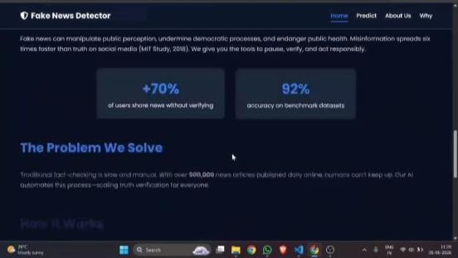
This screen displays statistical analysis like the percentage of users posting unverified news and the accuracy of the system. These parameters measure the efficiency of the trained machine learning algorithm and encourage users to use automated verification instead of manual verification.

How It Works (High-Level Workflow): Module: System Workflow Visualization

This module illustrates the overall workflow of the system: User inputs news text The AI model analyzes news content through NLP and OSINT indicators. The system provides a definitive result with confidence level. This is a simplified representation of internal system operations.

Who Can Benefit (User Classification Module): Module: Stakeholder Identification Module

This module shows the classification of various user types like individuals, journalists, and teachers who can use the system. This highlights that the system has broad usability applications across several sectors.

Predict Page (Input Module):
Module: News Input Module

In this module, users are required to input news text in the designated input box. The frontend checks the input and submits it to the backend API for processing. This initiates real-time fake news analysis.

Backend Processing Trigger
Module: Backend Request Handling Module

When the user clicks on “Analyze Authenticity”, the frontend sends the request to the backend (FastAPI). The backend preprocesses the text, removes noise, and converts it into numerical features using a trained vectorizer before sending it to the machine learning model.

Fake News Detection Result

Module: Classification & Result Module
The machine learning model analyzes the processed text and classifies it as Fake News. The result includes a confidence percentage and OSINT reliability score. These values are returned from the backend and displayed on the frontend in real time.

Real News Detection Result
Module: Final Output & Reporting Module



This screen displays a Real News verdict with a high confidence score. The final result is generated after successful classification and verification. The system ensures clarity by presenting results in an understandable and visually structured format.

DISCUSS AND RESULTS

Home Page (User Engagement Result) What happened:
The home page effectively engages the user and conveys the purpose of the system—detecting fake news. The user is encouraged to start analysis with a single call- to-action.

Why it matters:
Having an effective entry point enhances user engagement and

ensures that even non-technical users can easily use the system.

AI Features Display
What happened:
The system showcases its advanced AI model, OSINT capability, instant analysis, and privacy-centric approach.

Why it matters:
The system showcases its features to build user trust and assure them that the system is technically sound, secure, and capable of real- time fake news analysis.

Importance of Fake News Detection What happened:
The system explains the dangers of fake news to society and displays statistics on how quickly fake news spreads.

Why it matters:
This explains the need for the proposed system and proves the practicality of fake news analysis.

Accuracy and Problem Statistics What happened:
The system displays the benchmark accuracy (92%) and points out the user behavior concerning the sharing of unverified news.

Why it matters:
The high accuracy level confirms the efficiency of the trained machine learning model and demonstrates that the automated system is superior to the manual verification process.

High-Level Workflow Explanation

What happened:
The system breaks down the detection process into three easy steps: input, analysis, and verdict delivery.

Why it matters:
The easy-to-understand workflow enhances the transparency of the system and makes it easier for users to comprehend how the system makes its decisions.

Beneficiary Identification
What happened:
The system points out that individuals, journalists, and educators are the main beneficiaries.

Why it matters:
This indicates that the system has wide-ranging applications and can be used in various fields, thus adding to its social and academic significance.

News Input Interface
What happened:
The users are able to successfully input the news text into the prediction interface for analysis.

Why it matters:
Correct input processing is critical to achieving accurate analysis, thereby ensuring the backend processes the data correctly and meaningfully.

Fake News Detection Result

What happened:
The system was able to successfully detect the input as Fake News with a confidence level of 91% and an OSINT reliability score.

Why it matters:
This shows that the system is capable of successfully detecting fake news and providing confidence levels, which are critical to improving interpretability.

Real News Detection Result What happened:
The system was able to successfully detect another input as Real News with a confidence level of 92%.

Why it matters:
Correct detection of real news confirms that the system is not biased towards fake news and has balanced prediction capability.

Final Result Visualization What happened:
The results are displayed in a well-organized and user-friendly manner, including verdict, confidence level, and reliability score.

Why it matters:
The results are critical to improving user interpretability and facilitating informed decision-making without requiring technical knowledge.

CONCLUSION

The proposed fake news detection system provides an effective and automated approach to identifying misinformation using machine learning and Natural Language Processing techniques. By combining text preprocessing, feature extraction, and a trained classification model, the system enables accurate and real-time detection of fake news. The web-based interface further enhances usability, making the system suitable for practical deployment. This project contributes to combating misinformation and improving the credibility of digital news platforms.

REFERENCE

- C. Wu, F. Wu, Y. Huang, and X. Xie, “Personalized news recommendation: Methods and challenges,” ACM Trans. Inf. Syst., vol. 41, no. 1,
pp. 1–50, Jan. 2023.
- X. Su, G. Sperlì, V. Moscato, A. Picariello, C. Esposito, and C. Choi, “An edge intelligence empowered recommender system enabling cultural heritage applications,” IEEE Trans. Ind. Informat., vol. 15, no. 7, pp. 4266–4275, Jul. 2019.
- F. Zhou, X. Xu, G. Trajcevski, and K. Zhang, “A survey of information cascade analysis: Models, predictions, and recent advances,” arXiv:2005.11041, 2020.
- S. Gaillard, Z. A. Oláh, S. Venmans, and M. Burke, “Countering the cognitive, linguistic, and psychological underpinnings behind susceptibility to fake news,” Front. Commun., vol. 6, Art. no. 661801, Jul. 2021.
- M. L. D. Vedova et al., “Automatic online fake news detection combining content and social signals,” in Proc. FRUCT, May 2018, pp. 272–279.
- E. C. Tandoc, Z. W. Lim, and R. Ling, “Defining ‘fake news’: A typology of scholarly definitions,” Digit. Journalism, vol. 6, no. 2, pp. 137–153, Feb.
2018.
- H. Kim, “An exploratory study on fake news using topic modeling,” M.S. thesis, Kookmin Univ., Seoul, South Korea, 2017.

- A. K. Cybenko and G. Cybenko, “AI and fake news,” IEEE Intell. Syst., vol. 33, no. 5, pp. 1–5, Sep. 2018.
- N. Seddari et al., “A hybrid linguistic and knowledge-based analysis approach for fake news detection,” IEEE Access, vol. 10, pp. 62097–62109, 2022.
- A. Galli et al., “A comprehensive benchmark for fake news detection,” J. Intell. Inf. Syst., vol. 59, no. 1, pp. 237–261, Aug. 2022.
- A. P. Salazar, “AI tools on fake news detection,” Tech. Rep., Technol. Univ. Philippines, 2020.
- A. Kim and A. R. Dennis, “Says who? The effects of presentation format and source rating,” MIS Quart., vol. 43, no. 3, pp. 1025–1039, Jan.
2019.
- N. K. Conroy, V. L. Rubin, and Y. Chen, “Automatic deception detection,” Proc. ASIS&T, vol. 52, no. 1, pp. 1–4, 2015.
- H. Rashkin et al., “Truth of varying shades,” in Proc. EMNLP, 2017, pp. 2931–2937.
- V. Pérez-Rosas et al., “Automatic detection of fake news,” arXiv:1708.07104, 2017.
- M. Granik and V. Mesyura, “Fake news detection using naive Bayes classifier,” in Proc. UKRCON, May 2017, pp. 900–903.
- Y. Chen, N. J. Conroy, and V. L. Rubin, “Misleading online content,” in Proc. ACM Multimodal Deception Detection, Nov. 2015, pp. 15–19.
- C. Chen et al., “Battling the Internet water army,” in Proc. ASONAM, Aug. 2013, pp. 116–120.
- Z. Jin et al., “News credibility evaluation on Microblog,” in Proc. IEEE ICDM, Dec. 2014, pp. 230–239.
- V. L. Rubin, Y. Chen, and N. K. Conroy, “Deception detection for news,” Proc. ASIS&T, vol. 52, no. 1, pp. 1–4, 2015.
- R. J. Sethi, “Spotting fake news,” in Proc. IEEE ICWS, Jun. 2017, pp. 866–869.
- M. Carter, M. Tsikerdekis, and S. Zeadally, “Approaches for fake content detection,” IEEE Internet Comput., vol. 25, no. 2, pp. 73–83, Mar.
2021.
- M. M. Wasko and S. Faraj, “Why should I share?” MIS Quart., vol. 29, no. 1, pp. 35–57, Mar. 2005.
- J. Nahapiet and S. Ghoshal, “Social capital and organizational advantage,” Acad. Manage. Rev., vol. 23, no. 2, pp. 242–266, Apr. 1998.
- P. Dawson et al., “Innovation and social capital,” in Proc. Massey Univ. Conf., 2011, pp. 177–191.
- N. Lin, “Building a network theory of social capital,” Connections, vol. 22, no. 1, pp. 28–51,
1999.
- C.-M. Chiu et al., “Knowledge sharing in virtual communities,” Decis. Support Syst., vol. 42, no. 3, pp. 1872–1888, Dec. 2006.
- D. R. Bild et al., “Twitter user behavior,” ACM Trans. Internet Technol., vol. 15, no. 1, pp. 1–24,
Mar. 2015.
- B. Gonçalves et al., “Modeling users’ activity on Twitter,” PLoS ONE, vol. 6, no. 8, Art. no. e22656, Aug. 2011.
- M. Cha et al., “Measuring user influence in Twitter,” in Proc. ICWSM, 2010.
- X. Chen et al., “Network centrality effects,” Physica A, vol. 600, Art. no. 127546, Aug. 2022.
- R. Garcia-Gavilanes et al., “Cultural dimensions in Twitter,” in Proc. AAAI ICWSM, 2013.
- D. Gayo-Avello, “Nepotistic relationships in Twitter,” Inf. Process. Manage., vol. 49, no. 6, pp. 1250–1280, Nov. 2013.
- E. Tsourougianni and N. Ampazis, “Recommending who to follow,” Social Netw., vol. 2, no. 4, pp. 165–173, 2013.
- H. Kwak et al., “What is Twitter?” in Proc. WWW, Apr. 2010, pp. 591–600.
- D. Kim and Y. Lee, “News-based stock market sentiment,” Korea J. Big Data, vol. 3, no. 1, pp. 13– 20, Aug. 2018.
- Y. Dang et al., “Lexicon-enhanced sentiment classification,” IEEE Intell. Syst., vol. 25, no. 4, pp. 46–53, Jul. 2010.

- D. M. J. Lazer et al., “The science of fake news,” Science, vol. 359, no. 6380, pp. 1094–1096,
2018.
- A. Dey, “Machine learning algorithms: A review,” Int. J. Comput. Sci. Inf. Technol., vol. 7, no. 3, pp. 1174–1179, 2016.
- T. Chen and C. Guestrin, “XGBoost,” in Proc. ACM SIGKDD, Aug. 2016, pp. 785–794.
- L. Torlay et al., “XGBoost analysis of language networks,” Brain Inform., vol. 4, no. 3, pp. 159–169,
Sep. 2017.
- X. C. Nguyen et al., “ML-based waste forecasting,” Resour. Conserv. Recycling, vol. 167, Art. no. 105381, Apr. 2021.
- Y. Bengio and Y. Grandvalet, “No unbiased estimator,” J. Mach. Learn. Res., vol. 5, pp. 1089– 1105, Dec. 2004.
- F. Khan et al., “Effect of feature selection,” Electronics, vol. 11, no. 21, p. 3518, Oct. 2022.
- D. Kauchak et al., “Text simplification tools,” in Proc. HICSS, Jan. 2014, pp. 2616–2625.
- I. Pentina et al., “Trust in social media brands,” Comput. Hum. Behav., vol. 29, no. 4, pp. 1546–1555, Jul. 2013.
- N. Karimi and J. Gambrell, “Hundreds die of poisoning in Iran,” The Times of Israel, Mar. 27, 2020.
- K. Miller, “Human writer or AI?” Stanford Univ. HAI, Feb. 13, 2023.
- A. A. A. Ahmed et al., “Detecting fake news using ML,” arXiv:2102.04458, 2021.
- J. Botha and H. Pieterse, “Fake news and deepfakes,” in Proc. ICCWS, Mar. 2020.
- W. Y. Wang, “Liar, liar pants on fire,” arXiv:1705.00648, 2017.
- K. Shu et al., “FakeNewsNet,” Big Data, vol. 8, no. 3, pp. 171–188, Jun. 2020.

