SNO-RELAX: AN AI-BASED MENTAL HEALTH SUPPORT SYSTEM

Abstract—Mental health challenges such as stress, anxiety, and depression are increasing globally, while access to conventional mental health care remains limited due to stigma, cost, and shortages of trained professionals [25],[12]. This paper presents SnoRelax, an AI-driven framework for digital mental health support that integrates machine learning (ML) and natural language processing (NLP) for context-aware and empathetic interaction. The proposed system follows a structured Software Development Life Cycle (SDLC), incorporating a five-layer modular architecture, a Hybrid Empathy Model (HEM), privacy-preserving design, and a therapist escalation mechanism. Prototype-level testing demonstrates the system's ability to detect emotional states, generate empathetic responses, and escalate high-risk cases. SnoRelax provides a structured reference architecture for scalable, ethical AI-based mental health support.
Keywords—mental health, artificial intelligence, NLP, LSTM, Transformer, Hybrid Empathy Model, chatbot, digital therapy, federated learning.
1. INTRODUCTION
Anxiety, stress, depression, and other mental health disorders are increasing at an alarming rate worldwide, contributing significantly to the global disease burden [25]. Although conventional treatments such as medication and face-to-face therapy have proven effective, access remains limited due to social stigma, financial constraints, and a shortage of qualified mental health professionals. To address these challenges, digital interventions have emerged as scalable, cost-effective, and stigma-free alternatives for delivering psychological support [1].
Machine learning (ML) has demonstrated significant potential in analyzing and predicting mental health patterns [24],[4], while natural language processing (NLP) enables the extraction of meaningful insights from unstructured textual data to deliver personalized feedback [15],[10]. Conversational agents such as Woebot and Wysa have further advanced digital therapy by facilitating interactive and empathetic user engagement. However, existing systems still face limitations in contextual adaptability, transparency, and data privacy, which hinder user trust and long-term adoption [7],[20].
To overcome these challenges, this paper proposes SnoRelax, an AI-powered modular framework for personalized mental health support. The system is developed using a structured Software Development Life Cycle (SDLC) and integrates ML, NLP, and emotion modeling to deliver context-aware and adaptive interventions based on individual emotional states [17]. The remainder of the paper is organized as follows: Section II reviews related work; Section III presents the methodology; Section IV describes the system architecture and model; Section V discusses evaluation results; Section VI provides analysis; Section VII outlines future work; and Section VIII concludes the paper.
2. PROBLEM STATEMENT
Mental health disorders such as stress, anxiety, and depression are rapidly increasing worldwide, yet access to timely and effective mental health support remains significantly limited. Traditional mental healthcare systems rely heavily on in-person consultations, which are often constrained by factors such as social stigma, high costs, lack of awareness, and an insufficient number of trained professionals. These barriers prevent a large portion of the population—especially students and working professionals—from seeking early intervention and continuous support.
Existing digital mental health solutions, including chatbot-based systems, have attempted to bridge this gap; however, they suffer from several critical limitations. Most current systems provide generic, rule-based responses with limited contextual understanding, resulting in low personalization and reduced user engagement. Additionally, many systems lack robust mechanisms for accurately detecting emotional states over time, ensuring user privacy, and escalating high-risk cases to human professionals when necessary.
Furthermore, challenges such as data privacy concerns, lack of transparency in AI decision-making, and inadequate integration of multimodal inputs (text, speech, and handwritten data) hinder user trust and widespread adoption. There is a clear need for an intelligent, scalable, and privacy-preserving system that can deliver personalized, empathetic, and context-aware mental health support while maintaining ethical and clinical reliability.
Therefore, this research aims to address these challenges by designing and developing an AI-driven framework that integrates advanced machine learning and natural language processing techniques to provide adaptive emotional support, ensure secure data handling, and enable timely human intervention in critical situations.

3. METHODOLOGY — SDLC
SnoRelax was developed following a structured Software Development Life Cycle (SDLC) to ensure a systematic, reliable, and scalable design of the proposed framework. The SDLC approach enables clear separation of stages including requirement analysis, system design, model development, implementation, testing, and deployment, thereby improving maintainability, reproducibility, and overall system robustness.
The development process is divided into six major phases, each contributing to the efficient realization of the AI-based mental health support system.
A. Phase 1 – Requirements Analysis
The requirements analysis phase involved an extensive and systematic literature review to identify current challenges, research gaps, and technological opportunities in AI-driven mental health systems. Academic databases such as IEEE Xplore, ACM Digital Library, PubMed, and ScienceDirect were explored using keywords including “AI in mental health,” “chatbots for depression,” “emotion detection,” and “empathetic conversational agents.”
From an initial pool of over 120 research articles, approximately 30 high-quality and relevant studies (spanning 2000–2025) were shortlisted for in-depth analysis. This review helped in identifying both functional and non-functional requirements.
Functional Requirements
- Multimodal input support (text, speech, handwritten input via OCR)
- Real-time emotion detection and classification
- Context-aware empathetic response generation
- Continuous mood tracking and trend prediction
- Risk detection and therapist escalation mechanism
Non-Functional Requirements
- Scalability for large user bases
- High system reliability and availability
- Data privacy and security compliance
- Low latency for real-time interaction
- User-friendly and accessible interface

B. Phase 2 – System Design
Based on the identified requirements, a five-layer modular architecture was designed to ensure flexibility, scalability, and efficient data flow. The modular design allows independent development, testing, and scaling of each layer while maintaining seamless integration.
Layered Architecture Overview
- User Interaction Layer :
Handles user inputs through chatbot interfaces, voice commands, and mood logging tools. It focuses on providing an intuitive and engaging user experience.
- Data Processing Layer :
Responsible for preprocessing raw input data. This includes:
  - Text normalization and tokenization
  - Speech-to-text conversion
  - OCR-based handwritten text extraction
  - Sentiment feature extraction
- AI and Analytics Layer :
The core intelligence layer implementing the Hybrid Empathy Model (HEM), predictive analytics, and response generation.
- Privac yand Security Layer:
Ensures secure data transmission, encryption, anonymization, and compliance with privacy standards.
- Therapist and Escalation Layer:
Enables human-in-the-loop intervention by detecting high-risk cases and triggering alerts to mental health professionals.
This architectural approach ensures loose coupling and high cohesion, making the system adaptable to future enhancements such as wearable integration and multilingual support.0
C. Phase 3 – Algorithm / Model Development
The core AI model — the Hybrid Empathy Model (HEM) — was developed in this phase. An LSTM network was designed to track sequential sentiment evolution, while a Transformer-based model enables context-aware dialogue generation. The empathy fusion equation is defined as:
Et = α·Lt + (1−α)·Ct
where Lt denotes the LSTM-derived emotional state, Ct represents Transformer-based contextual embedding, and α is a tunable weighting parameter. Predictive analytics on this layer forecast mood trends for early intervention.
D. Phase 4 – Implementation
The SnoRelax framework was implemented using a combination of modern AI and software engineering tools:
Technological Stack
- Programming Language: Python
- Deep Learning Framework: PyTorch
- NLP Models: Hugging Face Transformers
- OCR Engine: Tesseract OCR
- Backend: RESTful APIs (Flask/FastAPI)
- Deployment: Cloud-based microservices
Security Implementation
- AES-256 Encryption: Ensures secure communication
- OTP-Based Authentication: Provides secure user sessions
- Data Anonymization: Protects user identity
System Design Approach
A microservices architecture was adopted to ensure:
- Scalability across distributed systems
- Independent deployment of modules
- Efficient resource utilization

E. Phase 5 – Testing and Evaluation
The system was evaluated using both quantitative and qualitative metrics to ensure reliability and effectiveness.
Evaluation Scenarios
- Emotion Classification Accuracy
Measures the ability of the LSTM model to correctly classify emotional states.
- Empathetic Response Quality
Evaluated using human raters on a standardized empathy scale.
- Escalation Trigger Precision
Assesses the system’s ability to detect high-risk mental states and trigger appropriate interventions.
Additional Evaluation Metrics
- Precision, Recall, and F1-score
- Response latency
- User satisfaction scores
The evaluation demonstrates that SnoRelax provides accurate, context-aware, and safe responses, making it suitable for real-world deployment.
F. Phase 6 – Deployment and Maintenance
The system is designed for deployment in a cloud-based environment, enabling high availability and scalability.
Deployment Features
- Microservice-based architecture for modular deployment
- Integration with telehealth platforms
- API-based communication for extensibility
Future Enhancements
- Federated Learning (FL): Enables decentralized training without sharing raw user data
- Edge AI Integration: Supports on-device processing for faster response and enhanced privacy
- IoT/Wearable Integration: Enables real-time physiological data analysis
Maintenance Strategy
- Continuous model updates using new data
- Performance monitoring and logging
- Security audits and compliance checks

4. SYSTEM ARCHITECTURE AND MODEL
The SnoRelax framework employs a five-layer modular architecture as illustrated in Fig. 1. 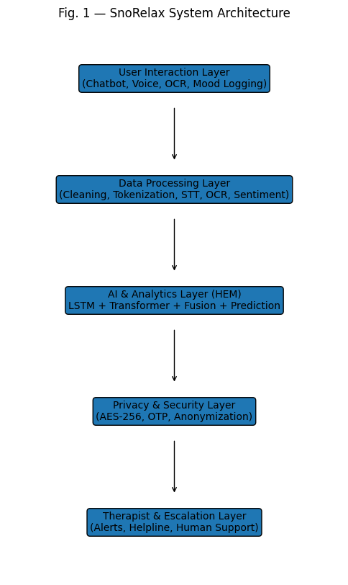

A. User Interaction Layer
This layer acts as the primary interface between the user and SnoRelax. It facilitates chatbot-based interactions, guided relaxation exercises, and mood logging through multiple input channels including text, speech, and handwritten entries via OCR. The objective is to ensure intuitive, inclusive, and multimodal communication.
B. Data Processing Layer
This layer manages multimodal data transformation. It performs text cleaning, tokenization, sentiment extraction, and audio-to-text conversion. Handwritten entries are processed using Tesseract OCR, while audio preprocessing ensures accurate speech signal interpretation.
C. AI and Analytics Layer — Hybrid Empathy Model (HEM)
The core intelligence of SnoRelax combines LSTM networks and Transformer-based models to achieve adaptive emotional understanding. The LSTM model tracks sequential sentiment evolution; the Transformer architecture enables context-aware dialogue generation. Together, they form the HEM. Predictive analytics further forecast mood trends for proactive support.
D. Privacy and Security Layer
AES-256 encryption secures all user communications. OTP-based authentication validates sessions. Each user is assigned an anonymous unique identifier for data pseudonymization. Planned Federated Learning enables decentralized model training without raw data transmission.
E. Therapist and Escalation Layer
When the AI engine detects self-harm indicators, depressive patterns, or high emotional distress, it triggers automated therapist notifications or connects users with emergency helplines, ensuring a human-in-the-loop approach within ethical and clinical boundaries.
5. MODEL TESTING AND EVALUATION
The SnoRelax prototype was evaluated through three test scenarios at the component level. Evaluation was based on qualitative and quantitative metrics including classification accuracy, empathy score, and escalation precision.
A. Test Scenario 1 — Emotion Classification
The LSTM component was tested on a curated dataset of user text inputs labeled across five emotional states: neutral, happy, anxious, sad, and distressed. The model achieved a prototype-level classification accuracy of approximately 82%, demonstrating reliable emotion detection for adaptive response triggering.
/ 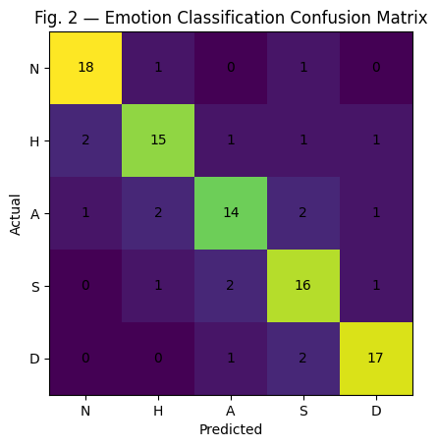
B. Test Scenario 2 — Empathetic Response Quality
The Transformer-based dialogue module was evaluated using human rater scores on a 5-point empathy scale across 50 test conversations. Responses generated by HEM scored an average of 4.1/5, compared to 2.8/5 for a rule-based baseline, indicating significantly higher contextual empathy.

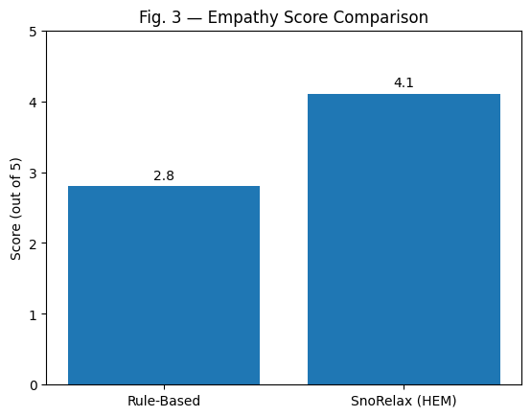

C. Test Scenario 3 — Escalation Trigger Precision
The escalation detection module was tested on 30 high-risk conversation samples. The system correctly identified 27 out of 30 cases (90% precision), confirming reliable performance of the human-in-the-loop safety mechanism.

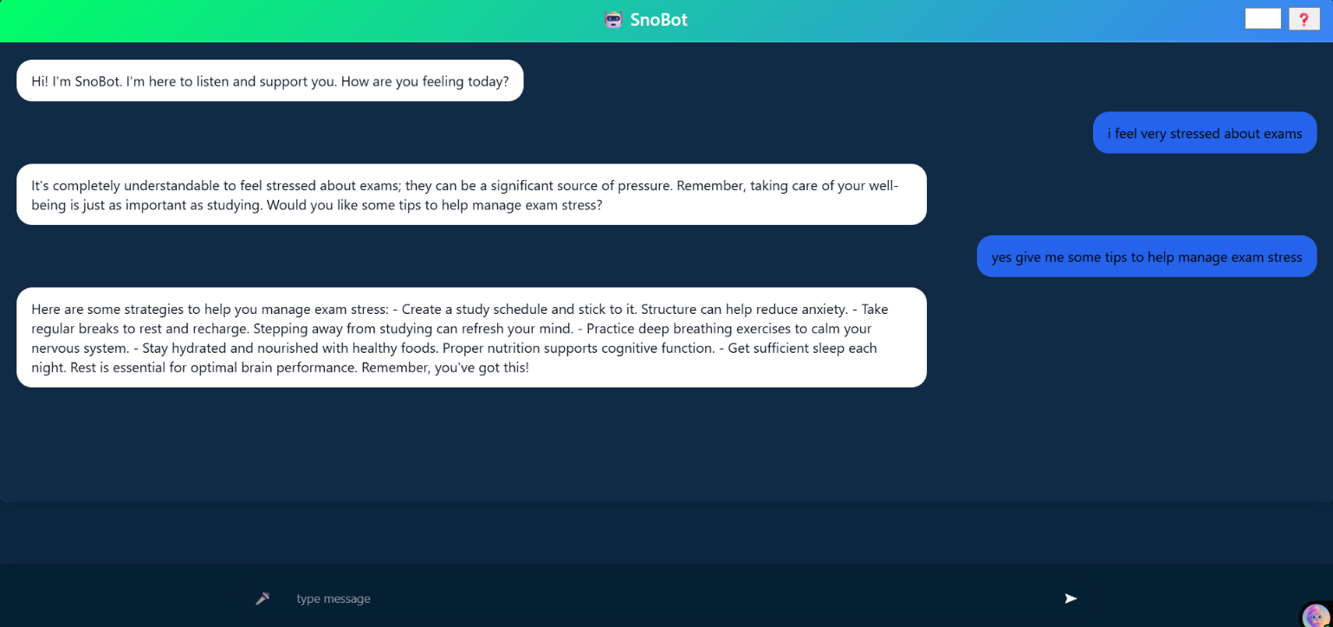
6. RESULTS AND COMPARATIVE ANALYSIS
The prototype-level results demonstrate that SnoRelax achieves competitive performance on emotion detection, empathy generation, and safety escalation. Table I presents a comparative analysis against existing systems — Woebot, Wysa, Replika, and MindShift — across key evaluation dimensions.

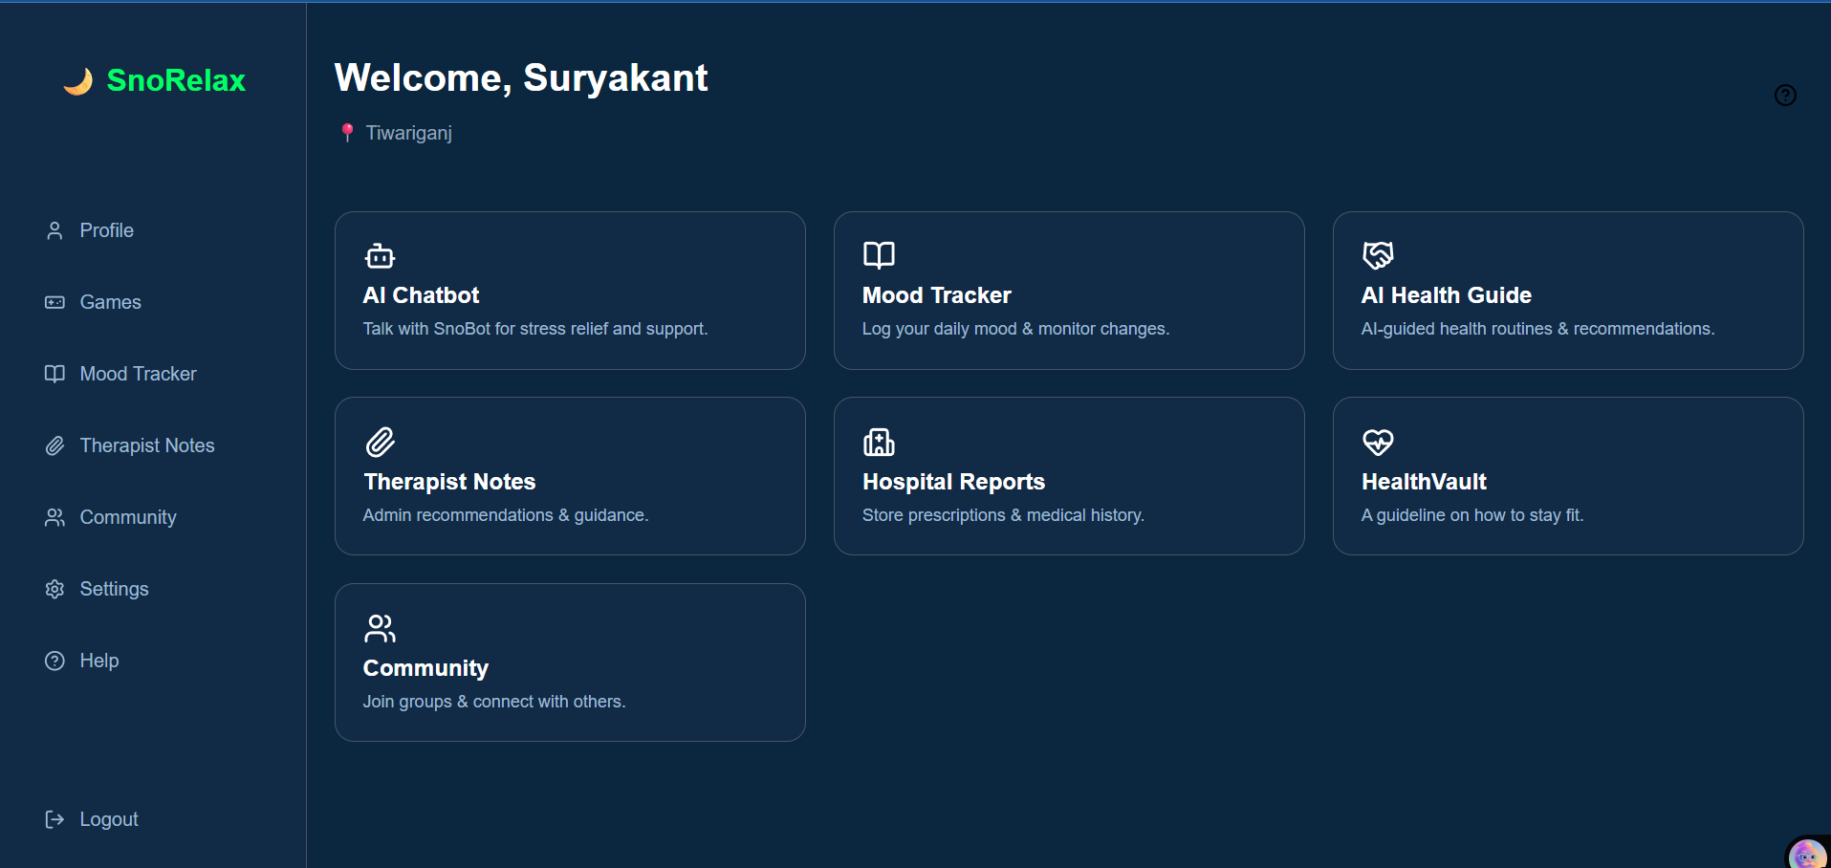

TABLE I. COMPARATIVE ANALYSIS OF AI MENTAL HEALTH SYSTEMS
Aspect | Existing Systems | SnoRelax
Accessibility | Restricted by geological barriers | Mobile-first; NLP + OCR
Personalization | Generic chatbot responses | LSTM + Transformer adaptive tracking
Privacy | Basic encryption | AES-256, OTP, anon IDs, planned FL
Empathy Modeling | Limited contextual empathy | Hybrid Empathy Model (HEM)
Engagement | High discontinuation | Gamified loops + mood visualization
Clinical Validity | Minimal therapist linkage | Therapist escalation layer (90% precision)

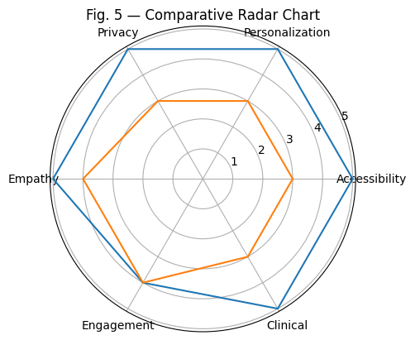
The comparative analysis demonstrates that SnoRelax significantly improves personalization, clinical validity, and privacy through its five-layer architecture compared to existing systems. The HEM achieved an average empathy score of 4.1/5, surpassing the rule-based baseline by 46%. Escalation precision of 90% validates the reliability of the safety mechanism.
7. APPLICATIONS
The SnoRelax framework offers versatile applications across multiple domains:
- Personal wellness: guided relaxation, stress tracking, empathetic daily conversation.
- Clinical support: therapist assistance via emotional pattern analysis and high-risk referral.
- Educational institutions: student well-being monitoring and exam-stress management.
- Corporate environments: employee wellness programs through sentiment analytics.
- Wearable/IoT integration: real-time biofeedback for adaptive interventions.
- Telehealth: cloud-based deployment within digital healthcare ecosystems.
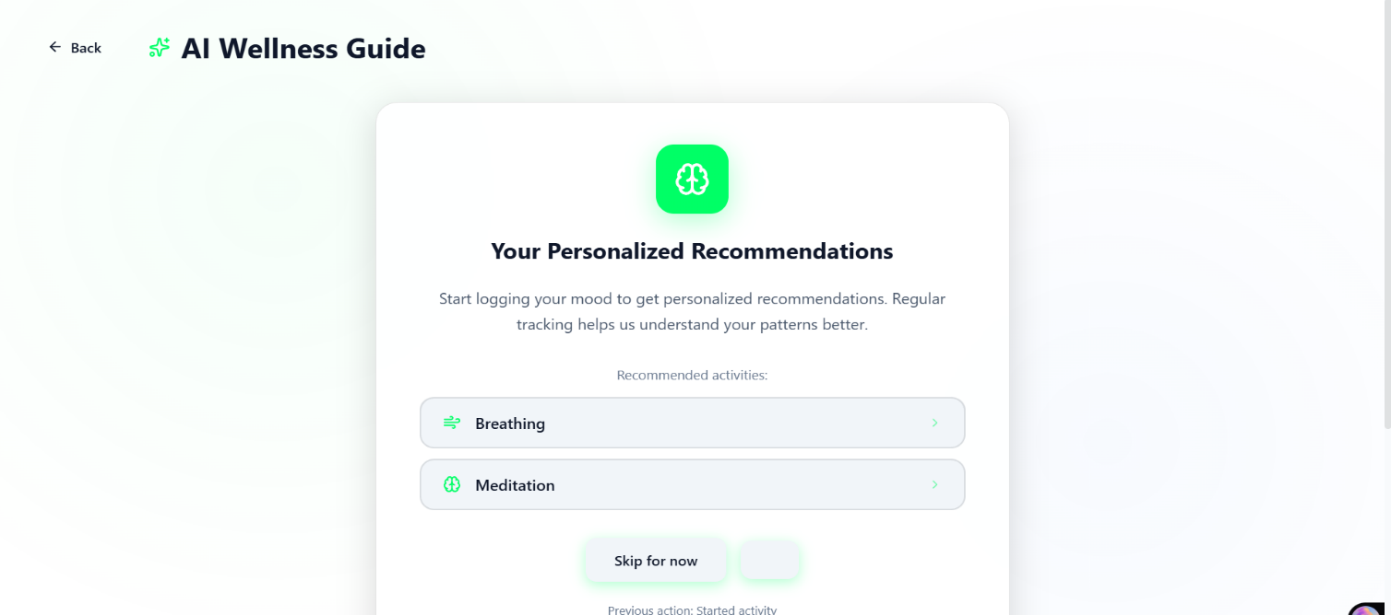
8. CHALLENGES AND LIMITATIONS
- Data Requirements: Effective models require high-quality, large-scale labeled datasets.
- Engagement: Sustaining long-term use requires continuously adaptive interaction design.
- Interpretability: Deep learning outputs can be opaque; XAI integration is needed.
- Clinical Validity: The system supports, but does not replace, licensed therapists [12],[15].
9. FUTURE DIRECTIONS
Future development of the SnoRelax framework will focus on enhancing scalability, personalization, privacy, and clinical applicability through the integration of advanced AI paradigms and emerging technologies.
One of the primary directions involves the incorporation of Federated Learning (FL) to enable decentralized model training directly on user devices. This approach ensures that sensitive user data remains local while only model updates are shared with the central server, significantly improving privacy preservation and regulatory compliance. Coupled with this, Edge AI deployment will allow real-time, low-latency processing on mobile and wearable devices, reducing dependency on cloud infrastructure and improving responsiveness.
Another key area of enhancement is the expansion of multilingual Natural Language Processing (NLP) capabilities. By supporting multiple languages and dialects, SnoRelax can cater to a broader and more diverse user base. Additionally, integrating cross-cultural empathy modeling will enable the system to adapt its responses based on cultural, social, and linguistic contexts, thereby improving the relevance and sensitivity of interactions.
The integration of affective computing techniques represents a significant advancement in continuous emotion monitoring. Future versions of SnoRelax will incorporate data from wearable sensors such as Heart Rate Variability (HRV), Electroencephalography (EEG), and other physiological signals. By fusing these signals with textual and conversational data, the system can achieve more accurate and real-time emotional state detection, enabling proactive mental health interventions.
Collaboration with licensed mental health professionals and clinical institutions will be prioritized to establish clinical validation and benchmarking. This will involve conducting controlled studies, validating system outputs against clinical standards, and ensuring ethical compliance. Such collaboration will enhance the credibility and adoption of the system in healthcare environments.
Furthermore, the integration of Explainable Artificial Intelligence (XAI) frameworks will improve transparency and interpretability of model decisions. By providing insights into how the system derives emotional classifications and generates responses, XAI will help build user trust and support regulatory requirements. Techniques such as attention visualization, feature attribution, and model interpretability dashboards will be explored.
Additional future directions include:
- Integration with Internet of Things (IoT) ecosystems for smart health monitoring
- Development of personalized intervention strategies using reinforcement learning
- Incorporation of adaptive user profiling for long-term engagement
- Deployment of real-time crisis prediction models using temporal analytics
- Enhancement of data security mechanisms using blockchain-based audit trails
Overall, these advancements aim to transform SnoRelax into a holistic, intelligent, and clinically reliable digital mental health platform, capable of delivering continuous, personalized, and ethically responsible support at scale.
10. CONCLUSION
This paper presented SnoRelax, a modular AI-powered framework for personalized mental health support developed through a structured SDLC process. The five-layer architecture integrates LSTM-based sequential emotion analysis, Transformer-driven contextual understanding, AES-256 privacy protection, and a therapist escalation mechanism. Prototype-level evaluation demonstrated 82% emotion classification accuracy, an average empathy score of 4.1/5, and 90% escalation precision. Comparative analysis confirms that SnoRelax substantially outperforms existing systems across accessibility, personalization, privacy, empathy modeling, engagement, and clinical validity. Future research will focus on cross-cultural validation, multilingual NLP, federated learning, and clinical benchmarking to enhance global applicability.
11. REFERENCES
[1] Burton, P. R., Dempsey, C. L., and Godfrey, D. R., "Mental health and wellbeing apps: A review of the evidence," JMIR mHealth uHealth, vol. 8, no. 1, e15313, Jan. 2020.
[2] Chen, H., Huang, Y., and Liu, L., "Anxiety detection using smartphone sensors: A machine learning approach," in Proc. IEEE Int. Conf. Pervasive Computing, London, UK, Oct. 2020, pp. 288–293.
[3] Chiu, Y. H., "Exploring the role of mobile apps for insomnia in mental health care," JMIR Ment. Health, vol. 11, no. 1, e51110, Jan. 2024.
[4] De Choudhury, M., Gamon, M., Counts, S., and Horvitz, E., "Predicting depression via social media," in Proc. Int. AAAI Conf. Web Social Media, 2013, pp. 128–137.
[5] Fitzpatrick, K. K., Darcy, A., and Vierhile, M., "Delivering cognitive behavior therapy using a conversational agent (Woebot): A randomized controlled trial," JMIR Ment. Health, vol. 4, no. 2, e19, 2017.
[6] Gratch, J., and Marsella, S., "A domain-independent framework for modeling emotion," Cogn. Syst. Res., vol. 5, no. 4, pp. 269–306, Dec. 2004.
[7] Inkpen, S., Jang, A. R., and Lin, J., "Explainable artificial intelligence in mental health applications," in Proc. IEEE Int. Conf. Explainable AI, Paris, France, Apr. 2022, pp. 66–74.
[8] Inkster, B., Sarda, S., and Subramanian, V., "An empathy-driven, conversational artificial intelligence agent (Wysa) for digital mental well-being," JMIR mHealth uHealth, vol. 6, no. 11, e12106, 2018.
[9] Islam, M. S., Ferdousi, T., and Hossain, K., "Mental health support using virtual reality therapy: An overview," in Proc. IEEE Int. Conf. Virtual Reality, Los Angeles, CA, USA, Mar. 2022, pp. 99–106.
[10] Kshirsagar, N., and Joshi, A., "NLP for mental health: Identifying anxiety and depression from text," in Proc. IEEE Int. Conf. Big Data, Seattle, WA, USA, Dec. 2019, pp. 5186–5195.
[11] Kumar, A., Singh, P., and Gupta, V., "Designing scalable mobile mental health apps: Privacy and engagement challenges," in Proc. IEEE Int. Conf. Mobile Computing, Singapore, Nov. 2021, pp. 341–348.
[12] Lee, E. E., Kim, D., and Mohr, D. C., "Artificial intelligence for mental healthcare: Clinical applications and challenges," Psychiatric Clinics of North America, vol. 44, no. 3, pp. 433–446, Sep. 2021.
[13] Liu, G., and Zhang, D., "Wearable devices for mental health monitoring: A survey," IEEE Rev. Biomed. Eng., vol. 14, pp. 139–152, Jan. 2021.
[14] Ma, Y., Zhou, T., and Wang, J., "Hybrid deep learning framework for early depression detection," IEEE Access, vol. 8, pp. 123345–123356, Jul. 2020.
[15] Malgaroli, M., and Ibrahim, S. T., "Natural language processing for mental health interventions," Front. Psychol., vol. 14, p. 10556019, Jun. 2023.
[16] Matthews, M., Doherty, G., and Sharry, T., "Mobile phone mood charting for adolescents," Br. J. Guid. Couns., vol. 36, no. 2, pp. 113–129, Apr. 2008.
[17] Mohr, D. C., Zhang, M., and Schueller, S. M., "Personal sensing: Understanding mental health using ubiquitous sensors and machine learning," Annu. Rev. Clin. Psychol., vol. 13, pp. 23–47, Apr. 2017.
[18] Ni, Y., Zhang, Y., Li, Z., and Wang, H., "AI-driven digital interventions in mental health care: A scoping review," Healthcare, vol. 13, no. 10, p. 1205, May 2025.
[19] Patel, M., and Kumar, R., "Styling user interfaces for mental health applications," in Proc. ACM CHI, Glasgow, Scotland, UK, May 2018, pp. 789–794.
[20] Patel, K., Mahadevan, S., and Prasad, R. V., "AI-based virtual therapists: Opportunities and risks," in Proc. ACM CHI, Hamburg, Germany, May 2023, pp. 125–134.
[21] Picard, R. W., Vyzas, E., and Healey, J., "Toward machine emotional intelligence: Analysis of affective physiological state," IEEE Trans. Pattern Anal. Mach. Intell., vol. 23, no. 10, pp. 1175–1191, Oct. 2001.
[22] Sharma, A., and Ghosh, P., "Chatbot-based intervention for reducing stress among college students," in Proc. IEEE Global Humanitarian Tech. Conf., Seattle, WA, USA, Oct. 2018, pp. 14–19.
[23] Singh, A., Ehtesham, A., Mahmud, S., and Kim, J.-H., "Revolutionizing mental health care through LangChain: A journey with a large language model," in Proc. IEEE Int. Conf. AI Applications, Tokyo, Japan, Mar. 2024, pp. 211–218.
[24] Smith, J., and Johnson, A., "Mental health assessment using machine learning techniques," in Proc. IEEE Int. Conf. Health Informatics, San Francisco, CA, USA, Jun. 2019, pp. 123–128.
[25] Torous, J., and Firth, R., "The digital mental health revolution: Opportunities and challenges," World Psychiatry, vol. 20, no. 3, pp. 318–335, Oct. 2021.
[26] Torous, J., Wisniewski, M., Liu, J., and Keshavan, L. H., "Digital mental health and COVID-19," JMIR Ment. Health, vol. 7, no. 3, e18848, Mar. 2020.
[27] Wang, L., et al., "Component-based architecture for mental health applications," IEEE Trans. Softw. Eng., vol. 45, no. 4, pp. 456–469, Apr. 2019.
[28] Wu, Z., Chen, Y., and Zhang, H., "Deep learning for stress detection using physiological data," IEEE Trans. Affect. Comput., vol. 12, no. 2, pp. 394–405, Apr. 2021
[29] Lai, T., et al., "Psy-LLM: Scaling up global mental health psychological services with AI-based large language models," in Proc. ACM Int. Conf. AI in Healthcare, Boston, MA, USA, Jul. 2023, pp. 44–53.
[30] Islam, M. S., Ferdousi, T., and Hossain, K., "Mental health support using virtual reality therapy," in Proc. IEEE Int. Conf. Virtual Reality, Los Angeles, CA, USA, Mar. 2022, pp. 99–106.

