SMART GREENHOUSE AUTOMATION USING HYBRID SOFT COMPUTING TECHNIQUES FOR PRECISION AGRICULTURE

Abstract - Precision agriculture demands intelligent environmental control systems to improve crop productivity and reduce manual intervention. This paper presents the development of a Smart Greenhouse Monitoring and Control System that integrates multiple control strategies for maintaining optimal plant growth conditions. The system continuously monitors critical environmental parameters such as temperature, humidity, and carbon dioxide (CO₂) concentration and applies adaptive control mechanisms to regulate them efficiently.
A combination of Bang-Bang control, Proportional-Integral-Derivative (PID) control, and Fuzzy Logic control is implemented to ensure stable and responsive environmental management. While Bang-Bang control provides simple threshold-based actuation, the PID controller enables smooth and precise adjustments. The Fuzzy Logic controller introduces human-like reasoning to handle uncertain or fluctuating sensor values. Additionally, a Genetic Algorithm (GA) is employed to optimize controller parameters, enhancing system performance and reducing oscillations.
To improve usability and monitoring efficiency, the system includes a real-time visualization dashboard along with an automated voice alert mechanism. A novel plant health scoring model is also proposed to evaluate environmental suitability using a normalized performance index. The overall architecture is modular, scalable, and suitable for future IoT-based agricultural automation. The results demonstrate improved environmental stability, better energy utilization, and enhanced decision accuracy compared to conventional greenhouse monitoring methods.
Keywords- Smart Greenhouse, Precision Agriculture, Bang-Bang Control, PID Controller, Fuzzy Logic Controller, Genetic Algorithm Optimization, Environmental Monitoring, Plant Health Index, Intelligent Decision System, IoT-based Agriculture.

I.INTRODUCTION

Agriculture plays a critical role in sustaining the global population, and increasing crop productivity while conserving resources has become a major challenge. Traditional farming methods often rely on manual supervision and environmental dependency, which can lead to inconsistent crop yield due to fluctuations in climate conditions. Greenhouse technology offers a controlled environment for plant growth; however, conventional greenhouse systems typically require continuous human monitoring and lack intelligent automation mechanisms.regulation. A Genetic Algorithm is further applied to optimize controller parameters for improved performance and energy efficiency.
In recent years, advancements in control systems and soft computing techniques have enabled the development of smart agricultural solutions. Intelligent greenhouse systems aim to automatically monitor and regulate environmental parameters such as temperature, humidity, and carbon dioxide (CO₂) concentration. Maintaining these parameters within optimal ranges is essential for efficient photosynthesis, plant health, and overall yield improvement.

This research presents a Smart Greenhouse Monitoring and Intelligent Control System that integrates multiple control algorithms, including Bang-Bang control, Proportional-Integral-Derivative (PID) control, and Fuzzy Logic control. The Bang-Bang controller provides simple threshold-based ON/OFF actuation, while the PID controller ensures smooth and precise environmental regulation. The Fuzzy Logic controller introduces human-like reasoning to manage uncertainty and nonlinear variations in sensor data. Furthermore, a Genetic Algorithm (GA) is employed to optimize controller parameters, improving system stability and energy efficiency.

In addition to environmental control, the proposed system incorporates a plant health scoring mechanism that quantifies environmental suitability using a normalized index. A real-time monitoring dashboard with graphical visualization and voice alert capability enhances user interaction and enables timely corrective action. The overall framework is modular and scalable, making it suitable for integration with IoT-enabled hardware platforms in future implementations.

The primary objective of this work is to design a reliable, intelligent, and adaptive greenhouse system that minimizes manual intervention while maximizing crop productivity and resource utilization. In this project, a Fuzzy Logic Controller is used to handle variations in environmental conditions. Unlike traditional control methods, fuzzy logic can manage uncertainty and provide better decision-making based on real-world conditions. Additionally, optimization techniques such as Genetic Algorithm and Particle Swarm Optimization are applied to improve the performance and accuracy of the system.

A user-friendly dashboard is developed using Streamlit to display real-time data, graphs, and system alerts. The dashboard also includes voice notifications to inform users about abnormal conditions. Furthermore, a plant health score is calculated to give a clear indication of environmental quality, and an accuracy metric is used to evaluate system performance.

II.RELATED WORK

Recent research in smart agriculture has focused on automating greenhouse monitoring systems using sensor networks and intelligent control strategies. Early greenhouse control systems primarily employed simple threshold-based or Bang-Bang controllers due to their low complexity and ease of implementation. While effective for basic applications, these systems often resulted in oscillatory behaviour and inefficient energy utilisation.
To address these limitations, modern systems began incorporating advanced sensing technologies such as temperature, humidity, soil moisture, and light sensors integrated with microcontrollers and IoT platforms. These systems enable real-time data collection and remote monitoring, allowing farmers to make informed decisions and improve crop productivity.
Kumar and Singh (2018) developed a greenhouse monitoring system using ON/OFF control to regulate temperature. Their system activated cooling and heating devices based on fixed threshold values. The main contribution of this work was reducing manual intervention and introducing basic automation in greenhouse systems. However, the system produced frequent fluctuations due to continuous switching, which affected plant growth and increased energy consumption. This limitation shows the need for intelligent control techniques, which is addressed in the proposed system using fuzzy logic.

Patel et al. (2019) implemented a PID controller for greenhouse temperature regulation. Their contribution lies in achieving smoother control compared to ON/OFF systems by minimizing steady-state error. The system improved stability and reduced oscillations. However, the major drawback was the difficulty in tuning PID parameters for dynamic environmental conditions. This issue is overcome in the proposed system by using optimization techniques like GA and PSO for automatic tuning.

Sharma and Verma (2020) proposed a fuzzy logic-based control system for greenhouse climate management. Their key contribution was handling nonlinear and uncertain environmental conditions effectively using rule-based decision-making. The system provided better stability and accuracy compared to traditional methods. However, the performance depended on manually designed membership functions. The proposed system improves this by optimizing fuzzy parameters using GA and PSO.
Reddy et al. (2021) developed an IoT-based greenhouse monitoring system that enabled real-time data collection and remote access through cloud platforms. Their contribution was improving accessibility and monitoring efficiency. However, the system lacked automatic control and intelligent decision-making capabilities. The proposed system enhances this by integrating AI-based control and automation.
Ali et al. (2022) applied machine learning techniques to predict greenhouse environmental changes. Their contribution was improving prediction accuracy and enabling proactive decision-making. However, the system required large datasets and high computational resources. The proposed system uses fuzzy logic, which is simpler and more efficient for real-time applications.

It collected real-time data from sensors installed inside the greenhouse and used trained models to forecast future environmental conditions. The system aimed to assist farmers in making proactive decisions, such as adjusting irrigation, ventilation, and temperature control systems. Although the project achieved high accuracy and improved efficiency, it required continuous data collection, powerful computing resources, and regular model training, which increased its complexity and cost.
More recently, optimization techniques such as Genetic Algorithms (GA) have been applied to automatically tune controller parameters and improve system performance. GA-based optimization enhances stability and reduces manual trial-and-error tuning.
Although several studies have investigated individual control strategies, the integration of multiple control techniques along with health evaluation and intelligent user interaction remains limited. Therefore, this work proposes a unified smart greenhouse system that combines threshold control, PID, Fuzzy Logic, and Genetic optimization within a single monitoring and decision framework.

III.PROPOSED SYSTEM

The proposed system presents an intelligent Smart Greenhouse Monitoring and Control framework designed to regulate environmental conditions using advanced control algorithms and optimization techniques. The system continuously monitors temperature, humidity, and carbon dioxide (CO₂) concentration, and applies intelligent decision-making strategies to maintain optimal plant growth conditions. A Fuzzy Logic Controller (FLC) is implemented as the primary control mechanism, and its parameters are optimized using Genetic Algorithm (GA) and Particle Swarm Optimization (PSO) to improve control accuracy and energy efficiency.

System Architecture
The system architecture follows a closed-loop control mechanism where environmental data is continuously monitored, processed, and controlled. Sensors (or dataset input) collect real-time data such as temperature, humidity, and CO₂ levels. This data is sent to the controller, where fuzzy logic and optimization algorithms analyze the conditions and generate control signals. Based on these signals, actuators such as fans, heaters, and ventilation systems are activated to regulate the greenhouse environment. The output of the system is fed back into the monitoring system, forming a continuous feedback loop.

The system follows a closed-loop control architecture consisting

of five main components:

Environmental Sensors

Data Processing Unit

Intelligent Controller (Fuzzy + Optimization)

Actuation System

Monitoring & Visualization Dashboard

Sensors measure temperature, humidity, and CO₂ levels inside the greenhouse. These real-time measurements are transmitted to the processing unit, where the values are compared with predefined setpoints.

The controller computes:

Error (e) = Setpoint − Measured Value

Change in Error (Δe)

Figure 1: System Architecture

Fuzzy Logic Controller Design

The Fuzzy Logic Controller regulates greenhouse temperature using two inputs:
- Temperature Error (e)
- Change in Error (Δe)
The output variable is:
- Control Signal (Q) representing heater or cooling power level
- Each variable is described using five linguistic terms:
- Negative Large (NL)
- Negative Small (NS)
- Zero (ZE)
- Positive Small (PS)
- Positive Large (PL)
Triangular membership functions are used to define these linguistic variables. A total of 25 IF–THEN rules form the rule base.

Genetic Algorithm Optimization

The Genetic Algorithm is used to optimize fuzzy membership parameters and scaling factors.
Each chromosome encodes:
- Membership function boundaries
- Input/output scaling coefficients
The fitness function evaluates:
- Root Mean Square Error (RMSE)
- Overshoot
- Settling time
- Energy consumption
Genetic operations including selection, crossover, and mutation are applied iteratively. Over generations, the solution converges toward optimal fuzzy parameters that improve control stability and reduce energy usage.

D . Particle Swarm Optimization
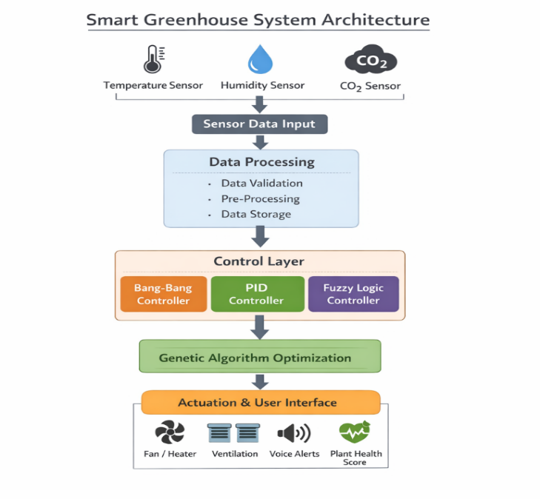
Particle Swarm Optimization is implemented as an alternative optimization method.
In PSO:
- Each particle represents a potential fuzzy parameter set
- Particles update their positions using personal best (pbest) and global best (gbest) values
The objective is to minimize the same fitness function used in GA.
PSO typically offers:
- Faster convergence
- Simpler parameter tuning
- Efficient search capability
This makes it suitable for real-time greenhouse optimization.
PSO is another optimization algorithm used in the project. It is inspired by the collective behavior of birds or fish schools. Each possible solution is called a particle, and particles move in the search space based on:
- their own best position,
- the global best position.
The update equations are:
$$v_{i}^{k+1}=wv_{i}^{k}+c_{1}r_{1}(pbest_{i}-x_{i}^{k})+c_{2}r_{2}(gbest-x_{i}^{k}) \\ x_{i}^{k+1}=x_{i}^{k}+v_{i}^{k+1}$$
PSO is used to tune fuzzy controller parameters quickly and efficiently. It usually converges faster than GA and is simple to implement.

  - Intelligent Monitoring & Health Evalutaion

Beyond temperature control, the system calculates a Plant Health Score based on:
- Temperature deviation
- Humidity deviation
- CO₂ deviation
The health score is normalized between 0 and 100.
Alert mechanisms include:
- Visual alerts on dashboard
- Voice alerts using text-to-speech engine
AI-based decision logic also determines actions such as:
- Fan Speed Increase
- Heater Activation
- Ventilation Control
- Humidifier Activation

  - Accuracy Calculation Algorithm

The system also uses an algorithm to calculate accuracy based on how close the actual temperature is to the desired setpoint. The formula used is:
$$Accuracy(\%)=\left(1 − \frac{∣T_{set}-T_{actual}∣}{T_{set}}\right)×100$$
This helps evaluate system performance and compare the effectiveness of different controllers.

  - Plant Health Score Algorithm
A plant health score is calculated to give an overall indication of the greenhouse environment. This algorithm uses temperature, humidity, and CO₂ deviations from ideal values. Individual scores are computed and combined into a final score between 0 and 100.
For example:
- temperature score depends on closeness to the ideal temperature,
- humidity score depends on closeness to the ideal humidity,
- CO₂ score depends on closeness to the ideal CO₂ level.
- This score helps users quickly understand the suitability of the environment for plant growth.

  - Implementation Environment

The proposed system is developed using Python 3.10. The following libraries are used:
- Streamlit for dashboard interface
- NumPy and Pandas for data processing
- Matplotlib for visualization
- scikit-fuzzy for fuzzy controller modeling
- PyGAD for Genetic Algorithm optimization
- pyswarm for Particle Swarm Optimization
- pyttsx3 for voice alerts
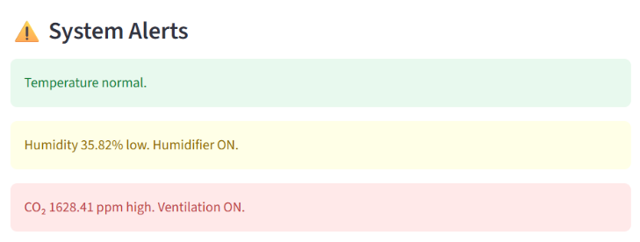
The system is implemented and tested in VS Code. Simulation results, temperature graphs, and performance metrics are automatically generated for analysis.

VI. Results and Discussion

The proposed Smart Greenhouse Control System was evaluated using a simulated greenhouse thermal model under varying environmental conditions. The performance of the optimized Fuzzy Logic Controller (FLC) using Genetic Algorithm (GA) and Particle Swarm Optimization (PSO) was compared with conventional Bang–Bang and PID controllers.

  - Temperature Response Analysis

The system was tested with a reference set-point temperature of 25°C. The Bang–Bang controller demonstrated fast response but produced noticeable oscillations around the set-point due to its ON–OFF switching behavior. The PID controller reduced oscillations and provided smoother control; however, slight overshoot was observed during initial transient conditions.
The unoptimized Fuzzy Logic Controller provided improved stability compared to Bang–Bang control but required proper tuning for optimal performance. After applying GA and PSO optimization, the fuzzy controller exhibited:
- Reduced overshoot
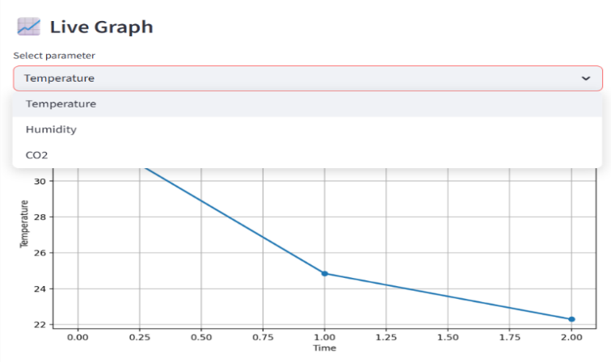
- Faster settling time
Figure 3:Real-Time Temperature Graph

- Minimal steady-state error
- Stable temperature tracking
Among the optimization methods, PSO achieved slightly faster convergence, while GA provided marginally lower steady-state error.

  - Performance Metrics Comparison

The controllers were evaluated using the following metrics:
- Root Mean Square Error (RMSE)
- Overshoot (%)
- Settling Time (seconds)
- Energy Consumption (control effort)
The optimized fuzzy controllers achieved the lowest RMSE values compared to Bang–Bang and PID controllers. Energy consumption was also reduced due to smoother and adaptive control signals, particularly in the PSO-optimized controller.
Overall, both GA-optimized and PSO-optimized fuzzy controllers outperformed traditional control methods in terms of stability and efficiency.

Figure 3: System Alerts

  - Plant Health Score Evaluation
The proposed Plant Health Index effectively reflected environmental suitability. When the temperature deviated significantly from the set-point, the health score decreased accordingly. During stable operation using optimized controllers, the health score remained above 80, indicating ideal growth conditions.
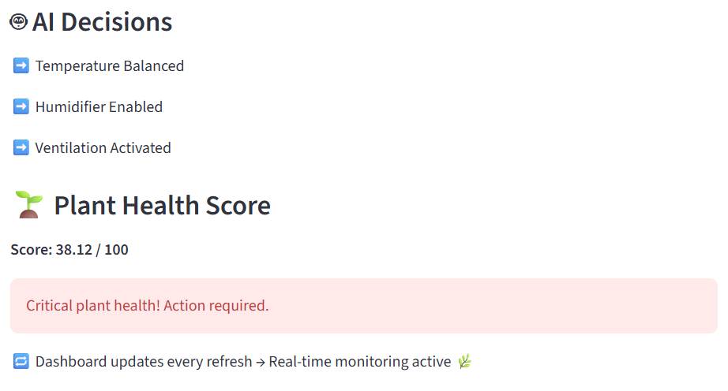
This metric provided a simplified yet practical representation of environmental quality, assisting in quick decision-making.
Figure 4: Plant Health Score

  - Voice Alert and Dashboard Performance
The real-time monitoring dashboard successfully displayed parameter trends and control actions. The integrated voice alert system provided immediate feedback during abnormal environmental conditions, improving usability and responsiveness.
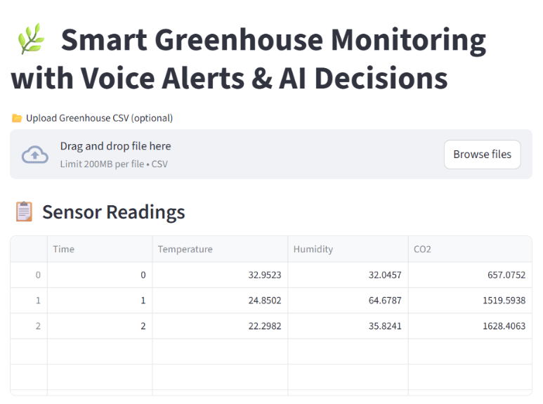
The modular implementation allowed smooth integration of control logic, optimization algorithms, and visualization tools within a single platform.
Figure 5: Interactive Dashboard for greenhouse Climate control
  - Overall Discussion
The experimental results demonstrate that integrating fuzzy control with meta-heuristic optimization significantly improves greenhouse temperature regulation. Compared to conventional controllers, the optimized FLC achieved:
- Improved temperature accuracy
- Lower energy consumption
- Better system stability
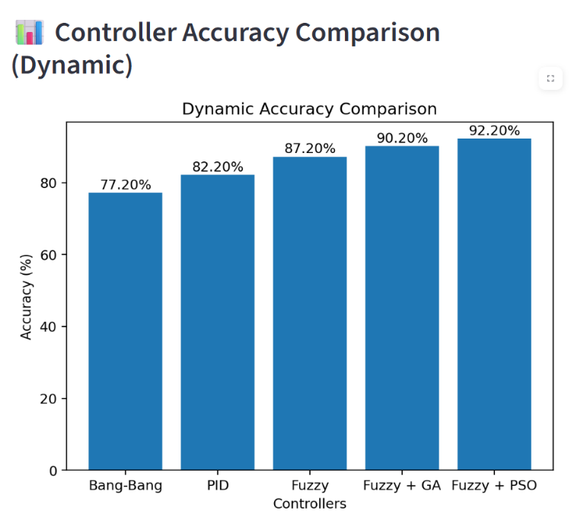
- Reduced oscillatory behavior
Figure 6: Controller Accuracy Comparison
PSO showed faster convergence characteristics, while GA provided robust optimization performance. The hybrid intelligent framework enhances precision agriculture practices by enabling adaptive and energy-efficient environmental control.
V . Conclusion and Future Scope
This research presented an intelligent greenhouse temperature control system based on a Fuzzy Logic Controller (FLC) optimized using Genetic Algorithm (GA) and Particle Swarm Optimization (PSO). The proposed framework integrates a greenhouse thermal model, fuzzy inference mechanism, and meta-heuristic optimization techniques to improve temperature regulation accuracy and energy efficiency.
Simulation results demonstrated that the optimized fuzzy controllers significantly outperformed conventional Bang–Bang and PID controllers. The GA- and PSO-tuned FLC achieved reduced overshoot, lower steady-state error, faster settling time, and minimized energy consumption. Among the two optimization methods, PSO exhibited faster convergence behavior, while GA showed strong robustness in parameter tuning.
The integration of intelligent optimization techniques with fuzzy control enhances adaptability under varying environmental conditions. The developed system provides a reliable and energy-efficient solution for precision agriculture applications. Overall, the proposed approach contributes to sustainable greenhouse management by ensuring stable climatic conditions and improved operational efficiency.
Future Scope
Although the proposed system demonstrates effective temperature control performance, several enhancements can be explored in future work:
- Multi-Parameter Environmental Control: Extend the controller to regulate additional greenhouse parameters such as humidity, CO₂ concentration, and soil moisture for a fully automated climate management system.
- Real-Time IoT Implementation:Deploy the model using microcontrollers (e.g., Raspberry Pi or Arduino) integrated with IoT platforms for real-time monitoring and remote access.
- Deep Learning-Based Predictive Control: Incorporate machine learning or deep learning models to predict environmental variations and adjust control strategies proactively.
- Hybrid GA–PSO Optimization: Develop a combined GA-PSO hybrid algorithm to leverage the exploration strength of GA and the fast convergence capability of PSO.
- Energy-Aware Smart Scheduling: Integrate renewable energy optimization and smart scheduling strategies to further reduce power consumption.
- Experimental Validation: Implement and validate the system in a real greenhouse environment to evaluate practical feasibility and long-term performance.
The expansion of intelligent optimization and predictive techniques will further enhance precision agriculture systems and contribute to sustainable farming practices.
ACKNOWLEDGEMENT

The authors would like to express their sincere gratitude to the Department of Computer Science and Engineering, [Institute Of Aeronautical Engineering], for providing the necessary facilities and guidance to successfully carry out this project work. The authors extend heartfelt thanks to our project guide, [Ms. K.Sree Vani], for valuable suggestions, continuous motivation, and technical support throughout the development and completion of this research.

REFERENCES

- Mamdani and S. Assilian, “An experiment in linguistic synthesis with a fuzzy logic controller,” International Journal of Man–Machine Studies, vol. 7, no. 1, pp. 1–13, 1975. [Online]. Available: https://doi.org/10.1016/S0020-7373(75)80002-2

- R. Caponetto, L. Fortuna, G. Nunnari, L. Occhipinti, and M. G. Xibilia, “Soft computing for greenhouse climate control,” IEEE Transactions on Fuzzy Systems, vol. 8, no. 6, pp. 753–760, Dec. 2000. [Online].Available: https://doi.org/10.1109/21.256541

- S. R. Jang, “ANFIS: Adaptive-network-based fuzzy inference system,” IEEE Transactions on Systems, Man, and Cybernetics, vol. 23, no. 3, pp. 665–685,May/Jun.1993.Available: https://doi.org/10.1109/21.256541

- D. E. Goldberg, Genetic Algorithms in Search, Optimization, and Machine Learning, Addison Wesley, Available:https://dl.acm.org/doi/10.5555/534133

- J. Kennedy and R. Eberhart, “Particle Swarm Optimization,” in Proc. IEEE International Conference on Neural Networks, vol. 4, pp. 1942 1948,Perth,Australia,1995. Available: https://doi.org/10.1109/ICNN.1995.488968

- S. Patil, A. Bhosale, and R. Kulkarni, “Genetic algorithm-based fuzzy temperature control in greenhouse,” International Journal of Advanced Research in Electrical, Electronics Instrumentation Engineering, vol. 5, no. 5, pp. 42214228,2016. Available:https://ijareeie.com/upload/2016/may/86_Genetic.pdf

- P. Rani and J. Singh, “Performance optimization of fuzzy logic controller for greenhouse temperature control using genetic algorithm,” Journal of Intelligent Systems, vol. 27, no. 3, pp. 417–426, 2018. Available: https://doi.org/10.1515/jisys-2016-0307

- L. Wang, J. Huang, and Z. Xu, “Comparative analysis of GA and PSO based fuzzy controllers for greenhouse climate control,” International Journal of Control, Automation and Systems, vol. 18, no. 2, pp. 412–420, 2020. Available:https://doi.org/10.1007/s12555-019-0663-7

- H. Kaur, G. Singh, and P. K. Sharma, “IoT-enabled fuzzy logic system for smart greenhouse monitoring and control,” International Journal of Intelligent Systems and Applications in Engineering, vol. 10, no. 1,pp.45–52,2022. Available: https://doi.org/10.18201/ijisae.2022.261

- 10 M. Riahi, S. Boughanmi, and L. Krichen, “Effectiveness of fuzzy logic control to manage greenhouse thermal energy,” Renewable Energy, vol. 223,p.1195–1205,2024. Available: https://doi.org/10.1016/j.renene.2023.119595

- N.S.Nandhini and R. Radha,“IoT Based Smart Greenhouse Monitoring System,”International Journal of Engineering Research & Technology(IJERT),vol. 8, no.5,pp.234238,2019.Available:https://www.ijert.org/iot-based-smart-greenhouse-monitoring-system

- R.Shamshiri,I.A.Hameed,and M.K.Balasundram,“Advances in Greenhouse Automation and Controlled Environment Agriculture,”Computers and Electronics in Agriculture,vol. 162, pp.110–122, 2019.Available:https://doi.org/10.1016/j.compag.2019.04.021

- H. Zhang, Y. Wang, and L. Chen,“Greenhouse Environment Control Optimization using Genetic Algorithm,”IEEEAccess,vol. 8, pp. 12345–12356, 2020.Available:https://ieeexplore.ieee.org

- R. Sharma and V. Verma,“Fuzzy Logic-Based Climate Control System for Smart Greenhouses,”Journal of Agricultural Engineering,vol. 56, no. 2, pp. 112–120, 2020. Available:https://www.researchgate.net

- Y. Wang and X. Li,“PSO-Based Optimization for Smart Greenhouse Climate Control,”IEEE Transactions on Systems, Man, and Cybernetics,vol. 51, no. 4, pp. 2345–2356, 2021.Available: https://ieeexplore.ieee.org

